Contents
1. What is microservice and why we used it? 2
Resources: https://www.geeksforgeeks.org/microservices-interview-questions/ 2
2. Diff between the Monolithic, SOA, and Microservices 3
3. What is Eureka Service/ Service Registry? 3
Resources: https://www.geeksforgeeks.org/spring-boot-eureka-server/ 4
4. What is blue green deployment? 4
Resource: https://docs.aws.amazon.com/whitepapers/latest/overview-deployment-options/bluegreen-deployments.html 4
5. What is API Gateway in microservice? 4
6. What is Saga pattern in microservices? 4
Resources: 4
7. What is resiliency in microservice? 5
8. What is fault tolerance then? 5
9. What is Hystrix in microservice? 5
Resources: 5
10. What is circuit Breaker in microservice? 5
Resources: 5
11. Tell me about some design in microservice? 6
12. How to microservices communicate with each other in spring boot? 6
Resources: https://www.geeksforgeeks.org/different-ways-to-establish-communication-between-spring-microservices/ 6
13. Diff between the synchronous and asynchronous in microservices 6
Resources: https://www.geeksforgeeks.org/difference-between-synchronous-and-asynchronous-transmission/ 7
14. What is spring cloud and how it’s useful? 7
Resources: https://www.geeksforgeeks.org/what-is-spring-cloud/ 7

What is microservice and why we used it?
Microservices is an architecture in which the application performs as a loosely coupled service that can be developed, deployed, and maintained independently. Each service in this architecture is called a Microservice.
- In Microservices, each service performs a different and unique function.
- Through APIs it communicates with other services by focusing on the business strategies.
- Different microservices can be used for different architecture and languages.
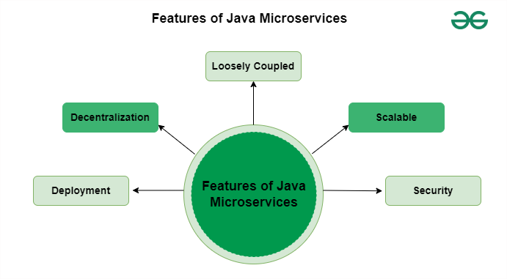
- Deployment: It breaks an application into small services, because of this it is possible to deploy and develop each of these services independently.
- Decentralization: Data storage management is decentralized. Each of the services has its own data related to a particular business functionality.
- Loosely Coupled: If a single process fails, it will not affect the other services and the entire system.
- Security: It provides authentication and authorization based on the Role-based access model (RBAC).
- Scalable: Based on the requirements, services can be scaled which results in better scalability.

Resources: Introduction - Blue/Green Deployments on AWS (amazon.com)

Diff between the Monolithic, SOA, and Microservices
Features | Monolithic | SOA | Microservices
Structure | A single application where all software components are assembled and tightly coupled. | Collection of services and loosely coupled. | Collection of small services and services independently deployable.
Communication | Within the same application, components communicate with each other. | Using some standardized protocols, services communicate with each other. | Through some lightweight protocols, all the services communicate with each other.
Scalability | Scaling is required according to the needs of the entire application. | All services can be scaled independently. | All the services can be scaled independently according to the business requirement.
Development and Deployment | It maintains centralized development and components deployed as a single unit. | It also maintains centralized development and here the services are deployed as monolithic applications. | It maintains decentralized development and services deployed independently.

What is Eureka Service/ Service Registry?
Eureka Server is a service registry that plays a central role in the automatic detection of devices and services on a network. It acts as the heart of your microservices ecosystem, allowing service instances to register themselves and facilitating service discovery. Key aspects of Eureka Server include:
- Client Registration: Instances of microservices automatically register themselves with Eureka Server.
- Service Discovery: Eureka Server maintains a registry of all client applications running on different ports and IP addresses.
Benefits of using Eureka Server in Spring Boot Applications
Eureka Server operates on a simple “Register, Lookup, connect” principle, making it an excellent choice for managing microservices in a Spring Boot environment. Here are some compelling reasons to use Eureka Server:
- Centralized Service Registry: Eureka Server knows about all client applications and their locations. This centralization simplifies service discovery.
- Automatic Registration: Microservices automatically register themselves with Eureka Server, reducing manual configuration efforts.
- Load Balancing: Eureka Server can help implement load balancing among service instances.
- Health Checks: Eureka Server can perform health checks on registered services, ensuring robustness and reliability.
- Integration with Spring Cloud: Eureka Server seamlessly integrates with the Spring Cloud ecosystem, enabling easy scaling and deployment.
- Some famous providers of service registry. E.g. Netflix, Consul, Apache ZooKeeper,

Resources: https://www.geeksforgeeks.org/spring-boot-eureka-server/

What is blue green deployment?
A blue/green deployment is a deployment strategy in which you create two separate, but identical environments. One environment (blue) is running the current application version and one environment (green) is running the new application version. Using a blue/green deployment strategy increases application availability and reduces deployment risk by simplifying the rollback process if a deployment fails. Once testing has been completed on the green environment, live application traffic is directed to the green environment and the blue environment is deprecated.

Resource: https://docs.aws.amazon.com/whitepapers/latest/overview-deployment-options/bluegreen-deployments.html

What is API Gateway in microservice?
The API Gateway pattern is a microservices architecture design pattern that acts as a single entry point for clients to access multiple microservices. It's also known as the "backend for frontend" (BFF) pattern.
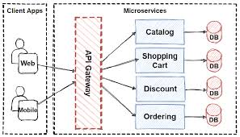

What is Saga pattern in microservices?
The Saga pattern is the way of handling the transaction in distributed service.The saga pattern is a failure management pattern that helps establish consistency in distributed applications, and coordinates transactions between multiple microservices to maintain data consistency. A microservice publishes an event for every transaction, and the next transaction is initiated based on the event's outcome. It can take two different paths, depending on the success or failure of the transactions.
Resources: https://www.baeldung.com/cs/saga-pattern-microservices#1-what-is-saga-architecture-pattern

What is resiliency in microservice?
Resilient microservices architectures ensure that the overall system remains available even if individual microservices fail. By employing redundancy, load balancing, and failover mechanisms, the system can continue functioning and providing services to users without significant disruptions.

What is fault tolerance then?
Fault tolerance is a process that enables an operating system to respond to a failure in hardware or software. This fault-tolerance definition refers to the system's ability to continue operating despite failures or malfunctions. And the resilience and fault tolerance can be both uses interchangeably
Fault tolerance: how to respond and handle the failure event.
Resilience: resilience refers to a microservice's ability to continue functioning and recover gracefully even when encountering a certain number of failures, utilizing mechanisms like retries, circuit breakers, and fault tolerance to manage those failures, rather than being limited to a single threshold of failed requests.

What is Hystrix in microservice?
Hystrix is one of the components, and it can be used to stop cascading failures and enable resilience in complex distributed systems. It is a latency and fault tolerance library designed to isolate points of access to remote systems.
Key Terminologies:
- Circuit Breaker: In Spring Cloud Netflix, Hystrix can use the circuit breaker pattern to stop cascading failures in the microservices environment. When failures occur, the circuit breaker calling the failing services is automatically redirected to the fallback mechanism.
- Fallback: The fallback Mechanism can be used to execute a call when a service call fails, and it provides the graceful degradation of the service.
- Command: Hystrix command can be used to represent a potential failure point in the system or microservice.
- Matrix: Matrix can be used to provide the monitoring and metrics to track the health and performance of the microservices.
Resources: https://www.geeksforgeeks.org/spring-cloud-netflix-hystrix/

What is Circuit Breaker in microservice?
A circuit breaker in microservices is a design pattern that acts as a protective shield to prevent a failure in one part of the system from affecting the rest. It works similarly to an electrical circuit breaker, stopping requests to a service that appears to be failing.
This pattern is inspired by the electrical circuit breaker, which automatically opens the circuit if the current flow exceeds a certain threshold. This prevents the circuit from overheating and causing a fire.
In a microservices architecture, it works the same way, monitors the health of a microservice and automatically blocks requests from that service if it becomes unhealthy.
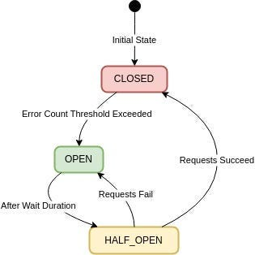

The circuit breaker has three states:
Closed:
In this state, the circuit breaker allows normal service communication, and requests go through to the service.
Circuit breaker monitors the responses from the service for errors. If the responses are successful with no issues, it remains in the closed state.
Open:
When the number of failures reaches a threshold, the circuit breaker switches to the open state, preventing requests from reaching the service and providing a fallback response.
(Threshold Value like 5 failures within 10 seconds)
Half-Open:
Once the timeout or reset interval passes, the circuit breaker goes to the “Half-Open” state.
It allows a limited number of test requests to pass through to the service to see if the service has recovered or not.
If the test requests succeed, it means the service has recovered and the circuit breaker goes back to “Closed” state.
If any of the test requests fails, it means the service has still issues and the circuit breaker goes to “Open” state to block further requests.

Resources: https://medium.com/@minadev/circuit-breaker-pattern-in-microservices-9568320f2059#:~:text=Circuit%20Breaker%20is%20a%20design,tolerance%20of%20a%20distributed%20system.

Tell me about some design pattern in microservice?
- API Gateway: A single-entry point for clients to access multiple microservices, handling routing, authentication, and rate limiting.
- Aggregator Pattern: Combines responses from multiple microservices into a single response for the client, useful when data needs to be aggregated from various sources.
- Circuit Breaker Pattern: A mechanism to handle failures gracefully by automatically failing fast and retrying later when a service becomes unavailable.
- Event-Driven Architecture: Services communicate through asynchronous events, allowing for scalable and decoupled interactions.
- Saga Pattern: Manages complex transactions spanning multiple microservices by breaking them down into smaller, locally consistent operations.
- CQRS (Command Query Responsibility Segregation): Separates data read operations (queries) from write operations (commands), often using different data models for each.

How to microservices communicate with each other in spring boot?
Synchronous Way
- REST Template
- Feign
Asynchronous Way (Using message broker)
- Active MQ
- Apache Kafka

Resources: https://www.geeksforgeeks.org/different-ways-to-establish-communication-between-spring-microservices/

Diff between the synchronous and asynchronous in microservices

Synchronous Transmission | Asynchronous Transmission
In Synchronous transmission, data is sent in form of blocks or frames. | In Asynchronous transmission, data is sent in form of bytes or characters.
Synchronous transmission is fast. | Asynchronous transmission is slow.
Synchronous transmission is costly. | Asynchronous transmission is economical.
In Synchronous transmission, the time interval of transmission is constant. | In Asynchronous transmission, the time interval of transmission is not constant, it is random.
In this transmission, users have to wait till the transmission is complete before getting a response back from the server. | Here, users do not have to wait for the completion of transmission in order to get a response from the server.
In Synchronous transmission, there is no gap present between data. | In Asynchronous transmission, there is a gap present between data.
Efficient use of transmission lines is done in synchronous transmission. | While in Asynchronous transmission, the transmission line remains empty during a gap in character transmission.
The start and stop bits are not used in transmitting data. | The start and stop bits are used in transmitting data that imposes extra overhead.
Synchronous transmission needs precisely synchronized clocks for the information of new bytes. | Asynchronous transmission does not need synchronized clocks as parity bit is used in this transmission for information of new bytes.
Errors are detected and corrected in real time. | Errors are detected and corrected when the data is received.
Low latency due to real-time communication. | High latency due to processing time and waiting for data to become available.
Examples: Telephonic conversations, Video conferencing, Online gaming. | Examples: Email, File transfer,Online forms.

Resources: https://www.geeksforgeeks.org/difference-between-synchronous-and-asynchronous-transmission/

What is spring cloud and how it’s useful?
Spring Cloud is an open-source framework that provides tools to help developers build cloud and microservice applications. It can help developers solve problems when moving to a distributed environment, where components are spread across many different computers. Spring Cloud is useful because it:
- Simplifies cloud application development
Spring Cloud makes it easier to develop, deploy, and operate cloud applications.
- Helps with distributed system patterns
Spring Cloud provides tools for developers to build common patterns in distributed systems, such as configuration management, service discovery, and circuit breakers.
- Supports multiple cloud platforms
Spring Cloud applications can connect to services and discover information about the cloud environment in multiple clouds, such as Cloud Foundry and Heroku.
- Supports event-driven microservices
Spring Cloud Stream is a framework for building event-driven microservices that are connected with shared messaging systems.

Resources: https://www.geeksforgeeks.org/what-is-spring-cloud/

