Contents
Spring Core 3
1. What is spring core and its feature? 3
2. What is Inversion of Control (IoC)? How does it relate to Dependency Injection (DI)? 3
3. Compare XML-based, annotation-based, and Java-based configuration. When would you use each? 3
4. What is a Spring Bean, and how is it different from a regular Java object? 4
5. How do you define a Spring Bean in a Spring application? Explain different ways to create beans. 4
6. What are the different bean scopes in Spring? Explain each with examples. 4
7. What is lazy initialization in Spring? When and why would you use it? 4
8. What is Autowiring and its type? 4
9. What is DI? 5
10. What is Circular Dependency and how you will fix it? 5
11. What is transitive dependency? 6
12. What is @Qualifier annotation do? 6
13. What is ApplicationContext and BeanFactory Container? 6
14. Spring Profiles 7
Q1: What are Spring Profiles, and why are they used? 7
Q2: How do you activate a Spring Profile? 7
Q3: How can you define and use multiple profiles in a Spring Boot application? 7
15. Explain the lifecycle of spring bean? 7
Spring Boot/Rest 8
1. What is the role of the @RestController annotation in Spring Boot, and how does it differ from @Controller? 8
2. What is the feature of spring boot? 8
Resources: https://www.geeksforgeeks.org/spring-boot-features-for-java-development/ 9
3. What is the difference between the spring core and spring boot annotation. 9
4. What is the internal working of @SpringBootApplication annotation? 10
5. What is the API versioning? Is it possible in rest? How to do it? 11
6. What is hateoas in spring boot? 11
7. What is richardson maturity model? 12
8. Diff between rest and soap architecture. 14
9. What is path variable and request parameters? 14
10. What does @Value and @ConfigurationProperties annotation do? 15
11. How to handle the exception in rest api? 16
12. Tell me the name of some starter dependency in spring boot? 17
13. What is mean by path and classpath in java? 17
14. What is mean by API and REST API? 18
References: https://aws.amazon.com/what-is/restful-api/ 19

Spring Core

What is spring core and its feature?
The Spring Framework is an open-source Java framework that helps developers build enterprise applications. The Spring Framework provides infrastructure support for Java applications, allowing developers to focus on business logic. It's designed to simplify the development process and make applications more scalable, secure, and maintainable.
- Features
The Spring Framework includes:
  - Aspect-oriented programming (AOP): and dependency injection (DI)
  - Plain Old Java Object (POJO): support
  - Inversion of Control (IoC) Container
  - Data access framework
  - Transaction management framework
  - Spring ORM Module

What is Inversion of Control (IoC)? How does it relate to Dependency Injection (DI)?
IoC is a design principle in which control of object creation and lifecycle is transferred from the object itself to a container or framework. In Spring, this is achieved through Dependency Injection (DI), where the framework injects dependencies into objects, rather than the object instantiating its dependencies

Compare XML-based, annotation-based, and Java-based configuration. When would you use each?
XML-based Provides centralized configuration in an XML file, which is easier to modify for large projects.
Annotation-based: Allows for inline configuration directly in the code, reducing the need for external configuration files.
Java-based: Offers type safety and is commonly used in Spring Boot applications.
Example of Java-based configuration:
@Configuration
public class AppConfig {
@Bean
public Car car() {
return new Car(engine());
}

@Bean
public Engine engine() {
return new Engine();
}
}

What is a Spring Bean, and how is it different from a regular Java object?
A Spring Bean is an object that is managed by the Spring IoC container. Unlike regular Java objects, Spring Beans are instantiated, configured, and managed by the Spring framework, which allows for dependency injection, lifecycle management, and scope configuration.

How do you define a Spring Bean in a Spring application? Explain different ways to create beans.
  - Using @Component: Automatically detects and registers the bean.
  - Using @Bean in a @Configuration class:
  - Using XML configuration

What are the different bean scopes in Spring? Explain each with examples.
- singleton - only one instance of the spring bean will be created for the spring container. This is the default spring bean scope. While using this scope, make sure bean doesn’t have shared instance variables otherwise it might lead to data inconsistency issues.
- prototype – A new instance will be created every time the bean is requested from the spring container.
- request – This is same as prototype scope, however it’s meant to be used for web applications. A new instance of the bean will be created for each HTTP request.
- session – A new bean will be created for each HTTP session by the container.

What is lazy initialization in Spring? When and why would you use it?
Lazy initialization means that a bean is not created until it is requested for the first time. It can be enabled using the @Lazy annotation. It is useful when a bean might be expensive to create or is not always needed

What is Autowiring and its type?
Autowiring reduces the efforts of object instantiation by auto injection of dependencies into beans managed by spring.
byName:
Spring matches the name of the property with the name of a bean definition. The property name and the bean ID must match exactly.
Best usage: Suitable when you have multiple beans of the same type but want to inject based on the property name. The property name in the class must exactly match the bean's ID in the Spring configuration. Often used with setter injection, this method relies on precise naming conventions.
byType:
Spring will inject a bean into a property if there is exactly one bean of the required type in the application context. If multiple beans of the same type exist, Spring throws an exception due to ambiguity.
Best Usage - Used when you want Spring to inject dependencies based on their type. This is most effective when there's exactly one bean of a given type in the Spring context. It's commonly applied for setter or field injection. If multiple beans of the same type exist, Spring will throw an error unless you further specify the desired bean with @Qualifier.
constructor
Spring will attempt to find the most appropriate constructor for autowiring by matching the types of constructor parameters with available beans in the context.
Best Usage: Applied for constructor injection, where dependencies are injected directly via the class constructor. This mode is useful when the dependencies are mandatory, as it ensures they are injected when the object is created. Spring looks for a constructor that matches the argument types with available beans. If more than one constructor matches, it may lead to ambiguity unless resolved with @Qualifier.

What is DI?
Dependency Injection is used by the framework to auto-inject the dependencies into the beans when beans are created, hence increasing developers' productivity by reducing boilerplate code.
Types of Dependency Injection-
- Constructor injection - injection using constructor
- Setter injection - using setter methods
- Field injection - directly into the fields

What is Circular Dependency and how you will fix it?
A circular dependency occurs when two or more beans depend on each other either directly or indirectly. For example, if Bean A depends on Bean B, and Bean B depends on Bean A, this leads to a circular dependency. It occurs primarily in constructor-based injection when both beans try to be instantiated simultaneously. We can fix this by forcing the one of bean to initialize lazy using the lazy annotation

What is transitive dependency?
A transitive dependency occurs when a bean depends on another bean, which in turn depends on a third bean, forming a chain of dependencies. For example, Bean A depends on Bean B, and Bean B depends on Bean C. Unlike a circular dependency, transitive dependencies do not form a cycle, so they do not cause errors related to circular references.

What is @Qualifier annotation do?
In Spring, the @Qualifier annotation is used to specify which bean should be injected when there are multiple beans of the same type available.
Here's how it works:
- Ambiguity:
When you use @Autowired to inject a dependency, Spring looks for a bean that matches the type of the dependency. If there are multiple beans that match the type, Spring throws an exception because it doesn't know which one to inject.
- Resolving Ambiguity:
You can use the @Qualifier annotation to provide additional information to Spring, helping it identify the correct bean. You can specify the bean's name or a custom qualifier value.

What is ApplicationContext and BeanFactory Container?
Feature | BeanFactory | ApplicationContext
Definition | Fundamental container providing basic functionality for managing beans. | Advanced container extending BeanFactory with additional features.
Usage | Suitable for building standalone applications. | Suitable for building web applications, integrating with AOP modules, ORM, and distributed applications.
Bean Scopes Supported | Supports only Singleton and Prototype bean scopes. | Supports all types of bean scopes, including Singleton, Prototype, Request, Session, etc.
Annotation Support | Does not support annotations; requires configuration in XML files. | Supports annotation-based configuration for bean autowiring.
Internationalization | Does not provide internationalization (i18n) functionality. | Extends MessageSource interface to provide internationalization (i18n) functionality.
Event Handling | Does not support event publication. | Supports event handling via the ApplicationEvent class and ApplicationListener interface.
Bean Post Processing | Requires manual registration of BeanPostProcessors and BeanFactoryPostProcessors. | Automatically registers BeanFactoryPostProcessor and BeanPostProcessor at startup.
Initialization | Creates bean objects on demand using lazy initialization. | Loads all beans and creates objects at startup using eager initialization.
Resource Usage | Provides basic features requiring less memory, suitable for memory-critical standalone applications. | Provides basic and advanced features, suitable for enterprise applications, requiring more memory.

Spring Profiles

Q1: What are Spring Profiles, and why are they used?
Answer: Spring Profiles are a way to segregate parts of your application configuration and make it available only in specific environments. They allow you to define different configurations for different environments (e.g., development, testing, production) without having to change the codebase. Profiles help in managing environment-specific beans and properties.

Q2: How do you activate a Spring Profile?
Answer: A Spring Profile can be activated using various methods:
Command-line argument: Pass --spring.profiles.active=profileName when starting the application. Environment variable: Set SPRING_PROFILES_ACTIVE to the desired profile name. Application properties file: Set spring.profiles.active=profileName in application.properties or application.yml. Programmatically: Use the @Profile annotation in code.

Q3: How can you define and use multiple profiles in a Spring Boot application?
Answer: Multiple profiles can be activated by separating profile names with commas in the spring.profiles.active property
spring.profiles.active=dev,db
Beans or configurations annotated with @Profile("dev") will be active when the dev profile is active, while those with @Profile("db") will be active when the db profile is active

Explain the lifecycle of spring bean?
Spring bean lifecycle consists of mainly four phases
- Loading bean definition
- Bean Instantiation: Bean object is created
- Bean Initialization: Bean object is initialized
- Bean destruction: Bean object is destroyed or deleted

Spring Boot/Rest

What is the role of the @RestController annotation in Spring Boot, and how does it differ from @Controller?
The @RestController annotation is a specialized version of the @Controller annotation in Spring Boot. It is used to create RESTful web services and combines @Controller and @ResponseBody in one. This means that methods in a @RestController class are capable of handling HTTP requests and returning data directly to the client as JSON or XML, without the need to annotate each method with @ResponseBody.

What is the feature of spring boot?
Auto Configuration
The spring boots use the annotation ‘@SpringBootApplication’ that triggers auto-configuration, which automatically sets up your application based on the libraries present in the classpath. It auto-configures your application based on what it sees, thus eliminating the need for specifying beans in the configuration file manually.
2. Standalone Nature
Spring Boot applications are self-contained, meaning they can run independently without relying on any external server. This facilitates microservices architecture, as developers can run the application independently without the need for an external server (like Tomcat). The embedded server (like Tomcat) is part of the deployable unit, and simplifies deployments.
3. Production Ready
It has built-in tools for checking the health and performance of apps. Spring boot provides tools and features that are really out-of-box. Through the Actuator module, the Spring Boot provides out-of-the-box endpoints which are much more efficient for monitoring and managing production applications. These include metrics, health checks, environment info, and more.
4. No Code Generation
This keeps things clean with no unnecessary code. Here the developer is only needed to solely focus on the business logic, rest spring boot tool can handle as spring boot doesn’t generate code and there’s zero requirement for XML configuration which reduces the boilerplate code.
5. Opinionated Defaults
Spring Boot offers ‘opinionated’ starter POMs (Project Object Model), that is a ‘pom.xml’ file which simplifies your build configuration. These defaults cover everything from the external server that is embedding the Tomcat, Jetty, or Undertow servers to configuring Spring’s JPA. It offers ready-to-use settings for faster setup, you can also manually add dependencies in the ‘pom.xml’ file as per your requirement.
6. Supports Microservices
Modern apps have moved from one big piece to many smaller parts that work together. This new style is called “microservices”. Spring Boot is a top tool for creating these small parts easily. The microservices provides the seamless integration with the spring cloud robust frameworks, it has an ability to embed the external servers like Tomcat, Jetty, or Undertow directly into your application that allows each microservice to run as its own standalone unit, and this encapsulation ensures that the services are lightweight and independent.
With spring boot, each microservice has its own distinct database, it has easy scalable and flexible deployment, that centralised configuration. Spring Cloud, in conjunction with tools like Eureka, offers dynamic service discovery. This ensures that microservices can find and communicate with each other with ease as well as spring boot allows for efficient API gateway integrations, ensuring secure and optimised requests and responses between client and services.
7. Embedded Servers
Spring Boot supports the popular embedded servers like Tomcat, Jetty, and Undertow. This means that your applications can run as standalone Java applications with an embedded web server and there’s no need to deploy WAR files, as you can run the application directly from the main method.
8. Extensive Plugin Support
Spring Boot has many tools to help build and handle apps. One tool, the Spring Boot Maven plugin, makes it easy to package and start the app. Another web tool lets developers set up a new Spring Boot app quickly by choosing features they want. It simplifies the usual complexities, ensuring a smooth start for any project.
9. Customizable
You can change the settings any time whenever it’s needed, even though spring boot has its own set ways of doing things, as it’s very flexible. Where the developers can change their various parts of the applications like settings, components, or setups and other which means they can adjust the program just how they like. So, while Spring Boot offers a clear path to get started and has the customizable feature.
10. Extensions
It easily connects with other tools and libraries, provides a multitude of extensions for various tasks like connecting with databases, messaging, caching, etc. This means you can readily integrate a vast array of third-party libraries and tools, through its starters. These starters are pre-configured templates with a set of default plugins and are designed for quick setup and integration of technologies like JPA, Thymeleaf, Security, etc.

Resources: https://www.geeksforgeeks.org/spring-boot-features-for-java-development/

What is the difference between the spring core and spring boot annotation.
Spring | Spring Boot
Spring is an open-source lightweight framework widely used to develop enterprise applications. | Spring Boot is built on top of the conventional spring framework, widely used to develop REST APIs.
The most important feature of the Spring Framework is dependency injection. | The most important feature of the Spring Boot is Autoconfiguration.
It helps to create a loosely coupled application. | It helps to create a stand-alone application.
To run the Spring application, we need to set the server explicitly. | Spring Boot provides embedded servers such as Tomcat and Jetty etc.
To run the Spring application, a deployment descriptor is required. | There is no requirement for a deployment descriptor.
To create a Spring application, the developers write lots of code. | It reduces the lines of code.
It doesn’t provide support for the in-memory database. | It provides support for the in-memory database such as H2.
Developers need to write boilerplate code for smaller tasks. | In Spring Boot, there is reduction in boilerplate code.
Developers have to define dependencies manually in the pom.xml file. | pom.xml file internally handles the required dependencies.

What is the internal working of @SpringBootApplication annotation?
The @SpringBootApplication consist of the 3 main annotations
- @ComponentScan
- @Configuration
- @EnableAutoConfiguration

@ComponentScan
It’s a class level annotation. @ComponentScan annotation tells Spring to scan the current package (and all sub-packages) for Spring-managed components. These components include @Component, @Service, @Repository, and @Controller annotated classes. This helps register beans within the application context without needing manual configuration.
If the main application class (@SpringBootApplication annotated class) is in the base package, all other components in that package and its sub-packages will be scanned.

@Configuration
It’s also the class level annotation. Using @Configuration with @Bean allows you to create custom beans in Spring. It’s equivalent to defining a configuration class in Spring using XML but in a more modern Java way. When @Configuration is applied, Spring will scan the class for any @Bean-annotated methods and register them in the application context.

@EnableAutoConfiguration
The @EnableAutoConfiguration annotation in Spring Boot scans the application's classpath for available beans and configuration classes. Based on the detected dependencies and settings, it automatically configures the Spring application context by enabling necessary configurations. This includes setting up components, beans, and libraries based on what’s available on the classpath (e.g., setting up a DataSource if a JDBC driver is present). It doesn't itself register custom beans for classes annotated with @Configuration; rather, it imports configurations from relevant auto-configuration classes.

What is the API versioning? Is it possible in rest? How to do it?
API versioning is a method to manage different versions of a REST API, allowing developers to introduce new features or changes without breaking existing client applications that rely on older versions; in Spring REST, it is absolutely possible to implement API versioning using various strategies like including the version number in the URL path, using query parameters, or custom HTTP headers, effectively managing different API versions for different clients depending on their needs.
There are several types of strategies to versioning REST API using Spring Boot.
- URI Path Versioning
- Query Parameters Versioning
- Custom Header Versioning
- Content Negotiation Versioning

What is hateoas in spring boot?
HATEOAS stands for Hypermedia as the Engine of Application State. It's a constraint of the REST architectural style that promotes a more self-descriptive and decoupled approach to building APIs.
In essence:
- Instead of hardcoding URLs in your client, HATEOAS-compliant APIs provide links within their responses, allowing clients to discover and navigate the API dynamically.
- These links guide the client on what actions can be performed on a resource, and how to perform them.

Benefits of using HATEOAS in Spring Boot:
Improved decoupling:
Clients don't need to know the exact structure of your API's URLs. They can simply follow the links provided in the responses.
Easier evolution of the API:
You can change the URLs of your API endpoints without breaking existing clients, as long as you maintain the links in the responses.
Self-descriptive responses:
The responses provide not just data, but also information about how to interact with that data.

How to implement HATEOAS in Spring Boot:
Spring HATEOAS library:
Spring Boot provides a library specifically for implementing HATEOAS, which makes it easy to add links to your API responses.
Representation models:
You can use classes like RepresentationModel and its subclasses (e.g., EntityModel) to wrap your data and add links.
Link builders:
The Link class and its builders allow you to create links with appropriate relations and URIs.

What is richardson maturity model?
The Richardson Maturity Model (RMM), proposed by Leonard Richardson, is a model used to assess the maturity of a RESTful API based on its implementation levels. It consists of four levels, each representing a stage of maturity in the design and implementation of RESTful principles. When it’s reach to level four which is level 3 then it can say it’s completely rest Api and other level are stepping stone to rich that level

Level 0
- It is also called as plain old xml
- Http is used only as transport protocol. Http is used for remote interaction.
- To get the data and post the data we send the request to the same URL, only post request may be used.
- Eg. To get the data
POST http://localhost:8080/customer
To post the data
POST http://localhost:8080/customer

Level 1
- In level 0, there was only 1 URI
- In level 1, each resource is mapped to specific URI
- For example. URI to get the product
http://localhost:8080/products
URI to get the specific product
http://localhost:8080/products/1
- Still only one end point is used to retrieve and creating the data

Level 2
- In level 2, correct http verb is used for each request
- For each of those request, correct http response code is provided
- Eg. Get
http://localhost:8080/customers/1
200 OK

Level 3
- At level 3, API supports hateoas
- Example
GET http://localhost:8080/customers
For this, the response that we get is
Customer JSON+Self- documenting hypermedia
- Help in self-documentation

Diff between rest and soap architecture.
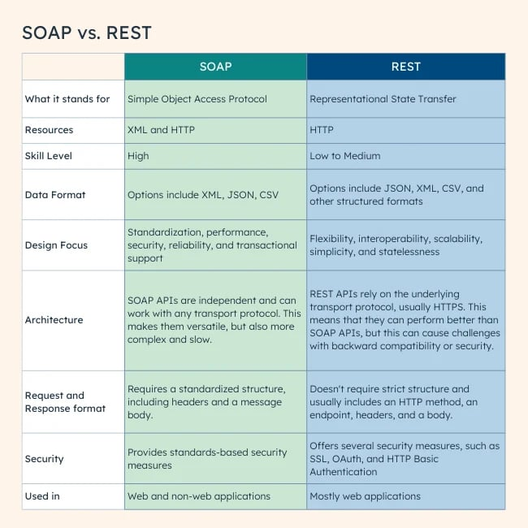

What is path variable and request parameters?
Path Variables
- Purpose: Used to capture dynamic elements within the URL path itself.
- Syntax: Defined within the URL path using curly braces {}.
- Example: /users/{userId}
- Access: Accessed using the @PathVariable annotation in controller methods.
- Required: Yes, by default.
- Use Case: Ideal for identifying specific resources in a RESTful API, like a user or a product.
@GetMapping("/users/{userId}")
public User getUser(@PathVariable Long userId) {
// ...
}

Request Parameters
- Purpose: Used to pass additional data to the server, typically for filtering, sorting, or pagination.
- Syntax: Appended to the URL after a question mark ?, in the format key=value. Multiple parameters are separated by ampersands &.
- Example: /users?page=2&size=10
- Access: Accessed using the @RequestParam annotation in controller methods.
- Required: No, by default. You can set the required attribute to true if needed.
- Use Case: Useful for providing optional parameters that modify the behavior of the request.
@GetMapping("/users")
public List<User> getUsers(@RequestParam(required = false) Integer page,
@RequestParam(required = false) Integer size) {
// ...
}

What does @Value and @ConfigurationProperties annotation do?
In Spring, both @Value and @ConfigurationProperties are used to inject values from external configuration sources (like application.properties or application.yml) into your Spring beans. However, they differ in their approach and capabilities:
@Value
- Purpose: Injects a single property value directly into a variable or method parameter.
- Syntax: @Value("${property.name}")
- Example
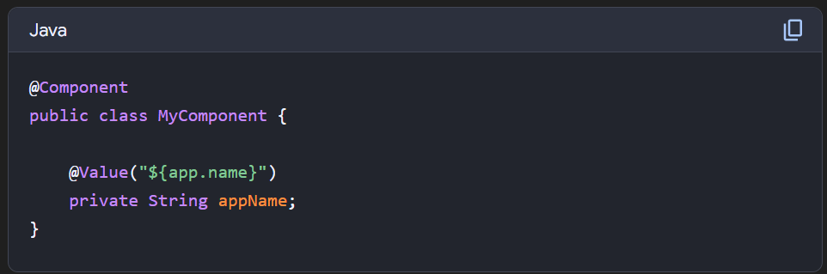

@ConfigurationProperties
- Purpose: Binds a group of related properties to a Java object.
- Syntax: @ConfigurationProperties(prefix = "prefix.for.properties")

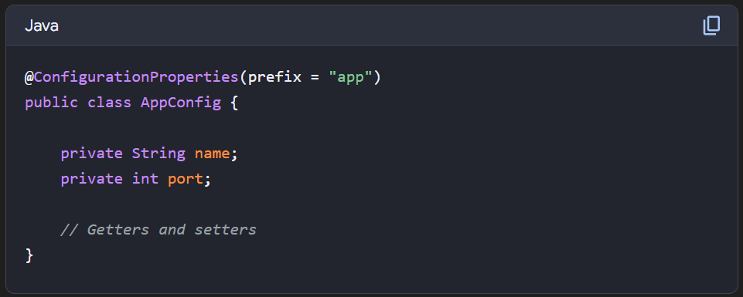

How to handle the exception in rest api?
Global Exception Handling with @ControllerAdvice
- @ControllerAdvice is a specialized annotation in Spring that allows you to handle exceptions globally across all controllers.
- You can create a class annotated with @ControllerAdvice to centralize your exception handling.

Custom Exception Classes
- Define custom exceptions for common issues like resource not found, bad requests, or unauthorized access.

Error Response Structure
- Create a custom error response class to ensure that error messages returned to the client are informative and standardized.

HTTP Status Codes and Detailed Messages
- Set appropriate HTTP status codes based on the type of error:
  - 404 for resource not found (HttpStatus.NOT_FOUND)
  - 400 for bad requests (HttpStatus.BAD_REQUEST)
  - 500 for internal server errors (HttpStatus.INTERNAL_SERVER_ERROR)
- Provide meaningful error messages to help the client understand the cause

Using @ResponseStatus
- Alternatively, annotate custom exception classes with @ResponseStatus to set a specific HTTP status code when the exception is thrown.

Tell me the name of some starter dependency in spring boot?
- spring-boot-starter-web: For building web applications with Spring MVC.
- spring-boot-starter-data-jpa: For working with JPA and databases.
- spring-boot-starter-security: For adding security features to your application.
- spring-boot-starter-test: For writing tests for your Spring Boot application.
- spring-boot-starter-actuator: For monitoring and managing your application.
- spring-boot-starter-thymeleaf: For using Thymeleaf as your templating engine.
- spring-boot-starter-mail: For sending emails from your application.
- spring-boot-starter-batch: For batch processing.
- spring-boot-starter-websocket: For building WebSocket applications.

What is mean by path and classpath in java?
Path
- The path variable tells the operating system where to find the executable files (like javac, java, javap, etc.) needed to run Java programs.
- It is set to the location of the Java Development Kit (JDK) binaries, like the bin directory where these executables reside.
- When you run a command like java or javac, the OS checks the path to locate these programs.
- Usage:
  - For example, in Windows, it might look like this: C:\Program Files\Java\jdk1.8.0_251\bin.
- Configuration:
  - To set the path, add the JDK bin directory to your OS’s path variable.
Classpath
- The classpath variable specifies the location of user-defined classes and packages, including external libraries (JAR files) that your Java programs need to run.
- It tells the Java compiler and runtime where to look for classes that are referenced in your code but are not in the same directory or JDK libraries.
- If you’re working with multiple external JARs or custom class files, you add them to the classpath.
- Usage:
  - For example, you might set the classpath like this: .;C:\libs\someLibrary.jar;C:\otherLibs\anotherLibrary.jar.

What is mean by API and REST API?
API
API stands for Application Programming Interface, and it's a set of rules that allows software applications to communicate with each other. APIs are the "interface" that enables one piece of software to interact with another program to obtain needed services.
REST API
API developers can design APIs using several different architectures. APIs that follow the REST architectural style are called REST APIs. Web services that implement REST architecture are called RESTful web services. The term RESTful API generally refers to RESTful web APIs. However, you can use the terms REST API and RESTful API interchangeably.
Uniform interface
The uniform interface is fundamental to the design of any RESTful webservice. It indicates that the server transfers information in a standard format. The formatted resource is called a representation in REST. This format can be different from the internal representation of the resource on the server application. For example, the server can store data as text but send it in an HTML representation format.
Statelessness
In REST architecture, statelessness refers to a communication method in which the server completes every client request independently of all previous requests. Clients can request resources in any order, and every request is stateless or isolated from other requests. This REST API design constraint implies that the server can completely understand and fulfill the request every time.
Layered system
In a layered system architecture, the client can connect to other authorized intermediaries between the client and server, and it will still receive responses from the server. Servers can also pass on requests to other servers. You can design your RESTful web service to run on several servers with multiple layers such as security, application, and business logic, working together to fulfill client requests. These layers remain invisible to the client.
Cacheability
RESTful web services support caching, which is the process of storing some responses on the client or on an intermediary to improve server response time. For example, suppose that you visit a website that has common header and footer images on every page. Every time you visit a new website page, the server must resend the same images. To avoid this, the client caches or stores these images after the first response and then uses the images directly from the cache. RESTful web services control caching by using API responses that define themselves as cacheable or noncacheable.
Code on demand
In REST architectural style, servers can temporarily extend or customize client functionality by transferring software programming code to the client. For example, when you fill a registration form on any website, your browser immediately highlights any mistakes you make, such as incorrect phone numbers. It can do this because of the code sent by the server.

References: https://aws.amazon.com/what-is/restful-api/

