A CRM APPLICATION FOR SCHOOLS AND COLLEGES

INTRODUCTION:

1.1 Overview

Today, a good customer relationship management (CRM)

Platform is the backbone of many successful student recruitment efforts.

A CRM is a customer – centric system that can help education professionals nurture Relationships with prospects and enrolls, produce data-driven insights to illustrate Progress towards goals, and streamline their admissions and marketing initiatives to save time and effort.

Even if you are familiar with the basic idea of a CRM, understanding exactly what it can do to help your school and colleges take

Some thorough research. CRM software offers a wide range of applications

to help you manage and interact with leads, with different systems including

a variety of different features.

The process of building connections with prospective students may

Feel more like an art than a precise science, but with CRM, it’s possible to shift that balance. Consider what an ideal series of interactions with a prospective student would look like. At a basic level, it would involve reaching out to them soon after they express an interest in your institution.

With CRM, however, this work can be done for you. The software can build lists of new prospects who have submitted inquires, which can be segmented by location, course, or any other parameter that your school wishes.

Each contact’s profile will include detailed information based on what they have provided when completing your inquiry forms.

A typical contact profile in HEM’s Mautic CRM system. The profile includes personal details, contact information, the lead’s educational background, and even a section for details about their education agent should it be needed.

One of the great strengths of the CRM model is in how it collects and organizes large quantities of useful data in a manner that is easily accessible. As a result, the [CRM reports](https://www.higher-education-marketing.com/blog/reporting-crm-schools) you can generate will make a valuable addition to your school’s recruitment measurement tools.

For example, HEM’s customized Mautic CRM comes with a readymade supporting suite designed especially for schools, including the following reports:

* **Speed to Lead**– A measure of how soon your staff members are following up with new leads once they enter the system.
* **Meetings Outcome**– A summary of any meetings your staff have held with leads.
* **Leads with no Scheduled Follow-up**– A quick view of any leads for whom no follow-up activities (calls, meetings, emails, etc.) have been scheduled, sorted by lead owner.
* **Leads by Stage**– All leads segmented by admissions stage showing the percentage and number of each.
* **Leads by Program**– All leads segmented by program of interest (if known) showing the percentage and number of each.
* **Leads by Source**– All leads attributed to their original source (e.g. organic website traffic, paid advertising campaigns, online sources etc.) showing the percentage and number of each.
* **Lead Status**– Leads segmented by status (Hot, Warm, Cold, Not Interested, Not Applicable).
* **Lead Conversion**– Details how many of your leads have been successfully contacted, held a meeting, made an application, or enrolled with your school over a given period of time.
* **Calls Outcome**-All calls made by specific outcome (Connected, Busy, No Answer, etc.).
* **Admissions Activities Summary**– A summary of all follow-up actions taken by your admissions staff (calls held, meetings, emails sent, etc.).

Mautic, as well as most other CRMs, will also allow you to build your own customized reports. This means you can tailor your data collection to your school’s specific needs and goals.

Additionally, CRM platforms use “dashboards,” which are pages on which your most important tracked data can be presented. Dashboards are typically highly visual, presenting information as charts, graphs, or lists which are easily understandable at a glance, and are often interactive.

**Example**: This sample dashboard from HEM’s Mautic CRM includes a quick view of a school’s leads by location, lead generation over time, top performing contact lists, and website visits.

1.2 Purpose :

A CRM system can help educational organisations effectively manage and track leads, resulting in improved enrolment numbers. Additionally, by personalising communication and providing automated follow-up, educational organisation can build better relationships with students and leads, and keep them engaged over time.

The use of [**CRM in education industry**](https://www.nopaperforms.com/education-crm/?utm_source=Blog&utm_medium=cta&utm_campaign=Benefits+of+CRM) is important for many reasons. A CRM system can help educational organisations effectively manage and track leads, resulting in improved enrolment numbers. Additionally, by personalising communication and providing automated follow-up, educational organisation can build better relationships with students and leads, and keep them engaged over time.

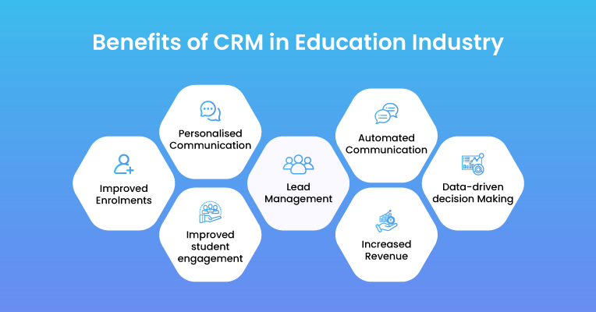

Using a CRM system provides educational organisation with the data they need to make informed decisions about recruitment, marketing, and other key areas. It also allows you to improve student engagement by tracking student interactions and providing personalised communication. Furthermore, a CRM system can improve communication between different departments within an organisation and help to increase efficiency and productivity. In short, a CRM system is an essential tool for any educational organisation to improve enrolments, lead management, communication and student engagement.

To help you take the right decision in choosing a CRM for your educational organisation, here we have devised the top 10 benefits of using a purpose-built CRM in the education industry-

1. **Improved Enrolments:**A CRM system can help counsellors/ sales representatives to more effectively manage and track leads, resulting in improved overall efforts and increased enrolment numbers.
2. [**Personalised Communication**](https://www.nopaperforms.com/education-crm/marketing-automation-for-educational-institutions/)**:**A CRM system allows educational institutions to personalise communication with leads/ prospects or students, resulting in more effective communication and better relationships.
3. [**Lead Management**](https://www.nopaperforms.com/education-crm/lead-management-system/?utm_source=Blog&utm_medium=cta&utm_campaign=Benefits+of+CRM)**:** Educational organisation to more effectively manage leads, including lead scoring, segmentation, and personalised follow-up.
4. **Automated Communication:**Automating communication works wonders for educational organisation, thus, it is one of the most beneficial features of CRM in the Education Industry. It allows counsellors/ sales representatives to communicate with leads and students, to keep them engaged and interested over time
5. **Data-driven decision Making**: A CRM system provides counsellors/ sales representatives with the data they need to make informed decisions about recruitment, marketing, and other vital areas.
6. **Improved student engagement:**CRMs help in improving student engagement by tracking student interactions and providing personalised communication.
7. **Better Communication:** One of the most beneficial reasons to use CRM in education industry is that it improves communication between different departments within an educational institution, helping to increase efficiency and collaboration.
8. **Increased Revenue**: By improving enrolment and student engagement, a CRM system can help educational organisation in increasing revenue.

Using[best CRM in education industry](https://www.nopaperforms.com/education-crm/) provides organisations with the tools they need to improve enrolments, lead management, automated communication, data-driven decision-making, student engagement, revenue, better communication, easy tracking of student performance and attendance, alumni engagement and many more. **NoPaperForms** Education CRM enables you to do this and much more right at your fingertips on a single platform. Ready to experience growth like never before? Schedule a demo today!

……..

Problem Definition & Design Thinking:

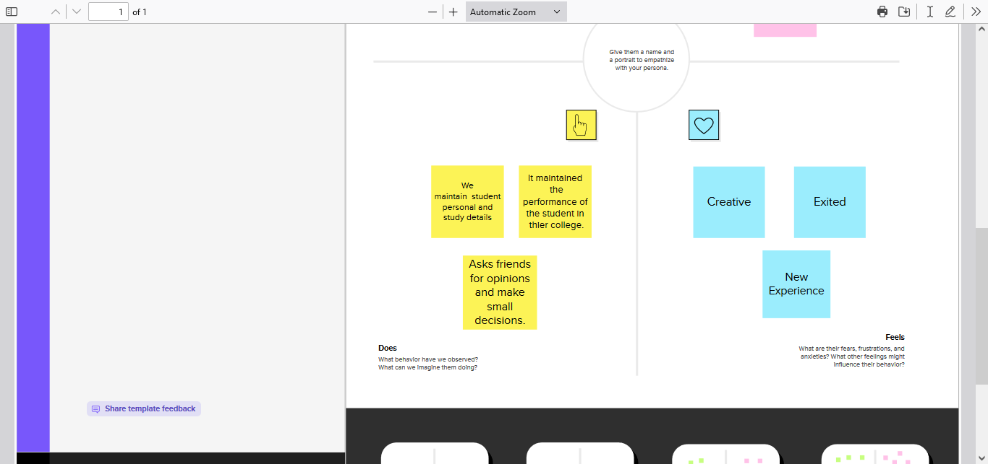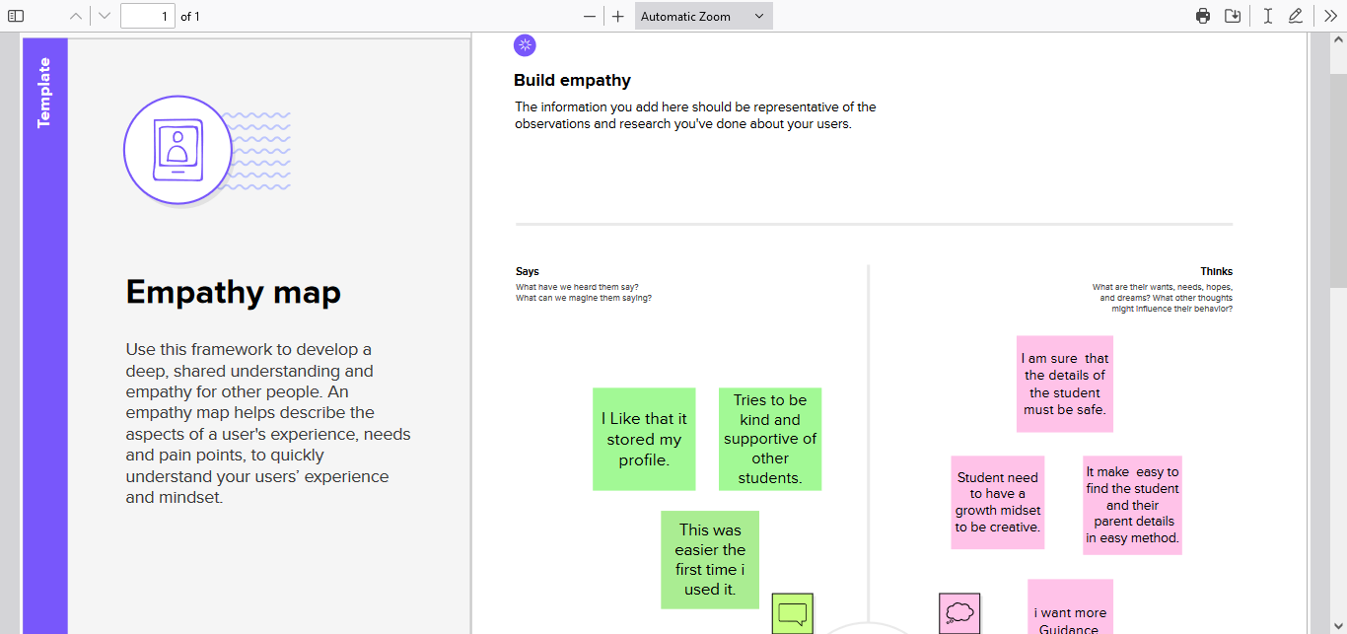2.1 Empathy Map:

2.2 Ideation & Brainstorming Map:

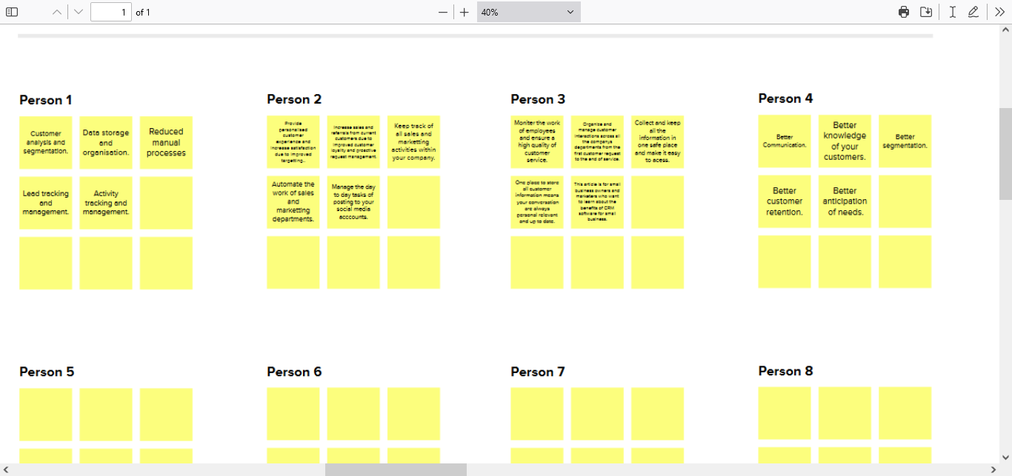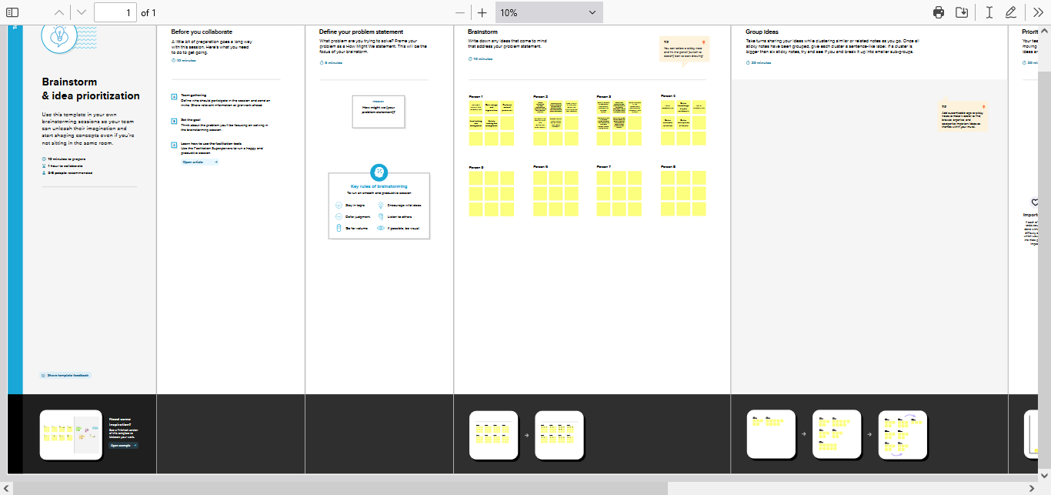

RESULT:

3.1 Data Model :

|  |  |  |
| --- | --- | --- |
| Object name | | Fields in the Object |
| Obj 1  Obj 2 | |  |  | | --- | --- | | Field label | Data type | | Phone Number | Phone |  |  |  | | --- | --- | | Field label | Data type | | Results | Picklist | | |

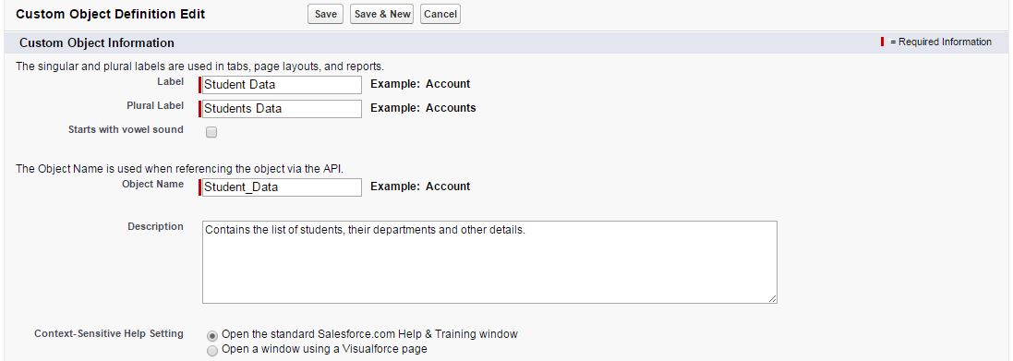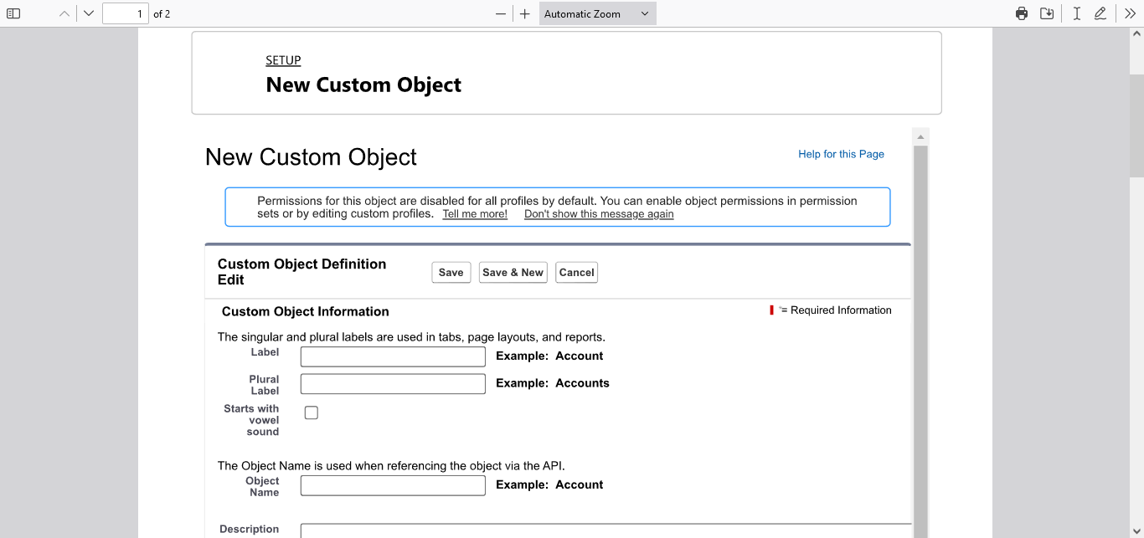

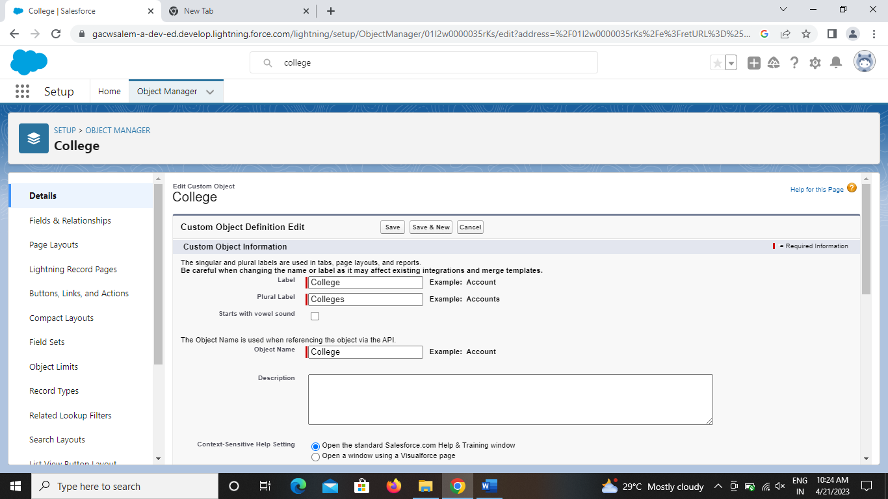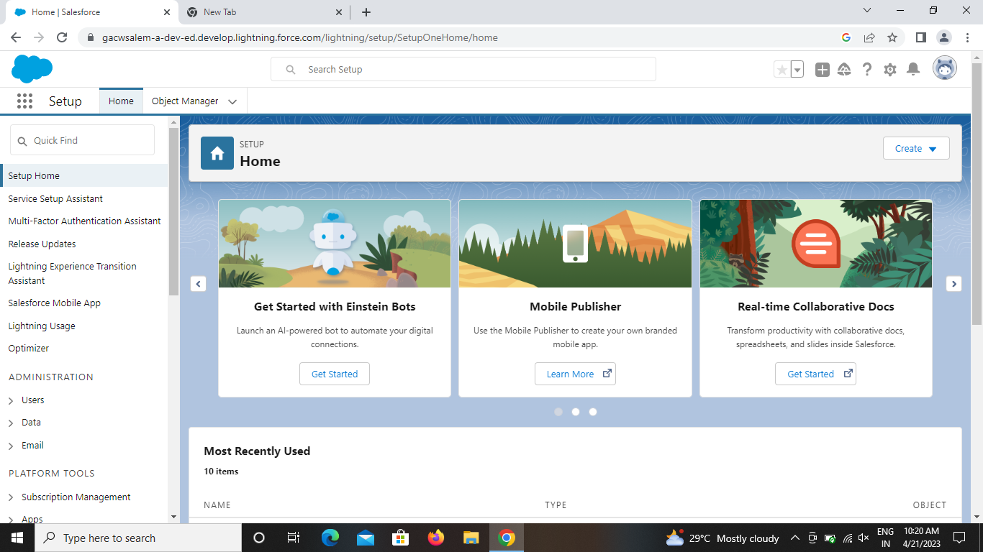

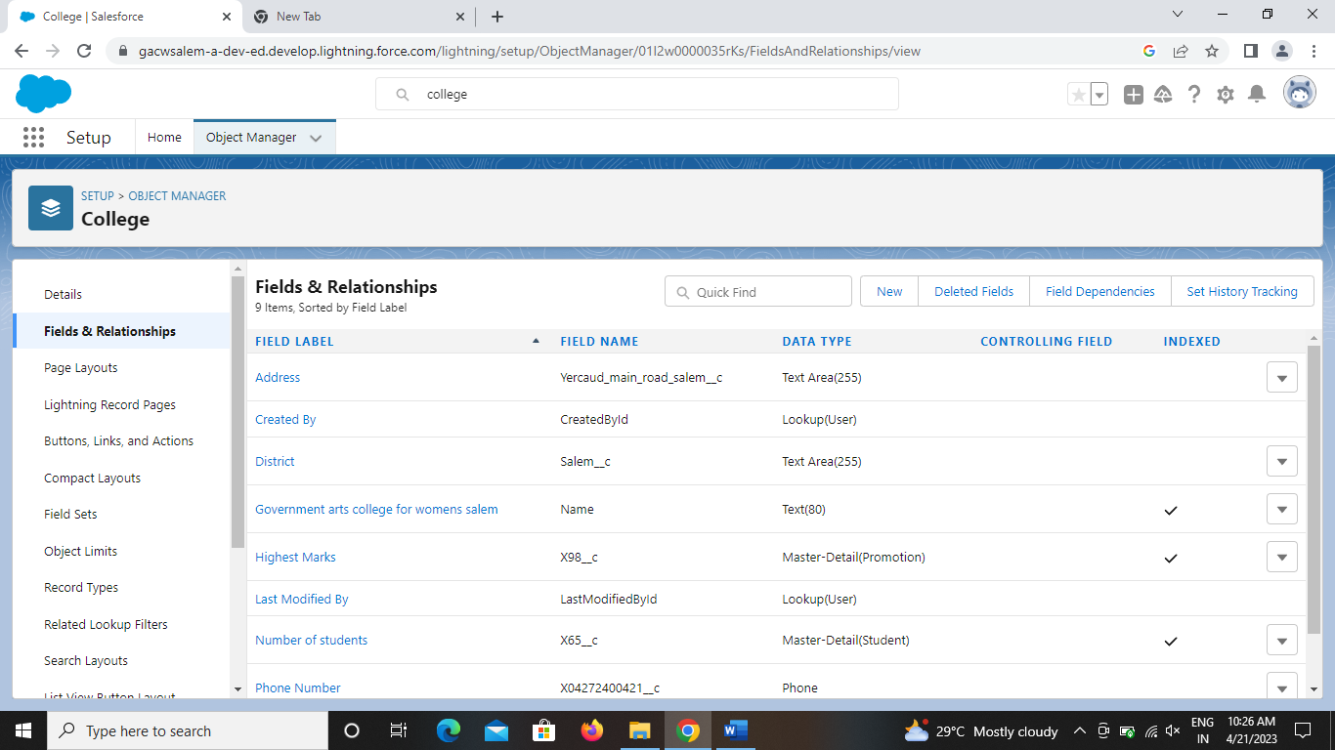

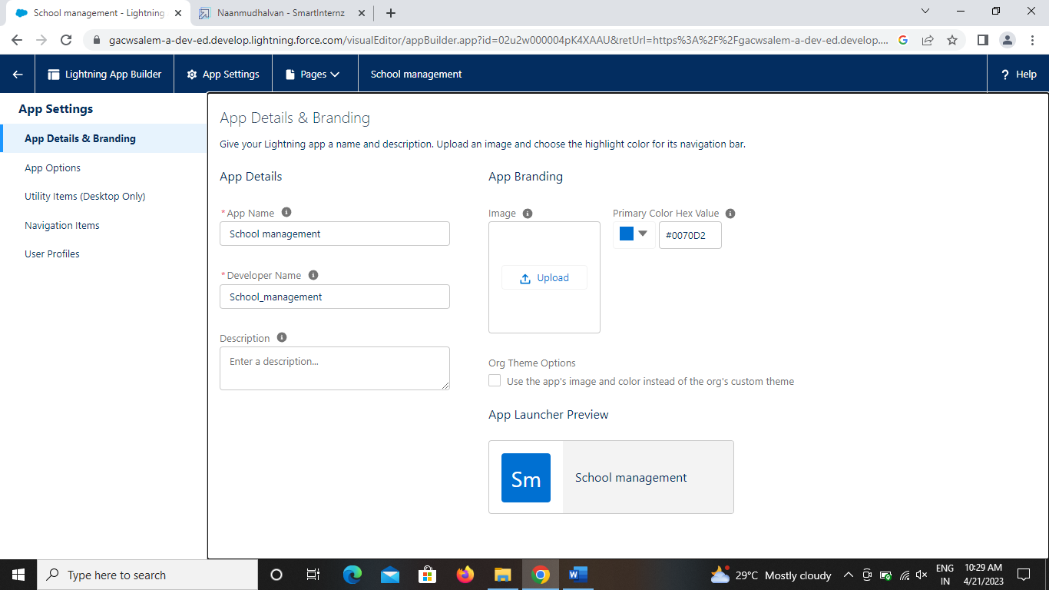

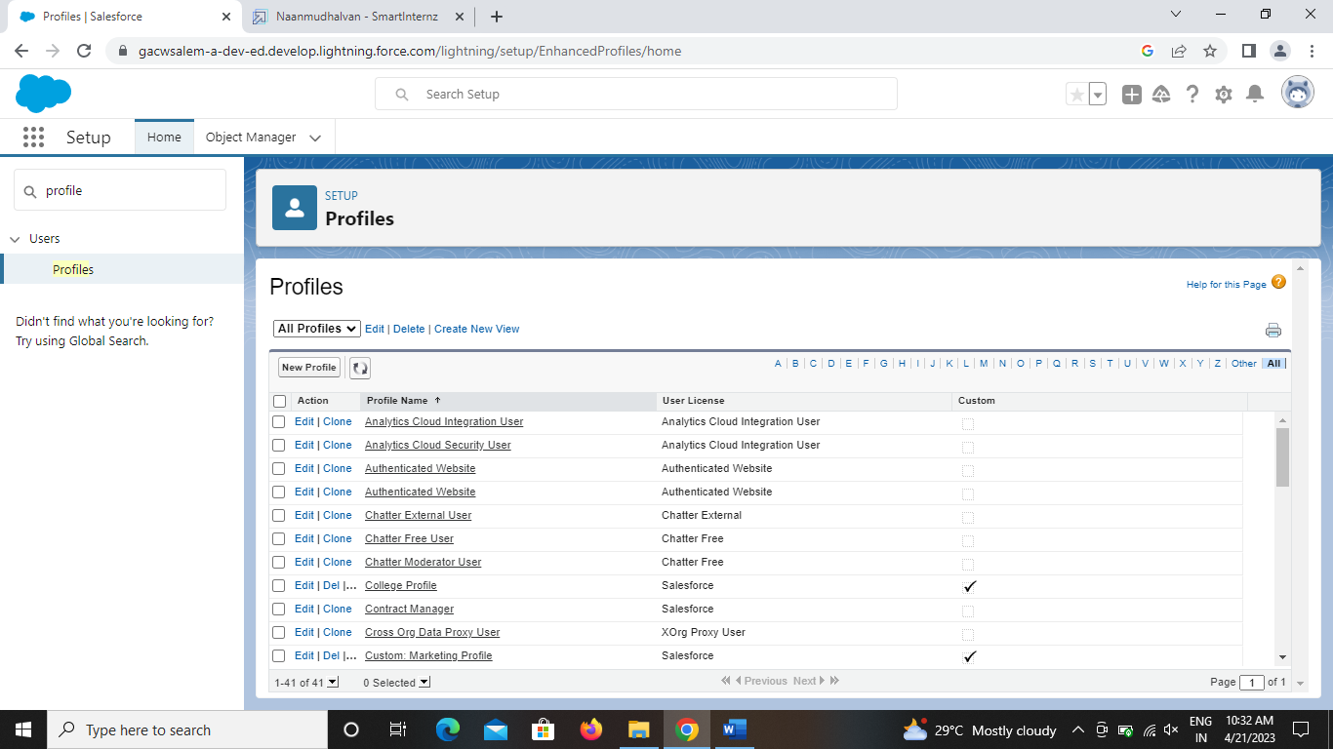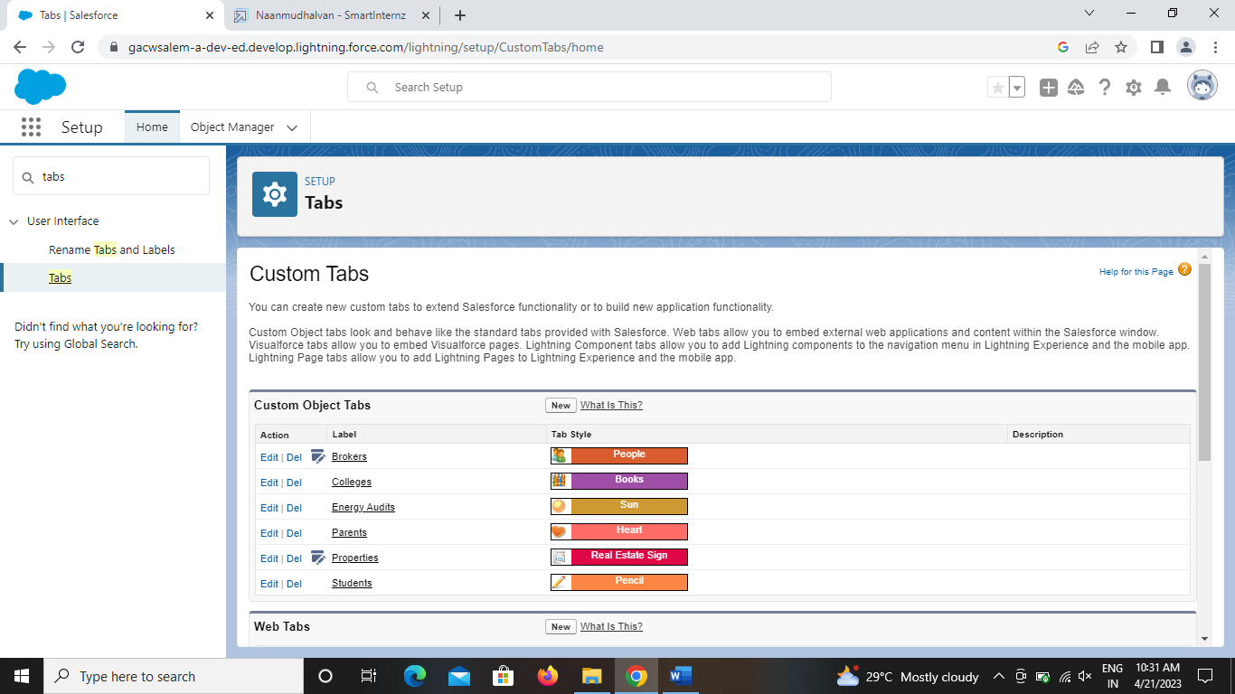

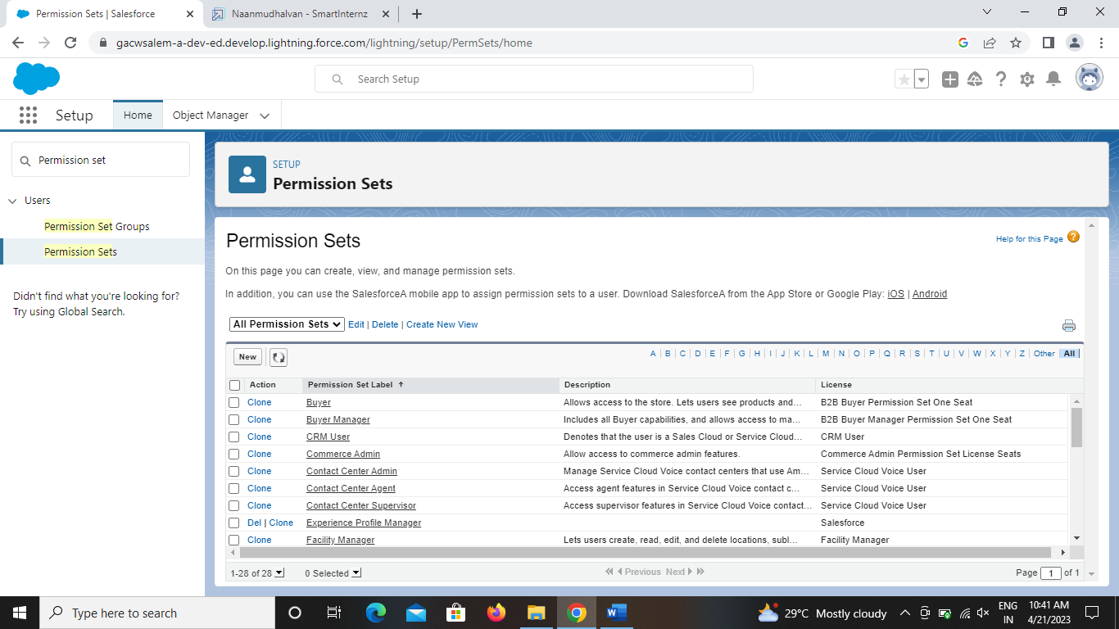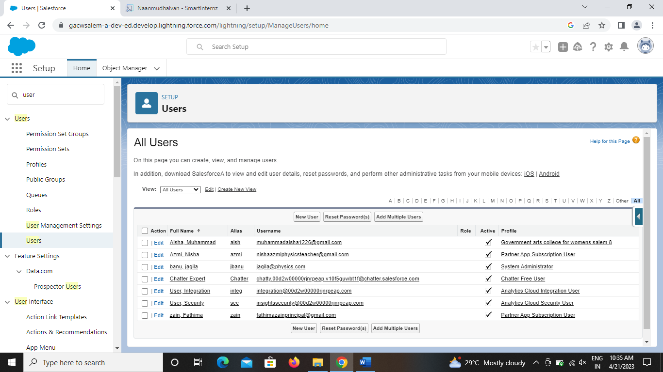

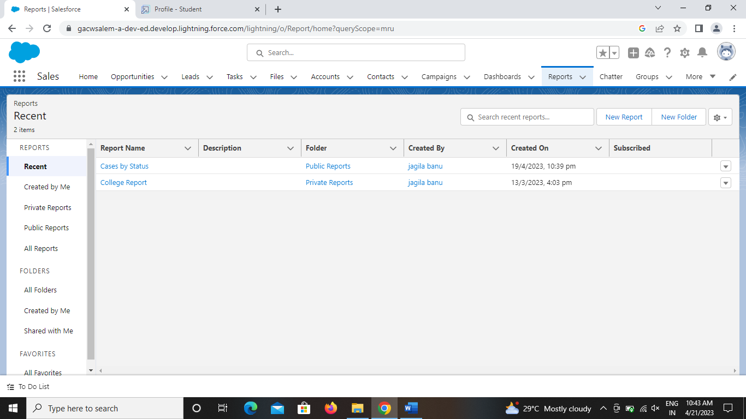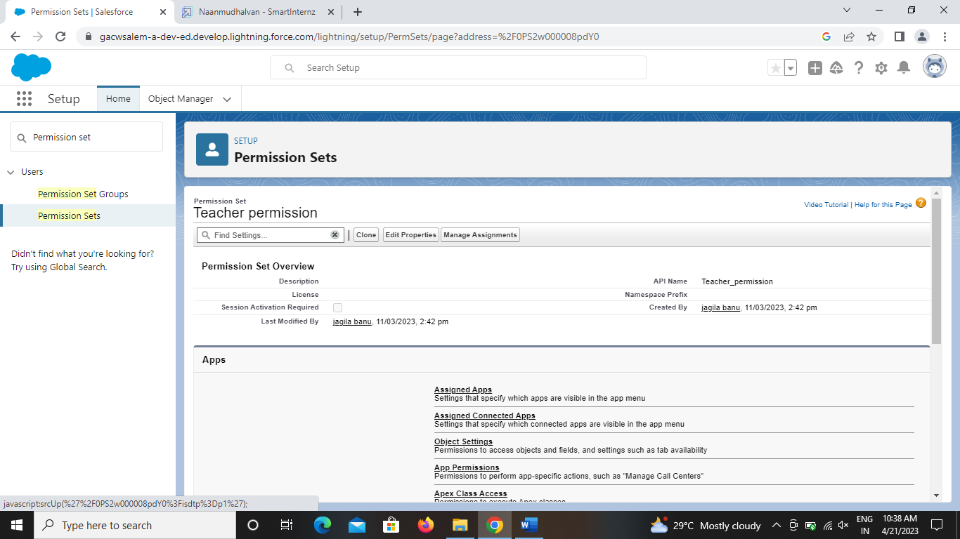

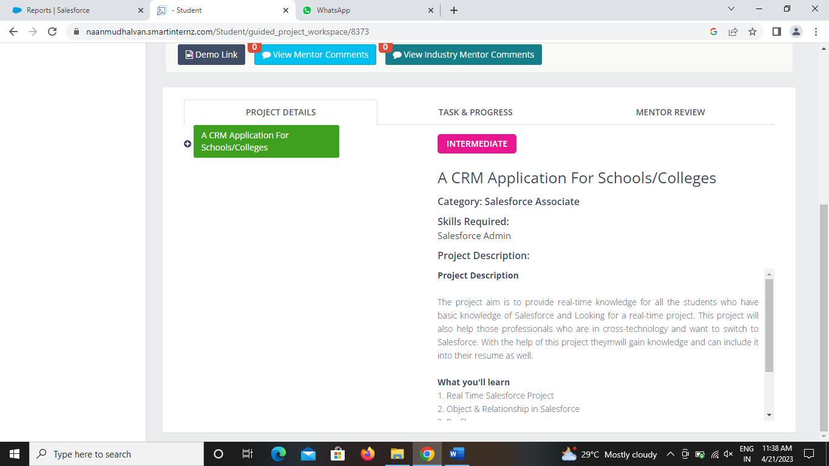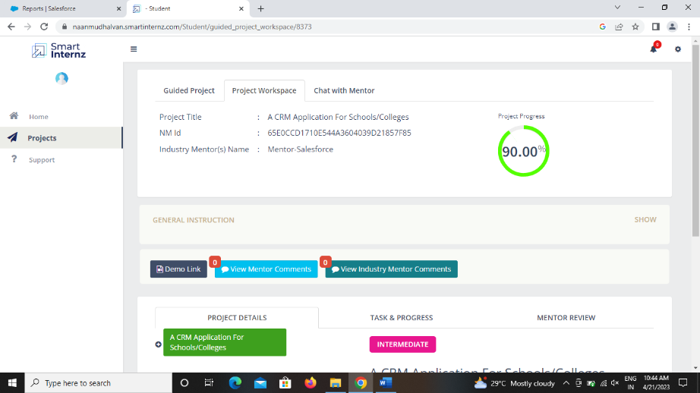

Trailhead Profile Pubilc URL :

Team Lead - <https://trailblazer.me/id/bbilal10>

Team Member 1 - <https://trailblazer.me/id/achandran34>

Team Member 2 - <https://trailblazer.me/id/mahak62>

Team Member3 <https://trailblazer.me/id/kaviyapriya2003>

5 ADVANTAGES & DISADVANTAGES:

Advantages:

Education Industry including Schools/ University/ Colleges/ Management Institutes etc.  are becoming one of the basic needs of human being because of the fact for a human being to get higher education and lot of other factors.

In my previous posting, I covered with the features of the EducationalCRM implemented by Bista solutions for one of the leading institute so let’s have a look on the ROI (Return on Investment) or simply the advantages for education institutes such as schools/ University for implementing this educational Customer relationship management software.

There are many other advantage apart from the advantages considered below for student, institute and for vendors etc.

* **Increase in the revenue**

With this **educational CRM** institutes such as **schools**/ **University** increase their revenue because the lead is properly converted into an account with the help of dormancy module.

* **Reduction in the cost of expenses**

This Educational CRM allows your institute to have a proper allocation of your money in different areas such as advertisement for different course, road show, other external vendors for raw leads etc. as this [**CRM**](https://www.odoo.com/page/crm) provides you with the graphical view of how much return every medium is providing you in terms of the expenses incurred.

* **Proper Lead tracking with no errors**

This education CRM allows you proper lead tracking and reduction in the errors or duplication of entries into your institute which ultimately reduce the time of the executive for following up with the similar lead which is admitted from different source and also it provides you further merging if there is any duplicate entry is made.

* **Less sales cycle**

This education CRM allows you to have a less length of your sales cycle as due to dormancy module every lead is properly nurtured with the lead history on where the most time is been given for converting the lead into an account.

* **Increase in margins with reduction in Cost of Acquisition per student**

As my first point covered that it increase the revenue not only because the lead is properly converted into an account but because of the lead is properly nurtured which reduce the chances of loss of the lead which can increase the margins of the university schools, and other institutes.

* **Increase in customer satisfaction:**

This education customer relationship management software allows the customer with higher satisfaction as every stage of the lead is been integrated with predefine SMS and email with different course so when an inquiry is made by the student immediately after completion personalized emails/ sms is sent to the mobile number and email provided by the caller, which build more confident in the mind of the student.

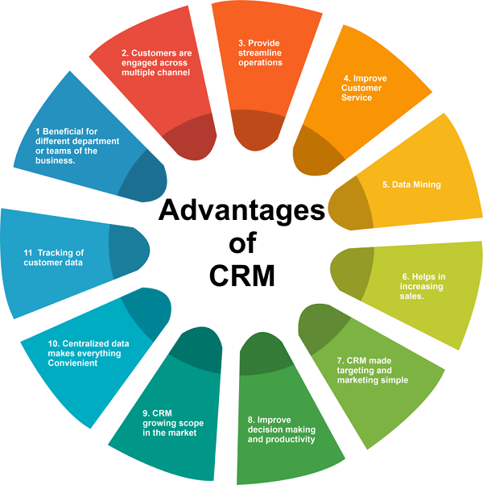

Disadvantages:

* A costly project. ...
* Loss of collected information or records. ...
* Not suitable for every business. ...
* It eliminates the human element. ...
* Can be accessed by the third party. ...
* CRM is not fully customized. ...
* Have poor usability. ...
* Employee training is a mus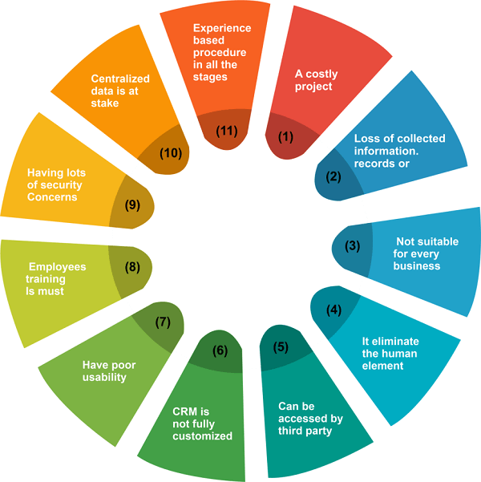t.
  1. APPLICATIONS:

Effortless admission process: Track applications and collaborate with parents and students through automated email alerts and collaboration via the Application portal.

Seamless Billing and invoicing: Take advantage of the highly flexible Fee Management capabilities with the ability to go fully digital.

Streamlined Class Registration: Define course offerings for students based on CBCS to let them register as per their choice.

Attendance with QR code: Flexible methods provides attendance reporting in a variety of ways to gain insights on attendance trends.

Efficient Assessment: The internal Assessments function is designed to cater to any kind of continuous assessment model.

Student Digital Record: Instantly access student details like contact information, grades, homework or accounts at any time on the mobile app or desktop.

* 1. CONCLUSION:
* CRM systems are most commonly used for recruitment and admissions with 57% of institutions
* using the CRM system(s) for both processes.
* Microsoft Dynamics CRM is used by most HEIs that responded to the survey, with 19
* respondents using this CRM, followed by Student Recruitment System with seven and Salesforce
* with five institutions using these systems, respectively.
* Smaller institutions tend to use a proprietary CRM system more often than existing standard
* systems.
* Most generic systems were not willing to provide an online demo, whereas most education
* specific system providers were very eager to collaborate and provide a demo.
* It is impossible to recommend any system in particular, as every system in this report comes with
* unique functionalities that different institutions might find useful.
* For institutions looking for CRM software that offers tools to manage every part of the student
* life cycle, from enquiry to alumni, the following systems may be a good fit:
* • Campus Management (Campus Nexus CRM)
* • Ellucian (Recruiter)
* • Hobsons (Radius)
* • Jenzabar (SEM CRM)
* • Maximizer CRM (Student Relate)
* • Proretention (Enrollment CRM)

8 FUTURE SCOPE:

The scope of CRM includes a wide range of activities, from managing customer contact information to developing personalized marketing campaigns. In order to be effective, CRM must be tailored to the specific needs of each business. As such, the scope of CRM can vary greatly from one company to the next.

Defining the scope of CRM projects means figuring out which areas of your business need to be included in the CRM implementation plan. Before any CRM initiative begins, scoping is essential to establish what the effort will and will not cover, as well as to prevent feature creep and project bloating.

Customers now communicate through multiple channels, and businesses need to ensure that they have a consistent communication strategy across all these channels. Future CRM systems will allow businesses to interact with customers via email, phone, social media, and other channels.