**Business Problem:**

We are going to compare the Neighborhoods of New York, US and Toronto, Canada to see how similar are these two cities. We will generally be exploring the attributes provided to us by the FourSquare API.

**Interest:**

In this project we will give analysis which would help suggest the best possible & suitable home location for people across various walks of life. Like Bachelors, Families, Old People etc.

This Analysis is very useful for anyone who is trying to analyze the two cities in terms of the diversity of avenues these two cities offer. This is one of the problem we can try to research through this.

However, this Project will provide the generic Comparison Attributes based on FourSquare data, its Users discretion where ever they want to use it.

**Data Sources:**

The Data for the two cities will be taken from a New York Data set [***here***](https://geo.nyu.edu/catalog/nyu_2451_34572)and We will scrapping the Wikipedia Page [https://en.wikipedia.org/wiki/List_of_postal_codes_of_Canada:_M,](https://en.wikipedia.org/wiki/List_of_postal_codes_of_Canada:_M) for Toronto and will be combining the Geospacial data for Toronto from the link [*here*](http://cocl.us/Geospatial_data).

Some of the Ideas to use the data above is as below:

1. We will take and combine the above data sets and will get the venue categories in and around the neighborhoods of two cities, and we can check the most happening Neighborhood (where there are variety of venues present) with help of #no of venues present.

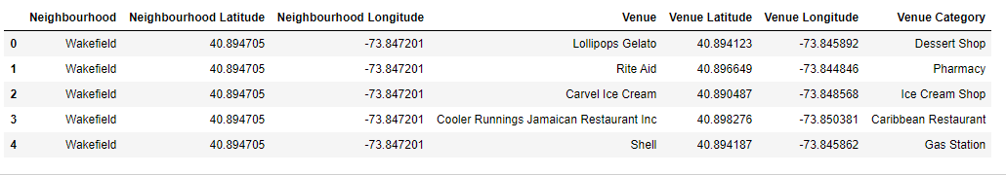

1. Borough can be used as another Grouping criterion to see how densely a Borough is populated with different types of Venues. This is important in case a person has a predominant preference of city and he/she wants to have some data to choose the best place to be so that minimum compromises are made.