## 

**Abstract**

• A C++ console-based Library Management System.  
• Automates library tasks: add, search, issue, and return books.  
• Maintains records using file I/O for persistence.  
• Demonstrates OOP, file handling, and modular design.

Introduction

• Manual record-keeping in libraries is slow and error-prone.  
• The system simplifies and automates core operations.  
• Practical mini project demonstrating C++ programming skills.  
• Includes classes, file handling, and structured logic.

**Problem statement & Objectives**

Problem: Managing library books and members manually is inefficient.  
  
Objectives:  
• Manage books and members efficiently.  
• Automate issuing and returning of books.  
• Store and retrieve data from text files.  
• Demonstrate object-oriented and modular design.

**System Design / Approach**

Architecture Overview:  
• Data Layer: File-based storage (books.txt, members.txt).  
• Domain Layer: Classes – Book, Member, Library.  
• Presentation Layer: Menu-driven console UI.  
  
Flow:  
Start → Load Data → Menu → Action → Update Data → Save → Exit

Class Diagram (Simplified)

Library 1 --- * Book  
Library 1 --- * Member  
  
Book: id, title, author, total, available  
Member: id, name, issued_books  
  
Key Classes: Book, Member, Library

**Flowchart**

Start  
 ↓  
Load data from files  
 ↓  
Display Menu  
 ↓  
Perform selected operation  
 ↓  
Update records  
 ↓  
Save changes  
 ↓  
Exit

Implementation

Modules:  
• book.h / book.cpp — Book class and methods.  
• member.h / member.cpp — Member data and operations.  
• library.h / library.cpp — Manages operations, handles file I/O.  
• main.cpp — Menu-driven interface.  
  
Concepts Used:  
• Classes and Objects  
• File Handling  
• Vectors and Maps (STL)

**Key Code Snippet**

bool issueBook(int bookId, int memberId) {  
 if (!books.count(bookId) || !members.count(memberId)) return false;  
 Book &b = books[bookId];  
 Member &m = members[memberId];  
 if (b.available <= 0) return false;  
 b.available--; m.issued.push_back(bookId);  
 cout << "Book issued"; return true;  
}  
  
Highlights:  
• Ensures availability before issuing.  
• Updates both book and member data.

Results

## C++ code of library management system:

#include <iostream>

#include <string>

using namespace std;

struct Book {

int id;

string title;

string author;

bool isIssued;

};

class Library {

Book books[100];

int count;

public:

Library() {

count = 0;

}

void addBook() {

cout << "\nEnter Book ID: ";

cin >> books[count].id;

cin.ignore();

cout << "Enter Book Title: ";

getline(cin, books[count].title);

cout << "Enter Author Name: ";

getline(cin, books[count].author);

books[count].isIssued = false;

count++;

cout << "Book added successfully!\n";

}

void showAllBooks() {

if (count == 0) {

cout << "\nNo books in library!\n";

return;

}

cout << "\n--- Library Books ---\n";

for (int i = 0; i < count; i++) {

cout << "ID: " << books[i].id

<< " | Title: " << books[i].title

<< " | Author: " << books[i].author

<< " | Status: " << (books[i].isIssued ? "Issued" : "Available") << endl;

}

}

void issueBook() {

int id;

cout << "\nEnter Book ID to issue: ";

cin >> id;

for (int i = 0; i < count; i++) {

if (books[i].id == id) {

if (!books[i].isIssued) {

books[i].isIssued = true;

cout << "Book issued successfully!\n";

} else {

cout << "Book already issued!\n";

}

return;

}

}

cout << "Book not found!\n";

}

void returnBook() {

int id;

cout << "\nEnter Book ID to return: ";

cin >> id;

for (int i = 0; i < count; i++) {

if (books[i].id == id) {

if (books[i].isIssued) {

books[i].isIssued = false;

cout << "Book returned successfully!\n";

} else {

cout << "Book was not issued!\n";

}

return;

}

}

cout << "Book not found!\n";

}

};

int main() {

Library lib;

int choice;

while (true) {

cout << "\n--- LIBRARY MANAGEMENT SYSTEM ---\n";

cout << "1. Add Book\n";

cout << "2. Show All Books\n";

cout << "3. Issue Book\n";

cout << "4. Return Book\n";

cout << "5. Exit\n";

cout << "Enter your choice: ";

cin >> choice;

switch (choice) {

case 1: lib.addBook(); break;

case 2: lib.showAllBooks(); break;

case 3: lib.issueBook(); break;

case 4: lib.returnBook(); break;

case 5: cout << "Exiting..."; return 0;

default: cout << "Invalid choice!\n";

}

}

}

**Output**:

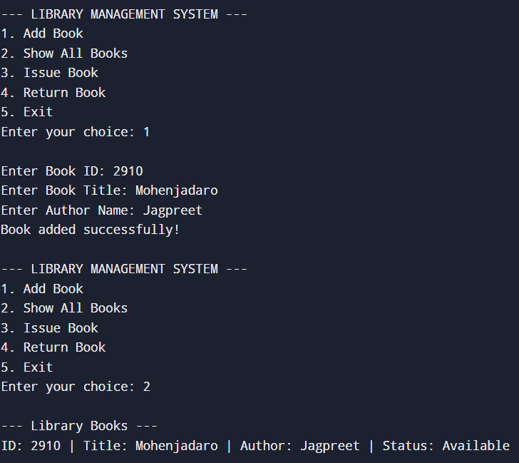

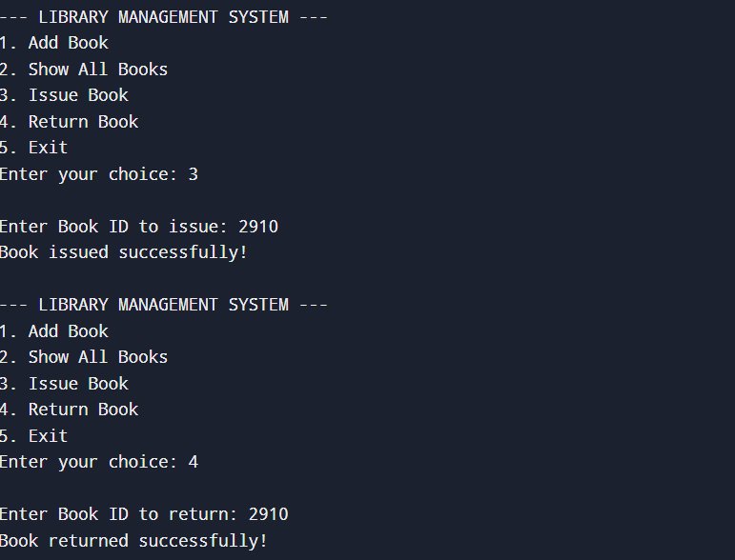

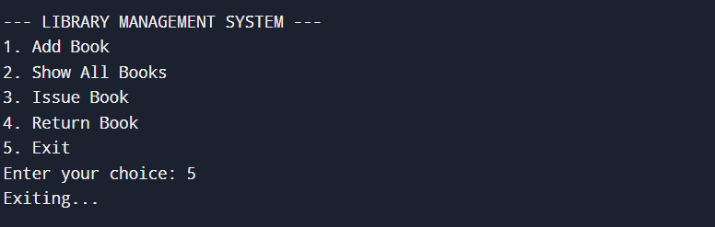

**Conclusion**

• Functional Library Management System implemented in C++.  
• Demonstrated OOP, file handling, and persistence.  
• Enhances programming and logical design skills.  
  
Future Enhancements:  
• GUI interface  
• Database integration (MySQL/SQLite)  
• Add fine management and due dates

References

1. Bjarne Stroustrup, The C++ Programming Language  
2. https://en.cppreference.com/  
3. Online tutorials and documentation