Sushmita Pal  
00576807218

CSE- 3

PYTHON

LAB PROGRAM

Submission -2

Github link : [LAB Program - 2](https://github.com/sush096/ML-Assignments/blob/main/LAB%20PROGRAM%20-2.ipynb)

**PROBLEM STATEMENT** - Implementation of decision tree on a breast cancer dataset using sklearn in python.

**Program Code Snippet**

**Loading Dataset**



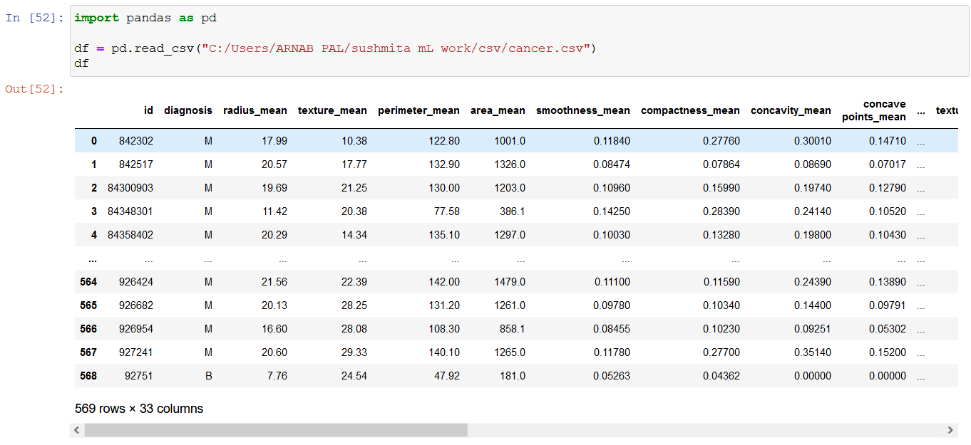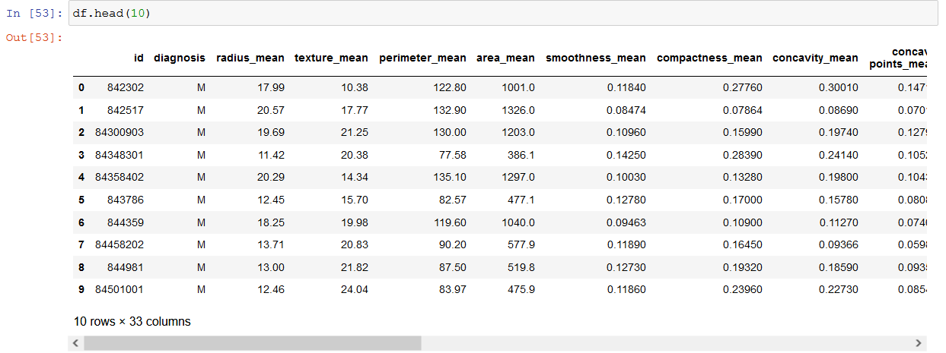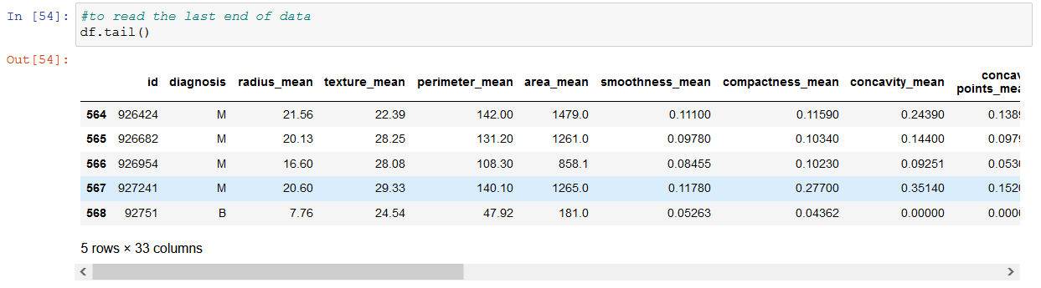

**Preprocessing/Cleaning of dataset**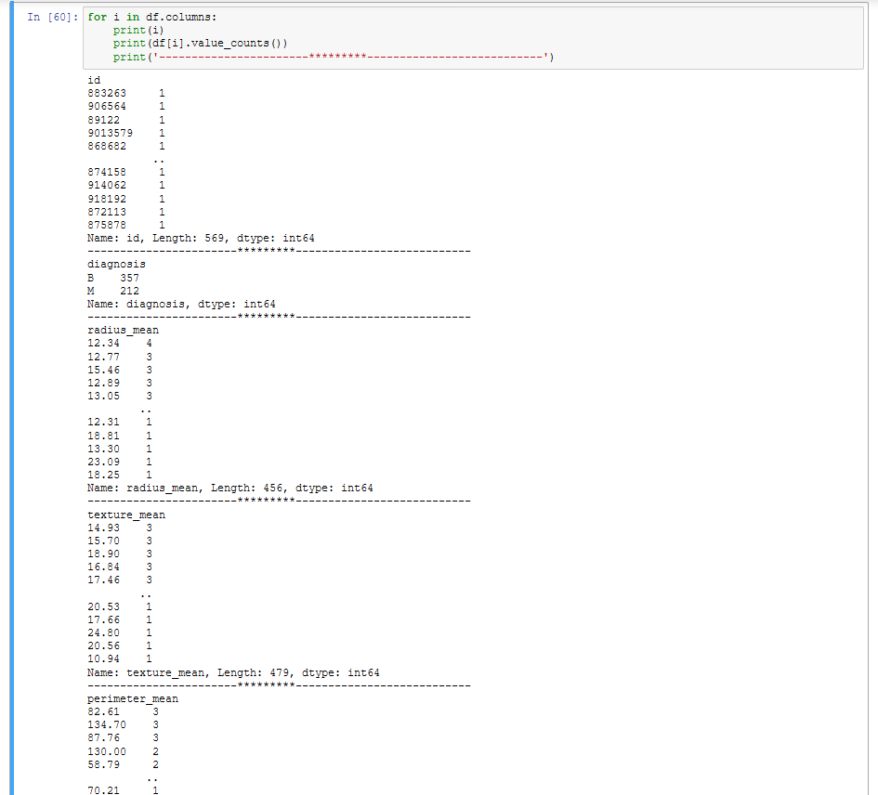 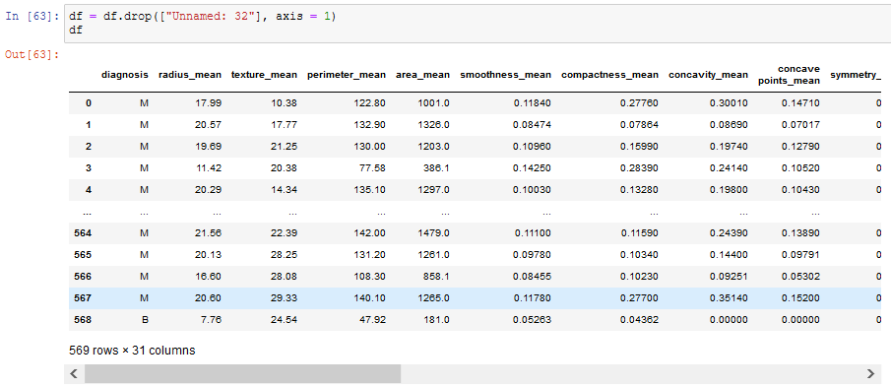

**Visualization**

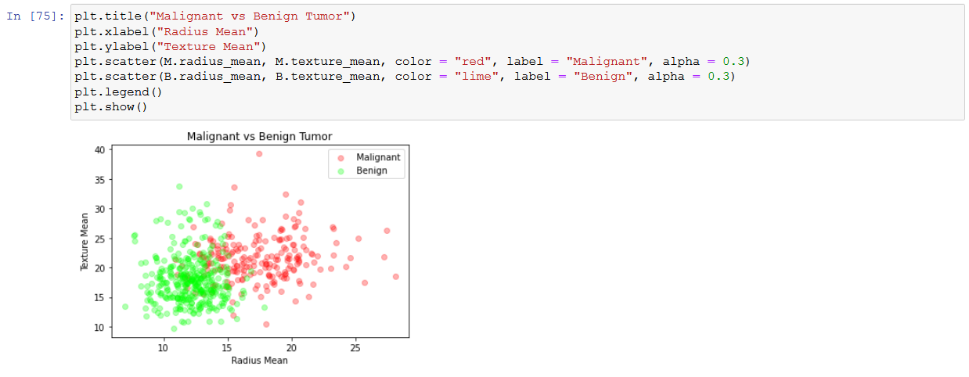

**ML algorithm implementation of prediction or comparison**

Decision tree models where the target variable uses a discrete set of values are classified as Classification Trees. In these trees, each node, or leaf, represent class labels while the branches represent conjunctions of features leading to class labels.

A decision tree where the target variable takes a continuous value, usually numbers, are called Regression Trees. The two types are commonly referred to together at CART (Classification and Regression Tree).

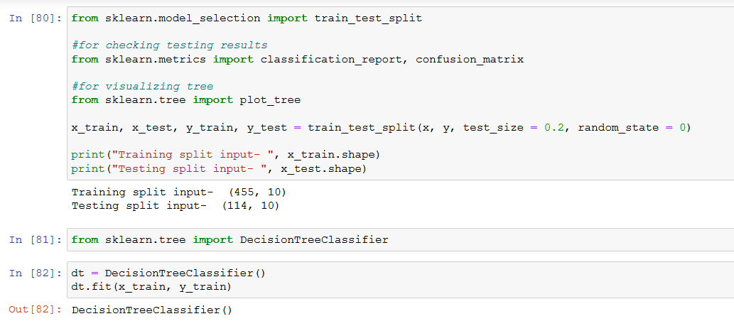

**ROC/AUC/Confusion matrix**



