UML Diagrams

Submission Guidelines:
- Diagrams can be:
  - Created using Draw.io / Lucidchart
- File format: PDF or PPT
- Naming: IntID_UMLDiagrams_Assignment

You are working on a Task Management System (like Jira) used in an organization.
The system allows users to:
- Log in
- Create projects
- Create tasks
- Assign tasks
- Track task status
- View tasks in List, Board, and Timeline views
There are three types of users:
- Admin
- Manager
- Team Member

Task 1: Use Case Diagram
Goal: Identify who can do what in the system.
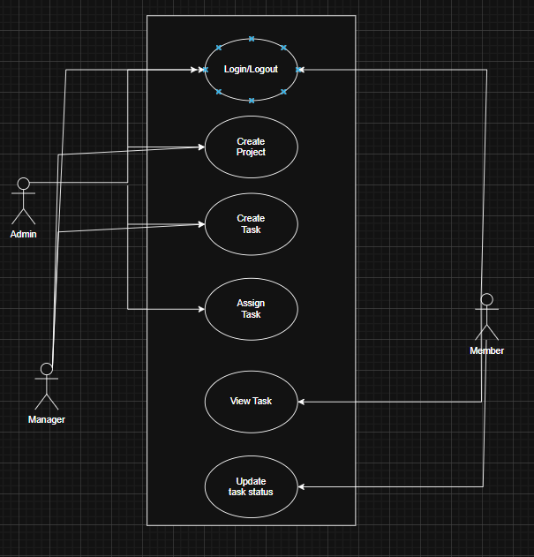

Task 2: Activity Diagram
Goal: Show the step-by-step flow of a task - Creating and completing a task
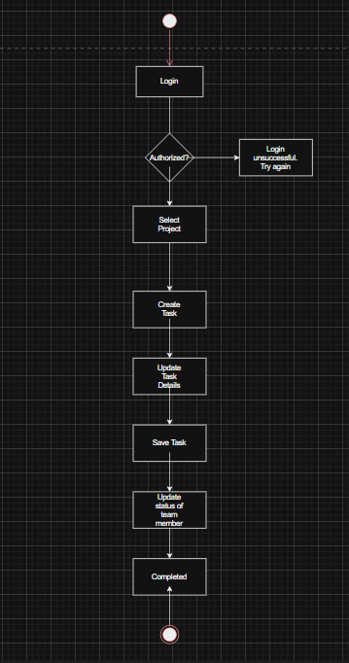

Task 3: Class Diagram
Goal: Show what data exists in the system.
