Git – Commands Assignment
Contents
Instructions:.............................................................................................................. 1
TASK 1: Repository Setup ........................................................................................... 1
TASK 2: Branch Creation & Work ................................................................................. 2
TASK 3: Branch Switching Observation ........................................................................ 2
TASK 4: Undo a Mistake .............................................................................................. 2
TASK 5: Merge Feature Branch (6 Marks) ...................................................................... 3
TASK 6: Checkout a Commit (Detached HEAD) (4 Marks) .............................................. 3

Instructions:
1. This is a local Git assignment only
2. Do NOT use GitHub
3. Use Command Prompt / Terminal
4. Commit messages must be meaningful
5. Screenshots for each step in each task
6. Follow steps in sequence

TASK 1: Repository Setup
Goal: Initialize Git and create first commit
Steps:
1. Create a folder named git-assignment-yourfullname
2. Navigate into the folder
3. Initialize Git repository
4. Create a file named index.txt
5. Check repository status
6. Stage the file
7. Commit with message:
Initial project setup
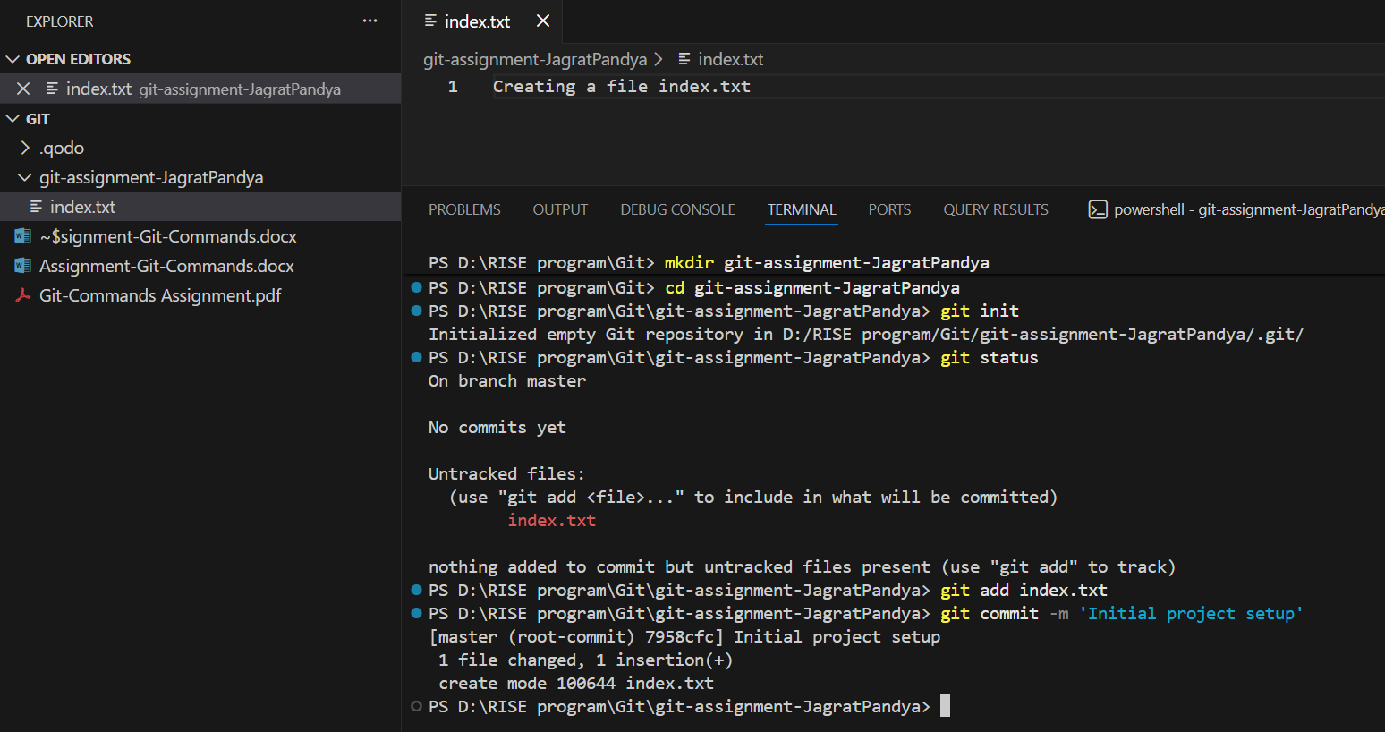
TASK 2: Branch Creation & Work
Goal: Work independently in a branch
Steps:
1. Create a branch named feature-header
2. Switch to feature-header
3. Create a file named header.txt
4. Stage the file
5. Commit with message:
Added header section
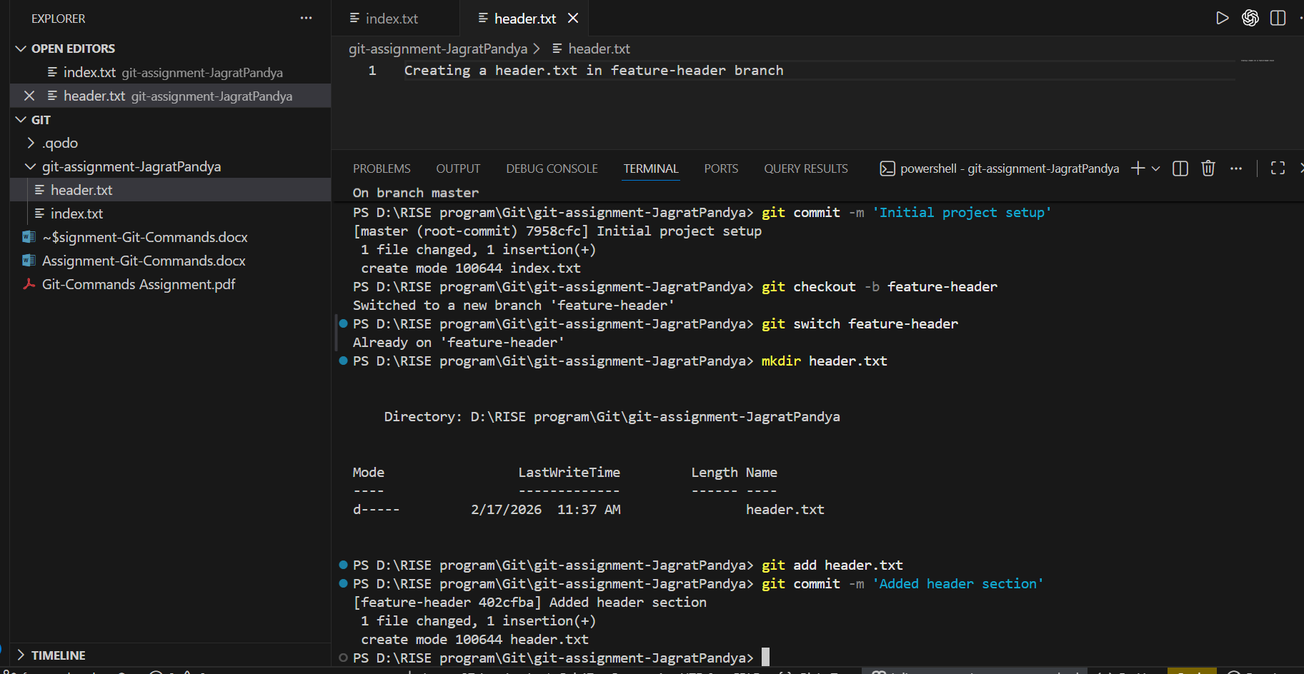
TASK 3: Branch Switching Observation
Goal: Observe branch isolation
Steps:
1. Switch back to master
2. List files and observe
3. Switch again to feature-header
4. List files and observe
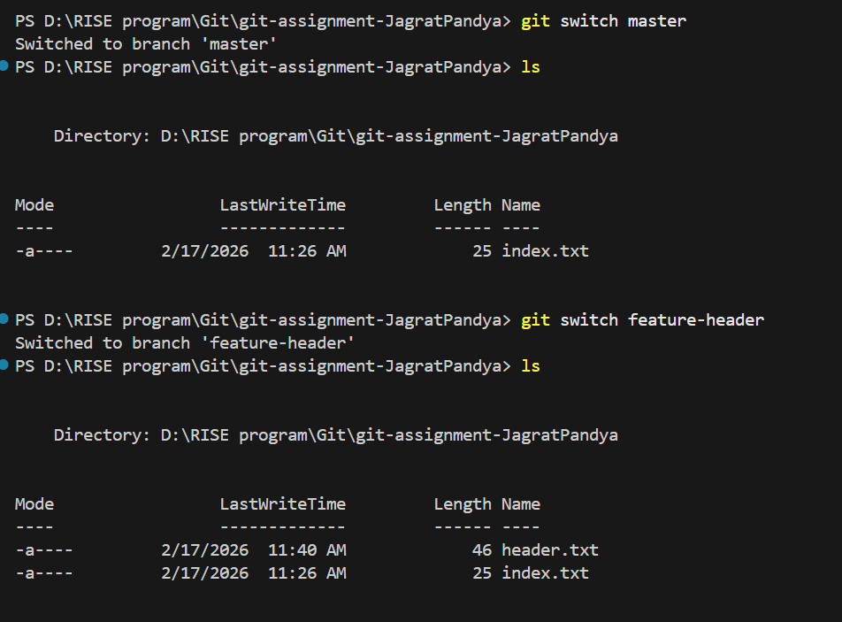
TASK 4: Undo a Mistake
Goal: Safely undo file changes
Steps:
1. In feature-header, modify index.txt
2. Check repository status
3. Undo the change using Git
4. Verify status again
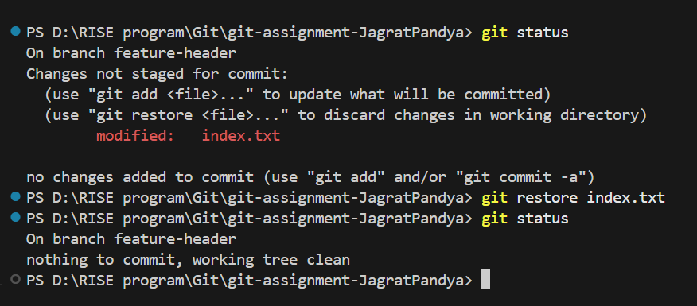
TASK 5: Merge Feature Branch
Goal: Combine work into master
Steps:
1. Switch to master
2. Merge feature-header
3. Verify merged files
4. Check commit history
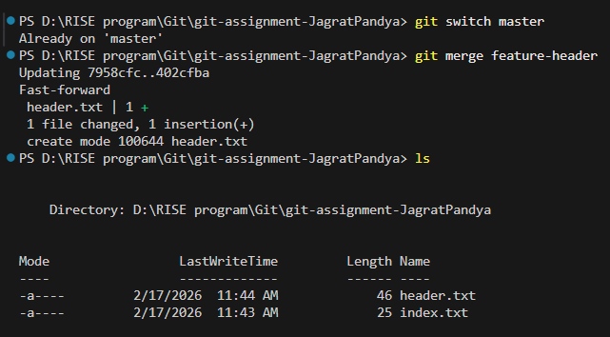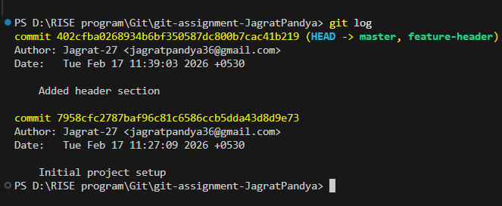
TASK 6: Checkout a Commit (Detached HEAD)
Goal: Understand commit-level navigation
Steps:
1. View commit history
2. Checkout any older commit
3. Check current branch status
4. Switch back safely to master
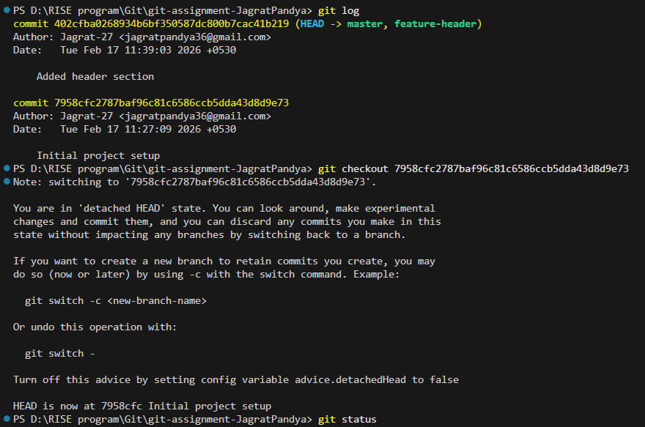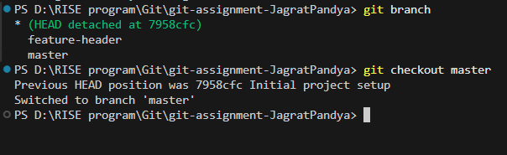

Task 7: Local to Remote connection
