UNIVERSITY OF BRIDGEPORT

FALL-2017



CPSC-501-11- OOP with Design Patterns-2017FA

Assignment-1

By:

Jagrithi Palachanda Chittiappa

ID: 1033162

Due date- 09/25/2017

Submitted date- 09/24/2017

**Table of Contents**

Documented Source Code 3

Screenshots 11

Things you learned 12

Work Cited 12

**Header file:**

Filename: GuessTheWord.h

Author: Jagrithi

Date: 09/25/2017

Compiler: Netbeans 8.2

Description: This file contains all the members and the member method declarations.

#ifndef GUESSTHEWORD_H

#define GUESSTHEWORD_H

#include <iostream>

#include <stdio.h>

#include <fstream>

#include<string>

#include<stdlib.h>

#include <ctype.h>

#include <time.h>

using namespace std;

class GuessTheWord

{

private:

string array1[50]; //This stores the contents of the file

int WordLength,len;

string temp1; //This variable stores the random word that has been extracted from array1

char ch1;

string copy; //Stores the random word after each guess made by the user each time

bool flag1,flag2;

public:

GuessTheWord(); //constructor

void LoadDictionary(string="InputFile2.txt"); //Loads array1 with the contents of the input file

void Clear();

int GetSecretWord(); //Extracts random word from the file each time the game is loaded

bool CheckChar(); //Checks if the entered character is part of the word to be guessed

bool IsWin(); //Checks copy against temp1, to see if the user has won the game

friend ostream& operator<<(ostream& out, const GuessTheWord& game) //overloading << operator

{

for(int i=0;i<=game.temp1.length()-1;i++)

{

out<<game.copy[i];

}

out<<endl;

return out;

}

friend istream& operator>>(istream& in, GuessTheWord& game) //overloading >> operator

{

in>>game.ch1;

return in;

}

};

#endif

**Source file**

File name: GuessTheWord.cpp

Author: Jagrithi

Date: 09/24/2017

Compiler: Netbeans 8.2

Description: This has all the definitions of the methods used in the program.

#include <iostream>

#include <stdio.h>

#include <fstream>

#include <string>

#include <stdlib.h>

#include <ctype.h>

#include <time.h>

#include "GuessTheWord.h"

using namespace std;

GuessTheWord::GuessTheWord(){

flag1=0;

flag2=0;

len=0;

}

//If the file isn't passed as parameter then it takes a default file i.e.,InputFile2.txt

void GuessTheWord::LoadDictionary(string file1)

{

ifstream file2;

file2.open(file1);

if(file2.is_open())

{

while(!file2.eof()) //file is open

{

getline(file2,array1[len]); //eof hasn't been reached yet

len++;

} //all the contents are read and is stored in array1

}

file2.close(); //file is closed

}

void GuessTheWord::Clear() //When the user wants to play again, temp1 and copy variables will be reset to null values

{

WordLength = temp1.length();

for(int i = 0; i<WordLength; i++){

temp1[i]='\0';

copy[i]='\0';

}

}

int GuessTheWord::GetSecretWord()

{

srand (time(NULL));

int i=rand()%len; //random number is selected in a range of 0-length of the array1

temp1=array1[i]; //temp1 has the random word and its the ith word in array1

srand (time(NULL));

int j=rand()%temp1.length()-1; //another random number is selected in the range, 0-length of the word in temp1

for(int k=0;k<temp1.length()-1;k++)

{

if(temp1[j]==temp1[k])

{

copy[k]=temp1[j]; //an initial clue is displayed in all its occurences

}

else

{

copy[k]='*'; //other than the clue all the other spaces of the word are displayed as '*'

}

}

return temp1.length()-1; //word length of the secret word is returned to the main program

}

bool GuessTheWord::CheckChar()

{

flag1=0;

ch1=toupper(ch1); //whatever be the input character entered by the user, it's converted to uppercase

for(int i=0;i<temp1.length()-1;i++)

{

if(ch1==temp1[i]) //input character is compared with each letter of the secret word

{

flag1=1; //if they match,flag value is set to 1

copy[i]=temp1[i]; //copy is altered accordingly

}

}

if(flag1==1)

return true;

else

return false;

}

bool GuessTheWord::IsWin()

{

flag2=0;

for(int i=0;i<temp1.length()-1;i++)

{

if(copy[i]!=temp1[i]) //copy is compared against the secret word and if they match, the flag is set to 1

flag2=1;

}

if(flag2==1)

return false;

else

return true;

}

**Driver program:**

File name: main.cpp

Author: Professor

Date: 09/24/2017

Compiler used: Netbeans 8.2

Description: This is the program boundaries set to us by the professor.

#include <cstdlib>

#include <iostream>

#include "GuessTheWord.h"

using namespace std;

int main()

{

int playAgain=-1, WordLength = 0;

GuessTheWord game;

game.LoadDictionary("InputFile.txt");

do

{

game.Clear();

WordLength = game.GetSecretWord();

cout << "Game starts "<< endl;

cout << game;

int j = 0;

for (int i = 0; i < WordLength + 3; i++)

{

cout << "Enter your next Guess"<< endl;

cin >> game;

if (game.CheckChar())

cout << "You got it right | Attempts : "<<(WordLength + 3)-i <<"/"<< WordLength + 3 << endl;

else

cout << "Oops. You got it wrong | Attempts : " << (WordLength + 3) - i << "/" << WordLength + 3 << endl;

cout << game;

if (game.IsWin()) {

cout << "You won!!";

break;

}

}

if(!game.IsWin())

cout << "Sorry, You lost." << endl;

cout << "Press 1 to play again, any key to exit";

cin >> playAgain;

if (playAgain != 1)

break;

playAgain = -1;

} while (true);

return 0;

}

**Input files:**

1. Filename: InputFile.txt

Author: Professor

Date: 09/24/2017

Compiler used: GNU

Description: This is the main input file which is fed to the program.

ARIES

ZOMBIE

PUZZLE

ABSOLUTE

ABACAS

MENU

PLATUE

ACACIA

SKYWALK

FRAMEWORK

1. Filename: InputFile2.txt

Author: Jagrithi

Date: 09/24/2017

Compiler used: GNU

Description: This file is an extra input file and will be used if none of the files are passed as input files to the program. This file will be set as a default parameter in the program.

JAGRITHI

SHREYA

HINDHUJA

MONISHA

DIANA

LIKITHA

**Output screenshots:**

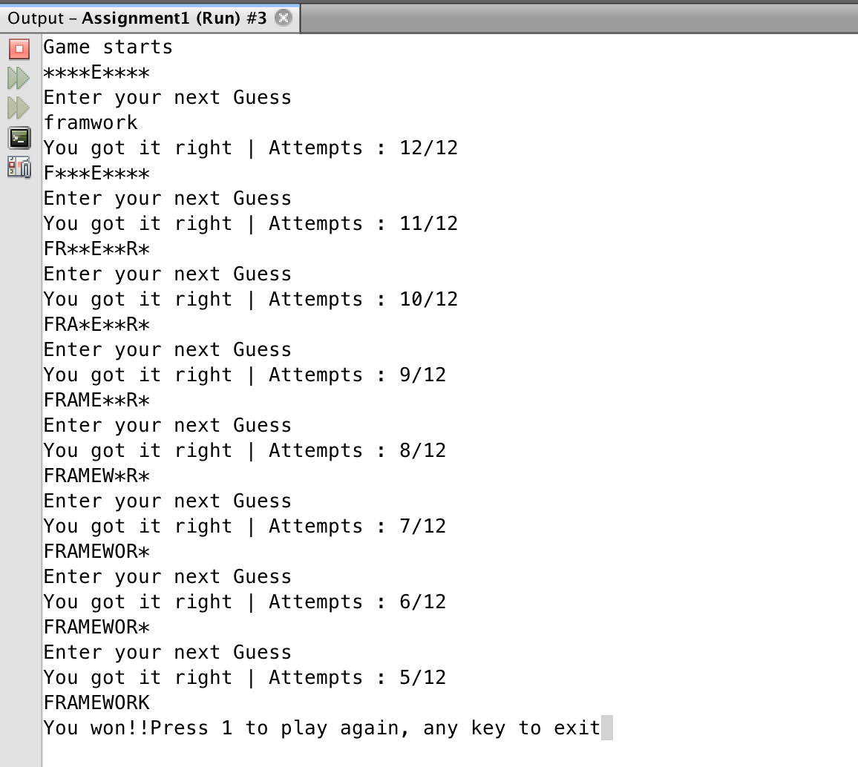

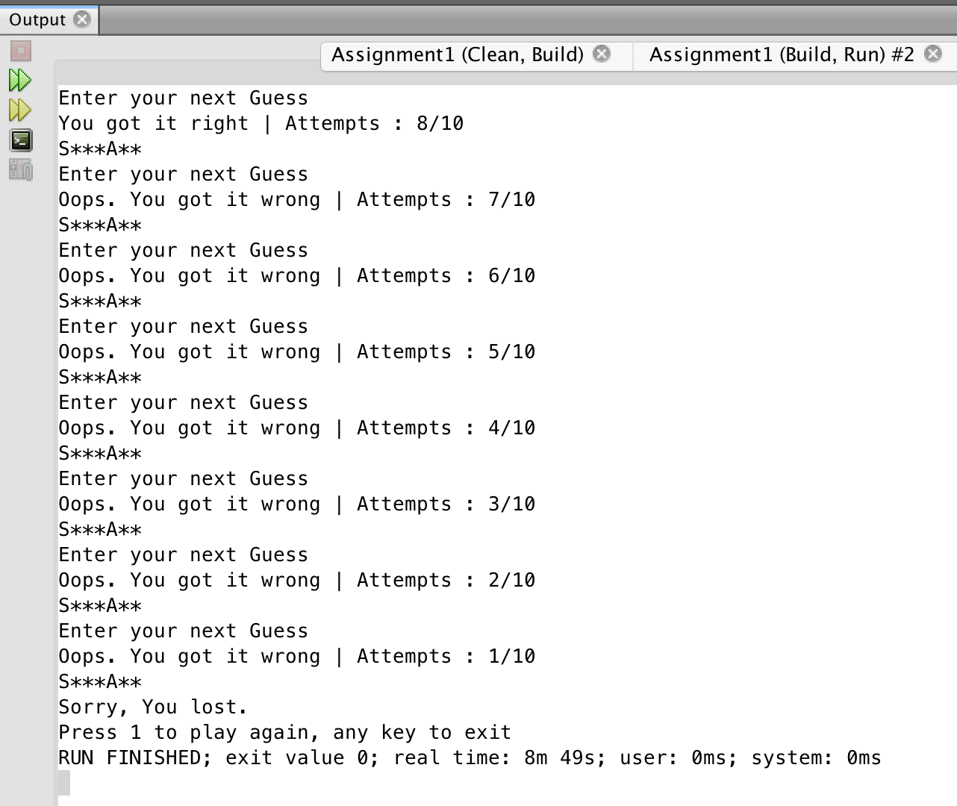

**Things learned:**

* Concepts of operator overloading.
* Modularization of the source code.
* Implementation of the logic for hangman concept.

**Works Cited:**

1. <https://stackoverflow.com>
2. <http://www.tutorialspoint.com/>
3. <http://www.cplusplus.com/>
4. <http://www.geeksforgeeks.org/>
5. <https://isocpp.org/>