Global Terrorist Attack Prediction
Jagriti Jain and Ted Scully
1 Abstract and Introduction
GTD or Global Terrorist Attack database is a database of around 1,90,000 terrorist attacks worldwide since 1970. This is available freely on https://www.start.umd.edu/research-projects/global-terrorism-database-gtd as well as on Kaggle https://www.kaggle.com/tags/terrorism

This data is in .csv format and is around 1,58,997 KB in size. It consists information of when the attack took place, where the attack took place, who was the target group, what is the identified terrorist group name, weapons used etc. Out of the total 135 columns, only the most informative columns will be used to predict the gname or terrorist group name. As the data is huge so it’s quite important to use Feature Selection techniques to pick the most relevant features. The Class that I am predicting is the gname. Following Feature Selection will be Data Preprocessing Techniques to cleanse the data to get it to a form to apply Machine Learning techniques on it. Summary of results, I achieved 90% + accuracy in predicting the gname with various models: KNN, Random Forest, Decision Trees, SVM and Naive Bayes.

Motivation behind choosing this dataset, firstly, I was keen in understanding patterns of various attacks worldwide and find who are the most prolific groups.
Secondly, this project allows me to get my hands dirty on this huge real life dataset so I can apply most of the machine learning techniques I learnt so far on this.
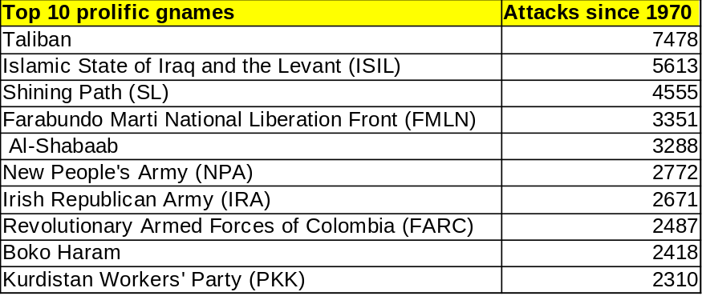
2 Research
Data Preprocessing is the first task before performing any Machine Learning Algorithm to the dataset. To start with we will first reduce the dataset to attacks by top 10 prolific gnames/terrorist groups. After which we will tackle missing values and then encoding categorical values to numerical values. Research is done on missing values, comparing different techniques and its impacts. Majority of the time was spent encoding technique and finally I settled with Label Encoding for the Class -Gname and the features chosen were containing numerical values only, as each relevant feature in the dataset had both numerical column and categorical column, so after data exploration, I picked those. Also, as the columns are huge, applying One Hot Encoding led to notebook crashes as it manifolds the no. of features based on each unique value per feature. As the dataset contains 135 columns, we want to pick only the relevant features for predicting gname, so we will use various techniques for feature selection.
2.1 Reduction Of Data
The dataset has a shape of (1863911, 135) i.e. 1863911 rows and 135 columns which is quite difficult to handle. Not only that, it contains huge no. of columns with categorical data, thus applying One Hot encoding to them will only increase no. Of columns which isn’t favourable. So we selected top 10 prolific terrorist groups based on the count of attacks which reduced it to almost half in terms of the rows (98909, 135).
col_selected = ['iyear', 'imonth', 'iday', 'country', 'region', 'success', 'suicide', 'attacktype1', 'targtype1', 'natlty1', 'gnameEncoded', 'guncertain1', 'individual', 'weaptype1']

I have purposely not combined the year, month and day together as there could be underlying patterns of dates which the terrorist groups aim for, like 9/11 and others.
2.2 Missing data
Even after reduction of data in the above step, the data set is still huge with 98909 rows.
In real world projects, there are always some missing values in some features due to data unavailability or human error. I performed the exploratory data analysis to see how many values are missing per feature, we used the df.isnull().sum() method. The isnull() method only detects missing values which are marked as ‘nan’. There could be other missing values such as “ ”, ? etc.
Top 10 columns with missing values are below, interestingly non of these columns have made to my selected features list.

gsubname3 36943
claimmode3 36940
claimmode3_txt 36940
guncertain3 36920
weapsubtype4_txt 36920
gname3 36920
weapsubtype4 36920
weaptype4_txt 36920
weaptype4 36920
claim3 36920

Majority of Machine Learning algorithms require the data to be full, free of missing values. To deal with that, we have mainly 3 techniques like Imputation, Deletion of Rows and Deletion of columns. I will discuss in detail about these below. Threshold parameter inside the dropna(thresh=3) means the no. of non-nan values a row/column must have to be retained.

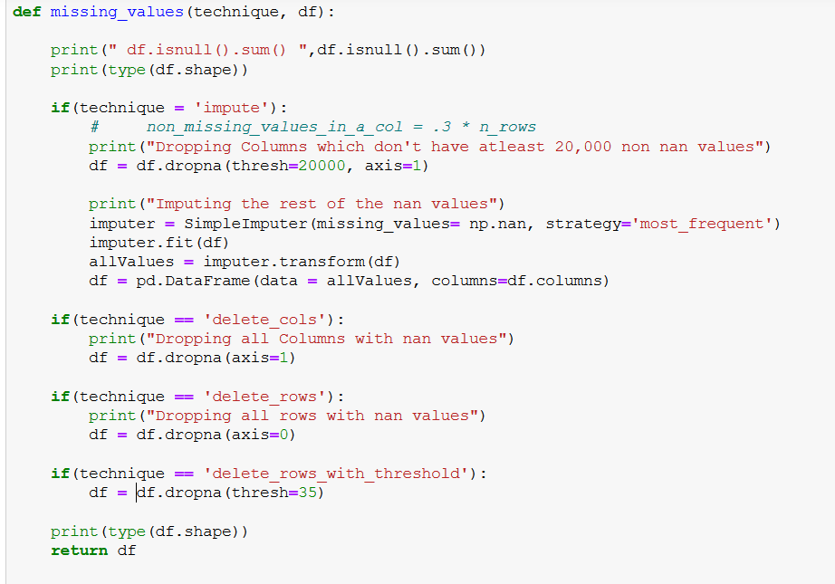

2.2.1 Imputation:
Imputation refers to replacing the missing value with another value like most frequent value or mean value or even a custom value.
Using SimpleImputer(missing_values = np.nan, strategy='most_frequent') I replaced these nan values to most frequent values in that column/feature. As there were some categorical columns involved, so used the ‘most frequent’ strategy instead of mean. However before imputation, I have deleted all columns having more than 20,000 missing values. (We usually delete features having more than 30% of total values)

Shape after handling missing values (36943, 58)
This is the most desirable approach and I have used this approach for the project as this involves sensible deletion and imputation.

2.2.2 Delete Columns
Here I deleted all the columns having missing values
df = df.dropna(axis=1).
Shape after handling missing values (36943, 31)

Though this is not the best way to deal missing values, I have done it to compare the results with Imputation technique. This approach also don’t work in my favour as it deleted the columns which I found relevant for the remaining ML model and have based all the categorical encoding based on the selected columns. So I am not opting this approach.

2.2.3 Delete Rows
Here I deleted
a. All rows having missing values
df = df.dropna(axis=0)
Shape after handling missing values (0, 135), which has deleted all rows, that means every row contains missing values. So this is not desirable.

b. All rows meeting the threshold condition:
df = df.dropna(thresh=35) (why 35? closer to 30% of total rows)
Shape after handling missing values (36943, 135)
This is relatively better result than above.

2.3 Handling Categorical Data
Most Machine Learning algorithms can operate only on numerical data.
There are many techniques for handling categorical data. One Hot encoding is one technique which takes every unique value per feature and forms a new column out of it and providing numerical values. Label Encoding is another technique of converting categorical data to numerical form, this is used for class only and features.
2.4 Feature Selection
One of the biggest challenges I faced working on this dataset was to reason if I should perform encoding first to convert all categorical values to numerical or to do feature selection first. Ideally we should encoding first, but One Hot encoding technique adds so many different columns for each unique categorical value per column, this leads to crash of the jupyter notebook or colab notebook. However, if I do feature selection first using univariate technique or greedy based approach, each of them require the data to be in numerical format. So this might seem like a deadlock. So to sort this out, I have explored the data and selected features which I found most relevant. Even better if we have the domain knowledge of the dataset for feature selection.

def selecting_features_by_intuition(df):

# Selected columns by intuition
col_selected = ['iyear', 'imonth', 'iday', 'country', 'region', 'success', 'suicide', 'attacktype1', 'targtype1', 'natlty1',
'gnameEncoded', 'guncertain1', 'individual', 'weaptype1']

df = df[col_selected].head(5)

The accuracy with this technique alone was above 95%, so ideally other techniques aren’t needed, but I have visualized them for the sake of understanding.
There is another technique to it, I could select all the non-object dtype columns, however this technique can pick some non-relevant features as well, so probably not the best thing to do.

Apply feature selection techniques to the above selected data.
After that we can apply the One Hot encoding to the selected features which looks like this:

[[1. 0. 0. ... 0. 0. 1.]
[1. 0. 0. ... 0. 0. 1.]
[1. 0. 0. ... 0. 0. 0.]
...
[0. 0. 0. ... 0. 0. 0.]
[0. 0. 0. ... 0. 0. 0.]
[0. 0. 0. ... 0. 0. 0.]]

2.4.1 Univariate Selection
Out of the 14 features which I gave input, Univariate Selection selected the top 10 as below in decreasing order or precedence :

------------------------Univariate Selection----------------------------------
Specs Score
3 country 553.073744
8 targtype1 13.698113
7 attacktype1 12.250000
12 weaptype1 6.681818
2 iday 5.488201
1 imonth 3.195652
4 region 1.588235
9 natlty1 1.355693
5 success 0.055556
0 iyear 0.000000

2.4.2 Feature Importance
Out of the 14 features which I gave input, Feature Importance ranked the top 10 as below :
[ 0. 0. 0.1 0. 0.18333333 0.
0. 0.1 0.11666667 0.3 0. 0.
0.2 ]
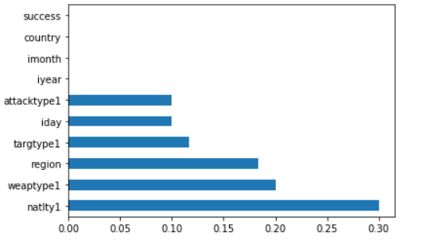

2.4.4 Dimensionality Reduction
Dimensionality Reduction is a technique which takes input of all features (minus the target/class) and reduces them to fewer columns, this technique is great when we have huge no. of columns, like in this case. It further uses a concept called as PCA – principal component analysis. However, this technique also requires the features to be in numerical form. Thus, I have used this technique only for my already selected columns, else I would need to apply One Hot encoding on all features and then do feature selection, which was very expensive for huge data like this.
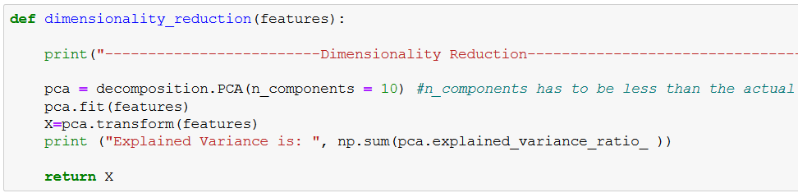

After applying Dimensionality Reduction on my selected columns:
Explained Variance: 0.999995314966751
reduced_features_df1.shape (36943, 10)
2.4.3 Correlation Matrix with Heat Map
Correlation Matrix takes in all features and target and plots a heatmap indicating which features are most related to the target value. I have only visualized this, not using further in my project.
2.4.4 Greedy Feature Selection
This is an ensemble technique where random forest is created which decides reduces the features to relevant ones alone. This is done by recursive feature elimination or RFECV. Applied this approach on my dataset and these are the initial and after results.

Initial Result 0.9950252974721046 before RFECV

No. of features reduced to - 2
Ranking of each feature - [ 3 8 7 1 1 11 10 6 4 2 9 12 5]
Result after feature selection: 0.9946193662141741
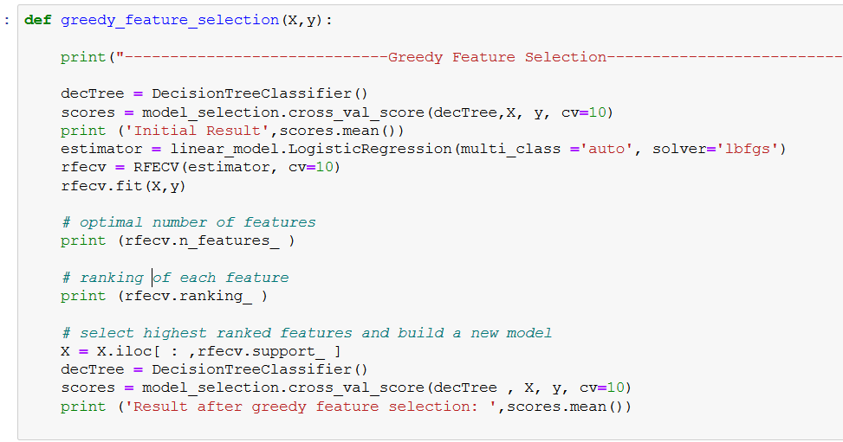
Ideally this technique would be ideal to follow, however it also requires lot of computation to build the random forest of trees. In my case the accuracy is not changing much, so I have only ran this for visualization, not taking this approach further, as I would anyways be using ensemble techniques during modelling.
3. Scaling/Standardization/Normalization
Scaling becomes important when there are huge differences in data values amongst 2 cols (or more), as many machine learning algorithms work with distances like euclidean or others, the difference of the 2 values from columns will become biased towards larger value, which is not desirable. Thus we need techniques to scale data.

Scaling consists of 2 techniques:

3.1 Standardization:
Reducing all features values in such a way that each feature has mean of 0 and standard deviation of 1. Thus it brings negative values as well.

3.3 Normalization:
Bringing all features values in range of 0 to 1

I have used Standard Scaler in my project to scale all values of features.
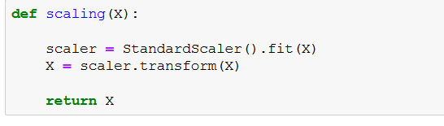

4. Imbalance Data And Outlier Detection
Outliers are the points per feature which lie outside a given range, the features should be in numerical data before analyzing outliers. Box plots are used to see points lying outside given range. In the given dataset, country and nationality columns have max outliers.

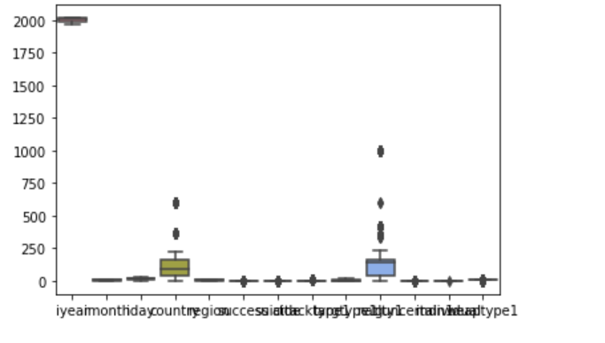
5. Model Selection
I used various models like KNN, Decision Tree and Random Forest and observed the accuracies.

5.1 Random Forest (Using Ensemble)

“ In machine learning, ensemble methods utilize/combine the results from a number of learning algorithms to obtain a better predictive performance than could be obtained from any single one of the learning algorithms learning algorithms. Instead of learning one model, we learn several and combine them. Such combinations are known as model ensembles.” (Taken from ML Notes)

I used GridSearchCV – wherein I provided many different hyper parameeter values and the algorithm used all of those and found the best grid or best set of values out of the ones I gave using cross fold validations. After getting the best grid, that set of parameters was applied to the test data to obtain final accuracy.

After applying this technique to my dataset:
Accuracy = 99.88%.
best_grid RandomForestClassifier(bootstrap=True, class_weight=None, criterion='gini',
max_depth=80, max_features=3, max_leaf_nodes=None,
min_impurity_decrease=0.0, min_impurity_split=None,
min_samples_leaf=3, min_samples_split=10,
min_weight_fraction_leaf=0.0, n_estimators=500,
n_jobs=None, oob_score=False, random_state=None,
verbose=0, warm_start=False)

grid_accuracy 99.88353677288103
5.2 Decision Tree with Grid Search
Decision Tree is a popular classifier and along with GridSearchCV, found the best grid and applied to the test data.
scores.mean() 0.9953637645841915
n Best parameters set found on training set:
{'max_depth': 17, 'min_samples_split': 30} with a score of 0.9952629085741355
Decision Tree Accuracy 0.9963459196102314
5.3 KNN with Grid Search.
K Nearest Neighours classifier forms a compares K nearest neighbour values to identify which class the train data value should go to. Again used GridSearch to find best value of k and p hyper parameters out of the values I gave.
scores.mean() 0.9712069548279167
n Best parameters set found on development set:
{'n_neighbors': 4, 'p': 1}
Score of 0.9821346398505806
5.4 Naive Bayes
Naive Bayes is the Simplest Classifier in Machine Learning
Naive Bayes Accuracy 0.9527676275544729
5.5 SVM
SVM or Support vector Machine Algorithm

Accuracy (C=1.0, cache_size=200, class_weight=None, coef0=0.0,
decision_function_shape='ovr', degree=3, gamma='auto', kernel='rbf',
max_iter=-1, probability=False, random_state=None, shrinking=True,
tol=0.001, verbose=False)

Accuracy using SVM 0.9699553390174583

Confusion matrix:n
[[ 667 0 0 0 0 0 0 0 0 12]
[ 0 449 0 0 0 0 0 0 0 15]
[ 0 0 660 0 0 0 0 0 0 23]
[ 0 0 0 500 0 0 0 0 0 19]
[ 1 0 0 0 1053 11 4 0 0 26]
[ 0 0 0 0 2 462 0 0 0 26]
[ 0 0 0 0 0 0 499 0 16 14]
[ 0 0 0 0 0 0 0 471 0 16]
[ 0 0 0 0 0 0 12 1 878 23]
[ 0 0 0 0 0 1 0 0 0 1528]]

f1score is 0.9699553390174583

class_report is:
precision recall f1-score support

0 1.00 0.98 0.99 679
1 1.00 0.97 0.98 464
2 1.00 0.97 0.98 683
3 1.00 0.96 0.98 519
4 1.00 0.96 0.98 1095
5 0.97 0.94 0.96 490
6 0.97 0.94 0.96 529
7 1.00 0.97 0.98 487
8 0.98 0.96 0.97 914
9 0.90 1.00 0.95 1529

accuracy 0.97 7389
macro avg 0.98 0.97 0.97 7389
weighted avg 0.97 0.97 0.97 7389

Model Performance
Average Error: 0.1245 degrees
6. Hyper Parameter Optimization
Hyper Parameters are the parameters or arguments passed in the Machine Learning algorithm. Different hyper parameters lead to different accuracies. Thus it becomes imperative to choose the best.
When using different values of hyper-parameters to train and test on same set of data, it can lead to surprisingly high accuracy due to overfitting of data. To avoid that, we divide the train data further into train and validation data, so after the hyper parameter optimizaton, testing is done on validation data(and not on test data). Finally when best is chosen comparing results of various combinations of hyper parameters, then those are applied on the test data.
Most popular method for hyper parameter optimization is GridSearchCV which provides a method called param_grid in which we can give a list of values to iterate on for each hyper parameter. e.g. in KNN, various values of n_neighbors and p can be given :

param_grid=[{'n_neighbors': list(range(1, 80)), 'p':[1, 2, 3, 4, 5] } ]
clf=GridSearchCV(KNeighborsClassifier(),param_grid, cv=10, n_jobs =-1)
clf.fit(features, .target)
print(clf.best_params_ , "with a score of ", clf.best_score_)

This method is CPU intensive as there will be multiple iterations, especially when using Cross Fold Method of separating the data into train, validation and test. n_jobs = -1 leads all the tasks in parallel, such increasing speed at which the hyper parameter optimization is being done.

GridSearchCV returns classifier with best parameters, we can view those parameter values by printing clf.best_params_ on the console.

For my dataset I got set of best parameters {'n_neighbors': 4, 'p': 1} with a score of 0.9821346398505806 which is a quite good score.

knn = KNeighborsClassifier()
scores = model_selection.cross_val_score(knn , features , target , cv=10)
print ("scores.mean()" , scores.mean())
param_grid = [ {'n_neighbors': list(range(1, 80)), 'p':[1, 2, 3, 4, 5] }]
clf = GridSearchCV(KNeighborsClassifier (), param_grid , cv=10)
clf.fit(features , target)

print("n Best parameters set found on development set:")
print(clf.best_params_ , "with a score of ", clf.best_score_)

scores.mean() 0.9712069548279167
n Best parameters set found on development set:
{'n_neighbors': 4, 'p': 1} with a score of 0.9821346398505806

One of the drawbacks of using cross fold validation is that it uses the same data to tune the model parameters and evaluate model performance which can positively bias the accuracy estimation. The escape here is Nested Cross Fold, which has 2 nested loops and thus even more CPU intensive. For this reason, I didn’t use it here. If the dataset is relatively smaller than my current dataset, then I can use Nested Fold technique of splitting data into train, validation and test.

7. Evaluation
This is a classification problem and there are many techniques for evaluating the algorithm/machine learning model.

7.1 Accuracy Score Accuracy in machine learning algorithm is measured as:
𝑇𝑟𝑢𝑒𝑃𝑜𝑠𝑖𝑡𝑖𝑣𝑒𝑠+𝑇𝑟𝑢𝑒𝑁𝑒𝑔𝑎𝑡𝑖𝑣𝑒𝑠
--------------------------------------------------
𝑇𝑟𝑢𝑒𝑃𝑜𝑠𝑖𝑡𝑖𝑣𝑒𝑠+𝐹𝑎𝑙𝑠𝑒𝑃𝑜𝑠𝑖𝑡𝑖𝑣𝑒𝑠+𝑇𝑟𝑢𝑒𝑁𝑒𝑔𝑎𝑡𝑖𝑣𝑒𝑠+𝐹𝑎𝑙𝑠𝑒𝑁𝑒𝑔𝑎𝑡𝑖𝑣𝑒𝑠

I have used this accuracy accuracy_score and score methods from sklearn to evaluate models.

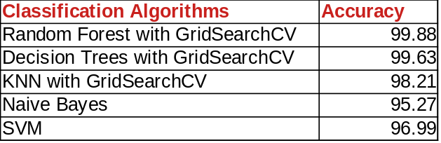

So Random Forest with GridSearchCV worked best for me with the below values of hyper parameters:
bootstrap=True, class_weight=None, criterion='gini',
max_depth=80, max_features=3, max_leaf_nodes=None,
min_impurity_decrease=0.0, min_impurity_split=None,
min_samples_leaf=3, min_samples_split=10,
min_weight_fraction_leaf=0.0, n_estimators=500,
n_jobs=None, oob_score=False, random_state=None,
verbose=0, warm_start=False

(I am getting very high accuracy, this may have come from overfitting of data because of rerunning the algorithm 10-12 times while testing)
7.2 Confusion Matrix
In Classification problem, the machine learning algorithm may give great predictions biasing on some classes, however it may or may not be performing well on minority classes. To visualize this, we have something called as confusion matrix, which gives full details of True Positives, True Negatives, False Positives and False Negatives.

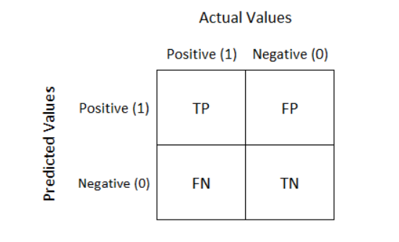
my_confusion_matrix=confusion_matrix(y_true= y_test, y_pred = y_predicted)

Confusion matrix using SVM for my dataset

[[ 667 0 0 0 0 0 0 0 0 12]
[ 0 449 0 0 0 0 0 0 0 15]
[ 0 0 660 0 0 0 0 0 0 23]
[ 0 0 0 500 0 0 0 0 0 19]
[ 1 0 0 0 1053 11 4 0 0 26]
[ 0 0 0 0 2 462 0 0 0 26]
[ 0 0 0 0 0 0 499 0 16 14]
[ 0 0 0 0 0 0 0 471 0 16]
[ 0 0 0 0 0 0 12 1 878 23]
[ 0 0 0 0 0 1 0 0 0 1528]]

This shows 667 values of col1 are True positives
7.3 Precision
Precision = True Positives
-------------------------------------------
True Positives + False Positives
7.4 Recall
Recall only takes into account the data instances of a particular class.
Recall = True Positives
-------------------------------------------
True Positives + False Negatives
7.4 F1 Score
F1 score is a combination of Recall and Precision :

𝑅𝑒𝑐𝑎𝑙𝑙∗(𝑃𝑟𝑒𝑐𝑖𝑠𝑖𝑜𝑛)
2 * ------------------------------
𝑅𝑒𝑐𝑎𝑙𝑙+(𝑃𝑟𝑒𝑐𝑖𝑠𝑖𝑜𝑛)
Fscore is higher when both Recall and Precision are higher (as can be interpreted from the above formula) Method in sklearn: f1_score(y, y_pred)
Using SVM on my dataset:
f1score is 0.9699553390174583

7.5 Classification Report:
Classification beautifully shows precision, recall, f1score and support in tabular format. Method used in sklearn: classification_report(y, y_pred))

class_report using SVM on my dataset is:
precision recall f1-score support

0 1.00 0.98 0.99 679
1 1.00 0.97 0.98 464
2 1.00 0.97 0.98 683
3 1.00 0.96 0.98 519
4 1.00 0.96 0.98 1095
5 0.97 0.94 0.96 490
7.7 Measures of Error
I used the below formula to calculate errors in classification:
errors = abs(y_preds – test_labels)
myerrors = 100 * np.mean(errors / test_labels)
Conclusion:
I obtained 99.88 accuracy using RandomForest with GridSearch CV Machine Learning Algorithm after I reduced the data to top 10 gnames, removed Unknown gname rows, imputed missing values with most frequent ones, scaling the data using Standard Scaler, encoding categorical values in features and target, performing feature selection, running different models and comparing them.
References
1. Lecturer Ted Scully’s Class Notes/Slides
2. https://thispointer.com/python-pandas-how-to-drop-rows-in-dataframe-by-conditions-on-column-values/
3.https://towardsdatascience.com/understanding-confusion-matrix-a9ad42dcfd62
4.https://scikit-learn.org/stable/modules/generated/sklearn.ensemble.RandomForestClassifier.html
5. https://towardsdatascience.com/hyperparameter-tuning-the-random-forest-in-python-using-scikit-learn-28d2aa77dd74

Cork Institute Of Techology, Cork, Ireland jagriti.jain@mycit.ie
Cork Institute Of Technology, Cork, Ireland ted.scully@cit.ie

