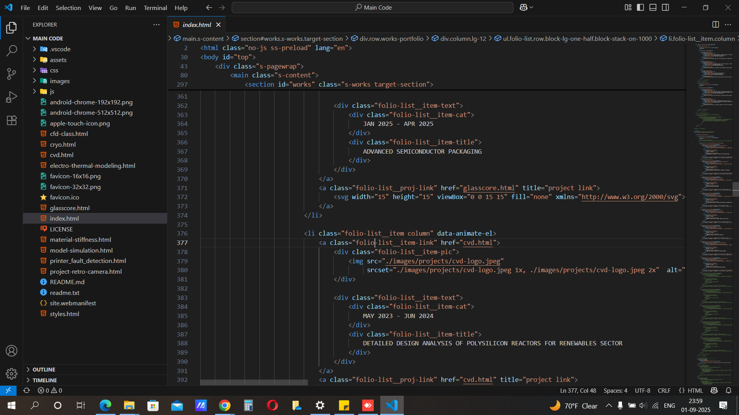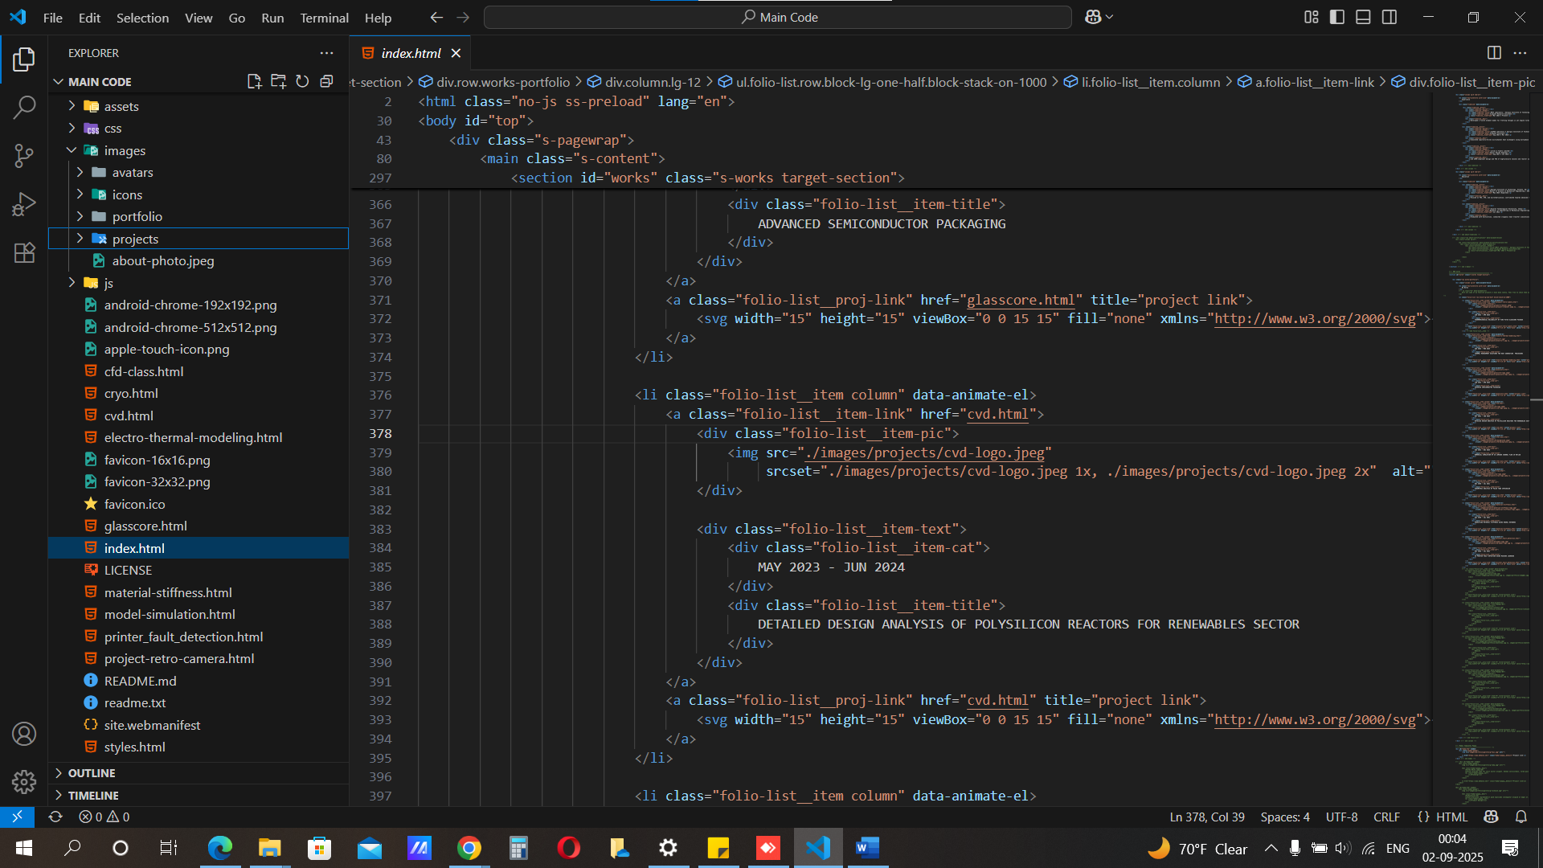
Add all images relevant to portfolio in this folder on local PC
D:\GaTech\Portfolio\Main Code\images\projects
Enter project.html here when creating new project
index -> new project -> add redirecting link -> add image-> add title -> add date

