A Mini Project Report
on
OFFLINE VIDEO STREAMING
(VIDEOGRAPHY)
by

Jagruti Dhondage (T120058525)
Sai Kapadekar (T120058540)
Janhavi Kode (T120058552)

Under the guidance of
Mrs Sumitra Jakhete



Department of Information Technology
PUNE INSTITUTE OF COMPUTER TECHNOLOGY
SAVITRIBAI PHULE PUNE UNIVERSITY
2016-2017

Date : 03/10/16
CERTIFICATE

This is to certify that,
Jagruti Dhondage (T120058525)
Sai Kapadekar (T120058540)
Janhavi Kode (T120058552)

of class T.E IT; have successfully completed their mini project work on “OFFLINE VIDEO STREAMING (VIDEOGRAPHY)’’ at PICT in the partial fulfillment of the Graduate Degree course in T.E at the department of Information Technology, in the academic Year 2016-2017 Semester – I as prescribed by the Savitribai Phule Pune University.

Mrs. Sumitra Jakhete Dr. Emmanuel M.
Guide Head of the Department
(Department of Information Technology)

Acknowledgements

We have taken efforts in this project. However, it would not have been possible without the kind support and help of many individuals. We would like to extend my sincere thanks to all of them.
We am highly indebted to Mrs. Sumitra Jakhete for her guidance and constant supervision as well as for providing necessary information regarding the project & also for the support in completing the project.

We would like to show my greatest appreciation to Prof. S. Chandak. We can’t say thank you enough for his tremendous support and help. We feel motivated and encouraged every time we attend her meeting. Without her encouragement and guidance this project would not have materialized. Her willingness to motivate us contributed tremendously to our project.

Furthermore we would like to thank Prof. Dhamankar for introducing me to the topic as well for the support on the way.

We would like to express my gratitude towards Dr. Emmanuel M., Head of the Department, for his kind co-operation and encouragement which help us in completion of this project.

The guidance and support received from our respected Principal P.T.Kulkarni who contributed and who are contributing to this project, was vital for the success of the project. We am grateful for their constant support and help.

We would like to express my special gratitude and thanks to the management and the lab attendants for giving me such attention and time.

We would like to express my gratitude towards my parents & member of for their kind co-operation and encouragement which help me in completion of this project.

Our thanks and appreciations also go to colleague in developing the project and people who have willingly helped me out with their abilities.

Jagruti Dhondage (T120058525)
Sai Kapadekar (T120058540)
Janhavi Kode (T120058552)
i
Contents

Sr. No. | Topic |  | Page No.
 | Acknowledgement |  | i
 | Contents |  | ii
 | List of Forms |  | iii
 | Abstract |  | iv
Chapter-1 | Introduction |  | 1
 | 1.1 | Problem Statement | 1
 | 1.2 | Scope | 2
 | 1.3 | Framework of the proposed work in project | 3
Chapter-2 | Literature Review |  | 4
 | 2.1 | Introduction | 4
 | 2.2 | Existing methodologies | 5
 | 2.3 | Proposed methodologies | 6
Chapter-3 | Software Requirement Specification |  | 7
 | 3.1 | Hardware Requirements | 7
 | 3.2 | Software Requirements | 8
Chapter-5 | Assumptions |  | 9
Chapter-6 | Collection diagram |  | 10
Chapter-7 | Collections |  | 11
Chapter-8 | Forms/jFrames |  | 15
Chapter-9 | Features |  | 25
Chapter-10 | Conclusion |  | 30
 | References |  | 31

ii
List of Forms

Figure No. | Title | Page No.
1. | Sign In | 7
2. | Sign Up | 7
3. | Upload video | 8
4. | Update video | 8

iii

Abstract
This project presents a designing of a web based system for offline video streaming. VideoGraphy provides the user to upload and view videos with ease.
The idea of VideoGraphy is that the user is able to view the contents of the website and view videos offline.
Videos can be searched according to the categories or his/her need. Contents of the video include title, description, uploader name, date of upload, number of views, number of likes and dislikes, comments and comment details.
VideoGraphy provides the user who haven't registered to view the contents of the site, search videos,etc
VideoGraphy provides the user who have registered to view th contents as well as upload, like, dislike, comment and update their videos. User can also delete his/her video and hide it's content from other viewers while being able to view the video. User can view his profile, his uploaded videos, liked videos and history. Also, analysis of his/her video categories can be done.

iv

Chapter 1
Introduction

  - Problem Statement
Design an application for Video Database and Streaming that uses MongoDB database technology to create, retrieve, update and delete videos. Videos are categorized by genre and searched using Indexing. User can create his own account in order to upload, like, dislike, comment. Videos can be viewed offline and without signing in.

1.2 Scope
VideoGraphy displays the videos in the order of recent uploads. These videos have been categorized in four categories namely Entertainment, Music, Sports, News. Also VideoGraphy can be used to grow audiences. There are independent content creators having their own channels because of the facility of sign up and creating owns profile.

1.2.1 Anonymous users/viewers:

Unregistered users can view all the contents of the website. Thus can stream the videos, search a specific video on the basis of a keyword. However no changes can be made to the video, cannot upload, delete, like, dislike or add a comment to the video.

1.2.2 Registered Users:
Along with streaming videos, registered users have their own profiles. Hence they can like/dislike a video, add a comment to a video provided that they are logged in. They can also upload a video to the website, delete a video uploaded by the user, and update the title/description of video. Also the user can view the log of videos that he has watched or liked or deleted. The user can also view the analysis of categories of videos that the user has uploaded in the form of pie chart.

1
  - Existing Methodologies
The existing methodologies include YouTube, Vimeo,DailyMotion, etc. The most popular online website YouTube is an American video-sharing website. The site allows users to upload, view, rate, share, and comment on videos, and it makes use of various formats. Available content includes video clips, TV shows clips, music videos audio recordings,movie trailers, and other content such as video blogging, short original videos, and educational videos. Most of the content on YouTube has been uploaded by individuals.
  - Proposed Methodologies
The proposed methodology in this project is similar to YouTube except that video streaming is done offline. Videography allows users to upload, view, comment, like and it makes use of formats like mp4,webm, ogg. Available contents include videos of various categories like music, sports, news, etc. Videography allows the users to view their profile, history, liked and viewed videos and category analysis.

Chapter 2
Requirement Specification.

2.1 HARDWARE REQUIREMENT

HARDWARE REQUIREMENTS:

PROCESSOR : Intel dual Core ,i5
RAM : 2 GB
HARD DISK : 10 GB

2.2 SOFTWARE REQUIREMENT

SOFTWARE REQUIREMENTS:

OPERATING SYSTEM : Ubuntu 14.04 64 bit OS
FRONT END : HTML, CSS, Javascript, Bootstrap.
SERVER SIDE SCRIPT : php.
DATABASE : MongoDB 3.2.9 64bit version

2
Chapter 3
Collections Diagram
Video.files
-_id
-title
-description
-category
-uploadDate

uploader_data
-u_id
-username

userInfo
-_id
-username
-email
-password

video_id
-_id

Liked_videos
-_id

Viewed_videos
-_id
-date

3
videoDetails
-_id
-video_id

comments
-commenter
-commentDate
-comment

likes
-u_id

dislikes
-u_id

-views

4
Chapter 4
Collections

Collections

Video Collection –
This collection consists of the video information like id,description, category, upload date, uploader information, etc. The collection also has embedded collection of corresponding uploader who has uploaded the respective video. The videos have been stored using GridFS collection.
UserInfo Collection –
This collection holds information about the user profile like name, email, password,id of videos. The collection will also maintain the video ids that have been uploaded, liked or viewed by the user.
VideoDetails collection –
This collection is used to store the video details like the comments below, likes, dislikes and views. Comments is an embedded collection which contains comment by, comment at and the comment.
Likes and dislikes contain the id of user who has liked or disliked the video. Views contains the count of views for that video.
Video.files
{
_id:
"title":
"desc":
"category":
"uploadDate":
"status":
"uploader_data ": [
{
"u_id":
"username":
}
]
"filename":
"length":
"chunkSize":
"md5":
}

5
UserInfo

{
_id:
"username":
"email":
"password":
"video_id ": [ ]
"likedVideo ": [ ]
"viewedVideo ": [ ]
}

videoDetails

{
_id:
"video_id ":
"comments": [ ]
"likes ": [ ]
"dislikes ": [ ]
"views": 0
}

6
Chapter 5
Forms
Sign In:
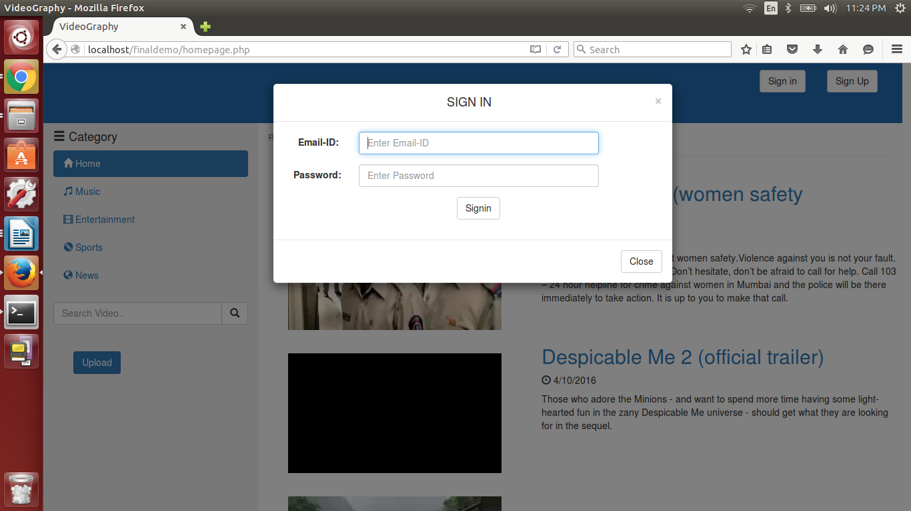

Sign Up:

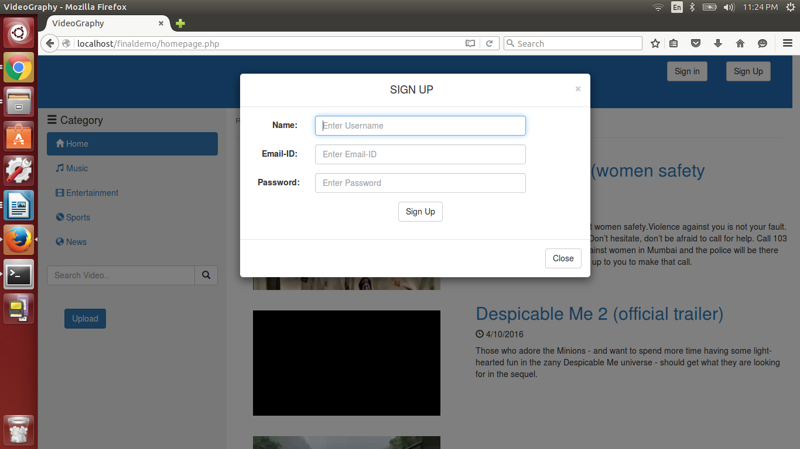

7
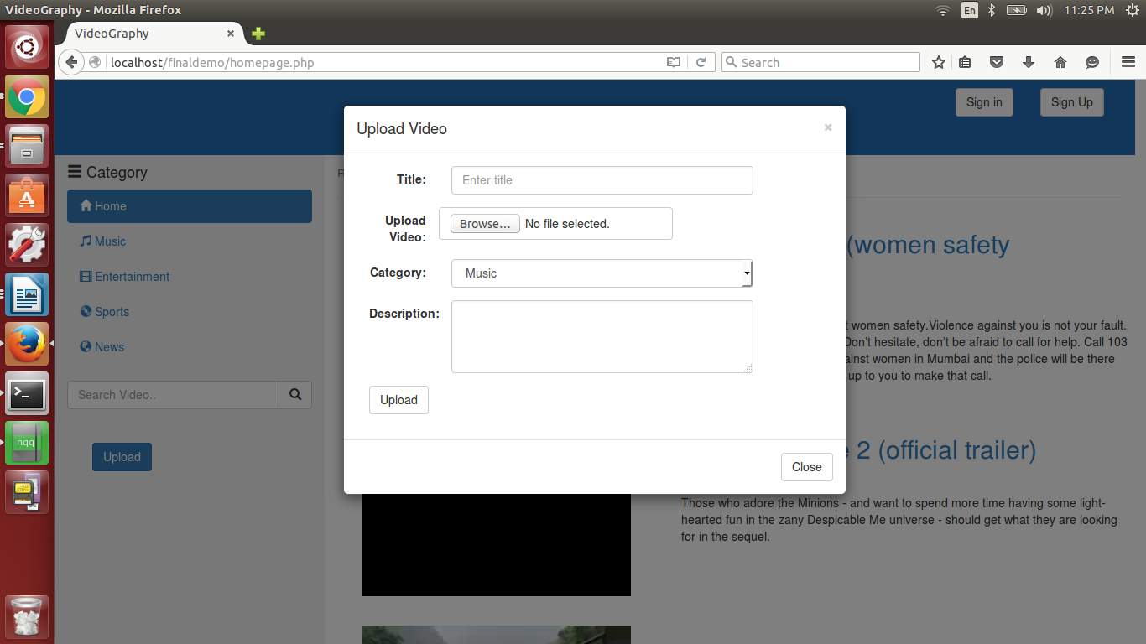
Upload Video:

Update:
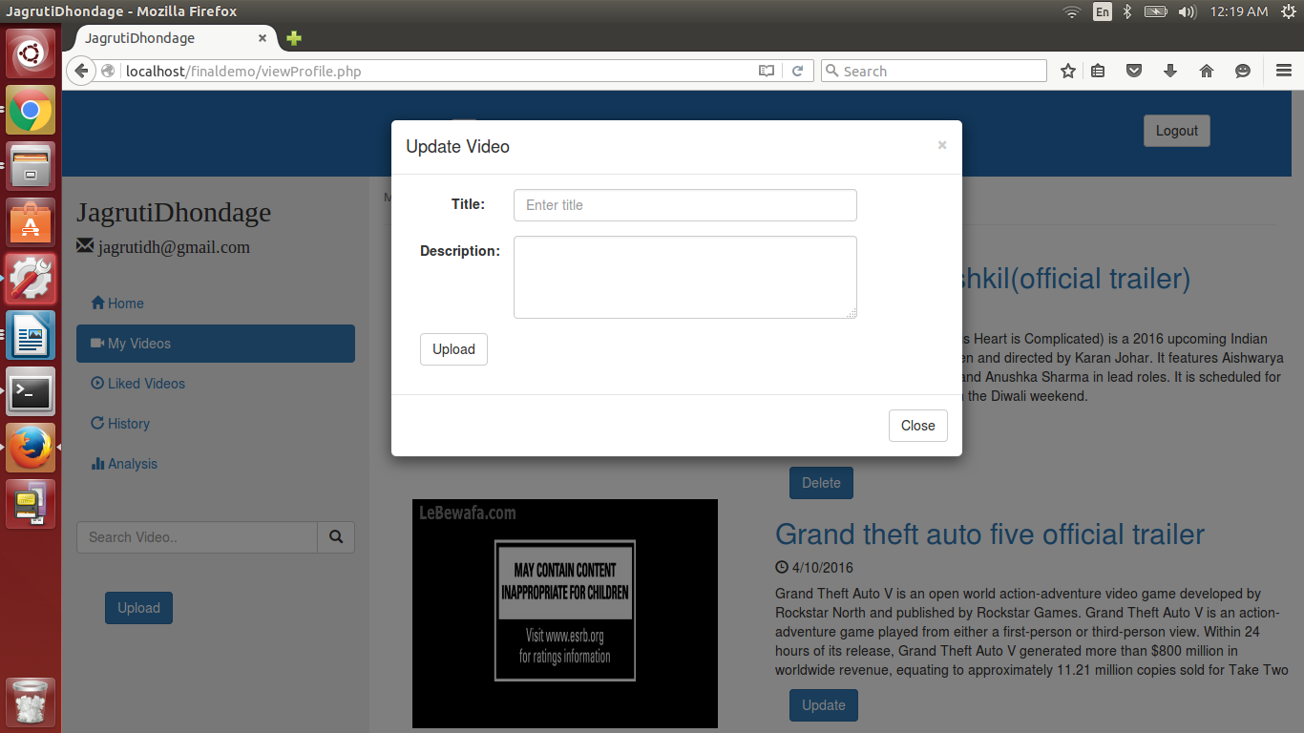
8
Chapter 7
Screenshots
Homepage:
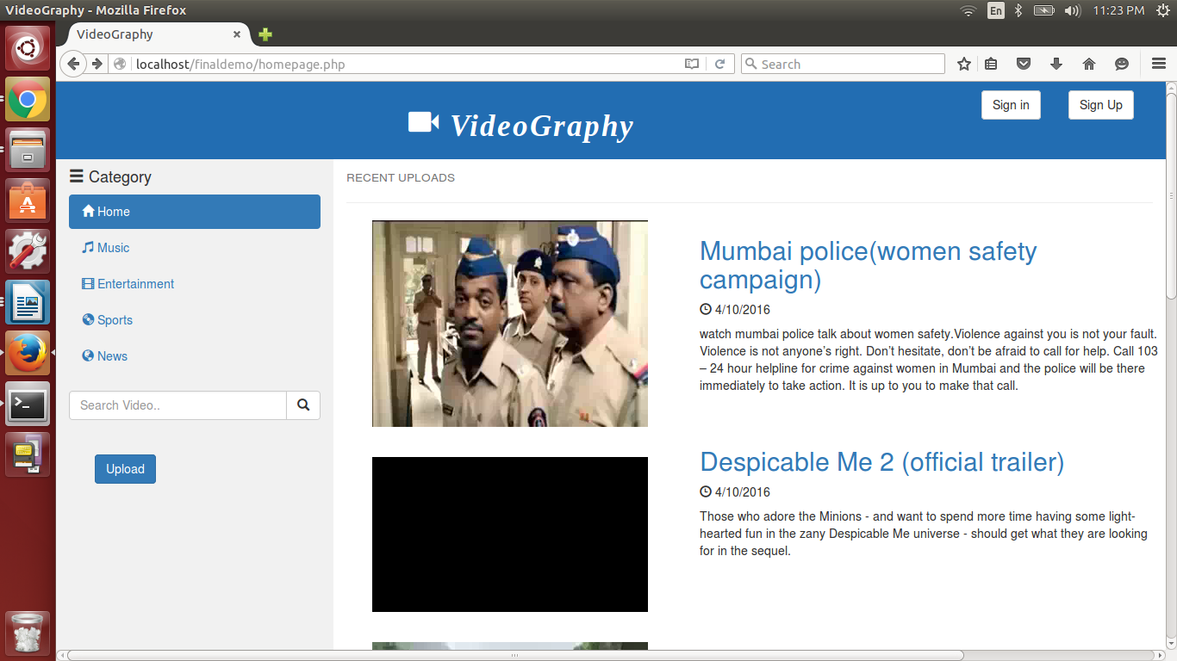

Search:

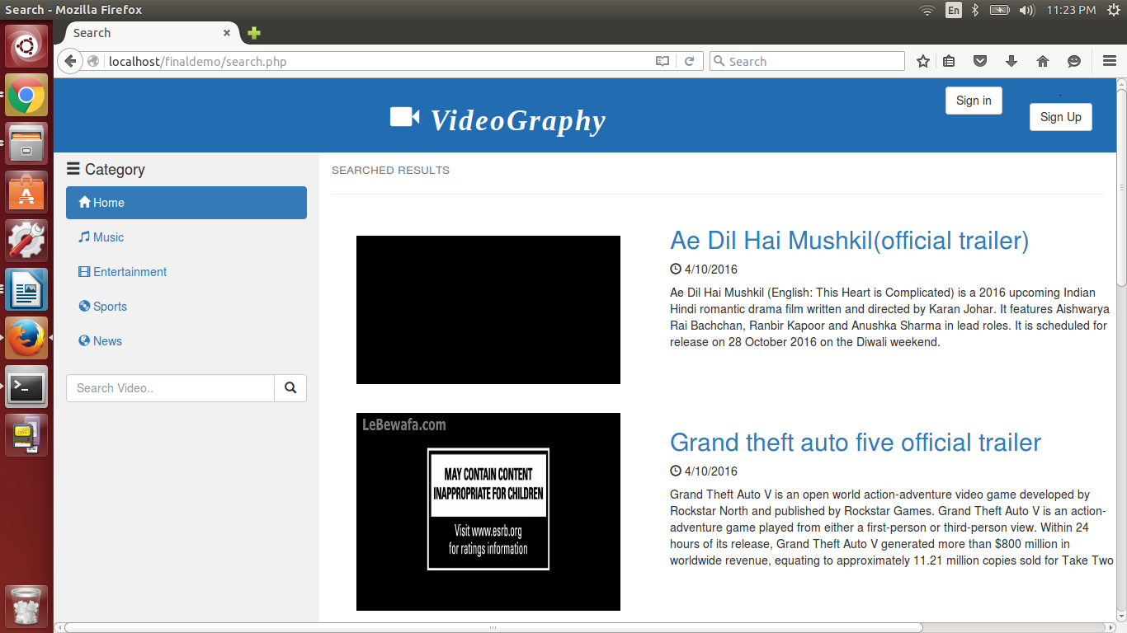

9
View Video:
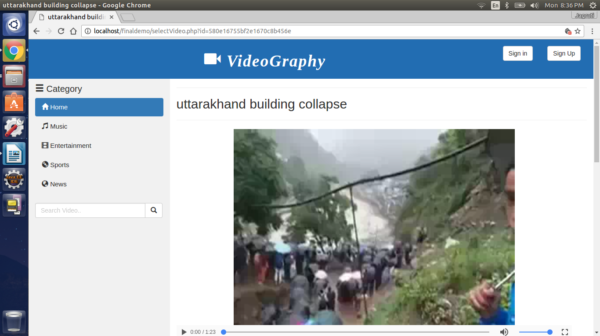

View Video (before Login):
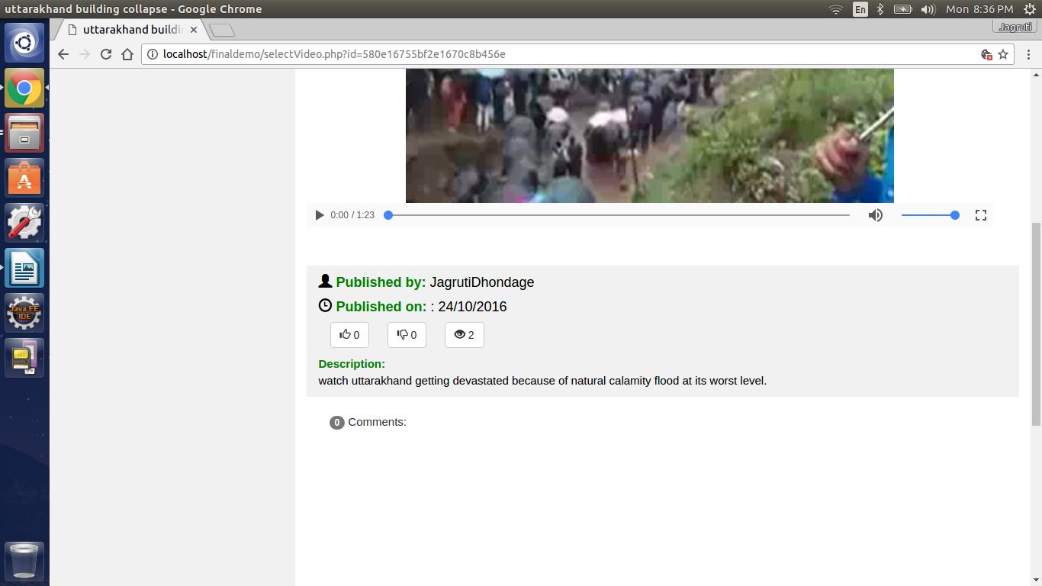
10

View video(after Login):
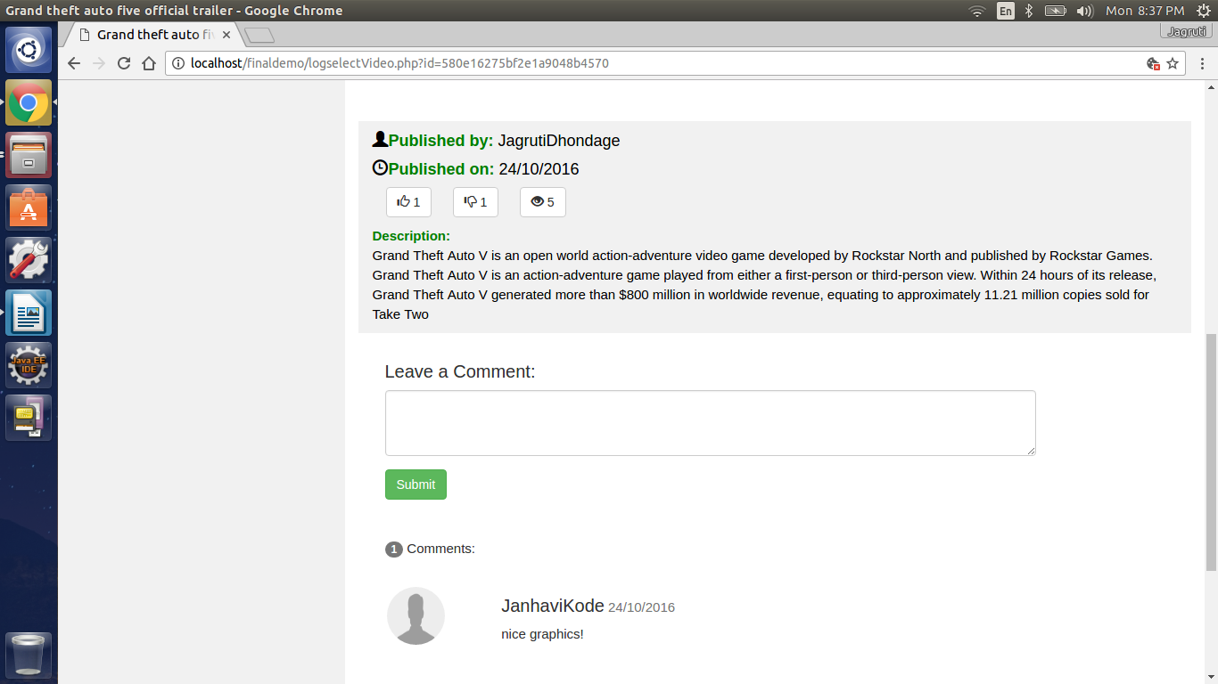

Logged homepage:

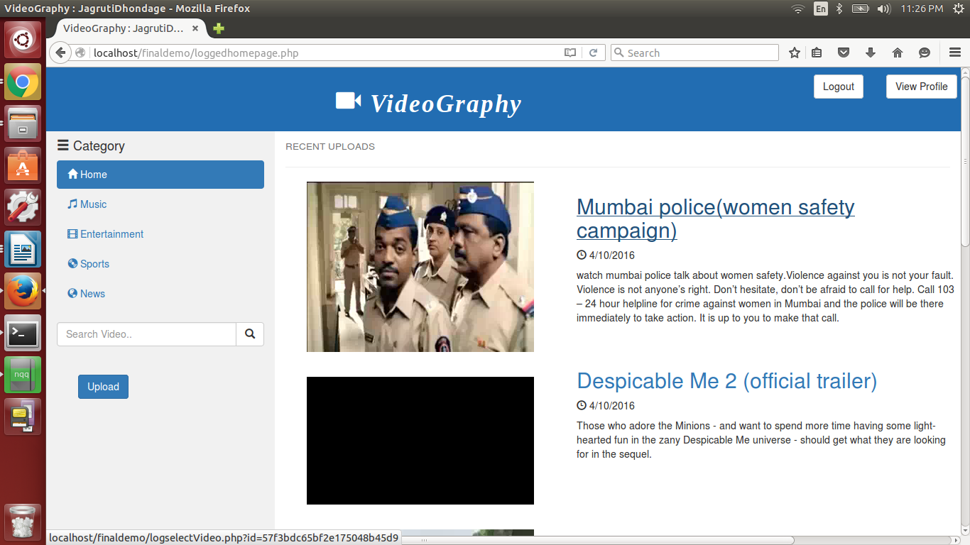

11
Profile view:

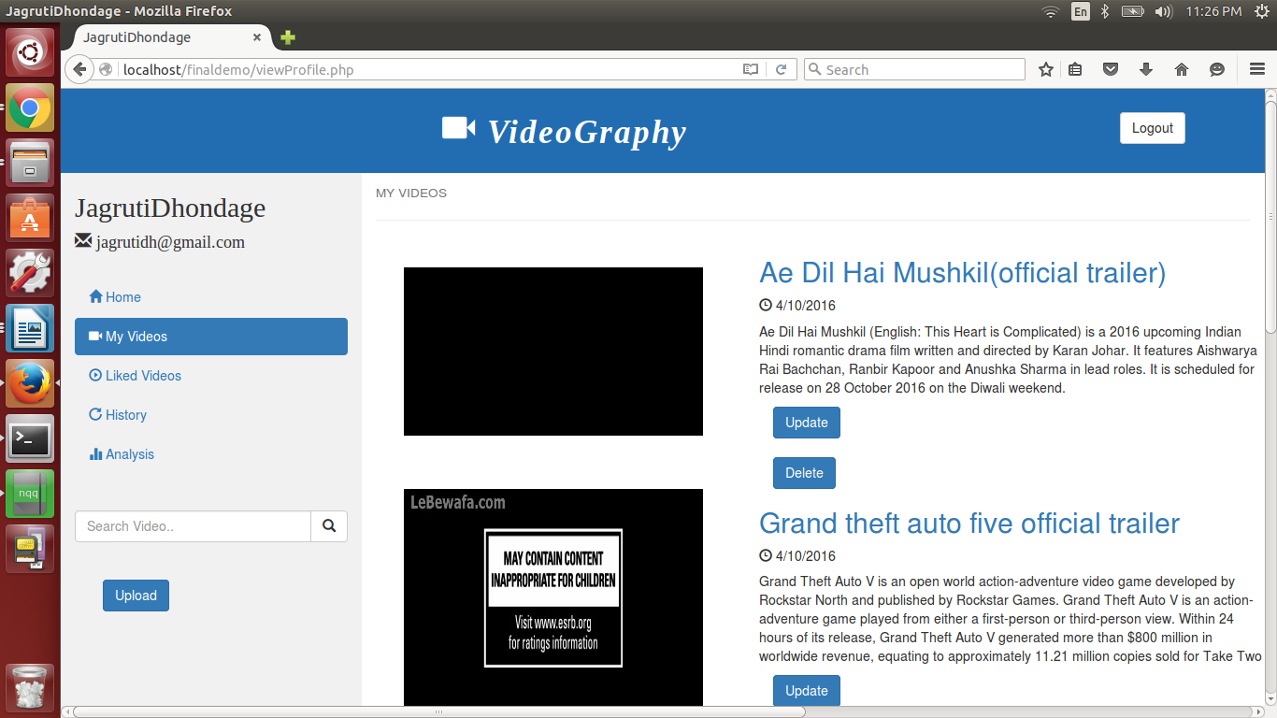

Analysis:

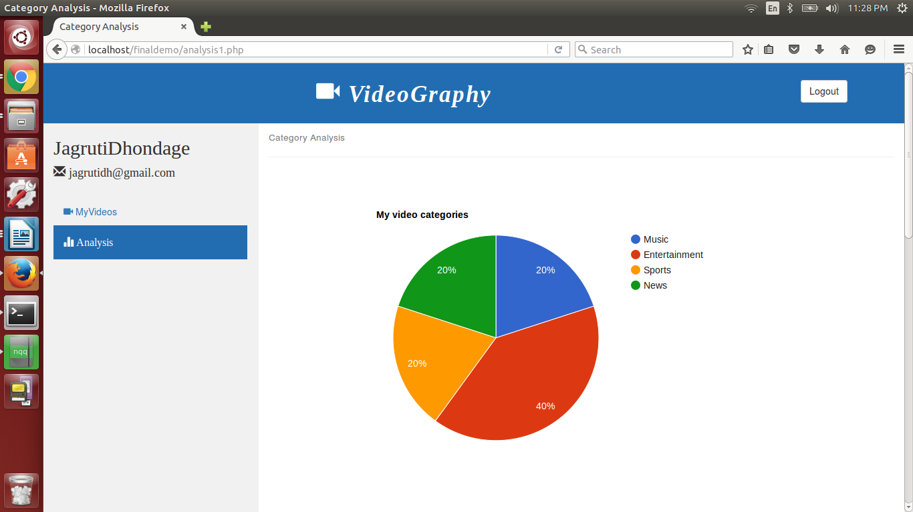

11
Chapter 8
Features

• Easy user interface
• Upload videos
• Delete videos
• Better streaming
• Edit Title and Description of video
• Like and Dislike video
• Comments
• Views of video
• User profile
• Analysis according to categories of video
• View liked videos
• View viewed Videos
• Search by Name or Title of video
• mp4, ogv, webm format support

12
Chapter 9
Conclusion

With all the accumulated efforts invested in VideoGraphy, there are reasons to believe that at the end of the project ‘offline video streaming’ is quite attainable. We summarize the progress with respect to the main objectives of the project, namely, Offline video streaming, Definitive website, Easy to handle profile .

- Offline video streaming:
This was the major obstacle in the accomplishment of this project, which was solved using MongoDB and its Gridfs feature that handles large size videos.
- Definitive website:
This term means achieving a content specific noncomplex website. A proper use of HTML and CSS helped us achieve this goal.
- Easy to handle profile:
The pleasant interface of VideoGraphy and features provided to the users makes it very easy to handle user profiles. Logs and analysis of users activities thus play a key role.
Hence we have completed the mini-project in Database Management Systems proposed by us. We have made use of MongoDB and PHP platform for the server side scripting and HTML,CSS for the client side scripting respectively. Designing this projects has also given us professional experience in the fields related to DBMS and Web Engineering Technology.

13
Chapter 10
References

- INTERNET
Websites:
1. www.tutorialspoint.com
2. www.w3schools.com
3. www.stackoverflow.com
4. www.mongodb.org
5.www.compose.com/mongodb
6.https://php.net
7.www.codecademy.com

14

