State University of New York at New Paltz

Jagruti Mohan Mohite

REPORT

for

FIELDWORK

Instructor: professor Hanh Pham

Summer 2019

Table of contents

1. Introduction

2. The company

3. My Task

4. System/ Software description

4.1. Architecture

4.2. Protocols

5. Test Results

6. Learning Outcomes

7. Conclusion

Report: Summer Internship

Place: One Epic Place

Project: one epic place website Extension

Introduction:

This summer internship teaches all about web designing and development. Goal for internship was to get more in-detail knowledge about how the websites are get designed and developed in corporate environment. Main motivation is to learn how to create more responsive website in real world. I got this inspiration from “web server programming” course, from this course I started developing a interested in this field and one epic place website extension had given me a chance to adapt the new skills in development.

The Company:

*One EPIC Place* is an affordable, collaborative workspace, providing local businesses a flexible location and supportive community to grow their business or practice, no matter what stage of growth they are in.  We have shared workspaces, private offices and treatment rooms, workshop/conference rooms, a kitchen, studio, and a creative and fun atmosphere all under one roof offering flexible and endless opportunities for local entrepreneurs.

*One EPIC Place* is much more than just a space to rent or work occasionally. Our collaborative environment is overflowing with the resources, inspiration, and structure needed to be a successful entrepreneur. We support and guide our members, promote their businesses, offer sources for networking and growth, hold workshops and meetings for support, serve as accountability partners, provide the necessary tools they need for them and their businesses. We offer solopreneurs the infrastructure to grow their business and the ability to tap into the resources in their community.

My Task:

My task was to design whole user-friendly responsive website and connect it to the backend/ server. This website is only for the one epic place members.

System/Software Description:

The One EPIC Place Scheduling Web Application is a web-based scheduler to help both the clients and the staff. The clients can use the application to view a schedule to see the availability of locations and to rent rooms from the business using a friendly intuitive interface. The staff can use the application to manage the rented locations by holding administrator privileges allowing for editing and removal of client made bookings. The application also serves as a data analysis platform to view data on the clients, locations, and provided resources that they are renting to help price the services and better accommodate the clients.

* Allows users to interact with the application API with restricted privileges:
  + View the renting availability.
  + Book locations at available times.
  + View offered accommodations (locations and resources).
* Let staff hold administrator level privileges in the site letting them:
  + Create accounts.
  + View the renting availability.
  + View and edit booking data with sorting functions.
  + View and edit client accounts.
  + View and edit offered accommodations (locations and resources).

This Scheduling Application is being made as a competitor against YArooms, another web-based scheduler that holds many of the same features as this application but does not have as many data analytic features as this application. This application has business tailored features such as allowing clients to list the noise level of their meeting as well making it a more suitable choice for the business.

Design1:

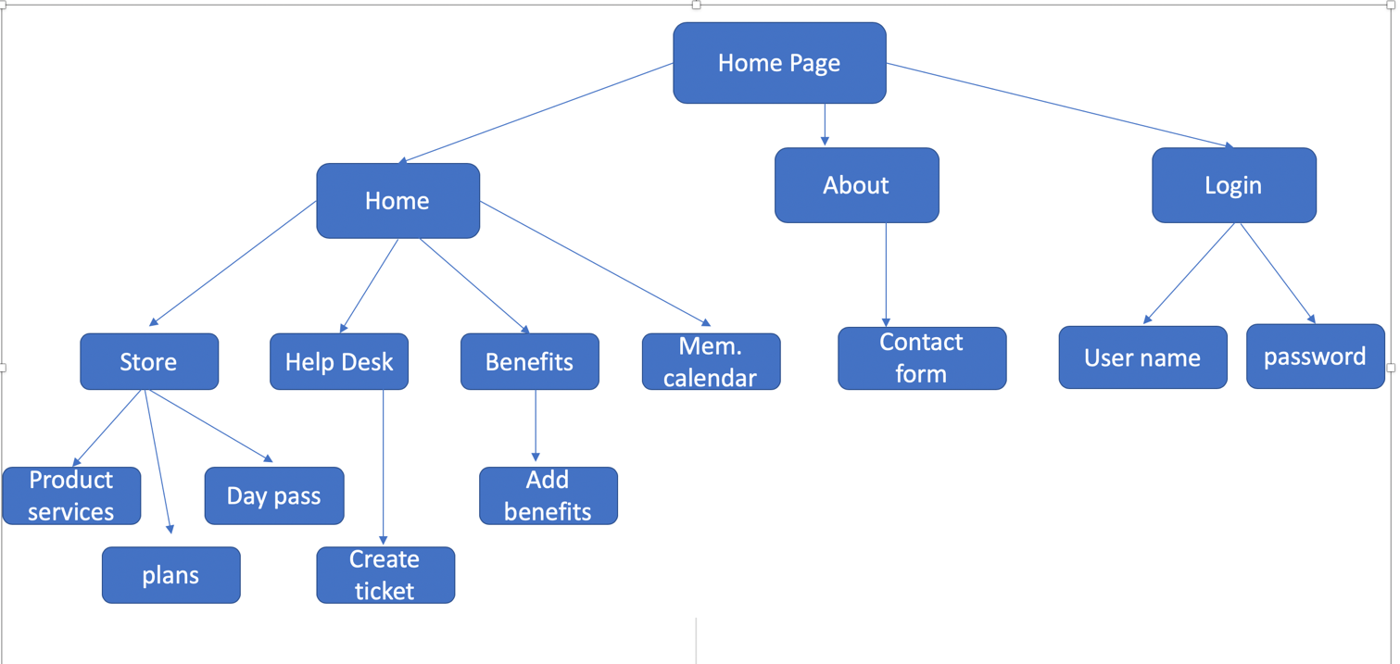

Diagram 2:

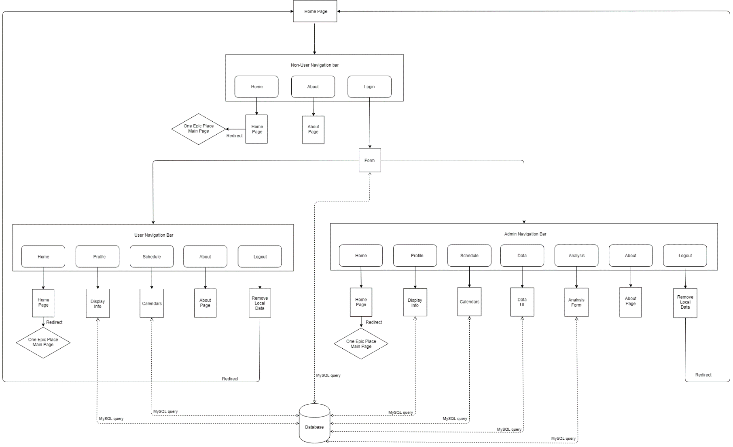

**Tech**

Application:

* HTML – Used to structure the web pages.
* CSS – Used to style the HTML.
* Bootstrap – Used to style Front end
* JavaScript – Used to make the pages interactive.
* Vue – Used to structure the JavaScript.
* Express – A JavaScript backend framework to run on a server that accepts requests and responds back to allow the API to interact with the server to interact with the database.
* Node – A runtime to run the Express.js framework inside of.
* MySQL – Used to statically store information for later reference.

Cloud Server (LEMP Stack):

* Linux – Operating system to manage the hardware and to run the other software.
* Nginx – A web server that is run to host the application.
* MySQL – A relational database management database system.
* PHP – A general purpose programming language installed to allow installed software to compile.
* phpMyAdmin – A PHP based UI to assist in interacting with the MySQL Database.

**Working**

Application:

1. Front End : It is responsive web designing using bootstrap and vue. This project includes the following pages :
   1. Home
   2. About
   3. Login – Users and Admin
   4. Store
   5. Help desk
   6. Benefits
   7. Members calendar
2. Home page: It has header, banner, cards, introduction about one epic place, testimonials, live chat, footer.
3. About page: It gives the more in-detail information about one epic place, who they are, what there company is about. It is design with the jumbotron concept in bootstrap. It also Include the contact form
4. Login – This page helps to login both user and admin
5. Store – In this user can access the public store, get product and services, create there category. Also can take there plan (weekly, monthly, yearly), even user can have day passes as well to book their own space.
6. Help desk: can generate ticket, search the ticket, check status and assign to the person who can solve the ticket.
7. Benefits: User can add benefits using a form and display all the benefits on the page.
8. Members calendar: Is gives the upcoming or all the events throughout the year.
9. Back end: It uses the Mysql to create a user database, which include the user details.
10. Connectivity: Connectivity is done using node and express.

Test Results:

As this project is very big, there are some changes on which I am currently working right now. This project is currently work in progress.

Things that are completed:

Home:

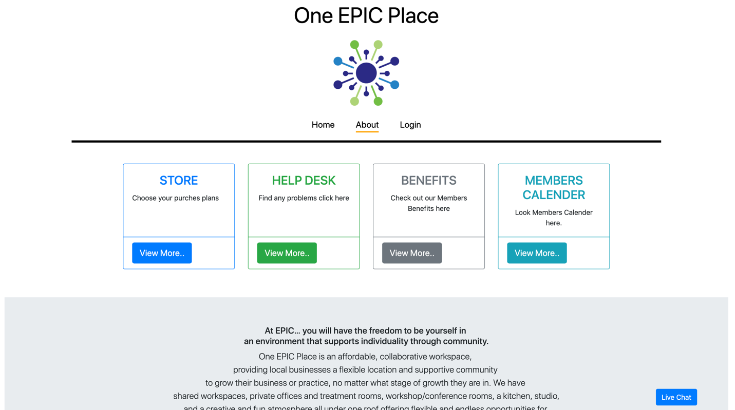

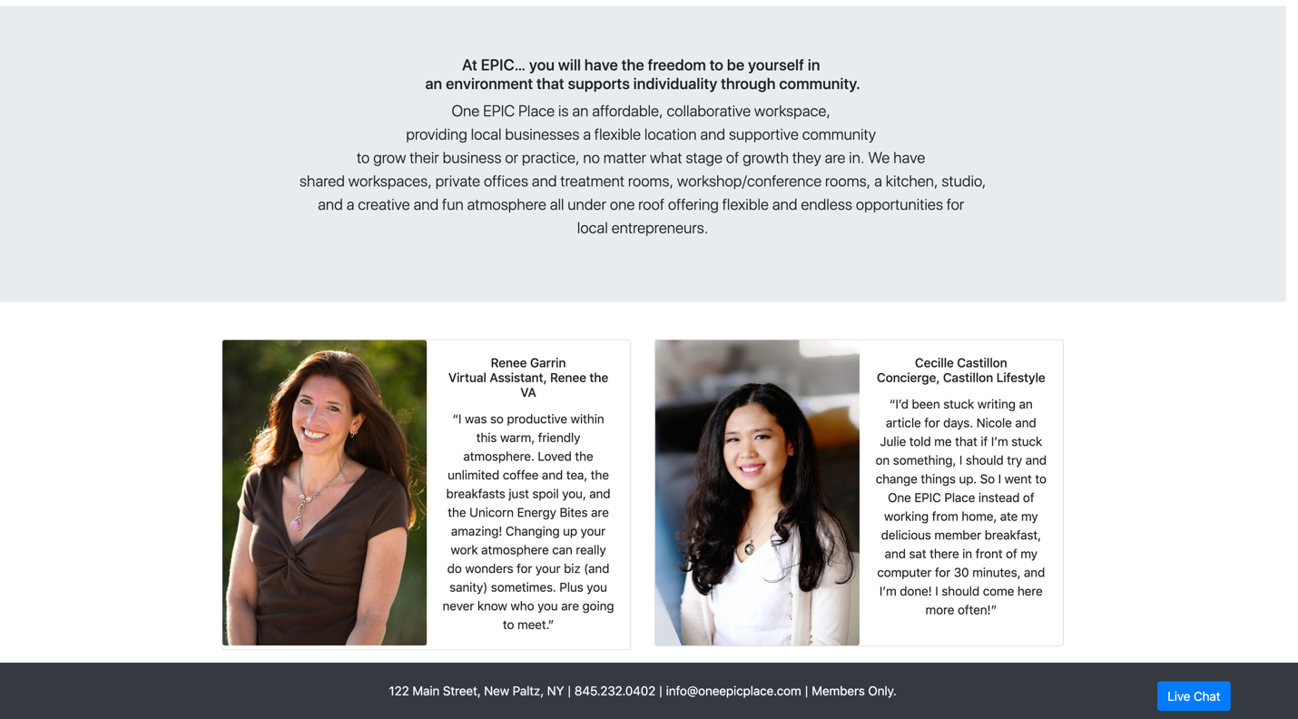

About:

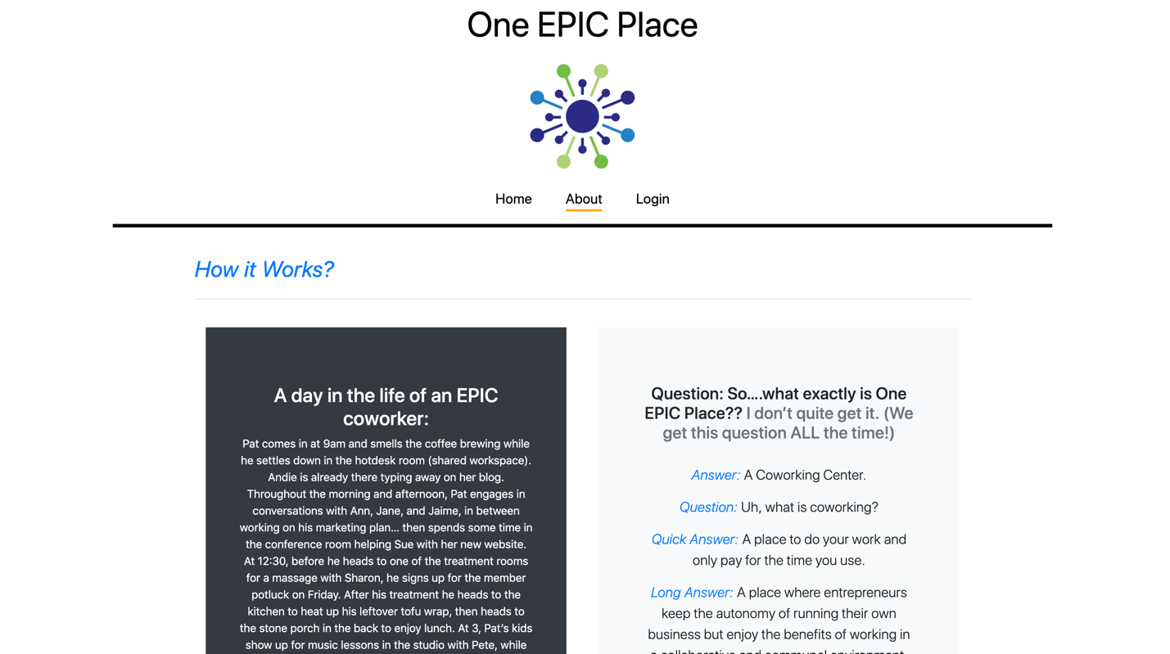

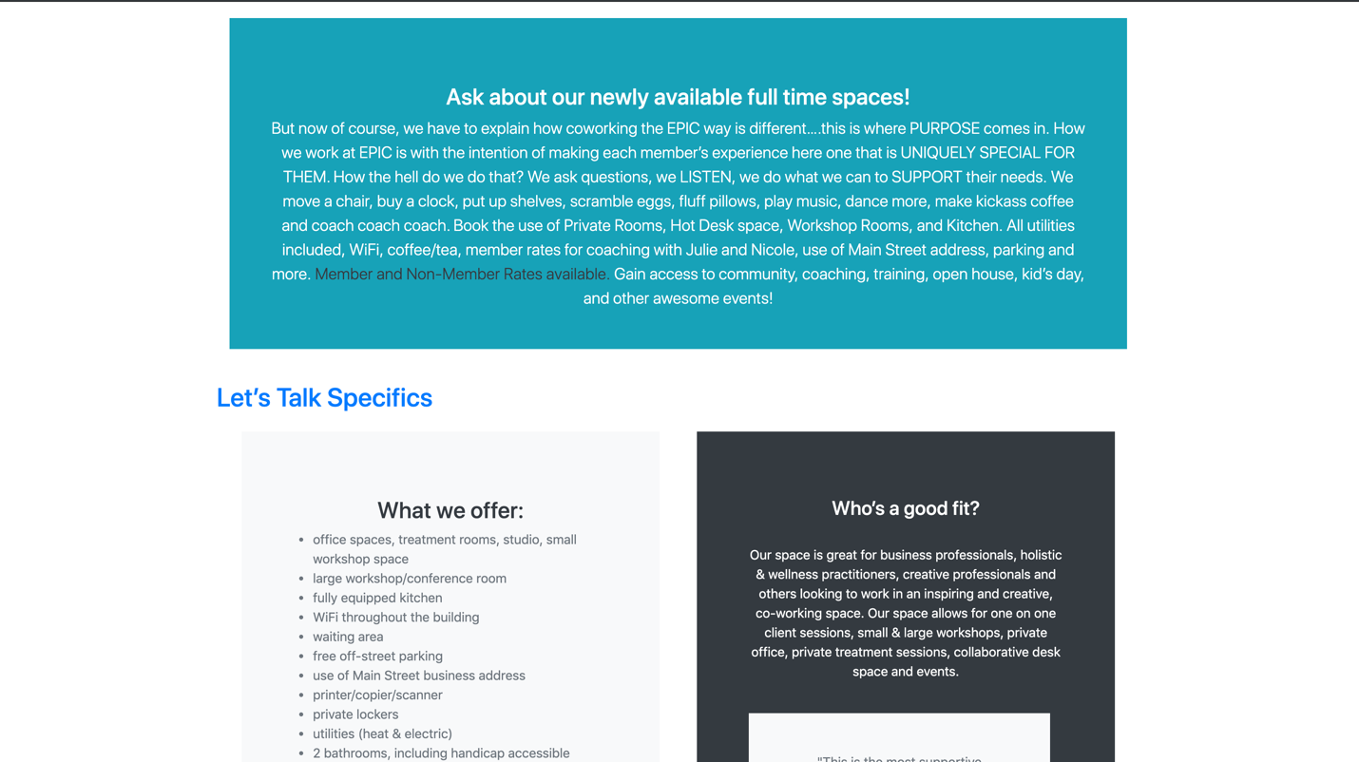

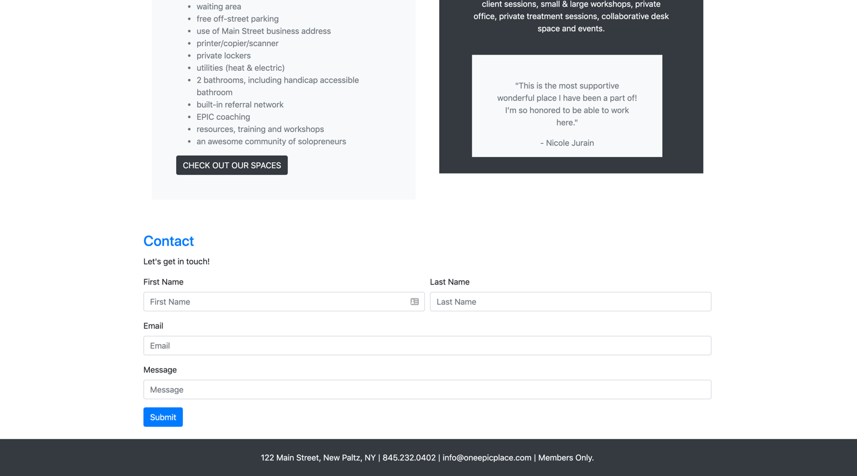

Login

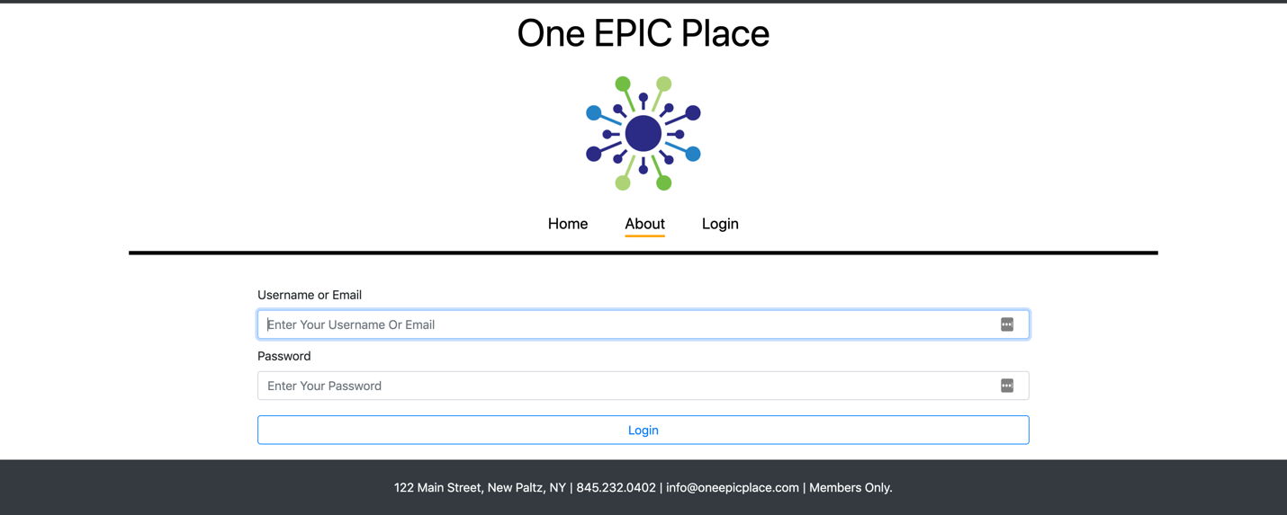

Store:

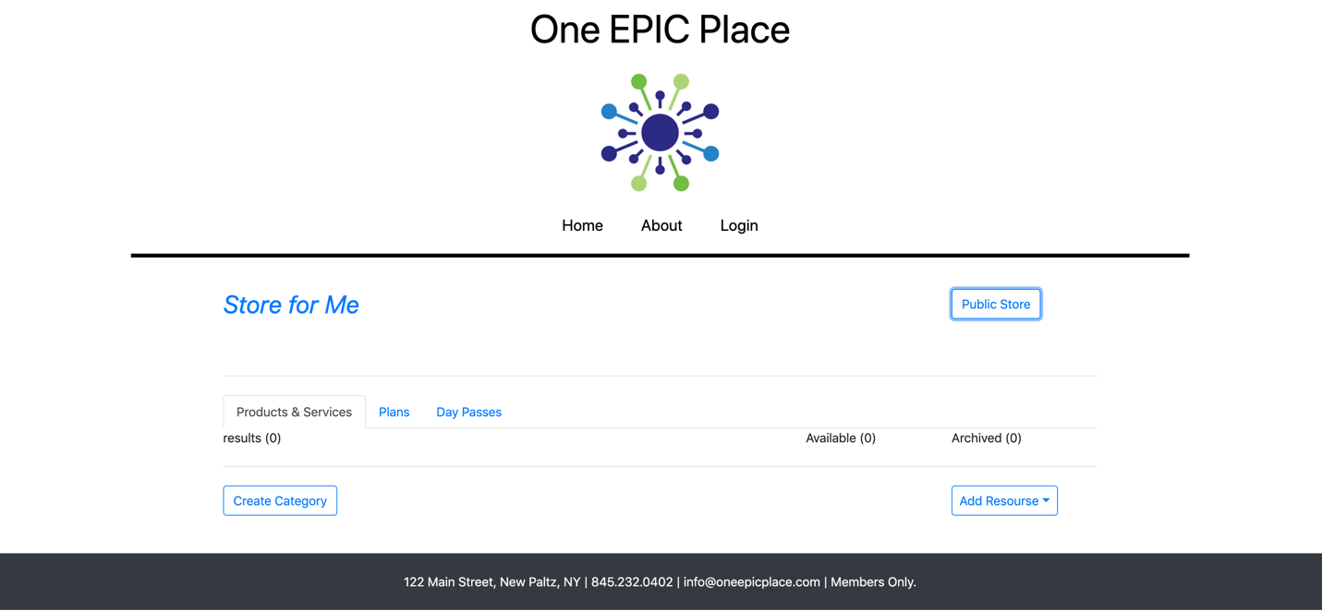

Help Desk:

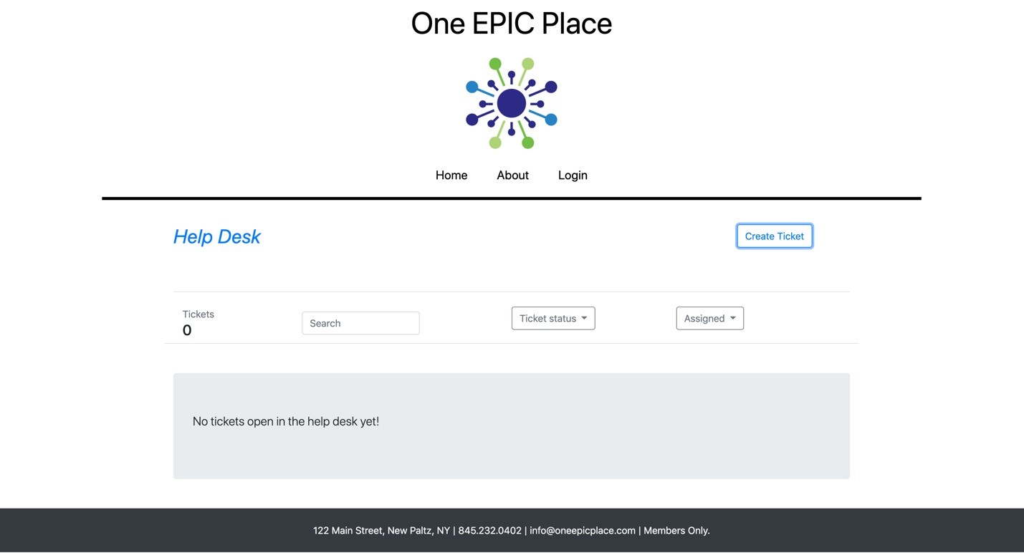

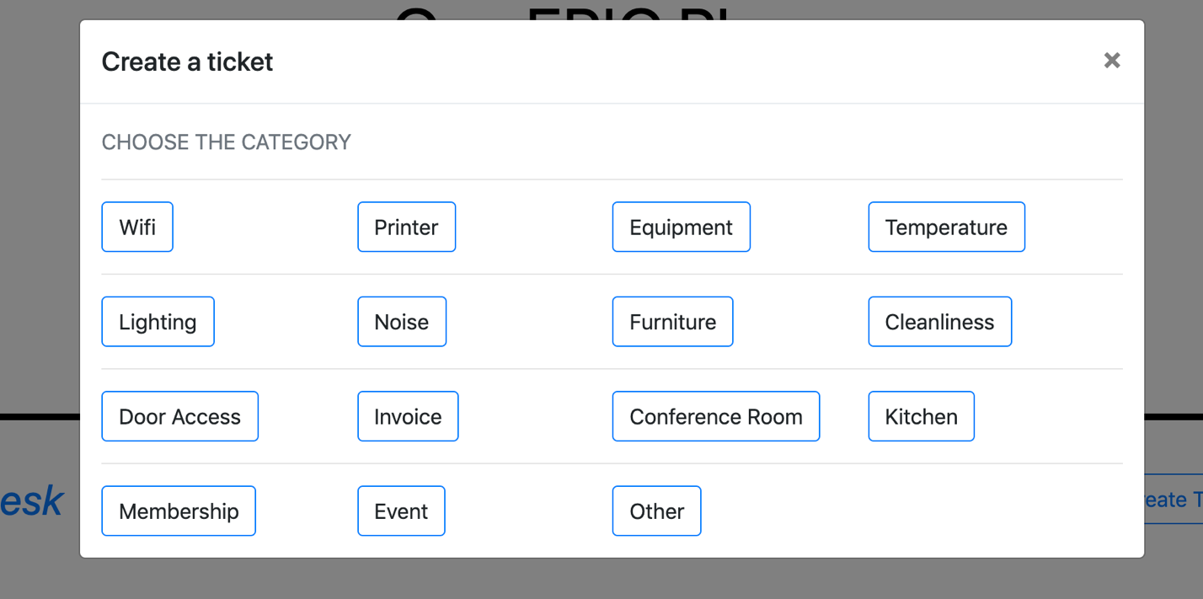

Benefits:

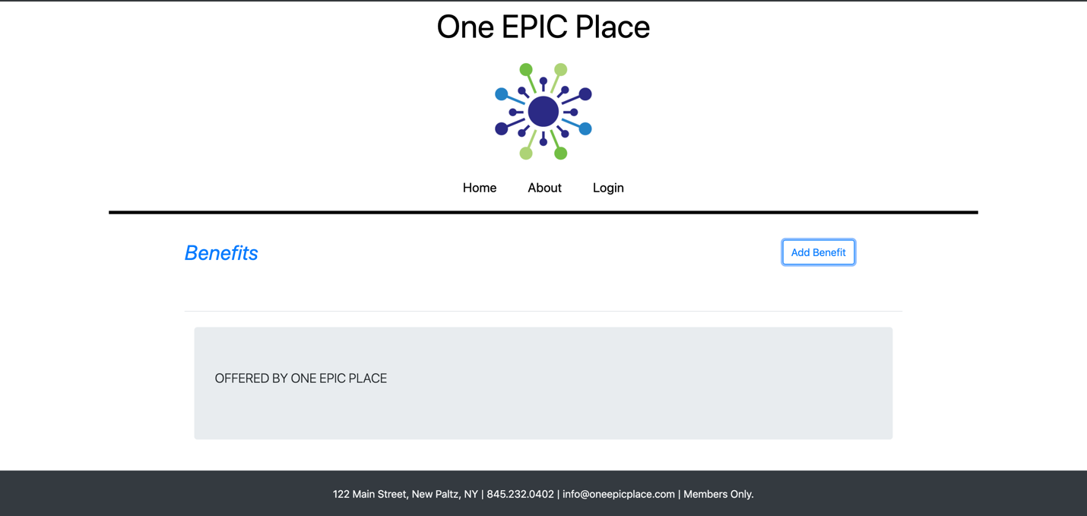

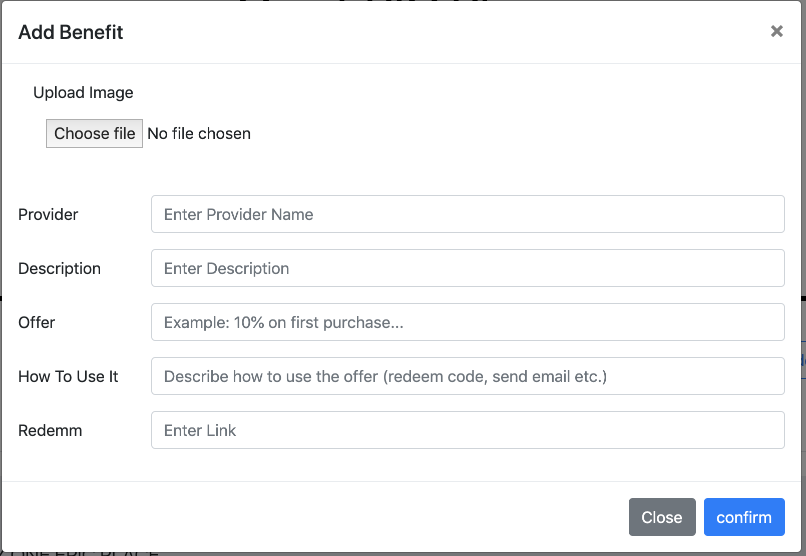

Members Calendar:

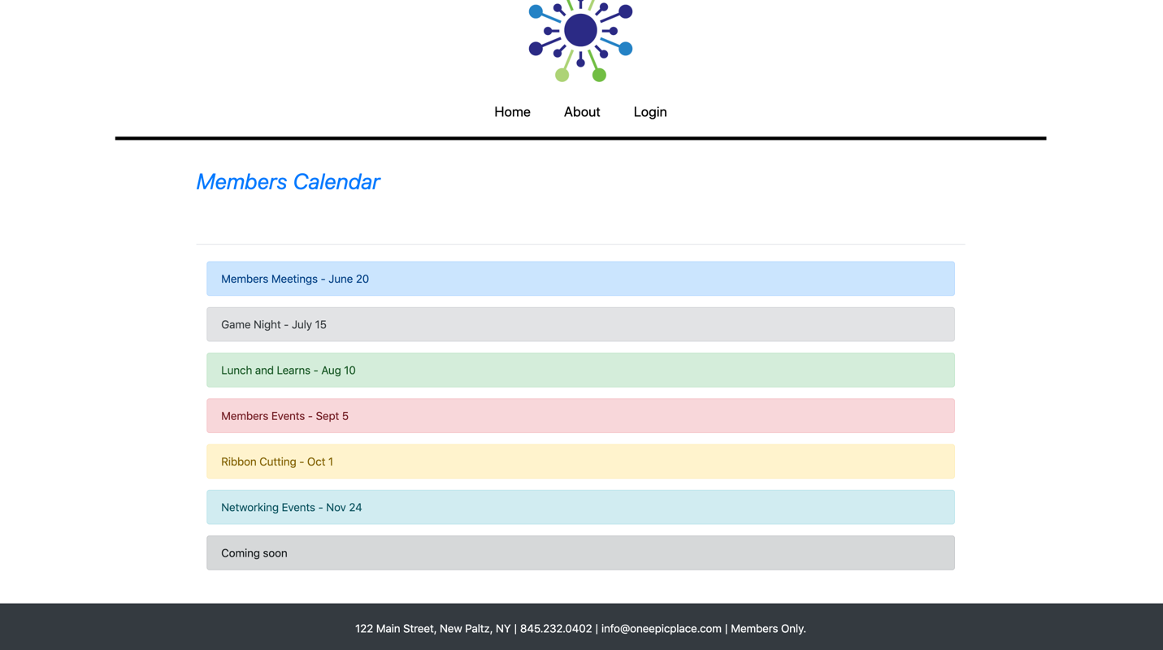

There are some modules which are work under process as this is the big project and still there are some changes on which I am working now

Project 2: IOS app for same site - As if now they have decided to complete website first and then if there is any time left then they are going to start working on this project.

Learning Outcomes:

Learned about how exactly whole process work which includes front end back end and connectivity. I got more knowledge about bootstrap, express, node during the project.

Conclusion:

To conclude, it is responsive web-based scheduler to help both the clients and the staff to find their own free space using one epic extension.