**ML Assignments 1**

**Name:** Jagruti Ravindra Patil

**Roll No:** 2089

**Batch:** S4 Comp

**Assignment 1:**

**Code:**

section .data

msg1 db 10,13,"Enter 5 64 bit numbers"

len1 equ $-msg1

msg2 db 10,13,"Entered 5 64 bit numbers"

len2 equ $-msg2

section .bss

array resd 200

counter resb 1

section .text

global _start

_start:

;display

mov Rax,1

mov Rdi,1

mov Rsi,msg1

mov Rdx,len1

syscall

;accept

mov byte[counter],05

mov rbx,00

loop1:

mov rax,0 ; 0 for read

mov rdi,0 ; 0 for keyboard

mov rsi, array

add rsi,rbx

mov rdx,17

syscall

add rbx,17

dec byte[counter]

JNZ loop1

mov Rax,1

mov Rdi,1

mov Rsi,msg2

mov Rdx,len2

syscall

mov byte[counter],05

mov rbx,00

loop2:

mov rax,1

mov rdi, 1

mov rsi, array

add rsi,rbx

mov rdx,17 ;16 bit +1 for enter

syscall

add rbx,17

dec byte[counter]

JNZ loop2

system call

mov rax ,60

mov rdi,0

syscall

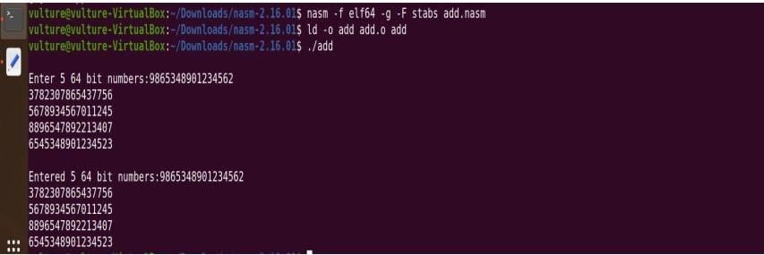**Output:**