**ML Assignment**

**Name:** Jagruti Ravindra Patil

**Roll No:** 2089

**Batch:** S4 Comp

**Assignment 2:**

**Code:**

%macro scall 4

mov rax,%1

mov rdi,%2

mov rsi,%3

mov rdx,%4

syscall

%endmacro

section .data

m1 db 10d,13d,"Enter a string: " l1 equ $-m1

m2 db 10d,13d,"Entered String: " l2 equ $-m2

m3 db 10d,13d,"Length: " l3 equ $-m3

section .bss

buffer resb 50

size equ $-buffer

count resd 1

dispnum resb 16

section .text

global _start

_start:

scall 1,1,m1,l1

scall 0,0,buffer,size mov [count],rax

scall 1,1,m2,l2 scall 1,1,buffer,[count] scall 1,1,m3,l3

mov rsi,dispnum+15 mov rax,[count] mov rcx,16

dec rax

UP1:

mov rdx,0

mov rbx,10

div rbx

add dl,30h

mov [rsi],dl

dec rsi

loop UP1

scall 1,1,dispnum,16

mov rax,60

mov rbx,0

syscall

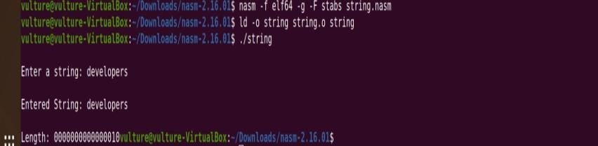**Output:**