**ML Assignment**

**Name:** Jagruti Ravindra Patil

**Roll No:** 2089

**Batch:** S4 Comp

**Assignment 6:**

**Code:**

Section .data

Msg1 db “Count of Positive numbers:”

Len1 equ $ - msg1

Msg2 db “Count of negative numbers:”

Len2 equ $ - msg2

Array db 10, 12, -21, -12, -19, -34, 41

%macro print 2

Mov rax, 1

Mov rdi, 1

Mov rsi, %1

Mov rdx, %2

Syscall

%endmacro

Section .bss

Count resb 2

Pcount resb 2

Ncount resb 2

Totalcount resb 2

Section .text

Global _start

_start:

Mov byte [count], 07

Mov byte [pcount], 00

Mov byte [ncount], 00

Mov rsi, array

Up:

Mov al, 00

Add al, [rsi]

Js neg

Inc byte [pcount]

Jmp Down

Neg:

Inc byte [ncount]

Down:

Add rsi, 01

Dec byte [count]

Jnz Up

Mov bl, [pcount]

Mov dl, [ncount]

B1:

Print msg1, len1

Mov bh, [pcount]

Call disp

Print msg2, len2

Mov bh, [ncount]

Call disp

Mov rax, 60

Mov rdi, 00

Syscall

Disp:

Mov byte [count], 02

Loop:

Rol bh, 04

Mov al, bh

AND al, 0FH

Cmp al, 09

Jbe l1

Add al, 07h

L1:

Add al, 30h

Mov [totalcount], al

Print totalcount, 02

Dec byte [count]

Jnz loop

Ret

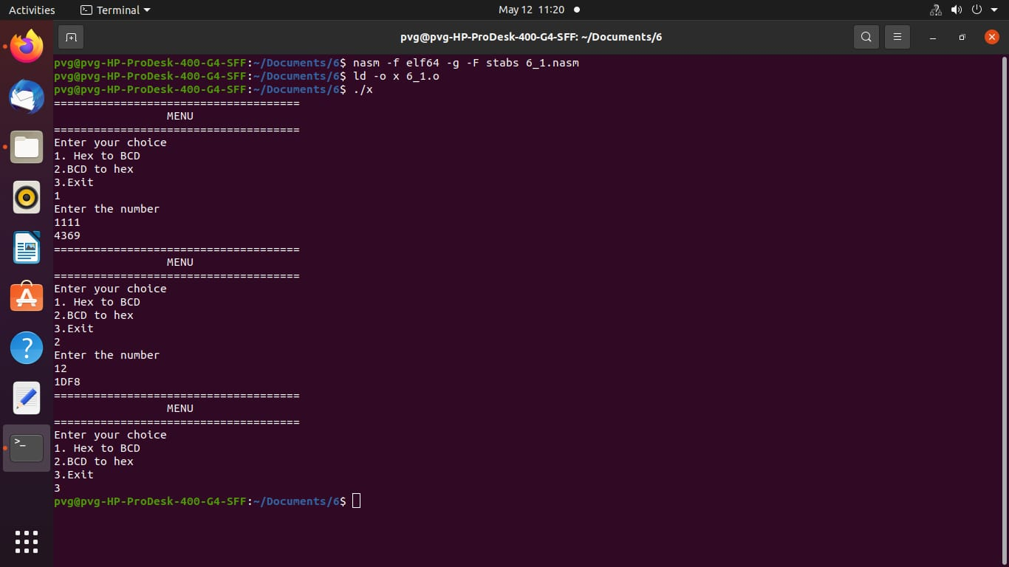**Output:**