**ML Assignments**

**Name:** Jagruti Ravindra Patil

**Roll No:** 2089

**Batch:** S4 Comp

**Assignment 8:**

**Code:**

%macro display 2

mov rax, 1

mov rdi, 1

mov rsi, %1

mov rdx, %2

syscall

%endm

global _start

section .data

arr db 11h, 22h, 33h, 44h, 55h, 66h

msg db "source array is:"

msg_len equ $ - msg

msg1 db "destination array is:"

msg1_len equ $ - msg1

section .bss

arr1 resb 6

arr_ascii resb 14h

arr1_ascii resb 14h

section .text

_start:

mov rsi, arr

mov rdi, arr1

mov cl, 06

up:

mov al, [rsi]

mov [rdi], al

inc rsi

inc rdi

dec cl

jnz up

display msg, msg_len

mov rsi, arr

mov rdi, arr_ascii

call print

display arr_ascii, 14h

display msg1, msg1_len

mov rdi, arr1_ascii

call print

display arr1_ascii, 14h

mov rax, 60

mov rdi, 0

syscall

print:

mov ch, 06

up2:

mov al, [rsi]

mov cl, 02

up1:

rol al, 4

mov bl, al

and al, 0fh

cmp al, 09

ja add37

add al, 30h

jmp dn2

add37:

add al, 37h

dn2:

mov [rdi], al

inc rdi

mov al, bl

dec cl

jnz up1

mov [rdi], byte ','

inc rdi

inc rsi

dec ch

jnz up2

ret

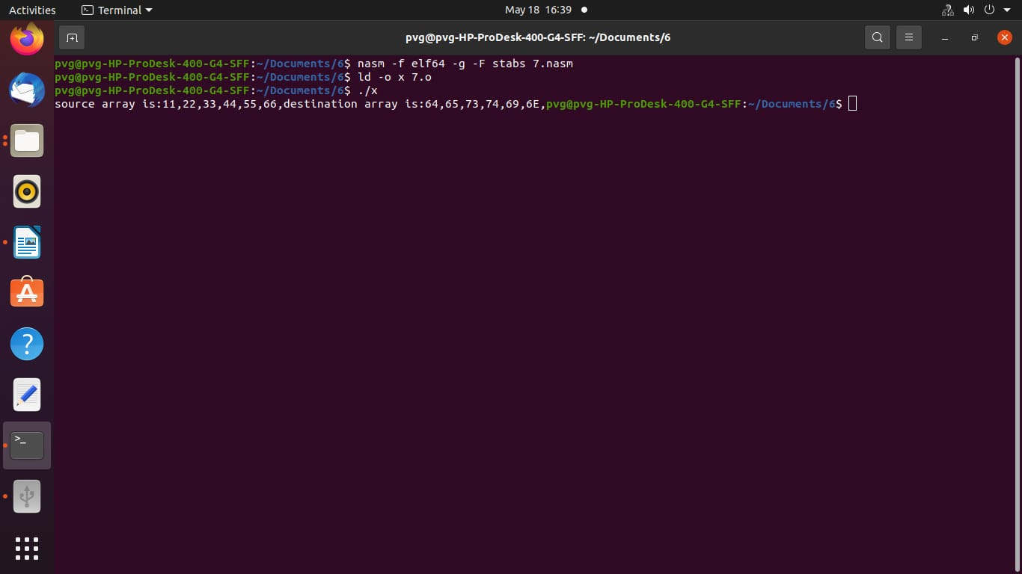**output:**