**ML Assignment**

**Name:** Akanksha Lokhande

**Roll No:** 2039

**Batch:** S4 Comp

**Assignment 9:**

**Code:**

%macro display 2

mov rax, 1

mov rdi, 1

mov rsi, %1

mov rdx, %2

syscall

%endmacro

%macro input 2

mov rax, 0

mov rdi, 0

mov rsi, %1

mov rdx, %2

syscall

%endmacro

global _start

section .data

arr db 11h, 22h, 33h, 44h, 55h, 66h

msg db 10, 13, "source array is:"

msg_len equ $-msg

msg1 db 10, 13, "destination array is:"

msg1_len equ $-msg1

msg2 db 10, 13, "how many overlap:"

msg2_len equ $-msg2

section .bss

arr1 resb 16H

ov resb 2

arr_ascii resb 14h

arr1_ascii resb 28h

section .text

_start:

display msg, msg_len

mov rsi, arr

mov rdi, arr_ascii

mov ch, 03

call print

display arr_ascii, 14h

display msg2, msg2_len

input ov, 2

sub byte [ov], 30h

mov rax, 00

mov al, [ov]

mov rsi, arr

mov rdi, 00

add rsi, 3

dec rsi

add rdi, rsi

add rdi, 3

sub rdi, rax

mov rcx, 03

STD

repz movsb

display msg1, msg1_len

mov rsi, arr

mov rdi, arr1_ascii

mov ch, 6

sub ch, [ov]

call print

display arr1_ascii, 28h

mov rax, 60

mov rdi, 0

syscall

print:

up2:

mov al, [rsi]

mov cl, 02

up1:

rol al, 4

mov bl, al

and al, 0fh

cmp al, 09

ja add37

add al, 30h

jmp dn2

add37:

add al, 37h

dn2:

mov [rdi], al

inc rdi

mov al, bl

dec cl

jnz up1

mov [rdi], byte ' '

inc rdi

inc rsi

dec ch

jnz up2

ret

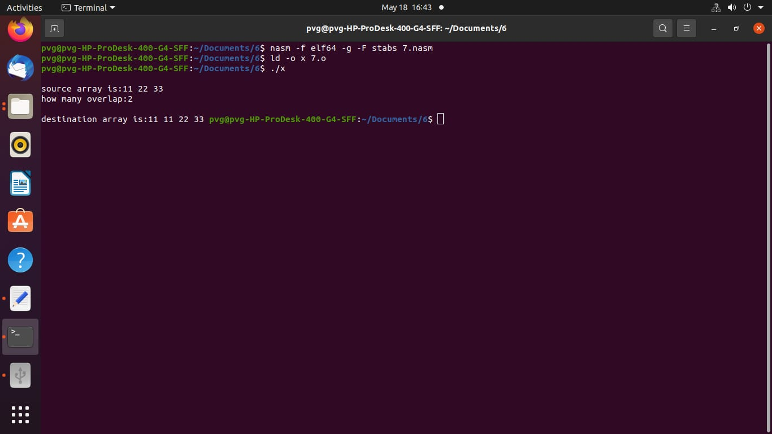**Output:**