**Hammurabi Installation**

Contents –

2 – Methodology

3 – Installation Tests

4 – IT 1 (Home computer run tests)

5 – IT 2 (Home computer uninstallation tests)

6 – IT 3 (Installation & uninstall on new computer via USB)

**Methodology**

For this installation test, A fresh install from a .exe setup file (created using the Visual Studio wizard) will be used to ensure a clean install of Hammurabi both installs and loads on the original machine. I will then perform a fresh installation on a different device from a USB stick, using the same .exe file.

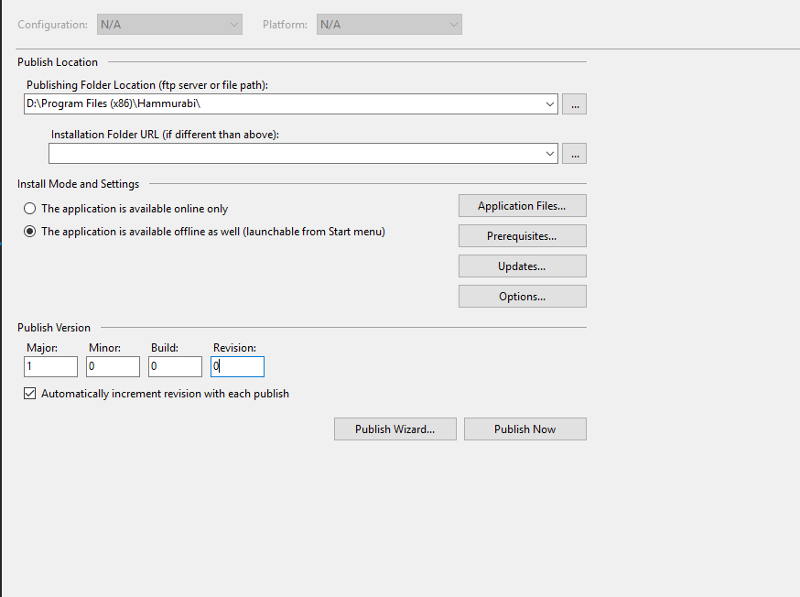

This is the setup for the publishing wizard in visual studio, which then resulted in the file below being created

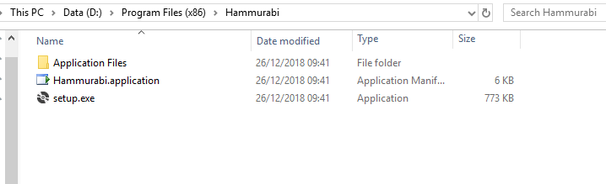

Installation tests

Tests how the programme installs, uninstalls, and runs

|  |  |  |  |  |  |
| --- | --- | --- | --- | --- | --- |
| Test number | Test | Method | Expected | Actual | Notes |
| IT 1 | Tests the programme installs on the home machine | Perform a ‘Publish’ In Visual Studio, check programme opens correctly on target device | Programme publishes and runs as intended | Programme runs as intended | Works as intended |
| IT 2 | Tests the programme uninstalls on home device | Run the ‘Uninstall’ function on windows | Programme de-installs with the windows function to do so | Programme uninstalls as intended | Works as intended |
| IT 3 | Test the programme installs from a USB on a different computer, and uninstalls | Save the application setup to a USB, test on a different computer | Programme executes a setup successfully, runs on target computer | Programme installs & uninstalls as intended | Works as intended |

**IT 1 – Test on home machine**

After ‘publishing’ the software on Visual studio, software was loaded on the home PC to ensure software run out of the debug scenario

Installation was a success on this PC, as noted with screenshots below

Files stored correctly in the PC memory

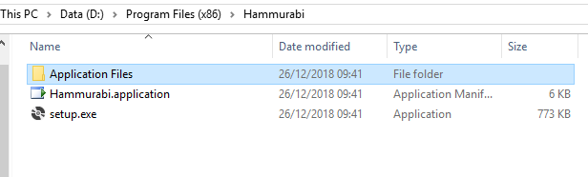

Icon is displayed for shortcut on target machine

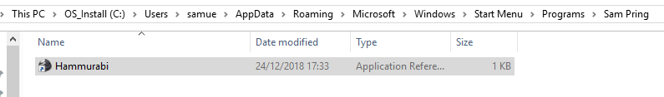

Below shot is the software running on the PC, including the task bar icon being set correctly.

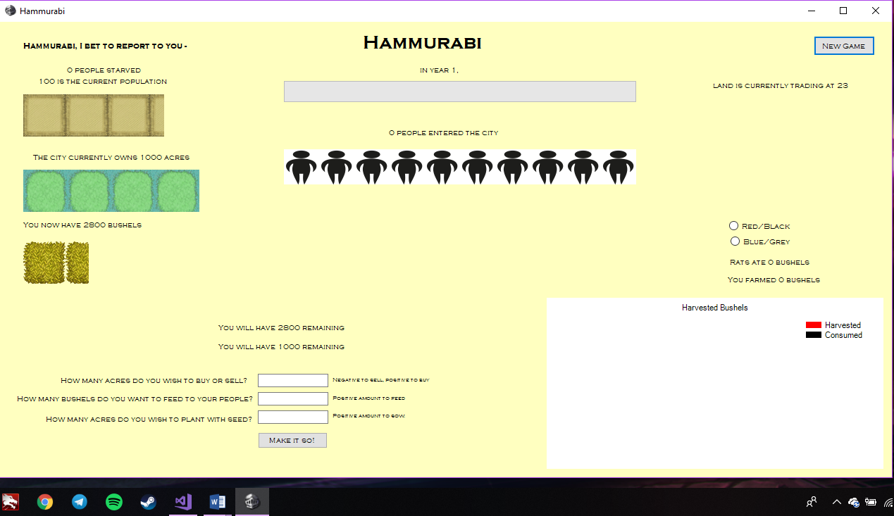

**IT 2 – De-installation on Home machine**

For this test, the windows uninstall procedure will be tested on the software to ensure a complete removal is actioned as intended

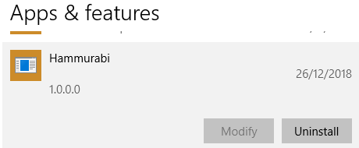

Simply clicking this should start the process

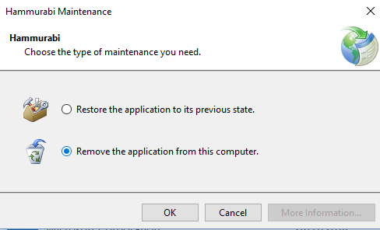

Maintenance message box is displayed by windows

Files were removed from proper storage

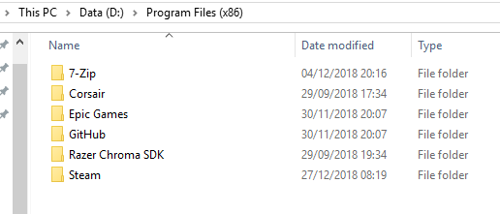

IT 3 – Testing the software on a different computer

First the publishing wizard needs to be adjusted to publish to the USB drive (F in this case)

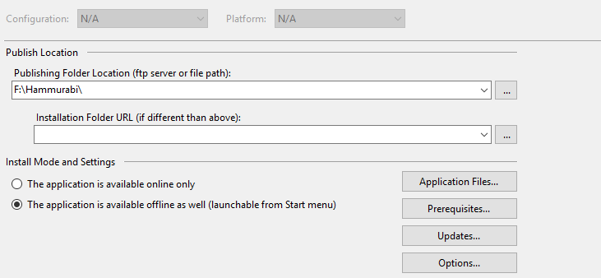

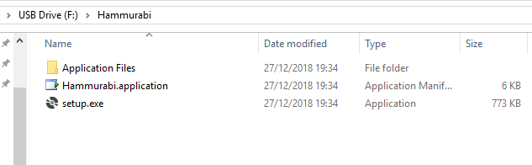

The device is ready to be used on another computer, with the correct files published into it by Visual Studio

The USB has been inserted into a new PC (Note the use of ‘H’ drive instead of ‘F’ drive, like was the case on the home pc)

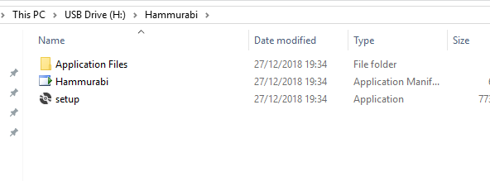

The install wizard that comes packaged with the application should install the software into the home computer’s memory

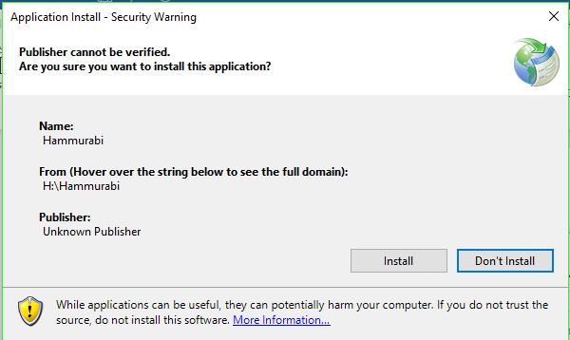

Installed successfully on the target machine, and running as intended

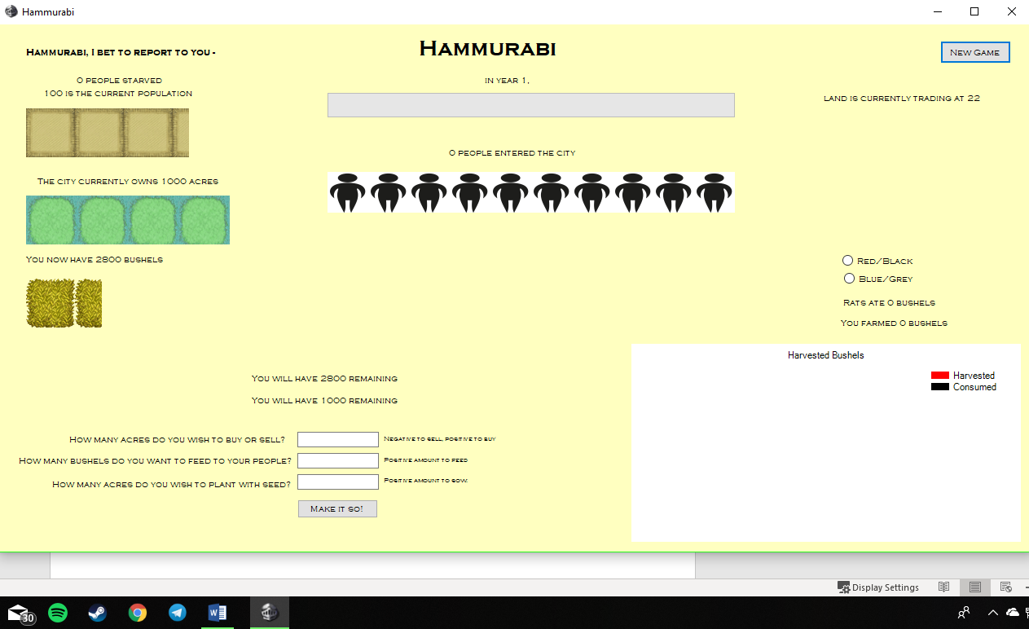

And the start shortcut showing as intended also

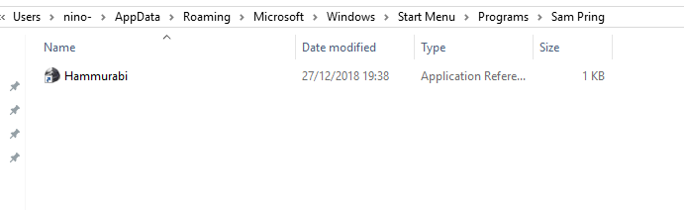

Further tests to ensure the program could read and write to the Scores.txt file were successful, as evident below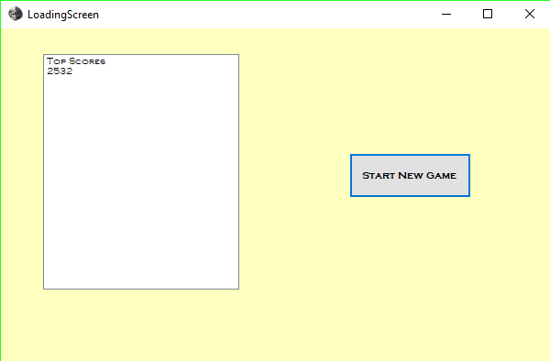

Uninstallation test –

Using the same method as IT 2, the uninstallation was processed by the wizard windows provides

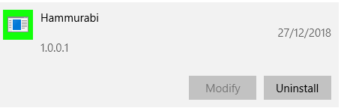

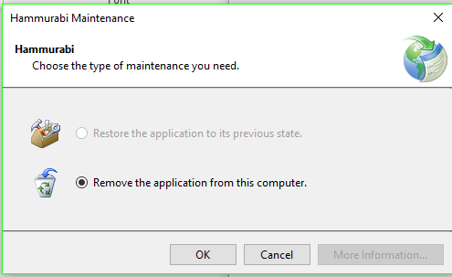

And below is evidence the files were removed, as intended

