*# Visualization of graph  
library*(readr)  
  
*# Read the csv file*crop_production<-*read.csv*("Crops.csv")  
*View*(crop_production)  
  
*# cr<-crop_production  
# summary(crop_production)  
# Calculate minimum production in dataset*cr<-crop_production  
min_value<-*min*(cr$Production,na.rm = TRUE)  
*print*(min_value)  
  
*# Calculate maximum production in dataset*max_value<-*max*(cr$Production,na.rm = TRUE)  
*print*(max_value)  
  
*# Claculate mean of production in dataset*mean_value<-*mean*(cr$Production,na.rm = TRUE)  
*print*(mean_value)  
  
*# To remove the na values and store the mean of that column*crop_production[*is.na*(crop_production)]<-76933  
*print*(crop_production)  
  
  
  
*# bar chart  
library*(ggplot2)  
*print*(crop_production)  
*ggplot*(data=crop_production,*aes*(x=Districts,color=*as.character*(Season)))+  
 *geom_bar*(start="identify")+*ggtitle*("Production of Districts")+*ylab*("Production")+*xlab*("Districts")  
  
*# Piechart  
library*(plotrix)  
*library*(MASS)  
*library*(ggplot2)  
*pie*(*xtabs*(~crop_production$Districts),main="Distribution of dataset",  
 xlab="Districts",col=*c*("blue","green","red","yellow","pink"))

Output:

> summary(crop_production111)

State Districts Year Season

Maharashtra:473 AHMEDNAGAR:107 Min. :2010 Kharif :318

AKOLA : 74 1st Qu.:2011 Rabi :155

AMRAVATI : 89 Median :2012

AURANGABAD: 90 Mean :2012

BEED :113 3rd Qu.:2013

Max. :2014

Crop Area Production

Maize : 43 Min. : 100 Min. : 20

Jowar : 40 1st Qu.: 1000 1st Qu.: 500

Sunflower : 39 Median : 5900 Median : 3700

Arhar/Tur : 25 Mean : 46877 Mean : 90503

Cotton(lint): 25 3rd Qu.: 56400 3rd Qu.: 53400

Gram : 25 Max. :540000 Max. :11516400

(Other) :276

> #calculate minimum produtcion in datasets

> min_value <- min<- min(cr$Production,na.rm = TRUE)

> print(min_value)

[1] 20

>

> #calculate maximum produtcion in datasets

> max_value <-max(cr$Production,na.rm = TRUE)

> print(max_value)

[1] 11516400

> #calculate mean of produtcion in datasets

> mean_value <- mean(cr$Production,na.rm = TRUE)

> print(mean_value)

[1] 90503.17

1. Bar Chart

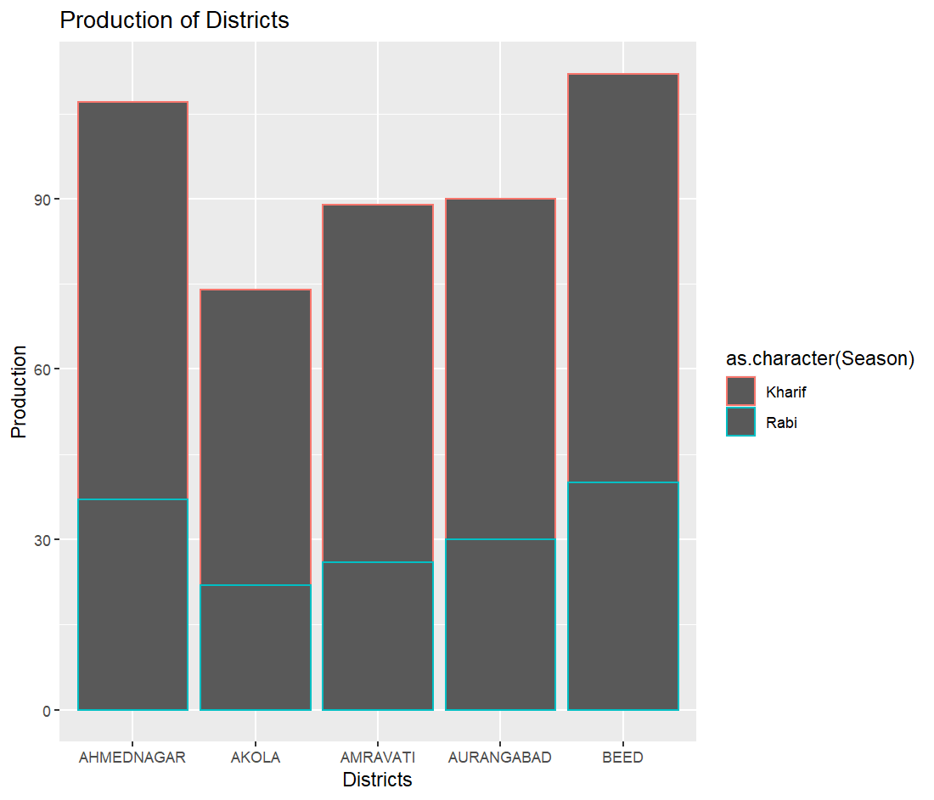

1. Pie chart

