TenderAI: An AI-Based Framework for Intelligent Government Tender Analysis and Application Assistance for MSMEs
Jayshree Bedade  Department of CSE - Artificial Intelligence  Vishwakarma Institute of Technology  Pune, India  jayshree.bedade@viit.ac.in | Pranjal Pandit  Department of CSE - Artificial Intelligence  Vishwakarma Institute of Technology  Pune, India  pranjalpandit90@gmail.com | Jagdev Hake  Department of CSE - Artificial Intelligence  Vishwakarma Institute of Information Technology  Pune, India  jagdev.22310711@viit.ac.in | Aditya Parade  Department of CSE - Artificial Intelligence  Vishwakarma Institute of Information Technology  Pune, India  aditya.22311577@viit.ac.in
Abstract— Participation in government tenders can offer valuable opportunities for micro, small and medium enterprises (MSMEs), but the documents employed in public procurement are usually long, technically detailed and hard to compare against the capabilities of a small business. This paper introduces TenderAI, a decision-support framework which helps MSMEs to read tender documents, identify the relevant requirements, check the mandatory eligibility conditions and prepare their application materials. The system takes tender documents in either PDF or scanned form and makes use of document intelligence to extract the text, tables and overall document structure. The information obtained is then converted into a structured version of the tender which includes the scope, quantities, financial limits, deadlines, locations, eligibility conditions and the evidence required. A rule-based eligibility module deals with the hard constraints, while semantic representations are used to compare the tender requirements with the products and capabilities listed in the MSME's profile. A weighted score is calculated based on product relevance, eligibility readiness, location, turnover and experience. The system also detects any missing evidence, points out time-sensitive risks and generates draft applications. The prototype was tested using four synthetic tender documents covering IT hardware, rooftop solar, housekeeping and medical supplies. Instead of giving benchmark accuracy that is not supported, the evaluation concentrates on workflow completeness, traceability and decision logic. The framework shows how document AI, natural language processing and structured business rules can be combined to make tender analysis more practical and transparent for MSMEs.
Keywords— Government Tenders, MSMEs, Document Intelligence, Sarvam Vision, Natural Language Processing, Semantic Matching, Eligibility Assessment, Public Procurement, Decision Support

I. INTRODUCTION
Public procurement is a major means by which small businesses can meet the demand of institutions and the government. Yet this opportunity is linked to a procedure that involves a large amount of documentation. One tender may include a statement of work, item schedules, technical specifications, eligibility clauses, financial conditions, delivery terms and a list of certificates. For a small and medium-sized enterprise which does not have a special tender-management team, spending the time needed to read each clause and to decide if the organisation is ready to submit a bid can take up a lot of time.
The problem doesn't end with the length of the documents since tender information can be spread out over different paragraphs and tables, and the same business capability may be referred to using different terms in various documents. For example, a furniture supplier might call a product an institutional storage cabinet while the tender uses the expression lockable steel cupboard. Keyword matching exactly therefore does not work. Moreover, a purely generative system is not appropriate for use in procurement decisions since a plausible-sounding answer might incorrectly assume that a registration, certificate or previous project exists.
TenderAI is suggested not as an autonomous bidder but as a decision-support system. It makes use of document intelligence to read out the tenders, applies structured extraction to arrange the requirements, employs deterministic rules for the mandatory conditions, uses semantic matching to determine the relevance of products and capabilities, and includes an evidence-based assistant to spot any gaps and to draft the responses. The fact that these functions are separated enables language models to help with interpretation without permitting the text they generate to override the explicit procurement conditions.
The major contributions of the work are:
• A single process turns different types of tender documents into organized procurement requirements.
• There is an eligibility layer based on hard constraints which identifies the PASS, FAIL, MISSING EVIDENCE and REVIEW states.
• A method based on semantic matching for comparing tender items with business capabilities beyond simply matching keywords.
• A weighted score that is interpretable and which can be used to prioritize actionably tender opportunities.
• A layer combining requirements and application assistance, based on source evidence and involving human review.
II. LITERATURE SURVEY
Research on intelligent procurement has taken several related directions, from information extraction from procurement documents, to semantic search and similarity, to machine-learning-based decision support, to recommender systems and to AI governance. Whilst these motivate the design of TenderAI, they also highlight that tender analysis should not be approached as a single classification task.
Vaswani et al. introduced the Transformer architecture and demonstrated that attention can be used as the principal mechanism for sequence modeling [1]. Devlin et al. later demonstrated the value of contextual bidirectional representations with BERT [2]. These are relevant to TenderAI as tender clauses often express the same requirement, using different linguistic constructions.
Lewis et al. proposed retrieval-augmented generation, combining a generative model with retrieved external knowledge [3]. Reimers and Gurevych introduced Sentence-BERT for efficient semantic sentence comparison [4]. These, together with the work of Vaswani et al. and Devlin et al., support a tender workflow where source clauses can be retrieved for evidence, and embeddings can be used to compare tender requirements vs. business descriptions.
Procurement-specific research provides a stronger motivation for the proposed architecture. An AI-based decision-support system for public procurement combined structured and unstructured tender information, semantic search, summarization, open information extraction and dashboards [9]. Another study looked at public tenders, complaints and recommender systems, and explored machine learning for identifying procurement anomalies and returning similar procurement opportunities and potential bidders [10].
Arroyo et al. demonstrated that key information extraction from purchase documents can benefit from a combination of deep learning and rule-based correction [11]. This is relevant to TenderAI as extracted tender fields, such as dates, quantities, prices and registration requirements, require deterministic validation, after model-based extraction.
Research on tender-document similarity has also demonstrated the value of contextual representations. A 2025 study proposed a deep-learning approach for identifying similarities in contracted-object descriptions in public procurement and used contextualized embeddings with named-entity extraction to improve textual similarity [12]. This supports the use of semantic product and service matching in the proposed framework.
The broader literature also emphasizes that AI adoption in procurement has organizational and governance implications. A systematic state-of-the-art study mapped AI uses across procurement processes and identified potential benefits and adoption challenges [13]. More recent work on AI in public procurement highlights tensions involving data access, transparency, accountability and the ability to challenge automated recommendations [14]. These motivate the evidence traceability and human-review mechanisms incorporated into TenderAI.
The research gap addressed here, is therefore practical and architectural in nature: existing work often addresses extraction, semantic search, recommendation or risk detection independently, whereas TenderAI combines document understanding, mandatory eligibility gates, business-to-tender matching, explainable gap analysis and application assistance, in a single MSME-oriented workflow.
III. METHODOLOGY
TenderAI uses an approach. First an MSME creates a business profile. This profile includes information about the products or services it offers annual turnover, business registrations years of experience locations where it operates and any supporting documents. Once the business profile is ready a tender is. Collected. The system then digitizes the tender document. It processes the information normalizes it and creates a version. Next mandatory conditions are checked using predefined rules. After passing this check does the system move to the semantic matching and ranking layer. This layer evaluates how well the tender matches the business profile.
A. System Architecture
The system is made up of layers. These include the presentation layer, API layer, document-intelligence layer, structured data layer, decision layer and application-assistance layer. The frontend is built using React and Next.js. It provides the user interface. The backend runs on FastAPI. Handles the processing tasks. Business and tender data are stored in PostgreSQL. Embeddings, for search are stored using pgvector. Sarvam Vision is the component used for document intelligence. It handles PDFs. Scanned documents. Its Document AI service supports full-document digitization. It also enables schema-based field extraction. This includes extracting tables and preserving the document layout. This capability is documented in references[5]. 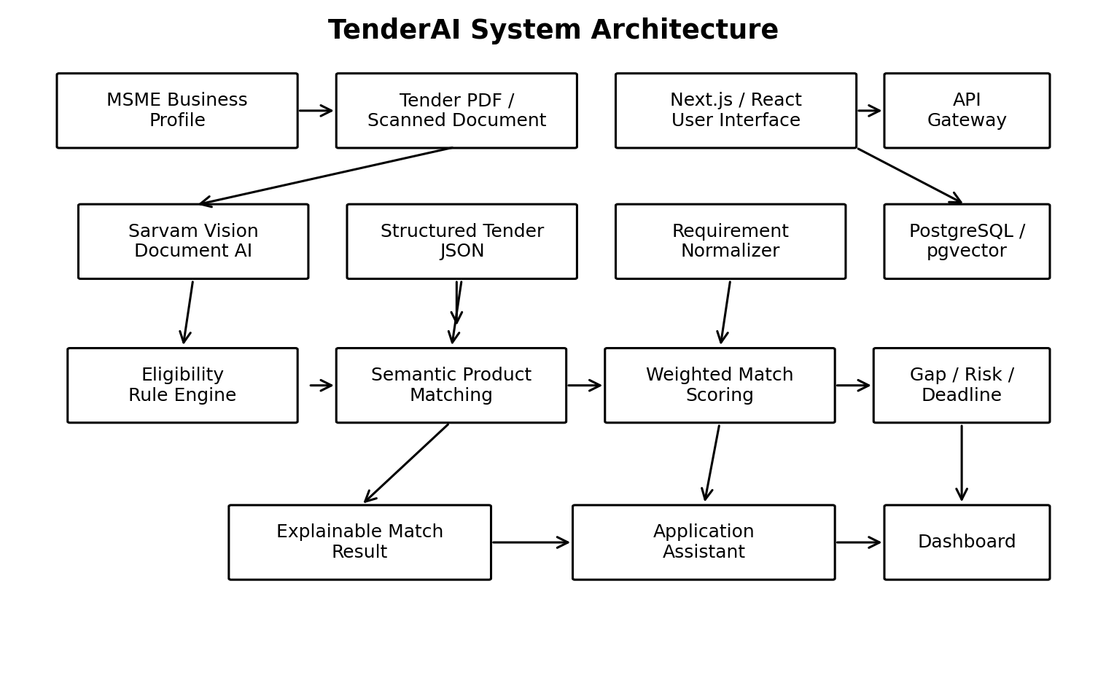
Fig. 1. TenderAI system architecture.
B. Tender Document Ingestion
The ingestion service checks the file creates a processing job and saves the original document. The document‑intelligence stage can digitise the tender when the next step needs the original text and its layout or it can pull out a fixed set of fields when only those are needed. Sarvam’s current documentation allows PDF, PNG, JPG and ZIP files and limits each PDF job to ten pages [5] [6]. So if a tender is larger it can be split into parts before it is analysed.

Page‑level source information stays with the extracted fields. That matters because a user should be able to go from a suggestion such as "minimum turnover required" to the exact clause, in the tender that set that rule.
C. Structured Tender Extraction
I notice that the extraction module creates a Tender JSON representation that includes fields such as tender identifier, title, authority, issue date, submission deadline, estimated value, EMD, delivery location, scope, item list, quantities, technical specifications, eligibility conditions and required documents. A schema‑constrained approach is used to reduce free‑form output. When a field is not present the system records it as unavailable, than filling it from assumptions. Tender tables are converted into item objects. A typical object contains item name, quantity, unit and technical specification. Dates and monetary values are normalized to representations so that downstream rule checks can compare them consistently.
D. MSME Business Profile
The business profile is kept as structured evidence. It includes the business category, descriptions of products or services annual turnover, registration status, locations where services are offered years of experience relevant past work and any uploaded certificates. Product and service descriptions can be embedded to support search while statutory details like GST number or MSME registration are stored as explicit values, for rule evaluation.
E. Eligibility Assessment
Mandatory requirements are treated as constraints. Common checks include registration status, minimum turnover, minimum experience, geographic capability, technical authorization and whether the organization is on a blacklist. The rule engine does not return a simple pass or fail. Instead it returns one of four outcomes: PASS, FAIL MISSING EVIDENCE or REVIEW. This helps avoid confusion, between situations where a document's missing and situations where the organization genuinely does not meet the requirement.

The eligibility gate also ensures that a high semantic score cannot hide a failure. For instance a company might have products that closely match what a tender is looking for. If the tender requires a minimum turnover that the company does not meet the company still cannot bid. The system is designed to catch these mismatches even if other parts of the submission look strong.
F. Semantic Matching and Weighted Score
Semantic matching is used to identify conceptual similarity between tender requirements and business capabilities. Embeddings can compare descriptions that use different words but refer to related products or services [4]. The prototype score combines five factors:
M = 0.30P + 0.30E + 0.10L + 0.15T + 0.15X
where P is product or service relevance, E is eligibility readiness, L is location compatibility, T is turnover adequacy, and X is experience alignment. The weights are configurable prototype values. The score is intended to support prioritization, not to replace the procurement authority's decision or the user's final bid/no-bid judgment.
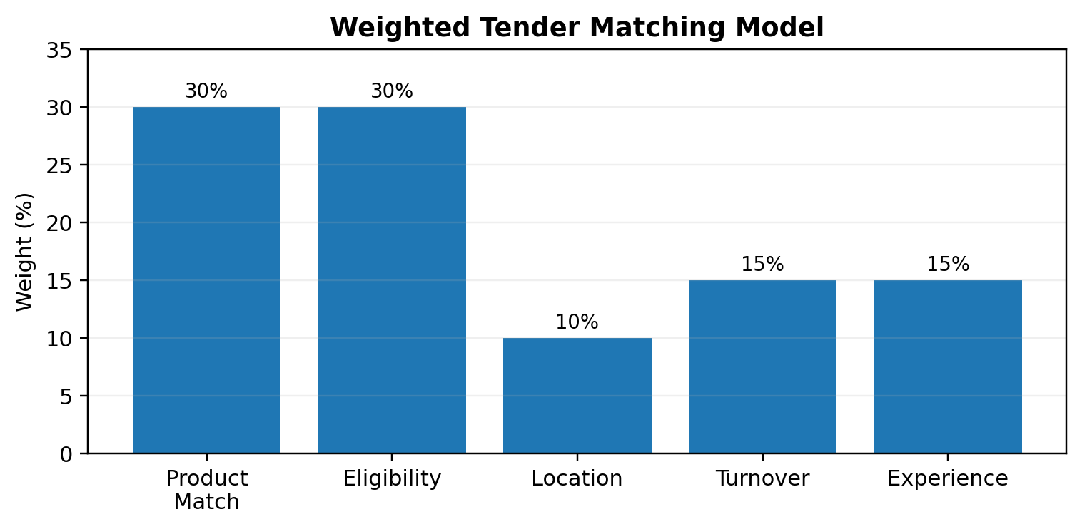
Fig. 2. Weighted matching factors used in the prototype.
G. Requirement Gap and Risk Analysis
The gap module looks at the tender requirements. Checks them against the business evidence that is available. It shows which requirements are met, which documents are missing where there is information and what needs to be checked by hand. A risk layer can look at how close the deadline's if important documents are missing if technical compliance is unclear and if there are any eligibility clauses that haven't been settled. The final view shows the questions: what has been met what is still not complete and what needs to be taken care of before submitting the tender.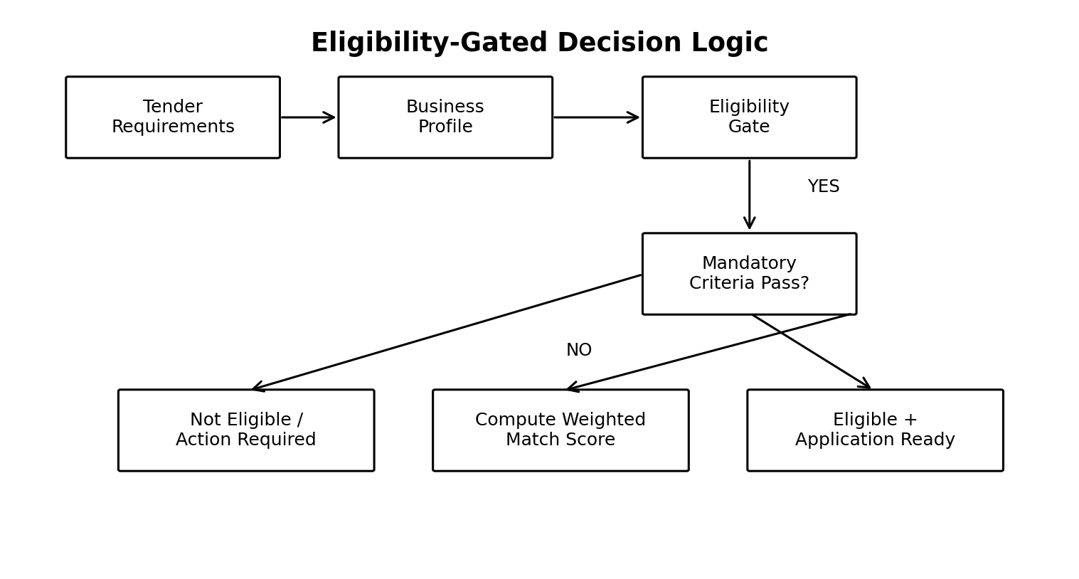
Fig. 3. Eligibility-gated decision logic.
H. Application Assistance
The application assistant prepares drafts such as a cover letter, eligibility response, technical compliance matrix and document checklist. Generated text is grounded in extracted tender information and the business profile. The assistant must not invent certificates, turnover, previous project experience or product specifications. Any legally significant or factual response is presented for human verification before use.
I. End-to-End Workflow
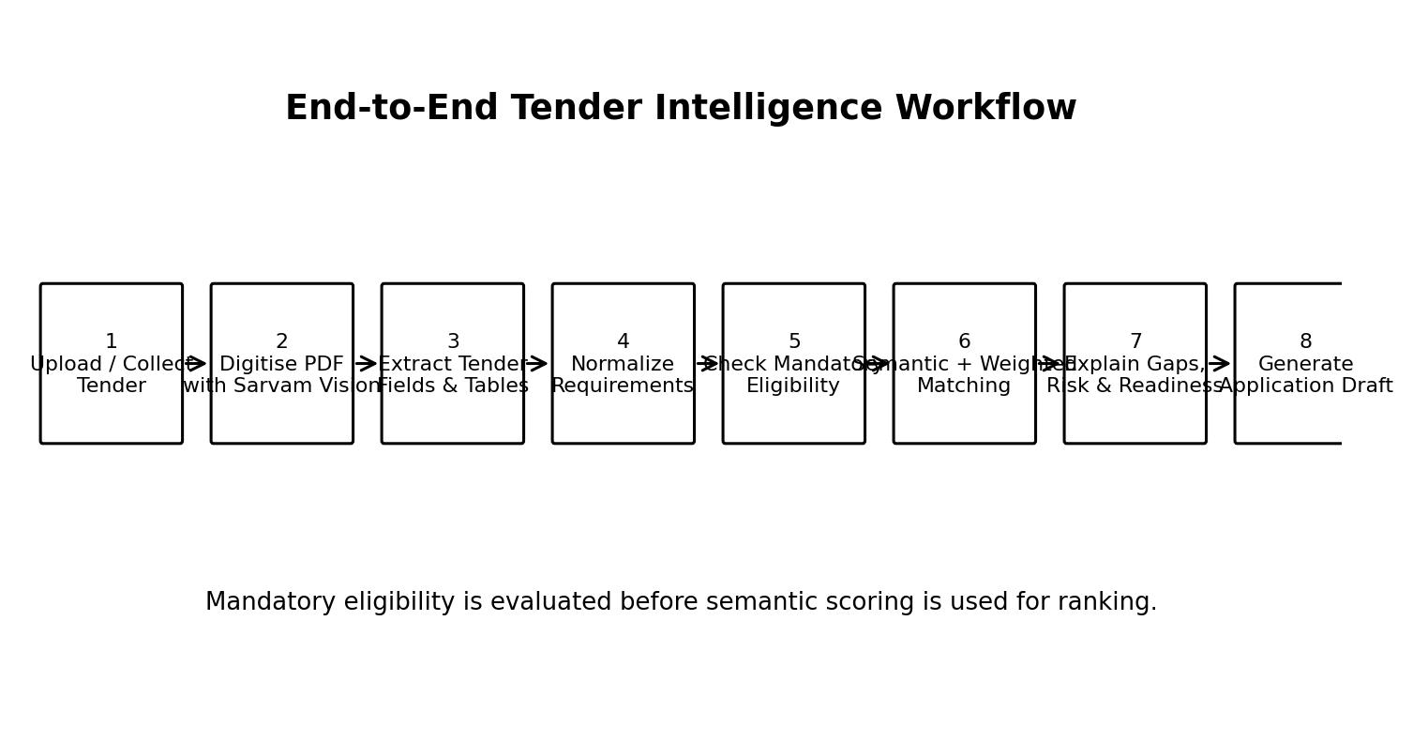
Fig. 4. End-to-end tender intelligence workflow.
The workflow is: business profile creation, tender ingestion, document digitisation, structured extraction, requirement normalization, eligibility assessment, semantic matching, weighted scoring, gap and risk analysis, and application drafting. Provider abstractions allow the document model, language model and embedding model to be replaced independently.
IV. IMPLEMENTATION
A prototype can be built using a Next.js and React frontend, a FastAPI backend, a PostgreSQL database and pgvector for storage. The user interface includes key screens: a dashboard, business profile, tender upload, tender details, requirement analysis, match results and application assistance. The backend provides APIs for authentication, managing business profiles uploading documents processing them matching requirements and generating applications. Processing happens asynchronously. When a user uploads a tender the system creates a job identifier. The backend then tracks the processing job until it reaches a state. Once the document is processed the extracted data is validated before being saved. This approach follows the job lifecycle described in the Sarvam Document AI documentation [5] [6].Prompt templates, model settings and scoring weights are kept separate from the application code. This separation allows experiments to be reproduced and makes it easier to compare model providers. Decision traces should be recorded to show which tender requirement led to a result and which business evidence was used to meet that requirement. Security measures include authenticated access, proper authorization, file validation upload size limits, protected API keys, audit logging and restricted access, to documents. Since tender documents and business certificates may contain commercial information the system must avoid logging raw documents or secrets. This prevents data from being exposed in application logs.
V. EXPERIMENTAL EVALUATION AND DISCUSSION
The prototype was tested using four tender documents created for controlled evaluation: IT hardware supply, rooftop solar installation, annual housekeeping services and medical consumables. Each document includes an identifier, submission deadline, estimated value, location, scope, item quantities, technical requirements, eligibility criteria and a list of required supporting documents.

The evaluation was split into three parts. First extraction was checked to see if the system could correctly pull out the expected fields and table content. Second eligibility reasoning was tested to make sure that the system correctly assigned PASS, FAIL MISSING EVIDENCE or REVIEW based on requirements. Third matching was examined to verify that business capabilities could be compared semantically with items and that the final score stayed below the threshold set by mandatory eligibility conditions. Because the test documents are artificial and the test set is small this paper does not claim any accuracy, precision, recall or F1 scores. Reporting numbers without a large properly labeled dataset would give a wrong impression about how well the system works in real situations. A proper evaluation would need tender documents from different procurement areas and expert reviews for extracted fields, eligibility decisions, missing evidence and relevance assessments. Still the prototype shows a strength at the system level: procurement analysis improves when strict rules are kept separate from fuzzy similarity. A semantic match may suggest a tender is relevant. Only clear evidence can confirm if a mandatory requirement is actually met. This separation makes results easier to check and lowers the risk of a language model offering a result without solid proof. The system design also tackles the traceability issue highlighted in research on AI in procurement. Recommendations must stay connected to clauses so users can follow the logic and question mistakes. This is especially important, in procurement, where transparency and accountability are essential parts of the process [13].
TABLE I
Prototype Tender Test Set
Tender Domain | Value | Eligibility Focus | Primary Test
IT Hardware | ₹48 lakh | GST/business status, ₹20 lakh turnover, 3 years experience | Tables + technical fields
Rooftop Solar | ₹62 lakh | ₹30 lakh turnover, project experience, authorization | Capability + eligibility
Housekeeping | ₹18 lakh/year | ₹12 lakh turnover, 2 years service experience | Service matching
Medical Supplies | ₹35 lakh | ₹25 lakh turnover, hospital experience, compliance | Document gaps
VI. LIMITATIONS AND FUTURE WORK
The proposed solution offers many opportunities for improvement. The current synthetic evaluation set provides little insight into performance on real-world procurement documents. The future evaluation should incorporate several departments, categories of procurement, document layouts, languages, and scan qualities. Each field's extraction should be compared to an expert-verifiable ground truth.
The semantic matching can result in false positives if two products are related but not technically interchangeable. A better implementation would combine embeddings with comparing structured attributes for specifications, such as capacity, voltage, material, size, certifications, and service levels. The confidence score and correction interface should be employed to let users edit the results before they are passed to the decision layer.
The future work includes multilingual understanding of tenders, connections to tender portals, clause level retrieval, learning-to-rank models, trained by user's interaction, automated compliance matrices, deadline aware task planning, and a better evidence graph for every decision backed by the corresponding document page. The human-in-the-loop feedback mechanism can capture accepted, rejected, and corrected recommendations and use them for training the ranking model without making the system fully autonomous and opaque.
VII. CONCLUSION
TenderAI: An End-to-End Framework for MSMEs to Operate Government Tender Documents Essay
The paper introduces TenderAI, an end-to-end framework designed to assist MSMEs in operating government tender documents. The framework is based on the combination of document intelligence, structured extraction, deterministic eligibility assessment, semantic business matching, weighted ranking, gap analysis and application assistance. The main design choice is to make mandatory procurement criteria fully explicit and subject to rule-based control while utilizing language and embedding models for interpretation, retrieval, and drafting.
The demonstration on the prototype test set highlights the potential of the framework to transform complex tender documents into an intelligible format, outlining requirements, eligibility criteria, business matching, evidence gaps, and application assistance. The tool aims to complement rather than replace procurement judgment by providing a transparent layer of decision-support grounded in explicit rules and traceable to tender items and business logic.
By building on a larger annotated corpus, more comprehensive technical-attribute matching, and multilingual evaluation, TenderAI can be further developed as a viable research and production framework to facilitate MSME access to public procurement..
REFERENCES
[1] A. Vaswani et al., “Attention Is All You Need,” in Proc. Advances in Neural Information Processing Systems (NeurIPS), 2017, pp. 5998–6008.
[2] J. Devlin, M.-W. Chang, K. Lee, and K. Toutanova, “BERT: Pre-training of Deep Bidirectional Transformers for Language Understanding,” in Proc. NAACL-HLT, 2019, pp. 4171–4186.
[3] P. Lewis et al., “Retrieval-Augmented Generation for Knowledge-Intensive NLP Tasks,” in Proc. Advances in Neural Information Processing Systems, 2020.
[4] N. Reimers and I. Gurevych, “Sentence-BERT: Sentence Embeddings using Siamese BERT-Networks,” in Proc. EMNLP-IJCNLP, 2019, pp. 3982–3992.
[5] Sarvam AI, “Sarvam Vision — Document Intelligence,” Sarvam API Documentation, 2026. [Online]. Available: https://docs.sarvam.ai/api/getting-started/models/sarvam-vision
[6] Sarvam AI, “Document Intelligence Overview,” Sarvam API Documentation, 2026. [Online]. Available: https://docs.sarvam.ai/api/api-guides-tutorials/document-intelligence/overview
[7] C. D. Manning, P. Raghavan, and H. Schütze, Introduction to Information Retrieval. Cambridge, U.K.: Cambridge Univ. Press, 2008.
[8] K. Sparck Jones, “A statistical interpretation of term specificity and its application in retrieval,” Journal of Documentation, vol. 28, no. 1, pp. 11–21, 1972.
[9] “AI-based decision support system for public procurement,” Information Systems, vol. 119, Art. no. 102284, 2023, doi: 10.1016/j.is.2023.102284.
[10] R. Nai, R. Meo, G. Morina, and P. Pasteris, “Public tenders, complaints, machine learning and recommender systems: A case study in public administration,” Computer Law & Security Review, vol. 51, Art. no. 105887, 2023.
[11] R. Arroyo, J. Yebes, E. Martínez, H. Corrales, and J. Lorenzo, “Key Information Extraction in Purchase Documents using Deep Learning and Rule-based Corrections,” in Proc. First Workshop on Pattern-based Approaches to NLP in the Age of Deep Learning, 2022, pp. 11–20.
[12] “A Deep Learning Approach for Identifying Similarities in Contracted Object Description in Public Procurement,” Procedia Computer Science, vol. 264, pp. 125–136, 2025, doi: 10.1016/j.procs.2025.07.124.
[13] “The role of artificial intelligence in the procurement process: State of the art and research agenda,” Journal of Purchasing and Supply Management, Art. no. 100823, 2023, doi: 10.1016/j.pursup.2023.100823.

