
_____________________________________
Projects in Machine Learning
INFO8665 - Spring 2025 - Section 1
Prof. Anasuya Bhima
Group 4 - Section 1
Assignment 2
Due on June 3, 2025
_____________________________________

Assignment 2

1.1 DevOps Project Board

1.1.1 Project Board URL and Snapshots
URL: https://dev.azure.com/Vsharma3188/SageCare%202.0/_sprints/taskboard/SageCare%202.0%20Team/SageCare%202.0/Sprint%200

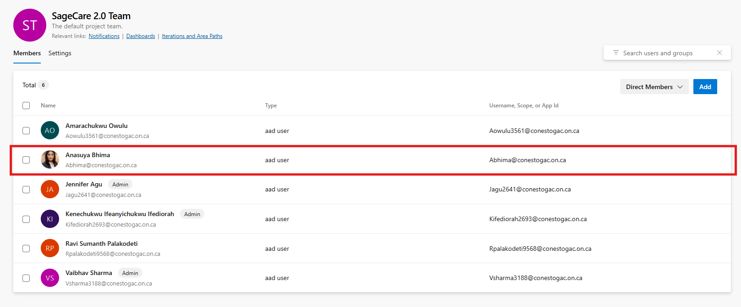
  - fig 1.1 Snapshot of team members including professor

1.2 ML Use Case Description

Use Case | Gap | Critical Point of Occurrence | Technological Countermeasure | Target
Food Nutritional Analysis | Seniors struggle to manage their diets due to cognitive decline, poor nutritional knowledge, and limited mobility. | When meals are consumed without understanding their nutritional content or tracking dietary habits. | Computer Vision model (CNN/Transfer Learning) to analyze food images, map results to a nutrition database (e.g., USDA), visualize data, track trends, and generate personalized diet suggestions. | Promote healthy eating, reduce diet-related illnesses, empower caregivers, and reduce hospital admissions.
NLP and Deep Learning for Free-Text Diagnosis | Elderly patients often use vague or non-medical terms to describe symptoms, leading to miscommunication, misdiagnosis, or referral delays. | When users input symptoms in free text (typed or spoken), especially during triage or initial interaction with the system. | GenAI-enhanced NLP using BioBERT/Bioformer to generate embeddings, predict diagnoses, map to medical specialties, and suggest next actions via a plain-language interface. | Improve diagnosis accuracy, bridge communication gaps, accelerate specialist referrals, and enhance triage in digital health settings.
Speech-to-Text for Doctor-Patient Consultation | Aids understanding and patient engagement by transcribing consultations in real-time, improving communication and documentation. | During video consultations where vital health information is shared verbally and needs to be clearly understood, retained, or reviewed later. | Real-time transcription using Whisper AI, AWS Transcribe, or Google Speech API; transcripts with timestamps; NLP-based key term highlighting; caregiver access; accessibility options. | Enhance understanding, documentation, caregiver collaboration, and reduce treatment errors through improved communication and record keeping.
  - Table 1.1 ML Use Case description in TBP format

1.3 Product Backlog Items
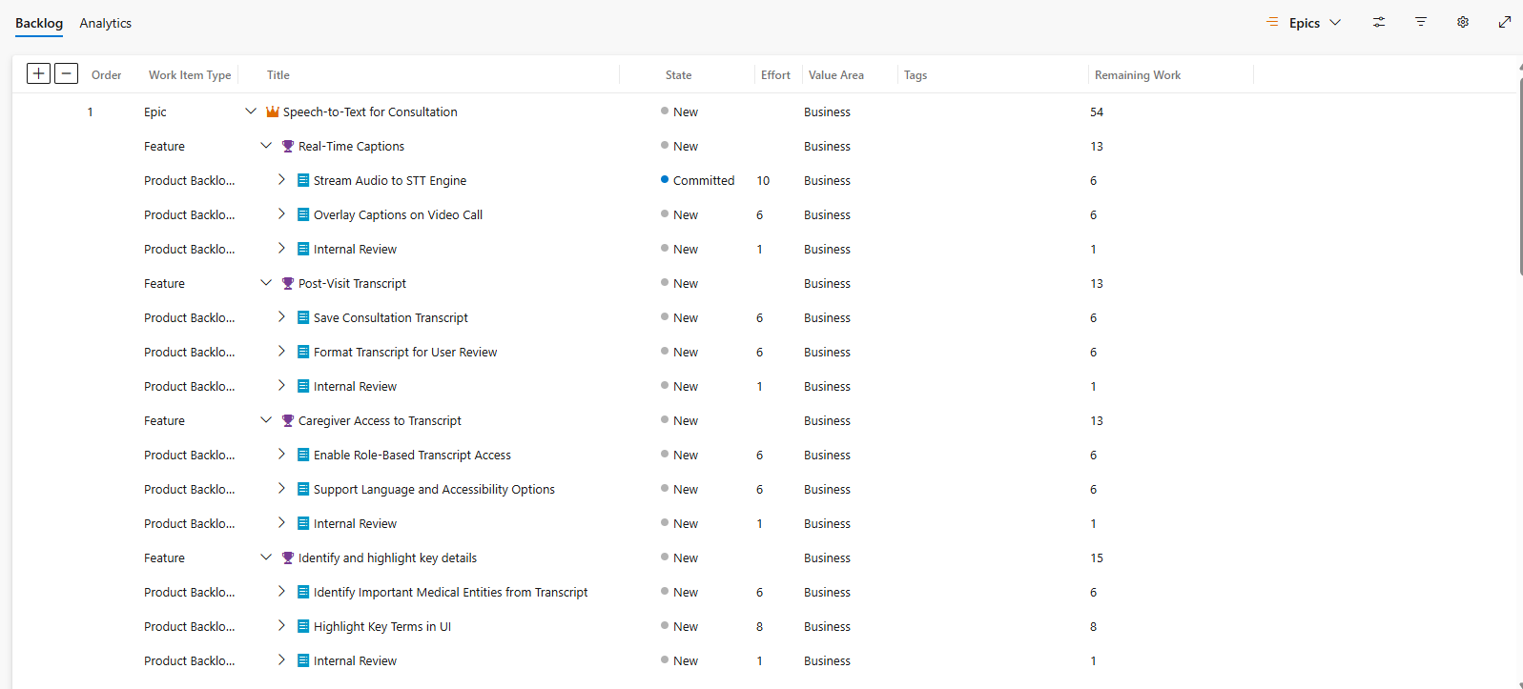
  - Fig 1.2 Snapshot of product backlog with epics. Features, PBIs and tasks
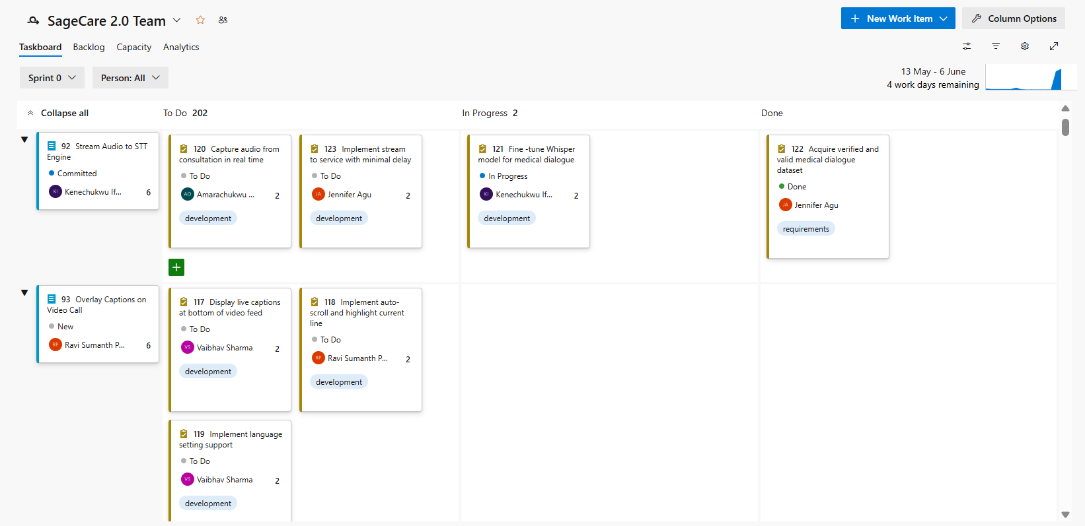
  - Fig 1.3 Snapshot of project board with tasks for sprint 0

1.4 GitHub Repo and DevOps Board Integration

1.4.1 GitHub URL and Folder Structure
URL: https://github.com/CelebrityITPro/SageCare-2.0
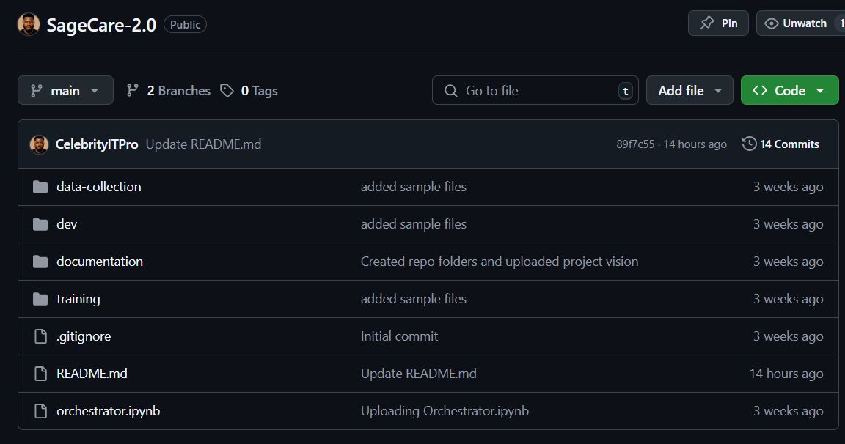
  - Fig 1.4 Snapshot of GitHub folder structure
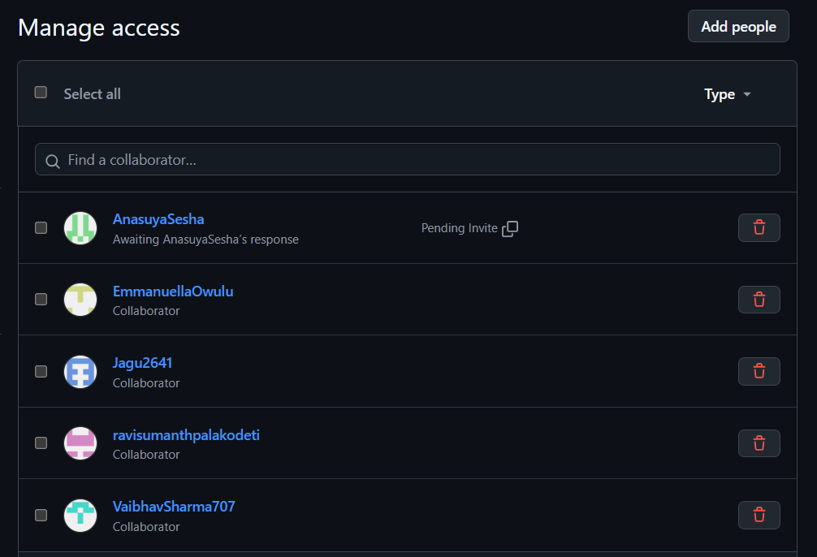
  - Fig 1.5 Snapshot of GitHub Repo access
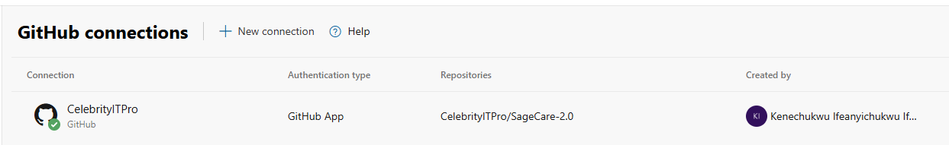
  - Fig 2.6 GitHub Repo integration with Azure DevOps board

1.5 Team Roles and Responsibilities

Names | Roles | Responsibilities
Ifediorah Kenechukwu | Project Manager | - Break down tasks and ensures alignment with vision  - Work on project submission documents  - Works on ML model development
Agu Jennifer | Scrum Master | - Ensures team follows agile process and all tasks are updated accordingly  - Works on ML model development  - Manages Azure DevOps board
Palakodeti Ravi Sumanth | Developer | - Works on ML model development  - Explore and Preprocesses collected data and selects the best algorithms.  - Deploys models into production and ensures they perform reliably.
Sharma Vaibhav | Developer | - Designs the product frontend interface  - Develops backend and frontend architectures  - Works with APIs, databases, and UI.
Owulu Amarachukwu | Software Tester | - Designs and runs test cases.  - Explore and preprocesses collected data.  - Develops presentation slides.
  - Table 1.2 Team roles and responsibilities

