Credit Risk Prediction System
with Explainable AI, Historical Cohort Analysis and Fair-Lending Audit
A Project Report Submitted in
the partial fulfillment of the requirements for the award of the degree of
BACHELOR OF TECHNOLOGY
In
DEPARTMENT OF COMPUTER SCIENCE AND ENGINEERING
By
J.Madhura | :2420030535
Ch.Srikar | :2420030610
R.Lokesh | :2420030534

Under the Esteemed Guidance of
Dr. N. Sunanda
Associate Professor
Department of Computer Science and Engineering
KLH CSE Bowrampet Campus
AY: 2026 - 2027 Semester: odd


K L (Deemed to be) University
DEPARTMENT OF COMPUTER SCIENCE AND ENGINEERING
Declaration
The Project Report entitled “Credit Risk Prediction System” is a record of Bonafide work of J Madhura – 2420030535, Ch Srikar – 2420030610, R Lokesh Reddy – 2420030534 submitted in partial fulfillment for the award of B. Tech in Computer Science and Engineering to the K L University. The results embodied in this report have not been copied from any other departments/University/Institute.

J Madhura – 2420030535
Ch Srikar – 2420030610
R Lokesh Reddy – 2420030534
K L (Deemed to be) University
DEPARTMENT OF COMPUTER SCIENCE AND ENGINEERING
CERTIFICATE
This is to certify that the mini project based report entitled “Credit Risk Prediction System” is a bonafide work done and submitted by J Madhura – 2420030535, Ch Srikar – 2420030610, R Lokesh Reddy – 2420030534 in partial fulfillment of the requirements for the award of the degree of BACHELOR OF TECHNOLOGY in Department of Computer Science and Engineering, K L (Deemed to be University), during the academic year 2026-2027.

Signature of the Guide Signature of the Course Coordinator Signature of the HOD
ACKNOWLEDGEMENT
The success of this project would not have been possible without the timely help and guidance rendered by many people. We wish to express our sincere thanks to all those who have assisted us in one way or the other in the completion of our project.
Our greatest appreciation goes to our Course Coordinator and our guide, Dr. N. Sunanda,
Associate Professor, Department of Computer Science and Engineering, KLH CSE Bowrampet Campus, whose tremendous support, encouragement and guidance cannot be expressed in words.
We express our gratitude to the Head of the Department of Computer Science and Engineering for providing us with adequate facilities, ways and means by which we were able to complete this project-based lab.
We thank all the members of the teaching and non-teaching staff who have assisted us directly or indirectly in the successful completion of this project. Finally, we sincerely thank our parents, friends and classmates for their kind help and cooperation during our work.

J Madhura – 2420030535
Ch Srikar – 2420030610
R Lokesh Reddy – 2420030534
ABSTRACT
Credit risk assessment is a critical function in banking and finance because an incorrect lending decision can lead to loan defaults and financial loss. Traditional evaluation relies on manual verification and fixed rules, which are slow and may miss hidden patterns in large volumes of applicant data. This project presents the Credit Risk Prediction System, a data science and machine learning application that estimates the probability that a loan applicant will default and classifies the applicant as Low, Medium or High risk.
The system is built on the Statlog German Credit dataset (1,000 borrower records, 20 attributes, 30% default rate). The data has no missing values or duplicates; a stratified 80/20 train–test split is used, with StandardScaler and OneHotEncoder fitted only on the training split so that no information leaks from the test set, giving 61 model input features. Four classifiers – Logistic Regression, Decision Tree, Random Forest and Support Vector Machine – are trained with balanced class weights and compared using accuracy, precision, recall, F1-score, ROC-AUC and confusion matrices on a 200-record hold-out set.
Random Forest was selected as the primary model because it gives a strong ROC-AUC of 0.797, detects 71.7% of defaulters (43 of 60) and supports exact SHAP explanations. Predicted default probability is mapped to Low (< 28%), Medium (28–58%) and High (≥ 58%) tiers. Beyond prediction, the system provides SHAP and LIME explanations with plain-language narratives, a K-nearest-neighbour historical cohort of similar borrowers, an interactive what-if simulator, a fair-lending audit using the four-fifths rule, and an audit log. These are delivered through a six-module Streamlit web application and verified by a nine-point automated test suite. The system is designed strictly as a decision-support tool, with the final lending decision remaining with a human underwriter.
Keywords: credit risk, machine learning, Random Forest, explainable AI, SHAP, LIME, fair lending, Streamlit
INDEX
S. No. | Chapter | Topics | Page No.
 | Acknowledgement |  | 4
 | Abstract |  | 5
1 | Introduction | 1.1 Background 1.2 Problem statement 1.3 Scope 1.4 Objectives 1.5 Importance 1.6 Target users | 8
2 | System Requirements | 2.1 Hardware 2.2 Software 2.3 Development tools and frameworks | 10
3 | Technology Stack | 3.1 Front-end 3.2 Back-end 3.3 Database 3.4 Version control 3.5 APIs / external services | 11
4 | System Architecture | 4.1 Architecture diagram 4.2 Description of layers 4.3 Deployment architecture | 12
5 | Design | 5.1 Wireframes and feature summary 5.2 Data schema | 13
6 | Implementation | 6.1 Modules 6.2 Data and EDA 6.3 Preprocessing 6.4 Training 6.5 Evaluation 6.6 Risk tiers 6.7 XAI, cohort, what-if, fairness 6.8 Authentication | 14
7 | Features | 7.1 Main features 7.2 How each feature works | 18
8 | Testing and Results | 8.1 Approach 8.2 Test cases 8.3 Model comparison 8.4 Discussion 8.5 Fairness audit | 20
9 | Deployment | 9.1 Steps 9.2 Environment configuration 9.3 Hosting | 23
10 | Challenges & Limitations | 10.1 Issues 10.2 Solutions 10.3 Limitations | 24
11 | Future Enhancements | 11.1 Planned features 11.2 Integrations | 25
12 | Conclusion | 12.1 Summary 12.2 Achievements 12.3 Skills learned | 26
13 | References | Books, papers and documentation used | 27
14 | Appendices | Screenshots, sample code, setup instructions, certifications | 28
LIST OF FIGURES AND TABLES
No. | Title | Chapter
Fig 4.1 | System architecture of the Credit Risk Prediction System | 4
Fig 6.1 | Class distribution of the target variable | 6
Fig 6.2 | Default rate by checking-account status | 6
Fig 6.3 | Default rate by loan duration | 6
Fig 8.1 | Model comparison across all metrics | 8
Fig 8.2 | ROC curves of the four models | 8
Fig 8.3 | Confusion matrices of the four models | 8
Fig 7.1 | Top-10 Random Forest feature importances | 7
Table 2.1 | Hardware requirements | 2
Table 2.2 | Software requirements | 2
Table 5.1 | Dataset feature summary | 5
Table 6.1 | Algorithms and configuration | 6
Table 8.1 | Automated test cases | 8
Table 8.2 | Model performance on the hold-out set | 8
Table 8.3 | Fairness audit results | 8

CHAPTER 1
Introduction

1.1 Background of the project
Lending is one of the core services of banks and financial institutions, and its profitability depends on how well lenders can separate applicants who will repay from those who will default. The process of estimating this likelihood is called credit scoring or credit risk assessment. Traditional assessment depends on manual verification of documents and predefined rules. As the number of applications and the amount of historical information grow, such approaches become slow, inconsistent and unable to capture nonlinear relationships between applicant attributes.
Data science and machine learning allow patterns to be learned directly from historical loan records and applied consistently to new applicants. However, in a regulated domain such as lending, accuracy alone is not enough: decisions must be explainable, auditable and fair. This project therefore builds not only a predictive model but a complete decision-support system around it.

1.2 Problem statement
Manual and rule-based credit evaluation is time-consuming, may fail to identify hidden patterns in customer and loan data, and can lead to incorrect decisions that cause loan defaults and financial losses. There is a need for a data-driven machine learning system that can assess the creditworthiness of loan applicants, classify them as Low, Medium or High risk, and justify each prediction in terms a credit analyst can understand and defend.

1.3 Scope of the project
- Uses the Statlog German Credit dataset (1,000 borrower records, 20 attributes) as the historical data source.
- Covers the full data science life cycle: data collection, preprocessing, exploratory data analysis, model training, evaluation, selection and deployment as a web application.
- Compares four classifiers: Logistic Regression, Decision Tree, Random Forest and Support Vector Machine.
- Adds an explainable decision-support layer: SHAP and LIME explanations, similar-borrower cohorts, a what-if simulator, a fair-lending audit and an audit log.
- The system is advisory only; it does not make final lending decisions and is not connected to a live banking system.

1.4 Objectives
- To develop a machine learning-based Credit Risk Prediction System.
- To analyse customer and loan-related attributes affecting credit risk.
- To preprocess the dataset (missing values, unnecessary records, categorical encoding, feature preparation) without data leakage.
- To perform exploratory data analysis to understand data patterns.
- To train and compare Logistic Regression, Decision Tree, Random Forest and SVM using accuracy, precision, recall, F1-score, ROC-AUC and confusion matrix.
- To select a suitable model and classify new applicants into Low, Medium and High risk.
- To make predictions transparent through explainable AI and to audit them for fairness.

1.5 Importance of the application
A missed defaulter costs a lender far more than a good applicant sent for extra review; the project treats this cost asymmetry as roughly 5 to 1 and uses it to justify balanced class weights, a recall-oriented model choice and the risk-tier thresholds. Explainability and fairness checks respond to the practical need for defensible, auditable credit decisions. The system reduces manual effort and gives consistent, data-driven risk estimates.

1.6 Target users/audience
- Credit analysts and underwriters who need a risk estimate and the reasons behind it.
- Risk and compliance teams who need fairness and audit information.
- Students and researchers studying credit scoring and explainable machine learning.

CHAPTER 2
System Requirements

2.1 Hardware requirements
Table 2.1 Hardware requirements
Component | Requirement
Processor | Intel Core i3 or equivalent (i5 recommended)
RAM | 4 GB minimum (8 GB recommended)
Storage | About 500 MB free (project files and models are about 5 MB; the rest is for libraries)
Display | 1366 x 768 or higher
GPU | Not required
The project needs no expensive hardware because the dataset is small and all models train in seconds on a normal CPU.

2.2 Software requirements
Table 2.2 Software requirements
Software | Details
Operating system | Windows 10/11, Linux or macOS
Language | Python 3.10, 3.11 or 3.12
Libraries | streamlit ≥ 1.35, pandas ≥ 2.0, numpy ≥ 1.24, scikit-learn ≥ 1.3, scipy ≥ 1.10, matplotlib ≥ 3.7, seaborn ≥ 0.12, shap ≥ 0.42, lime ≥ 0.2, joblib ≥ 1.3
Browser | Any modern browser (Chrome, Edge, Firefox)

2.3 Development tools and frameworks
- Python: core programming language.
- scikit-learn: preprocessing pipeline, models, calibration, metrics and nearest-neighbour search.
- pandas and NumPy: data loading, cleaning and numerical computation.
- SHAP and LIME: explainable AI libraries.
- matplotlib and seaborn: charts used in the dashboard.
- Streamlit: framework for the interactive web interface.
- joblib: saving and loading trained models and the fitted preprocessor.

CHAPTER 3
Technology Stack
This project is a Python data application rather than a conventional multi-tier web application, so the layers requested in the report format are mapped as follows.

3.1 Front-end
The user interface is a single-page Streamlit dashboard (app.py, 1,131 lines). Streamlit renders forms, tabs, tables and matplotlib charts directly from Python, so no separate HTML, CSS or JavaScript code is required. The interface has six modules: applicant assessment, explainable AI, historical cohort analysis, what-if simulator, model performance and fairness audit, and assessment history.

3.2 Back-end
The back-end is a Python package (src/) containing the configuration, data processing, model training, explainability, cohort matching, fairness evaluation and history storage modules. Streamlit calls these modules directly; there is no separate REST server.

3.3 Database
No database server is used. The historical data is stored as credit_data.csv; trained models, the fitted preprocessor, metrics, confusion matrices and ROC data are stored as joblib/JSON files in the models/ folder; and assessments are logged to models/prediction_history.json. A database back end is listed as future work.

3.4 Version control
Git and GitHub can be used for version control and collaboration (the project is organised as a standard repository with README.md and requirements.txt).

3.5 APIs or external services
The system runs fully offline and uses no paid or external web service. The only external resource is the public UCI Statlog German Credit data, which is included in the project folder.

CHAPTER 4
System Architecture

4.1 High-level architecture diagram
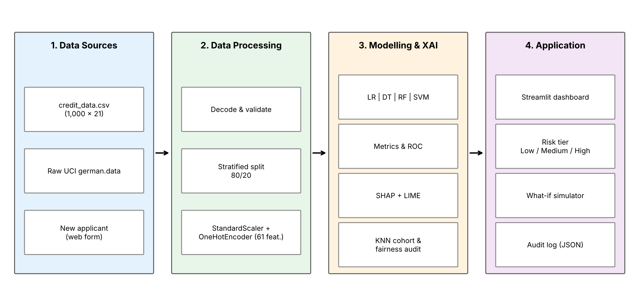
Fig 4.1 System architecture of the Credit Risk Prediction System

4.2 Description of each layer
- Data layer: credit_data.csv (1,000 x 21) and the raw UCI files in extracted_data/. New applicant data arrives through the web form.
- Data processing layer: decodes UCI codes such as A11 into readable labels, validates the data, performs a stratified 80/20 split and applies StandardScaler (7 numerical columns) and OneHotEncoder (13 categorical columns, 54 encoded columns), producing 61 input features.
- Modelling and explainability layer: trains and evaluates the four classifiers, stores the Random Forest as the primary model, and provides SHAP and LIME explanations, KNN historical cohorts and fairness metrics.
- Application layer: the Streamlit dashboard that shows the risk tier and recommended action, explanations, what-if analysis, model performance and the audit log.

4.3 Deployment architecture
The application is deployed locally: a single Python process serves the Streamlit app on port 8501 and reads the serialized artifacts from the models/ folder. The same code can be hosted on a cloud service or container; this, together with authentication and a database, is listed under future enhancements.

CHAPTER 5
Design

5.1 Wireframes or mockups
The dashboard is organised into six tabs. The assessment form is split into three sub-tabs to keep it short: Loan Terms (duration, credit amount, installment rate, purpose), Liquidity & Banking (checking status, savings, credit history, other payment plans) and Applicant Demographics & Collateral (age, employment, job, housing, property, guarantor, foreign-worker status). Insert the screenshots of each tab in Appendix A.
Table 5.1 Dataset feature summary
Numerical feature | Min | Mean | Max
Duration (months) | 4 | 20.9 | 72
Credit amount (DM) | 250 | 3,271 | 18,424
Installment rate | 1 | 3.0 | 4
Years at residence | 1 | 2.8 | 4
Age (years) | 19 | 35.5 | 75
Existing credits | 1 | 1.4 | 4
Dependents | 1 | 1.2 | 2
The 13 categorical features are checking status, credit history, purpose, savings status, employment, personal status/sex, other parties, property, other payment plans, housing, job, telephone and foreign worker. After one-hot encoding they produce 54 columns; with the 7 numerical columns the model receives 61 features.

5.2 Data schema (instead of ER diagram)
As no relational database is used, the data design is a single table. Each row of credit_data.csv is one borrower with 20 predictor columns and one target column, credit_risk (0 = good/repaid, 1 = bad/default). The dataset contains 700 good and 300 bad records (30% default rate), with 0 missing values and 0 duplicates. Each audit-log entry in prediction_history.json stores an applicant ID, timestamp, loan amount, duration, checking status, credit history, risk tier, default probability and key drivers; no personal identifiers are stored.

CHAPTER 6
Implementation

6.1 Module-wise implementation
Module | Implementation
config.py | Column schemas, valid category options, risk thresholds (0.28 / 0.58) and classify_risk_tier()
data_processor.py | Loads and decodes the UCI data, dataset profile, ColumnTransformer (StandardScaler + OneHotEncoder) and stratified split
model_trainer.py | Trains the four models, computes metrics, confusion matrices and ROC curves, saves best_model.joblib
xai_engine.py | SHAP local/global attributions, LIME cross-check, plain-language narrative and contribution plots
historical_matcher.py | NearestNeighbors search; cohort repayment/default counts, average amount and duration
fairness_evaluator.py | Approval rate, disparate impact ratio and demographic parity difference by group
history_store.py | Logs each assessment (tier, probability, top factors) to JSON with privacy safeguards
app.py | Streamlit UI tying all modules together

6.2 Data preparation and exploratory analysis
The raw german.data file is space-separated with coded values. The data processor assigns column names, maps codes to readable labels (for example A11 to “< 0 DM”) and converts the target so that 0 is a good borrower and 1 is a defaulter. The dataset has 700 good and 300 bad records and no missing or duplicate rows, so no imputation or record removal was required.
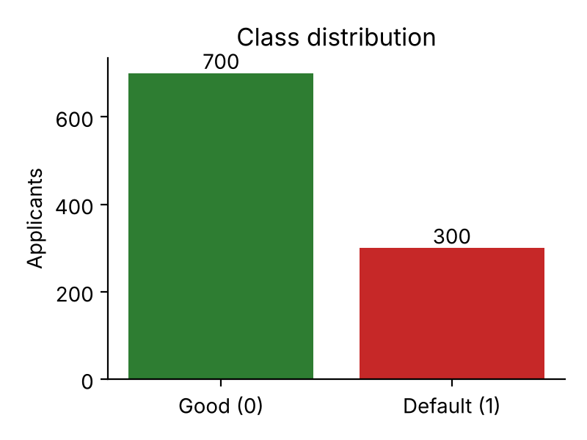
Fig 6.1 Class distribution of the target variable
Exploratory analysis shows clear risk patterns. Applicants with no checking account default least (about 12%), while those overdrawn (< 0 DM) default most (about 49%). Default rate also rises steadily with loan duration, from about 21% for loans of up to 12 months to about 52% for loans longer than 36 months. Credit history, savings, age and credit amount are also informative and are retained as model inputs.
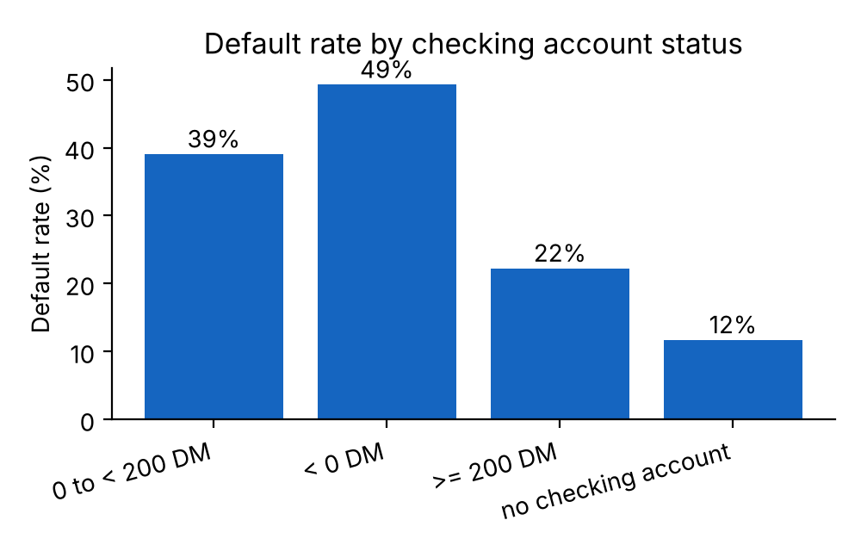
Fig 6.2 Default rate by checking-account status
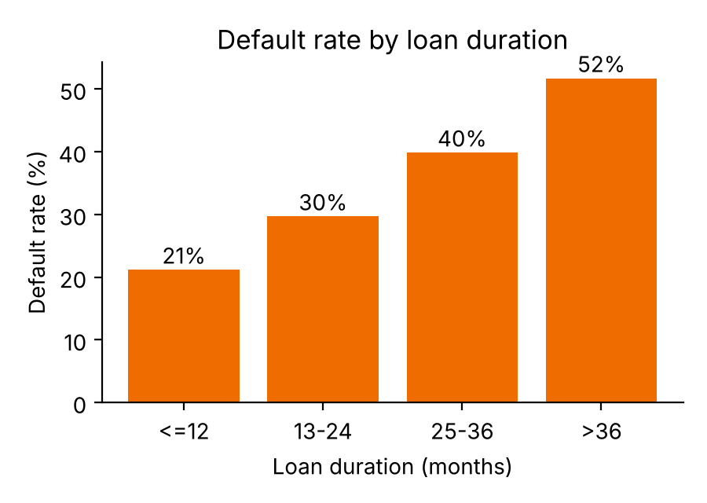
Fig 6.3 Default rate by loan duration

6.3 Preprocessing and leakage prevention
Data is split with train_test_split(test_size = 0.2, stratify = y, random_state = 42), giving 800 training and 200 test records with the 30% default rate preserved in both. The scaler and encoder are fitted only on the training split and then applied to the test split and to every new applicant, so no information from the test set influences training. The fitted ColumnTransformer is saved as preprocessor.joblib.
preprocessor = ColumnTransformer(transformers=[
("num", StandardScaler(), NUMERICAL_COLS),
("cat", OneHotEncoder(handle_unknown="ignore",
sparse_output=False), CATEGORICAL_COLS)])
X_train, X_test, y_train, y_test = train_test_split(
X, y, test_size=0.2, random_state=42, stratify=y)
X_train_proc = preprocessor.fit_transform(X_train) # fit on train only
X_test_proc = preprocessor.transform(X_test)

6.4 Model training
Table 6.1 Algorithms and configuration
Algorithm | Purpose | Key configuration
Logistic Regression | Baseline linear classifier | liblinear solver, C = 1.0, class_weight = balanced, max_iter = 1000
Decision Tree | Interpretable rule-based model | max_depth = 5, min_samples_split = 10, min_samples_leaf = 5, balanced
Random Forest (selected) | Primary risk model | 150 trees, max_depth = 8, min_samples_split = 6, min_samples_leaf = 3, balanced
Support Vector Machine | Margin-based classifier | SVC (RBF kernel), balanced weights, sigmoid probability calibration (3-fold)
All models use class_weight = balanced to handle the 70:30 class imbalance and the higher cost of approving a defaulter. The SVM is wrapped in CalibratedClassifierCV so that it produces usable default probabilities.
"Random Forest": RandomForestClassifier(
n_estimators=150, max_depth=8,
min_samples_split=6, min_samples_leaf=3,
class_weight="balanced", random_state=42)

6.5 Evaluation and model selection
Each model is evaluated on the 200-record hold-out set (60 defaults, 140 good) with accuracy, precision, recall, F1-score, ROC-AUC and a confusion matrix. Detailed results are given in Chapter 8. Random Forest is stored as best_model.joblib. It was chosen because it combines strong ROC-AUC (0.797), good default recall (71.7%) and native compatibility with the exact SHAP TreeExplainer.

6.6 Risk classification
The predicted default probability is mapped to three tiers whose thresholds are anchored to the 30% base default rate and the 5:1 cost asymmetry:
Tier | P(default) | Recommended action
Low Risk | < 28% | Standard or fast-track approval
Medium Risk | 28% to < 58% | Manual underwriter review, proof of income or guarantor
High Risk | ≥ 58% | Decline or require substantial secured collateral

6.7 Explainability, cohort analysis, what-if and fairness
- SHAP: shap.TreeExplainer gives exact Shapley values that split a prediction into risk-increasing and risk-reducing contributions, shown as local bar charts and a global ranking. A natural-language narrative converts them into plain sentences.
- LIME: LimeTabularExplainer fits a local surrogate model around the applicant as an independent check of the main drivers.
- Historical cohort: NearestNeighbors (Euclidean, k = 3 to 15) retrieves the most similar past borrowers and reports how many repaid or defaulted and their average amount and duration. Neighbour search uses only the features, not the outcome.
- What-if simulator: lets the analyst change loan amount, duration, checking/savings status, guarantor and installment rate and shows the change in probability and risk tier.
- Fairness audit: computes approval rate, disparate impact ratio and demographic parity difference by gender, age (< 25 vs ≥ 25) and foreign-worker status against the four-fifths (80%) rule.
- Audit log: every assessment is saved to prediction_history.json for later review.

6.8 Authentication and authorization
The current version is a single-user local application and has no login. Role-based access control is listed in future enhancements. The system includes governance safeguards instead: it is labelled decision-support only, and the model never holds unilateral rejection authority.

CHAPTER 7
Features

7.1 List of main features
- Applicant assessment with three-part input form and instant default probability
- Low / Medium / High risk classification with recommended action
- Explainable AI: SHAP bar charts, LIME verification and plain-language narrative
- Historical cohort analysis of similar past borrowers
- Interactive what-if scenario simulator
- Model performance dashboard (metrics, ROC, confusion matrices) and fairness audit
- Assessment history / audit log with privacy safeguards
- Automated nine-point test suite

7.2 How each feature works
- Assessment: the user enters 20 applicant attributes; the saved preprocessor transforms them into 61 features; the Random Forest returns P(default); classify_risk_tier() assigns the tier and action.
- Explainability: TreeExplainer computes SHAP values for the applicant; the narrative generator ranks them and describes the top risk-raising and risk-lowering factors; LIME confirms them independently.
- Cohort: the applicant vector is compared with the training records and the k nearest records and their outcomes are summarised.
- What-if: the form values are copied, modified and re-scored; the difference in probability and any tier change are shown with a short explanation.
- Fairness: the model predictions on the test split are grouped by sensitive attributes and approval-rate ratios are compared with the 80% rule.
Top drivers identified by the Random Forest are shown in Fig 7.1 and in the next chapter.
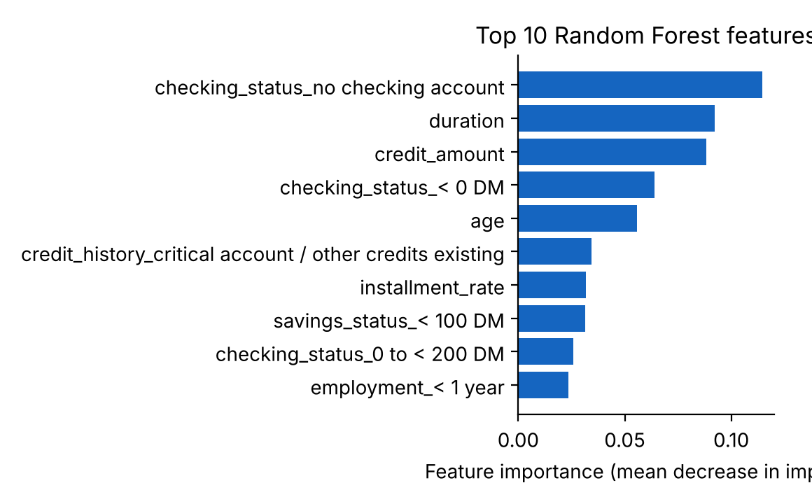
Fig 7.1 Top-10 Random Forest feature importances

CHAPTER 8
Testing and Results

8.1 Testing approach
Because the project is a Python application rather than a REST service, Postman testing is replaced by unit and integration testing with Python’s unittest framework. The file test_system.py contains nine tests that exercise the data, models, explainability, cohort, fairness and logging modules together.

8.2 Test cases
Table 8.1 Automated test cases (test_system.py)
No. | Test | What is verified
1 | Dataset integrity | 1,000 records, target present, 0 missing values
2 | Preprocessing pipeline | Single applicant is transformed to the correct number of features
3 | All four models predict | Each model returns a probability between 0 and 1
4 | Risk tiering | Probabilities map to the correct Low/Medium/High tier
5 | SHAP and narrative | Attributions and plain-language explanation are generated
6 | LIME | Local explanation is generated for an applicant
7 | Historical matcher | Nearest-neighbour cohort and outcome counts are returned
8 | Fairness evaluator | Disparate-impact metrics are computed for each group
9 | History store | Assessments are written to the audit log
Run with: python test_system.py. The project documentation states that all nine tests pass in under five seconds.

8.3 Model comparison results
Table 8.2 gives the hold-out results for the 200 test applicants.
Table 8.2 Model performance on the hold-out set
Model | Accuracy | Precision | Recall | F1-score | ROC-AUC
Logistic Regression | 75.0% | 55.8% | 80.0% | 0.658 | 0.806
Decision Tree | 56.0% | 37.3% | 68.3% | 0.482 | 0.598
Random Forest (selected) | 73.0% | 53.8% | 71.7% | 0.614 | 0.797
SVM (calibrated) | 78.0% | 69.1% | 48.3% | 0.569 | 0.811
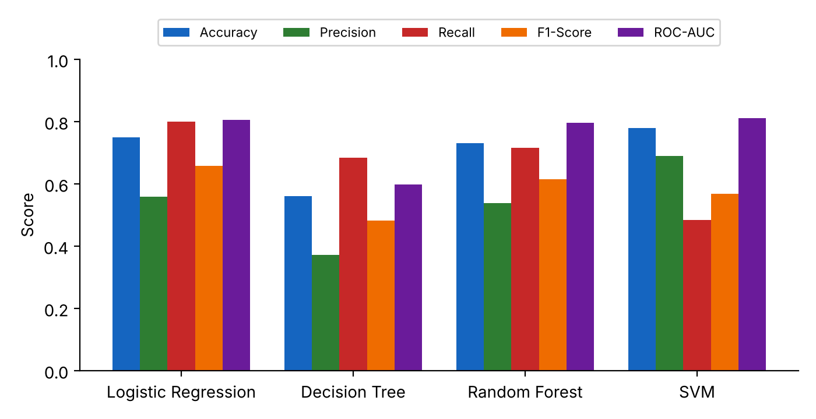
Fig 8.1 Model comparison across all metrics
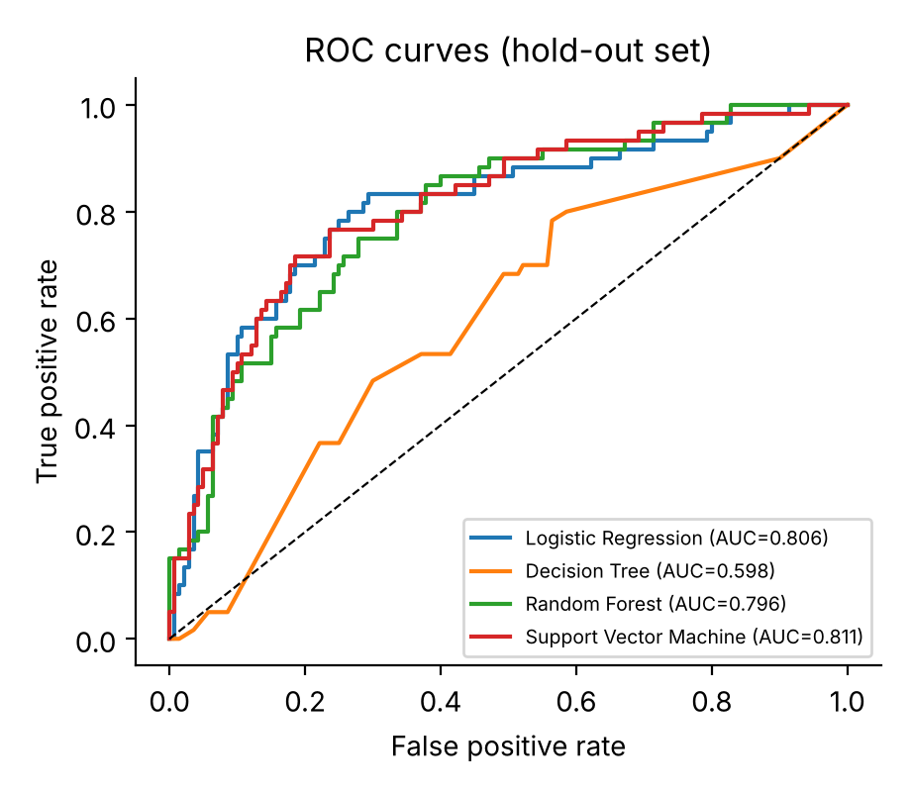
Fig 8.2 ROC curves of the four models
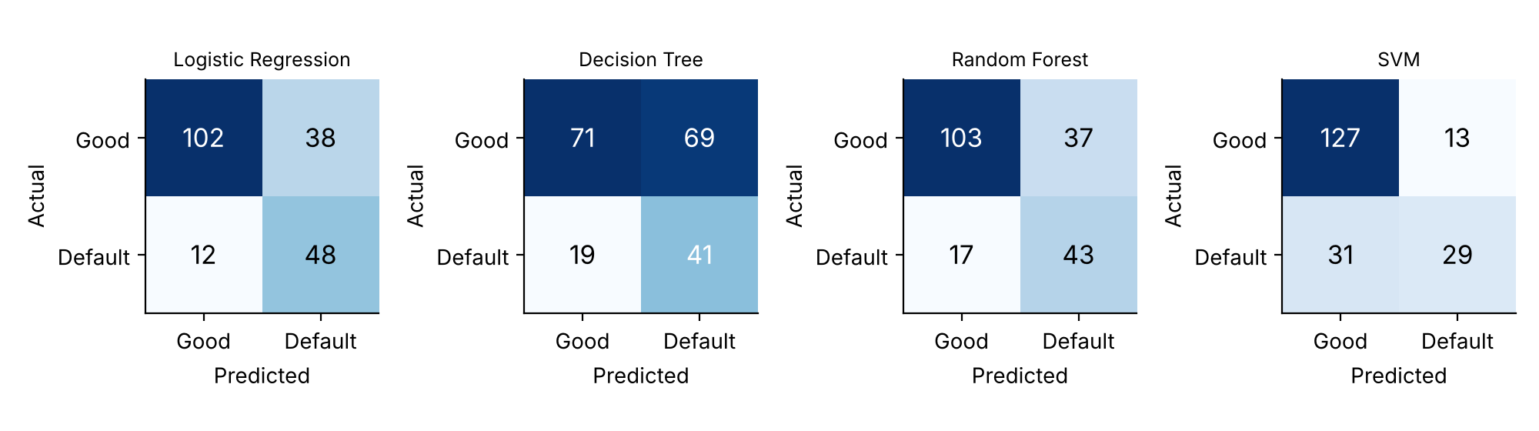
Fig 8.3 Confusion matrices of the four models

8.4 Discussion
- Random Forest: correctly flags 43 of 60 defaulters (recall 71.7%) and misses 17; it approves 103 of 140 good applicants and sends 37 for review. Its ROC-AUC of 0.797 is close to the best value.
- SVM: has the highest accuracy (78%) and AUC (0.811) but misses 31 of 60 defaulters (recall 48.3%), which is costly when a missed default is about five times worse than a false alarm.
- Logistic Regression: is very competitive (recall 80%, AUC 0.806) but is a linear model and does not offer exact tree-based SHAP; it is kept as an interpretable baseline.
- Decision Tree: is the weakest model (AUC 0.598).
Random Forest was therefore selected as a balance of discrimination, default detection and explainability. The test set is small (200 records), so differences of a few percentage points between models should be interpreted with caution.

8.5 Fairness audit
The fairness evaluator was applied to the Random Forest predictions on the 200-record test split, where approval means a predicted good borrower.
Table 8.3 Fairness audit results
Attribute (group A vs B) | Approval A | Approval B | DI ratio | Status
Gender (female vs male) | 55.7% | 61.9% | 0.901 | Acceptable
Age (< 25 vs ≥ 25) | 41.0% | 64.6% | 0.635 | Potential disparity
Foreign vs domestic worker | 59.3% | 83.3% | 0.711 | Potential disparity*
*Only 6 domestic workers are in the test split, so this ratio is statistically unreliable. The age result is a genuine warning: younger applicants are approved noticeably less often, which should be reviewed before any real use. This is why the model is positioned as decision support with a human in the loop.

CHAPTER 9
Deployment

9.1 Steps to deploy
1. Install Python 3.10, 3.11 or 3.12.
2. Copy the ds_PROJECT folder to the target machine.
3. Install dependencies: pip install -r requirements.txt
4. (Optional) Retrain the models: python -m src.model_trainer
5. (Optional) Run the tests: python test_system.py
6. Launch the app: streamlit run app.py
7. Open http://localhost:8501 in a browser.

9.2 Environment configuration
Paths, schemas and thresholds are centralised in src/config.py. A custom port can be given with: streamlit run app.py --server.port 8501 --server.headless true. If the models/ files are missing, load_trained_artifacts() automatically retrains and saves them.

9.3 Hosting
The application runs locally. It can be hosted on Streamlit Community Cloud, a virtual machine or a Docker container because it needs only Python and the packages in requirements.txt. Before real-world hosting, authentication and a database should be added.

CHAPTER 10
Challenges & Limitations

10.1 Issues faced during development
- Class imbalance: only 30% of records are defaults.
- Data leakage risk: scalers and encoders must never see test data.
- Cost asymmetry: accuracy alone hides the cost of missed defaulters.
- SVM probabilities: SVC does not natively give calibrated probabilities.
- Black-box predictions: lenders need reasons, not only scores.

10.2 Solutions applied
- Balanced class weights: all models use class_weight = balanced and are compared on recall and ROC-AUC as well as accuracy.
- Leak-free pipeline: stratified split first; transformers fitted on the training split only.
- Calibration: CalibratedClassifierCV with sigmoid method for the SVM.
- Explainability: SHAP, LIME and natural-language narratives, plus cohort and what-if tools.

10.3 Current limitations
- The dataset is small (1,000 records), old and from one German source, so results may not transfer to other institutions or countries.
- Only default hyperparameters near sensible values were used; no extensive tuning or gradient boosting has been tried.
- The fairness audit shows possible disparity for younger and foreign applicants; no bias mitigation is implemented yet.
- No authentication, database or model-drift monitoring; the system is not production hardened.
- Statistical explanations (SHAP/LIME) show associations, not causes.

CHAPTER 11
Future Enhancements

11.1 Planned features
- Train and validate on larger, more recent and locally collected loan portfolios.
- Tune hyperparameters and try gradient boosting (XGBoost, LightGBM).
- Optimise decision thresholds with cost-sensitive learning and handle imbalance with techniques such as SMOTE.
- Add bias mitigation for age and foreign-worker disparities.
- Monitor model drift and retrain periodically.

11.2 Possible integrations or optimizations
- Authentication and role-based access control.
- A database back end instead of JSON/CSV files.
- Cloud or container deployment with a REST API for integration with loan-origination systems.
- Additional behavioural and transaction-level features.

CHAPTER 12
Conclusion

12.1 Summary of the project
The Credit Risk Prediction System was implemented end-to-end on the 1,000-record German Credit dataset. Four classifiers were trained and compared, and Random Forest was selected for its ROC-AUC of 0.797, 71.7% default recall and exact SHAP explainability. Applicants are classified into Low, Medium and High risk, and the system adds explanations, similar-borrower cohorts, what-if simulation, a fairness audit and an audit log in a Streamlit web app.

12.2 What was achieved
- A leak-free preprocessing pipeline producing 61 model features.
- A four-model comparison on a 200-record hold-out set with six evaluation measures.
- Transparent, three-tier risk classification with recommended actions.
- An explainable and auditable decision-support application with an automated test suite.

12.3 Skills learned during development
The team gained practical experience in data preprocessing, exploratory analysis, supervised classification, model evaluation with imbalanced data, explainable AI (SHAP, LIME), fairness metrics, modular Python software design, automated testing and building web dashboards with Streamlit.

CHAPTER 13
References
[1] D. J. Hand and W. E. Henley, “Statistical classification methods in consumer credit scoring: A review,” J. Royal Statistical Society: Series A, vol. 160, no. 3, pp. 523–541, 1997.
[2] D. W. Hosmer Jr., S. Lemeshow, and R. X. Sturdivant, Applied Logistic Regression, 3rd ed. Hoboken, NJ, USA: Wiley, 2013.
[3] L. Breiman, “Random forests,” Machine Learning, vol. 45, pp. 5–32, 2001.
[4] C. Cortes and V. Vapnik, “Support-vector networks,” Machine Learning, vol. 20, pp. 273–297, 1995.
[5] S. Lessmann, B. Baesens, H.-V. Seow, and L. C. Thomas, “Benchmarking state-of-the-art classification algorithms for credit scoring: An update of research,” European J. Operational Research, vol. 247, no. 1, pp. 124–136, 2015.
[6] A. E. Khandani, A. J. Kim, and A. W. Lo, “Consumer credit-risk models via machine-learning algorithms,” J. Banking & Finance, vol. 34, no. 11, pp. 2767–2787, 2010.
[7] S. M. Lundberg and S.-I. Lee, “A unified approach to interpreting model predictions,” in Proc. NeurIPS, 2017, pp. 4765–4774.
[8] M. T. Ribeiro, S. Singh, and C. Guestrin, ““Why should I trust you?”: Explaining the predictions of any classifier,” in Proc. ACM SIGKDD, 2016, pp. 1135–1144.
[9] F. Pedregosa et al., “Scikit-learn: Machine learning in Python,” J. Machine Learning Research, vol. 12, pp. 2825–2830, 2011.
[10] D. Dua and C. Graff, “UCI Machine Learning Repository: Statlog (German Credit Data),” University of California, Irvine, 2019. [Online]. Available: https://archive.ics.uci.edu/ml

CHAPTER 14
Appendices

A. Screenshots of the application
[Insert screenshots here: (1) Applicant Assessment form, (2) Risk result card, (3) SHAP/LIME explanation, (4) Historical cohort, (5) What-if simulator, (6) Model performance and fairness audit, (7) Assessment history.]

B. Sample code – risk tier classification (src/config.py)
RISK_THRESHOLD_LOW = 0.28
RISK_THRESHOLD_HIGH = 0.58

def classify_risk_tier(default_prob):
if default_prob < RISK_THRESHOLD_LOW:
return "Low Risk"
elif default_prob < RISK_THRESHOLD_HIGH:
return "Medium Risk"
else:
return "High Risk"

C. Installation and setup
pip install -r requirements.txt
python test_system.py
streamlit run app.py
# open http://localhost:8501

D. Project folder structure
ds_PROJECT/
app.py Streamlit dashboard
credit_data.csv 1,000 x 21 dataset
test_system.py 9-point test suite
requirements.txt
src/ config, data_processor, model_trainer,
xai_engine, historical_matcher,
fairness_evaluator, history_store
models/ best_model, all_models, preprocessor (.joblib),
model_metrics.json, prediction_history.json

E. Certifications
[Attach any course or workshop certificates here.]

