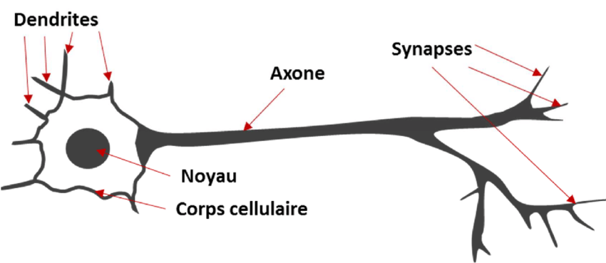

(Reche, 2019)

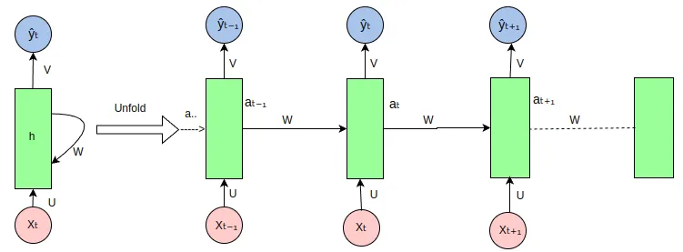

(Poudel, 2023)

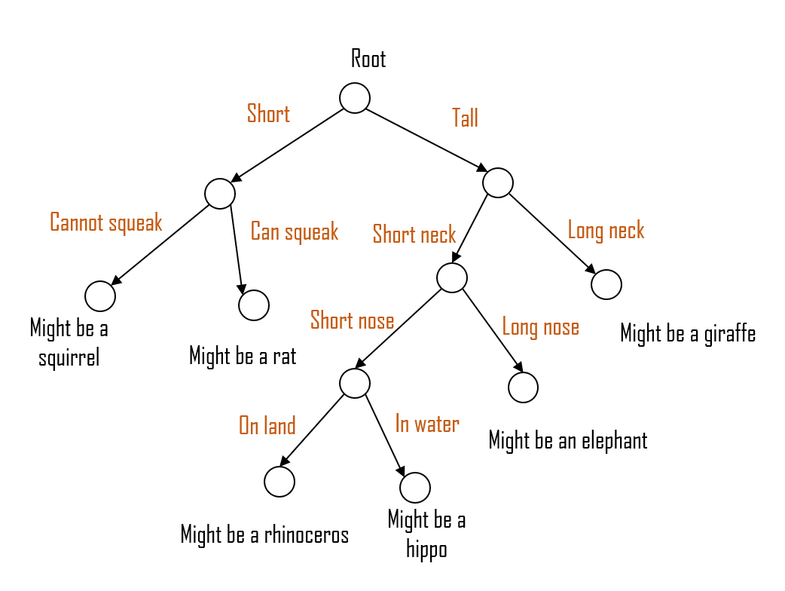

(Zhao, 2021)

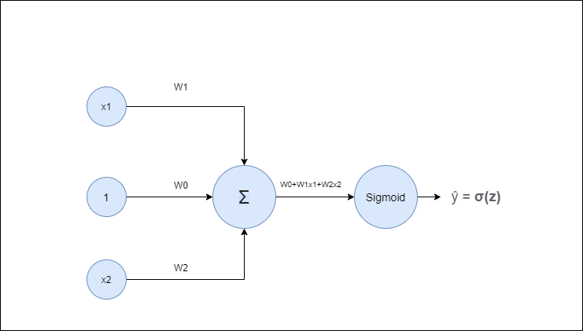

(Kumar, 2020)

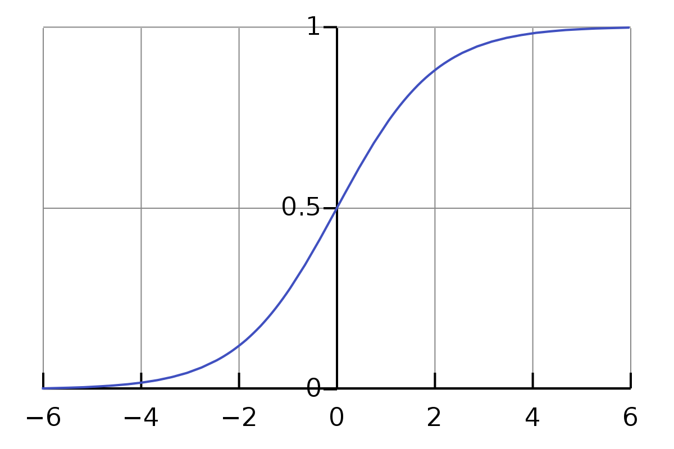

(Saleem, 2023)

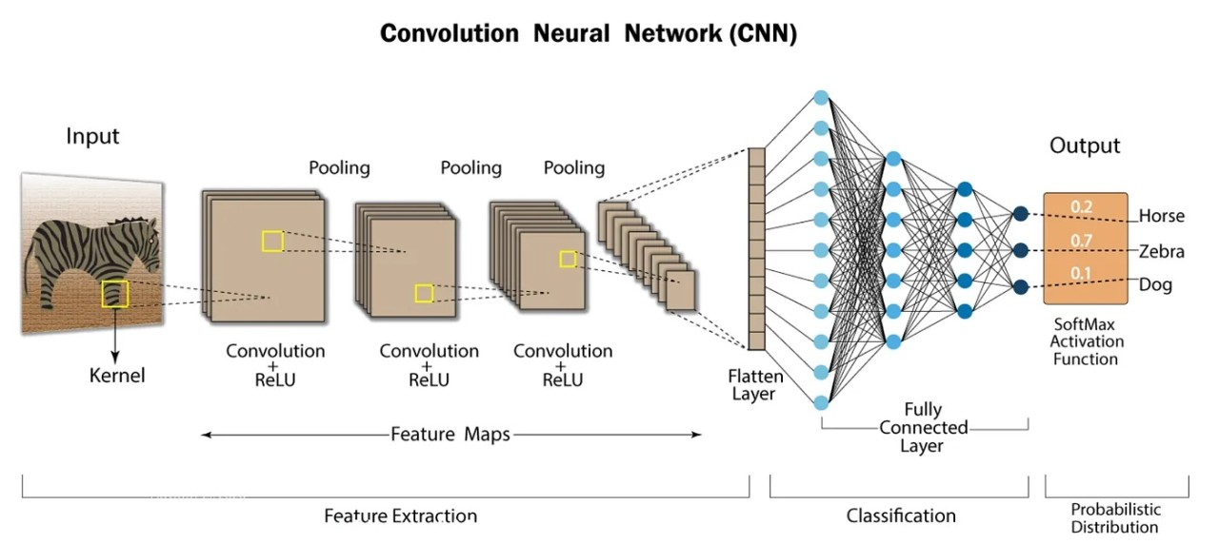

(Shahriar, 2023)

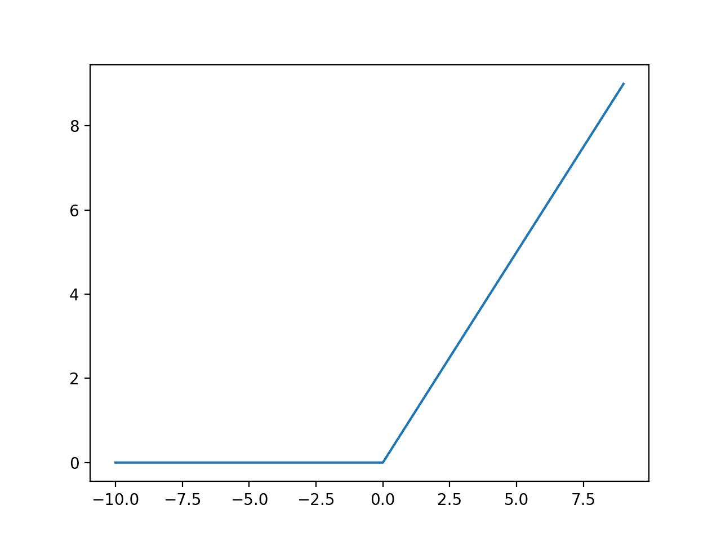

(Friedman, 2020)

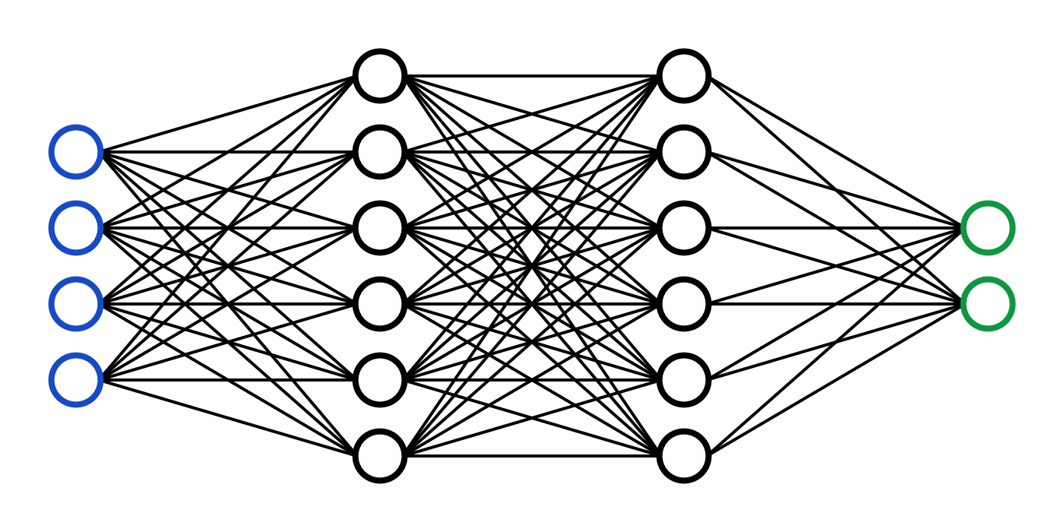

(Ahmad, 2020)

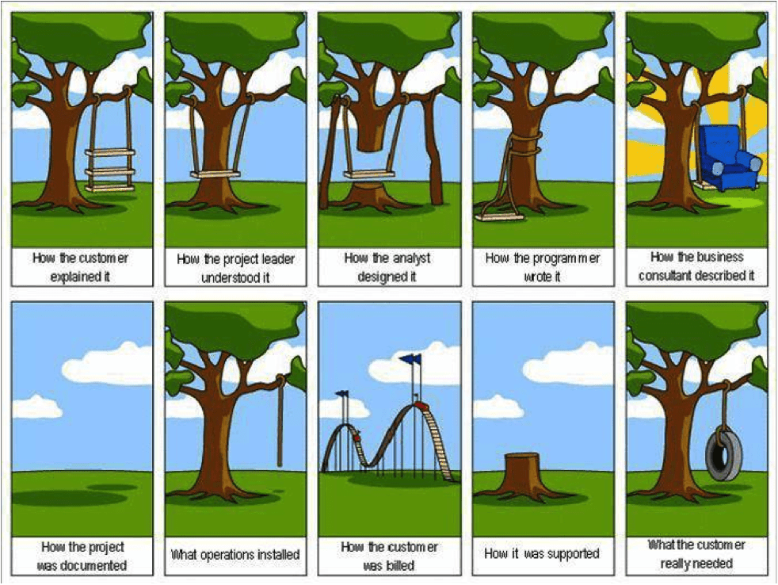

(Rooij, 2020)

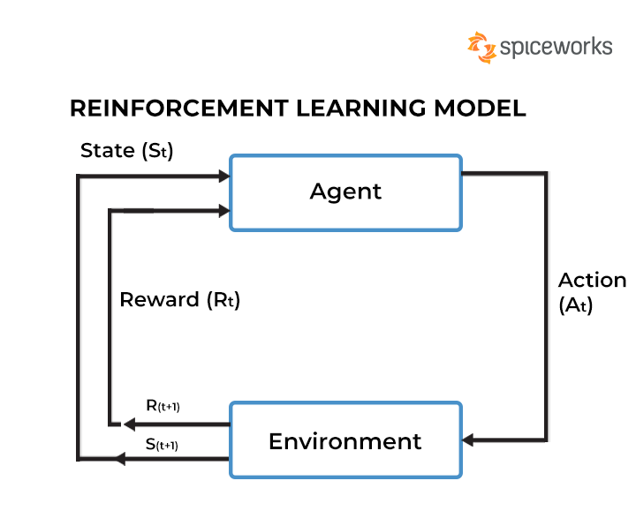

(Kanade, 2022)

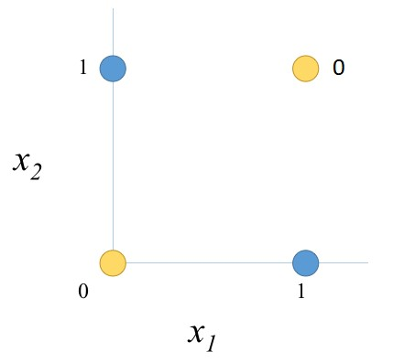

(Oman, 2016)

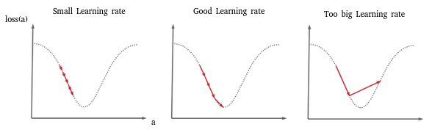

(Cayla, 2021)

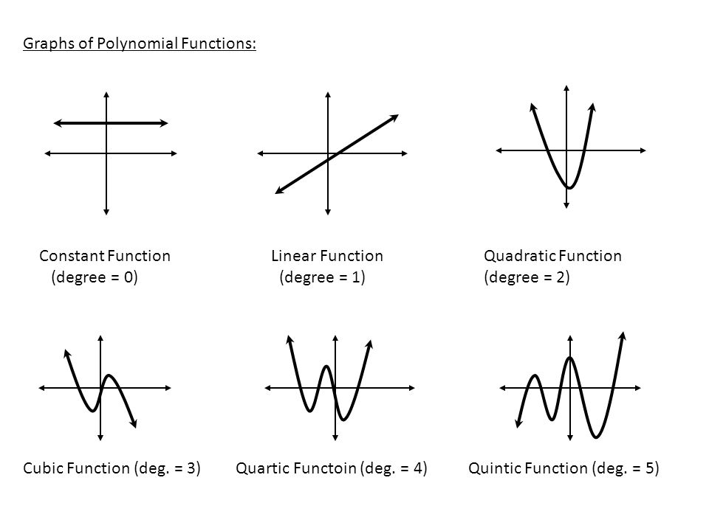

(Graph of polynomial functions, 2020)

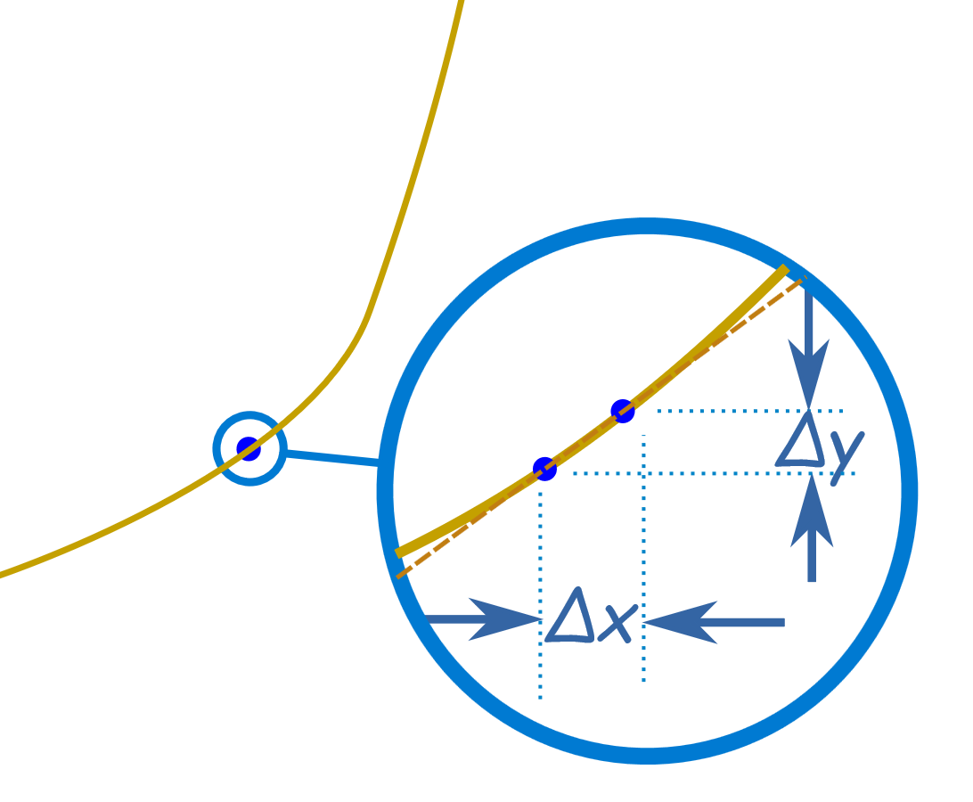

(mathisfun)

# Bibliography

Ahmad, B. (2020, Juillet). Basic design of a neural network.

Cayla, B. (2021, Mars 7). The Stochastic Gradient Descent (SGD) & Learning Rate.

Friedman, D. (2020). Relu Activation.

Graph of polynomial functions. (2020, Juin 20).

Kanade, V. (2022, Setempre 29). A Pictorial Representation of the Reinforcement Learning Model.

Kumar, V. (2020, Mai 4). Neural Network.

mathisfun. (n.d.). Introduction to Derivatives.

Oman, S. (2016, Janvier 11). Xor representation.

Poudel, S. (2023, Aout 28). RNN Unfolded.

Reche, J. (2019, Octobre). 7 : Schématisation d'un neurone biologique. Paris.

Rooij, P. V. (2020, Decembre 23). The four key questions for comprehensive knowledge management.

Saleem, M. (2023, Juillet). The standard logistic function.

Shahriar, N. (2023, Fevrier 1). Convolutional Neural Network — CNN architecture.

Zhao, O. (2021, Mars 24). What is a Decision Tree.