Problem Analysis

Requirements and business rules
Customers may register, sign in and out, search dated flights, inspect availability, book one to four passengers, retrieve their own reservations and cancel them. Administrators maintain airports, aircraft, routes, departures, fares and reservations. Roles are checked on the server. A public registration request always creates a customer; it cannot grant administrator privileges.
Each booking belongs to one customer and exactly one FlightInstance. Flight is a reusable route and flight number; FlightInstance is a particular departure, aircraft, arrival and fare. There is no multi-segment itinerary. Passenger records contain fictional names. The BookingPassenger junction makes group bookings explicit. SeatAssignment identifies a passenger’s seat on one departure and retains released allocations as history.
Rule | Implementation
Capacity | An aircraft owns a fixed set of Seat rows. An active seat can be assigned once per departure.
Fare | Positive integer cents. Total = saved unit fare × passenger count. Clients cannot set totals.
Booking states | Confirmed -> cancelled. No reopening; create a new booking.
Departure states | Scheduled -> cancelled. Cancelling a departure cancels its bookings atomically.
Payment | One simulated record per successful booking; cancellation changes it to voided.
Availability | Only future scheduled departures can be booked. Aircraft schedules cannot overlap.
Ownership | Every customer lookup and cancellation filters by authenticated user ID.

Transactions and constraints
Creation locks the dated departure before inserting all related rows in a single transaction. A generated active_seat value equals seat_id only while released_at is NULL. UNIQUE(instance_id, active_seat) prevents active duplicates while permitting multiple historical released rows. Composite foreign keys ensure the seat’s aircraft matches the departure and the allocation’s departure matches the booking. Rollback removes every insert if any passenger fails.

Entity Relationship Design
The diagram specifies the implemented ER model. SQL permits zero children; application transactions require 1 to 4 passengers and one payment per booking. PK = primary key; AK = alternate key; FK = foreign key. Each child FK is mandatory unless explicitly nullable. All twelve implemented tables are included.
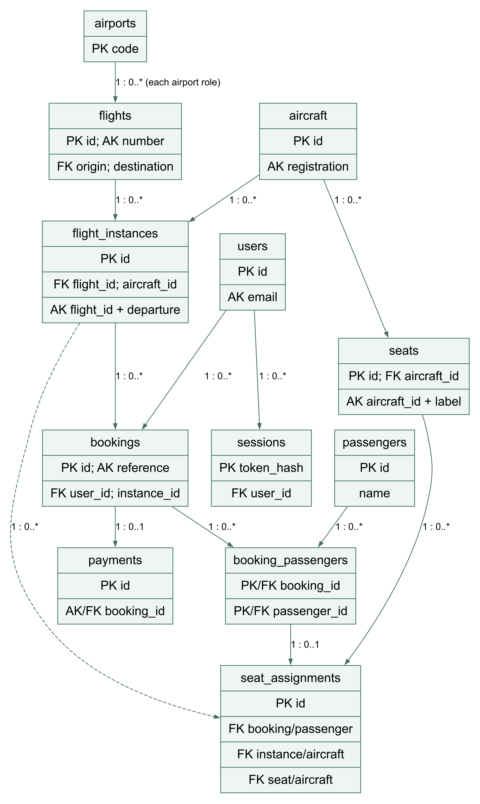
Additional composite FKs: seat_assignments(booking_id, passenger_id) -> booking_passengers; (booking_id, instance_id) -> bookings; (instance_id, aircraft_id) -> flight_instances; (seat_id, aircraft_id) -> seats. Each assignment requires exactly one matching parent in all four relationships.

Normalization and Dependencies

Unnormalized starting point
A spreadsheet reservation might store Reference, CustomerEmail, CustomerName, FlightNumber, OriginCity, Departure, AircraftRegistration, SeatList, PassengerNameList, Fare, Total and PaymentStatus in one row. Lists such as “1A, 1B” violate atomicity. Repeating customer, aircraft and airport descriptions creates update anomalies; deleting the last reservation could also delete the only stored airport information.

First normal form
Replace repeating passenger and seat lists with one row per booking and passenger. Each cell now holds one value. A tentative relation keyed by (BookingReference, PassengerID) still repeats booking fare, customer and flight details for every passenger. Inserting a route without a booking remains difficult, and updating a customer email in one row can leave conflicting copies.

Second normal form
Separate attributes dependent on only part of the composite key. BookingReference determines customer ID, departure ID, unit fare, total and status. PassengerID determines passenger name. BookingPassenger contains only the composite booking/passenger association. Each fact is now attached to its full key. SeatAssignment relates that pair to a seat and dated departure.

Third normal form
Remove transitive dependencies: UserID -> Email, Name, PasswordHash, Role; AirportCode -> Name, City, Timezone; AircraftID -> Registration, Model; FlightID -> Number, Origin, Destination; InstanceID -> FlightID, AircraftID, Departure, Arrival, CurrentFare, Status. Keeping these facts in separate tables avoids copying airport names or aircraft models into each reservation.
Dependency | Design consequence
(aircraft_id, label) -> seat_id | Seat labels are unique within an aircraft, not globally.
(flight_id, departure) -> instance_id | The same route can depart on many dates.
booking_id -> reference, user_id, instance_id, saved fare, status | Booking keeps its sale-time fare even after schedule fare edits.
(booking_id, passenger_id) -> seat assignment | A booked passenger has one seat for this single-segment itinerary.
booking_id -> payment amount and status | Unique payment booking_id implements at most one simulated payment.
Controlled redundancy: booking total and unit fare are sale-time financial snapshots; payment amount is a reconciliation record. Aircraft and instance IDs in assignments support composite integrity constraints. The generated active_seat is derived rather than manually updated. Data-quality queries check these deliberate repetitions.

Table Specifications Part One
MySQL 8.4 types. U means UNSIGNED. Null Y/N indicates SQL nullability. All identifiers are auto-increment unless a natural or composite key is stated. Exact DDL is schema.sql.
Table and column | Type | Null | Key or reference
aircraft.id | int U | N | PK
aircraft.registration | varchar(12) | N | AK
aircraft.model | varchar(80) | N | -
airports.code | char(3) | N | PK
airports.name | varchar(100) | N | -
airports.city | varchar(80) | N | -
airports.timezone | varchar(60) | N | -
flight_instances.id | bigint U | N | PK
flight_instances.flight_id | int U | N | indexed FK flights.id
flight_instances.aircraft_id | int U | N | indexed FK aircraft.id
flight_instances.departure | datetime | N | indexed
flight_instances.arrival | datetime | N | -
flight_instances.fare_cents | int U | N | -
flight_instances.status | ENUM status | N | -
flights.id | int U | N | PK
flights.number | varchar(10) | N | AK
flights.origin | char(3) | N | indexed FK airports.code
flights.destination | char(3) | N | indexed FK airports.code
seats.id | int U | N | PK
seats.aircraft_id | int U | N | indexed FK aircraft.id
seats.label | varchar(4) | N | -
sessions.token_hash | char(64) | N | PK
sessions.user_id | bigint U | N | indexed FK users.id
sessions.csrf_token | char(48) | N | -
sessions.expires_at | datetime | N | indexed
users.id | bigint U | N | PK
users.name | varchar(80) | N | -
users.email | varchar(200) | N | AK
users.password_hash | varchar(200) | N | -
users.role | ENUM role | N | -
users.created_at | timestamp | N | -
Alternate candidate keys: seats(aircraft_id,label), flight_instances(flight_id,departure). Composite UNIQUE superkeys seats(id,aircraft_id) and flight_instances(id,aircraft_id) support foreign keys; they are not minimal candidate keys. Role ENUM: customer/admin. Departure status ENUM: scheduled/cancelled. Check constraints reject equal origin/destination, nonpositive fares and arrival before or equal to departure.

Table Specifications Part Two
Table and column | Type | Null | Key or reference
booking_passengers.booking_id | bigint U | N | PK FK bookings.id
booking_passengers.passenger_id | bigint U | N | PK FK passengers.id
bookings.id | bigint U | N | PK
bookings.reference | char(16) | N | AK
bookings.user_id | bigint U | N | indexed FK users.id
bookings.instance_id | bigint U | N | indexed FK flight_instances.id
bookings.status | ENUM status | N | -
bookings.unit_fare_cents | int U | N | -
bookings.total_cents | int U | N | -
bookings.created_at | datetime | N | -
bookings.cancelled_at | datetime | Y | -
passengers.id | bigint U | N | PK
passengers.name | varchar(80) | N | -
payments.id | bigint U | N | PK
payments.booking_id | bigint U | N | AK FK bookings.id
payments.amount_cents | int U | N | -
payments.status | ENUM payment | N | -
seat_assignments.id | bigint U | N | PK
seat_assignments.booking_id | bigint U | N | indexed composite FK
seat_assignments.passenger_id | bigint U | N | composite FK
seat_assignments.instance_id | bigint U | N | indexed composite FK
seat_assignments.aircraft_id | int U | N | composite FK
seat_assignments.seat_id | int U | N | indexed composite FK
seat_assignments.released_at | datetime | Y | -
seat_assignments.active_seat | int U | Y | -
Booking status ENUM: confirmed/cancelled. Payment status ENUM: simulated/voided. active_seat is a stored generated INT U; it is NULL for released allocations. UNIQUE(instance_id,active_seat) and UNIQUE(booking_id,passenger_id) enforce inventory and passenger allocation rules. bookings(id,instance_id) is a composite UNIQUE superkey used by an FK, not a minimal candidate key.

Indexes and referential actions
Alternate candidate keys identify rows: users.email, aircraft.registration, flights.number, bookings.reference and payments.booking_id. Secondary indexes accelerate access without defining identity: sessions(expires_at), bookings(user_id,created_at), flight_instances(departure,status). MySQL also creates indexes needed by foreign keys; these are distinct concepts. All FKs use RESTRICT/NO ACTION on deletion and update except sessions.user_id, which cascades on user deletion. Parent records with history are preserved. Cancellation changes status instead of deleting business records. Composite FKs listed on page 2 all use RESTRICT. Enrollment, passenger-count and exactly-one-payment rules are enforced by application transactions; the ER diagram distinguishes those rules from SQL optionality.

