Solution Synthesis
Airline Reservation System connects fourteen individually supplied HTML pages to JSON routes in Node.js. Shared app.js handles forms and renders API results; styles.css provides consistent navigation, spacing, keyboard focus and mobile breakpoints. The interface distinguishes fictional reservations from valid airline tickets.
HTML file | Access | Purpose
index.html | Public | Route/date search
register.html | Public | Customer account creation
login.html | Public | Authentication
flights.html | Public | Search results
flight-details.html | Public | Schedule, fare, aircraft, seats
booking.html | Customer | Passenger names and seat selection
confirmation.html | Customer | Reference, fare, passengers, print
my-bookings.html | Customer | Owned lookup and cancellation
admin.html | Administrator | Operations overview
admin-airports.html | Administrator | Create/edit airport details
admin-aircraft.html | Administrator | Create aircraft/seats; edit model
admin-flights.html | Administrator | Define routes, schedule, fare, cancel
admin-reservations.html | Administrator | Inspect/cancel reservations
analytics.html | Administrator | KPIs, route occupancy, CSV
Public page shells contain no protected records. Protected API routes check the session and role before returning data. Client redirects help navigation but are not the security boundary.

Interface Wireframes
These wireframes illustrate the intended booking and analytics layouts. They are design illustrations, not screenshots or proof of browser execution.
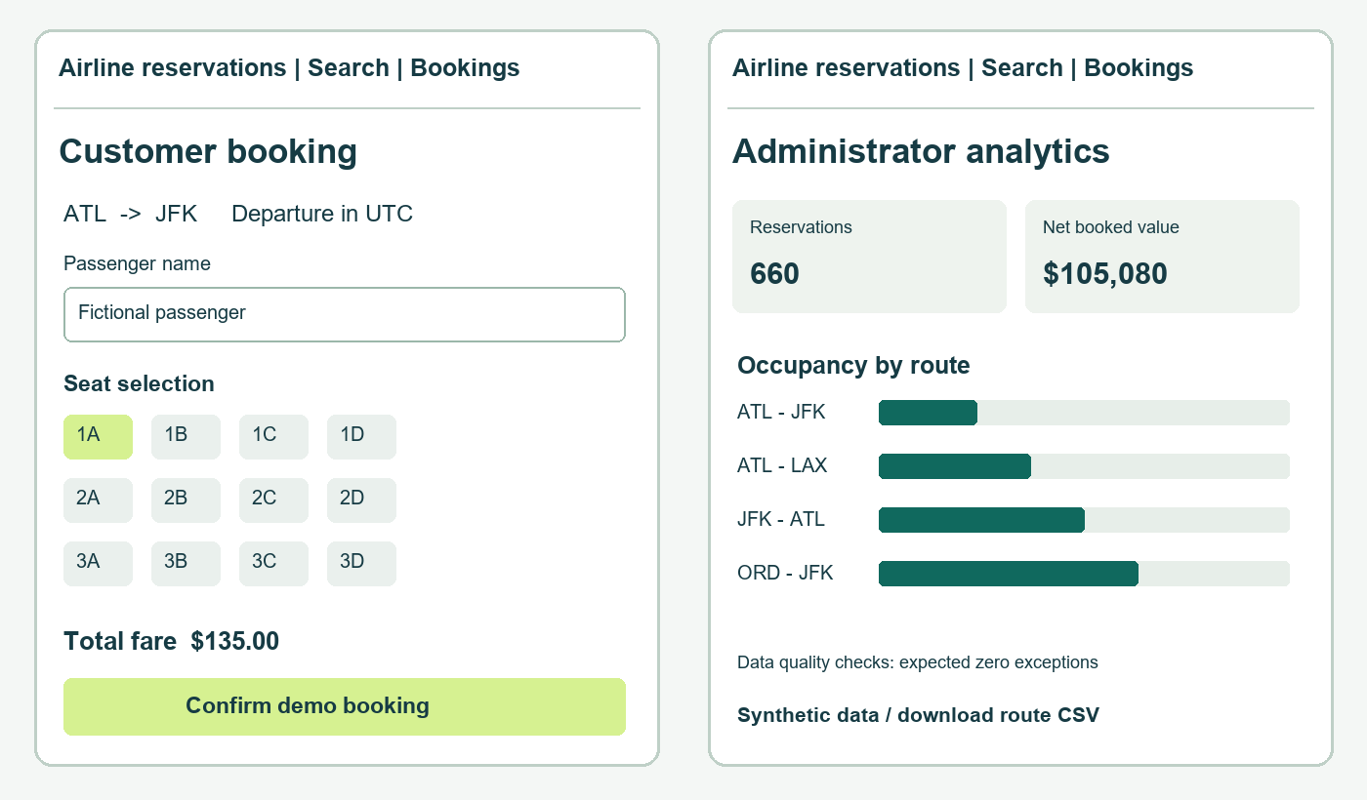

Customer journey
Search selects origin, destination and UTC date. Results show a flight number, fare and remaining seats. Details show departure, arrival, aircraft and the single-flight scope. Booking collects one to four names and a seat per passenger. The confirmation supplies the saved reference and total. My bookings lists owned reservations, supports reference filtering and asks for confirmation before cancellation.

Administrator journey
Create an airport, add an aircraft and generated seat layout, define a route, then schedule a dated departure. The server rejects an overlapping aircraft schedule. An administrator can change the selling fare or cancel a departure; cancellation updates reservations, allocations and payments together. Historical fares remain unchanged. Route definitions with instances cannot be rewritten.

Inputs Outputs and Interaction States
Surface | Validation and output
Registration | Name 1–80 characters; email syntax and max 200; password 12–128. Duplicate emails return an error.
Login | Generic invalid-credentials message. Database session lasts 8 hours. Sign-out revokes the session.
Search | Different three-letter airports and valid calendar date. No matches renders an empty-state message.
Booking | 1–4 nonblank passenger names; different seats on the selected aircraft. Occupied seats disabled in UI; server rechecks.
Confirmation | Reference, status, route, date, passenger names, seats and saved total. Print stylesheet hides controls.
Administration | Required fields; valid IANA timezone; future ordered timestamps; positive fare; overlap validation.
Errors and loading | Status region announces errors. Loading placeholders appear while fetching; booking button disables during submission.

Accessibility and responsive behavior
Forms use visible labels, native controls and keyboard focus outlines. A skip link bypasses navigation. Status messages use an aria-live region. At narrow widths the search and content grids stack. Tables scroll horizontally. Occupied seat radios are disabled and labeled; status labels also use text. The owner reported successful narrow-window and keyboard checks on October 10, 2026. Print preview was visually verified after the CLI fix. Actual mobile-device and assistive-technology testing remain unverified; no accessibility compliance is claimed.

Communication and storage
The browser sends JSON using fetch. The server validates inputs, resolves the database session, checks customer ownership or administrator role, and executes parameterized MySQL statements. Mutating authenticated routes require a CSRF token. The server returns JSON and appropriate HTTP codes; no database credentials are included in HTML or JavaScript.

Feature Traceability
Feature | Page and route | Tables
Accounts | register/login; POST /api/register, /login, /logout | users, sessions
Search/details | index, flights, flight-details; GET /api/flights and /:id | airports, flights, flight_instances, aircraft, seats, seat_assignments
Group booking | booking; POST /api/bookings | bookings, passengers, booking_passengers, seat_assignments, payments
Lookup/print | confirmation, my-bookings; GET /api/bookings | bookings plus route, passenger and seat joins
Cancellation | my-bookings; POST /api/bookings/:id/cancel | bookings, seat_assignments, payments
Airport/aircraft | admin-airports/aircraft; /api/admin/airports and /aircraft | airports, aircraft, seats
Flight scheduling | admin-flights; /api/admin/flights and /instances | flights, flight_instances
Admin reservation | admin-reservations; GET /api/admin/reservations; POST /:id/cancel | bookings, users, flight_instances, flights, allocations, payments
Analytics/export | analytics; GET /api/admin/analytics and /analytics.csv | bookings, flights, flight_instances, seats, allocations, payments

Design exclusions
No connecting itineraries, discount programs, vacation planning, hotel/car inventory, email delivery or real payment gateway. Single-segment bookings keep the relationship model explainable and allow strong tests of the required workflow. Additional portfolio value comes from SQL analysis, explicit metrics and data-quality checks.

