PROFILE – Engineering-focused high school student with leadership, research and quality engineering experience. Passionate about improving systems by understanding people, data and processes.

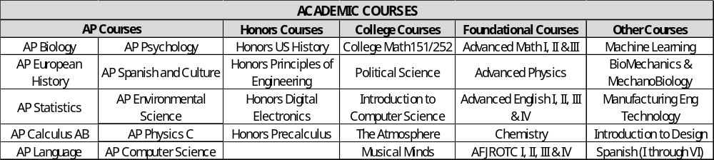

SKILLSET –
- Technical Skills – Literature research, DMAIC, Root Cause Analysis, Pareto Charts, Fishbone Diagram, Use of Statistical tools, AutoCAD (ONSHAPE), Python, Documentation, Process Improvement.
- Soft Skills – Leadership, Communication, Project Management, Coaching, Collaboration, Fund-raising, Negotiation, Problem-Solving, Mentoring

ACHIEVEMENTS AND AWARDS –
- Published Engineering Research Paper in Journal - https://ijsrp.org/research-paper-0626.php?rp=P17414283
- Undergraduate degree in Indian Classical dance – KATHAK (University – Pracheen Kala Kendra, India) (2024)
- AP Scholar Award based on exams offered by College Board by end of Junior Year
- Won a U.S President’s Award (PVSA) for volunteering leadership and raising funds for NGO - Akshay Patra (2024)
- Placed 3rd in California State Science Olympiad in Experimental Design (2022)
- Badminton – 2026 – Runners Up at Stay Classy Invitational (Individual); Semifinalist at CIF tournament (Team); 2024 – Semifinalist at San Diego Badminton Rookie tournament; First Freshman in 20 years of Scripps Ranch High School to start off in Varsity Tournament Opener; 2019 Bronze Medal at Palm Springs Badminton Championship.
- Gifted and Talented Education Seminar Identified Student (2018-PRESENT)

ENGINEERING EXPERIENCE –
Fluid Power AI – Battery data startup company Summer 2025; June 2026 – August 2027
Engineering Intern
- Consolidated manufacturing documentation to reduce errors by 2%.
- Improved assembly instructions using user feedback to improve 26 discrepancies.
- Redesigned phone holder for more consistent and safe data collection to improve accuracy by 7%.
- Applied continuous improvement principles.
- Ongoing Project – Identify cause for premature battery death through Design of Experiments.
Engineering Outreach – Independent Passion Project to increase awareness June 2024 - August 2027
- Surveyed 1,300+ participants to increase awareness by 30%.
- Published children's engineering book. – “Maya and Jasper’s Engineering Adventures”
- Presented engineering workshops to increase clarity about engineering majors by 19%.
Engineering College Programs June 2026 – July 2026
- 2-week program – OPERATION CATAPULT at Rose-Hulman Institute of Technology
- 1-week program – EPIC at California Polytechnic State University, San Luis Obispo

