In this section, we used Absolute Binding Free Energy (AB-FEP+) calculations to enrich virtual screening results. For that we generated custom force field parameters and set up to examine AB-FEP+ results of our chosen SBVS and LBVS ligands to enrich the AmpC Case Study virtual screening results. Our SBVS and LBVS ligand libraries were profiled, filtered, prepared before we conduct anything further. But from module 3 to module 6 we have learned how to validate target and screen and prepare library of ligands by structure-based virtual screening and ligand-based virtual screening. In the following we will mention the outline of the process:

From work of Scoichet and coworkers (*Structure* 10, no. 7 (2002): 1013-1023) we know that $β-lactamases$ are the most widespread resistance mechanisms to $β-lactam$ drugs. They used a database of over 200000 compounds to validate their docking in the active site of AmpC $β-lactamase$ to identify potential inhibitors. Among them 56 were tested. Three had Ki values of 650 $μM$ or better. The best of these, STC (3-[(4-chloroanilino)sulfonyl]thiophene-2-carboxylic acid), was a competitive noncovalent inhibitor (Ki = 26 μM), which also reversed resistance to β-lactams in bacteria expressing AmpC. The structure of AmpC in complex with this compound was determined by X-ray crystallography to 1.94 Å and reveals that the inhibitor interacts with key active-site residues in sites targeted in the docking calculation. Indeed, the experimentally determined conformation of the inhibitor closely resembles the prediction. After that, Lyu et al. (Nature 2019, 566, 224-229) used structure-based docking to screen virtual libraries of 99 million molecules, 1 million clustered by scaffold. 51 top-ranking molecules with different scaffolds were selected for testing. 44 compounds were successfully synthesized and tested; 5 of them inhibited AmpC.

Protein 1L2S(Chain A and Chain B) comes with co-crystalized ligand or inhibitor, STC. Before docking and AB-FEP+, we prepared and validated the target and since chain A apparently has the active site to bind ligand we will use only chain A to analyze AB-FEP+. From the sitemap analysis it appears that, evaluated active site and identified potential site 1 coincide with position of cognate ligand in Chain A. Watermap analysis reveals that no water molecules with free energy > 4Kcal/mol get displaced from the binding pocket.

Then ligand libraries were prepared, some of which contain compounds that are known AmpC $β-lactamase$ inhibitors. To do that, AmpC $β-lactamase$ DUD-E library was profiled and filtered. This library contains a mixture of known actives and decoys and were used as part of the validation study to assess whether our targets (Chain A and Chain B) can identify known binders effectively. Then LigPrep used to prepare the DUD-E library and cognate ligand for a docking validation study. It is good practice to perform docking validation using known binders prior to running a structured-based virtual screen. Before conducting docking with cognate ligands and AmpC DUD-E ligands library, 4 receptor grids were prepared (Chain A-dry-no-constraints, Chain A-constraints, Chain B-dry-no-constraints, Chain B-constraints). We filtered DUD-E library to 2898 compounds library, and after preparation with LigPrep we found 65 actives (48 actives with multiple conformations of several compounds) and 4133 decoys (2850 decoys with multiple conformations). Then they were docked in 4 receptor grids (Chain A-dry-no-constraints, Chain A-constraints, Chain B-dry-no-constraints, Chain B-constraints) to rank their docking scores.

We also prepared ligand library by using shape-based screening of a chemical library with GPU Shape which were profiled and filtered from ~2M enamine REAL ligands library. Cognate ligands and AmpC DUD-E actives that were prepared with LigPrep to select probe molecules. After that DISE-like selection of ordered compounds were used to assess and potentially enhance the diversity of virtual screen results. That helped to reduce the compounds to a more manageable set of 1000 SBVS hits and 1000 LBVS hits. Then further clustering and strain assessment were conducted to reduce the compounds to 200 for each group.

Based on the docking score, strain(kcal/mol), strain docking score we selected two hits from SBVS compounds and based on the shape score, (kcal/mol) we selected two hits from LBVS compounds, mentioned in below:

|  |  |  |  |  |  |  |
| --- | --- | --- | --- | --- | --- | --- |
| **Vendor ID** | **Native rank** | **Docking score** | **Shape Similarity** | **Strain (Kcal/mol)** | **Strain docking score** | **RMSD, $Å$** |
| **SBVS hits** | | | | | |  |
| **Z3357096556** | **48** | **-8.520** |  | **0.583** | **-8.520** | **1.4796** |
| **Z3789971937** | **373** | **-8.025** |  | **0.206** | **-8.025** | **1.1947** |
| **LBVS hits** | | | | | |  |
| **Z2273863002** | **42** | **-5.194** | **0.656** | **0.810** |  | **0.9278** |
| **Z1739286355** | **121** | **-3.627** | **0.624** | **0.147** |  | **2.1273** |

Comparing all the properties of LBVS hits we chose compound 42 and compound 48 from SBVS to carry out the AB-FEP+ in order to further enrich the results and create more reliable purchase list. we conducted absolute binding free energy perturbation method to predict binding free energies for top two compounds (1 from SBVS and another from LBVS).

We conducted 5~ns AB-FEP+ MD simulation ($μVT or grand canonical ensemble$) at 300 K on our chosen hits (1 from SBVS and another from LBVS) and 1L2S Chain A (apo dry) in water and Na+Cl-(no ion for LBVS hit).

From the analysis we got the following results:

|  |  |  |  |  |  |  |
| --- | --- | --- | --- | --- | --- | --- |
| **Vendor ID** | **Native rank** | **Docking score** | **Shape Similarity** | **Strain (Kcal/mol)** | **Strain docking score** | **RMSD, $Å$** |
| **SBVS hits** | | | | | |  |
| **Z3357096556** | **48** | **-8.520** |  | **0.583** | **-8.520** | **1.4796** |
| **Z3789971937** | **373** | **-8.025** |  | **0.206** | **-8.025** | **1.1947** |
| **LBVS hits** | | | | | |  |
| **Z2273863002** | **42** | **-5.194** | **0.656** | **0.810** |  | **0.9278** |
| **Z1739286355** | **121** | **-3.627** | **0.624** | **0.147** |  | **2.1273** |

|  |  |  |
| --- | --- | --- |
| **Vendor ID** | **pred dg (Kcal/mol)** | **pred dg error**  **(Kcal/mol)** |
| **Z3357096556** | **-5.9** | **0.13** |
| **Z2273863002** | **-1.93** | **0.13** |

|  |  |  |  |  |  |  |
| --- | --- | --- | --- | --- | --- | --- |
| **Vendor ID** | **Native rank** | **Docking score** | **Shape Similarity** | **Strain (Kcal/mol)** | **Strain docking score** | **RMSD, $Å$** |
| **SBVS hits** | | | | | |  |
| **Z3357096556** | **48** | **-8.520** |  | **0.583** | **-8.520** | **1.4796** |
| **Z3789971937** | **373** | **-8.025** |  | **0.206** | **-8.025** | **1.1947** |
| **LBVS hits** | | | | | |  |
| **Z2273863002** | **42** | **-5.194** | **0.656** | **0.810** |  | **0.9278** |
| **Z1739286355** | **121** | **-3.627** | **0.624** | **0.147** |  | **2.1273** |

From the results we can see that compound 48 from SBVS shows the higher binding affinity than compound 42 from LBVS with 1L2S chain A.

Please check the attached pdf file of the results from both ligands and protein.

In the interest of time, you were asked to run absolute binding FEP+ for just two hits. In reality, for a prospective screen you would want to use FEP+ to generate binding affinity predictions for as many hits as your computational resources allow, and we have done this for you, so that you can see your results in the context of a larger number of hits.

As well as strain energy rescoring, the 200 clustered structure-based hits were rescored using MM-GBSA. The top 50 compounds in terms of strain docking score along with the top 50 compounds ranked by the MM-GBSA free energy of binding prediction were then subjected to absolute binding FEP+. The absolute free energy of binding was also computed for five known binders; the 1L2S cognate ligand, along with the four ligands identified in the Shoichet paper (PDBs: 6DPZ, 6DPY, 6DPX, 6DPT). The results can be seen in the histogram below.

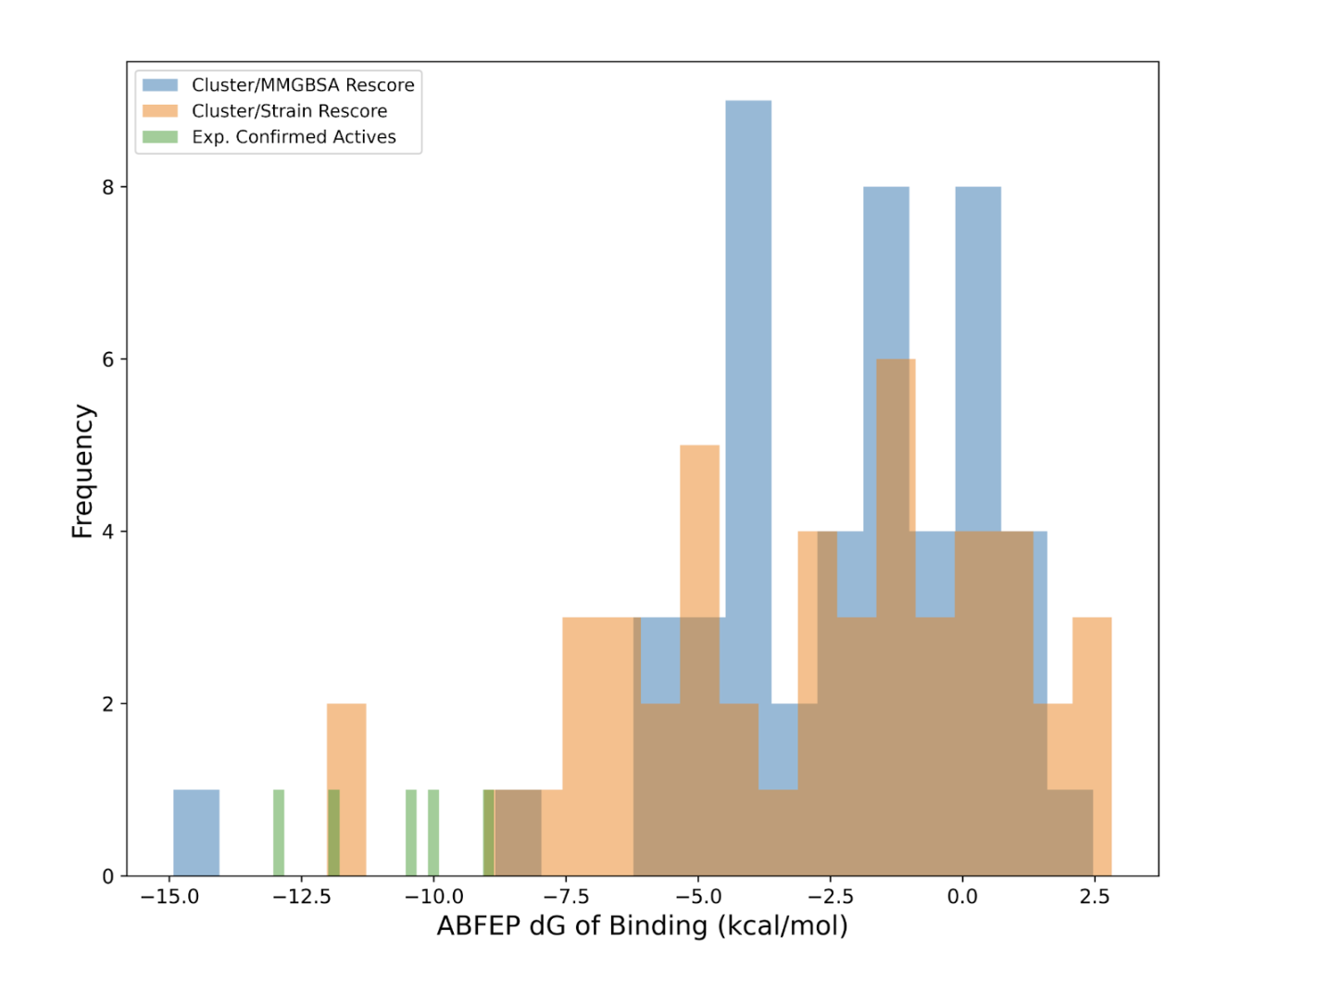

Consider your AB-FEP+ results in the context of these results, and think about whether you would still add your chosen hits to the list for purchase, synthesis, and testing.