SuprMentr – Assignment(9th Feb 2026):

Assignment: Internet Explorer.
Draw and explain the client-server architecture and trace what happens when you open a website.

Ans: 1. Client–Server Architecture

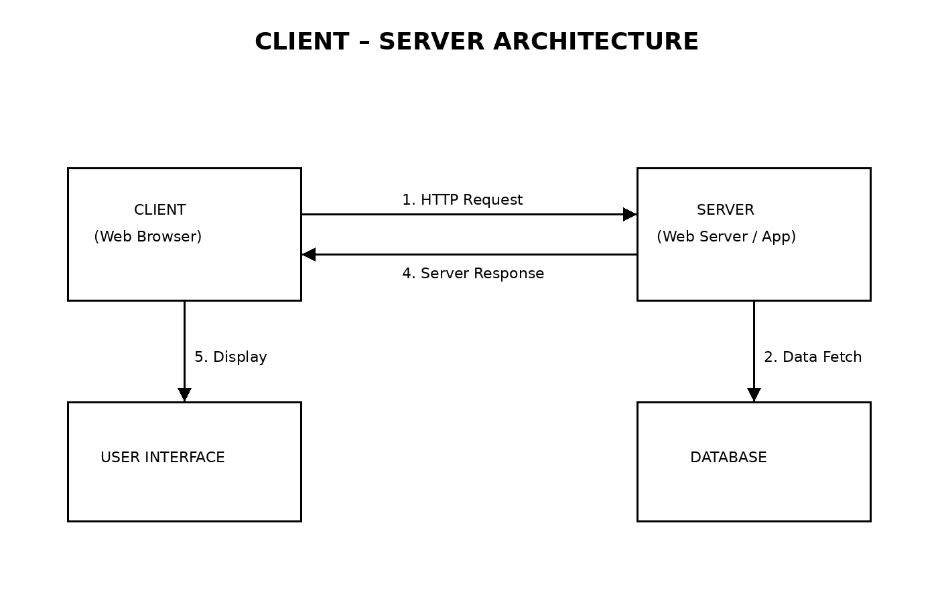
Fig: Client–Server Architecture.

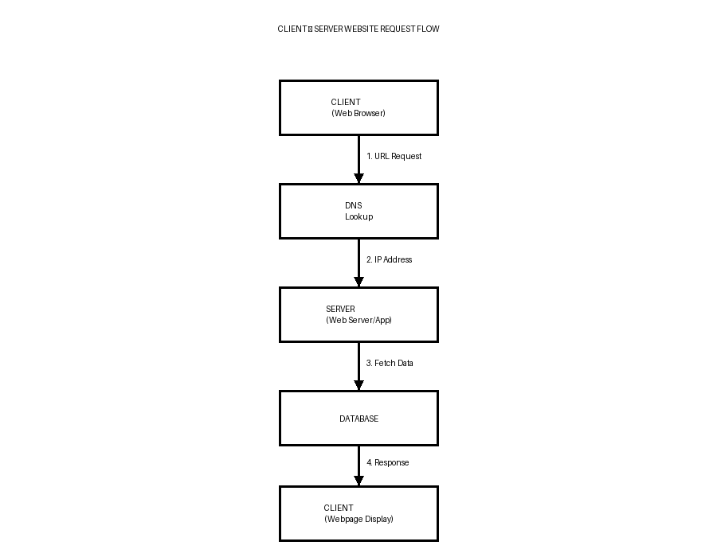
Fig: Website Request Flow.

Explanation:
Client–Server Architecture is the basic model on which the internet and web applications work.
- Client
The client is the user’s device or software that requests services.
Examples:
- Web browsers(Chrome, Edge, Firefox, Internet Explorer).
- Mobile apps.

Functions:
- Sends requests to servers.
- Displays webpage content.
- Handles user interaction.
- Server
The server is a powerful computer/system that provides resources or services.
Examples:
- Web servers(Apache, Nginx).
- Application servers.
- Cloud servers.
Functions:
- Processes client requests.
- Runs backend code.
- Retrieves data from database.
- Sends response back.
- Database(Supporting Component)
- Stores website data.
- Example: user accounts, posts, products.

Simple Real-Life Example:

Client = You ordering food on Swiggy.
Server = Swiggy system processing order.
Database = Restaurant menu + user details.

2. What Happens When You Open a Website?
Example: www.google.com
Step-by-Step Process
- User Enters URL
You type:
www.google.com in the browser address bar.
Browser = Client.
- DNS Lookup Happens
- Browser asks: “Where is this website located?”
- DNS(Domain Name System) converts domain → IP address.
Example:
www.google.com → 142.250.xxx.xxx
Like converting contact name → phone number.
- Browser Sends HTTP/HTTPS Request
Browser sends a request to server:
GET / HTTP/HTTPS
This request travels through the internet.
- Request Reaches Web Server
Server receives request and checks:
- What page is requested?
- Any backend processing needed?
- Server Processes the Request
Server may:
- Run backend code(Node.js, Python, Java, etc).
- Fetch data from database.
- Authenticate user(if login).
- Server Sends Response
Server returns:
- HTML → Structure.
- CSS → Styling.
- JavaScript → Functionality.
- Images / Videos.
This is called HTTP Response.
- Browser Renders the Webpage
Browser:
- Reads HTML.
- Applies CSS.
- Executes JavaScript.
- Displays final webpage visually.
Now you see Google homepage.

Process Flow:
1. Enter URL.
2. DNS converts domain → IP.
3. Browser sends request.
4. Server receives request.
5. Server processes data.
6. Server sends response.
7. Browser displays webpage.

3. Components Involved

Component | Role
Browser | Sends request & displays page
DNS | Converts domain to IP
Internet | Transfers data
Server | Processes request
Database | Stores website data

4. Importance of Client–Server Architecture
- Enables web browsing.
- Supports web applications.
- Handles multiple users.
- Centralized data storage.
- Improves scalability & security.

5. Conclusion
The client–server architecture forms the backbone of modern web development. It enables communication between users and web services through structured request and response cycles. Understanding how a browser interacts with servers, DNS and databases helps in building efficient full stack applications. This knowledge provides a strong conceptual foundation for learning frontend, backend and API communication in future development tasks.

