SuprMentr – Assignment(5th March 2026):

Assignment: Component Hunt.
Break a popular website into components and sketch the structure.

Ans: 1. Website Chosen
Amazon Homepage
Amazon is a good example because it contains many reusable UI parts like navbar, product cards, search bar, etc.

2. Main Components Breakdown
- Header Component

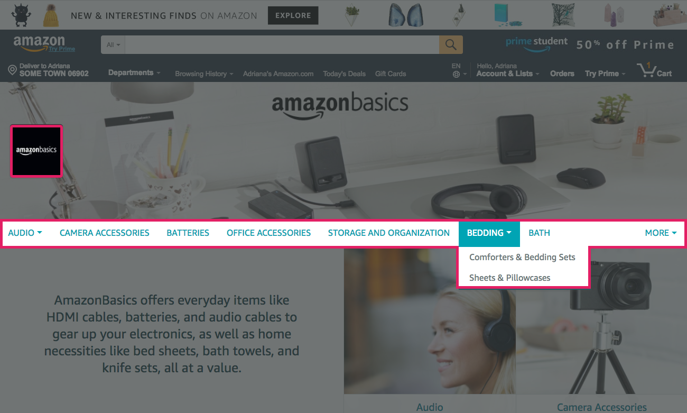
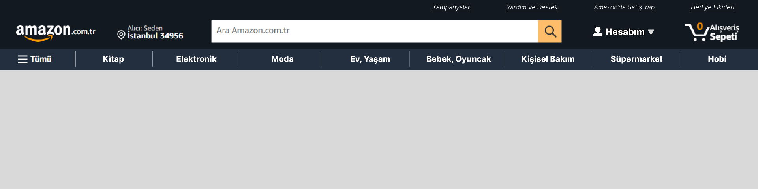

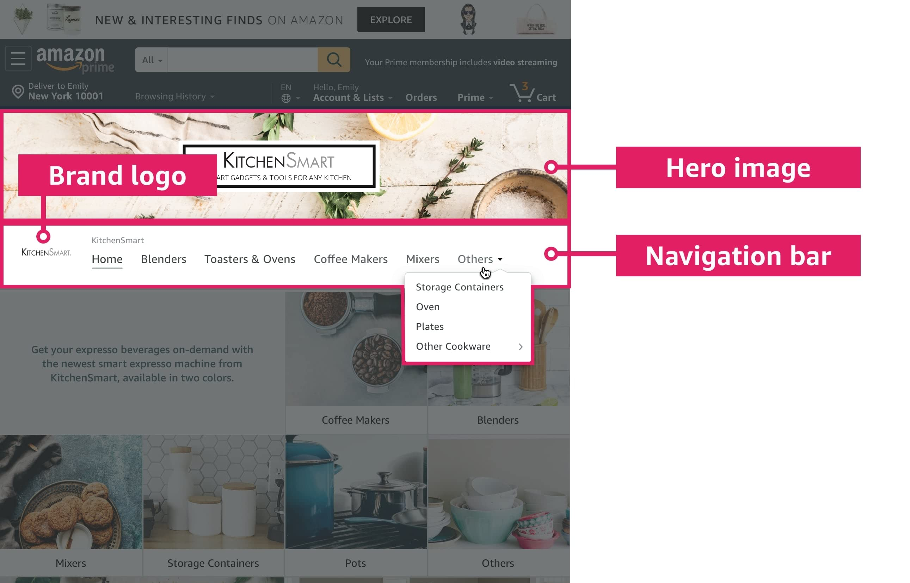

Sub-components inside Header:
  - Logo.
  - Location selector.
  - Search Bar.
  - Language Selector.
  - Account & Lists.
  - Orders.
  - Cart Icon.

Component Structure:
Header
├── Logo
├── Location
├── SearchBar
├── LanguageSelector
├── AccountMenu
├── Orders
└── CartIcon

- Navigation Menu Component

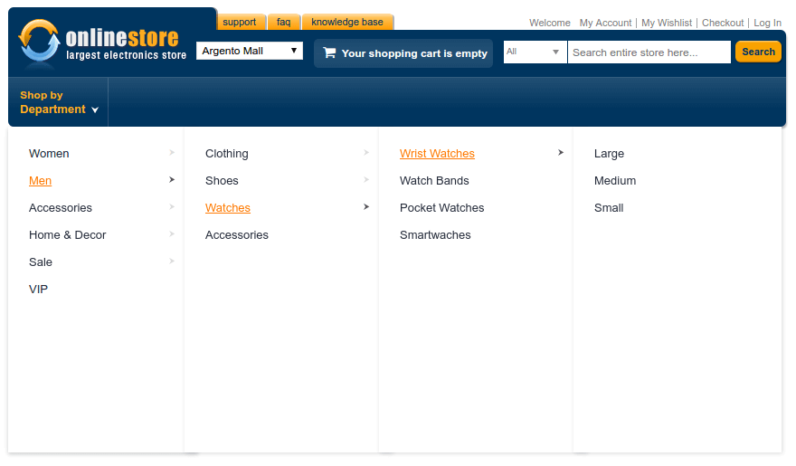


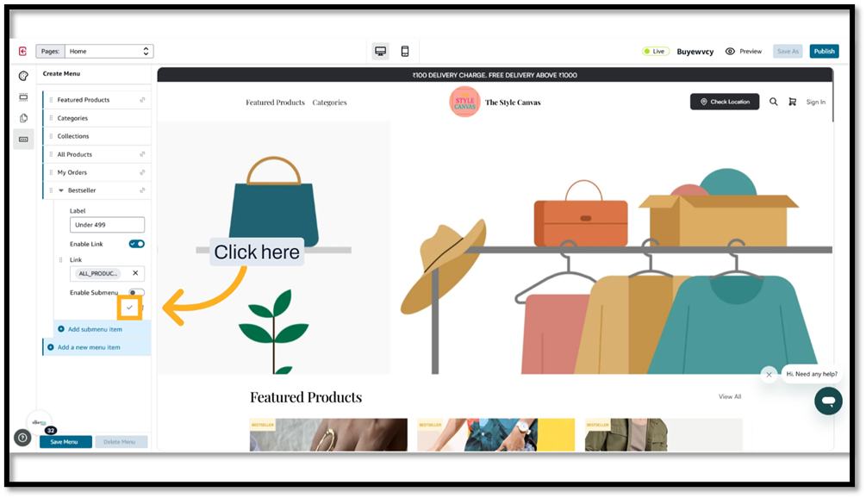

Sub-components:
  - All Menu Button.
  - Category Links (Today's Deals, Electronics, Fashion, etc).

Component Structure:
NavMenu
├── MenuButton
├── CategoryLink
├── CategoryLink
└── CategoryLink

- Banner / Hero Section
Sub-components:
- Banner Image.
- Slider Controls.
- Promotion Text.

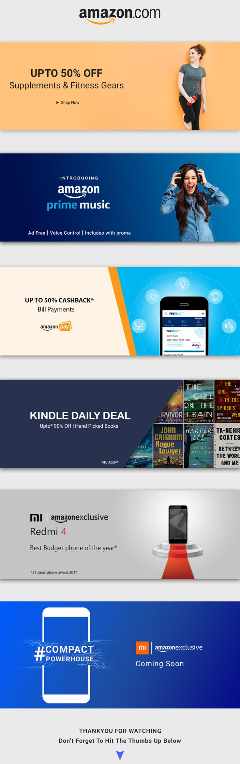



Component Structure:
HeroBanner
├── BannerImage
├── SliderControls
└── PromotionText

- Product Section

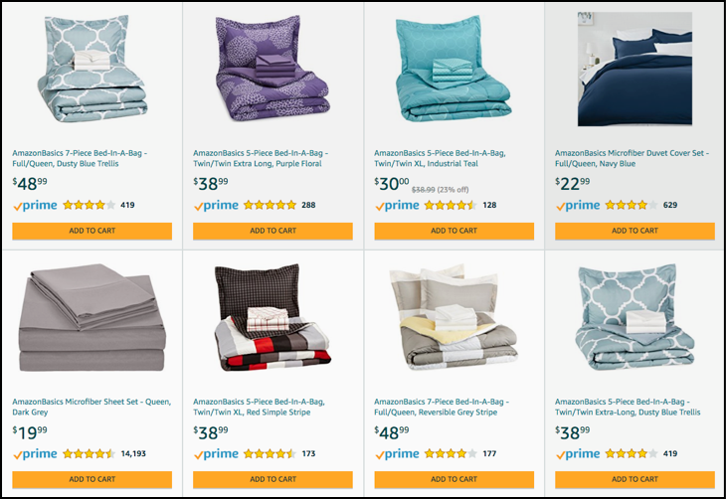

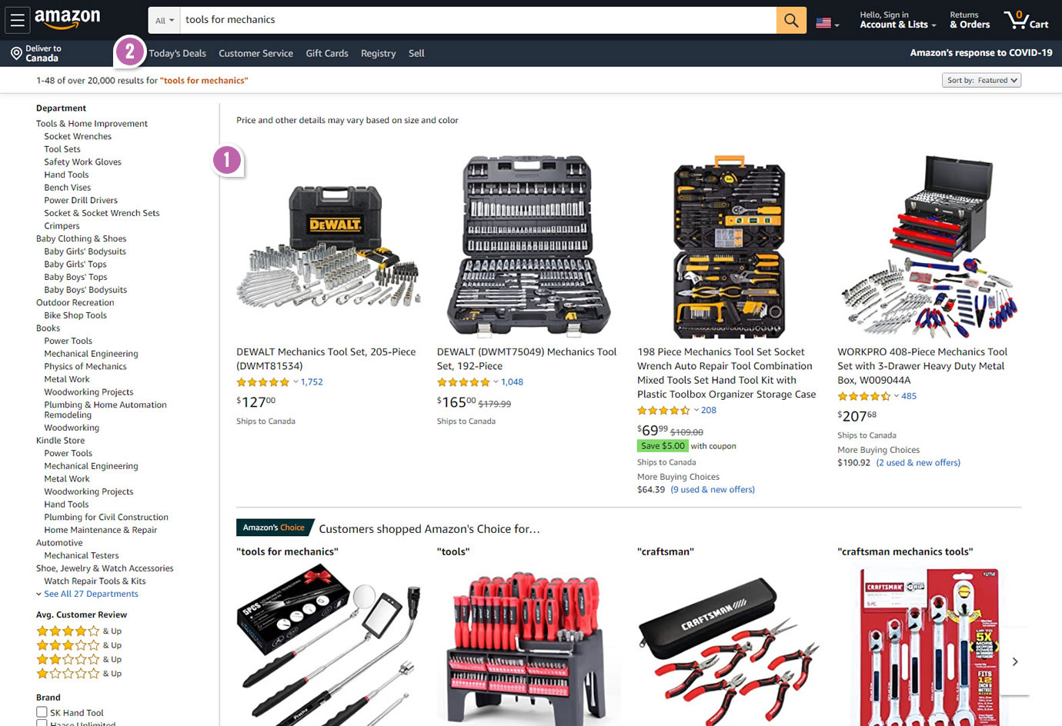
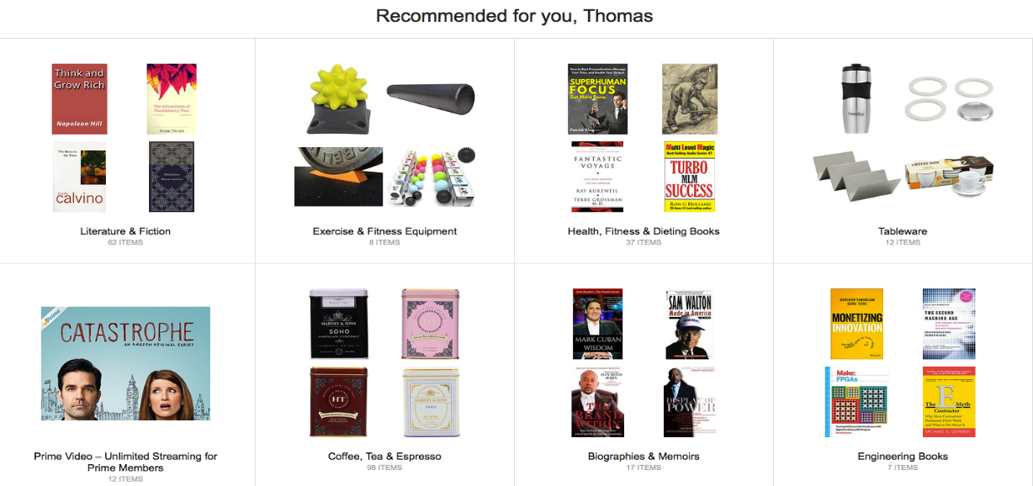



Sub-components:
- Product Card.
- Product Image.
- Product Title.
- Price.
- Rating.
- Add to Cart Button.

Component Structure:

ProductSection
├── ProductCard
│ ├── ProductImage
│ ├── ProductTitle
│ ├── Price
│ ├── Rating
│ └── AddToCartButton
├── ProductCard
└── ProductCard

- Footer Component

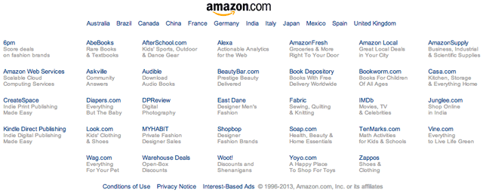

Sub-components:
- About Links.
- Customer Service Links.
- Social Media Links.
- Copyright Text.

Component Structure:
Footer
├── AboutSection
├── HelpSection
├── SocialLinks
└── Copyright

3. Overall Component Tree(Sketch)
App
├── Header
│ ├── Logo
│ ├── SearchBar
│ └── CartIcon
│
├── NavMenu
│ └── CategoryLinks
│
├── HeroBanner
│
├── ProductSection
│ └── ProductCard
│ ├── Image
│ ├── Title
│ ├── Price
│ └── AddToCart
│
└── Footer
├── About
├── Help
└── SocialLinks

4. Conclusion
Breaking a website into components helps developers create reusable, maintainable and scalable UI structures, especially in frameworks like React.

