**Part # 02**

**Locate the company’s financial Statements.**

**Financial Statements of Nestle Company**

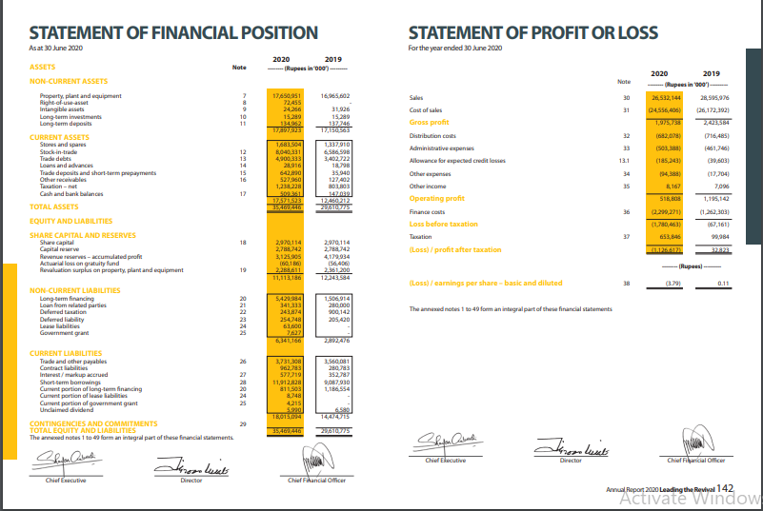

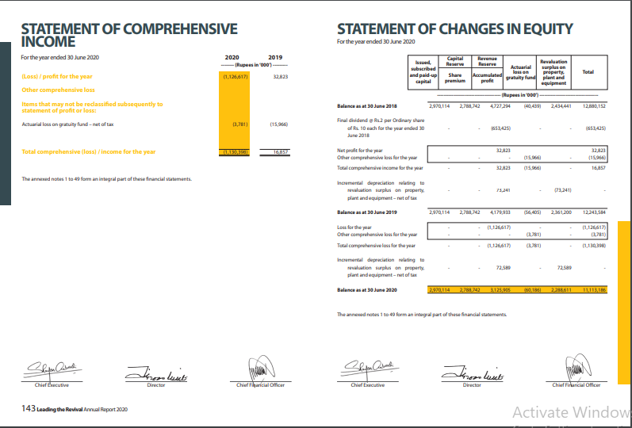

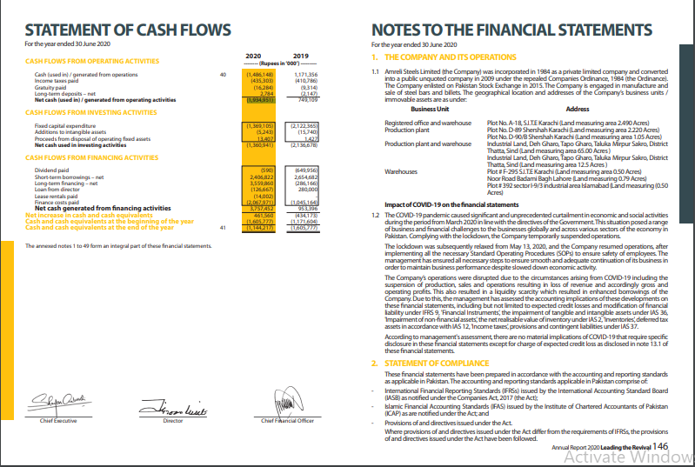

**Part # 03**

**Calculate the financial Ratios Nestle Company For 2020**

**1. Current Ratio = Current Assets / Current liabilities**

**= 17,571,523 / 18,015,094 = 0.9753**

**2= Working Capital = Current Asset – Current liabilities**

**= 17,571,523- 18,015,094 = -443,571(Unfavorable Case)**

**3= Net Cash providing by operating Activities =**

**Appears in the statement of cash flows = 1,934,951**

**4=Cash Flows from operations to current liabilities**

**= Cash flows from operating Activities / Current Liabilities**

**=1,934,951/18,015,094 = 0.10740**

**5= Accounts Receivable**

**= net Sale=1126,617**

**= Average Turnover rates Accounts Receivable**

**= 527,960+127,402/2=327,681**

**=net Sale / Average=1126,617/327,681=3.438**

**6=Days to collect Average = 365 Days / Accounts account receivable receivable turnover rate = 365 / 3.4338 = 106.413**

**7= Inventory = Cost of goods sold / Average Turnover rate inventory =**

**-1,453,733/ 7,313,464.5 = -0.19877**

**8=Days to sell the = 365 days / inventory Average inventory turnover rate = 365 / -0.19877 = -1,836.293**

**9= Operating = Days to sell inventory + Cycle Days to collect Receivables =**

**8,040,331/-1,453,733= -5.5308/365= -2,018.7481 = Days Sales Inventory**

**-2,018.7481+-1,836.293= -3,855.0411**

**10=Free cash flow = net cash from operating Activities-Cash used for investing activities and dividends = 1,934,951 – (1,360,941+590) = 1,934,951 – 1,361,531 = 573,420**

**Measures of long-term credit risk**

**11= Debit ratio = Total Liabilities / Total Assets =18,015,094/ 35,469,446 = 0.507**

**12=Trend in net cash provided by operating activities = positive**

**13=Interest coverage ratio = Income before interest and taxes / Annual interest Expenses = (12,591,094 + 3,706,499) / 2,805,015 = 16,297,593 / 2,805,015 = 5.8102**

**Measures of Profitability:**

**14= Gross profit ratio = Gross profit/net sales = 1,975,738 / 26,532,144 =0.0744**

**15. Operating Expense Ratio =Operating Expenses/net sales =** 94,388 **/** 26,532,144 **= 0.00355**

**16.Operating income = Gross Profit – Operating Expenses =1,975,738 – 94,388 = 1,881,350**