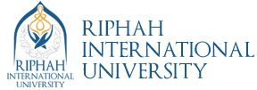

**Group Member:**

**Ayesha Akbar (20916)**

**Ayesha Zahoor (20322)**

**Date: 28 Jan 2022**

**Submitted to: Ma’am Ambreen Sultan**

**Department: BBA 04**

**Subject: Financial Accounting and Reporting – II**

**Final Project**

**Theoretical Type**

We choose Philip Morris and Pakistan Tabaco Company limited which is listed in stock exchange in Pakistan.

* **Part A**

**Find and read the description of the company, including the type of business it is in. Why is gaining an understanding of the industry and type of business an important starting point for financial statement analysis?**

1. **Philip Morris (PMI)**

**Company Profile**

Philip Morris International (PMI) is one of the world’s leading international tobacco companies. Headquartered in New York City and listed on the New York Stock Exchange (NYSE: PM), the American company has a workforce of over 71,000.

PMI is building its future on replacing cigarettes with smoke-free products that—while not risk-free—are a far betterchoice than cigarette smoking.

**BUSINESS DESCRIPTION:**

Philip Morris (Pakistan) Limited was incorporated in Pakistan on February 10, 1969 as a public limited company under the Companies Act, 1913 (now the Companies Act, 2017). The principal activity of the Company is manufacturing and sale of cigarettes and tobacco products.They are one of the largest manufacturers of cigarettes in Pakistan and support a wide range of charitable projects in communities where we source and manufacture our tobacco.

**KEY PEOPLE**

* Mr. Roman Yazbeck is the CEO of the company
* Mr. Kamran Y. Mirza is the Chairman of the company
* Ms. Sana Enait Hashmi is Company Secretary

**ADDRESS**

19TH FLOOR, THE HARBOUR FRONT, DOLMEN CITY, HC-3, BLOCK-4, CLIFTON, KARACHI-75600

**WEBSITE**

www.philipmorrispakistan.com.pk

**REGISTRAR**

Central Depository Company of Pakistan CDC HOUSE, 99-B, BLOCK-B, S.M.C.H.S., MAIN SHAHRAH-E-FAISAL, KARACHI

1. **Pakistan TabacoCompany limited(PTC)**

**Company Profile**

Pakistan Tobacco Company Limited was incorporated in 1947 immediately after partition, when it took over the business of the Imperial Tobacco Company of India which had been operational in the subcontinent since 1905.

**BUSINESS DESCRIPTION:**

Pakistan Tobacco Company Limited is a public limited company incorporated in Pakistan on November 18, 1947 under the Companies Act, 1913 (now the Companies Act, 2017). The Company is a subsidiary of British American Tobacco (Investments) Limited, United Kingdom, whereas its ultimate parent company is British American Tobacco p.l.c, United Kingdom. The Company is engaged in the manufacture and sale of cigarettes/ tobacco.

**Status of Company**

Economically Significant Company

**KEY PEOPLE**

* Mr. Syed Ali Akbar is the CEO of the company
* Mr. Zafar Mahmood is the Chairman of the company
* Mr. Nauman Masood Butt is Company Secretary

**ADDRESS**

Serena Business Complex Khayaban-e-Suhrwardy, Islamabad

**WEBSITE**

www.ptc.com.pk

**REGISTRAR**

FAMCO Associates (Pvt.) Ltd., 8-F, Near Hotel Faran, Nursery, Block 6, P.E.C.H.S, Shahrah-e-Faisal, Karachi

* **Part B**

**Locate the company’s primary financial statements.**

This is the primary financial statement of Philip Morris and Pakistan Tabaco company limited.

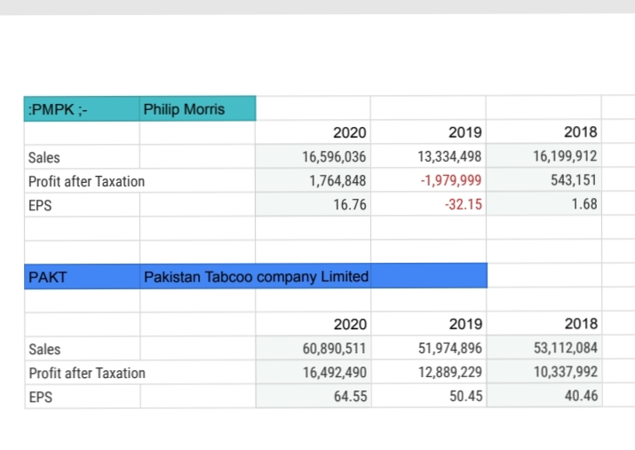

* **Part C**

**Calculate the financial ratios provided below and compare the financial performance of both companies. Show your work in calculating these ratios**

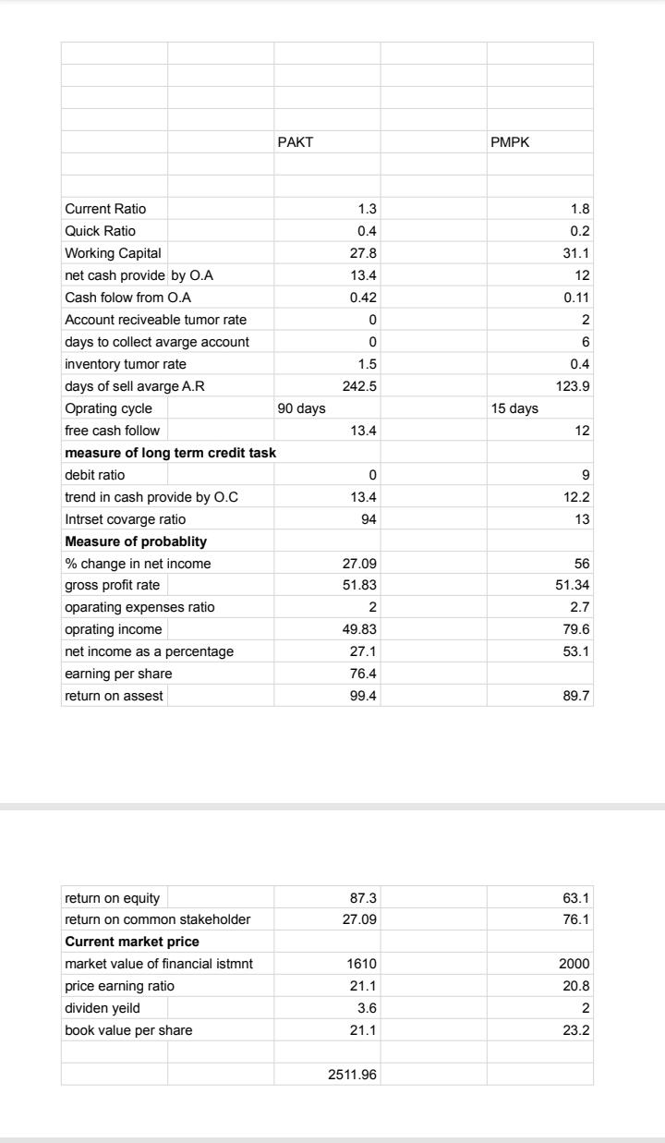

**Part D**

**Write a brief statement describing what you have learned about these companies liquidity, credit risk, profitability, book and market value.**

**FINANCIAL RISK MANAGEMENT**

The Company’s activities expose it to certain financial risks. Such financial risks emanate from various factors that include, but are not limited to, market risk, credit risk and liquidity risk.

The Company’s overall risk management focuses on the unpredictability of financial markets and seeks to minimize potential adverse effects on the

Company’s financial performance. Risks measured and managed by the Company are explained below:

* **Market risk**

Market risk is the risk that the value of the financial instrument may fluctuate as a result of changes in market interest rates or the market prices of instruments due to change in credit rating of the issuer or the instrument,

Changes in market sentiments, speculative activities, supply and demand of instruments and liquidity in the market. The Company manages the market risk by monitoring exposure on financial instruments and by following internal risk management policies.

Market risk comprise of three types of risks:

1. **Interest rate risk**
2. **Currency risk and**
3. **Price risk**
4. **Interest rate risk**

Interest rate risk is the risk that the fair value or future cash flows from a financial instrument will fluctuate due to changes in market interest rates. Fair value risk - Fair value risk to the Company arises from instruments which are based on fixed interest rates. As at December 31, 2020, the Company did not have any fixed rate instrument.

Future cash flow risk - Presently, future cash flow risk to the Company arises from deposit accounts with banks and running finance under mark-up arrangements which are based on floating interest rates (i.e. KIBOR based). As at December 31, 2020, had there been increase / decrease of 50 basis

Points in KIBOR with all other variables held constant, profit after taxation for the year then ended would have been higher / lower by Rs 17.521 million mainly as a result of net of profit on deposit

Accounts and finance cost.

1. **Currency risk**

Currency risk arises mainly where receivables and payables exist due to transactions entered into foreign currencies. The Company primarily has foreign currency exposures in US Dollars, Euro and UK Pound in the form of other receivables, bank balances, trade and other payables.

"As at December 31, 2020, had the Company's functional currency strengthened / weakened by 5% against US Dollar, Euro and UK Pound, with all other variables held constant, profit after taxation for the year then ended would have been higher / lower by Rs 16.711 million (2019: Rs 29.033 million) mainly as a result of foreign exchange gains / losses

* **Profitability Ratios**

Over the years, our profitability ratios have followed an improving trend. This has been attributable to a growth in gross profit coupled with effective cost management. Gross turnover recorded an increase of 11.6% in 2020 which was

Primarily driven by the June-19 excise led price increase and premium portfolio price increase in second half of 2020. The gross profit ratio increased by 3% whereas net profit ratio increased by 9%. The increase in net profit ratio is clearly indicating that of our effective cost management, productivity

Savings and greater efficiency in operations.

* **Liquidity Ratios**

Our liquidity ratios present a healthy position over the years. Our cash advance sales model coupled with effective resource allocation enables us to meet our liquidity requirements including capital expenditures. In 2020, a slight deviation in this trend has been witnessed with current ratio deteriorating slightly compared to 2019 due to lower inventory position as compared to 2019. However, the quick ratio increased in 2020 due to more availability of cash and

Cash equivalents at year end.

* **Activity Ratios**

The activity ratios have improved significantly over the years mainly on account of a highly effective working capital management approach followed by us. As per the business model, the inventory days remain high due to a build-up of tobacco and raw material stock essential to support higher production in the first half of next year as well as to hedge against unfavorable FX headwinds. Further due to better working capital management, we have reduced our inventory days and resultantly the cash conversion cycle decreased from 153 days to 90 days only.

* **Investment /Market Ratios**

We aim to generate maximum value for our shareholders, both in the short and the long term. This is reflected in the consistent improvement of investment ratios over the years and in particular, the growth of EPS and increase in dividend per share, which are certainly very attractive for our shareholders. Our share price witnessed a decline of 34% from 2019 along with P/E ratio declining by 28% owing to deteriorating macroeconomic factors and under performance of Pakistan Stock Exchange in the wake of global Covid-19 pandemic.

* **Capital Structure Ratios**

The capital structure ratios reflect our ability to meet our financing needs organically, including those related to capital investment funded primarily through cash generated from its operations. As a result, there is no requirement for long-term financing, though, we avail a relatively small lease facility for financing vehicles provided to our employees. The debt to equity ratio is zero while interest cover has seen a minor increase from 2019 owing to increase in profits during the year.