Brotion issues

1. One should not bid on his own tender.
2. delivery city should be showing here

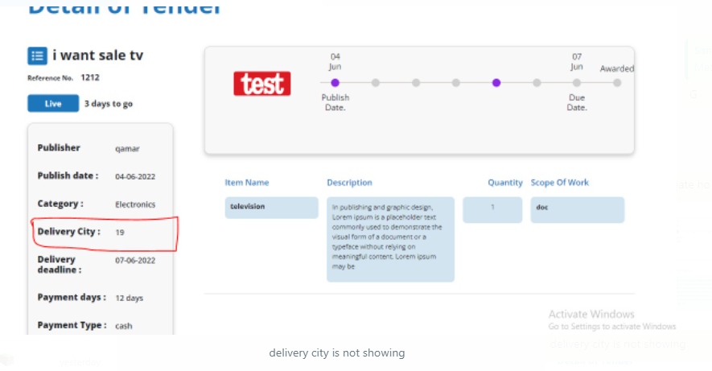

1. 4 june ko tender publish hua hai.. 7 due date hai, dots publish and due date k according hon gy

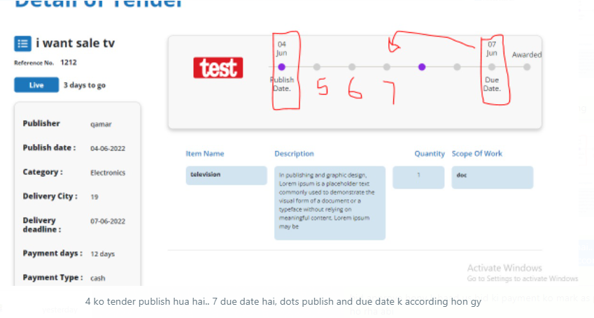

1. Bid approve hony k baad us bid ki payment ko mark as pay kary ga... That should happen. This page should when tender creator click on approved tender.

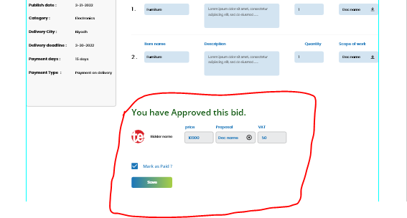

1. These filters should on marketplace page.

* Open filter
* Closed filter

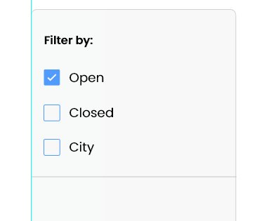

1. Filters for a tender.

* **Running tenders**

All tenders within due date will be running. Due date can be extended

* **Closed tender**

All tenders after due date will be closed. Due date can be extended

* **Paid tenders**

Tenders can be marked as paid after the payment is done.

* **Unpaid tenders**

1. no pr click kr k bhi next move krna chahey

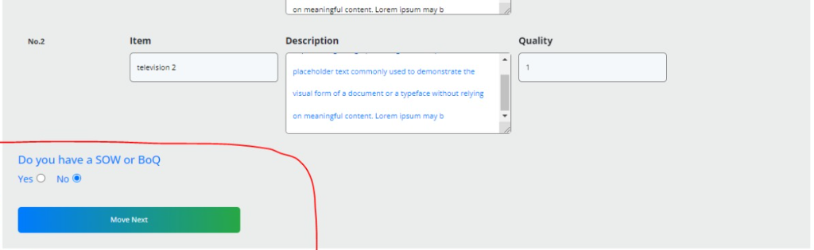

1. tender create krty waqt jo soq doc upload krty hain wo idr aay ga

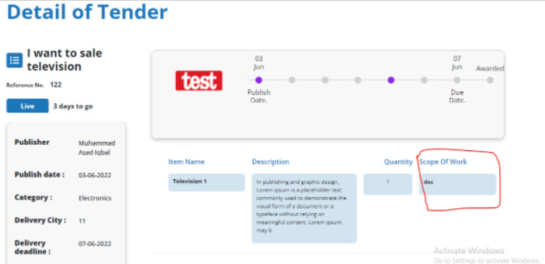

1. On the home page this summary should be dynamic.



1. After the bid is approved this page should be showing.

