Telco Customer Churn

Final Report

Structured Data Analytics | Spring 2025

Jahangir Babar | 002309458

1. Scenario Identification

1.1 Central Question
What are the key factors that drive customer churn in a telecom company, and how can we identify customers at risk of leaving?

1.2 Why is it Important?
Customer Churn refers to the phenomenon where customers discontinue their subscription or stop doing business with a company. Predicting churn is vital for businesses as retaining existing customers is often more cost-effective than acquiring new ones. By analyzing historical data, companies can identify patterns and factors that contribute to customer attrition, enabling proactive retention strategies.​

1.3 Objective
The objective of this analysis is to explore the Telco Customer Churn dataset to understand the factors that contribute to customer churn in a telecommunications company. By cleaning and visualizing the data in R, I aim to uncover patterns across customer segments and prepare the dataset for predictive modeling in Python. The ultimate goal is to identify high-risk churn profiles to help the company implement proactive retention strategies.

2. Dataset Description

2.1 Source and URL
Source: Kaggle
Url: https://www.kaggle.com/datasets/blastchar/telco-customer-churn

2.2 Key Variables
The Telco Customer Churn dataset contains information about customer demographics, subscription details, usage metrics, and whether the customer has churned. Notable features include:

Customer Demographics
- Gender
- Senior citizen status
- Partner status
- Dependents
Financial Metrics
- Tenure (months as customer)
- Monthly charges
- Total charges
Service Information
- Contract type
- Payment method
- Internet service type
Target Variable
- Churn (whether customer left the service)

2.3 Dataset Requirements Met
The Telco Customer Churn dataset meets all requirements for this project. It contains over 7,000 rows and 21 columns, providing a rich sample size for analysis. The dataset includes both categorical and numerical variables, which allow for meaningful data cleaning, visualization, and predictive modeling. It also contains missing values in the TotalCharges column, enabling demonstration of data imputation techniques. Lastly, the dataset represents a realistic business scenario relevant to telecom and customer retention, making it suitable for generating actionable insights through statistical data analysis.

3. As-Is Data Characteristics

3.1 Data Types and Structure
The Telco Customer Churn dataset includes 7,043 rows and 21 variables. These variables span demographic information, billing and usage metrics, service subscription details, and churn status. Variables are of mixed types — numeric, character, and binary categorical — which makes preprocessing essential.
The customerID column uniquely identifies each customer and is excluded from modeling. Initial inspection using glimpse() revealed that most variables are of type character or numeric, though some expected numeric columns were initially stored as text.
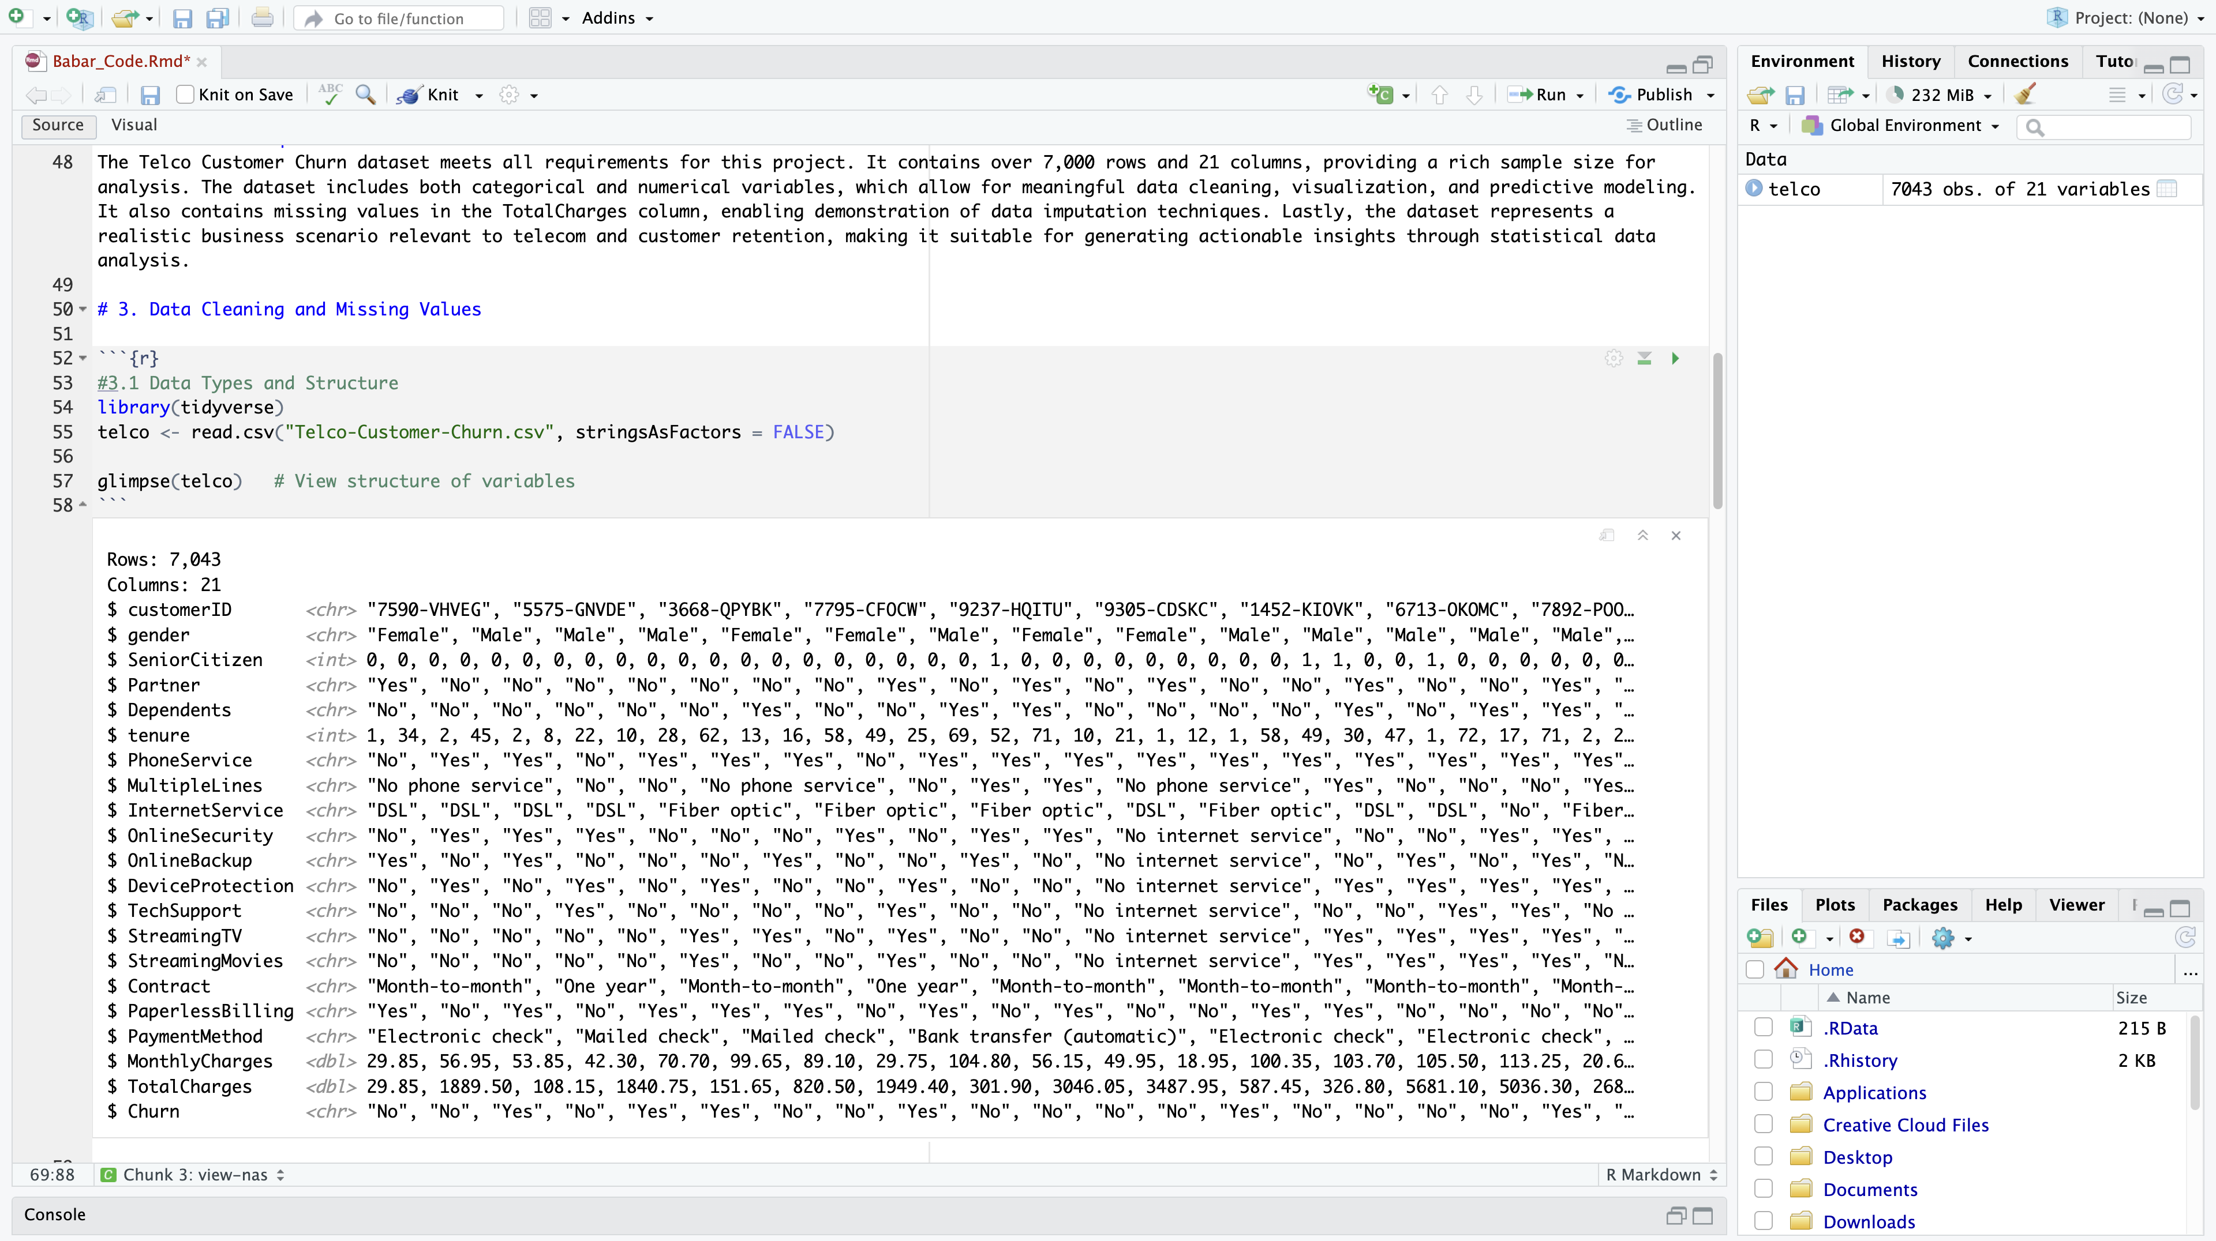

3.2 Missing Values and Anomalies
A check for missing values showed that the TotalCharges column contained non-numeric entries, even though it represents a financial amount. These were due to blank values for new customers with zero tenure.
Using as.numeric(), the column revealed NA values, confirming type mismatch. These missing values were imputed with 0, as these customers had not yet been billed. All other columns had complete values with no anomalies.
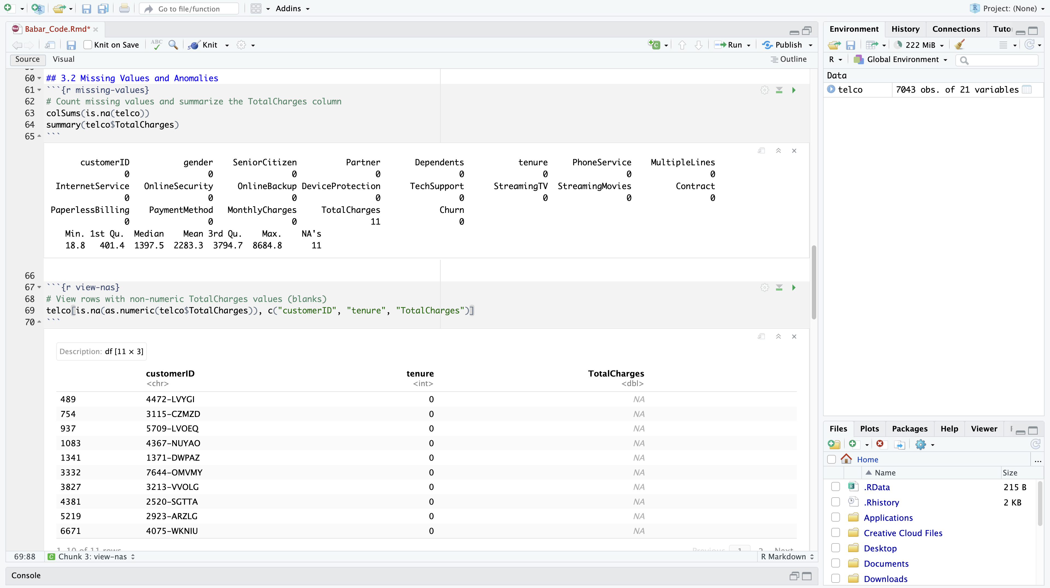
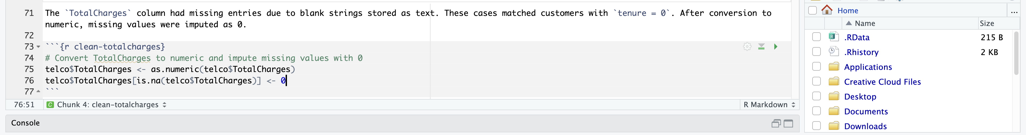

3.3 Visual Summary of Initial Data
The visual inspection of the dataset confirms a skew in tenure, with many new customers. The MonthlyCharges distribution shows a concentration of customers with mid-range billing, with a smaller number at the high and low ends.
Histograms were used to illustrate the spread of tenure and Monthly Charges:
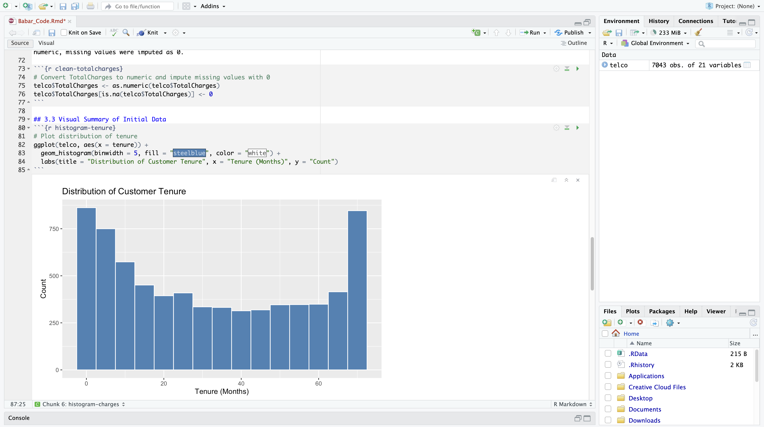
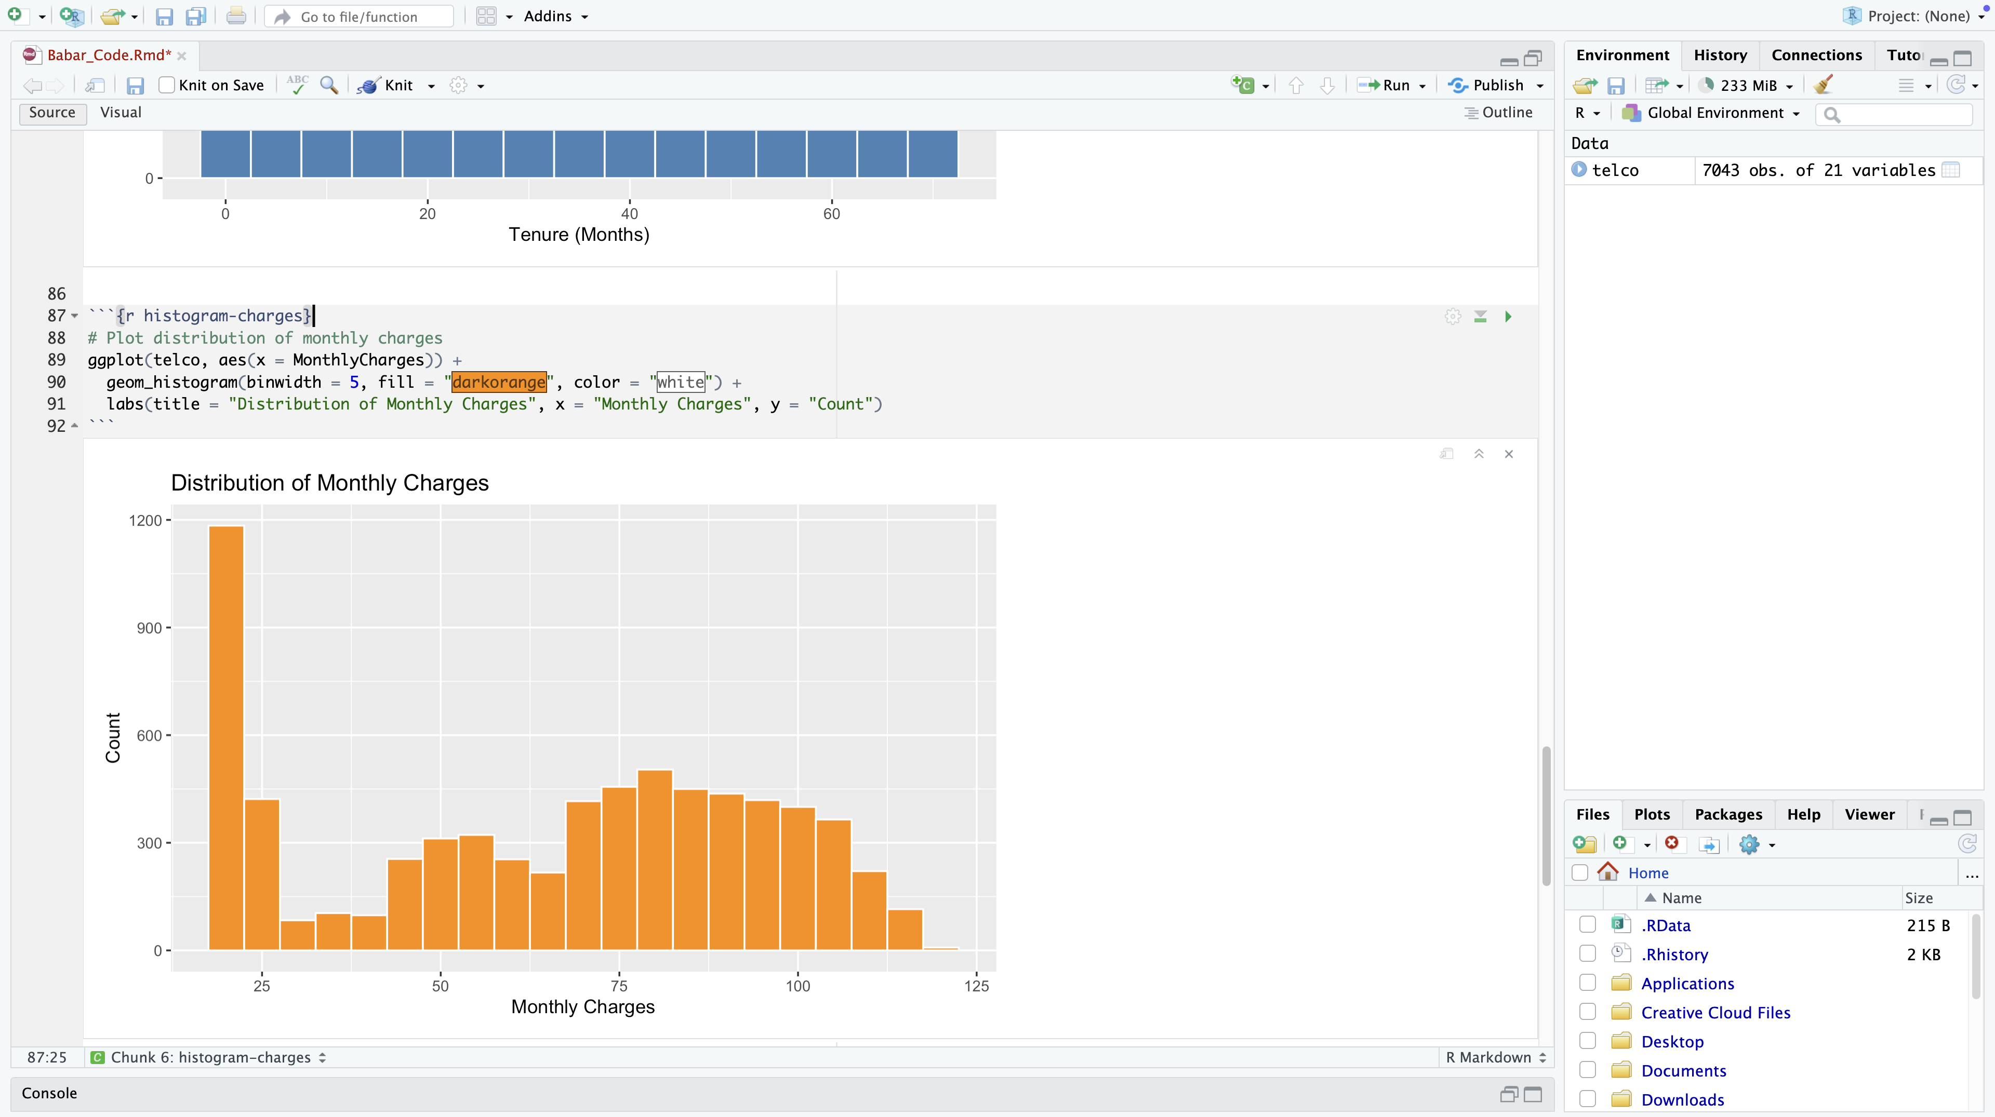

4. Data Cleaning and Preparation (in R)

4.1 Cleaning Steps
The following data cleaning actions were implemented:
- Converted TotalCharges from character to numeric, as it contained non-numeric values (blanks for new customers).
- Imputed missing values in TotalCharges with 0 for customers who had not been billed yet (i.e., tenure = 0).
- Checked for missing values across all columns using colSums(is.na(...)).
- Verified variable structure with str() and skim() to understand data types and distributions.
- Converted key categorical variables (SeniorCitizen, Churn) to factors to ensure proper grouping during visualization and modeling stages.

4.2 Rationale for Imputation
The only column with missing values was TotalCharges. These missing values were due to blank strings that occurred for customers with tenure = 0. Since these customers had just joined and had not incurred any charges, it was logical and business-consistent to replace the missing values with 0 rather than removing the rows or applying statistical imputation.
Additionally, character columns that represent categories were converted to factor variables, allowing R to treat them appropriately in plots and statistical models.

4.3 Screenshot of Code + Output

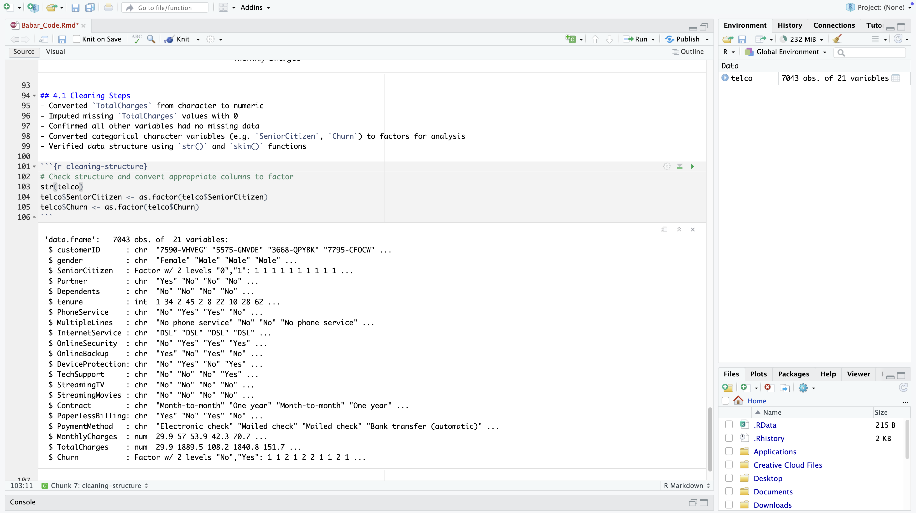

5. Exploratory Data Analysis (EDA)

5.1 Key Variable Relationships
Exploratory Data Analysis (EDA) was conducted to identify trends and patterns related to customer churn. Relationships between key features such as contract type, tenure, and monthly charges were visualized using bar plots and histograms.

5.2 Visualizations & Observations

5.2.1 Churn by Contract Type
Customers with month-to-month contracts exhibit a much higher churn rate compared to those with one-year or two-year contracts. This suggests that short-term contract customers are more likely to leave, possibly due to less commitment or greater dissatisfaction.
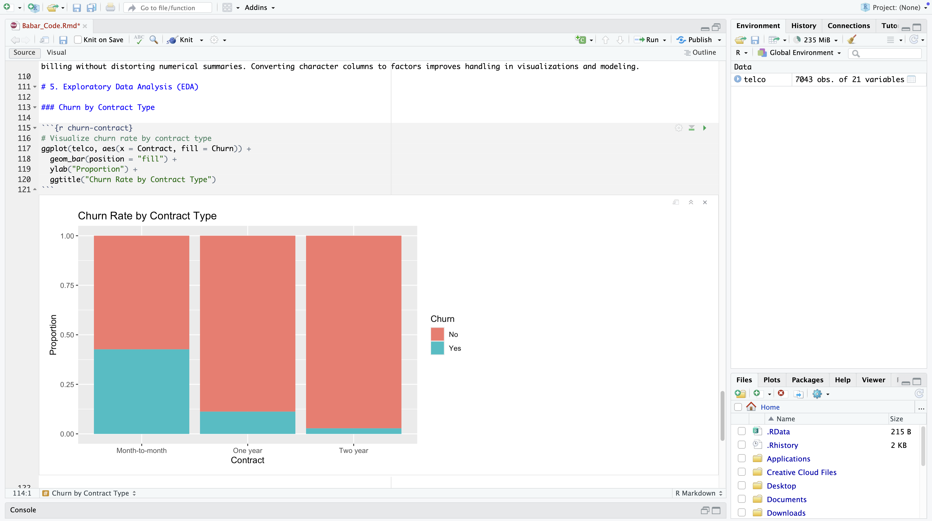

5.2.2 Monthly Charges by Churn
Customers with higher monthly charges are more likely to churn. The distribution shows a clear skew in churned customers toward the higher end of the pricing spectrum, indicating that cost may be a factor influencing churn.
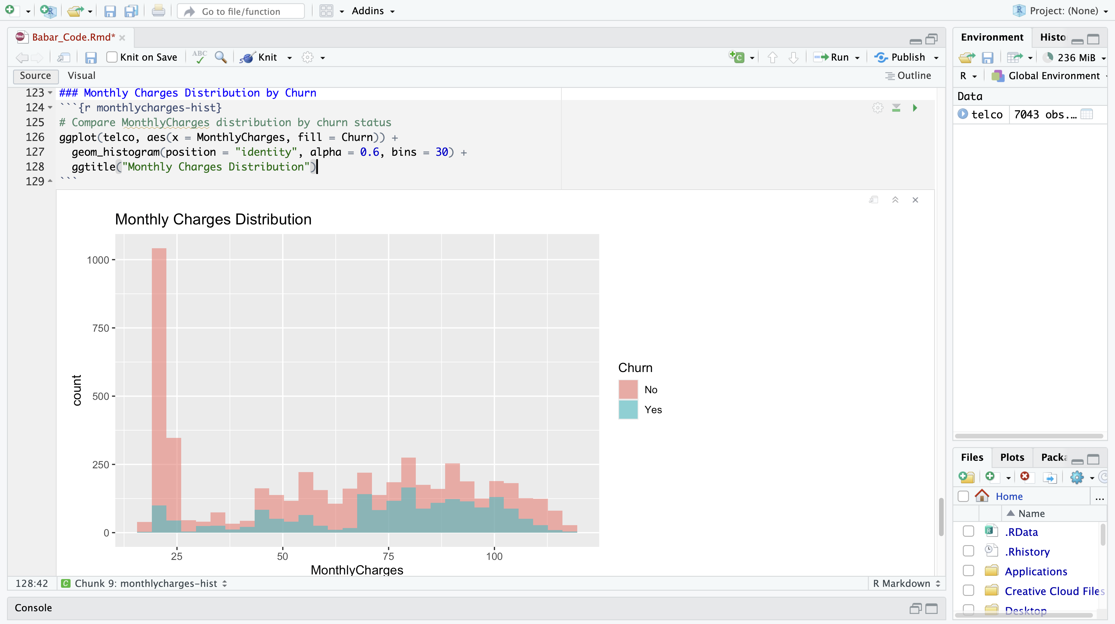

5.2.3 Tenure by Churn
Customers with lower tenure (shorter relationship with the company) have a significantly higher churn rate. This suggests that newer customers are more likely to leave early, potentially due to onboarding issues or unmet expectations.
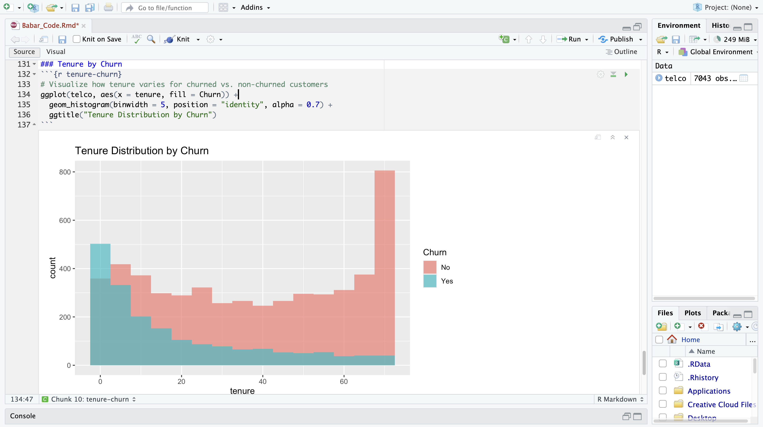

5.2.4 Internet Service Type by Churn
Churn is notably higher among customers using Fiber optic and DSL services compared to those without internet service. This implies that dissatisfaction with internet service quality or cost may be driving churn for connected customers.
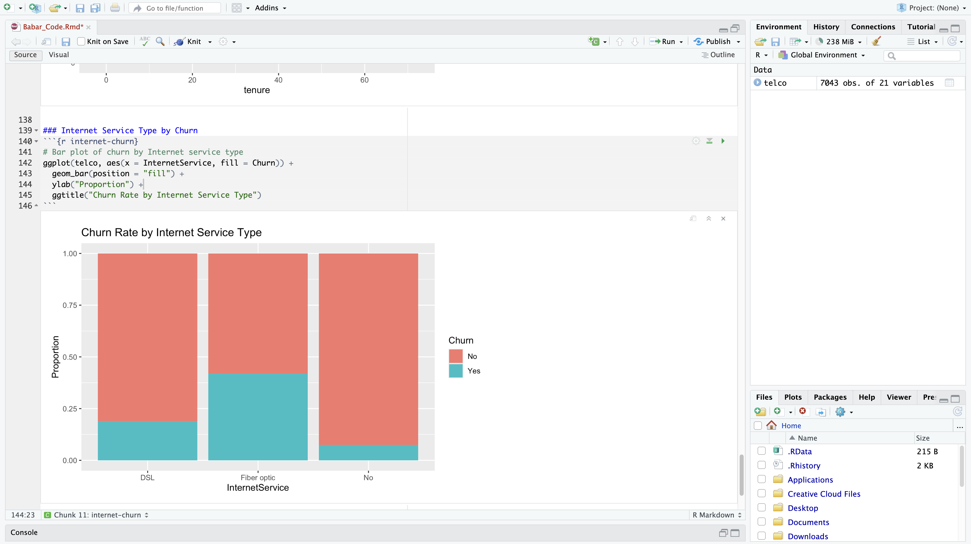

5.2.5 Payment Method by Churn
Customers using electronic check as their payment method show the highest churn rate, while those using credit cards or automatic bank transfers churn less frequently. This may suggest a correlation between payment flexibility, automation, and retention.
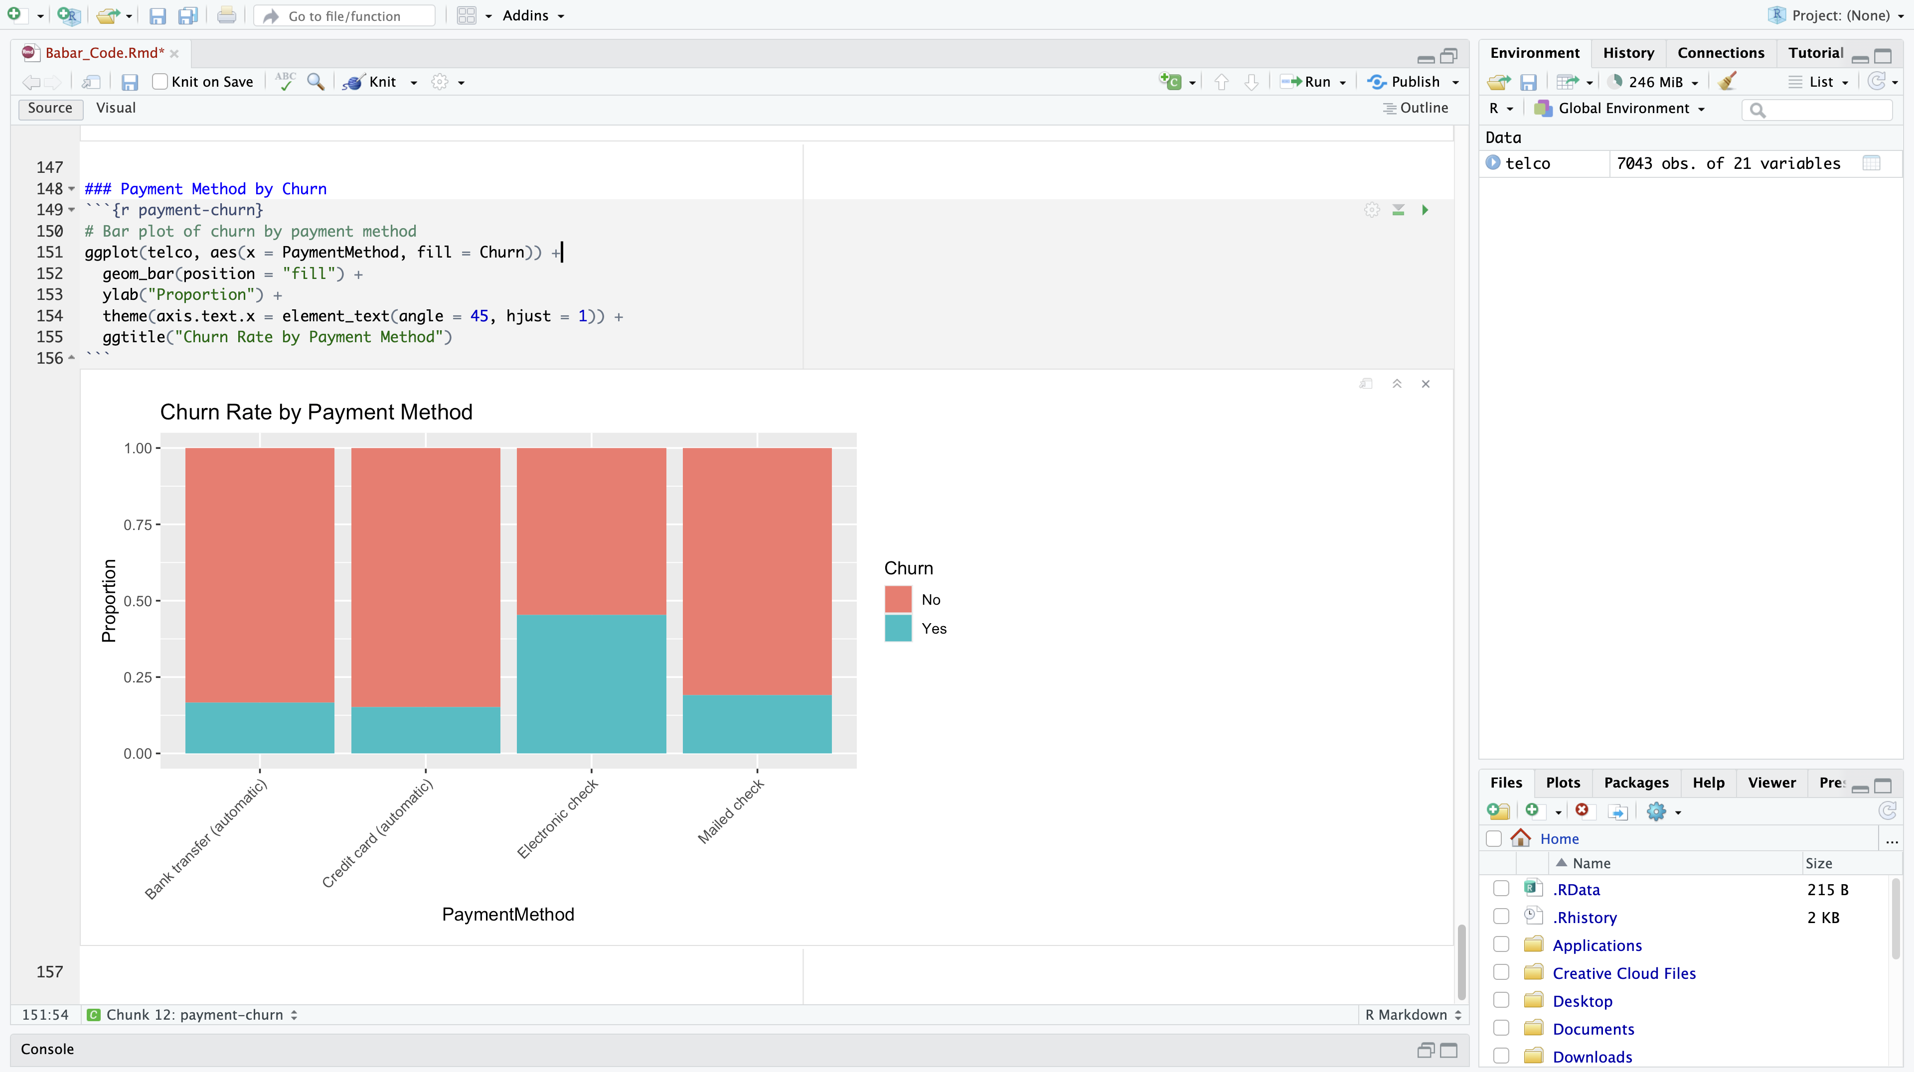

5.3 Exporting CSV from R Notebook
Before exporting the dataset for use in Python, the customerID column was removed, as it serves only as a unique identifier and has no predictive value. Including it in the modeling process would introduce unnecessary noise without offering any analytical benefit.
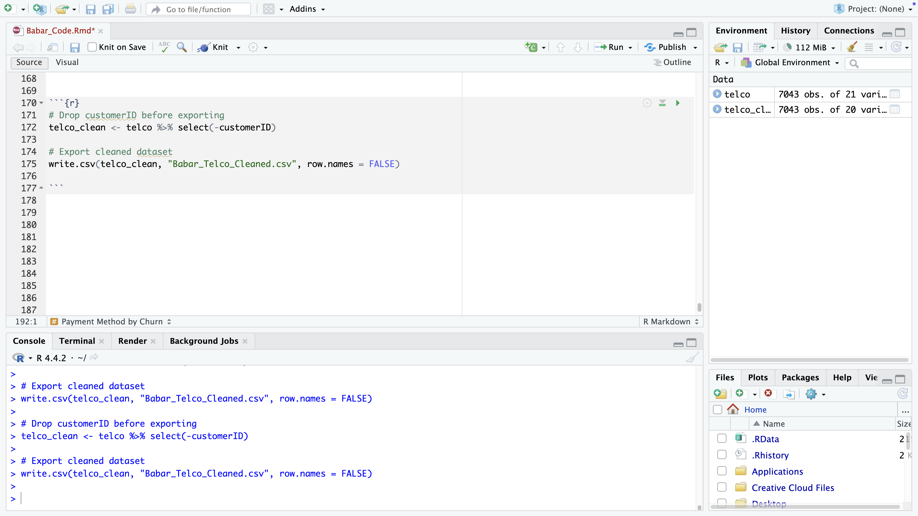
The cleaned and preprocessed dataset was then saved as a CSV file named Babar_Telco_Cleaned.csv. This step ensures continuity and consistency when transitioning from R to Python, allowing the modeling phase to begin with a clean, reliable dataset.
By exporting at this stage, I separated the data wrangling and visualization tasks handled in R from the machine learning and deployment tasks planned in Python. The next phase of the project will involve:
- Performing additional encoding on categorical variables using one-hot encoding
- Splitting the data into training and testing sets
- Building a classification model (e.g., Random Forest) to predict churn
- Evaluating the model’s performance using accuracy, recall, and precision metrics
- Deploying an interactive Streamlit dashboard for real-time churn prediction

6. Model Preparation and Predictive Analysis (in Python)
Objective: To build a machine learning model that predicts whether a customer is likely to churn based on their usage patterns, subscription type, and demographics.

6.1 One-Hot Encoding and Preprocessing
In this step, I prepared the dataset for machine learning. Many of the columns in the original dataset are categorical, meaning they contain text values like "Yes", "No", or types of service plans. Since machine learning models work with numbers, these text values were converted into a format the model can understand using a method called one-hot encoding.
One-hot encoding turns each category into a new column with either True or False, indicating whether a customer has that feature. For example, a column called Contract_Month-to-month will be marked True if the customer has a month-to-month contract, otherwise False.
I also converted the target variable, Churn, into a binary value: 1 if the customer churned, and 0 if they stayed.
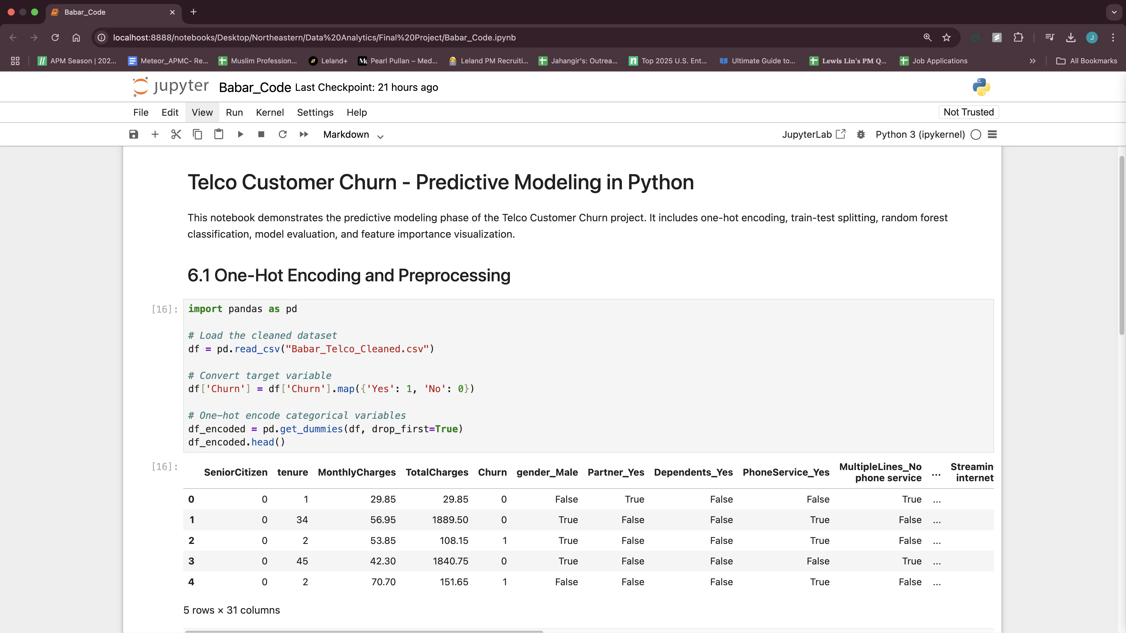

6.2 Train-Test Split
To evaluate how well the model works, I split the data into two groups:
- A training set (70% of the data), used to train the model
- A testing set (30%), used to test how well the model performs on new, unseen data
This approach helps simulate a real-world scenario where we want the model to make predictions on customers it has never seen before.
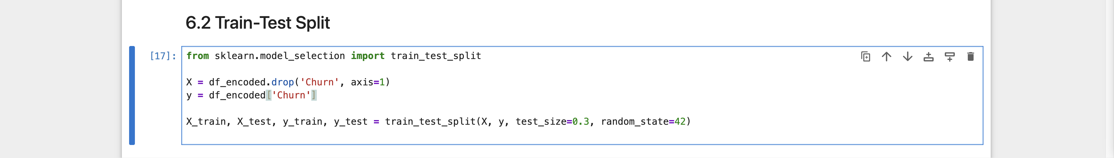

6.3 Model Used
I chose a Random Forest Classifier as the prediction model. Random Forest is a powerful machine learning method that uses multiple decision trees to make predictions.
This model is well-suited for datasets with both numeric and categorical data. It can capture complex patterns and is known for producing reliable results, even without a lot of fine-tuning. The model was trained using the training data created in the previous step.


6.4 Evaluation Results
After training the model, I tested it on unseen data (30% of the dataset) to evaluate how well it performs. The evaluation was based on four key metrics:
- Accuracy: How often the model is correct overall
- Precision: Out of all customers the model predicted would churn, how many actually did
- Recall: Out of all customers who actually churned, how many the model correctly identified
- F1-Score: A balance between precision and recall
The confusion matrix below shows how the model classified the test data:

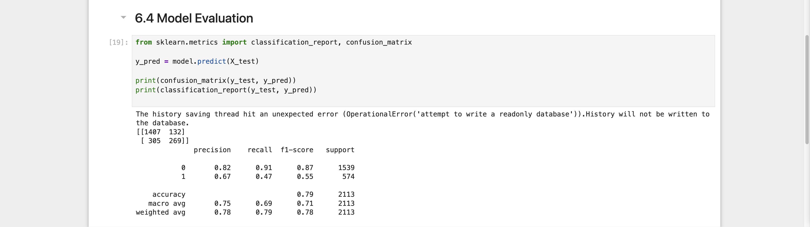

From this, we can interpret:
- 1407 customers were correctly predicted as not churning
- 269 customers were correctly predicted as churning
- 132 false positives (predicted to churn, but didn't)
- 305 false negatives (missed actual churners)
The classification report shows the performance metrics per class:
Class | Precision | Recall | F1-Score | Support
0 (Stayed) | 0.82 | 0.91 | 0.87 | 1539
1 (Churned) | 0.67 | 0.47 | 0.55 | 574
- Overall accuracy: 0.79 (i.e. the model correctly classified ~79% of customers)
- The model performs better at detecting customers who stay (Class 0) than those who churn (Class 1)
- This trade-off is typical when the churn class is smaller in size (only 574 churned vs. 1539 stayed)
Despite the imbalance, the model provides a useful baseline to flag churn risk. Precision and recall for churners can be improved using techniques like hyperparameter tuning or SMOTE (oversampling)

6.5 Feature Importance Plot
After training the model, I analyzed which customer attributes had the greatest impact on predicting churn. The Random Forest model automatically provides a feature importance score for each variable, indicating how influential it was in helping the model make its predictions.
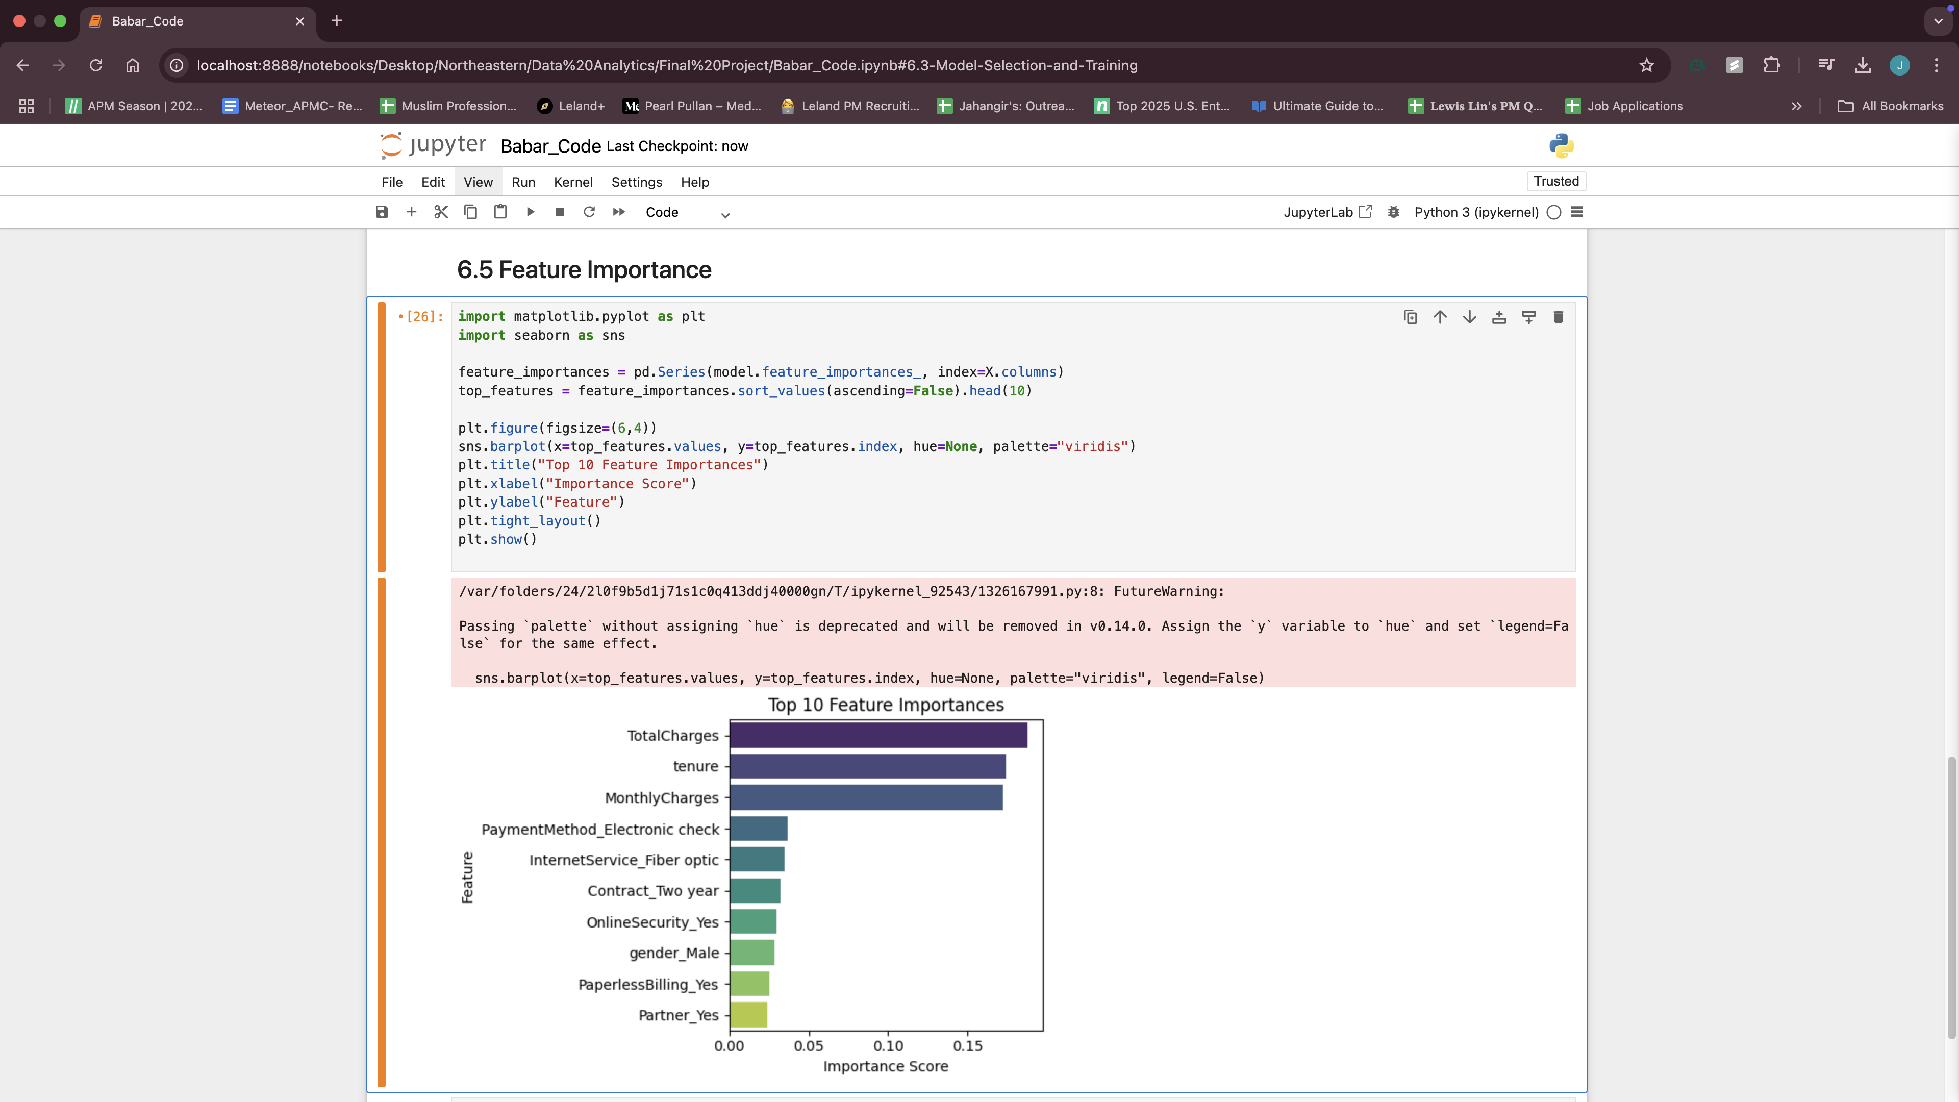
The top 10 most important features are shown in the bar chart above. These include:
- TotalCharges and MonthlyCharges: Higher billing amounts were strongly associated with churn.
- Tenure: Customers with shorter tenure were more likely to churn, consistent with the exploratory analysis.
- PaymentMethod_Electronic check: This specific payment method had a higher churn rate compared to others.
- InternetService_Fiber optic and Contract_Two year: Service types and contract durations significantly affected churn behavior.
- OnlineSecurity, PaperlessBilling, and demographic factors like gender and partner status also had notable influence.
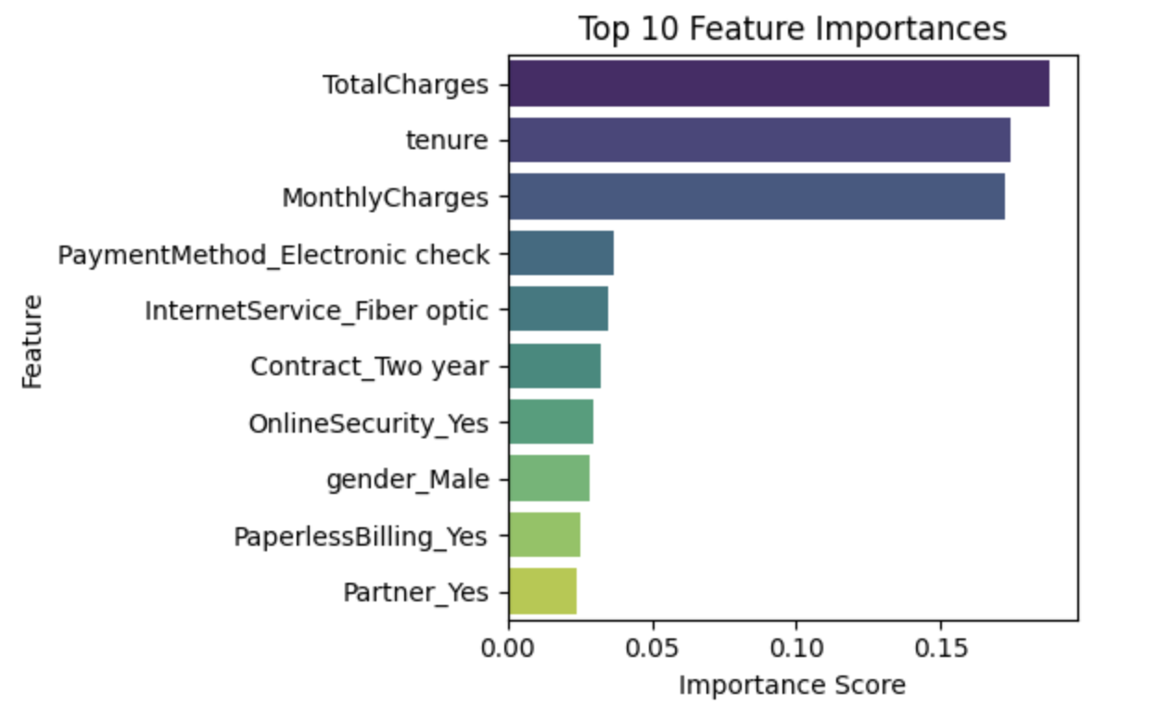
These insights are critical because they can guide business decisions. For instance, customers with high monthly charges and no security services might be good candidates for loyalty programs or upselling retention-friendly features.

6.6 Retrain Random Forest on Top 10 Features for Streamlit
In this phase, I retrained the Random Forest model using only the top 10 most important features previously identified during the feature importance analysis. This selective modeling approach served two goals:
- Simplicity: Reducing the model input to 10 key variables makes it easier to maintain and explain.
- Streamlit Integration: It aligns perfectly with the design of the interactive app, where users are only asked to enter these top 10 values.
The selected features included tenure, charges, contract type, internet service, and support options—all of which showed a strong relationship with churn in earlier analyses.
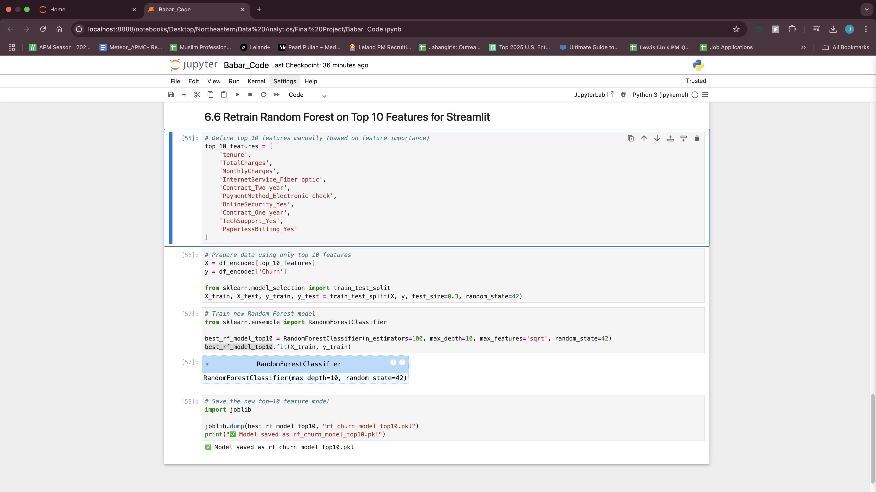
The process involved:
- Manually defining a list of the top 10 feature names
- Subsetting the dataset to only include those columns for modeling
- Splitting the dataset into training and test sets (70:30)
- Retraining a Random Forest classifier with hyperparameters from a separate tuning stage (n_estimators=100, max_depth=10, max_features='sqrt')
- Saving the trained model as rf_churn_model_top10.pkl using joblib
This streamlined model is used directly in the Streamlit app to make real-time predictions with just a few inputs, providing both speed and interpretability without sacrificing much performance.

7. Interactive Streamlit app
To add an interactive component to this analysis, I developed a web-based application using Streamlit, a Python library designed for building lightweight data apps. This app serves as a front-end interface for the trained Random Forest model that was re-trained specifically on the top 10 most important features identified earlier in the project.

7.1 How It Works:
- The app loads the pre-trained model file (rf_churn_model_top10.pkl) using joblib.
- Users are asked to input key customer attributes through intuitive interface elements such as sliders, dropdowns, and number inputs.
- Once inputs are submitted, the app converts them into a one-hot encoded format, aligning exactly with the model’s training schema.
- The model then outputs:
  - A churn prediction (Stay vs. Churn)
  - A churn probability score (e.g., 76%)
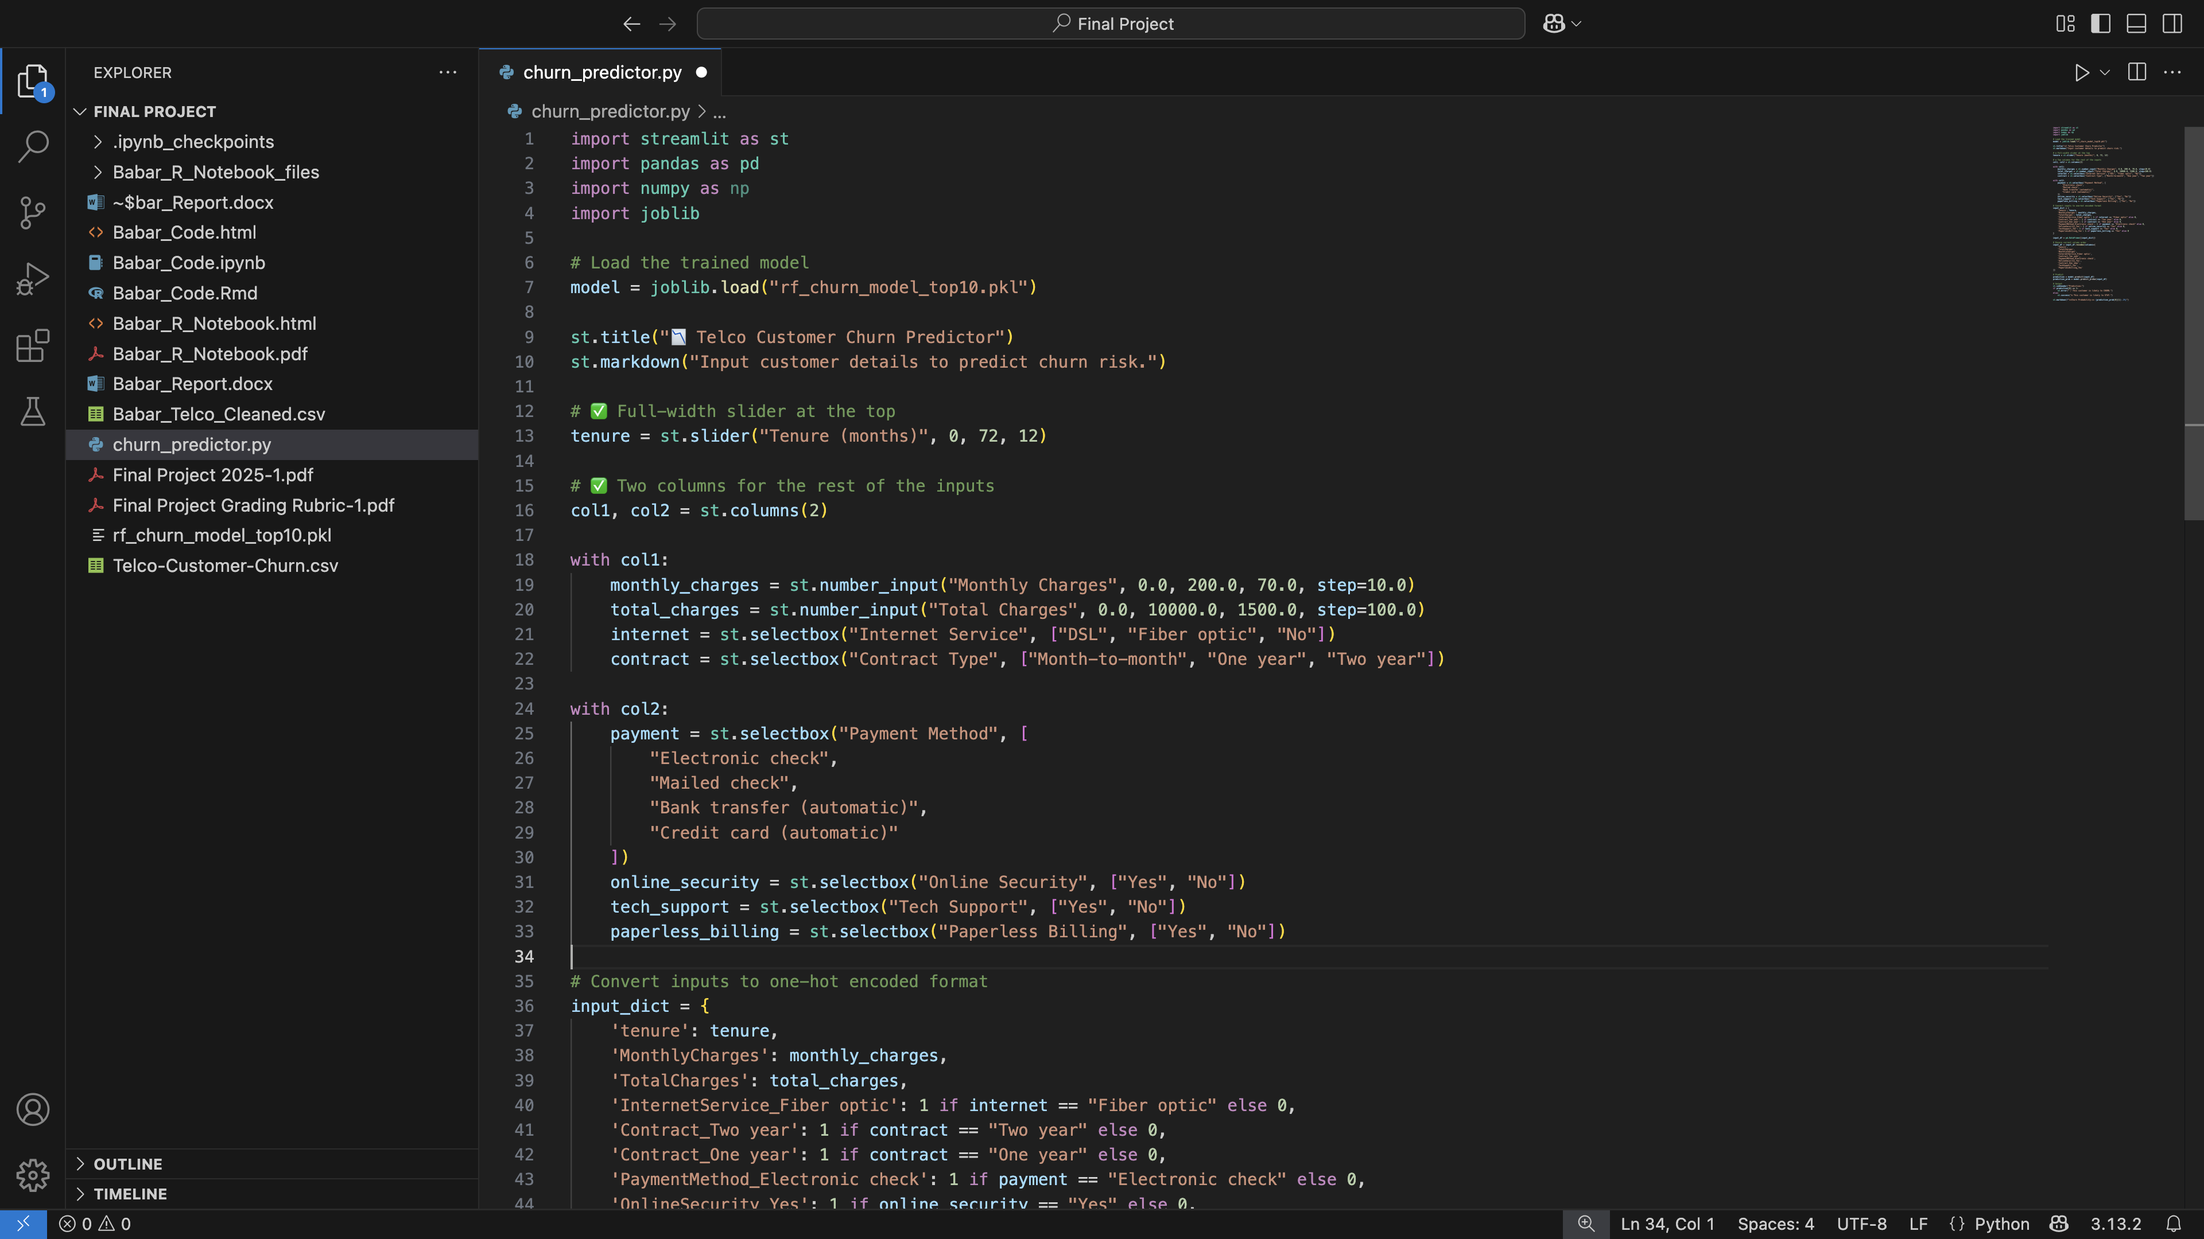
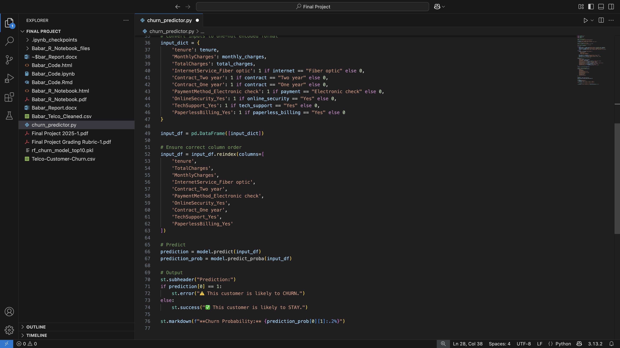

7.2 UI Design Decisions:
- The “Tenure” slider is placed at the top as a full-width element since it is the most continuous and business-relevant feature.
- All remaining inputs (e.g., contract type, monthly charges, service details) are split into two vertical columns for visual clarity and ease of use.
- The step size for numeric inputs was adjusted based on context:
  - Monthly Charges step in $10 increments
  - Total Charges step in $100 increments
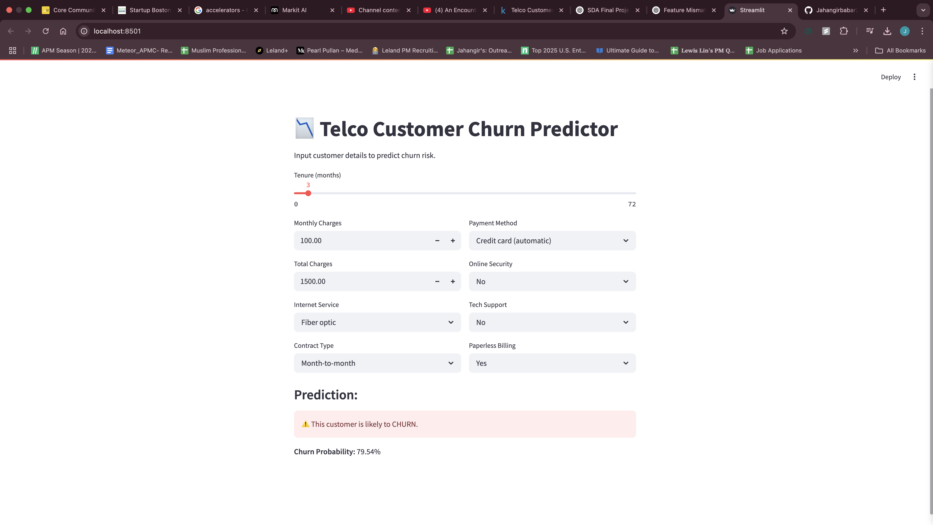
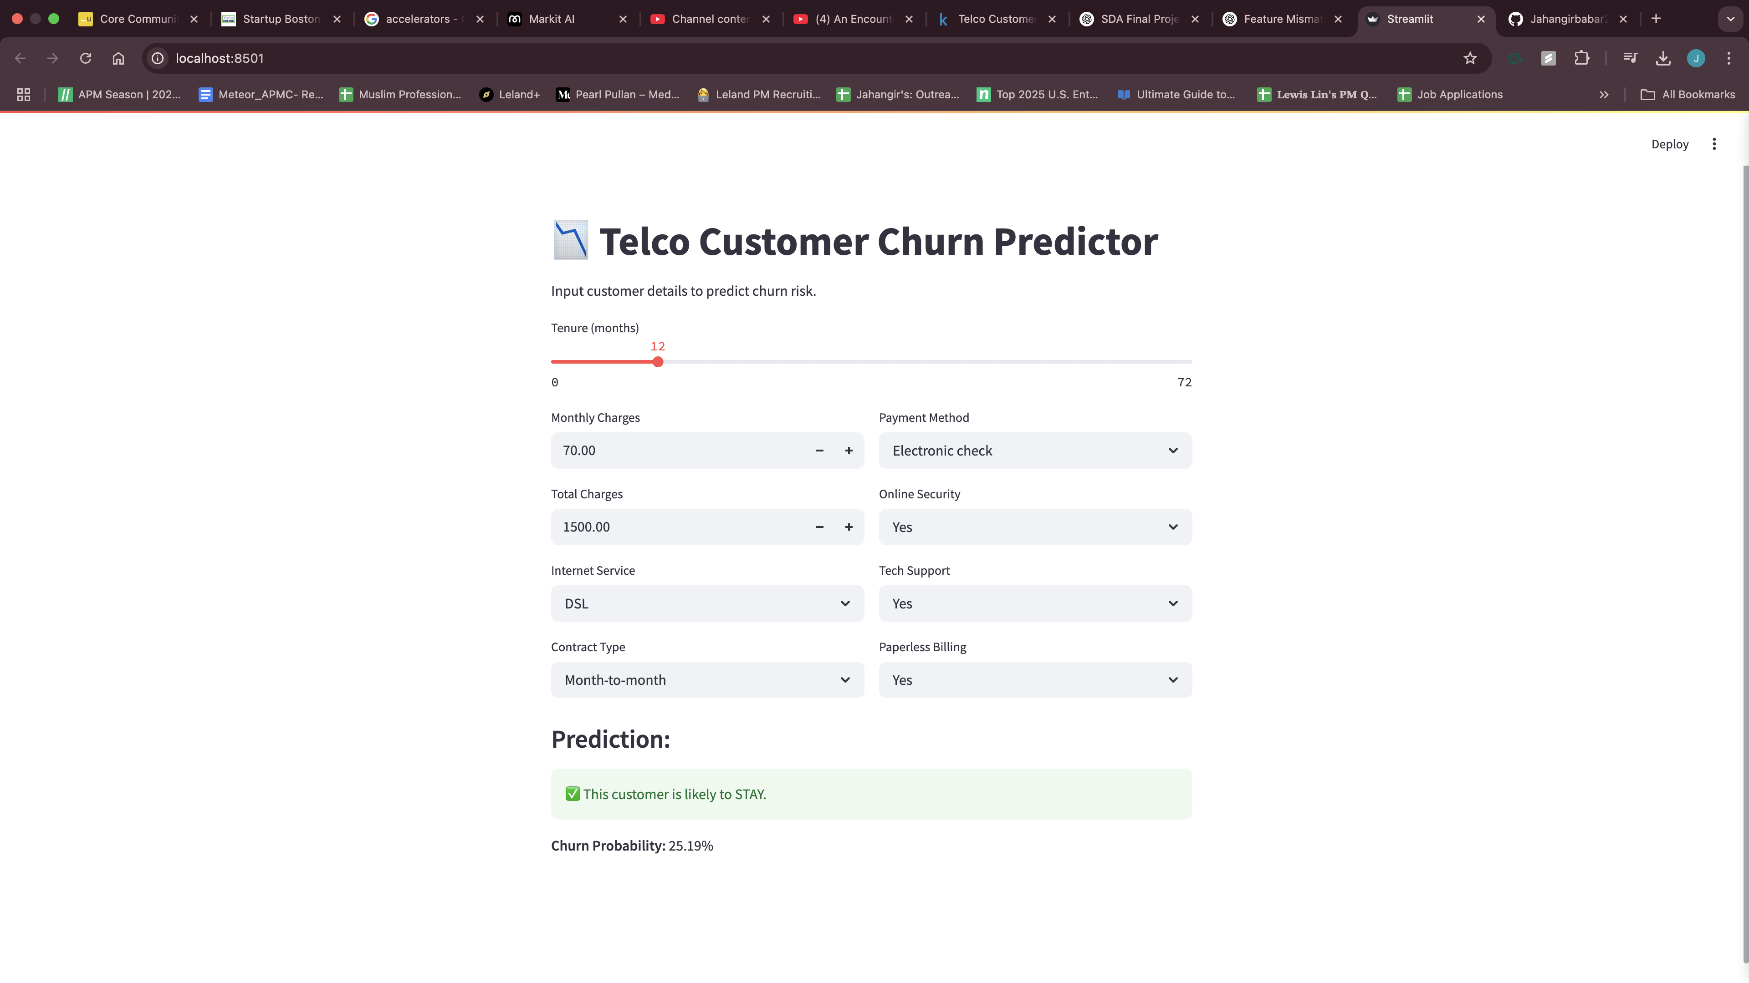

7.3 Why This Matters:
This app simulates a real-world scenario where a retention specialist or customer service rep could assess the likelihood of churn instantly and recommend targeted retention offers. It effectively bridges the gap between data science models and business decision-making by putting predictive insights into a usable tool.
A screenshot of the app is shown below, and the code (churn_predictor.py) is included with this report.

8. Tool Usage Justification

8.1 Why R?
R was primarily used for initial data cleaning, exploratory data analysis (EDA), and quick visualizations. Its built-in functions for data manipulation (such as dplyr and tidyr) made it easy to handle missing values, recode variables, and explore categorical distributions efficiently. The grammar of graphics offered by ggplot2 also allowed me to quickly spot trends, relationships, and outliers during early analysis phases. This made R especially useful for generating preliminary insights before building models.

8.2 Why Python?
Python was chosen for the core machine learning pipeline due to its extensive ecosystem of ML libraries, including scikit-learn, joblib, and pandas. I used Jupyter Notebook for building and evaluating various models (e.g., Random Forest, Logistic Regression), performing feature selection, and tuning hyperparameters. The notebook format allowed for modular development and easy iteration with embedded outputs, making it ideal for experimentation and documentation during model building.
In contrast, Streamlit was used to create an interactive user interface for the final model. This tool allowed me to deploy a fully functional churn predictor where business users can input customer details and get churn risk predictions in real-time. Streamlit enabled me to bridge the gap between technical analysis and business usability, turning a static notebook model into a dynamic web app that anyone can use.

9. Insights and Conclusion
From this project, I gained a deeper understanding of the customer attributes most strongly associated with churn in a telecom setting. The most significant churn drivers identified by the model include:
- Short tenure: Customers who recently joined are more likely to churn.
- Month-to-month contracts: These customers had a much higher churn risk than those on long-term contracts.
- Lack of tech support and online security: Customers without these services were more likely to leave.
- High monthly charges with low total charges: Suggests newer customers with expensive plans, likely dissatisfied.
To reduce churn, the company should consider:
- Offering incentives or discounts to new customers in the first few months.
- Encouraging longer contract terms with loyalty benefits.
- Bundling tech support and security services with premium plans.
- Proactively targeting high-risk customers identified by the model with personalized retention campaigns.
In real-world applications, this model can be integrated into the CRM system to flag at-risk customers and trigger timely interventions. This not only improves customer retention but also increases lifetime value and reduces marketing spend on reacquisition.

