
K. R. MANGALAM UNIVERSITY, GURUGRAM, HARYANA, INDIA

CAPSTONE ASSIGNMENT
-Delivery Route Optimization-
Analysis and Design Algorithm
Name: Jahanvi Deswal
Course: B-Tech CSE (Data Science) A
Roll No.: 2401420026
Semester: 4th
Batch: 2024-2028

Submitted to - Signature -
Dr Aarti Sangwan

Task 1 & 2 — Environment Setup & Input Modeling
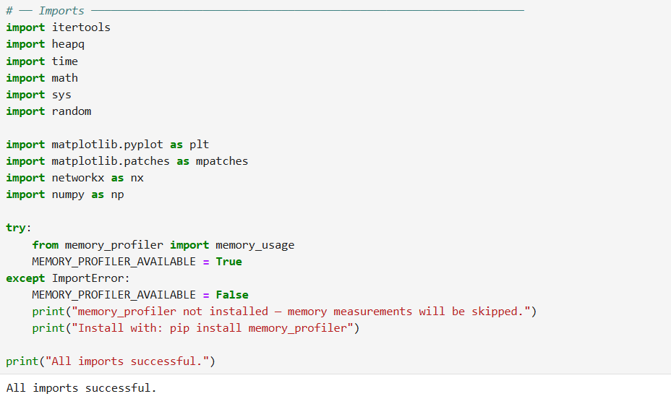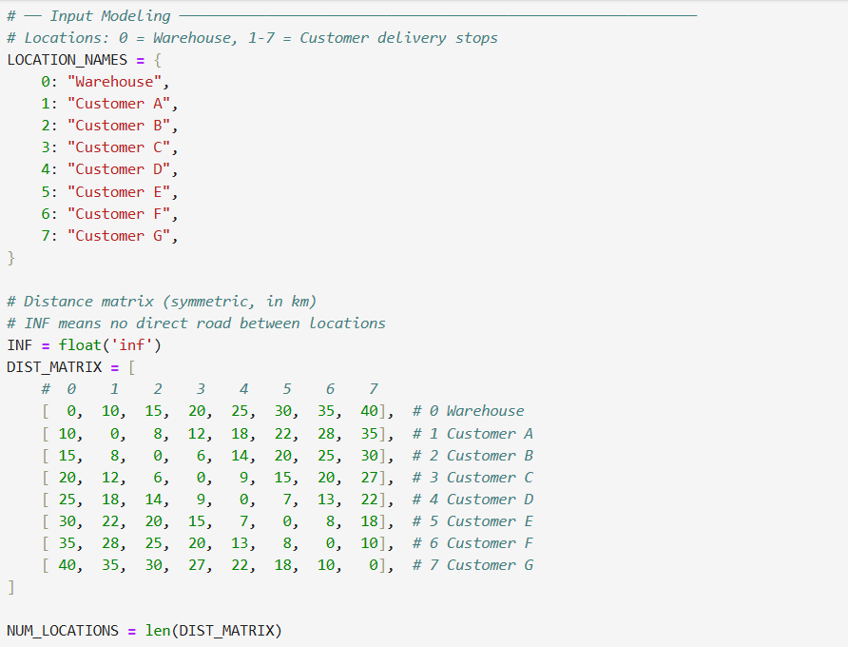

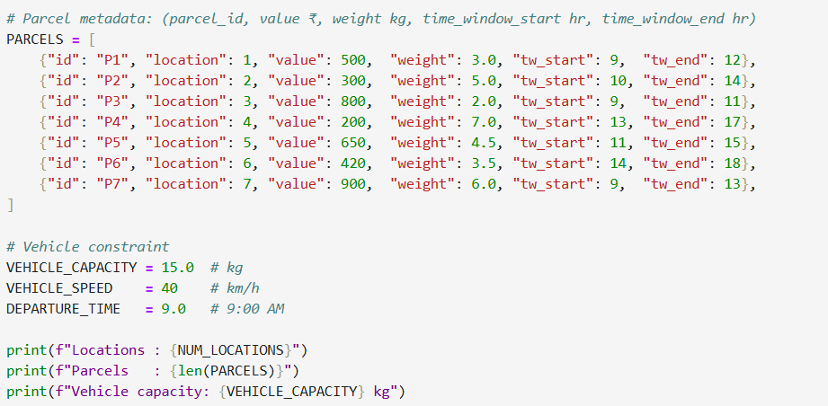

OUTPUT :

Task 3 — Recurrence-Based Route Cost Function
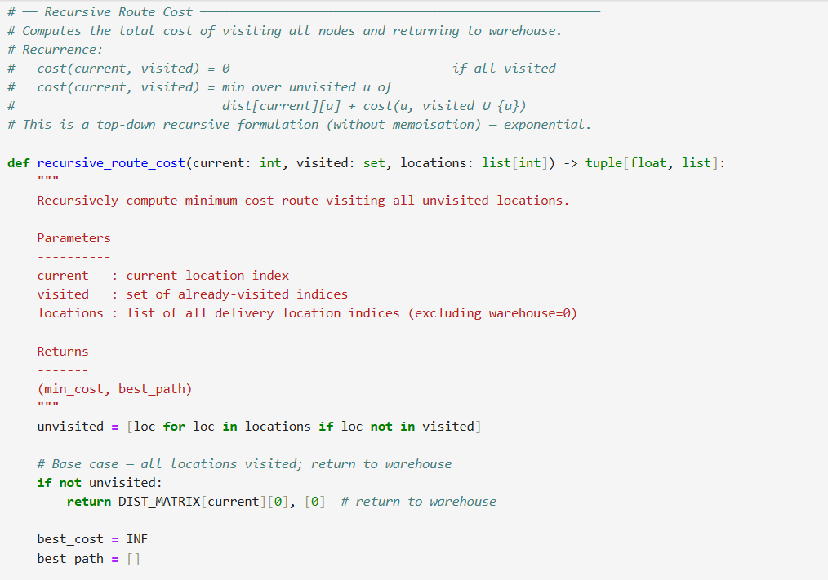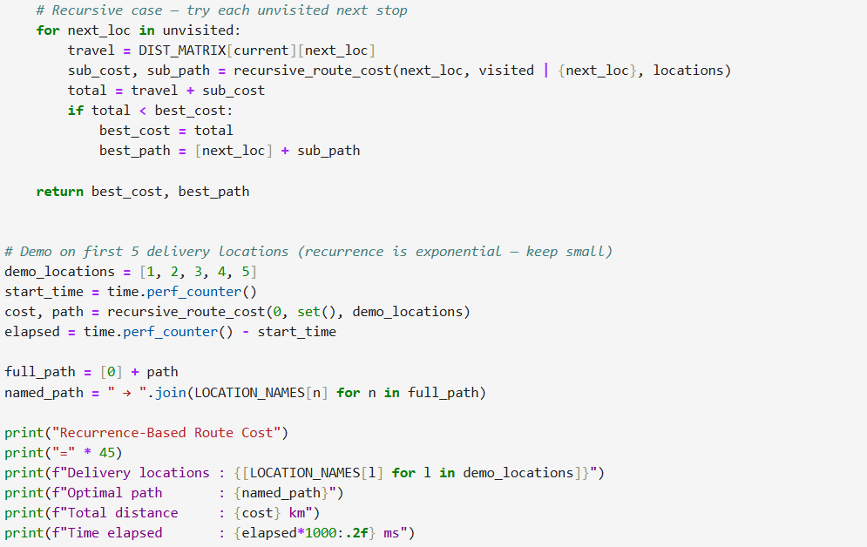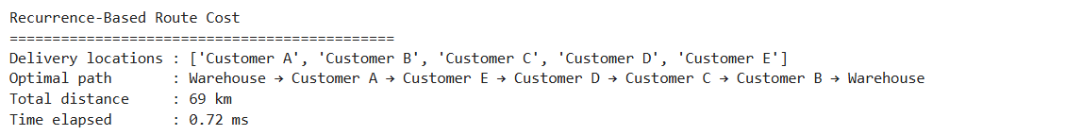
Task 4 — Greedy + DP for Delivery Planning
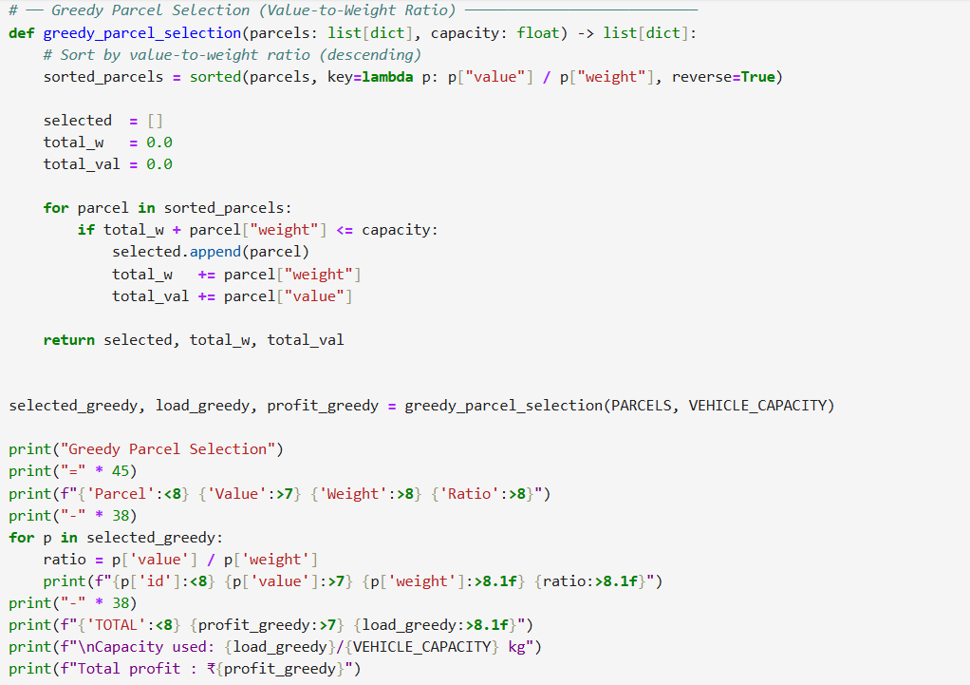
OUTPUT:
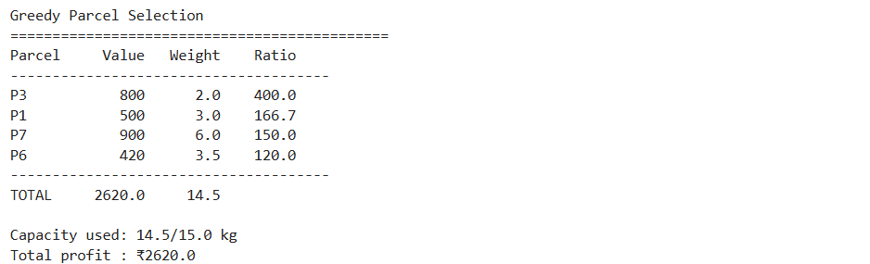

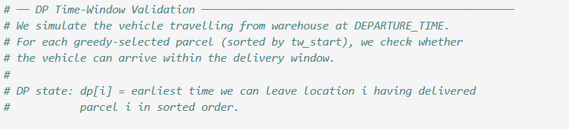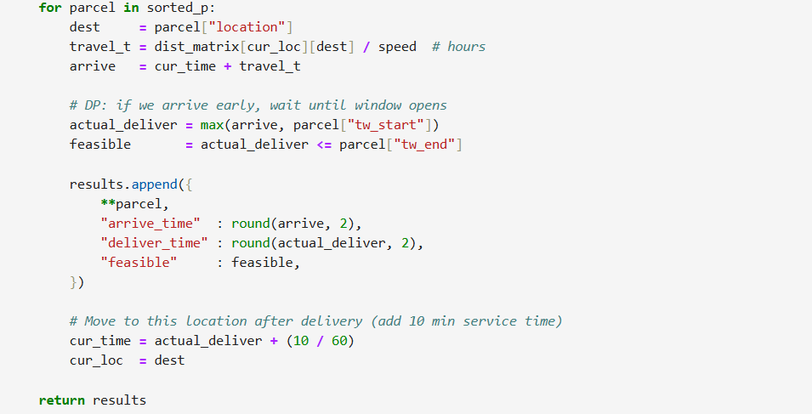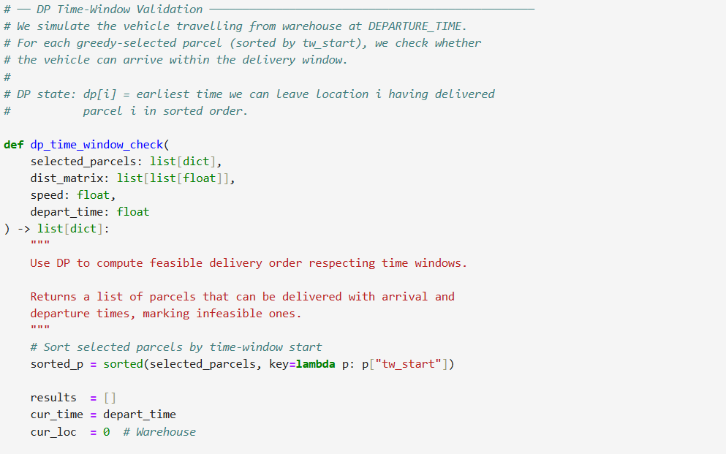
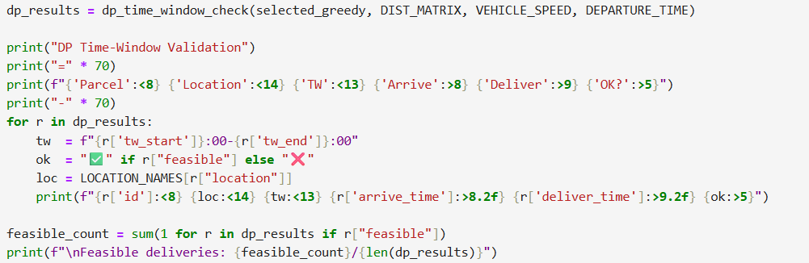

OUTPUT :
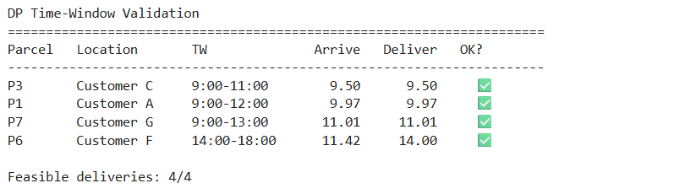

Task 5 — Graph Algorithms: Dijkstra & MST
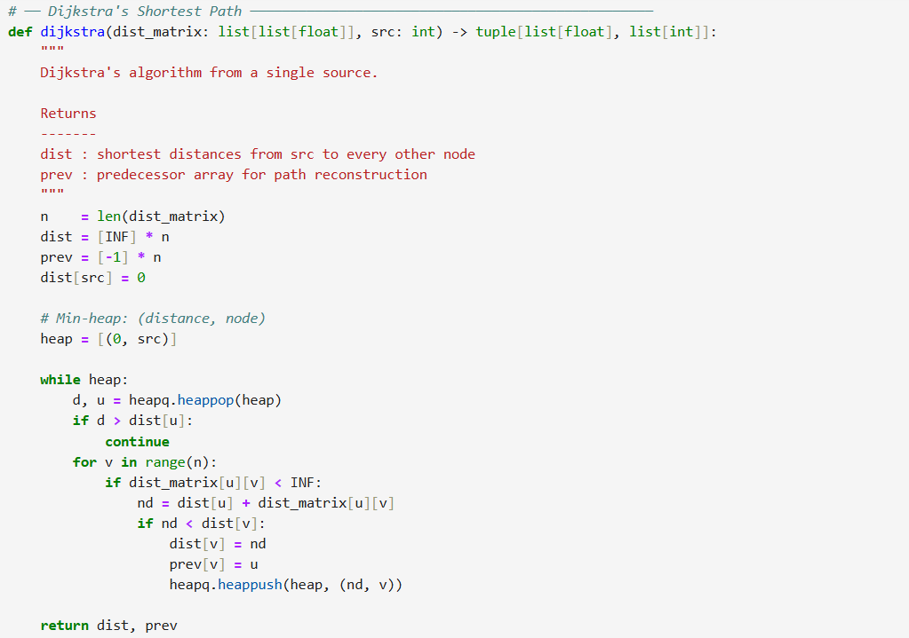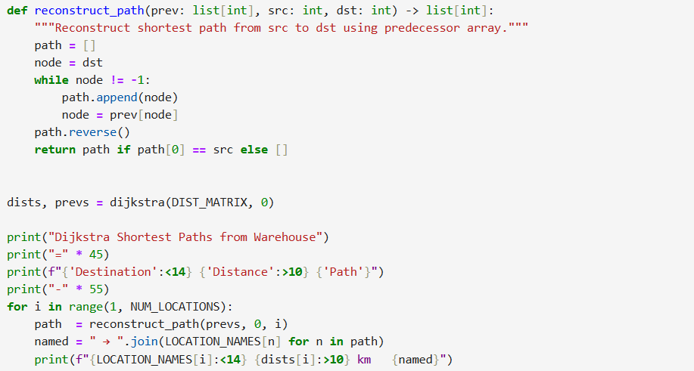

OUTPUT:
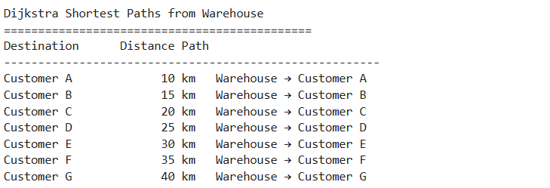
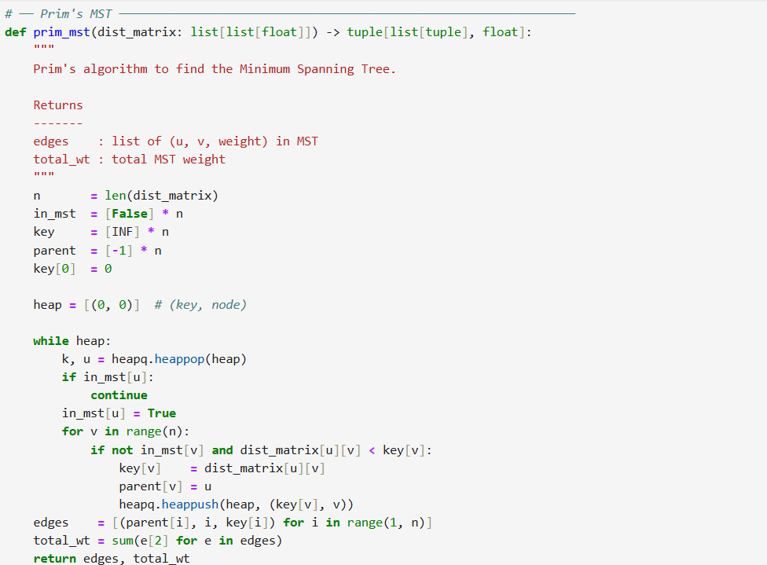
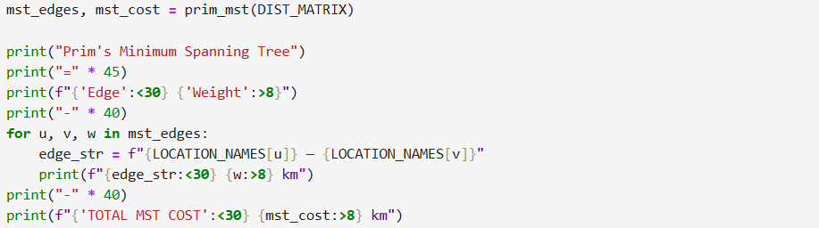

OUTPUT :
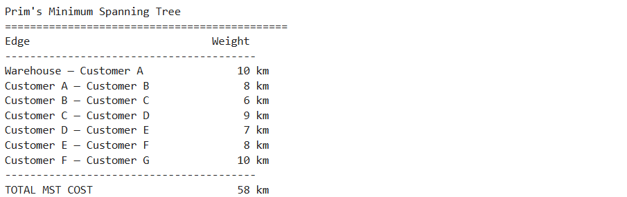

Task 6 — TSP Implementation
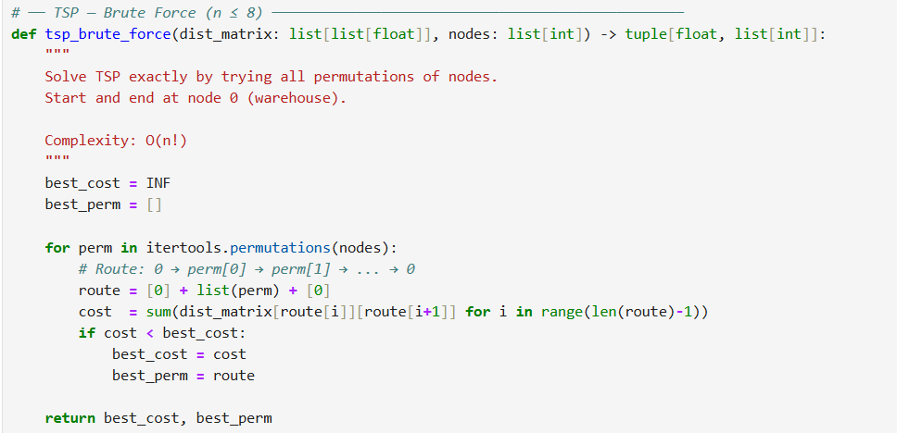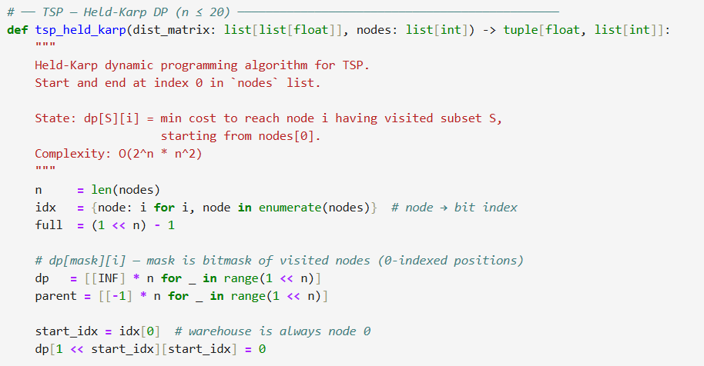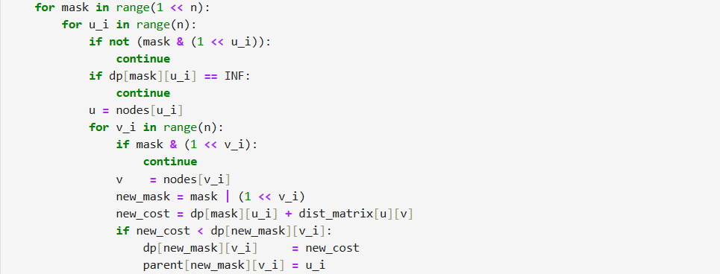
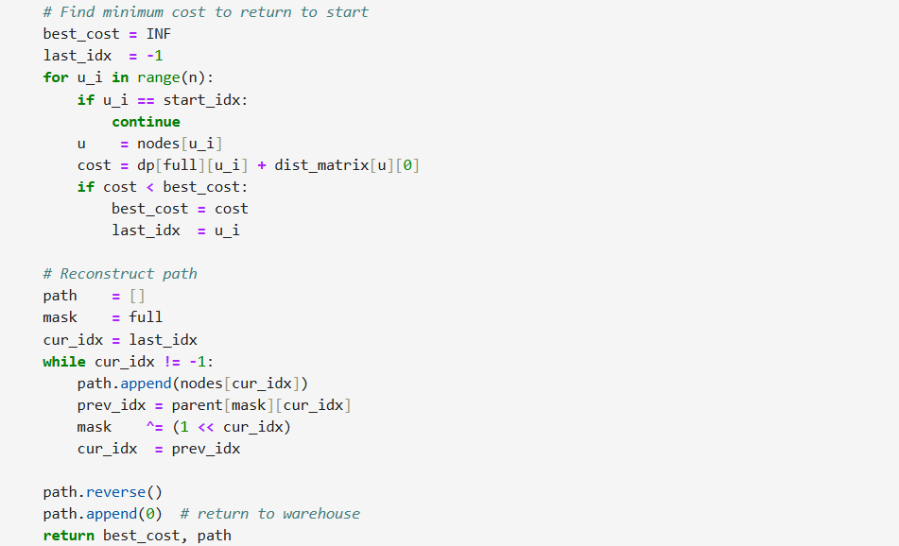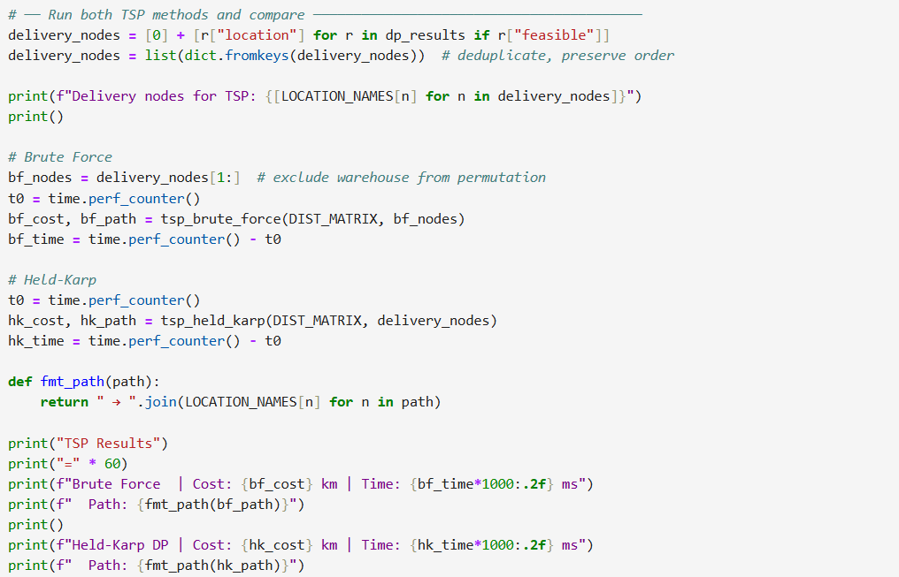

OUTPUT :
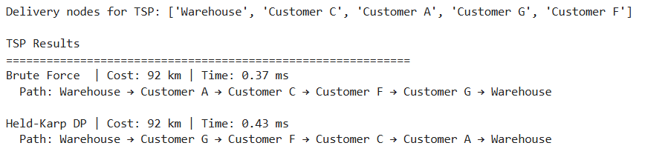

Task 7 — Profiling & Visualization
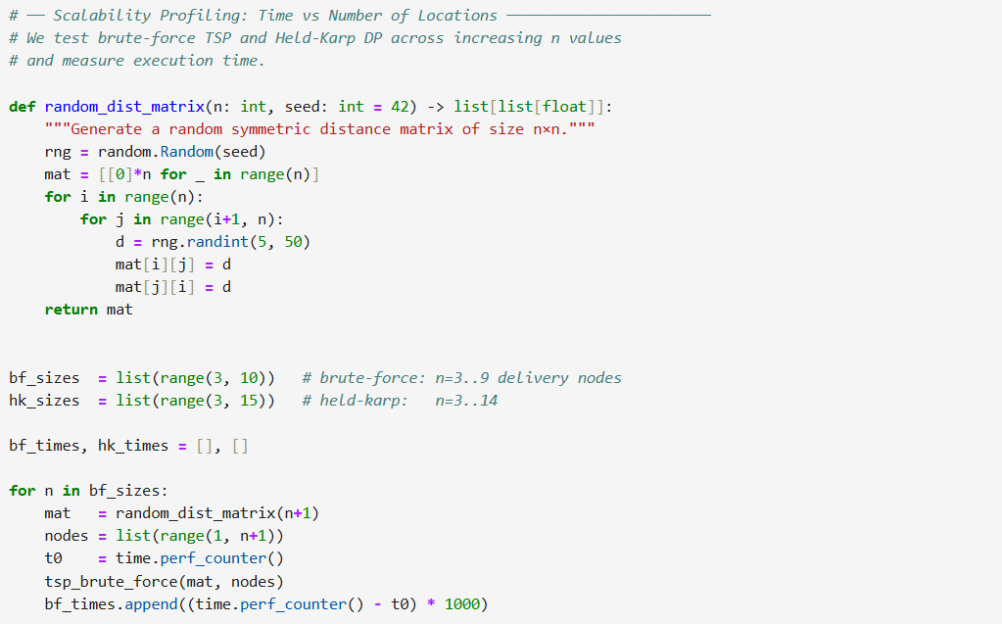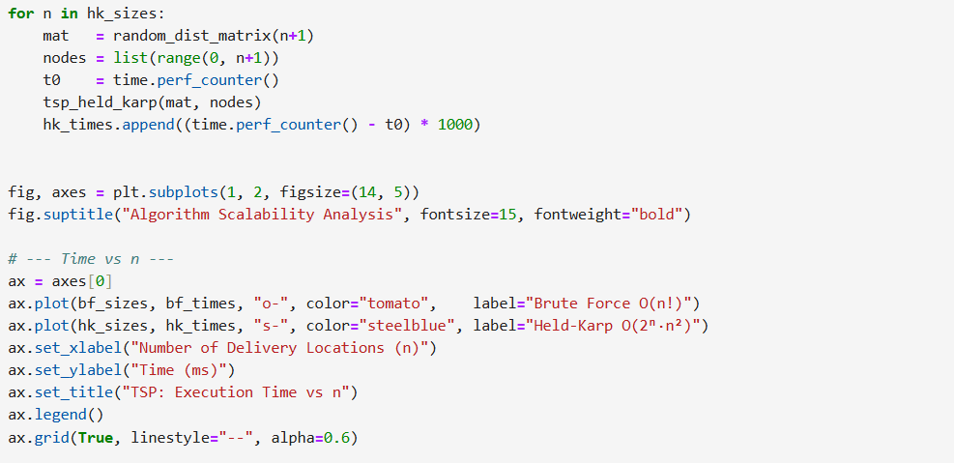
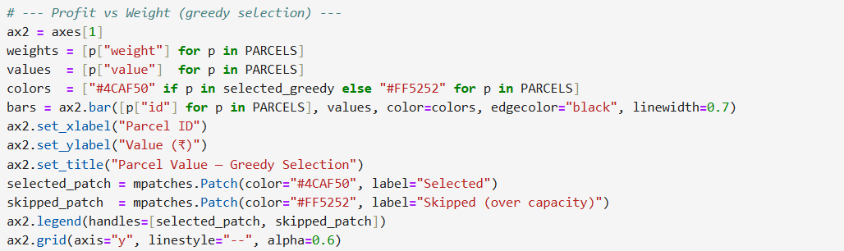
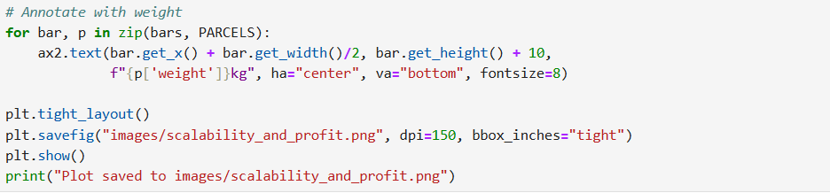

Algorithm scalability Analysis
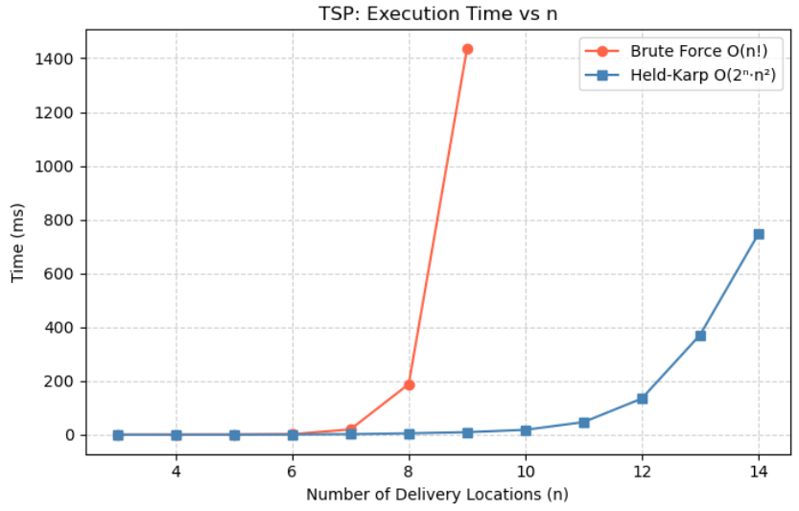
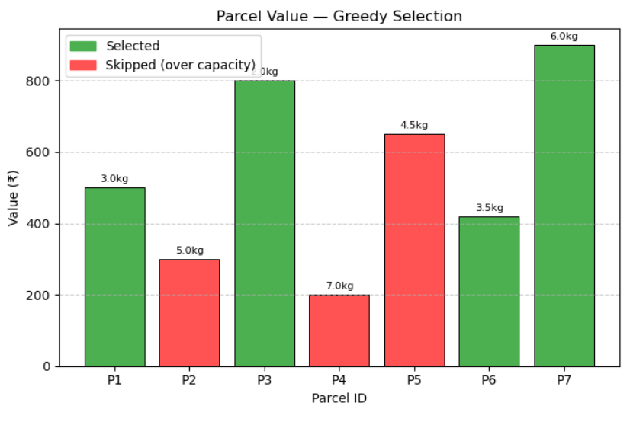
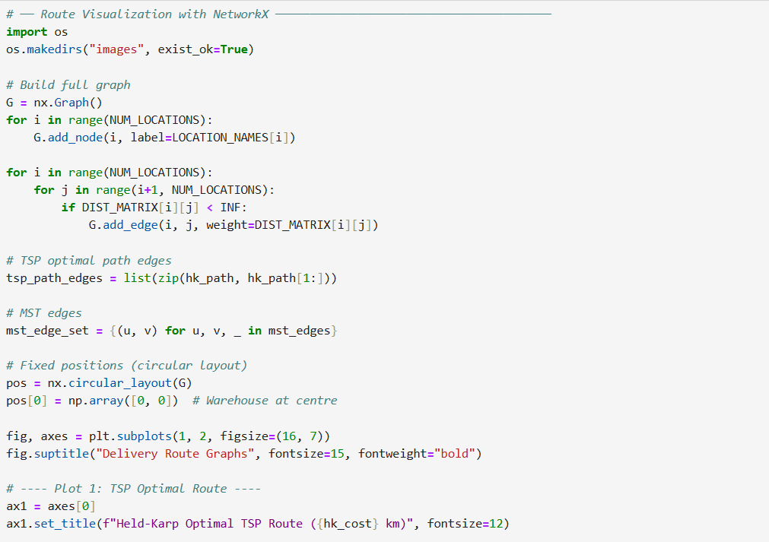
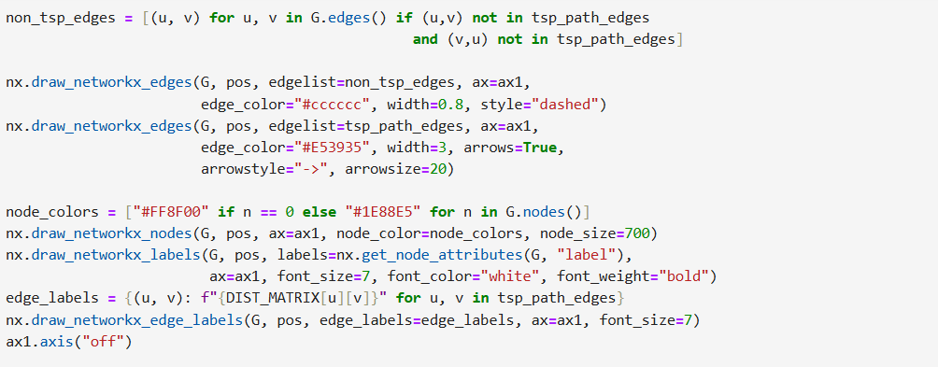
Delivery Route Graph :
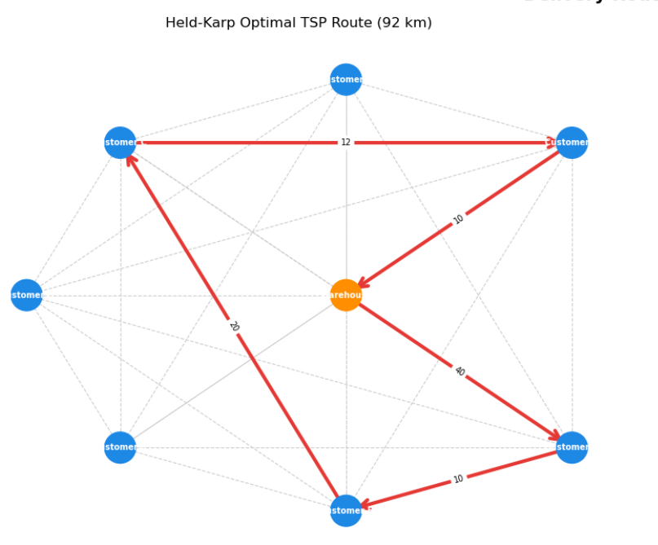
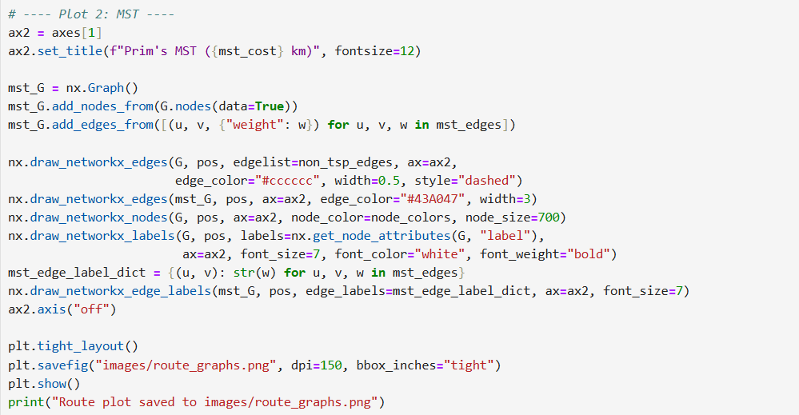
Delivery Route Graph :
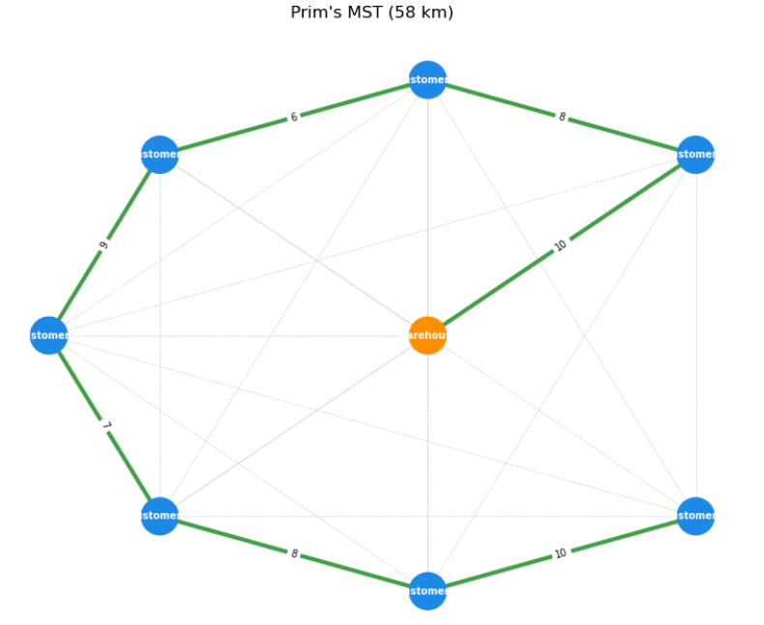

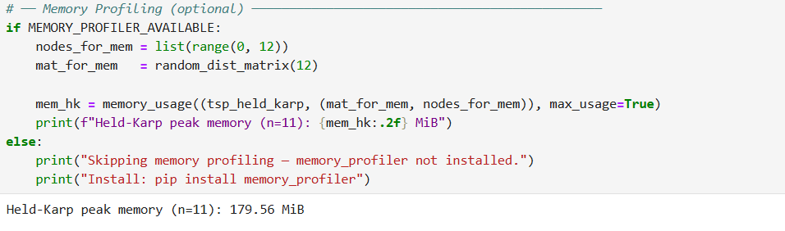

Task 8 — Summary Table & Performance Comparison
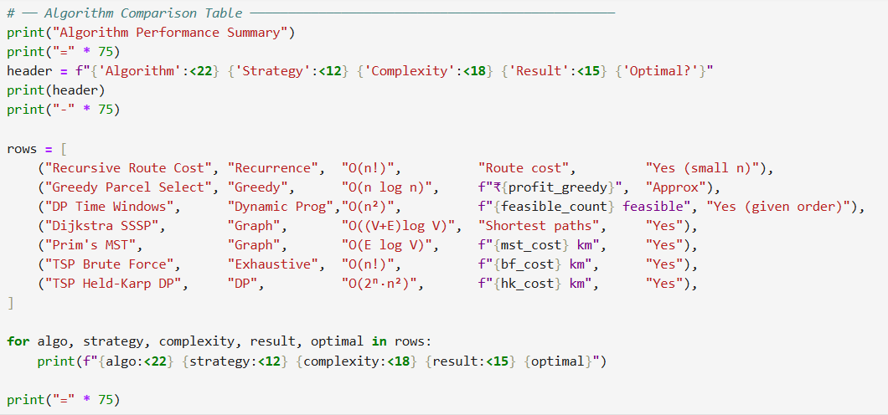
OUTPUT :
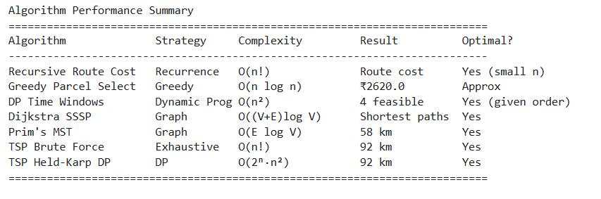

Reflection & Discussion
1. Optimization vs Realism
The Held-Karp TSP gives the mathematically optimal route by total distance, but it does not account for real-world constraints like delivery time windows. The DP time-window check must be run separately to validate feasibility, and some TSP-optimal orderings may violate windows — requiring a hybrid approach.
2. Algorithm Trade-offs
Algorithm | Speed | Scalability | Notes
Greedy Parcel Select | Fastest | O(n log n) | Sub-optimal for 0/1 knapsack
DP Time Windows | Fast | O(n²) | Optimal order given sorted windows
Dijkstra | Fast | O(E log V) | Exact shortest paths
TSP Brute Force | Slow | O(n!) | Infeasible beyond n≈10
TSP Held-Karp DP | Better | O(2ⁿn²) | Infeasible beyond n≈20
3. NP-hard Challenge
TSP brute force becomes infeasible around n = 12 (12! ≈ 479 million permutations). Held-Karp handles up to n ≈ 20 practically. Beyond that, heuristics (Nearest Neighbour, Christofides) or metaheuristics (GA, Simulated Annealing) are necessary.
4. Visualization Insight
Route graphs clearly showed that the MST and TSP routes are structurally similar for clustered nodes — confirming that the Christofides approximation (1.5× MST) would be an effective heuristic. The profit/weight chart quickly reveals which parcels offer the best value density.
5. Feature Suggestion
Adding fuel cost (proportional to weight × distance) and multi-vehicle routing (VRP) would significantly improve realism. A fleet of 3 vehicles with load balancing would reduce total delivery time and better model platforms like Amazon Prime.

