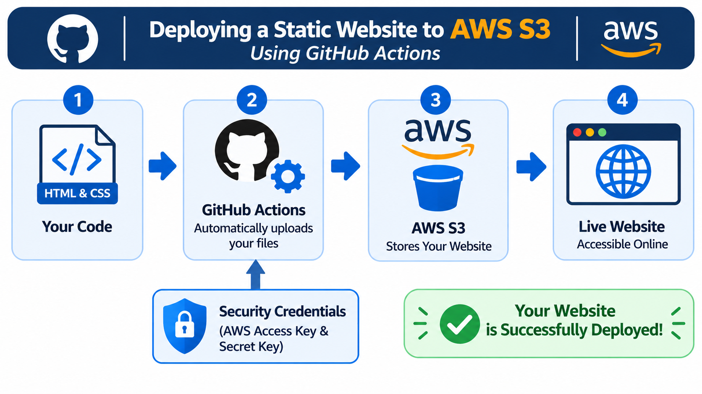

Bucket Policy:

{
"Version": "2012-10-17",
"Statement": [
{
"Sid": "PublicReadGetObject",
"Effect": "Allow",
"Principal": "*",
"Action": "s3:GetObject",
"Resource": "arn:aws:s3:::Your-Bucket-Name/*"
}
]
}

