|  |
| --- |
| **Lab01: Getting started with Netbeans** |

Introduction to:

|  |
| --- |
| 1. Netbeans IDE 2. Exercises |

**Exercises**

Exercise 1

Create a new java project on NetBeans named as “First_Exercise”. Display a text message saying, “this is my first program”. Provide multiline document string for the created program explaining the process in the program

package first.exercise;

public class FirstExercise {

public static void main(String[] args) {

System.out.println("This is my first exercise");

//Booted netbeans

/*

Named my project "First exercise"

Print whatever i wanted in the inverted commas

*/

}

}

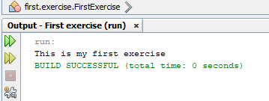

Exercise 2

Create a java program named “Second_Exercise”. Print the name, enrollment, Subject name, Instructor name and semester of a student and attach proper output screen shot. Provide proper comments.

**Expected Output:**

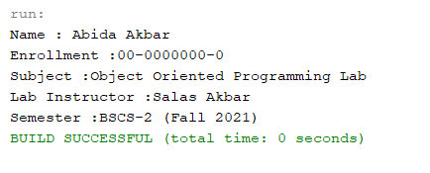

package second.exercise;

public class SecondExercise {

public static void main(String[] args) {

System.out.println("Name: Jahanzaib Ali");

System.out.println("Enrollment: 02-134221-054");

System.out.println("Subject: OOP");

System.out.println("Teacher Name : Salas Akber");}

}

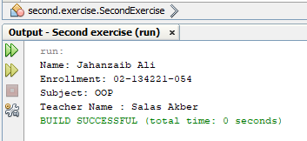

**NOTE: Provide proper comments to each line of code**