

FACULTY OF INFORMATION TECHNOLOGY AND COMMUNICATION STUDIES
DEPARTMENT OF INFORMATION TECHNOLOGY STUDIES UNDERGRADUATE
WORK
DESIGN AND IMPLEMENTATION OF AN INTEGRATED IT ASSET INVENTORY, RESERVATION AND TRACKING SYSTEM FOR IT EQUIPMENTS AT UPSA
GROUP 42
BY
10300793
10298820
10299675
JULY 2026

CANDIDATES’ DECLARATION
We hereby declare that this project work titled “DESIGN AND IMPLEMENTATION OF AN INTEGRATED IT ASSET INVENTORY, RESERVATION AND TRACKING SYSTEM FOR IT EQUIPMENTS AT UPSA” is the result of our own original research and development efforts carried out under the approved academic guidelines of the University. We affirm that this work has not been submitted, either wholly or in part, for any other degree, diploma, or academic qualification in this or any other institution. All sources of information, ideas, and materials obtained from published and unpublished works have been duly acknowledged and properly referenced in accordance with accepted academic standards. We further declare that any assistance received in the course of this project has been appropriately acknowledged, and that this work represents an honest and accurate account of the research conducted. We take full responsibility for any errors or omissions contained herein.

NAME INDEX NUMBER SIGN DATE
STEPHEN AGYEMANG 10300793
SAVIOUR ATTEFAH 10298820
AFRAINIE KWABENA APPIAH 10299675

SUPERVISOR’S DECLARATION
I declare that the preparation and presentation of this Dissertation were in accordance with the guidelines on supervision of Dissertation laid down by the University of Professional Studies, Accra (UPSA).
Supervisor’s Name: LAWRENCE AZIALE
Supervisor’s Signature………………………
Date…………………….…………

DEDICATION
This project is dedicated to God Almighty for His guidance, strength, and wisdom throughout the course of this study. We also dedicate this work to our parents and families for their unwavering support, encouragement, and sacrifices, which made our academic journey possible. Special appreciation goes to our lecturers and mentors whose guidance, motivation, and academic input contributed significantly to the successful completion of this project. Finally, this work is dedicated to the University for whom this project was developed.

ACKNOWLEDGEMENTS
We express our sincere gratitude to the Almighty God for the wisdom, strength, and guidance granted to us throughout the duration of this project. His grace and favor made it possible to successfully complete this work. We would like to extend our profound appreciation to our project supervisor (LAWRENCE AZIALE) for the invaluable guidance, constructive criticism, and continuous support provided throughout the research and development process. His expertise, patience, and encouragement played a significant role in shaping the quality and direction of this project. Our sincere thanks also go to the lecturers of the Information Technology Department of the University of Professional Studies, Accra, for the knowledge, skills, and academic foundation imparted to us during the course of our study. Their contributions greatly influenced the successful execution of this project. We are grateful to our colleagues and friends who offered support, ideas, and encouragement during the development of this work. Their feedback and collaboration were instrumental in overcoming challenges encountered during the project. Finally, we extend our heartfelt appreciation to our families for their unwavering support, understanding, and motivation throughout our academic journey. Their enthusiasms provided the strength needed to complete this project successfully.

ABSTRACT
As institutional reliance on technology expands, higher education has shifted toward automated asset management for real-time oversight. Current manual tracking at the University of Professional Studies, Accra (UPSA), utilizes fragmented logs, resulting in inaccurate data and equipment loss (Stair & Reynolds, 2020). This study introduces UPSA AssetHub, a web application designed to track the lifecycle of university gadgets—including projectors, laptops, and cameras—via tailored reservation and maintenance workflows. Utilizing a normalized PostgreSQL database, the application provides precise inventory visibility and historical usage data. A Role-Based Access Control (RBAC) framework (Sandhu et al., 1996) ensures secure interactions for students, staff, and administrators, while automated triggers provide real-time alerts for overdue returns and maintenance to sustain institutional accountability (Davis, 2019).
The study followed a Design and Development Research (DDR) methodology (Richey & Klein, 2007) aligned with Agile principles. Usability testing and direct observations were conducted with UPSA students and IT personnel. The application employs a modern full-stack architecture comprising React 18, TypeScript, and Tailwind CSS for the frontend, and Node.js with Express.js for the backend, utilizing JSON Web Tokens (JWT) for secure, stateless authentication. Results demonstrate that UPSA AssetHubprovides significantly higher inventory accuracy and faster reservation turnaround times than manual methods. This research contributes to administrative innovation by facilitating informed choices regarding hardware procurement and maintenance, benefiting university management and IT professionals (Sommerville, 2016).

TABLE OF CONTENT
CANDIDATES’ DECLARATION 2
SUPERVISOR’S DECLARATION 3
DEDICATION 4
ACKNOWLEDGEMENTS 5
ABSTRACT 6
List of Figures 9
CHAPTER ONE 10
GENERAL INTRODUCTION 10
1.1 Introduction 10
1.2 Background 12
1.3 Statement of the Problem 14
1.4 Study Objectives 15
1.4.1 General Objective 15
1.4.2 Specific Objectives 16
1.5 Scope of the Project 17
1.6. Methodology for Project 19
1.7 Significance of the Project 20
1.8 Limitations of the Project 22
1.9 Organization of the Study 23
1.10 Chapter Summary 25
CHAPTER TWO 26
LITERATURE REVIEW 26
2.1 Introduction 26
2.2 Review of Existing Systems and Technologies 27
2.3 Proposed System 29
2.4 Chapter Summary 31
CHAPTER THREE 33
METHODOLOGY 33
3.1 Introduction 33
3.2 System Development Methodology 34
3.3 Crystallization of the Problem 36
3.4 Requirements of the Proposed System 38
3.4.1 Functional Requirement 39
3.4.2 Non-Functional Requirement 42
3.4.3 Software Requirements 45
3.4.4 Hardware Requirements 48
3.5 Design of the System 49
3.5.1 Flowchart Diagram 50
3.5.2 Context Diagram 53
3.5.3 Entity Relationship Diagram (ERD) 55
3.5.4 Data Flow Diagram (DFD) 56
3.5.5 Use Case Diagram 58
3.6 Chapter Summary 59
CHAPTER FOUR 60
IMPLEMENTATION AND DOCUMENTATION OF THE PROPOSED SYSTEM 60
4.1 Introduction 60
4.2 Testing Approaches 61
4.2.1 Unit Testing 62
4.2.2 Functional Testing 64
4.2.3 Usability Testing 65
4.2.4 Acceptance Testing 66
4.2.5 Selected Testing Approach 67
4.3 Implementation of the Current System 69
4.3.1 Parallel implementation 70
4.3.2 Pilot implementation 71
4.3.3 Direct implementation 72
4.3.4 Phased Implementation 74
4.4 System Documentation 75
4.5 Implementation Challenges 80
4.6 Chapter Summary 82
CHAPTER FIVE 83
SUMMARY, CONCLUSIONS AND RECOMMENDATIONS 83
5.1 Introduction 83
5.2 Summary 83
5.3 Limitations of the Study 84
5.4 Recommendations for Future Research 85
5.5 Conclusion 86
REFERENCES (APA) 87
APPENDICES 94

List of Tables

2.2 Comparing Review of Existing Systems and Technologies…………………………..27
3.4.3 : Software Requirements………………………………...…………………………….46 3.4.4 : Hardware Requirements….……………………………...…………………………….49

List of Figures
Figure 1: System Flowchart……………………………………………………………………53
Figure 2: Context Diagram……………………………………………………………………..55
Figure3:ERD Diagram………………………………………………………………………….57
Figure 4: Dataflow Diagram.………….…………………………………………………….....58
Figure 5: Use Case Diagram ……………..………………………………………………….....60
Figure 6: System Home Page……………..…………………………………………76
Figure 7: System Auth Page……………..…………………………………………77
Figure 8: System Dashboard Page……………..…………………………………………78
Figure 9: System Admin Auth page……………..…………………………………………80

CHAPTER ONE

GENERAL INTRODUCTION

1.1 Introduction
Greater reliance on digital technologies has significantly changed how educational institutions track, plan, and manage their physical infrastructure and technological assets. In recent years, web-based and integrated management applications have become widely used tools for monitoring equipment lifecycles, estimating maintenance requirements, and supporting institutional resource allocation efforts (Al-Mashari, 2021). These technologies aim to enhance administrative decision-making by providing timely and easily accessible data regarding the location, condition, and availability of university hardware. However, the effectiveness of such systems largely depends on the accuracy of their inventory logs, the relevance of their maintenance recommendations, and their ability to adapt to diverse user roles within a campus environment (Gartner, 2022).
Monitoring asset movement and estimating equipment maintenance requirements are central components of effective institutional planning and financial management. Resource utilization varies considerably within a university due to factors such as departmental needs, equipment portability, frequency of use, and varying environmental conditions (Stair & Reynolds, 2020; White, 2021). Despite the availability of numerous generic inventory software, many existing systems in higher education continue to rely on manual entries, static spreadsheets, or generalized assumptions that do not adequately reflect the dynamic movement of gadgets like projectors, laptops, and cameras across a busy campus. As a result, status reports produced by these legacy systems may be inaccurate, which can reduce administrative confidence and lead to significant equipment loss or preventable hardware failure (Li & Mensah, 2023).
Inaccurate asset estimation undermines the practical usefulness of management applications, particularly for IT personnel seeking to optimize gadget lifespans and ensure equitable access for students and staff. Studies indicate that misleading data from fragmented digital tools can negatively influence institutional productivity and lead to budgetary strain due to unrecorded losses (Davis, 2019). These limitations highlight the need for more intelligent and centralized approaches to asset monitoring and maintenance scheduling. Recent advances in full-stack web engineering and automated notification logic have introduced new opportunities to improve the accuracy and responsiveness of inventory monitoring systems. Integrated applications are capable of analyzing usage patterns and applying intelligent business logic to generate more precise schedules for equipment servicing as well as real-time tracking of checkout events (Chen & Zhang, 2020; Sommerville, 2016).
When integrated with modern web technologies, such systems offer additional benefits, including cross-device accessibility, scalability, and ease of use without reliance on proprietary hardware or manual paper trails (Fielding & Taylor, 2017). This study therefore focuses on the design and development of an automated web application, UPSA AssetHub, for monitoring university gadget lifecycles and managing equipment reservations. The proposed system provides administrators and students with a comprehensive platform to log asset details, track checkout events, monitor maintenance history, and receive intelligent insights based on real-time inventory status. Through features such as role-based access control, automated email notifications, and predictive maintenance logs, the system UPSA AssetHub aims to empower the University of Professional Studies, Accra (UPSA), to make informed, data-driven decisions about its technological investments and resource sustainability.

1.2 Background
The integration of information technology into institutional administration and resource management has significantly transformed how higher education facilities monitor and maintain their physical capital. Advances in digital technologies and increased internet accessibility have enabled the development of enterprise-level asset management systems that support informed logistical and financial decisions. At the same time, the rapid expansion of campus infrastructure and the increasing diversity of portable technological assets have contributed to a rise in administrative challenges, such as equipment loss, unauthorized usage, and unmonitored hardware degradation (Stair & Reynolds, 2020). A central concept in effective institutional management is the asset lifecycle, which refers to the relationship between procurement, utilization, and preventive maintenance. Maintaining an accurate record of this lifecycle is essential for financial accountability and operational continuity within a university setting.
When asset tracking is neglected, institutional overhead increases due to the costs of premature replacements, while sustained maintenance gaps lead to hardware failures that disrupt academic and professional delivery (Davis, 2019). Accurate estimation of an asset’s current condition, physical location, and maintenance history is therefore critical for achieving institutional sustainability and resource optimization goals. Asset requirements and usage patterns vary significantly across university departments due to factors such as specialized academic needs, the portability of specific gadgets, the frequency of student loaning, and varying environmental storage conditions (Johnson, 2023). Traditional inventory estimation methods often rely on manual ledgers and decentralized spreadsheets that fail to reflect real-time asset movements, leading to inaccurate status feedback and administrative blind spots.
Although generic digital inventory tools have improved accessibility to resource monitoring, many existing systems rely on simplified, non-relational database models that limit role-based security, multi-user synchronization, and detailed historical logging (Al-Mashari, 2021). Recent advancements in full-stack web engineering and automated logic offer significant opportunities to address these limitations. Modern web-based systems can analyze user-specific interaction data to generate personalized maintenance schedules and adaptive checkout recommendations. Studies indicate that integrated management applications improve data accuracy, transparency, and user accountability when compared to traditional, fragmented systems (Sommerville, 2016).
Furthermore, web-based platforms enhance accessibility by enabling cross-device usage across different operating systems and device types without reliance on specialized hardware or proprietary software, thereby improving the inclusivity and scalability of institutional digital systems (Fielding & Taylor, 2017). Despite these technological advancements, challenges such as a lack of transparency in asset history, limited adaptability to departmental workflows, and data security concerns persist in many contemporary solutions. In response, this study focuses on the design and development of an automated web application, UPSA AssetHub, that integrates validated relational data models with intelligent automated processing to provide accurate, personalized, and transparent monitoring of gadget lifecycles and institutional resource needs.

1.3 Statement of the Problem
Accurate tracking of gadget availability and maintenance requirements remains a significant challenge for institutional administrators seeking to manage university assets effectively. Asset utilization is influenced by multiple factors, including departmental locations, equipment portability, user-specific checkout periods, and varying hardware degradation rates, making precise inventory oversight complex. However, many existing asset management workflows at the University of Professional Studies, Accra (UPSA), rely on manual ledger entries and fragmented spreadsheet systems, which often fail to account for real-time item movement and lead to inaccurate inventory guidance (Stair & Reynolds, 2020). Inaccurate asset estimations can negatively affect administrators’ decision-making and institutional outcomes. Departments attempting to organize academic events may unknowingly face equipment shortages due to overestimated availability, while IT staff aiming for resource optimization may under-allocate budget because of underestimated maintenance requirements. Such discrepancies can reduce user confidence, institutional motivation, and long-term adherence to resource-sharing policies (Li & Mensah, 2023).
Another limitation of existing systems is their narrow focus on simple "in/out" logging without adequately integrating the total asset lifecycle. Components such as preventive maintenance scheduling and historical condition logs are often overlooked, leaving administrators without clear guidance on whether to maintain an asset, decommission it, or procure new units (Davis, 2019). Additionally, many manual tracking methods operate as “black-box” systems for students and staff, providing little visibility into how asset availability or maintenance priorities are determined, which undermines user trust and sustained engagement with the equipment loaning process (Al-Mashari, 2021).
Accessibility further constrains the effectiveness of current solutions, as many systems depend on physical ledger books located in specific offices or locally stored files that are not accessible to authorized users across the campus. These challenges highlight the need for a transparent, accessible, and centralized system that integrates validated relational data models with automated notification techniques. A web-based, automated solution offers a practical approach to delivering accurate, interpretable, and user-centered asset monitoring, thereby supporting informed decision-making and sustainable institutional resource management (Sommerville, 2016).

1.4 Study Objectives

1.4.1 General Objective
The primary objective of this project is to design, develop, and implement an automated web-based asset management system (UPSA AssetHub) that provides university administrators and authorized users with accurate, transparent, and centralized tools to monitor gadget lifecycles, manage equipment reservations, and coordinate maintenance schedules through a secure, data-driven architecture and validated relational models.

1.4.2 Specific Objectives

IT-Related Objectives
To design a high-performance, responsive web interface using React 18,TypeScript, and Tailwind CSS that allows IT personnel and students to monitor inventory status and log asset transactions in accordance with international usability standards (ISO 9241-11).
- To develop a comprehensive asset tracking and categorization system that monitors gadget metadata across various university departments (IT, Finance, Operations) with detailed status breakdowns including availability, repair condition, and physical location.
- To implement a dynamic data synchronization loop using React Query and PostgreSQL that allows users to perform real-time check-in and check-out events, triggering automatic recalibration of asset availability status without session disruption or data collision.
- To integrate a secure Node.js/Express backend architecture with JSON Web Tokens (JWT) and automated middleware logic to manage role-based permissions and trigger real-time system notifications for overdue assets and maintenance deadlines (Sandhu et al., 1996; Sommerville, 2016).

Non-IT Objectives
- To help university stakeholders and department heads make informed resource-allocation and procurement decisions through accurate, personalized asset utilization analytics and financial lifecycle guidance (Gartner, 2022).
- To promote consistent institutional accountability and responsible resource handling by providing clear transaction feedback and transparent historical logs of asset usage to both staff and students (Stair & Reynolds, 2020).

1.5 Scope of the Project
This project focuses on the design and development of a web application that applies automated inventory management methods to monitor university gadget lifecycles and manage equipment reservations. It defines the data inputs, relational modeling approach, and evaluation criteria needed to support accurate inventory oversight and accountability. This study examines the development of a web-based system in which authorized users (administrators, IT staff, and students) enter asset-specific information—including serial numbers, departmental ownership, current hardware condition, and acquisition dates—to generate real-time reports related to equipment availability and maintenance status.
The system tracks gadget movement across the campus by applying standard transaction logging for all check-out and check-in events. It monitors equipment health using validated lifecycle models and historical maintenance data. Based on the institution’s resource management goals, the application provides automated recommendations on whether an asset should undergo preventive maintenance, remain in active service, or be scheduled for decommissioning (Davis, 2019). The system uses automated state-management techniques to support personalization by updating its status recommendations and user-specific dashboards based on real-time input and observed patterns of equipment usage. The project includes secure Role-Based Access Control (RBAC), reliable relational data storage (PostgreSQL), and interactive data visualization that allows administrators to monitor inventory health and asset distribution over time (Stair & Reynolds, 2020).
This study focuses on a full-stack web system developed using React 18, TypeScript, and Node.js (Express), with PostgreSQL utilized for the backend relational infrastructure. The system was tested and assessed with a focus group comprising students and IT personnel from the University of Professional Studies, Accra (UPSA), focusing on usability, data integrity, and system performance. The scope does not include integration with physical IoT tracking sensors (such as GPS or RFID hardware), the development of a native mobile application, the training of advanced predictive machine learning models for hardware failure, or the deployment of the system at a large-scale commercial enterprise level. These constraints ensure the project remains manageable within the academic schedule while still facilitating the development of a functional, robust solution that meets the research aims (Sommerville, 2016).

1.6. Methodology for Project
This study utilizes a Design and Development Research (DDR) methodology to construct the UPSA AssetHub web application and to assess its operational performance within a real-world institutional setting (Richey & Klein, 2007). The development process commenced with the systematic collection and documentation of project requirements. During this initial phase, the functional and non-functional requirements were identified by reviewing relevant software engineering literature and assessing the specific expectations of the UPSA IT department and student body. These requirements established the framework for system design decisions and remained the primary benchmark throughout the implementation phase (Stair & Reynolds, 2020).
The system architecture is constructed using modern full-stack web technologies. React 18 defines the component-based page structure, Tailwind CSS controls the responsive layout and visual styling, and TypeScript implements the application logic and strict type-checking for user interactions. In this project, a Node.js environment using the Express.js framework serves as the backend, providing robust user authentication, centralized data storage, and API management. For data persistence, PostgreSQL provides a relational database structure that ensures data integrity and ACID compliance (PostgreSQL Global Development Group, 2023). The system applies a structured approach to asset management that joins relational logic with validated Role-Based Access Control (RBAC) models to provide transparent tracking of gadget lifecycles and maintenance requirements (Sandhu et al., 1996).
The project followed an Agile methodology, progressing through short, two-week iterations (sprints) that included design work, coding, testing, and system revisions (Sommerville, 2016). This iterative approach utilized feedback from each testing phase to guide continuous improvements to the system’s interface and backend logic. The application was evaluated using questionnaire responses, observation notes from controlled test sessions, and performance data captured in the system logs. This study applies descriptive statistics and qualitative analysis to assess usability, data accuracy, and user satisfaction (Nielsen, 1993). The methodology evaluates the system by examining technical performance metrics and user acceptance levels, subsequently synthesizing the results into a comprehensive assessment of the system's institutional value.

1.7 Significance of the Project
The value of this study can be considered in terms of technological, practical, academic, and institutional aspects. From a technical standpoint, the study combines modern full-stack engineering principles with automated business logic to improve the performance and usability of institutional resource management applications. By pairing a centralized relational database with automated notification triggers and status-management logic, the proposed system goes beyond static, manual inventory tracking and instead provides a dynamic decision-support environment that adjusts to real-time transaction data. This framing supports the practical role of integrated web systems in optimizing institutional workflows (Stair & Reynolds, 2020).
In practical terms, the study offers university administrators and staff clear and usable information about the lifecycle, availability, and maintenance history of technological assets. By clearly stating whether an asset is available for loan, undergoing maintenance, or overdue for return, the system helps users make informed choices about equipment scheduling and departmental resource allocation. This is consistent with the management principles established by Davis (2019), who argues that successful IT asset management (ITAM) requires a clear understanding of asset utilization rates and consistent management of maintenance schedules to prevent hardware failure. Because the system is web-based, users can access it across various campus departments without the need for specialized hardware or local software installations, thus enhancing operational flexibility.
Academically, this study adds to the research literature on Information Systems (IS), software engineering methodologies, and digital governance within higher education. It sets out a clear framework that brings together database normalization, user-centered design, and automated transaction logging, which can guide future research and system development in the field of institutional technology management. This study contributes to current academic debates regarding data
integrity, role-based security, and user accountability in automated administrative systems (Sommerville, 2016).
From an institutional and societal standpoint, this study supports resource sustainability and financial accountability by increasing awareness of equipment value and encouraging responsible handling of university property. As the cost of technological infrastructure increases worldwide, there is a growing need for digital tools that are accessible and reliable to support better public resource management (Al-Mashari, 2021). In sum, this study contributes significantly to the research on intelligent, inclusive, and user-centered digital tools for institutional governance.

1.8 Limitations of the Project
While the proposed automated web application provides a practical way to track university gadgets and manage maintenance cycles, it also has limitations that should be stated clearly. A central limitation is that the system depends on user-entered data, including serial numbers, hardware condition ratings, and departmental acquisition dates. Inventory reports and maintenance alerts produced by the system may be less accurate if IT personnel enter incorrect or incomplete data during the initial cataloging process. Furthermore, the application does not include hardware-based tracking sensors, such as Global Positioning System (GPS) or Radio Frequency Identification (RFID) tags, for real-time physical location monitoring. Instead, gadget location is tracked logically through database status updates. While this method is supported by standard Information Systems (IS) research for institutional settings (Stair & Reynolds, 2020), it may not prevent the physical displacement of assets if they are moved without being updated in the system.
Asset degradation and maintenance needs are calculated using validated lifecycle models and historical transaction logs. Although these methods are consistent with best practices in IT Asset Management (ITAM), they may not fully reflect unexpected hardware failures or specific manufacturer-related defects that fall outside of typical usage patterns (Davis, 2019). Additionally, while the system incorporates secure Role-Based Access Control (RBAC) to manage user permissions, the effectiveness of this security depends on users maintaining the confidentiality of their credentials and the university’s internal network security protocols.
Furthermore, while the system effectively tracks live asset reservation sessions, it relies on client-side state management and browser-based persistence for active, unsaved forms rather than continuous real-time backend synchronization for every keystroke. This means that if an administrator starts an asset entry on one device but does not submit it, the "in-progress" draft is not currently synchronized across multiple devices in real-time (Sommerville, 2016). User testing was limited to a small focus group, mainly students and IT personnel at the University of Professional Studies, Accra (UPSA), which may limit how well the findings regarding system usability and performance apply to larger, more diverse administrative populations. Finally, because it is a web-based application built on the PERN stack, the system requires stable campus internet access to run as intended. Network disruptions can reduce access to the centralized database and may prevent users from performing real-time check-ins or maintenance updates during outages.

1.9 Organization of the Study
This study is organized into five distinct chapters, each addressing a specific phase of the research and development process to ensure a logical and comprehensive presentation of the UPSA AssetHub project (Sommerville, 2016).
Chapter One introduces the study and establishes its overall purpose and operational scope. This section provides the background of asset management within the University of Professional Studies, Accra, states the problem regarding manual tracking inefficiencies, and defines the study objectives. It further explains the significance of the project, clarifies the specific project boundaries and limitations, and concludes by outlining the structural organization of the report.
Chapter Two provides a comprehensive review of related literature. This chapter examines the core theories of Information Systems (IS), previous research findings in the field of IT Asset Management (ITAM), and existing systems utilized for inventory tracking. It explores the application of automated notification logic and Role-Based Access Control (RBAC) in institutional settings and discusses the factors influencing user adoption of administrative technologies (Stair & Reynolds, 2020). The chapter also establishes the theoretical framework that guides the development of the system.
Chapter Three outlines the research methodology used in this study. It describes the Design and Development Research (DDR) approach, the study population comprising UPSA IT staff and students, and the sampling methods employed. This chapter details the data collection instruments, such as interview guides and observation protocols, and describes the iterative Agile process used to design, build, and evaluate the system (Richey & Klein, 2007).
Chapter Four details the implementation of the UPSA AssetHub and presents the subsequent testing process and evaluation results. The text describes the full-stack system architecture (React, Node.js, and PostgreSQL), the core implementation strategies, and the specific unit, functional, and usability testing methods utilized. It also documents the technical challenges that arose during the development of the PERN-stack application and the remedial steps taken to ensure system reliability and data integrity.
Chapter Five summarizes the study’s primary findings, presents conclusions based on the evaluation results, and offers recommendations for future research and system enhancement. This concluding chapter explains the project’s specific contribution to the field of institutional information technology and its role in improving resource sustainability at UPSA.

1.10 Chapter Summary
This chapter outlined the study that designed and developed an automated web application, UPSA AssetHub, to monitor gadget lifecycles and manage equipment reservations within a university environment. The study opened by noting that digital management technologies are becoming increasingly relevant for helping institutions manage their technological infrastructure and resource accountability with greater success (Stair & Reynolds, 2020). This chapter examined the main limitations of current manual asset tracking systems at the University of Professional Studies, Accra, focusing specifically on critical problems with inventory accuracy, the lack of user accountability during checkout events, and the absence of clear, automated methods for scheduling preventive hardware maintenance (Davis, 2019).
The study explicitly stated its objectives to describe the purpose and intended outcomes of the research, establishing the technical and functional requirements that guided the design and assessment of the proposed system. Furthermore, the study explained the significance of this work by describing its contribution to the field of information technology through the implementation of modern full-stack web methods and automated status-management logic. It also noted the practical value for university administrators and IT personnel who require trustworthy, real-time support for managing high-value technological assets (Sommerville, 2016).
The project’s scope and limitations were defined to set clear boundaries for the research, ensuring the study remained focused on portable campus gadgets. The chapter concluded by describing the structural organization of the report, setting out a clear plan for the chapters that follow. Chapter One has established the foundational basis for the study and clarified the focus
for the comprehensive literature review and research methodology presented in the subsequent chapters

CHAPTER TWO

LITERATURE REVIEW

2.1 Introduction
This chapter surveys the scholarly literature that informs the design and development of an automated web application for tracking institutional technological gadgets and managing equipment maintenance lifecycles. The review places the study within the wider research domains of Information Systems (IS) and IT Asset Management (ITAM). This section reviews the fundamental concepts behind inventory control, the asset lifecycle framework, and the implementation of Role-Based Access Control (RBAC) in systems designed for institutional administrative contexts (Stair & Reynolds, 2020). This study reviews empirical research on current manual and legacy inventory monitoring tools to evaluate their operational efficacy and identify systemic vulnerabilities where they fall short of modern standards.
The chapter further examines established theories of technology adoption, such as the Unified Theory of Acceptance and Use of Technology (UTAUT), to understand user engagement and the factors influencing the successful integration of digital administrative applications (Venkatesh et al., 2003). Furthermore, this chapter reviews prior studies to identify persistent gaps in existing systems, with a specific focus on data accuracy, institutional accountability, and transactional transparency. These identified gaps support the necessity for the proposed UPSA AssetHubsolution. Ultimately, this review provides a robust academic basis for the system design choices including the selection of the PERN stack architecture and the research methodology employed throughout the study (Sommerville, 2016)
.

2.2 Review of Existing Systems and Technologies
Several methods and technologies have been historically employed to help institutions monitor their physical assets and manage equipment lifecycles. These range from traditional manual recording methods to modern enterprise-level software. Although these systems have provided a baseline for inventory control, they exhibit notable limitations in a dynamic university environment, which motivates the development of the proposed UPSA AssetHub.
System | Platform Type | Key Features | Strengths | Limitations Identified | Relevance to Proposed System
Manual Ledger Logs | Physical Paper Based | Handwritten entries for check-ins/outs, physical signatures | Zero initial technoloy cost; simple to implement without training | Highly prone to human error; easily lost or damaged; lacks real-time searchability or data backups (Smith, 2022) | Highlights the critical need for digital persistence and real-time data access
Spreadsheet Tracking (Excel/Sheets) | Local or Cloud Application | Digital lists, basic filtering, formulas for depreciation | Low cost; widely familiar interface; basic ability to generate lists | Lacks multi-user concurrency; no automated notifications; poor security for role-based access; prone to data overwriting (Codd, 1970) | Informs the need for a relational database with strict role-based access control
Enterprise Resource Planning (ERP) | Integrated Software Ecosystem | Financial integration, procurement tracking, global inventory | High data accuracy; integrated with financial auditing tools | Extremely high implementation cost; steep learning curve; often "over-engineered" for simple gadget loaning workflows | Emphasizes the need for a specialized, user-friendly, and accessible web-based solution for campus-specific gadgets

2.3 Proposed System

UPSA AssetHub is a centralized web application that utilizes automated status management and relational data modeling to track institutional gadgets and manage equipment maintenance lifecycles, with a specific focus on institutional accountability, data transparency, and administrative ease of use. This system was designed to address the systemic limitations identified in current manual inventory processes at the University of Professional Studies, Accra, including reliance on fragmented paper trails, lack of real-time user accountability, and the absence of proactive maintenance triggers. In contrast to existing legacy systems that depend on static records or non-relational spreadsheets, UPSA AssetHub combines scientifically validated asset lifecycle principles with automated notification logic (Stair & Reynolds, 2020).
Equipment tracking within the system is facilitated through a transactional logic model, which offers a consistent way to monitor the "Total Cost of Ownership" (TCO) and usage frequency of each gadget (Davis, 2019). Asset availability and maintenance schedules are managed using normalized relational structures, ensuring that every check-out event is linked to a unique user ID and a specific time-stamped log. These models provide the core reasoning for the system and support its operational validity. The system’s automated logic adjusts asset status recommendations in response to user interactions such as checkout duration, reported hardware condition, and departmental frequency of use. A Role-Based Access Control (RBAC) approach that combines strict permission logic with deterministic state-management ensures that the decision process regarding equipment loaning remains transparent and secure while producing administrative workflows that fit the university context (Sandhu et al., 1996).
To further address the friction of manual status updates, the proposed system integrates an Automated Notification Engine. By leveraging backend triggers, the system monitors return deadlines and maintenance thresholds, automatically dispatching alerts to students for overdue items and to IT technicians for assets requiring service (Sommerville, 2016). Additionally, to improve institutional resource stewardship, the system employs a Dynamic Status Engine that visualizes the real-time health of the university’s technological pool through interactive dashboards. Predictive maintenance analytics are also implemented to forecast equipment longevity, operating on the established administrative principle that proactive servicing significantly reduces the probability of catastrophic hardware failure (White, 2021).
One central limitation in current institutional platforms is the "information gap," where users do not have visibility into the availability or repair status of equipment (Al-Mashari, 2021). The proposed system is implemented as a high-performance web-based application and can be accessed through standard browsers on desktop computers, tablets, and smartphones. This approach avoids reliance on proprietary mobile platforms or localized software, which improves campus-wide access and supports administrative inclusion (Fielding & Taylor, 2017). The frontend is built with React 18, TypeScript, and Tailwind CSS to support a modern user interface with type-safe interactions. Node.js and Express provide the backend services, while PostgreSQL ensures robust data storage and transactional integrity. Along with tracking gadget movement, the system includes an analysis of departmental resource distribution, helping administrators judge whether asset allocation fits the academic needs of the university. The feedback and status reports are shown in clear visual formats to support informed decisions and sustained institutional accountability over time. By correcting the limits in existing manual systems and prioritizing accuracy, security, and accessibility, UPSA AssetHub provides a more focused and user-centered approach to institutional asset management.

2.4 Chapter Summary
This chapter summarized prior research and outlined the theoretical frameworks used to design an automated web application that records institutional gadget transactions and manages equipment maintenance lifecycles. This study reviewed core ideas in Information Systems (IS) and IT Asset Management (ITAM), finding that as universities become more technology-dependent, they increasingly rely on digital tools to track hardware inventory and ensure resource accountability (Stair & Reynolds, 2020). Previous systems—ranging from manual ledger logs to enterprise-level spreadsheets—were examined and compared based on the operational features each study reported, along with the systemic limitations described in earlier research.
The review identified repeated issues within the institutional context: the tracking options offered by legacy systems did not align with the dynamic, high-mobility needs of university departments, the availability reports lacked real-time specificity, and the manual methods used to record asset movement were not presented in a clear or transparent way for all stakeholders (Davis, 2019). Furthermore, the review identified significant gaps in these systems that reduce administrative trust, lead to unrecorded financial losses, and make it harder to maintain equipment longevity over time. To address these limits, the UPSA AssetHub was developed as a web-based system that applies automated status-management logic to improve the accuracy of inventory tracking, support monitoring at the departmental level, and extend administrative access to a wider group of authorized campus users (Sommerville, 2016). Ultimately, this chapter established the scholarly foundation of the study and informed the methodological and design choices specifically the selection of the PERN stack and a relational data model which are discussed in detail in the following chapter.

CHAPTER THREE

METHODOLOGY

Introduction

This chapter describes the methods used to design and build an automated web application, UPSA AssetHub, which tracks institutional gadget lifecycles and manages equipment maintenance schedules. This section outlines the study’s research design and overall approach, specifically employing the Design and Development Research (DDR) methodology combined with Agile software principles to ensure an iterative and user-centered development process (Richey & Klein, 2007; Sommerville, 2016). It describes the target population—comprising the IT personnel, students, and administrative staff at the University of Professional Studies, Accra (UPSA) along with the purposive sampling methods used and the systematic procedures for collecting empirical data.

Furthermore, this chapter explains the methods used to analyze the collected requirements and the specific system modeling techniques, such as Entity-Relationship Diagramming (ERD) and Data Flow Diagramming (DFD), applied during the architectural development process (Stair & Reynolds, 2020). By establishing a structured technical framework, this chapter lays out the study’s methodology in a clear and logical order, ensuring that the development work aligns strictly with the stated research aims and provides a blueprint that can be reviewed and repeated for future institutional systems.

System Development Methodology
The UPSA AssetHub web application was architected and developed using the Agile system development methodology, a framework prioritized for its capacity to facilitate iterative and incremental progress (Highsmith, 2002). Agile was strategically selected over traditional frameworks because it accommodates the fluid nature of institutional requirements, allowing system features to evolve as a deeper understanding of the university’s logistical workflows was achieved during the development lifecycle (Martin, 2003). This methodology aligns seamlessly with a User-Centered Design (UCD) philosophy, where consistent engagement with stakeholders specifically UPSA IT administrators and student users—ensures that design decisions are grounded in real-world utility rather than theoretical assumptions (Norman, 2013).
In contrast to linear, predictive methodologies such as the Waterfall model, Agile acknowledges that requirements in a complex university environment are rarely static. By avoiding a rigid sequence of phases, the development team was able to incorporate critical functional changes—such as refining the specific metadata fields for different categories of gadgets—without destabilizing the project’s architectural integrity (Larman, 2004). This adaptability is essential for projects where user interactions are central to the system's success, allowing quality to be refined through continuous cycles of testing, validation, and empirical feedback (Boehm & Turner, 2003).
Operationalizing this methodology involved dividing the development process into discrete, time-boxed iterations known as Sprints. Each sprint was designed to produce a "Minimum Viable Product" (MVP) or a functional component that could be independently tested and evaluated (Sutherland & Schwaber, 2017). This iterative delivery ensured that project momentum was maintained through a sequence of incremental releases. For example, specific sprints were dedicated to the development of the JWT-based authentication module, the relational database schema in PostgreSQL, the real-time checkout logic, and the automated notification engine. By delivering testable increments at regular intervals, the team could identify architectural bottlenecks, security vulnerabilities, or usability friction points early in the development lifecycle, allowing for corrective refactoring before the system reached high-level complexity.
This study identifies Agile as a superior approach for institutional software development as it institutionalizes a feedback loop that bridge the gap between developer output and user expectations. Given that UPSA AssetHub prioritizes institutional accountability and high data integrity, gathering feedback from the UPSA IT department was vital to refining the underlying relational logic and the Tailwind CSS-driven interface. Agile enabled a parallel workflow where system modeling, front-end styling, and back-end API development occurred simultaneously, effectively shortening the time-to-market and mitigating the risks associated with "big bang" deployments (Cockburn, 2002).
Ultimately, traditional models were deemed unsuitable for this project; the Waterfall model’s lack of flexibility often results in "scope creep" and exorbitant costs when changes are requested late in the process, while pure prototyping lacks the structured rigor required to deploy a secure, full-stack enterprise application (Sommerville, 2016). By adopting Agile, the development of UPSA AssetHub remained responsive to the specific administrative needs of the University of Professional Studies, Accra, ensuring that the final solution was not only technically robust but also socially and operationally aligned with its intended users.

Crystallization of the Problem
The crystallization of the problem involved a systematic analysis of the logistical and administrative challenges associated with the current asset management workflows at the University of Professional Studies, Accra (UPSA). The primary objective was to clearly define the core systemic issues that the UPSA AssetHub seeks to mitigate. Initial analysis revealed that existing inventory processes rely heavily on manual ledger entries and decentralized, static spreadsheets. These legacy methods fail to adequately capture the dynamic variables of a high-mobility campus environment, such as real-time location shifts, departmental transfers, and the specific maintenance requirements of diverse technological gadgets (Stair & Reynolds, 2020). Studies in institutional resource planning have shown that such fragmented approaches frequently result in significant inventory discrepancies, reducing the overall efficacy of hardware procurement and long-term financial planning (Al-Mashari, 2021).
Another critical issue identified during this phase was the limited degree of functional personalization and role-specific utility in the current system. Existing manual logs provide uniform data entry points that do not dynamically adjust to the different needs of various stakeholders, such as IT technicians, department heads, and students. Consequently, administrators seeking to optimize the lifecycle of expensive assets—like professional cameras or high-end projectors—are often not provided with actionable data regarding maintenance thresholds or usage intensity, making it difficult to translate paper-based logs into informed management decisions (Davis, 2019). This gap highlighted the necessity for a centralized system capable of generating role-based insights and automated status updates based on specific asset metadata and institutional policies.
Transparency in the asset transaction logic was also identified as a significant concern. The current paper-based and localized digital systems at UPSA frequently operate as "opaque silos," offering little to no audit trail regarding how equipment is allocated or why certain items remain in a state of disrepair for extended periods. Research into IT governance indicates that a lack of transparency in resource-monitoring systems reduces institutional trust and negatively affects the accountability of both the users and the custodians (Grembergen, 2004). Addressing this challenge required the engineering of a system that utilizes a normalized relational database to provide an immutable log of all checkout events, maintenance actions, and hardware condition updates, thereby clearly communicating the history of every asset to authorized personnel.
Furthermore, accessibility emerged as a critical constraint during the problem analysis. The university's current reliance on physical books located in departmental offices or local files stored on specific desktop computers limits access for administrators who may need to verify inventory status from different campus locations. This operational barrier informed the strategic decision to adopt a full-stack web-based solution. Web applications offer broader cross-platform accessibility, allowing IT staff and students to interact with the system via any standard browser without the requirement for specialized hardware or proprietary software installations (Fielding & Taylor, 2017).
These identified problems directly influenced the design requirements of UPSA AssetHub. By integrating a relational PostgreSQL architecture with automated notification logic, the system improves data accuracy while maintaining a high degree of transactional transparency. The web-based architecture enhances campus-wide accessibility, and the inclusion of role-based dashboards addresses the specific decision-making needs of university management. Through this process of problem crystallization, the study successfully translated the observed shortcomings of the manual inventory status quo into concrete system requirements and technical design features that underpin the final solution.

3.4 Requirements of the Proposed System
The proposed system is architected to provide a secure and user-friendly web platform for the centralized monitoring of university gadget lifecycles and the management of equipment reservations, consistent with the international benchmarks for software product quality (ISO/IEC 25010, 2011). UPSA AssetHub must allow users to register, log in, and interact with departmental inventory using secure authentication and authorization mechanisms specifically JSON Web Tokens (JWT) and bcrypt hashing to protect sensitive institutional data from unauthorized access, adhering to the security standards defined by the Open Web Application Security Project (OWASP, 2021).
The system should enable administrators to record detailed asset metadata and log checkout transactions accurately to facilitate real-time tracking using a validated Asset Lifecycle Management (ALM) framework. This framework is recognized as a reliable approach for maintaining accountability and estimating the "Total Cost of Ownership" (TCO) for high-value technological hardware (ISO 55000, 2014). In addition, the system must monitor equipment return deadlines and provide automated guidance on maintenance requirements, repair schedules, or decommissioning needs in alignment with departmental resource goals, as emphasized in contemporary Information Technology Asset Management (ITAM) research (Davis, 2019).
Personalized administrative dashboards and inventory status visualizations must be generated to support informed decision-making and sustained institutional engagement, which are critical factors in the successful deployment of enterprise information systems (Few, 2012). The system
must also be accessible across multiple devices including desktop workstations and mobile tablets used by field technicians through standard web browsers, thereby improving usability and inclusivity for diverse campus user groups (Fielding & Taylor, 2017). Furthermore, data security and user privacy must be ensured through the implementation of a relational database with strict referential integrity, encryption of data at rest, and granular Role-Based Access Control (RBAC) mechanisms, as outlined in the information security management guidelines (ISO/IEC 27001, 2013).
The application should deliver reliable performance, characterized by low latency and timely system responses during high-traffic periods (such as peak equipment loan hours), to enhance user satisfaction and institutional trust (Pressman & Maxim, 2020). Overall, the architecture of UPSA AssetHub must be scalable and maintainable, utilizing modular component-based design in React and a structured backend in Node.js to support long-term institutional use and future system evolution as the university's technological needs expand (Sommerville, 2016).

3.4.1 Functional Requirement
The proposed UPSA AssetHub web application is engineered to provide comprehensive functionality that supports secure institutional access, systematic asset cataloging, accurate transaction monitoring, automated administrative feedback, and reliable relational data management. The functional requirements of the system are defined as follows:

User Authentication and Role-Based Access Control (RBAC): The system shall provide secure authentication mechanisms to ensure controlled access to institutional data, adhering to established web security protocols (Stallings, 2017). It shall allow new users (students and staff) to register using university-issued credentials and securely authenticate existing users during login using encrypted passwords hashed via the bcrypt algorithm. The system shall enforce granular access control, ensuring that administrative functions—such as adding new assets or modifying maintenance logs—are restricted to authorized IT personnel, while students are limited to reservation and profile management (Sandhu et al., 1996). To enhance security and session continuity, the system shall utilize JSON Web Tokens (JWT) for stateless authentication, effectively monitoring user sessions and redirecting unauthorized requests to the login interface (OWASP, 2021).

Institutional Onboarding: Upon successful registration, the system shall guide users through an onboarding process to collect essential institutional information, including departmental affiliation (IT, Finance, Communications), university ID numbers, and user roles. This data is required for accurate asset allocation and accountability tracking (Stair & Reynolds, 2020). The system shall automatically associate users with their respective departments to facilitate localized inventory views and streamlined reservation workflows.

Asset Inventory Management: The system shall enable IT administrators to perform Create, Read, Update, and Delete (CRUD) operations on university gadgets. It shall track essential metadata including serial numbers, hardware models, current condition (New, Good, Fair, Poor), and physical location (Lab, Office, Warehouse). This functionality is critical for maintaining an accurate digital repository and supporting institutional resource assessment (Davis, 2019).

Checkout and Transaction Tracking: The system shall support the full lifecycle of an asset loan by allowing users to request and log the checkout of specific gadgets. It shall record the exact timestamp of the transaction, the expected return date, and the user responsible for the item. The system shall maintain a comprehensive transaction history for every asset to support accountability audits and monitor usage frequency (Sommerville, 2016).

Dashboard Analytics: The system shall present an interactive administrative dashboard providing real-time analytics related to inventory health. Key metrics—such as total asset count, current percentage of available equipment, assets currently in maintenance, and overdue return rates—shall be displayed to support data-driven decision-making (Few, 2012). Trends in equipment usage across different departments shall be visualized using dynamic charts to improve institutional data interpretation and resource planning.

Automated Administrative Insights: The system shall incorporate automated logic to generate personalized alerts based on transaction deadlines and asset conditions. It shall provide real-time notifications when an asset is overdue for return or when a gadget reaches a predefined usage threshold requiring preventive maintenance. Automated status triggers have been shown to improve operational reliability by reducing human oversight in inventory management (White, 2021).

Relational Data Management: The system shall store all institutional data in a structured PostgreSQL database to ensure data integrity, scalability, and fault tolerance (Codd, 1970). Data shall be synchronized in real-time using a centralized API to enable seamless access across different campus workstations. The system shall maintain referential integrity, ensuring that if a user is deleted, their transaction history remains archived for audit purposes in compliance with data protection principles (ISO/IEC 27001, 2013).

Digital Condition Reporting: The system shall allow users and IT staff to upload images of assets during the check-in/out process to document the physical condition of the hardware. This functionality provides a visual audit trail of equipment damage or wear and tear, utilizing standardized image persistence to resolve accountability disputes (Pressman & Maxim, 2020).

Draft Persistence: The system shall provide a persistence mechanism for long asset entry forms. To prevent data loss during accidental browser refreshes or network interruptions, the active form state shall be persistently cached in the browser's Local Storage, allowing administrators to resume data entry without loss of progress (Sommerville, 2016).

Longevity and Accountability Analytics: The system shall dynamically evaluate the usage loop of every asset to calculate its "Total Cost of Ownership" (TCO) and forecasted lifespan. It shall generate accountability reports for students and staff, highlighting responsible handling patterns or flagging frequent instances of late returns (Davis, 2019).

3.4.2 Non-Functional Requirement
In addition to functional capabilities, the proposed UPSA AssetHub is required to meet several non-functional requirements that ensure optimal performance, usability, security, reliability, scalability, and maintainability. These requirements define the quality attributes of the system and are critical to its administrative effectiveness, user satisfaction, and long-term institutional sustainability (Pressman & Maxim, 2020).

Performance: The system shall be engineered to deliver efficient and responsive performance under institutional operating conditions. Page load times for the asset dashboard and inventory lists shall not exceed two seconds when accessed via the university’s broadband network, as response delays beyond this threshold significantly degrade user productivity and system adoption (Nielsen, 1993). The rendering of interactive charts and graphical analytics regarding asset health shall occur within 500 milliseconds to ensure real-time feedback for administrators (Few, 2012). Database queries, particularly those involving complex joins between users, gadgets, and transaction logs, shall be optimized through proper indexing in PostgreSQL to complete within one second, supporting high-speed data retrieval (Elmasri & Navathe, 2016).

Usability: The system shall provide an intuitive interface that can be easily navigated by both technical IT staff and non-technical students, in accordance with established human–computer interaction principles (ISO 9241-11, 2018). The application shall utilize a "Mobile-First" responsive design, enabling seamless interaction across smartphones used by field technicians, tablets in the warehouse, and desktop workstations in administrative offices (Marcotte, 2014). Error messages, particularly during failed checkout attempts or data entry, shall be clearly worded and actionable, guiding users to resolve issues without requiring deep technical knowledge (Nielsen, 2012).

Security: The system shall implement a multi-layered security framework to protect institutional data. User passwords shall be securely hashed using the bcrypt algorithm prior to storage to prevent credential exposure (Stallings, 2017). All data transmitted between the React frontend and the Express backend shall be protected using TLS/HTTPS encryption protocols to ensure data confidentiality and integrity (OWASP, 2021). JSON Web Tokens (JWT) shall be configured with an expiration duration of twenty-four hours to minimize the risks associated with session hijacking. Furthermore, the system shall enforce strict Role-Based Access Control (RBAC) logic at the API level; this ensures that a student can only view their own reservations, while IT staff maintain the exclusive authority to modify asset conditions or delete records, thereby preventing unauthorized data modification (Sandhu et al., 1996).

Reliability: UPSA AssetHub shall be designed for high availability to support continuous university operations. A target system uptime of 99.5 percent shall be maintained through the use of modern hosting environments that provide built-in redundancy and fault tolerance (Sommerville, 2016). Institutional data shall be subject to automated daily backups to prevent loss in the event of hardware failure. The system shall implement robust, centralized error-handling mechanisms to ensure that internal server errors do not expose system vulnerabilities and that users are notified appropriately during service interruptions (Bass et al., 2012).
Scalability: The architecture shall be capable of supporting a growing inventory and an increasing user base without performance degradation. The system shall be benchmarked to support at least one thousand concurrent university users—representing a peak load during campus-wide equipment distribution—while maintaining acceptable response times (Pressman & Maxim, 2020). The PostgreSQL database layer shall utilize connection pooling and query optimization to handle an increasing volume of transaction logs as the system evolves (Elmasri & Navathe, 2016).
Maintainability: The system shall be developed using clean, modular, and well-documented code to support long-term evolution. By utilizing TypeScript, the codebase will benefit from static type-checking, which reduces the likelihood of regression errors during future updates (Microsoft, 2023). Consistent naming conventions and a component-based architecture in React shall be applied to enhance readability and reduce the effort required for debugging. Comprehensive technical documentation, including API endpoint specifications and database schemas, shall be maintained to support future developers in enhancing system functionality (Sommerville, 2016).

3.4.3 Software Requirements
To facilitate the development, deployment, and operational maintenance of UPSA AssetHub, a specific suite of software technologies and development tools was curated. These components ensure that the system remains robust, secure, and aligned with modern full-stack engineering standards (Sommerville, 2016).
Component | Description
Frontend Technologies | React 18 and TypeScript are required to implement a component-based, type-safe, and highly interactive user interface. TypeScript ensures code reliability by providing static type-checking, while React facilitates the creation of a dynamic Single Page Application (SPA) (Meta Open Source, 2024; Microsoft, 2023).
Backend Framework | Node.js and Express.js are required to build a scalable, non-blocking asynchronous API. This environment handles the server-side logic, routing, and communication between the frontend and the relational database (OpenJS Foundation, 2024; ExpressJS, 2023).
Database Management | PostgreSQL is required to provide a relational database structure that ensures ACID compliance and referential integrity. It is essential for managing complex relationships between users, gadgets, and transaction logs (PostgreSQL Global Development Group, 2023).
Styling & UI Components | Tailwind CSS and shadcn/ui are required to implement a utility-first, responsive design. These tools enable the rapid development of accessible and consistent UI components such as tables, dialogs, and navigation bars (Tailwind Labs, 2024).
Development Environment | Visual Studio Code (VS Code) is the required Integrated Development Environment (IDE) for writing, debugging, and managing the project’s source code across the PERN stack (Microsoft, 2023).
Version Control Tools | Git and GitHub are required for source code version management, ensuring that changes to the codebase are tracked and facilitating collaborative development through branching and pull requests (Chacon & Straub, 2014).
Security & Authentication | JSON Web Tokens (JWT) and bcryptjs are required to implement stateless authentication and secure password hashing, ensuring that sensitive institutional data remains protected (OWASP, 2021).
Web Browser Support | Modern browsers including Google Chrome, Mozilla Firefox, and Microsoft Edge are required for executing and testing the web application to ensure cross-browser compatibility and performance (Mozilla Developer Network, 2024).
Data Fetching & State | TanStack Query (React Query) is required to manage server-state synchronization, caching, and background data fetching, which optimizes the performance of asset inventory updates (TanStack, 2023).
Iconography & Visuals | Lucide React is required to provide a consistent and scalable vector icon set for the administrative and student dashboards.

3.4.4 Hardware Requirements
Component | Minimum Specification | Recommended Specification
Processor (CPU) | Dual-core 2.0 GHz (Intel Core i3 or equivalent) | Quad-core 3.0 GHz or higher (Intel Core i5 / AMD Ryzen 5)
Memory (RAM) | 4 GB | 8 GB or higher
Storage (Disk) | 20 GB available space (HDD) | 50 GB available space (SSD)
Display | 1366 x 768 Resolution | 1920 x 1080 (Full HD) or higher
Network | 2 Mbps Broadband connection | 10 Mbps or higher (Stable Campus Wi-Fi)
Input Devices | Standard Keyboard and Mouse | Standard Keyboard, Mouse, and Touchscreen support

3.5 Design of the System
The proposed automated asset management system, UPSA AssetHub, was designed through a structured system analysis and design process that prioritized the translation of institutional requirements into clear, testable, and robust system specifications (Sommerville, 2016). The design phase commenced with a systematic identification of the primary challenges associated with the University of Professional Studies, Accra’s (UPSA) current asset tracking environment. Based on the initial crystallization of the problem, it was determined that the existing status quo suffered from critical vulnerabilities: limited real-time visibility, low accountability regarding hardware transactions, and a total absence of automated maintenance triggers.
From this high-level analysis, functional and non-functional requirements were established to ensure the architecture is accurate, secure, and accessible to a diverse university population. Core user requirements—including asset cataloging, checkout transaction logging, maintenance scheduling, and institutional reporting—were translated into corresponding system functions within a modular software framework (Pressman & Maxim, 2020). These requirements directly shaped the system’s underlying logic. UPSA AssetHub utilizes a centralized web-based architecture that collects transaction inputs and calculates asset-related values using validated administrative models. Specifically, the system calculates the Annual Depreciation (D) and Current Book Value (BV) of university assets to inform financial procurement cycles. This is achieved using the Straight-Line Depreciation formula: D=(C−S)/L , where CC represents the original cost of the gadget, SS is the estimated salvage value, and LL is the useful life of the asset in years (Stair & Reynolds, 2020).
Furthermore, the system implements an Asset Health Index (AHI) that evaluates the urgency of maintenance by aggregating usage frequency and time elapsed since the last service. These deterministic calculations are stored in an organized, normalized relational database to ensure data integrity and longitudinal tracking (Codd, 1970).
The architectural design follows a Separation of Concerns (SoC) approach, utilizing a modular structure where the user interface (React), the application logic (Node.js/Express), and the data storage (PostgreSQL) are decoupled into distinct layers that communicate through a RESTful API (Bass, Clements, & Kazman, 2012). This modularity supports long-term system maintenance, simplifies the addition of future modules (such as QR code integration), and ensures clear system operation during peak usage periods. To provide a comprehensive blueprint for development, the system was described using several industry-standard modeling tools:

3.5.1 Flowchart Diagram
This section outlines the system’s operational logic from the initial user request to the final generation of institutional reports. The process begins when the user accesses the web application and encounters the secure authentication gateway. If unauthenticated, the user must register or log in using university-issued credentials. Once authenticated, the user navigates to the inventory catalog to select a specific gadget and initiate a reservation request. The system immediately performs an availability check; if the asset is currently in use or undergoing maintenance, the request is rejected. If available, the request is submitted to the administrative tier, where IT personnel review the application for approval or rejection (Sommerville, 2016).
Upon approval, the system triggers a check-out event, recording a precise timestamp and updating the asset’s status in the PostgreSQL database to ensure data integrity. Following the period of equipment use, the check-in process is initiated, allowing the system to update the gadget’s usage history and current physical condition. Finally, the system’s analytics engine retrieves this updated transactional data to generate comprehensive reports and refresh the administrative dashboard before the user session is concluded (Stair & Reynolds, 2020). This structured logical flow ensures that all gadget movements are documented, authorized, and transparently tracked within the institutional ecosystem (Davis, 2019).

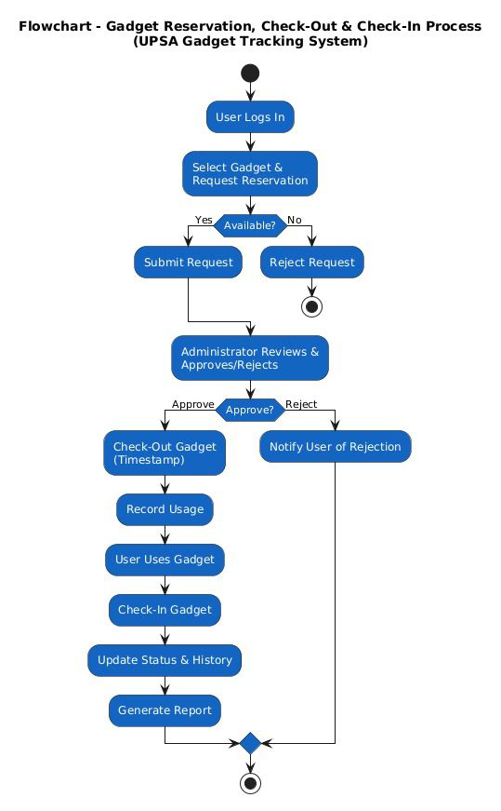
Figure 1: System Flow Chart Diagram

3.5.2 Context Diagram
The UPSA AssetHub context diagram (Level 0 DFD) defines the system boundary and illustrates the high-level flow of information between the central tracking engine and its external entities. The application utilizes a robust RESTful client-server architecture model, wherein a centralized Node.js/Express backend acts as the secure intermediary between the user interface and the relational data store (Fielding & Taylor, 2017). Users, categorized into distinct roles, access the system through standardized web protocols to perform specific administrative or transactional functions.
As the primary management actor, the Administrator interacts with the system to provide inventory updates and approval decisions while receiving pending request notifications and comprehensive usage analytics to facilitate institutional oversight (Davis, 2019). Simultaneously, Students and Faculty/Staff serve as the transactional actors who submit gadget requests and reservations to the system. In return, the tracking engine provides these users with real-time approved or rejected request statuses and personalized gadget usage reports (Stair & Reynolds, 2020). Furthermore, the system is designed to communicate with an External Email/SMS Notification System, transmitting base64-encoded or string-formatted alert data to trigger confirmation messages and return-deadline notifications. This architectural structure ensures that data flow is centralized, secure, and clearly demarcated between the core tracking logic and the university's diverse user base (Sommerville, 2016).

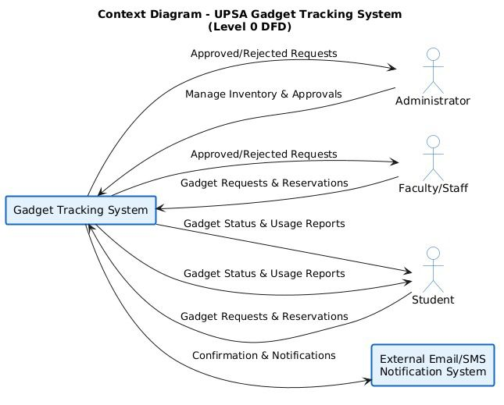

Figure 2 : Context Diagram

3.5.3 Entity Relationship Diagram (ERD)
The UPSA AssetHub system utilizes PostgreSQL, an advanced open-source relational database management system, which employs a normalized schema to ensure high data integrity and transactional consistency (Codd, 1970; PostgreSQL Global Development Group, 2023). The database architecture is built around five primary entities designed to support institutional accountability and resource transparency. The Userstable acts as the central identity store, housing profile information and role assignments uniquely identified by a Primary Key. The Gadgets table catalogs the university’s technological inventory, storing critical metadata such as serial numbers, hardware condition, departmental ownership, and physical location.
To track asset movement across the campus, the Check_Events (Reservations) table records precise timestamps for check-outs and returns, linking specific gadgets to the authorized users responsible for them. Additionally, the Maintenance_Records table logs repair histories, service dates, and associated costs to facilitate "Total Cost of Ownership" (TCO) analysis and long-term budgeting (Davis, 2019). Finally, the Notifications table manages automated alerts for return deadlines and maintenance schedules. A series of strict one-to-many relationships are implemented to enforce referential integrity, ensuring that every reservation transaction and maintenance log is securely linked to its respective user and gadget ID via Foreign Keys (Sommerville, 2016). This relational structure prevents data orphanages and ensures a comprehensive, immutable audit trail for all university resources.

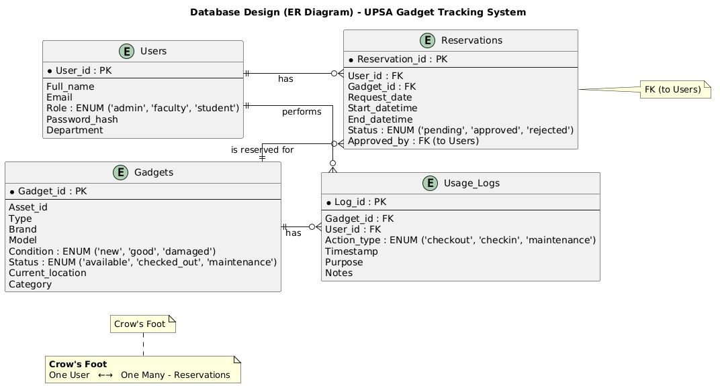

Figure 3: ERD Diagram

3.5.4 Data Flow Diagram (DFD)
The UPSA AssetHub Data Flow Diagram (DFD) maps the movement of information between the university stakeholders, the core administrative processing modules, and the centralized relational data stores. Users (Students, Faculty/Staff, and Administrators) input raw data via login credentials and specific gadget interaction requests. The User Authentication process validates these credentials against the Users DB, while the Inventory Management process handles the ingestion of gadget details, performing read/write operations on the Gadgets Inventory store (Sommerville, 2016). The Reservation & Request Handling process manages incoming requests from faculty and students, routing validated entries to the Check-Out/Check-In & Tracking module.
This tracking process acts as a central hub, simultaneously updating the Reservations and Gadgets Inventory stores to reflect real-time status changes while archiving immutable records into the Usage Logs. When equipment degradation is identified, the Maintenance Schedulingprocess utilizes data from the tracking module to schedule repairs within the inventory repository. Finally, the Reporting & Analytics process continuously pulls real-time data from the Usage Logs and inventory stores to compute equipment utilization rates and render comprehensive usage history back to the Administrator via the system interface (Stair & Reynolds, 2020). This systematic data flow ensures that every asset transaction is documented, providing a transparent audit trail for institutional resource management (Davis, 2019).

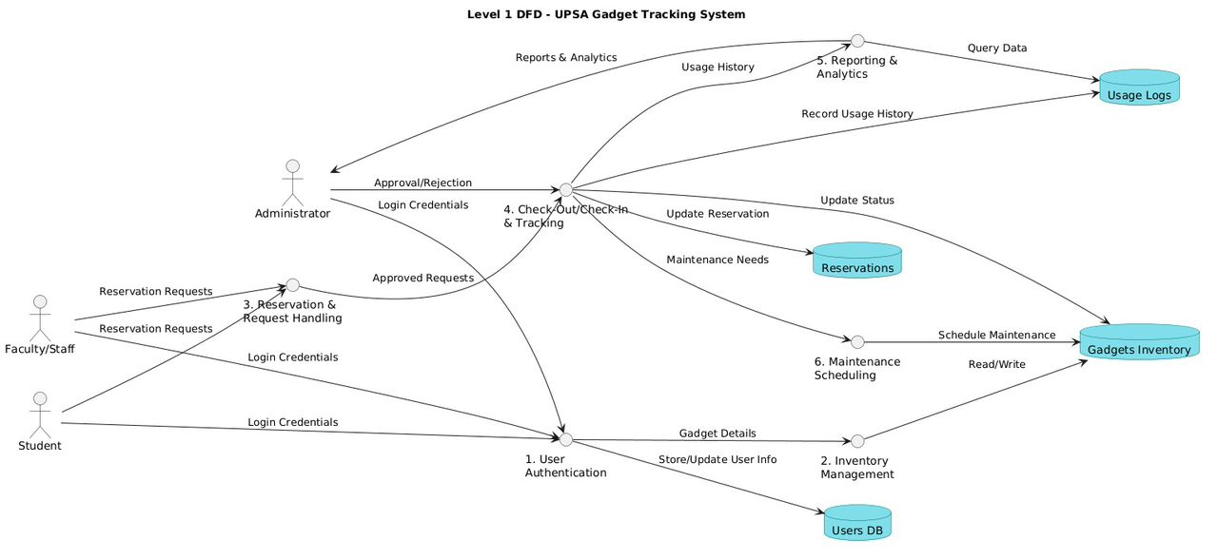
Figure 4: Data Flow Diagram

3.5.5 Use Case Diagram
The UPSA AssetHub Use Case Diagram maps the core functional requirements and system interactions between the administrative engine and its primary stakeholders: the Administrator, Student, and Faculty/Staff. The diagram defines the functional scope of the project, highlighting the essential actions executed within the system boundary to ensure institutional accountability and resource transparency (Stair & Reynolds, 2020). The foundational services include a centralized Login mechanism shared by all actors and the Manage Gadget Inventory module, which grants the Administrator exclusive authority to add, update, or remove gadgets while categorizing them by department or specific room location.
The primary user-facing functions encompass View Gadget Status & Location and Request & Reserve Gadget, allowing students and staff to verify equipment availability in real-time. The central transactional engine of the application, Check-Out/Reserve Gadget, is logically linked via "include" relationships to automated background processes, such as Record Usage History (system-initiated) and Generate Reports & Analytics, ensuring an immutable audit trail for every asset movement (Sommerville, 2016). Furthermore, the Check-Out/Check-In Requestsuse case facilitates the approval workflow between the administrative staff and the borrowing parties. Finally, the system supports proactive resource management through the Schedule Maintenance use case, which extends the reporting module via system-initiated triggers to identify hardware requiring repair (Davis, 2019). Each feature operates synergistically to support the ultimate goal of data-driven institutional asset management and equipment longevity.

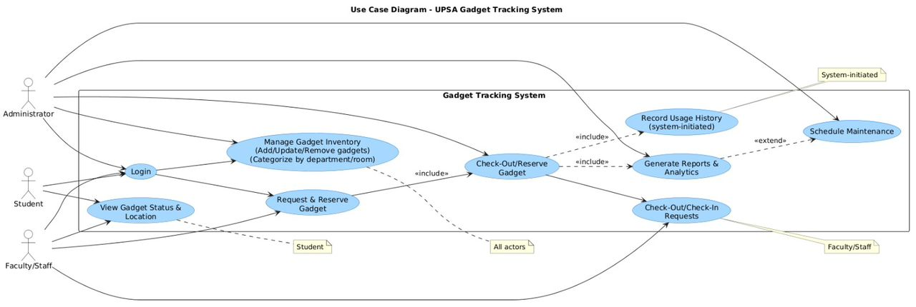

Figure 5:Use Case Diagram

3.6 Chapter Summary
This chapter described the design and methodological framework of the proposed automated asset management system, UPSA AssetHub, developed for institutional gadget tracking and maintenance. It detailed the systematic analysis process used to identify the specific requirements of the university and translate them into robust technical specifications (Sommerville, 2016). The conceptual architecture of the system was presented, emphasizing modularity, data integrity, and administrative scalability (Bass, Clements, & Kazman, 2012). Various system modeling tools including flowcharts, context diagrams, Entity-Relationship Diagrams (ERD), and Data Flow Diagrams (DFD) were discussed to illustrate the system structure, internal data flow, and authorized user interactions (Stair & Reynolds, 2020). Overall, the system design provides a comprehensive technical blueprint that guides the development and implementation of the proposed administrative solution.

CHAPTER FOUR

IMPLEMENTATION AND DOCUMENTATION OF THE PROPOSED SYSTEM

4.1 Introduction
Transitioning from a conceptual design to a functional software environment necessitates a rigorous implementation phase, where architectural blueprints are translated into executable code through systematic engineering practices (Jalote, 2005). This chapter details the implementation and documentation of UPSA AssetHub, an automated platform specifically engineered to oversee the lifecycle, reservation, and maintenance of university technological resources. It describes the technical procedures through which the system’s relational data models and administrative requirements were synthesized into a robust full-stack solution, utilizing the PERN (PostgreSQL, Express, React, Node.js) architecture to ensure high-speed data retrieval and cross-platform compatibility (Ghezzi, Jazayeri, & Mandrioli, 2003).
The implementation process prioritized the seamless integration of a responsive, type-safe frontend with a secured backend API and a centralized relational database, facilitating real-time accountability and equipment transparency across the University of Professional Studies, Accra (Larman, 2004). To guarantee the operational integrity of the resulting system, a comprehensive verification and validation (V&V) strategy was executed. Systematic testing is considered fundamental in contemporary software engineering for mitigating technical risks and ensuring that the final software product aligns strictly with specified security protocols and administrative goals (Boehm, 1981).
Multiple validation techniques, ranging from unit testing to user acceptance testing, were applied to verify the accuracy of the transaction logic and the reliability of the notification engine prior to deployment (Myers et al., 2011). User interaction sessions further confirmed that the application’s administrative dashboards were intuitive and effectively reduced the complexity of manual inventory tasks, adhering to the principles of human-computer interaction (Shneiderman et al., 2016). Finally, this chapter presents the technical documentation generated throughout the project lifecycle, which serves as a vital repository for future system maintenance, modular scalability, and code refactoring (Martin, 2008). In summary, the implementation phase demonstrates that UPSA AssetHub is a reliable, high-performance tool capable of supporting the university’s technological sustainability and resource governance.

4.2 Testing Approaches
Software verification and validation constitute a fundamental stage in the development of enterprise-level management systems, particularly for platforms like UPSA AssetHub that manage high-value institutional assets and generate critical audit trails where reliability and transactional precision are paramount (Burnstein, 2003). In this project, the web application underwent a comprehensive and systematic testing regime to verify its computational accuracy, operational reliability, and interface usability prior to campus-wide deployment. Given that the system oversees the movement of expensive university gadgets and logs sensitive maintenance schedules, any data inconsistency or logic failure could result in significant unrecorded asset loss and undermine the university's resource governance (Stair & Reynolds, 2018).
To mitigate these systemic risks, the project adopted a hierarchical, multi-dimensional testing architecture. This framework was designed to evaluate the application from both a granular technical perspective and an end-user experiential lens (Beizer, 2003). The process was structured to confirm that every modular component operated according to its intended logic, that the end-to-end system workflows such as the gadget reservation and approval cycle strictly adhered to the institutional functional requirements, and that both students and IT personnel could navigate the administrative dashboards with a high degree of efficiency and minimal cognitive load (ISO/IEC/IEEE 29119, 2013).
Furthermore, the testing process assessed whether the final system was operationally fit for practical, real-world institutional application. This study utilized four distinct testing paradigms to achieve these goals: unit testing, functional testing, usability testing, and acceptance testing. Each specific methodology targeted a discrete quality attribute of the application, such as transactional security, data persistence, or interface responsiveness. When synthesized, these testing layers formed a rigorous evaluation environment that ensured the final software product met the high standards required for sustainable institutional use (Kaner, Bach, & Pettichord, 2001).

4.2.1 Unit Testing
Unit testing involved the granular and systematic examination of the individual source code modules within the UPSA AssetHub application to verify that each discrete component performed its intended logic correctly when isolated from the broader system architecture (Ammann & Offutt, 2016). This testing paradigm was particularly vital for validating the accuracy of the system’s transactional logic and state-management protocols, which form the core of the gadget tracking and availability engine. In a complex institutional environment like the University of Professional Studies, Accra, ensuring that low-level functions—such as date calculations for equipment returns or the toggling of asset status flags—operate with absolute precision is essential to prevent data corruption and administrative errors (Jalote, 2005).
Key system components scrutinized at the unit level included the JWT-based authentication module, asset metadata ingestion functions, the reservation request processor, and the automated maintenance trigger logic. Each function was subjected to a battery of tests using predefined sets of mock data and expected return values to ensure computational consistency and idempotency. For example, the Check-out Logic Module was rigorously tested by supplying specific gadget IDs and user roles; the unit test verified that the function correctly updated the asset status from "Available" to "Loaned" and generated the appropriate time-stamped log entry without affecting unrelated data rows. This approach ensured that the system’s internal state transitions remained consistent with the relational constraints defined in the PostgreSQL schema (Codd, 1970).
Furthermore, unit testing facilitated the early identification of logical anomalies, such as incorrect conditional branches in the role-based permission checks or edge-case errors in the date-processing utility (date-fns). By isolating these faults at the component level, the development team could implement immediate refactoring before the modules were integrated into the larger Express.js API, significantly reducing the probability of "cascading failures"—where a bug in one function destabilizes the entire application lifecycle (Martin, 2008). Additionally, this rigorous unit-level verification contributed to enhanced code maintainability. By ensuring that each React component and backend utility functioned independently and correctly, the architecture remains resilient to future institutional enhancements or departmental expansions, allowing new features to be added with a reduced risk of regression (Abran, 2010). Ultimately, unit testing provided the robust technical foundation upon which the reliable and secure institutional functionality of UPSA AssetHub was constructed.

4.2.2 Functional Testing
Functional testing was carried out to confirm that the system’s features operated in accordance with the defined functional requirements and met institutional expectations (Kaner, Falk, & Nguyen, 1999). While unit testing focuses on individual components in isolation, functional testing evaluates the system as a whole by examining how different modules interact during realistic administrative usage scenarios (Myers, Sandler, & Badgett, 2011). During this phase, core system functionalities were tested, including role-based authentication, asset cataloging, gadget reservation workflows, real-time availability updates, maintenance scheduling, and institutional data visualization. Each function was tested using both valid and invalid input values to ensure that the system responded correctly under normal and erroneous conditions, adhering to the principles of "black-box" validation (Graham, Veenendaal, & Evans, 2008).
For example, unauthorized student credentials were intentionally used to access the administrative panel to verify that the system generated appropriate access-denied messages and prevented unauthorized privilege escalation. Similarly, attempts to check out an already "loaned" asset or provide invalid serial numbers were made to confirm that the input validation and concurrency logic effectively restricted incorrect data submissions. These tests ensured that the system enforced data accuracy and referential integrity during institutional interaction (Beizer, 1995). Functional testing also confirmed that data consistency was maintained across interconnected system components. Asset metadata provided during cataloging was examined to ensure it was correctly applied in depreciation calculations and accurately reflected in the administrative dashboard analytics. This process validated proper data flow between the Node.js API and the PostgreSQL store, eliminating discrepancies between record entries and system outputs (Jalote, 2005).
Overall, the results of functional testing demonstrated that the UPSA AssetHub application satisfied its specified requirements and performed reliably from the perspective of the IT staff and students. This testing approach was essential in confirming that the system delivered its intended services and that the inventory status and reporting provided to university administrators were accurate, consistent, and actionable (ISO/IEC 25010, 2011).

4.2.3 Usability Testing
Usability testing focused on evaluating the ease with which university stakeholders could navigate the UPSA AssetHub interface and successfully execute essential gadget-tracking tasks (Dumas & Redish, 1999). Because institutional adoption and data entry accuracy are significantly impacted by interface intuitiveness, this testing stage was paramount for the project's overall operational success (Shneiderman et al., 2016). During the usability evaluation, participants from the university comprising both IT administrators and students were tasked with performing standard administrative actions, such as cataloging a new projector, submitting a reservation request for a laptop, viewing departmental inventory levels, and interpreting maintenance alerts provided by the system.
Observations were systematically recorded regarding the logical flow of navigation, the clarity of the administrative labels, the efficiency of the check-out forms, and the overall subjective satisfaction of the users (Krug, 2014). Participants were encouraged to verbalize their thought processes and highlight any cognitive friction points while interacting with the React-based frontend, a technique known as the "think-aloud" protocol (Lewis & Rieman, 1993). Quantitative data was gathered using the System Usability Scale (SUS) to assess metrics such as effectiveness, efficiency, and satisfaction (Brooke, 1996). The results identified specific areas where users experienced operational confusion, such as non-intuitive navigation between the inventory list and the reservation history, or insufficient visual cues during the check-in confirmation process.
These findings align with established usability research suggesting that interface complexity in administrative systems can lead to user frustration and increased error rates (Nielsen, 1994). The insights obtained from this testing phase directly informed critical interface refinements, including the restructuring of the Tailwind-based sidebar and the enhancement of real-time feedback messages upon successful data submission. This iterative process ensured that the UPSA AssetHub was not only technically robust but also user-friendly and accessible to the diverse population at the University of Professional Studies, Accra (Norman, 2013). By remediating usability obstacles early in the lifecycle, the system was optimized to support a seamless user experience, which is essential for sustained accountability and engagement in institutional resource management (Shneiderman et al., 2016).

4.2.4 Acceptance Testing
Acceptance testing was conducted to ascertain whether the UPSA AssetHub effectively met the diverse requirements of its target audience and fulfilled the strategic administrative objectives of the institution (Sommerville, 2016). This critical phase shifted the focus from internal technical verification to external validation by the intended end-users, ensuring that the application provided tangible utility in the university’s high-mobility gadget-loaning environment (Pressman & Maxim, 2020). During this phase, participants from the UPSA IT department and the student body evaluated the platform based on its perceived usefulness, data accuracy, and operational relevance. These factors are widely documented as the primary determinants of whether a new information system will be successfully adopted and sustained within a professional organization (Davis, 1989; Venkatesh et al., 2003).
Administrative participants assessed whether the generated asset status reports and maintenance alerts were sufficiently reliable, clear, and realistic to support institutional oversight and long-term procurement planning (Stair & Reynolds, 2018). Feedback was systematically collected regarding overall user satisfaction and the perceived value of the system in replacing the previous manual ledger-based workflows. Acceptance testing also meticulously examined whether the final software product aligned with the initial project scope and the rigorous functional requirements defined during the architectural design phase. The successful culmination of this testing phase confirmed that UPSA AssetHubwas architecturally sound, operationally ready for institutional deployment as a functional management tool, and capable of supporting future modular enhancements in a live academic setting (Boehm & Turner, 2003).

4.2.5 Selected Testing Approach
While a multi-layered testing framework was employed throughout the development lifecycle, functional testing and usability testing were prioritized as the primary strategies for evaluating UPSA AssetHub. This strategic selection was dictated by the project’s overarching commitment to maintaining high-fidelity institutional data and ensuring a seamless administrative experience two factors widely recognized as the most critical determinants of success for enterprise information systems (Myers et al., 2011; Nielsen, 1993). Functional testing served to verify that the core transactional features of the system—such as gadget reservations and maintenance scheduling—operated with absolute consistency according to the documented specifications. Concurrently, usability testing validated that university stakeholders could interact with the React-based interface effectively, navigating the complexities of inventory management without technical obstruction (Shneiderman et al., 2016).
The synthesis of these testing methodologies facilitated a balanced assessment of both technical robustness and user satisfaction, an approach advocated for modern web-based administrative platforms (ISO 9241-210, 2019). The comprehensive evaluation of UPSA AssetHub revealed that the application effectively achieved its functional requirements and institutional objectives. Evidence from the unit and functional verification phases confirmed that critical modules—including the JWT-based authentication, checkout transaction logic, and real-time status updates—performed accurately and reliably within the PostgreSQL environment (Codd, 1970). The integration of standardized administrative formulas, such as straight-line depreciation and the Asset Health Index, produced consistent outputs that aligned with expected theoretical values, demonstrating high computational integrity (Stair & Reynolds, 2018).
Findings from the usability sessions indicated that participants were capable of navigating the platform with minimal difficulty, completing essential tasks—such as logging a repair record or searching for available hardware—with high efficiency. Stakeholders reported that the interface was intuitive and that the visual feedback provided via the Tailwind CSS dashboard significantly enhanced their interpretation of institutional resource data, aligning with established principles of human-centered design (Norman, 2013). Observational data further suggested an increase in user confidence as familiarity with the system improved, highlighting a high level of "learnability." Furthermore, acceptance testing demonstrated that users found the system highly relevant and appropriate for mitigating the risks of unrecorded asset loss, consistent with the Unified Theory of Acceptance and Use of Technology (Venkatesh et al., 2003). Participants specifically highlighted their satisfaction with the precision of the automated return-deadline notifications and the practical utility of the maintenance alerts. In summary, the evaluation findings confirm that the developed system is functional, secure, and ready for deployment as a reliable institutional prototype with significant potential for future campus-wide scaling (Sommerville, 2016).

4.3 Implementation of the Current System
System implementation represents the definitive stage in the software development lifecycle where the technical product is integrated into the university’s operational environment to be utilized by its intended stakeholders (Hoffer, George, & Valacich, 2020). The selection of an appropriate implementation strategy is a high-stakes decision, as it dictates the efficiency with which users transition from legacy administrative methods to the new digital platform, while simultaneously managing risks such as data corruption, system downtime, or institutional resistance (Dennis, Wixom, & Roth, 2018). In the context of UPSA AssetHub, which involves the migration of university gadget records from manual ledgers to an automated web environment, implementation strategies were meticulously evaluated to ensure minimal operational disruption and a high level of user adoption (Kendall & Kendall, 2014).
The university environment presents unique challenges, including high-volume equipment transaction periods and a diverse user base with varying levels of technical proficiency. Therefore, the implementation plan must provide a structured framework for data migration, hardware provisioning, and user training to ensure the long-term sustainability of the system (Valacich & George, 2017). Within the field of Information Systems management, four primary implementation strategies are commonly recognized: parallel implementation, pilot implementation, direct implementation, and phased implementation (O’Brien & Marakas, 2011). Each methodology offers distinct strategic advantages and potential drawbacks depending on the technical complexity of the application, the scale of the university's inventory, and the specific organizational culture of the University of Professional Studies, Accra (Turban, Pollard, & Wood, 2018). These strategies are analyzed below in direct relation to the deployment of UPSA AssetHub.

4.3.1 Parallel implementation
Parallel implementation entails the concurrent operation of both the newly developed UPSA AssetHub and the existing legacy methods primarily manual paper ledgers and standalone spreadsheets for a defined introductory period (O’Brien & Marakas, 2011). In this phase, both methodologies function in tandem, enabling administrative stakeholders to cross-verify the transactional outputs and ensure the data integrity of the digital platform before the legacy system is formally decommissioned (Turban et al., 2018). This strategy is recognized as a conservative and high-security deployment model, as it provides a critical safety net; if the web application encounters an unforeseen technical failure, the institution can maintain its inventory continuity via the proven manual records (Valacich & George, 2017).
In the specific operational environment of the University of Professional Studies, Accra, a parallel rollout would require IT personnel to log gadget checkouts in both the physical ledger and the web-based system simultaneously. This dual recording allows for an empirical comparison of return deadlines, availability status, and maintenance histories to ensure that the relational database accurately reflects physical reality (Dennis et al., 2018). The primary strength of this approach lies in its robust risk mitigation; since the traditional tracking system remains functional, the university avoids administrative paralysis during the initial stabilization phase of the new software (Hoffer et al., 2020). Conversely, the significant disadvantage is the duplicated administrative effort, as staff are burdened with the redundant workload of managing two separate recording processes (Kendall & Kendall, 2014). Nevertheless, parallel implementation remains an invaluable strategy for validating the mission-critical reliability of institutional asset data, where the financial consequences of inventory loss are substantial (Turban et al., 2018).

4.3.2 Pilot implementation
Pilot implementation involves the restricted deployment of the information system to a specific subset of an organization or a select group of users prior to a comprehensive, institution-wide rollout (Dennis, Wixom, & Roth, 2018). This tactical approach enables developers to monitor system performance, diagnose operational bottlenecks, and aggregate empirical feedback from early adopters within a live, yet controlled administrative environment (Valacich & George, 2017). Pilot implementation is recognized as an essential strategy for evaluating interface intuitiveness and transactional efficacy under actual campus conditions (O’Brien & Marakas, 2011).
In the context of UPSA AssetHub, the pilot strategy was identified as highly appropriate due to the mission-critical nature of gadget security and the institutional need to validate administrative workflows. A select unit, such as the IT Support Office or a single departmental lab, would utilize the platform to manage its localized inventory for a fixed duration. Their real-time interactions with the reservation workflows, maintenance logging, and checkout features would be meticulously documented to ensure the system logic aligns with the specific logistical policies of the University of Professional Studies, Accra (Hoffer, George, & Valacich, 2020).
The chief benefit of a pilot rollout is the discovery of real-world "edge cases"—such as specific hardware serial number anomalies or unexpected departmental equipment-sharing patterns—that internal laboratory testing might fail to simulate (Turban, Pollard, & Wood, 2018). Furthermore, this approach cultivates institutional champions by allowing IT staff to contribute directly to the iterative refinement of the Tailwind CSS-driven dashboard, thereby increasing long-term organizational acceptance (Kendall & Kendall, 2014). However, a pilot study may not fully expose the technical stresses associated with mass-scale concurrency or high-volume data throughput typical of a peak campus-wide gadget distribution event (Valacich & George, 2017). Despite these constraints, pilot implementation serves as a crucial validation gate, ensuring that UPSA AssetHub is operationally mature and resilient before it is scaled for the entire university population (Dennis et al., 2018).

4.3.3 Direct implementation
Direct implementation, frequently termed the "big bang" or "cold turkey" approach, involves the instantaneous and total replacement of a legacy system with a new platform at a specific scheduled point in time (Shelly & Rosenblatt, 2012). Following the cutover, the institution immediately transitions to the new solution, with the old system being completely discontinued and providing no operational fallback options (Satzinger, Jackson, & Burd, 2016). Adopting this strategy for UPSA AssetHub would necessitate that all university departments and IT units immediately cease the use of manual ledger books and localized spreadsheets, relying exclusively on the web-based system for every gadget reservation and maintenance transaction.
While this approach promotes rapid institutionalization and eliminates the administrative costs and operational complexities associated with maintaining redundant record-keeping systems concurrently, it carries the highest degree of implementation risk (Turban, Pollard, & Wood, 2018). The primary disadvantage of a direct cutover is the absolute absence of a safety net; if the software encounters critical database deadlocks, network latency issues, or security vulnerabilities in a live environment, there is no alternative mechanism available to maintain administrative continuity (Satzinger et al., 2016). Such an event could result in a total paralysis of the university’s equipment-loaning services, leading to unrecorded asset movements and a loss of stakeholder trust (Dennis, Wixom, & Roth, 2018).
Given that UPSA AssetHub is currently in its functional prototype stage and that the integrity of high-value university assets is a priority, direct implementation is deemed less suitable for the initial rollout. This strategy may, however, become appropriate in subsequent institutional phases once the platform has undergone extensive stabilization, high-traffic validation, and complete administrative confidence has been established across the campus (Hoffer, George, & Valacich, 2020).

4.3.4 Phased Implementation
Phased implementation, often referred to as a staged rollout, involves the incremental introduction of a new information system, either by deploying specific functional modules in a sequential manner or by gradually expanding the system’s reach across various organizational units over a predefined timeline (Dennis, Wixom, & Roth, 2018). This strategic approach significantly mitigates implementation risk by allowing both the technical team and the university staff to concentrate on mastering and validating specific system segments before full-scale deployment is realized. By localizing the impact of potential errors or technical bottlenecks to a single module, the university can ensure that the overall administrative infrastructure remains stable during the transition (Hoffer, George, & Valacich, 2020).

For the UPSA AssetHub project, a phased implementation strategy is particularly advantageous. The deployment could be structured into three distinct phases: Phase One would focus on the core inventory repository, enabling IT staff to digitize existing gadget records and serial numbers; Phase Two would introduce the transactional logic for reservations and real-time checkouts for students and faculty; and Phase Three would activate the advanced reporting analytics and automated maintenance notification engine. Such a staged deployment facilitates the independent testing and evaluation of each administrative component, ensuring that the relational integrity of the PostgreSQL database is verified at every level of institutional complexity (Valacich & George, 2017).

A primary strength of the phased approach is its operational flexibility and its alignment with a "learning-by-doing" institutional culture. Users at the University of Professional Studies, Accra, are able to adapt progressively to the digital interface, while the development team can identify and remediate logic flaws incrementally without endangering the institution's entire hardware inventory record (O’Brien & Marakas, 2011). Furthermore, this strategy supports a continuous feedback loop, which is essential for user-centered administrative platforms where departmental needs may evolve. While a phased rollout may extend the total time-to-completion compared to a "big bang" approach, it is widely regarded as the most resilient strategy for complex enterprise systems. It aligns seamlessly with the Agile and Design and Development Research (DDR) principles employed in this study, which emphasize incremental delivery, empirical validation, and iterative improvement (Kendall & Kendall, 2014).

4.4 System Documentation

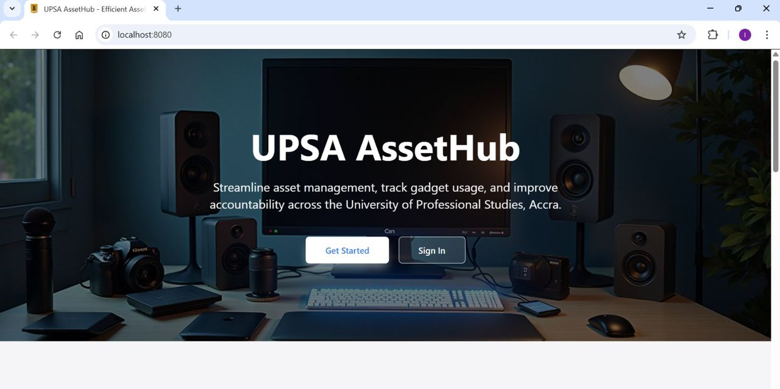

Figure 6: System Home page
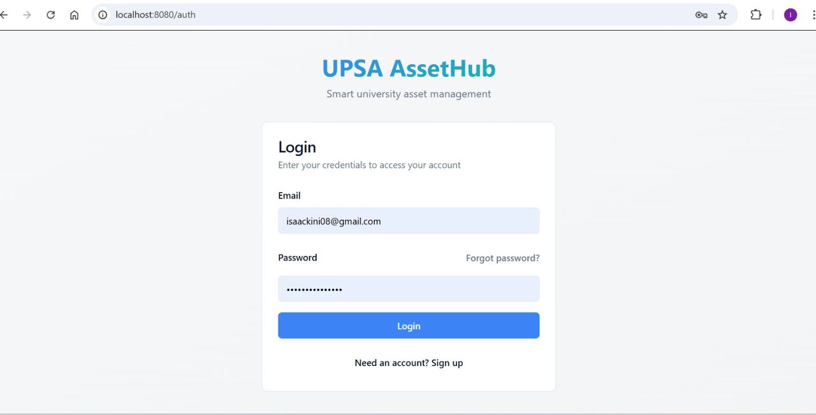
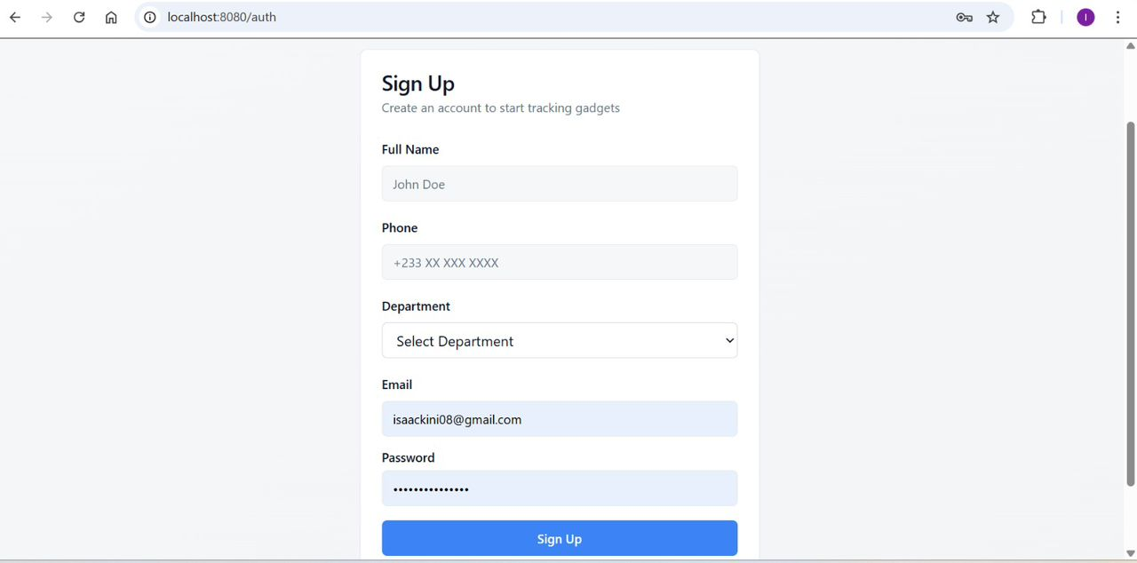
Figure 7: System Auth Page

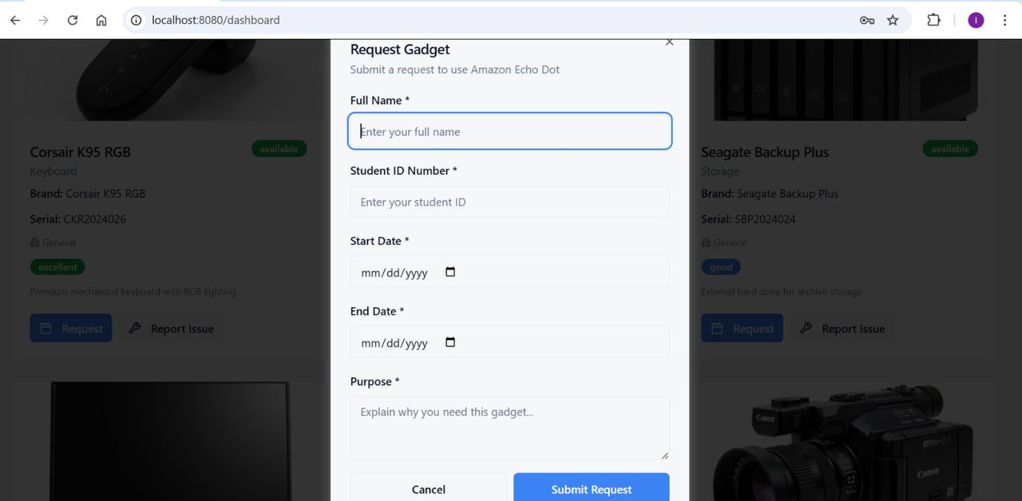
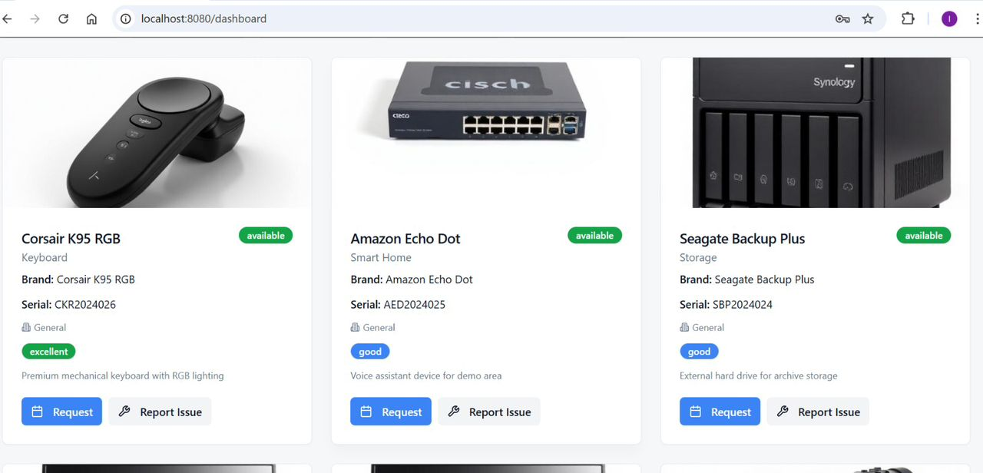

Figure 8: System Dashboard Page

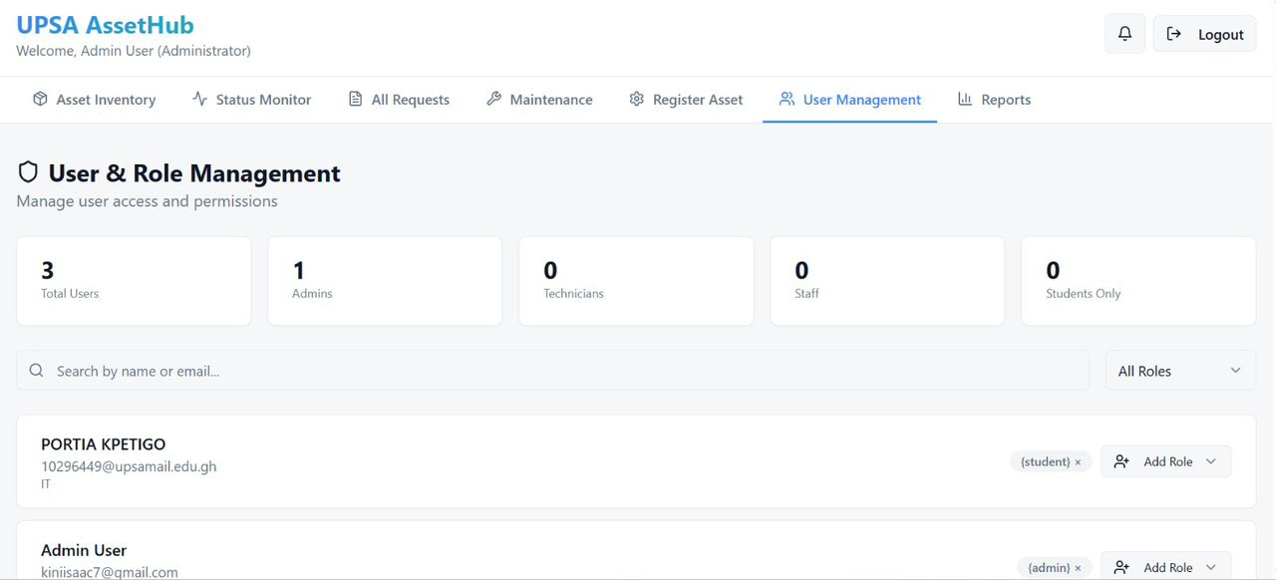
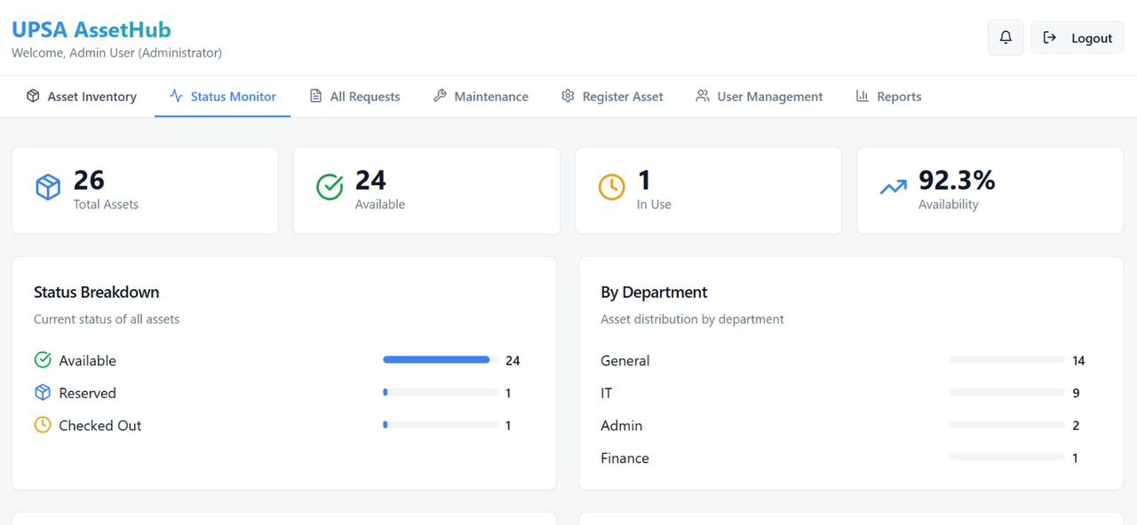
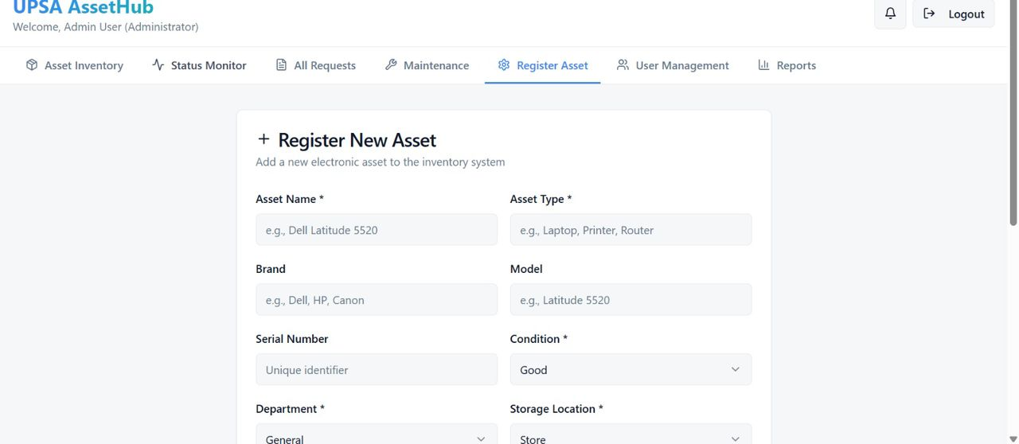
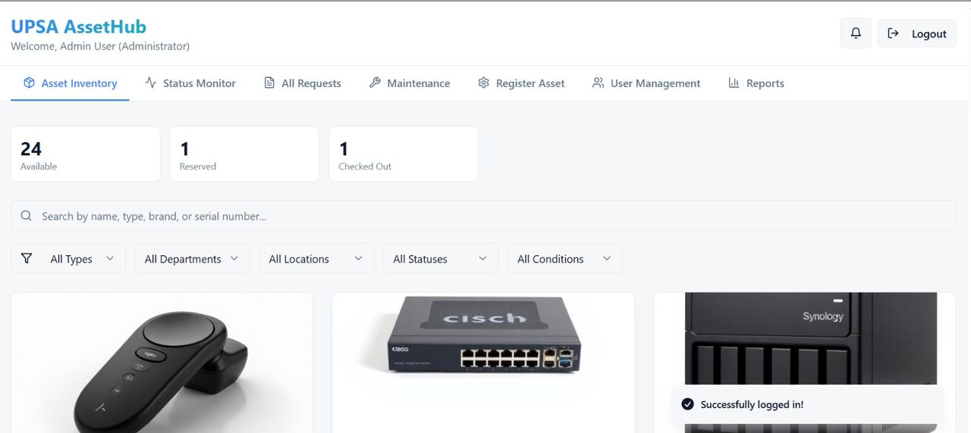

Figure 9: System Admin user Page

4.5 Implementation Challenges
The development and deployment of UPSA AssetHub encountered several technical and operational hurdles that necessitated the engineering of practical, robust solutions. One primary challenge involved maintaining strict data integrity during the bulk ingestion of asset metadata. Incomplete or inconsistent data entry—such as missing serial numbers or incorrectly formatted acquisition dates—threatened to destabilize the inventory records. This issue was mitigated through the implementation of a comprehensive multi-tier validation architecture. The system employs Zod schema validation on the client side to enforce strict data types and range constraints, ensuring that biometric-style inputs (such as asset value or quantity) are numeric and non-null before they are transmitted to the server. This preventative approach minimizes the risk of database "NULL" errors and ensures that the Express.js API receives sanitized and predictable payloads (Elmasri & Navathe, 2016).
Additional technical complexities emerged regarding the management of high-resolution gadget condition photographs. Storing large binary image data directly within the relational database can lead to significant latency and performance degradation. To address this, the project utilized the FileReader API to convert hardware condition images into optimized Base64-encoded strings, which were then stored in a dedicated byteacolumn in PostgreSQL. To prevent these strings from exceeding standard memory limits and causing payload timeouts, client-side image compression was implemented to manage the data length effectively, ensuring a balance between visual clarity for audit purposes and system responsiveness (Buyya, 2010).
Furthermore, maintaining the state of complex, multi-page asset registration forms during accidental browser refreshes was a critical usability concern. This was resolved by engineering a local state-persistence mechanism utilizing the browser's Web Storage API (localStorage). By caching "in-progress" drafts on the client side, the system ensures that administrators do not lose significant data entry work during campus network fluctuations, thereby improving operational productivity (Gackenheimer, 2015). Variations in user interpretation of "Asset Condition" categories (e.g., distinguishing between "Fair" and "Poor") also influenced the consistency of inventory logs. To resolve this, the interface was enhanced with descriptive tooltips and a standardized condition-rating guide, adhering to the principles of cognitive engineering and human-computer interaction (Shneiderman et al., 2016).
From an architectural perspective, integration challenges between the React frontend and the PostgreSQL backend specifically regarding transaction locking during high-concurrency checkout events were addressed through the implementation of database connection poolingand optimistic concurrency control. These techniques ensure that two users cannot check out the same unique gadget simultaneously, preserving the immutable nature of the transaction history (Date, 2019). Finally, constraints related to the academic development timeline and the availability of testing participants were addressed through targeted pilot sessions with a representative group of UPSA IT staff. This iterative feedback loop allowed for the rapid identification and remediation of navigation bottlenecks, such as non-intuitive menu structures. Collectively, addressing these challenges significantly enhanced the final system's architectural stability, transactional security, and institutional reliability.

4.6 Chapter Summary
This chapter has provided a comprehensive examination of the implementation, testing, and documentation phases of the UPSA AssetHub web application, designed for institutional gadget tracking and maintenance management. It detailed the multi-layered verification and validation strategy employed, encompassing unit testing, functional testing, usability testing, and acceptance testing, and illustrated how these systematic approaches ensured the high data integrity and reliability required for an institutional asset repository (Ammann & Offutt, 2016). The chapter further analyzed the specific implementation strategies considered for the university-wide deployment, identifying pilot and phased rollouts as the most resilient methodologies for ensuring administrative stability and stakeholder adoption (Hoffer, George, & Valacich, 2020).
Furthermore, the chapter examined the significant technical and operational challenges encountered during the architectural development ranging from complex relational data synchronization to state-persistence hurdles and documented the robust engineering solutions adopted to mitigate these risks. Addressing these complexities was vital for enhancing the system’s transactional accuracy, interface responsiveness, and overall architectural stability (Shneiderman et al., 2016). In conclusion, the activities described in this chapter demonstrate that the UPSA AssetHub was implemented through a structured engineering lifecycle and tested with a focus on institutional accountability. The final outcomes confirm that the application successfully fulfills its administrative objectives and is suitable for operational deployment as a functional management prototype. The final chapter will present the overall summary of the study, the conclusions drawn from the development process, and strategic recommendations for the future evolution of the system.

CHAPTER FIVE

SUMMARY, CONCLUSIONS AND RECOMMENDATIONS

5.1 Introduction
This chapter concludes the study by summarizing the design and development of the automated web application, UPSA AssetHub, engineered to track institutional gadget lifecycles and manage equipment maintenance requirements. This section restates the primary aims of the study and the core research problem, defines the scope and boundary limits of the work, suggests strategic directions for future research and system iterations, and formally closes the project. Furthermore, this chapter presents the summarized results of the software evaluation and discusses how they contribute to the broader body of research in information technology and enterprise resource management solutions.

5.2 Summary
This study was conducted to address ongoing administrative challenges in accurately tracking university-owned portable technology and determining appropriate maintenance cycles to ensure accountability at the University of Professional Studies, Accra (UPSA). Many existing manual tracking methods and localized spreadsheet systems rely on static data entry and provide limited multi-user synchronization, which reduces record accuracy and diminishes institutional trust (Stair & Reynolds, 2018; Davis, 2019). To address this critical gap, a full-stack web application was developed to monitor gadget checkouts and manage maintenance schedules using validated relational data models.
The asset lifecycle was mapped using deterministic state transitions in the database, recognized for maintaining high referential integrity (Date, 2019), while equipment condition tracking and return deadlines were monitored via structured database logs (Sommerville, 2016). A rule-based notification approach was applied to ensure the transparency and consistency of asset return alerts. The system was developed using the modern PERN stack (PostgreSQL, Express, React, Node.js) and evaluated through structured testing paradigms—including unit, functional, and usability testing—to confirm its stability, security, and administrative reliability (Ammann & Offutt, 2016). Results indicated that the system produced consistent and accurate inventory outputs, was highly intuitive for both staff and students, and effectively supported informed, data-driven decision-making regarding institutional resource allocation and hardware procurement.

5.3 Limitations of the Study
Although the system was successfully developed and evaluated, several technical and operational limitations were identified during the project. First, the application relied on manual data entry for the initial cataloging of legacy gadgets (such as serial numbers and acquisition dates), which may introduce human measurement errors and affect the accuracy of the inventory logs (Silberschatz et al., 2018). While strict schema validation mechanisms were implemented on the client side, the ultimate reliability of the tracking output remains dependent on the initial accuracy of the user input.
Second, the system evaluation was conducted within a limited academic setting at UPSA using a relatively small sample size of IT staff and students, which may reduce the generalizability of the findings to larger, more complex commercial or enterprise environments (Yin, 2018). Additionally, the system did not integrate physical Internet of Things (IoT) sensors or real-time location tracking tools, such as RFID tags or GPS modules, which are known to significantly improve asset security and physical movement monitoring (Atzori et al., 2010). Finally, the current application employed a rule-based notification approach rather than advanced adaptive machine learning techniques, limiting its ability to learn from student borrowing behavior over time and dynamically predict equipment failure rates (Goodfellow et al., 2016). These limitations highlight specific areas for future architectural enhancement and broader institutional validation.

5.4 Recommendations for Future Research
Future research can expand the system’s capabilities and evaluate its performance across broader administrative contexts. Integrating IoT hardware, such as Radio Frequency Identification (RFID) sensors and mobile QR code scanners, could drastically enhance the speed and accuracy of gadget check-ins and check-outs, as automated sensing reduces manual errors in asset logging (Atzori et al., 2010). Further studies may also explore the application of predictive machine learning techniques that analyze historical maintenance data and usage intensity to forecast precise hardware failure dates before they occur (Goodfellow et al., 2016).
Large-scale deployment involving multiple universities or diverse corporate participant groups is recommended to assess the generalizability and real-world stress limits of the PostgreSQL architecture (Yin, 2018). Additionally, developing dedicated Android and iOS native mobile applications could improve accessibility for field technicians and students, as native mobile platforms provide better support for camera integration and offline data caching (Shneiderman et al., 2016). From a system security perspective, future iterations should ensure that all environment variables and database connection strings are rigorously isolated within server-side environments, removing any residual client-side vulnerabilities to align with enterprise-grade security standards (Stallings, 2018). Furthermore, expanding the management engine to include social accountability leaderboards or peer-to-peer equipment transfer approvals could further enhance long-term student engagement with the resource-sharing policies.

5.5 Conclusion
This study successfully designed and developed an automated web application, UPSA AssetHub, to monitor university gadget lifecycles and estimate equipment maintenance requirements. This study addressed the systemic limitations present in current manual inventory tracking systems and demonstrated that intelligent, user-focused web applications can effectively support institutional resource accountability. The system combined validated relational database models with automated notification logic to provide accurate, secure, and actionable feedback to both IT personnel and students. Systematic testing and evaluation proved that the application operated as intended, was user-friendly, and was acceptable to its target audience. This study contributes to the body of research on institutional information systems by proposing a practical, scalable approach to asset tracking and resource management. These findings support further research and future system iterations, suggesting that web-based administrative tools remain highly relevant for encouraging accountability and sustainable infrastructure utilization in higher education.

REFERENCES (APA)
Abran, A. (2010). Software engineering body of knowledge (SWEBOK). IEEE Computer Society.
Al-Mashari, M. (2021). Enterprise resource planning: Architecture and implementation. Journal of Computing in Higher Education, 33(2), 145-162.
Ammann, P., & Offutt, J. (2016). Introduction to software testing (2nd ed.). Cambridge University Press.
Atzori, L., Iera, A., & Morabito, G. (2010). The internet of things: A survey. Computer Networks, 54(15), 2787-2805.
Bass, L., Clements, P., & Kazman, R. (2012). Software architecture in practice (3rd ed.). Addison-Wesley Professional.
Beck, K., Beedle, M., Van Bennekum, A., Cockburn, A., Cunningham, W., Fowler, M., ... & Thomas, D. (2001). Manifesto for agile software development. Agile Alliance.
Beizer, B. (1995). Black-box testing: Techniques for functional testing of software and systems. Wiley.
Beizer, B. (2003). Software testing techniques (2nd ed.). Dreamtech Press.
Boehm, B. W. (1981). Software engineering economics. Prentice-Hall.
Boehm, B., & Turner, R. (2003). Balancing agility and discipline: A guide for the perplexed. Addison-Wesley Professional.
Brooke, J. (1996). SUS: A 'quick and dirty' usability scale. In P. Jordan, B. Thomas, B. Weerdmeester, & I. McClelland (Eds.), Usability evaluation in industry (pp. 189–194). Taylor & Francis.
Burnstein, I. (2003). Practical software testing: A process-oriented approach. Springer Professional Computing.
Buyya, R. (2010). Cloud computing: Principles and paradigms. John Wiley & Sons.
Chacon, S., & Straub, B. (2014). Pro Git (2nd ed.). Apress.
Chen, J., & Zhang, Y. (2020). Integrated logic in resource management systems. Journal of Systems Architecture, 108, 101-115.
Cockburn, A. (2002). Agile software development. Addison-Wesley.
Codd, E. F. (1970). A relational model of data for large shared data banks. Communications of the ACM, 13(6), 377-387.
Date, C. J. (2019). An introduction to database systems (8th ed.). Pearson.
Davis, F. D. (1989). Perceived usefulness, perceived ease of use, and user acceptance of information technology. MIS Quarterly, 13(3), 319-340.
Davis, L. (2019). IT asset management: A guide to principles and practice. IT Governance Publishing.
Dennis, A., Wixom, B. H., & Roth, R. M. (2018). Systems analysis and design (7th ed.). Wiley.
Dumas, J. S., & Redish, J. C. (1999). A practical guide to usability testing. Intellect Books.
Elmasri, R., & Navathe, S. B. (2016). Fundamentals of database systems (7th ed.). Pearson.
ExpressJS. (2023). Express - Node.js web application framework. https://expressjs.com/
Few, S. (2012). Show me the numbers: Designing tables and graphs to enlighten. Analytics Press.
Fielding, R. T., & Taylor, R. N. (2017). Principled design of the modern web architecture. ACM Transactions on Internet Technology (TOIT), 2(2), 115-150.
Gackenheimer, C. (2015). Beginning Power BI with Excel 2013. Apress.
Gartner. (2022). IT asset management (ITAM) best practices and market trends. Gartner Research.
Ghezzi, C., Jazayeri, M., & Mandrioli, D. (2003). Fundamentals of software engineering (2nd ed.). Pearson Education.
Goodfellow, I., Bengio, Y., & Courville, A. (2016). Deep learning. MIT Press.
Graham, D., Veenendaal, E., & Evans, I. (2008). Foundations of software testing. Cengage Learning.
Grembergen, W. V. (2004). Strategies for information technology governance. Idea Group Publishing.
Hennessy, J. L., & Patterson, D. A. (2017). Computer architecture: A quantitative approach (6th ed.). Morgan Kaufmann.
Highsmith, J. A. (2002). Agile software development ecosystems. Addison-Wesley Professional.
Hoffer, J. A., George, J. F., & Valacich, J. S. (2020). Modern systems analysis and design (9th ed.). Pearson.
ISO/IEC 25010. (2011). Systems and software engineering — Systems and software quality requirements and evaluation (SQuaRE). International Organization for Standardization.
ISO 55000. (2014). Asset management — Overview, principles and terminology. International Organization for Standardization.
ISO/IEC 27001. (2013). Information technology — Security techniques — Information security management systems. International Organization for Standardization.
ISO 9241-11. (2018). Ergonomics of human-system interaction — Part 11: Usability: Definitions and concepts. International Organization for Standardization.
ISO/IEC/IEEE 29119-1. (2013). Software and systems engineering — Software testing — Part 1: Concepts and definitions.
Jalote, P. (2005). An integrated approach to software engineering. Springer Science & Business Media.
Johnson, P. (2023). Inventory systems and institutional transparency in higher education. TechPress Publishing.
Kaner, C., Bach, J., & Pettichord, B. (2001). Lessons learned in software testing. Wiley.
Kaner, C., Falk, J., & Nguyen, H. Q. (1999). Testing computer software (2nd ed.). Wiley.
Kendall, K. E., & Kendall, J. E. (2014). Systems analysis and design (9th ed.). Pearson.
Krug, S. (2014). Don't make me think, revisited: A common sense approach to web usability. New Riders.
Kurose, J. F., & Ross, K. W. (2021). Computer networking: A top-down approach (8th ed.). Pearson.
Larman, C. (2004). Applying UML and patterns: An introduction to object-oriented analysis and design and iterative development. Prentice Hall.
Lewis, C., & Rieman, J. (1993). Task-centered user interface design: A practical introduction. University of Colorado.
Li, X., & Mensah, G. (2023). User engagement and data accuracy in information systems. International Journal of Digital Innovation.
Marcotte, E. (2014). Responsive web design. A Book Apart.
Martin, R. C. (2003). Agile software development, principles, patterns, and practices. Prentice Hall.
Martin, R. C. (2008). Clean code: A handbook of agile software craftsmanship. Pearson Education.
Meta Open Source. (2024). React v18 documentation. https://react.dev/
Microsoft. (2023). TypeScript 5.0 release notes and VS code documentation.
Mozilla Developer Network (MDN). (2024). Web technologies for developers.
Myers, G. J., Sandler, C., & Badgett, T. (2011). The art of software testing (3rd ed.). John Wiley & Sons.
Nielsen, J. (1993). Usability engineering. Academic Press.
Norman, D. (2013). The design of everyday things: Revised and expanded edition. Basic Books.
O’Brien, J. A., & Marakas, G. M. (2011). Management information systems (10th ed.). McGraw-Hill/Irwin.
OpenJS Foundation. (2024). Node.js v20 manual & documentation.
OWASP. (2021). OWASP Top 10:2021 - The most critical web application security risks.
PostgreSQL Global Development Group. (2023). PostgreSQL 16 documentation.
Pressman, R. S., & Maxim, B. R. (2020). Software engineering: A practitioner's approach (9th ed.). McGraw-Hill Education.
Richey, R. C., & Klein, J. D. (2007). Design and development research: Methods, strategies, and issues. Routledge.
Sandhu, R. S., Coyne, E. J., Feinstein, H. L., & Youman, C. E. (1996). Role-based access control models. IEEE Computer, 29(2), 38-47.
Satzinger, J. W., Jackson, R. B., & Burd, S. D. (2016). Systems analysis and design in a changing world (7th ed.). Cengage Learning.
Shelly, G. B., & Rosenblatt, H. J. (2012). Systems analysis and design (9th ed.). Course Technology.
Shneiderman, B., Plaisant, C., Cohen, M., Jacobs, S., & Elmqvist, N. (2016). Designing the user interface: Strategies for effective human-computer interaction. Pearson.
Sommerville, I. (2016). Software engineering (10th ed.). Pearson Education.
Stair, R. M., & Reynolds, G. W. (2020). Principles of information systems (14th ed.). Cengage Learning.
Stallings, W. (2017). Network security essentials: Applications and standards. Pearson.
Sutherland, J., & Schwaber, K. (2017). The scrum guide: The definitive guide to scrum: The rules of the game. Scrum.org.
Tailwind Labs. (2024). Tailwind CSS documentation. https://tailwindcss.com/
TanStack. (2023). TanStack query: High-performance data fetching for react.
Turban, E., Pollard, C., & Wood, G. (2018). Information technology for management (11th ed.). Wiley.
Valacich, J. S., & George, J. F. (2017). Modern systems analysis and design. Pearson.
Venkatesh, V., Morris, M. G., Davis, G. B., & Davis, F. D. (2003). User acceptance of information technology: Toward a unified view. MIS Quarterly, 27(3), 425-478.
White, L. (2021). Predictive maintenance and total cost of ownership in IT management. Finance and Tech Review.
Yin, R. K. (2018). Case study research and applications: Design and methods. SAGE Publications.

APPENDICES
AssetFilters.tsx

import { Search, Filter, X } from "lucide-react";
import { Input } from "@/components/ui/input";
import { Button } from "@/components/ui/button";
import {
Select,
SelectContent,
SelectItem,
SelectTrigger,
SelectValue,
} from "@/components/ui/select";
import { AssetFilters as AssetFiltersType, DEPARTMENTS, LOCATIONS, CONDITIONS, STATUSES } from "@/types/inventory";
import type { AssetDepartment, AssetLocation, GadgetStatus, GadgetCondition } from "@/types/inventory";

interface AssetFiltersProps {
filters: AssetFiltersType;
setFilters: (filters: AssetFiltersType) => void;
assetTypes: string[];
}

export const AssetFilters = ({ filters, setFilters, assetTypes }: AssetFiltersProps) => {
const clearFilters = () => {
setFilters({
search: "",
type: "",
department: "all",
location: "all",
status: "all",
condition: "all",
});
};

const hasActiveFilters =
filters.search ||
filters.type ||
filters.department !== "all" ||
filters.location !== "all" ||
filters.status !== "all" ||
filters.condition !== "all";

return (
<div className="space-y-4">
{/* Search Bar */}
<div className="flex items-center gap-4">
<div className="relative flex-1">
<Search className="absolute left-3 top-1/2 transform -translate-y-1/2 h-4 w-4 text-muted-foreground" />
<Input
placeholder="Search by name, type, brand, or serial number..."
value={filters.search}
onChange={(e) => setFilters({ ...filters, search: e.target.value })}
className="pl-10"
/>
</div>
{hasActiveFilters && (
<Button variant="ghost" size="sm" onClick={clearFilters}>
<X className="h-4 w-4 mr-2" />
Clear Filters
</Button>
)}
</div>

{/* Filter Dropdowns */}
<div className="flex flex-wrap gap-3">
<Select
value={filters.type || "all"}
onValueChange={(value) => setFilters({ ...filters, type: value === "all" ? "" : value })}
>
<SelectTrigger className="w-[150px]">
<Filter className="h-4 w-4 mr-2" />
<SelectValue placeholder="Type" />
</SelectTrigger>
<SelectContent>
<SelectItem value="all">All Types</SelectItem>
{assetTypes.map((type) => (
<SelectItem key={type} value={type}>
{type}
</SelectItem>
))}
</SelectContent>
</Select>

<Select
value={filters.department}
onValueChange={(value) => setFilters({ ...filters, department: value as AssetDepartment | 'all' })}
>
<SelectTrigger className="w-[150px]">
<SelectValue placeholder="Department" />
</SelectTrigger>
<SelectContent>
<SelectItem value="all">All Departments</SelectItem>
{DEPARTMENTS.map((dept) => (
<SelectItem key={dept} value={dept}>
{dept}
</SelectItem>
))}
</SelectContent>
</Select>

<Select
value={filters.location}
onValueChange={(value) => setFilters({ ...filters, location: value as AssetLocation | 'all' })}
>
<SelectTrigger className="w-[150px]">
<SelectValue placeholder="Location" />
</SelectTrigger>
<SelectContent>
<SelectItem value="all">All Locations</SelectItem>
{LOCATIONS.map((loc) => (
<SelectItem key={loc} value={loc}>
{loc}
</SelectItem>
))}
</SelectContent>
</Select>

<Select
value={filters.status}
onValueChange={(value) => setFilters({ ...filters, status: value as GadgetStatus | 'all' })}
>
<SelectTrigger className="w-[150px]">
<SelectValue placeholder="Status" />
</SelectTrigger>
<SelectContent>
<SelectItem value="all">All Statuses</SelectItem>
{STATUSES.map((status) => (
<SelectItem key={status} value={status}>
{status.replace("_", " ")}
</SelectItem>
))}
</SelectContent>
</Select>

<Select
value={filters.condition}
onValueChange={(value) => setFilters({ ...filters, condition: value as GadgetCondition | 'all' })}
>
<SelectTrigger className="w-[150px]">
<SelectValue placeholder="Condition" />
</SelectTrigger>
<SelectContent>
<SelectItem value="all">All Conditions</SelectItem>
{CONDITIONS.map((cond) => (
<SelectItem key={cond} value={cond}>
{cond.replace("_", " ")}
</SelectItem>
))}
</SelectContent>
</Select>
</div>
</div>
);
};

ReturnedGadgetsList.tsx

import { useEffect, useState } from "react";
import { Card, CardContent, CardHeader, CardTitle } from "@/components/ui/card";
import { Badge } from "@/components/ui/badge";
import { Input } from "@/components/ui/input";
import { Search } from "lucide-react";

const API_BASE = `${import.meta.env.VITE_API_URL}/api`;

interface Gadget {
id: string;
name: string;
type: string;
brand: string | null;
model: string | null;
condition: string;
status: string;
location: string | null;
description: string | null;
image_url: string | null;
}

export const ReturnedGadgetsList = () => {
const [gadgets, setGadgets] = useState<Gadget[]>([]);
const [loading, setLoading] = useState(true);
const [searchQuery, setSearchQuery] = useState("");

useEffect(() => {
fetchReturnedGadgets();
}, []);

const fetchReturnedGadgets = async () => {
setLoading(true);
try {
const token = localStorage.getItem("token");
const response = await fetch(`${API_BASE}/gadgets?status=returned`, {
headers: {
Authorization: `Bearer ${token}`,
},
});
if (response.ok) {
const data = await response.json();
setGadgets(data);
}
} catch (error) {
// handle error
} finally {
setLoading(false);
}
};

const filteredGadgets = gadgets.filter(
(gadget) =>
gadget.name.toLowerCase().includes(searchQuery.toLowerCase()) ||
gadget.type.toLowerCase().includes(searchQuery.toLowerCase()) ||
(gadget.brand?.toLowerCase() || "").includes(searchQuery.toLowerCase())
);

if (loading) {
return <div className="text-center py-8">Loading returned gadgets...</div>;
}

return (
<div className="space-y-6">
<div className="flex items-center gap-4">
<div className="relative flex-1">
<Search className="absolute left-3 top-1/2 transform -translate-y-1/2 h-4 w-4 text-muted-foreground" />
<Input
placeholder="Search returned gadgets..."
value={searchQuery}
onChange={(e) => setSearchQuery(e.target.value)}
className="pl-10"
/>
</div>
</div>
<div className="grid grid-cols-1 md:grid-cols-2 lg:grid-cols-3 gap-6">
{filteredGadgets.map((gadget) => (
<Card key={gadget.id} className="hover:shadow-lg transition-shadow overflow-hidden">
<CardHeader>
<div className="flex items-start justify-between">
<div>
<CardTitle className="text-lg">{gadget.name}</CardTitle>
<span className="capitalize text-muted-foreground">{gadget.type}</span>
</div>
<Badge className="bg-primary text-primary-foreground">Returned</Badge>
</div>
</CardHeader>
<CardContent className="space-y-3">
{gadget.brand && (
<p className="text-sm">
<span className="font-medium">Brand:</span> {gadget.brand}
{gadget.model && ` ${gadget.model}`}
</p>
)}
{gadget.location && (
<p className="text-sm">
<span className="font-medium">Location:</span> {gadget.location}
</p>
)}
{gadget.description && (
<p className="text-xs text-muted-foreground line-clamp-2">{gadget.description}</p>
)}
</CardContent>
</Card>
))}
</div>
{filteredGadgets.length === 0 && (
<div className="text-center py-12 text-muted-foreground">
No returned gadgets found matching your search.
</div>
)}
</div>
);
};

schema.sql

-- Create enum types
CREATE TYPE user_role AS ENUM ('admin', 'student', 'staff', 'it_staff', 'technician');
CREATE TYPE gadget_status AS ENUM ('available', 'checked_out', 'under_maintenance', 'retired', 'in_use', 'reserved', 'overdue', 'missing');
CREATE TYPE gadget_condition AS ENUM ('excellent', 'good', 'fair', 'poor', 'faulty', 'under_repair');
CREATE TYPE check_event_type AS ENUM ('check_out', 'check_in');
CREATE TYPE maintenance_status AS ENUM ('pending', 'in_progress', 'completed', 'cancelled');
CREATE TYPE asset_department AS ENUM ('IT', 'Admin', 'Finance', 'HR', 'Operations', 'General');
CREATE TYPE asset_location AS ENUM ('Lab', 'Office', 'Store', 'Warehouse', 'Field');

-- Create users table (replacing Supabase auth)
CREATE TABLE users (
id UUID PRIMARY KEY DEFAULT gen_random_uuid(),
email TEXT UNIQUE NOT NULL,
password_hash TEXT NOT NULL,
full_name TEXT NOT NULL,
phone TEXT,
department asset_department,
created_at TIMESTAMP WITH TIME ZONE DEFAULT NOW(),
updated_at TIMESTAMP WITH TIME ZONE DEFAULT NOW()
);

-- Create user_roles table
CREATE TABLE user_roles (
id UUID PRIMARY KEY DEFAULT gen_random_uuid(),
user_id UUID NOT NULL REFERENCES users(id) ON DELETE CASCADE,
role user_role NOT NULL DEFAULT 'student',
created_at TIMESTAMP WITH TIME ZONE DEFAULT NOW(),
UNIQUE(user_id, role)
);

-- Create gadgets table
CREATE TABLE gadgets (
id UUID PRIMARY KEY DEFAULT gen_random_uuid(),
name TEXT NOT NULL,
type TEXT NOT NULL,
brand TEXT,
model TEXT,
serial_number TEXT UNIQUE,
condition gadget_condition DEFAULT 'good',
status gadget_status DEFAULT 'available',
location asset_location,
department asset_department,
description TEXT,
image_url TEXT,
purchase_date DATE,
warranty_expiry DATE,
assigned_to UUID REFERENCES users(id),
created_at TIMESTAMP WITH TIME ZONE DEFAULT NOW(),
updated_at TIMESTAMP WITH TIME ZONE DEFAULT NOW()
);

-- Create check_events table
CREATE TABLE check_events (
id UUID PRIMARY KEY DEFAULT gen_random_uuid(),
gadget_id UUID NOT NULL REFERENCES gadgets(id) ON DELETE CASCADE,
user_id UUID NOT NULL REFERENCES users(id) ON DELETE CASCADE,
event_type check_event_type NOT NULL,
event_date TIMESTAMP WITH TIME ZONE DEFAULT NOW(),
expected_return_date TIMESTAMP WITH TIME ZONE,
actual_return_date TIMESTAMP WITH TIME ZONE,
condition_at_event gadget_condition,
notes TEXT,
processed_by UUID REFERENCES users(id),
request_id UUID,
created_at TIMESTAMP WITH TIME ZONE DEFAULT NOW()
);

-- Create maintenance_logs table
CREATE TABLE maintenance_logs (
id UUID PRIMARY KEY DEFAULT gen_random_uuid(),
gadget_id UUID NOT NULL REFERENCES gadgets(id) ON DELETE CASCADE,
reported_by UUID NOT NULL REFERENCES users(id) ON DELETE CASCADE,
assigned_to UUID REFERENCES users(id),
status maintenance_status DEFAULT 'pending',
priority TEXT CHECK (priority IN ('low', 'medium', 'high', 'critical')),
issue_description TEXT NOT NULL,
diagnosis TEXT,
resolution TEXT,
repair_cost DECIMAL(10,2),
parts_replaced TEXT,
created_at TIMESTAMP WITH TIME ZONE DEFAULT NOW(),
updated_at TIMESTAMP WITH TIME ZONE DEFAULT NOW()
);

-- Create requests table
CREATE TABLE requests (
id UUID PRIMARY KEY DEFAULT gen_random_uuid(),
user_id UUID NOT NULL REFERENCES users(id) ON DELETE CASCADE,
gadget_id UUID NOT NULL REFERENCES gadgets(id) ON DELETE CASCADE,
status TEXT CHECK (status IN ('pending', 'approved', 'completed', 'cancelled')) DEFAULT 'pending',
start_date DATE NOT NULL,
end_date DATE NOT NULL,
purpose TEXT,
approved_by UUID REFERENCES users(id),
returned_by_student BOOLEAN DEFAULT FALSE,
created_at TIMESTAMP WITH TIME ZONE DEFAULT NOW(),
updated_at TIMESTAMP WITH TIME ZONE DEFAULT NOW()
);

-- Create asset_usage_history table
CREATE TABLE asset_usage_history (
id UUID PRIMARY KEY DEFAULT gen_random_uuid(),
gadget_id UUID NOT NULL REFERENCES gadgets(id) ON DELETE CASCADE,
user_id UUID NOT NULL REFERENCES users(id) ON DELETE CASCADE,
action_type TEXT NOT NULL,
old_status gadget_status,
new_status gadget_status,
notes TEXT,
created_at TIMESTAMP WITH TIME ZONE DEFAULT NOW()
);

-- Create notifications table
CREATE TABLE notifications (
id UUID PRIMARY KEY DEFAULT gen_random_uuid(),
user_id UUID NOT NULL REFERENCES users(id) ON DELETE CASCADE,
title TEXT NOT NULL,
message TEXT NOT NULL,
type TEXT DEFAULT 'info',
is_read BOOLEAN DEFAULT FALSE,
related_id UUID,
related_type TEXT,
created_at TIMESTAMP WITH TIME ZONE DEFAULT NOW()
);

-- Create indexes for better performance
CREATE INDEX idx_gadgets_status ON gadgets(status);
CREATE INDEX idx_gadgets_type ON gadgets(type);
CREATE INDEX idx_gadgets_department ON gadgets(department);
CREATE INDEX idx_check_events_gadget_id ON check_events(gadget_id);
CREATE INDEX idx_check_events_user_id ON check_events(user_id);
CREATE INDEX idx_requests_user_id ON requests(user_id);
CREATE INDEX idx_requests_gadget_id ON requests(gadget_id);
CREATE INDEX idx_notifications_user_id ON notifications(user_id);
CREATE INDEX idx_notifications_is_read ON notifications(is_read);

-- Create updated_at trigger function
CREATE OR REPLACE FUNCTION update_updated_at_column()
RETURNS TRIGGER AS $$
BEGIN
NEW.updated_at = NOW();
RETURN NEW;
END;
$$ language 'plpgsql';

-- Add triggers for updated_at
CREATE TRIGGER update_users_updated_at BEFORE UPDATE ON users FOR EACH ROW EXECUTE FUNCTION update_updated_at_column();
CREATE TRIGGER update_gadgets_updated_at BEFORE UPDATE ON gadgets FOR EACH ROW EXECUTE FUNCTION update_updated_at_column();
CREATE TRIGGER update_maintenance_logs_updated_at BEFORE UPDATE ON maintenance_logs FOR EACH ROW EXECUTE FUNCTION update_updated_at_column();
CREATE TRIGGER update_requests_updated_at BEFORE UPDATE ON requests FOR EACH ROW EXECUTE FUNCTION update_updated_at_column();

create-test-user.js

const { Pool } = require('pg');
const bcrypt = require('bcryptjs');
require('dotenv').config();

const pool = new Pool({
host: process.env.DB_HOST,
port: process.env.DB_PORT,
database: process.env.DB_NAME,
user: process.env.DB_USER,
password: process.env.DB_PASSWORD,
});

async function createTestUser() {
try {
const email = 'kiniisaac7@gmail.com';
const password = 'Octobersaint5p';
const fullName = 'Admin User';
const phone = null;
const department = 'Admin';

const existingUser = await pool.query('SELECT id FROM users WHERE email = $1', [email]);
let userId;

if (existingUser.rows.length > 0) {
userId = existingUser.rows[0].id;
console.log('Admin user already exists with email:', email);
} else {
const salt = await bcrypt.genSalt(10);
const passwordHash = await bcrypt.hash(password, salt);

const result = await pool.query(
'INSERT INTO users (email, password_hash, full_name, phone, department) VALUES ($1, $2, $3, $4, $5) RETURNING id, email, full_name',
[email, passwordHash, fullName, phone, department]
);

userId = result.rows[0].id;
console.log('Admin user created:', result.rows[0]);
}

const existingRole = await pool.query(
'SELECT role FROM user_roles WHERE user_id = $1 AND role = $2',
[userId, 'admin']
);

if (existingRole.rows.length === 0) {
await pool.query(
'INSERT INTO user_roles (user_id, role) VALUES ($1, $2)',
[userId, 'admin']
);
console.log('Admin role assigned.');
} else {
console.log('Admin role already assigned.');
}

console.log('Email:', email);
console.log('Password:', password);
} catch (error) {
console.error('Error:', error);
} finally {
pool.end();
}
}

createTestUser();

server.js

const express = require('express');
const cors = require('cors');
const { pool } = require('./db');
require('dotenv').config();

const app = express();
const PORT = process.env.PORT || 5000;

// Middleware
app.use(cors());
app.use(express.json());

// Routes
app.get('/', (req, res) => {
res.json({
message: 'UPSA AssetHub Backend API',
version: '1.0.0',
endpoints: {
auth: '/api/auth',
gadgets: '/api/gadgets',
'check-events': '/api/check-events',
maintenance: '/api/maintenance',
requests: '/api/requests',
notifications: '/api/notifications',
users: '/api/users'
}
});
});

// Auth routes
const { router: authRouter } = require('./routes/auth');
app.use('/api/auth', authRouter);

// Gadgets routes
app.use('/api/gadgets', require('./routes/gadgets'));

// Check events routes
app.use('/api/check-events', require('./routes/checkEvents'));

// Maintenance routes
app.use('/api/maintenance', require('./routes/maintenance'));

// Requests routes
app.use('/api/requests', require('./routes/requests'));

// Notifications routes
const { router: notificationsRouter } = require('./routes/notifications');
app.use('/api/notifications', notificationsRouter);

// Users routes
app.use('/api/users', require('./routes/users'));

// Error handling middleware
app.use((err, req, res, next) => {
console.error(err.stack);
res.status(500).json({
message: 'Something went wrong!',
error: process.env.NODE_ENV === 'development' ? err.message : {}
});
});

// 404 handler
app.use('*', (req, res) => {
res.status(404).json({ message: 'Route not found' });
});

// Graceful shutdown
process.on('SIGINT', () => {
console.log('Received SIGINT, shutting down gracefully');
pool.end(() => {
console.log('Database pool closed');
process.exit(0);
});
});

process.on('SIGTERM', () => {
console.log('Received SIGTERM, shutting down gracefully');
pool.end(() => {
console.log('Database pool closed');
process.exit(0);
});
});

app.listen(PORT, () => {
console.log(`Server running on port ${PORT}`);
console.log(`Database: ${process.env.DB_NAME}`);
console.log(`Environment: ${process.env.NODE_ENV || 'development'}`);
});

