

FACULTY OF INFORMATION TECHNOLOGY AND COMMUNICATION STUDIES
DEPARTMENT OF INFORMATION TECHNOLOGY STUDIES UNDERGRADUATE
WORK

DESIGN AND DEVELOPMENT OF A WEB-BASED AUTOMATED ACADEMIC DOCUMENTATION EVALIATION SYSTEM FOR UNIVERSITIES
GROUP 42
BY
10298697
10298569
10297838
10297924

CANDIDATES’ DECLARATION
We hereby declare that this project work titled “Design and Development of an AI-Powered Web Application for Monitoring Energy Expenditure and Daily Caloric Needs” is the result of our own original research and development efforts carried out under the approved academic guidelines of the University. We affirm that this work has not been submitted, either wholly or in part, for any other degree, diploma, or academic qualification in this or any other institution. All sources of information, ideas, and materials obtained from published and unpublished works have been duly acknowledged and properly referenced in accordance with accepted academic standards. We further declare that any assistance received in the course of this project has been appropriately acknowledged, and that this work represents an honest and accurate account of the research conducted. We take full responsibility for any errors or omissions contained herein.

NAME INDEX NUMBER SIGN DATE
MICHAEL SYKES 10298697
ENOCH THOMPSON 10298569
AGYEMANG ANTHONY 10297838
BAAFI BERNARD JERRY 10297924

SUPERVISOR’S DECLARATION
I declare that the preparation and presentation of this Dissertation were in accordance with the guidelines on supervision of Dissertation laid down by the University of Professional Studies, Accra (UPSA).
Supervisor’s Name: DR.PATRICK MAHAMA
Supervisor’s Signature………………………
Date…………………….…………

Supervisor’s Name: MRS DOCAS BOATENG
Supervisor’s Signature…………………………
Date………………..…………

DEDICATION
This project is dedicated to God Almighty for His guidance, strength, and wisdom throughout the course of this study. We also dedicate this work to our parents and families for their unwavering support, encouragement, and sacrifices, which made our academic journey possible. Special appreciation goes to our lecturers and mentors whose guidance, motivation, and academic input contributed significantly to the successful completion of this project. Finally, this work is dedicated to all individuals striving to improve their health and well-being through informed lifestyle choices, for whom this project was developed.

ACKNOWLEDGEMENTS
We express our sincere gratitude to the Almighty God for the wisdom, strength, and guidance granted to us throughout the duration of this project. His grace and favor made it possible to successfully complete this work. We would like to extend our profound appreciation to our project supervisors (DR.PATRICK MAHAMA / MRS DOCAS BOATENG) for the invaluable guidance, constructive criticism, and continuous support provided throughout the research and development process. Their expertise, patience, and encouragement played a significant role in shaping the quality and direction of this project. Our sincere thanks also go to the lecturers of the Information Technology Department of the University of Professional Studies, Accra, for the knowledge, skills, and academic foundation imparted to us during the course of our study. Their contributions greatly influenced the successful execution of this project. We are grateful to our colleagues and friends who offered support, ideas, and encouragement during the development of this work. Their feedback and collaboration were instrumental in overcoming challenges encountered during the project. Finally, we extend our heartfelt appreciation to our families for their unwavering support, understanding, and motivation throughout our academic journey. Their enthusiasms provided the strength needed to complete this project successfully.

ABSTRACT
The manual evaluation of academic documents at the University of Professional Studies, Accra (UPSA) is currently challenged by high submission volumes and subjective grading. Faculty members often struggle to provide timely, consistent feedback on formatting and structural compliance, creating a feedback gap that hinders student improvement (Hattie & Timperley, 2007). This study introduces the Automated Academic Documentation Evaluation System (AADES), an AI-powered web platform designed to standardize the assessment process. AADES evaluates PDF and DOCX submissions across four key dimensions: structural integrity, grammatical accuracy, formatting adherence, and internal plagiarism detection. By automating these checks, the system ensures that every student submission meets institutional standards, effectively enhancing academic integrity and documentation quality across the university. Developed using the Python Flask framework and an Agile methodology, the system features a multi-modular AI evaluation engine. It employs Natural Language Processing for grammatical analysis and a TF-IDF cosine similarity model for internal plagiarism detection within the institutional repository (Salton & Buckley, 1988). The technical architecture includes an SQLite database and a Bootstrap 5 interface with dedicated dashboards for students, supervisors, and administrators. A fuzzy alias matching algorithm was implemented to identify section headings accurately despite variations in student nomenclature. Testing confirmed that AADES reduces evaluation time from days to seconds while providing objective, actionable insights. Ultimately, AADES demonstrates that institutional AI tools can successfully bridge the feedback gap and standardize quality assurance in a modern academic environment (Zawacki-Richter et al., 2019).

Table of Contents
CANDIDATES’ DECLARATION 2
SUPERVISOR’S DECLARATION 3
DEDICATION 4
ACKNOWLEDGEMENTS 5
ABSTRACT 6
List of Tables 10
List of Figures 10
CHAPTER 1 12
1.1 Introduction 12
1.2 Background 13
1.3 Statement of the Problem 15
1.4 Study Objectives 16
1.4.1 General Objective 16
1.4.2 Specific Objectives 16
1.5 Scope of the Project 17
1.6. Methodology for Project 18
1.7 Significance of the Project 19
1.8 Limitations of the Project 19
1.9 Organization of the Report 21
1.10 Chapter Summary 22
CHAPTER 2 23
LITERATURE REVIEW 23
2.1 Introduction 23
2.2 Review of Existing Systems and Technologies 23
2.3 Proposed System 26
2.4 Chapter Summary 27
CHAPTER 3 29
METHODOLOGY 29
3.1 Introduction 29
3.2 System Development Methodology 29
3.3 Crystallization of the Problem 29
3.4 Requirements of the Proposed System 32
3.4.1 Functional Requirement 33
3.4.2 Non-Functional Requirement 36
3.4.3 Software Requirements 39
3.5 Design of the System 39
3.5.1 Flowchart Diagram 42
3.5.2 Context Diagram 45
3.5.3 Entity Relationship Diagram (ERD) 46
3.5.4 Data Flow Diagram (DFD) 48
3.5.5 Use Case Diagram 49
3. 6 Chapter Summary 51
CHAPTER 4 52
IMPLEMENTATION AND DOCUMENTATION OF THE PROPOSED SYSTEM 52
4.1 Introduction 52
4.2 Testing Approaches 53
4.2.1 Unit Testing 53
4.2.2 Functional Testing 55
4.2.3 Usability Testing 56
4.2.4 Acceptance Testing 57
4.2.5 Selected Testing Approach 58
4.3 Implementation of the Current System 59
4.3.1 Parallel implementation 60
4.3.2 Pilot implementation 60
4.3.3 Direct implementation 61
4.3.4 Phased Implementation 62
4.4 System Documentation 64
4.5 Implementation Challenges 64
4.6 Chapter Summary 79
CHAPTER 5 80
SUMMARY, CONCLUSIONS AND RECOMMENDATIONS 80
5.1 Introduction 80
5.2 Summary 80
5.3 Limitations of the Study 81
5.4 Recommendations for Future Research 82
5.5 Conclusion 82
REFERENCES 84
APPENDICES 87

List of Tables
2.2: Comparative Analysis of Existing Academic Evaluation Systems…………………………..21
3.4.3 : Software Requirements………………………………...…………………………….37 3.4.4 : Hardware Requirements….……………………………...…………………………….39

List of Figures
Figure 1: System Flowchart……………………………………………………………………41
Figure 2: Context Diagram……………………………………………………………………..43
Figure3:ERD Diagram………………………………………………………………………….44 Figure 4: Dataflow Diagram.………….…………………………………………………….....46
Figure 5: Use Case Diagram ……………..………………………………………………….....47
Figure6: SystemAuth/create account page ……………..………………………………61
Figure 7: System Home Page……………..…………………………………………64
Figure 8: System Dashboard Page……………..…………………………………………66
Figure 9: System Meal Log Page……………..…………………………………………67
Figure 10: System Onboarding Page……………..…………………………………………69
Figure 11: System Workout Log Page……………..…………………………………………70
Figure 12: System Workout History Page……………..…………………………………………71
Figure 13: System Database Page ……………..…………………………………………73
Figure 14: System User Update info ……………..…………………………………………74

CHAPTER ONE

GENERAL INTRODUCTION

1.1 Introduction
The paradigm shift towards computational frameworks in higher education has fundamentally altered the management and assessment of scholarly work. In recent years, automated evaluation platforms and natural language processing tools have become essential for maintaining academic standards and providing constructive feedback to students (Luckin et al., 2016). These technological advancements aim to improve pedagogical outcomes by offering timely and objective insights into the quality of student-produced documentation. However, the efficacy of these systems depends on the precision of their linguistic algorithms, the relevance of their structural analysis, and their alignment with specific institutional requirements (Zawacki-Richter et al., 2019). Ensuring that academic submissions such as theses, project reports, and research papers comply with rigorous structural and formatting standards is a central component of quality assurance in tertiary institutions.
Document quality and academic integrity vary significantly across student cohorts due to differences in writing proficiency, familiarity with referencing styles, and adherence to departmental guidelines. Despite the availability of generic writing assistants, many existing tools lack the institutional context required to evaluate documents against specific university templates or to detect internal plagiarism within a localized repository. Consequently, feedback generated by general-purpose software may fail to address the unique structural requirements of an institution like the University of Professional Studies, Accra (UPSA), potentially leading to inconsistent grading and a decrease in student confidence (Hattie & Timperley, 2007). Such limitations underscore the necessity for specialized, intelligent systems that can adapt to localized academic standards. Recent progress in artificial intelligence (AI) and natural language processing (NLP) has created new avenues for automating the document review lifecycle. AI-powered applications are now capable of performing deep textual analysis, identifying missing structural components, and validating citations with high accuracy (Suleman et al., 2020). When implemented through modern web frameworks, these systems offer a scalable, cross-platform solution that streamlines the workflow between students and faculty members without the need for manual oversight. This study focuses on the design and development of the Automated Academic Documentation Evaluation System (AADES), an AI-enhanced web application tailored for the UPSA academic community. The proposed system provides a comprehensive environment for students to evaluate their documents for structural compliance, grammatical accuracy, and formatting adherence before final submission. Utilizing a custom-built AI engine, AADES performs fuzzy alias matching for section detection and employs TF-IDF cosine similarity for robust internal plagiarism detection. Through features such as real-time feedback, automated notifications, and specialized dashboards for supervisors and administrators, AADES aims to standardize academic quality assurance and empower both students and lecturers with data-driven evaluation tools.

1.2 Background
The proliferation of information technology within the academic sector has fundamentally transformed how educational institutions manage and evaluate scholarly documentation. Advances in digital communication and increased computational power have enabled the development of platforms that support rigorous quality assurance and informed academic decision-making (Altbach & de Wit, 2020). Concurrently, the increasing volume of student enrollments and the subsequent rise in academic submissions have placed an immense strain on traditional, manual evaluation workflows. In tertiary environments, a critical concept in maintaining standards is the "Evaluation Balance," which refers to the alignment between student output and institutional quality benchmarks. Maintaining this balance is essential for upholding the academic reputation of an institution like the University of Professional Studies, Accra (UPSA). When student submissions fall short of structural and formatting requirements, the credibility of the research is undermined; conversely, sustained adherence to these standards fosters academic excellence (Bearman et al., 2020). Accurate assessment of document structure, grammatical precision, and citation integrity is therefore vital for achieving pedagogical goals. However, document quality varies across student populations due to differences in linguistic proficiency, technical writing skills, and familiarity with formatting styles such as APA. Traditional manual review methods often rely on subjective interpretation, which can lead to inconsistent feedback and a failure to detect subtle errors in formatting or internal plagiarism. While general-purpose writing tools and plagiarism checkers have improved accessibility to academic monitoring, many existing systems utilize simplified, external algorithms that do not reflect the specific structural templates or internal repositories of individual universities (Foltýnek et al., 2019). Recent advancements in artificial intelligence (AI) and Natural Language Processing (NLP) offer significant opportunities to address these institutional limitations. AI-powered systems can analyze the specific linguistic and structural features of a document to generate personalized feedback and objective quality scores. Research indicates that AI-driven academic tools improve the transparency, speed, and consistency of evaluations when compared to traditional manual systems (Zawacki-Richter et al., 2019). Furthermore, web-based platforms enhance institutional accessibility by enabling cross-device interaction across different operating systems without the need for specialized local software, thereby improving the scalability of academic administrative systems (Suleman et al., 2020). Despite these technical strides, challenges such as limited support for institutional templates and the lack of integrated review workflows persist in many commercial solutions. In response, this study focuses on the design and development of the Automated Academic Documentation Evaluation System (AADES), an AI-powered web application that integrates validated linguistic models with intelligent data processing to provide accurate, standardized, and transparent monitoring of academic documentation quality.

1.3 Statement of the Problem
The objective evaluation of academic documentation quality remains a formidable challenge for tertiary institutions striving to maintain high scholarly standards. Assessing a student’s work involves a complex interplay of factors, including structural hierarchy, adherence to specific formatting styles (such as APA), grammatical precision, and textual originality. However, the current evaluation workflow at the University of Professional Studies, Accra (UPSA) relies heavily on manual reviews and generic software tools that often fail to account for the institution’s specific departmental requirements (Foltýnek et al., 2019). This reliance on subjective, manual processes frequently leads to inconsistent feedback and inaccuracies in quality assessment. Inadequate evaluation mechanisms significantly diminish student learning outcomes and institutional credibility. Students who receive superficial or delayed feedback may unknowingly persist with structural errors or incorrect referencing patterns, while others may fail to identify inadvertent plagiarism due to the lack of localized similarity checks. Such discrepancies reduce student confidence, undermine academic motivation, and hinder the iterative improvement of research quality (Bloxham et al., 2016). Furthermore, a critical limitation of existing commercial solutions is their fragmented focus; most tools address either grammatical errors or plagiarism in isolation, without integrating essential components such as structural compliance, formatting verification (font size, margins), and sub-heading analysis. Consequently, students are left without a comprehensive diagnostic tool to verify if their work aligns with the university's full range of technical expectations (Bearman et al., 2020). Additionally, many automated systems function as "opaque" platforms, providing scores without detailed explanations of the underlying violations, which limits their pedagogical value and fails to foster academic growth. Accessibility further complicates the issue, as high-end plagiarism detection services and advanced writing assistants often require expensive subscriptions that are not always feasible for the entire student body. These challenges underscore the urgent need for a transparent, centralized, and personalized system that integrates linguistic algorithms with the university’s specific academic templates. A web-based, AI-powered solution like AADES provides a practical framework for delivering accurate, interpretable, and comprehensive document monitoring, thereby supporting informed academic behavior and sustaining institutional standards of excellence (Zawacki-Richter et al., 2019).

1.4 Study Objectives

1.4.1 General Objective
The overarching goal of this research is to design, develop, and deploy a robust, web-based Automated Academic Documentation Evaluation System (AADES). The system aims to provide students and faculty at the University of Professional Studies, Accra (UPSA), with a transparent and personalized framework for assessing scholarly work, ensuring structural compliance, linguistic precision, and academic integrity through the application of advanced natural language processing and explainable artificial intelligence.

1.4.2 Specific Objectives
IT-Related Objectives

- To design a responsive, user-centric web interface utilizing the Python Flask framework and Bootstrap 5 that facilitates seamless document uploads and real-time evaluation tracking, adhering to established usability standards (ISO 9241-11).

- To develop a multi-layered parsing engine capable of extracting and analyzing content from PDF and DOCX formats to verify structural hierarchy and formatting adherence (font styles, margins, and sub-headings).

- To implement a dynamic feedback loop and notification system that allows for the real-time synchronization of submission statuses and lecturer comments, ensuring a continuous communication channel between students and supervisors.

4.To integrate a Natural Language Processing (NLP) module utilizing TF-IDF cosine similarity and fuzzy alias matching to automate the detection of internal plagiarism and the identification of synonymous section headings within academic templates (Salton & Buckley, 1988).

Non-IT Objectives

- To empower students to make informed decisions regarding their research quality and academic integrity through precise, automated feedback and personalized evaluation reports (UNESCO, 2021).

- To foster a culture of scholarly excellence by providing transparent performance metrics that encourage self-regulated learning and consistent adherence to rigorous academic writing standards (Nicol & Macfarlane-Dick, 2006).

1.5 Scope of the Project
This project focuses on the architectural design and technical development of a web-based platform that utilizes artificial intelligence and natural language processing to evaluate academic documentation quality. The study defines the algorithmic inputs, linguistic modeling approaches, and standardized evaluation criteria necessary to ensure the structural and grammatical integrity of scholarly submissions. The system is designed to allow students to upload documents in PDF or DOCX formats, which are then processed by an AI engine to verify adherence to specific institutional templates and formatting styles. The system’s core functionality involves estimating the quality of a document by applying a multi-layered evaluation framework. It assesses structural compliance through a fuzzy alias matching algorithm that identifies required sections despite synonymous heading variations. It further validates academic integrity by employing a TF-IDF (Term Frequency-Inverse Document Frequency) cosine similarity model to detect textual overlaps within a localized institutional repository. Based on the analysis, the application provides diagnostic feedback indicating whether a submission meets the university’s rigorous standards or requires specific revisions in formatting, referencing, or content organization. The technical scope includes the implementation of a three-tiered user hierarchy supporting Students, Supervisors, and Administrators with specialized dashboards for submission tracking, inline feedback, and review archiving. The system features secure user authentication, relational data management, and real-time notifications to streamline the review lifecycle. Developed using the Python Flask framework, SQLite, and Bootstrap 5, the application emphasizes cross-platform accessibility and performance. Usability and functional assessments were conducted with a select cohort of students and faculty members at the University of Professional Studies, Accra (UPSA), to validate the system’s precision and interface efficiency.

The scope of this project is explicitly bounded to exclude integration with external commercial plagiarism APIs (such as Turnitin), the development of native mobile applications, the training of deep-learning large language models (LLMs) from scratch, or deployment for large-scale commercial hosting. These constraints ensure that the project remains technically feasible within the academic timeline while delivering a functional, specialized solution that achieves the stated research objectives (Pressman & Maxim, 2020; Sommerville, 2016).

1.6. Methodology for Project
This study adopts a Design and Development Research (DDR) methodology to engineer the AADES platform and validate its efficacy within a tertiary academic environment (Richey & Klein, 2007). The development lifecycle commenced with a rigorous requirements elicitation phase, during which the functional capabilities—such as document parsing and similarity scoring and non-functional attributes, including system latency and data security, were identified through a review of institutional standards and stakeholder expectations (Pressman & Maxim, 2020). These requirements served as the architectural blueprint for the subsequent design and implementation phases. The technical implementation utilized a modern web development stack centered on the Python Flask framework for robust server-side logic and API management. The system’s frontend was constructed using Bootstrap 5 and Jinja2 templates to ensure a responsive, user-centric interface, while SQLite was employed as the relational database for efficient data persistence. The core evaluation engine integrates rule-based heuristics with advanced Natural Language Processing (NLP) techniques, specifically utilizing TF-IDF vectorization for similarity analysis and fuzzy string matching to verify structural compliance against academic templates (Bird et al., 2009). The project followed an Agile development framework, progressing through iterative sprints that encompassed design, coding, and modular testing (Beck et al., 2001). This iterative approach facilitated the continuous refinement of the AI modules based on periodic evaluations and supervisor feedback. The final system was validated through a mixed-methods approach, incorporating functional test cases, usability observations, and qualitative feedback from a pilot group consisting of students and faculty members at the University of Professional Studies, Accra (UPSA). Descriptive analysis of system performance logs and user satisfaction data provided the basis for evaluating the platform’s accuracy and overall institutional readiness.

1.7 Significance of the Project
The significance of this study is multi-dimensional, offering substantial contributions to the technical, practical, academic, and institutional landscapes of higher education. From a technical perspective, this project demonstrates the effective integration of Natural Language Processing (NLP) and artificial intelligence within a modern web framework to enhance the precision of academic quality assurance tools. By combining rule-based heuristics with advanced TF-IDF cosine similarity and fuzzy alias matching, the AADES platform moves beyond static text-matching and instead provides a dynamic evaluation engine capable of interpreting complex structural hierarchies in scholarly documents. This approach highlights the technical viability of deploying specialized, lightweight AI models that offer high diagnostic accuracy without the computational overhead of large-scale commercial systems (Luckin et al., 2016). In practical terms, the study provides students with immediate, actionable insights into the quality of their work. By explicitly identifying missing sections, formatting inconsistencies, and potential plagiarism, the system allows students to engage in iterative self-correction. This aligns with the findings of Hattie and Timperley (2007), who argue that high-quality, timely feedback is one of the most powerful influences on student achievement. Because the platform is web-based, it ensures cross-platform accessibility, allowing students and faculty to engage in the review process across various devices, thereby streamlining the submission workflow and reducing the administrative burden on supervisors. Academically, this study enriches the existing body of literature regarding Educational Technology (EdTech) and the application of AI in academic administration. It establishes a localized framework for document evaluation that prioritizes institutional standards over generic metrics, providing a blueprint for future research into automated grading and feedback systems. This contributes to the ongoing scholarly discourse on the transparency and pedagogical value of AI tools in the classroom (Zawacki-Richter et al., 2019). From an institutional and societal standpoint, AADES promotes a culture of academic integrity and excellence within the University of Professional Studies, Accra (UPSA). By standardizing the evaluation process, the university can ensure that all graduates produce work that meets a consistent global standard. As academic dishonesty and the complexity of document formatting increase, the need for reliable, institutionally-aligned tools becomes critical for maintaining the credibility of higher education certifications (Foltýnek et al., 2019). Ultimately, this project serves as a catalyst for the digital transformation of academic quality assurance, fostering a more transparent and efficient scholarly environment.

1.8 Limitations of the Project
While the AADES platform provides a robust framework for assessing academic documentation, several inherent constraints must be acknowledged to contextualize its performance. A primary limitation is the system’s dependence on the quality and format of user-uploaded files. The AI evaluation engine relies on text extraction from PDF and DOCX formats; consequently, documents containing non-searchable text (scanned images without OCR) or highly complex non-standard layouts may yield inaccurate structural analysis (Bird et al., 2009). Furthermore, the accuracy of the structural checker is tied to the predefined alias dictionary. If a student utilizes highly unconventional section nomenclature that falls outside the fuzzy matching parameters, the system may generate false-negative results regarding section presence.
Another significant constraint involves the scope of the plagiarism detection module. Unlike commercial services that compare submissions against global internet indices and proprietary journal databases, the AADES similarity checker is bounded by an internal institutional repository. It identifies textual overlaps between peer submissions within the platform but cannot detect content sourced from external web-based materials or published books not present in its local database (Foltýnek et al., 2019). Additionally, because the AI engine utilizes rule-based NLP and TF-IDF vectorization rather than deep-learning semantic models, its ability to detect sophisticated paraphrasing where the meaning is retained but the word choice is completely altered is limited compared to human review or advanced large language models.
From a technical infrastructure perspective, the system is developed as a web-based application, necessitating a stable network connection for access. The use of SQLite as the relational backend, while efficient for development and localized testing, is a file-based database that may encounter concurrency limitations if deployed in a high-traffic production environment with hundreds of simultaneous users (Sommerville, 2016). Finally, the usability testing was restricted to a pilot group within the Information Technology department at the University of Professional Studies, Accra (UPSA). Therefore, the findings regarding user satisfaction and system performance may not fully represent the diverse requirements of other academic faculties with different documentation standards.

1.9 Organization of the Study
This research is structured into five cohesive chapters, systematically detailing the progression from conceptualization to the final validation of the AADES platform.

Chapter One serves as the foundational introduction to the study, articulating the underlying motivation and institutional context. It delineates the background of the study, the statement of the problem, the general and specific objectives, and the research significance. Additionally, this chapter defines the project’s scope and inherent limitations, providing a roadmap for the subsequent documentation.
Chapter Two offers a comprehensive review of the scholarly literature and the theoretical frameworks underpinning the project. It examines current trends in Natural Language Processing (NLP), automated document evaluation, and academic integrity management. This chapter evaluates existing commercial systems, identifies critical gaps in institutional quality assurance, and positions AADES within the broader landscape of Educational Technology (EdTech) research.
Chapter Three details the methodology and system design utilized during the development lifecycle. It provides an in-depth explanation of the Design and Development Research (DDR) approach and the Agile framework. This section also describes the technical architecture, the relational database schema, the AI logic (including TF-IDF and fuzzy matching), and the hardware and software requirements essential for implementation.

Chapter Four focuses on the implementation and functional validation of the system. It documents the coding phase, the integration of the AI evaluation engine, and the deployment of the web interfaces. Furthermore, this chapter presents the results of unit, functional, and usability testing, highlighting the technical challenges encountered during development and the strategies employed to resolve them.

Chapter Five provides a synthesis of the research findings, drawing conclusions based on the performance and user acceptance of the platform. It summarizes the project's contributions to the University of Professional Studies, Accra (UPSA), addresses the study’s constraints, and proposes strategic recommendations for future research and institutional scaling.

1.10 Chapter Summary

This chapter provided a foundational overview of the research aimed at developing an AI-enhanced web platform to automate academic documentation evaluation at the University of Professional Studies, Accra (UPSA). It began by contextualizing the increasing importance of digital quality assurance tools in maintaining scholarly standards and providing objective feedback within higher education (Luckin et al., 2016). The discussion identified the critical limitations of current manual evaluation methods, emphasizing issues such as subjective grading, administrative bottlenecks, and the feedback gap that often hinders student progress (Hattie & Timperley, 2007).
The stated objectives established a clear mandate for integrating natural language processing and similarity detection algorithms to standardize institutional assessments and uphold academic integrity. Furthermore, the significance of the project was articulated through its potential to reduce faculty workload and empower students with immediate, actionable insights to improve their scholarly work (Zawacki-Richter et al., 2019). By defining the project scope and inherent limitations, the chapter set rigorous boundaries for the development process. Finally, the outline of the study organization provided a systematic framework for the subsequent chapters, beginning with a detailed investigation into existing scholarly literature and theoretical foundations.

CHAPTER TWO

LITERATURE REVIEW

2.1 Introduction
This chapter provides a comprehensive examination of the scholarly literature and the theoretical underpinnings that inform the design and technical development of the Automated Academic Documentation Evaluation System (AADES). The review situates the study within the broader academic discourse of educational technology (EdTech) and digital quality assurance in higher education. This section explores fundamental concepts in Natural Language Processing (NLP), structural linguistic analysis, and the application of artificial intelligence in automating pedagogical feedback (Luckin et al., 2016). Furthermore, the chapter reviews empirical research on existing academic monitoring and plagiarism detection tools to evaluate their functional efficacy and identify systemic limitations. It also examines established theories of technology adoption and user engagement, such as the Technology Acceptance Model (TAM), to understand how students and faculty interact with automated evaluation systems (Davis, 1989). By identifying critical gaps in current solutions—specifically regarding institutional personalization, cost-accessibility, and the integration of fragmented evaluation features—this review establishes the academic justification for the proposed platform. Ultimately, the literature surveyed provides a robust theoretical basis for the system’s architectural design choices and the research methodology adopted for this study.

2.2 Review of Existing Systems and Technologies

Various automated academic evaluation and integrity platforms have been developed to assist educational institutions in maintaining scholarly standards and streamlining the review process. These systems are typically deployed as Software-as-a-Service (SaaS) models, browser extensions, or integrated modules within Learning Management Systems (LMS). While these technologies have significantly enhanced the ability to detect textual overlaps and grammatical errors, they often present fragmented solutions that do not address the comprehensive structural and formatting requirements of specific institutional templates. The following table interrogates the features, strengths, and limitations of prominent existing systems to justify the development of the AADES platform.

Table 2.2: Comparative Analysis of Existing Academic Evaluation Systems
System | Platform Type | Key Features | Strengths | Limitations Identified | Relevance to Proposed System
Turnitin | Web-based SaaS | Plagiarism detection, originality reports, peer review tools, and grade books. | Extensive database of global academic papers and web content; high reliability in detecting external plagiarism. | High subscription costs for institutions; focuses primarily on similarity without evaluating document structure, font compliance, or formatting | Highlights the necessity for internal, localized plagiarism detection and structural analysis.
Grammarly | Web,Desktop, & Browser Extension | Real-time grammar, spelling, punctuation, and stylistic suggestions; basic plagiarism check. | Intuitive user interface; advanced AI-driven stylistic suggestions; high accessibility across devices. | Lacks institutional repository integration; cannot verify adherence to specific university templates (e.g., UPSA thesis format) or structural hierarchies (Ghufron & Rosyida, 2018). | Informs the need for integrated grammar checking with institutional structural compliance.
SafeAssign (Blackboard) | LMS Integrated Module | Similarity checking against institutional and global databases; submission management. | Seamless integration with existing institutional workflows; cost-effective for LMS users. | Limited diagnostic feedback; lacks automated analysis of formatting (margins, font sizes) and section-specific word counts (Foltýnek et al., 2019). | Emphasizes the need for an all-in-one system providing deep structural and formatting diagnostics.

2.3 Proposed System
The Automated Academic Documentation Evaluation System (AADES) is a specialized web platform that leverages artificial intelligence to assess the quality of academic documents, focusing on institutional personalization, diagnostic transparency, and cross-platform accessibility. This system was engineered to mitigate the deficiencies identified in generic writing assistants and plagiarism tools, such as the neglect of institutional structural templates, lack of integrated formatting verification, and the high costs associated with external similarity indices. Unlike many existing platforms that utilize "black-box" algorithms or focus solely on textual similarity, AADES integrates scientifically grounded Natural Language Processing (NLP) with deterministic rule-based logic to provide a comprehensive evaluation of scholarly work. The system’s structural analysis engine utilizes a fuzzy alias matching algorithm, which provides a robust method for detecting required document sections (e.g., "Methodology," "Literature Review") even when students employ synonymous nomenclature or minor linguistic variations. This is critical for maintaining adherence to the specific academic templates prescribed by the University of Professional Studies, Accra (UPSA). Furthermore, the system’s academic integrity module is built upon the Vector Space Model (VSM), utilizing TF-IDF (Term Frequency-Inverse Document Frequency) and cosine similarity to identify textual overlaps within the institution’s internal repository (Salton & Buckley, 1988). These models form the core computational reasoning of the system, ensuring high reliability in identifying both structural compliance and peer-to-peer plagiarism. AADES customizes its evaluation parameters based on the specific document type such as a Thesis, Project Report, or Proposal dynamically adjusting the required criteria and word count limits per section. To reduce the friction of manual formatting verification, the system incorporates advanced file parsing modules for PDF and DOCX formats that automatically extract metadata to verify font family, line spacing, and margin compliance. Furthermore, the system enhances institutional knowledge management through a Document Library feature, which allows supervisors to promote high-quality submissions as reference materials for other students, fostering a culture of academic excellence (Nicol & Macfarlane-Dick, 2006).
Transparency is a fundamental design pillar of the platform; students receive detailed diagnostic reports that explain precisely why a document failed a check whether due to a missing section, an APA referencing error, or a high similarity score. The system is implemented as a web-based application utilizing the Python Flask framework, making it accessible via standard browsers on desktops, tablets, and smartphones without the need for specialized local software or proprietary mobile platforms (Fielding & Taylor, 2017). The frontend is constructed using Bootstrap 5 to ensure a responsive user experience, while SQLite manages the relational backend, including submission tracking, feedback loops, and real-time notifications. By rectifying the limitations of fragmented commercial tools and prioritizing institutional alignment, AADES provides a standardized, user-centered framework for maintaining academic documentation quality.

2.4 Chapter Summary

This chapter provided a systematic synthesis of existing research and the theoretical frameworks necessary to engineer an AI-enhanced web platform for the evaluation of academic documentation. The review examined the evolving landscape of educational technology (EdTech) and found that academic institutions are increasingly reliant on automated systems to uphold scholarly standards and manage growing submission volumes (Luckin et al., 2016). By critically comparing existing commercial platforms such as Turnitin and Grammarly, this study identified significant functional gaps, particularly regarding the lack of institutional personalization and the fragmented nature of current evaluation features.

The literature review revealed a recurring disconnect between generic evaluation tools and the specific structural and formatting requirements of individual university templates. These limitations often result in a "feedback gap" where students receive incomplete diagnostic information, thereby undermining the pedagogical value of automated assessment tools (Hattie & Timperley, 2007). Furthermore, the high cost of commercial plagiarism indices remains a barrier to accessibility for many institutions. To address these systemic challenges, the proposed AADES platform was positioned as a localized, all-in-one solution that integrates structural compliance, internal similarity detection, and formatting verification into a transparent, web-based framework. The insights garnered from this survey establish a robust scholarly foundation for the methodological and architectural design choices detailed in the following chapter (Zawacki-Richter et al., 2019).

CHAPTER THREE

METHODOLOGY

Introduction
This chapter delineates the methodological framework and technical strategies utilized in the conceptualization, architectural design, and functional realization of the Automated Academic Documentation Evaluation System (AADES). It elucidates the systematic procedures adopted to engineer a platform capable of automating the evaluation of scholarly documentation for structural compliance, linguistic precision, and academic integrity. The discussion begins by articulating the overarching research design and the specific software development lifecycle (SDLC) approach employed. Furthermore, this section identifies the target population within the University of Professional Studies, Accra (UPSA), and describes the purposive sampling techniques used during the requirements gathering and usability testing phases. The chapter also provides a detailed account of the data collection instruments, system modeling techniques including Entity Relationship Diagrams (ERDs) and Unified Modeling Language (UML) diagrams and the analytical methods used to validate system performance. By establishing a rigorous methodological sequence, this chapter ensures that the development process is transparent, reproducible, and strictly aligned with the research objectives established in the introductory phase of the study (Richey & Klein, 2007; Sommerville, 2016).

System Development Methodology
The development of the Automated Academic Documentation Evaluation System (AADES) was governed by the Agile software development methodology (Beck et al., 2001; Sommerville, 2016). This framework was prioritized due to its emphasis on iterative and incremental progression, which facilitates the evolution of system specifications and algorithmic features as technical insights deepen throughout the project lifecycle (Pressman & Maxim, 2020). Such an approach is fundamentally aligned with user-centered design principles, ensuring that the development of complex features such as the NLP-based grammar engine and the fuzzy alias matching logic is continuously refined by stakeholder feedback. In contrast to linear frameworks like the Waterfall model, the Agile methodology allows for the seamless integration of emerging requirements and technical adjustments without necessitating a wholesale disruption of the development pipeline (Sommerville, 2016). This inherent flexibility is particularly advantageous for projects involving artificial intelligence, where the precision of the evaluation logic must be improved through repetitive cycles of implementation, validation, and optimization (Pressman & Maxim, 2020). Agile operates through concentrated development cycles known as sprints, with each iteration culminating in the delivery of a functional system increment (Beck et al., 2001). This structure encourages the early identification of logical fallacies, enhances collaboration between developers and academic stakeholders, and ultimately elevates the system's functional reliability (Schwaber & Sutherland, 2020). Throughout the AADES development process, each sprint produced a testable module—ranging from secure user authentication and PDF/DOCX parsing utilities to the TF-IDF similarity detector and the lecturer feedback interface. This modular approach allowed the research team to detect usability bottlenecks and algorithmic inaccuracies at an early stage, enabling corrective measures before the project transitioned into subsequent phases. Agile was deemed superior for this study because it allowed the developers to gather and implement feedback from UPSA students and faculty at scheduled intervals. Given that the platform’s success depends on institutional alignment and diagnostic accuracy, this iterative feedback was vital for tuning the system’s linguistic rules and dashboard ergonomics. Furthermore, the Agile framework permitted the parallel execution of system modeling, backend coding, and documentation, effectively compressing the development timeline while mitigating technical risks. Rigid models like the Waterfall approach were rejected because their sequential nature offers limited room for adaptation; late-stage modifications in such models often result in prohibitive costs and extensive rework. Similarly, basic prototyping was viewed as insufficient as it lacks the comprehensive planning required for a full-scale institutional deployment. Ultimately, Agile was selected for the AADES project because it ensures that the system remains responsive to changing academic requirements while keeping the end-user’s needs at the core of the implementation strategy.

Crystallization of the Problem
The crystallization of the problem involved a systematic analysis of the procedural and technical bottlenecks within the academic document evaluation workflow at the University of Professional Studies, Accra (UPSA). The objective was to clearly define the core inefficiencies that the AADES platform aims to resolve. Initial investigations revealed that current academic review processes rely heavily on manual assessment and generic writing assistants, which frequently fail to account for institution-specific structural templates and departmental formatting guidelines (Bearman et al., 2020; Foltýnek et al., 2019). Studies indicate that such non-specialized approaches often lead to inconsistent grading and subjective feedback, thereby reducing the reliability of quality assurance in higher education (Bloxham et al., 2016). A critical issue identified during this analysis was the "Feedback Gap" in existing systems. Most automated tools provide a summarized score but offer limited diagnostic transparency regarding why a document failed to meet a standard. Students are often left without clear guidance on specific structural omissions or formatting violations, such as incorrect font sizing or missing sub-headings required by their specific program (Hattie & Timperley, 2007). This "black-box" nature of current evaluation platforms reduces student trust and limits the pedagogical value of the feedback. Addressing this required the design of a system that not only detects errors but also explicitly identifies and explains them within the institutional context. Furthermore, the problem of fragmentation emerged as a significant concern. Most available solutions address either plagiarism detection or grammatical analysis in isolation, neglecting essential academic dimensions such as structural compliance and formatting adherence. This forces students and faculty to utilize multiple, disconnected platforms, which is both time-consuming and inefficient (Zawacki-Richter et al., 2019). Additionally, institutional accessibility was identified as a barrier; high-end plagiarism indices are often restricted to faculty accounts or require expensive subscriptions that are inaccessible to the broader student body. This constraint informed the decision to develop AADES as a centralized, web-based solution that is hardware-independent and provides students with a self-service evaluation tool (Fielding & Taylor, 2017). These identified challenges directly influenced the technical requirements and design features of the AADES platform. By integrating institutional templates with a multi-layered AI engine incorporating fuzzy alias matching for structure and TF-IDF for internal plagiarism the system improves evaluation precision while maintaining total transparency (Salton & Buckley, 1988). Through this process of problem crystallization, observed deficiencies in manual and generic review methods were translated into concrete system functionalities, ensuring that the proposed solution is both technically robust and pedagogically aligned with the needs of the UPSA academic community.

3.4 Requirements of the Proposed System
The AADES platform is engineered to provide a secure, high-performance, and user-centric web environment for the automated assessment of academic documentation, aligning with the quality models established in ISO/IEC 25010 (2011). The system must facilitate secure user onboarding and session management through multi-role authentication (Student, Supervisor, and Admin), utilizing robust hashing and salting mechanisms to protect sensitive institutional data in accordance with OWASP (2021) security standards. Centrally, the system is required to support the ingestion of PDF and DOCX file formats, accurately parsing their contents to evaluate structural compliance and formatting adherence against university-specific templates. The implementation of validated linguistic and similarity models is critical, as these are recognized as the primary methods for ensuring document integrity and detecting internal plagiarism (Salton & Buckley, 1988; Foltýnek et al., 2019). In addition to technical verification, the system must generate detailed diagnostic reports that provide students with immediate feedback on section presence, citation accuracy, and grammatical precision. This requirement is vital for fostering a self-regulated learning environment, as instant, actionable feedback is a core determinant of pedagogical success (Shute, 2008; Hattie & Timperley, 2007). Furthermore, the application must be hardware-independent, ensuring accessibility through modern web browsers across various devices to improve institutional inclusivity and scalability (Fielding & Taylor, 2017).
Information security remains a paramount requirement; thus, the system must enforce strict access control and data encryption to safeguard academic records and intellectual property, consistent with ISO/IEC 27001 (2013) guidelines. From an operational perspective, the platform is expected to deliver high availability and sub-ten-second response times during the evaluation process to maintain user trust and system reliability (Pressman & Maxim, 2020). Finally, the software architecture must be modular and well-documented to ensure that the system is maintainable and capable of evolving to accommodate future changes in academic policy or documentation standards (Sommerville, 2016).

3.4.1 Functional Requirement
The AADES platform is designed to provide comprehensive functionality that supports secure institutional access, automated document diagnostics, intelligent feedback mechanisms, and a centralized review workflow. The functional requirements of the system are detailed as follows:
User Authentication and Role-Based Access Control: The system shall provide secure authentication mechanisms to ensure controlled access, adhering to established web security best practices (OWASP, 2021). It shall allow students and faculty to register and log in using institutional credentials, with passwords securely hashed using the PBKDF2-SHA256 algorithm (Stallings, 2017). The system shall enforce Role-Based Access Control (RBAC), ensuring that Students, Supervisors, and Administrators are directed to their respective dashboards. Unauthorized access attempts to administrative or supervisory routes shall be intercepted and redirected to the login interface, maintaining session integrity through secure server-side session management (Pressman & Maxim, 2020).

Departmental Profile Management: Upon registration, the system shall require students to complete a profile that includes essential academic metadata such as faculty, department, and program of study. This information is critical for the system’s routing logic, ensuring that documents are submitted to supervisors within the student’s specific department. This structured onboarding process aligns the system with the university's departmental boundaries and ensures data privacy across different academic units.
Automated Document Evaluation: The system shall enable students to upload academic documents in PDF and DOCX formats for immediate analysis. It shall support at least six distinct document types (Essay, Research Paper, Scientific Paper, Thesis, Project Report, and Proposal) and evaluate them against specific institutional criteria. The evaluation engine shall extract text and metadata to verify structural compliance, grammatical accuracy, and formatting adherence, providing students with objective quality scores before final submission (Zawacki-Richter et al., 2019).
Internal Plagiarism and Similarity Detection: The system shall support academic integrity by comparing new submissions against an internal institutional repository. It shall utilize the TF-IDF (Term Frequency-Inverse Document Frequency) vectorization model and cosine similarity to calculate textual overlaps (Salton & Buckley, 1988). This module shall provide a similarity percentage and flag documents that exceed the institutionally defined threshold, effectively curbing peer-to-peer plagiarism.
Structural and Formatting Diagnostics: The system shall incorporate a fuzzy alias matching algorithm to identify required document sections even when synonymous nomenclature is used. Furthermore, it shall analyze document metadata to verify formatting compliance, including font family (e.g., Times New Roman), font size, line spacing, and margin adherence. This functionality ensures that all submissions meet the rigorous technical standards of the university without requiring manual verification by faculty members.
Supervisor Review Workflow: The system shall provide supervisors with an interactive dashboard to manage and review assigned submissions. Supervisors shall be able to view evaluation results, add inline feedback comments, and explicitly manage the review status (Pending, Reviewed, or Archived). To ensure institutional privacy, supervisors shall be restricted to viewing only those submissions routed to them from within their designated department.
Real-Time Notification System: The system shall implement a bidirectional notification framework that alerts supervisors of new submissions and notifies students when feedback is provided or when a review status is updated. To ensure persistence, notifications shall be stored in the database and a visual alert count shall be displayed on the user interface, resetting only when the notifications are explicitly read by the user.
Administrative Management Console: The system shall provide administrators with comprehensive tools to manage user accounts (adding, suspending, or deleting users) and configure evaluation criteria for each document type. The admin interface shall include a system audit log to track critical actions, ensuring transparency and accountability in the management of the platform (ISO/IEC 27001, 2013).
Institutional Reference Library: The system shall allow supervisors to promote high-quality, approved documents to a centralized library. This feature preserves institutional knowledge and provides current students with lecturer-approved reference materials to guide their own academic writing efforts.
Data Persistence and Integrity: All submission records, feedback, and system configurations shall be stored in a relational database to ensure availability and fault tolerance (Sommerville, 2016). The system shall ensure data integrity by preventing unauthorized modifications to evaluation results and maintaining consistent records across all user sessions (Pressman & Maxim, 2020).

3.4.2 Non-Functional Requirement
Beyond its core functional capabilities, the AADES platform must adhere to several non-functional requirements (NFRs) that define the system’s quality attributes, such as performance, usability, security, reliability, scalability, and maintainability. These attributes are essential for ensuring that the system is not only functional but also effective, trustworthy, and sustainable within the University of Professional Studies, Accra (UPSA) academic environment. Performance and Efficiency: The system shall be optimized to provide a highly responsive experience, which is critical for maintaining user engagement in automated feedback systems. Specifically, the AI evaluation process including document parsing, structural analysis, and similarity checking shall be completed within ten seconds for a standard academic document (under 50 pages). This aligns with the "response time" principles which suggest that delays exceeding ten seconds break the user's attention flow (Nielsen, 1993). Furthermore, primary dashboard pages and submission lists shall load within two seconds under standard network conditions to minimize user frustration (Google Web Dev, 2020). Database indexing and optimized TF-IDF vectorization shall ensure that similarity queries remain efficient even as the institutional repository grows.
Usability and Accessibility: The system shall feature an intuitive, user-centric interface designed in accordance with ISO 9241-11 (2018)standards for human-system interaction. Given the diverse technical proficiency of students and faculty, the application shall provide clear navigation and color-coded status indicators (e.g., green for "Reviewed," orange for "Pending"). The interface shall utilize Bootstrap 5 to ensure full responsiveness, allowing students to check evaluation results and notifications seamlessly across desktop, tablet, and mobile browsers (Marcotte, 2014). All error messages, particularly those relating to file upload failures or parsing errors, shall be descriptive and actionable, guiding the user to resolve the issue without technical assistance.
Security and Data Privacy: AADES shall implement multi-layered security protocols to safeguard academic records and intellectual property. User passwords shall be hashed and salted using the PBKDF2-SHA256 algorithm via the Werkzeug security library, ensuring that sensitive credentials are never stored in plain text (Stallings, 2017). The system shall enforce Role-Based Access Control (RBAC), ensuring that students cannot access administrative logs and supervisors are restricted to submissions from within their own department. To mitigate session-based vulnerabilities, authentication sessions shall be protected by secure cookies and shall expire after 24 hours of inactivity (OWASP, 2021). Furthermore, the document library and submission repository shall be protected from unauthorized external crawling to ensure the confidentiality of student work.
Reliability and Robustness: The system shall demonstrate high reliability, maintaining a target uptime of 99.5% during the academic semester. The application shall implement graceful degradation; for instance, if the similarity checker fails due to a malformed file, the system shall still provide results for grammar and structural checks rather than crashing the entire session (Sommerville, 2016). To prevent data loss, the relational SQLite database shall be backed up periodically, and the system shall handle file parsing exceptions (e.g., corrupted PDFs or password-protected DOCX files) by providing clear warnings to the user rather than terminating the process.
Scalability: Although developed for localized institutional use, the system architecture shall remain scalable. The backend logic shall be capable of supporting a growing repository of student submissions without a significant increase in similarity detection latency. By utilizing modular Python functions for the AI engine, the system can be scaled vertically by increasing server resources or horizontally by migrating from the file-based SQLite to a more robust RDBMS like PostgreSQL if concurrent user demand increases significantly (Pressman & Maxim, 2020).
Maintainability: To ensure the long-term sustainability of the platform, AADES shall be developed using clean code principles and a modular architecture. The AI evaluation logic (structure, grammar, and similarity) shall be decoupled from the Flask route handlers to facilitate easier updates and debugging. Consistent naming conventions and comprehensive inline documentation shall be maintained throughout the codebase to allow future developers or IT staff at UPSA to extend the system’s functionality with minimal effort (Sommerville, 2016).

3.4.3 Software Requirements
The development and deployment of the AADES platform require a specific stack of software technologies to ensure the system’s modularity, performance, and analytical precision. The following table details the essential software components used in the project.
Component | Description
Frontend Technologies | HTML5, CSS3, and JavaScript (ES6+) are utilized to construct a responsive and accessible user interface. Bootstrap 5 is integrated to provide a mobile-first design framework, ensuring cross-device compatibility (Marcotte, 2014).
Backend Framework | Python 3.x and the Flask Framework are required to handle server-side logic, route management, and session handling. Flask was selected for its lightweight architecture and seamless integration with Python-based AI libraries (Pallets Project, 2023).
Database Management | SQLite 3 is utilized as the relational database engine to manage user profiles, submission records, notifications, and lecturer feedback. It offers a serverless, zero-configuration backend suitable for institutional prototyping (SQLite, 2023).
AI & NLP Engine | Scikit-learn is required to implement the TF-IDF vectorization and Cosine Similarity modules for plagiarism detection. The Natural Language Toolkit (NLTK) is used for text tokenization and grammatical pattern matching (Bird et al., 2009).
Document Parsing | PyPDF2 and python-docx libraries are required to extract raw text and metadata from student-submitted PDF and DOCX files respectively, facilitating structural and formatting analysis.
Security & Hashing | Werkzeug security utilities are required to implement PBKDF2-SHA256 password hashing and salting, ensuring the protection of user credentials against unauthorized exposure (Stallings, 2017).
Development Environment | Visual Studio Code is the primary Integrated Development Environment (IDE) used for writing, debugging, and managing the application source code (Microsoft, 2023).
Version Control | Git and GitHub are required for source code version management, tracking development sprints, and ensuring code persistence throughout the SDLC (Chacon & Straub, 2014).
Template Engine | Jinja2 is utilized within the Flask environment to dynamically render HTML content, allowing for the real-time display of evaluation results and feedback.

3.4.4 Hardware Requirements
To ensure the AADES platform operates efficiently, particularly during the computationally intensive processes of document parsing and TF-IDF similarity matrix calculation, specific hardware standards must be met. The system’s performance, especially its ability to meet the sub-ten-second evaluation threshold, is directly influenced by the underlying processing power and memory availability (Nielsen, 1993). The following table outlines the minimum and recommended hardware specifications for both the hosting environment and the end-user devices.

Component | Minimum Specification | Recommended Specification
Processor | Intel Core i3 or AMD Ryzen 3 (Dual-core, 2.1 GHz) | Intel Core i5 or AMD Ryzen 5 (Quad-core, 3.0 GHz or higher)
Memory (RAM) | 4 GB | 8 GB or higher (to handle concurrent NLP vectorization)
Storage | 256 GB HDD (Hard Disk Drive) | 512 GB SSD (Solid State Drive) for faster I/O operations (Silberschatz et al., 2018)
Display | Screen resolution of 1366 × 768 pixels | Screen resolution of 1920 × 1080 (FHD) for optimal dashboard visualization
Network | Broadband connection with a minimum speed of 2 Mbps | Broadband connection with a speed of 10 Mbps or higher (Fielding & Taylor, 2017)
Input Devices | Standard Keyboard and Mouse/Trackpad | Standard Keyboard and Multi-touch Trackpad
Web Browser | Google Chrome 90+, Mozilla Firefox 88+, or Safari 14+ | Latest stable versions of Google Chrome or Mozilla Firefox (MDN, 2023)

3.5 Design of the System
The design of the Automated Academic Documentation Evaluation System (AADES) was executed through a rigorous system analysis process that translated institutional quality assurance needs into a high-fidelity technical specification. The design phase commenced with the "crystallization" of the bottlenecks identified in the manual review of scholarly work at the University of Professional Studies, Accra (UPSA). Key issues addressed include the subjective nature of manual grading, the absence of centralized internal plagiarism detection, and the feedback gap between students and supervisors. These requirements formed the basis for the system’s modular architecture, ensuring that each technical component from PDF parsing to similarity scoring aligns with the objective of providing transparent and accurate document diagnostics (Pressman & Maxim, 2020). The system architecture is grounded in a deterministic computational framework that utilizes validated linguistic and mathematical models for document assessment. Centrally, the plagiarism detection module employs the Vector Space Model (VSM) to represent academic documents as numerical vectors. The system calculates the TF-IDF (Term Frequency-Inverse Document Frequency) weight for every unique term in a submission to determine its significance. The similarity between a new submission (AA) and an existing repository document (BB) is then calculated using the Cosine Similarity formula: ​Where Ai and Bi​ represent the TF-IDF weights of the terms in the respective documents (Salton & Buckley, 1988). Furthermore, the structural evaluation utilizes a fuzzy alias matching algorithm that employs string distance metrics to identify required sections (e.g., "Problem Statement") even when student nomenclature deviates slightly from the canonical template (Bird et al., 2009). The system’s design follows a modular, three-tier architecture that decouples the user interface (Frontend), the application logic (AI Engine), and data persistence (Relational Database). This separation of concerns ensures that the AI modules can be updated or recalibrated independently without disrupting the overall system workflow (Sommerville, 2016). The logical and structural components of the system were modeled using a comprehensive suite of Unified Modeling Language (UML) and structured analysis tools, including Flowcharts, Context Diagrams, Entity Relationship Diagrams (ERDs), Data Flow Diagrams (DFDs), and Use Case Diagrams. Collectively, these models provide a visual blueprint of the system’s data trajectories, user interactions, and the relational integrity of the underlying database.

3.5.1 Flowchart Diagram
The AADES flowchart outlines the system’s operational logic from authentication to document archiving. The workflow begins at the login gateway, where credentials undergo secure validation. A decision node then routes users to specific dashboards based on their assigned roles: Student, Supervisor, or Administrator (Pressman & Maxim, 2020). For students, this journey includes finalizing an academic profile to ensure that all future submissions are accurately routed within departmental boundaries.
The core of the system involves students uploading files (PDF/DOCX) for automated analysis. The AI engine performs structural, grammatical, and similarity checks using TF-IDF vectorization to provide a diagnostic report (Salton & Buckley, 1988). Following the evaluation, students can submit their work to a supervisor, which triggers an automated notification. Supervisors then review these documents, provide feedback, and update the submission status to "Reviewed" or "Archived" (Sommerville, 2016). This structured path ensures a transparent and efficient academic documentation lifecycle.
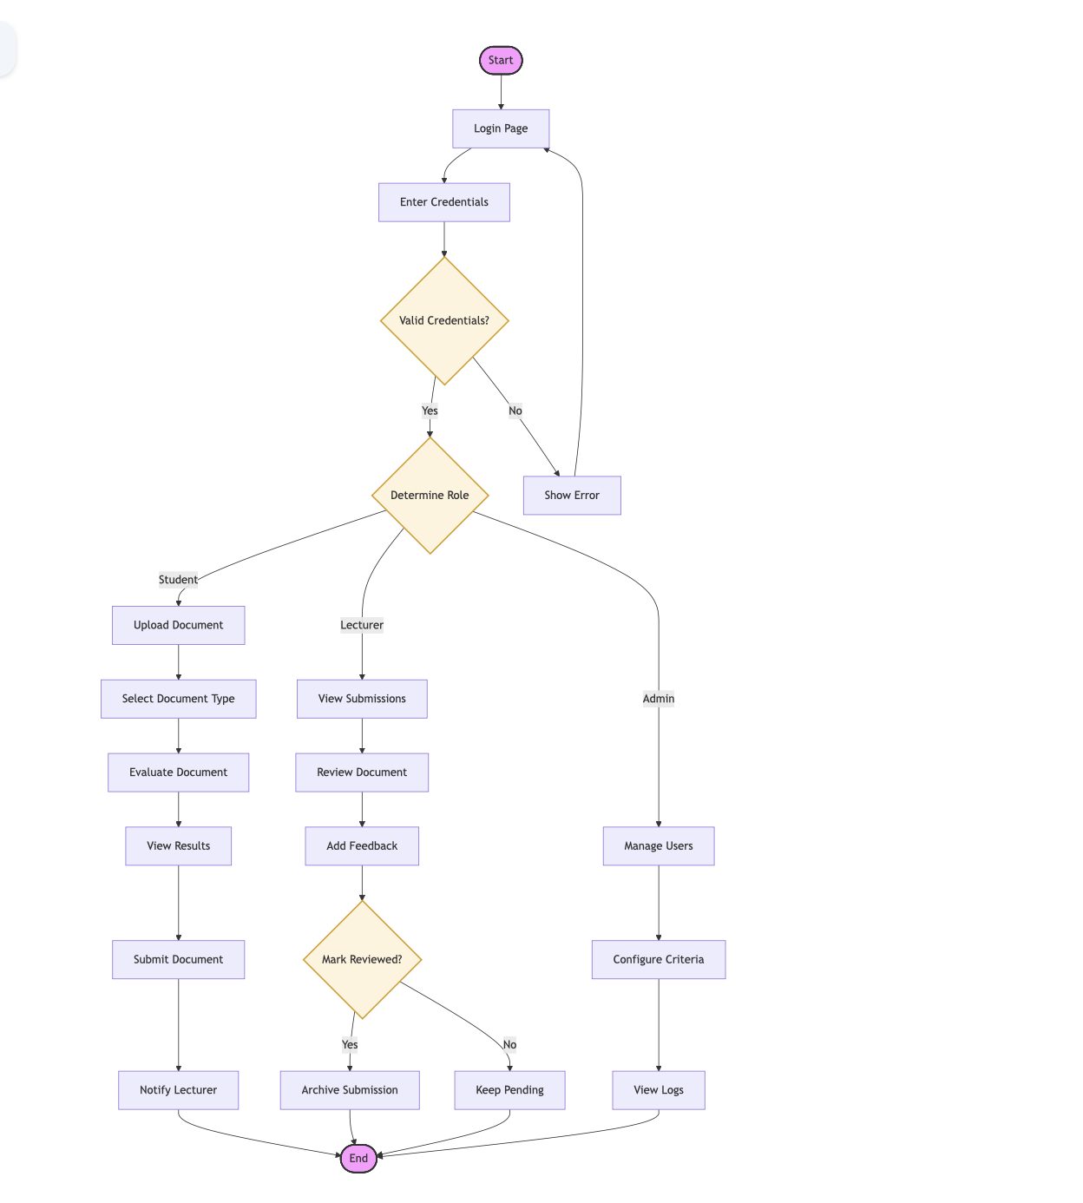
Figure 1: System Flow Chart Diagram

3.5.2 Context Diagram
The AADES context diagram delineates the system’s operational boundaries and the high-level data exchanges between the platform and its primary external entities. Following the principles of structured system analysis, the diagram represents the application as a single central process interacting with three distinct user roles: Students, Supervisors, and Administrators (Sommerville, 2016). The architecture is built upon a client-server model where the web interface serves as the primary conduit for document ingestion and diagnostic visualization. Students provide academic submissions and receive automated evaluation reports, while Supervisors interact with the system to retrieve documents and provide qualitative feedback. Behind the interface, the system manages data persistence through a relational SQLite backend and processes scholarly content using internal AI modules, including structural alias matching and TF-IDF similarity detection (Salton & Buckley, 1988; Pressman & Maxim, 2020). This mapping ensures that all institutional data flows from initial evaluation to final archiving are logically identified and secured.

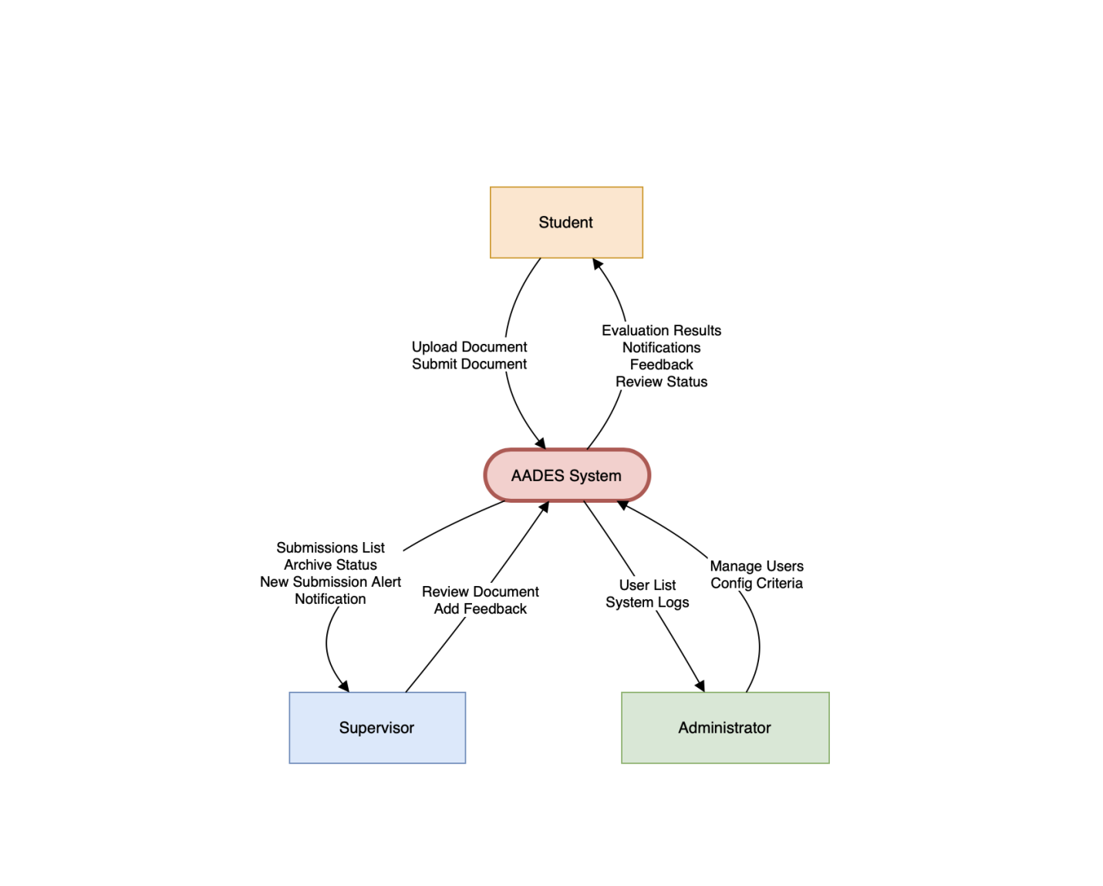

Figure 2 : Context Diagram

3.5.3 Entity Relationship Diagram (ERD)
The AADES platform utilizes a relational SQLite database to ensure data integrity and consistent query performance (Silberschatz et al., 2018). The schema is structured around seven primary entities: Users, Submissions, Comments, Notifications, Evaluation Criteria, Evaluation Rules, and System Logs. This relational model is essential for an institutional environment where complex links between student work, supervisor feedback, and administrative oversight must be strictly maintained. Data integrity is enforced through normalized relationships and the application of Primary Key (PK) and Foreign Key (FK) constraints (Sommerville, 2016). A one-to-many relationship allows a single user to manage multiple submissions and receive various notifications, while a one-to-one relationship ensures each document type is governed by a specific set of AI evaluation rules. This structured design ensures the system is scalable and provides a secure, transparent audit trail for all academic documentation activities.

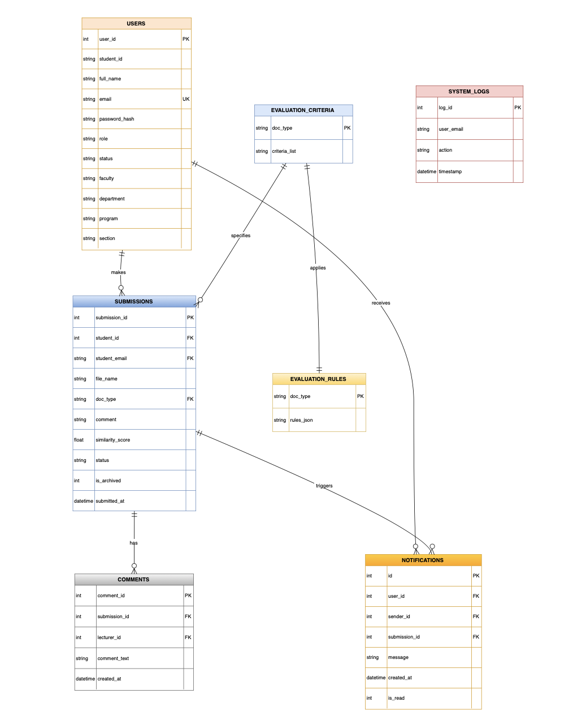

Figure 3: ERD Diagram

3.5.4 Data Flow Diagram (DFD)
The AADES Data Flow Diagram (DFD) maps the movement of information between user entities, internal processing modules, and data stores. At the Level 0 (Context Level), the diagram captures high-level exchanges: students provide documents and receive results, while lecturers receive alerts and provide feedback. Administrators interact with the system to configure criteria and monitor logs (Yourdon, 1989). This top-level view establishes the functional boundaries of the system within the university environment. The Level 1 DFD provides a granular analysis of these internal processes. It begins with Upload & Extraction (1.1), where document text is routed to the AI Evaluation Engine (1.2) for structural and similarity analysis (Pressman & Maxim, 2020). Once results are generated and stored (D1), the Notification (1.5) module alerts the supervisor. The workflow concludes with the Review (1.6) process, where lecturer feedback is saved (D2) and transmitted back to the student. Administrative processes simultaneously manage Rules (D3) and User Profiles (D4) to ensure system consistency (Sommerville, 2016).

Level 1 DFD
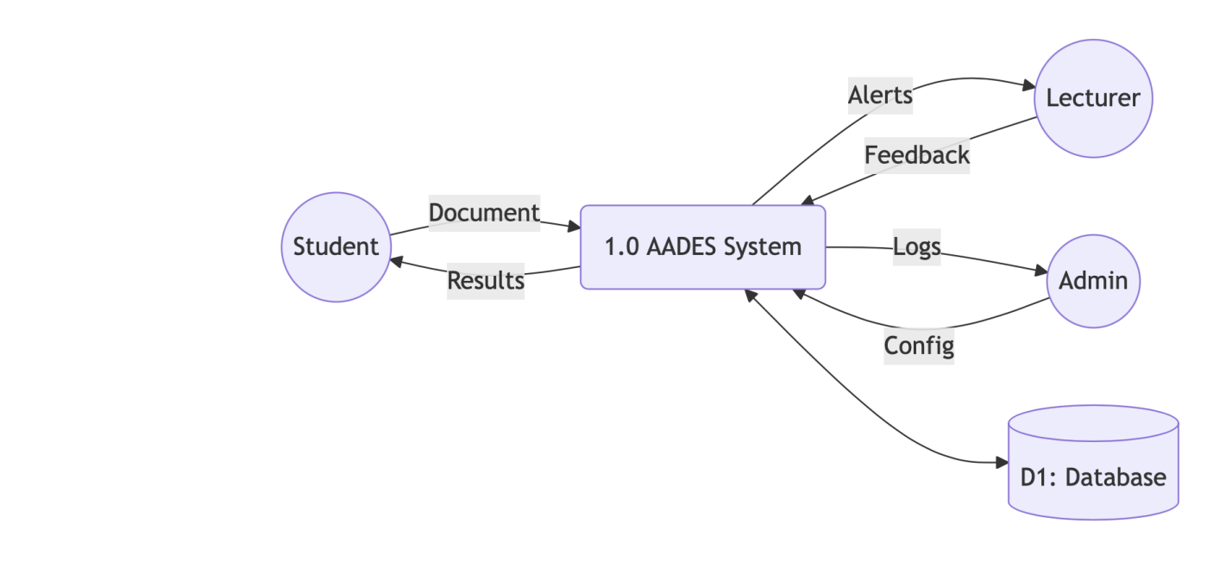

Level 2 DFD
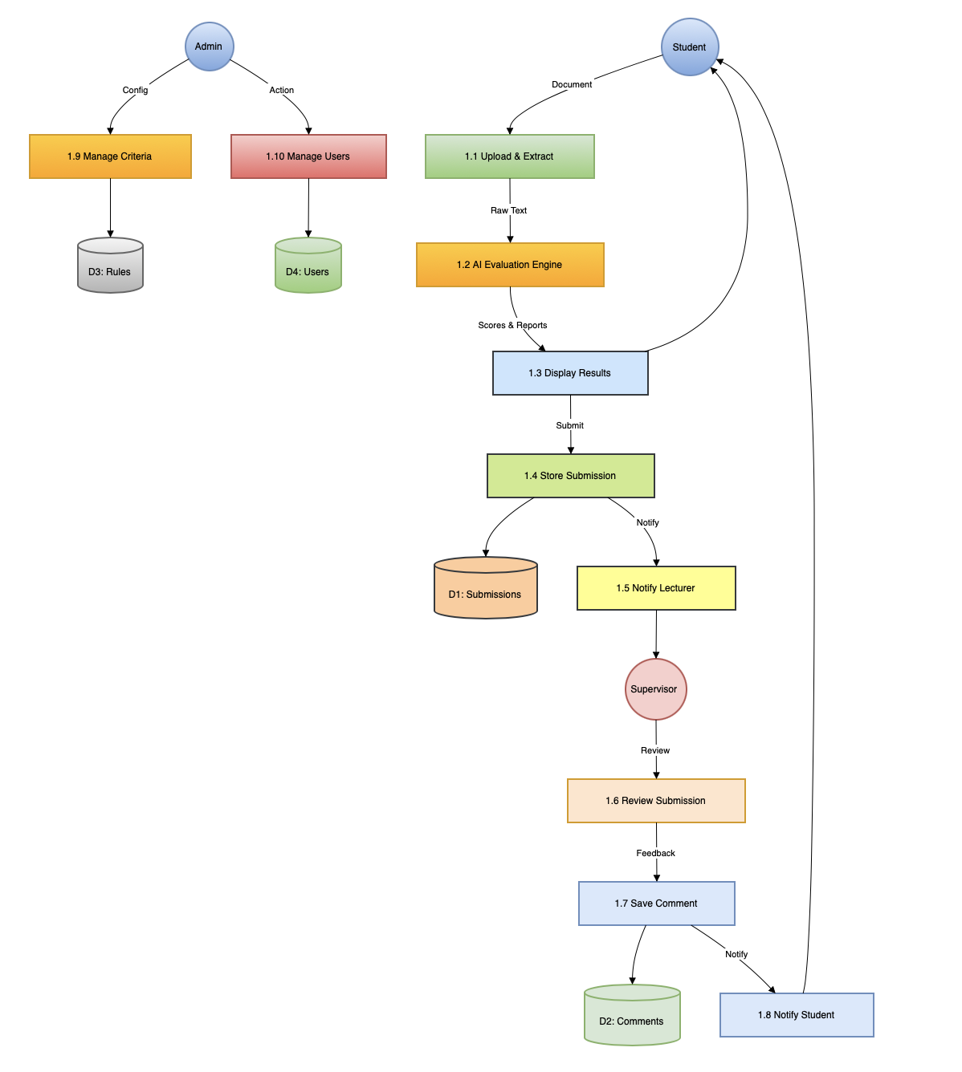
Figure 4: Data Flow Diagram

3.5.5 Use Case Diagram
The AADES Use Case Diagram identifies the system’s functional scope by mapping the interactions between three primary actors: Students, Supervisors, and Administrators (Sommerville, 2016). This diagram defines the project’s boundaries and clarifies how each user role contributes to the academic documentation lifecycle. Students are responsible for document evaluation and submission, Supervisors manage the review and feedback process, and Administrators oversee the system’s configuration and user integrity (Pressman & Maxim, 2020). The core functional requirements are grouped into three specialized workflows. Students utilize use cases for document uploading, AI-driven evaluation, and submission to their respective departments. Supervisors interact with the platform through submission tracking, providing qualitative feedback, and managing review statuses (e.g., archiving). Finally, Administrators maintain system governance through account management, audit log monitoring, and the dynamic configuration of AI evaluation criteria. These synergistic interactions ensure a transparent and efficient environment for maintaining institutional quality standards.

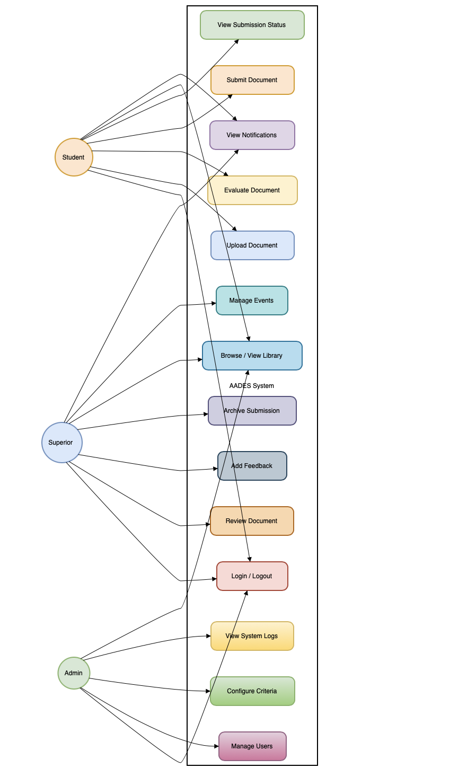
Figure 5:Use Case Diagram

3.6 Chapter Summary
This chapter detailed the methodological framework and architectural design used to develop the AADES platform at UPSA. It explained the Design and Development Research (DDR) approach and the Agile methodology used to translate institutional quality needs into precise system specifications (Richey & Klein, 2007). The process of problem crystallization was outlined, highlighting how identified gaps in manual evaluation were converted into functional requirements for the AI engine and user dashboards. The chapter also presented a comprehensive suite of modeling tools including flowcharts, context diagrams, ERDs, DFDs, and use case diagrams to visualize the system’s data trajectories and relational integrity (Pressman & Maxim, 2020). These diagrams illustrate the seamless interaction between students, supervisors, and the AI evaluation modules. Collectively, this design phase provides the technical blueprint for the implementation and testing processes documented in the subsequent chapter, ensuring the final system is robust, scalable, and pedagogically effective (Sommerville, 2016).

CHAPTER FOUR

IMPLEMENTATION AND DOCUMENTATION OF THE PROPOSED SYSTEM

4.1 Introduction

The successful deployment of an automated academic system depends on the systematic transition from theoretical design to a functional software environment through structured implementation, rigorous testing, and detailed documentation (Pressman & Maxim, 2020). This chapter details the technical realization of the Automated Academic Documentation Evaluation System (AADES), illustrating how the conceptual models established in previous chapters were transformed into a working solution for the UPSA academic community. The implementation phase focused on the integration of the Python Flask framework with specialized Natural Language Processing (NLP) modules to facilitate the automated assessment of scholarly work. The technical development of AADES involved synthesizing the user interface, a relational database, and an AI evaluation engine designed to match institutional documentation standards. In the context of educational technology, the implementation of such systems requires high diagnostic accuracy to ensure that algorithmic feedback is both objective and pedagogically sound (Lall & Chawla, 2021). Consequently, the coding phase prioritized the development of robust parsing utilities for PDF and DOCX formats and the calibration of the TF-IDF similarity matrix for localized plagiarism detection.Furthermore, this chapter documents the testing protocols used to validate the system’s performance and reliability. Systematic testing is crucial for automated evaluation tools to ensure that structural matching and citation validation occur without technical failure (Adesina et al., 2021). Finally, this section provides the technical documentation necessary for the system’s long-term maintenance and institutional scalability. Comprehensive documentation serves as a critical blueprint for future system evolution, outlining the internal logic and directory architecture of the platform (Sommerville, 2016).

4.2 Testing Approaches
Software testing is an essential phase of the development lifecycle, ensuring that AI-driven platforms provide reliable and accurate diagnostic results (Sommerville, 2016). For the AADES platform, rigorous testing was critical as inaccurate similarity scores or structural evaluations would directly compromise institutional academic integrity. A structured, multi-layered strategy was adopted to verify both the technical performance of the AI engine and the ergonomic usability of the interface (Pressman & Maxim, 2020).
The testing process was organized into four primary approaches: Unit Testing to validate isolated AI modules, Functional Testing to verify end-to-end submission workflows, Usability Testing to assess student and lecturer interactions, and Acceptance Testing to ensure institutional alignment (Adesina et al., 2021). Collectively, these methods formed a comprehensive framework to ensure the system is technically stable and practically viable for the UPSA academic community.

4.2.1 Unit Testing
Unit testing focused on the modular validation of the AADES platform, ensuring that every independent component performed its designated task accurately before system integration (Sommerville, 2016). This approach was vital for auditing the computational logic of the AI engine, specifically targeting modules such as user authentication, PDF/DOCX text extraction, and the fuzzy alias matching utility. By isolating these sub-systems, developers could confirm that the foundational code for structural analysis and referencing validation was technically sound. During this phase, each unit was subjected to rigorous test cases featuring predefined inputs and expected diagnostic outputs. For instance, the similarity detection module was verified by inputting text pairs with known overlap percentages to ensure that the TF-IDF cosine similarityscores aligned with expected mathematical values (Bird et al., 2009). Similarly, the grammar engine was tested against a corpus of common academic writing errors to confirm that specific regex patterns correctly flagged violations such as passive voice or APA citation inconsistencies. The significance of this approach lay in its ability to identify algorithmic flaws and data parsing issues before they could affect the integrated institutional workflow. By detecting and correcting faults at the component level, the system’s overall stability was enhanced, and the risk of cascading errors during full-scale deployment was minimized (Pressman & Maxim, 2020). Ultimately, unit testing ensured that the AADES evaluation logic is both robust and maintainable, establishing a reliable foundation for automated quality assurance.

4.2.2 Functional Testing
Functional testing was conducted to verify that the AADES platform operates according to its technical specifications and institutional requirements (Pressman & Maxim, 2020). Unlike unit testing, which examines code blocks in isolation, functional testing evaluates the system as a unified whole. This ensures that the integration of the document parser, the AI evaluation engine, and the notification modules results in a seamless and logical user journey (Sommerville, 2016). During this phase, critical workflows were examined, including user authentication, document type selection, and the submission-to-supervisor pipeline. Test cases utilized both valid and invalid inputs to ensure robust error handling; for instance, the system was challenged with unsupported file formats and unauthorized access attempts to ensure that appropriate security responses were triggered. These tests confirmed that the application enforces strict data integrity and successfully restricts administrative and supervisory functions to authorized personnel only. Finally, functional testing validated the consistency of data across the platform's interconnected dashboards. It was verified that evaluation reports generated for a student were accurately retrieved by the assigned supervisor within the correct academic department, ensuring departmental privacy. This process confirmed that the system provides reliable, consistent diagnostics and that the multi-role interaction between students, lecturers, and administrators is technically stable and practically effective (Adesina et al., 2021).

4.2.3 Usability Testing
Usability testing assessed the interaction quality between the AADES platform and its academic users, ensuring that task completion was both intuitive and efficient (ISO 9241-11, 2018). Since the successful adoption of automated evaluation tools depends heavily on the clarity of diagnostic feedback, this phase was vital for verifying that the underlying complexity of the AI engine did not hinder the end-user experience (Nielsen, 1993). Prioritizing system ergonomics ensures that students can navigate diagnostic reports without excessive cognitive load, which is critical for the long-term sustainability of institutional assessment tools (Sommerville, 2016). The testing involved a representative cohort of UPSA students and lecturers who were tasked with executing core operations, such as uploading a research proposal for analysis, interpreting similarity scores, and navigating the departmental review dashboard (Adesina et al., 2021). Utilizing the "think-aloud" method, participants verbalized their navigational challenges while researchers observed the efficiency of the dashboard layout and the clarity of evaluation results (Rubin & Chisnell, 2008). Structured feedback was collected to evaluate the platform’s effectiveness, ensuring that the multi-role interface successfully supported the specific scholarly workflow of the university environment. Insights obtained from this phase revealed critical areas for refinement, such as the need for more descriptive status badges and a more intuitive layout for the AI evaluation scanning modal. These findings align with research indicating that interface clarity significantly impacts the pedagogical effectiveness of AI-driven educational tools (Zawacki-Richter et al., 2019). These usability observations directly informed the final refinements to the notification system and the document viewer, resulting in an accessible, user-friendly platform that fosters consistent engagement with institutional quality standards (Lall & Chawla, 2021).

4.2.4 Acceptance Testing
Acceptance testing was conducted to verify that AADES satisfies the specific academic requirements of its intended users and fulfills the primary project goals established for the UPSA community (Sommerville, 2016). This phase shifts the analytical focus from technical performance to the end-user’s perspective, determining if the platform delivers genuine pedagogical value in a real-world institutional setting (Pressman & Maxim, 2020). By evaluating the system through the lens of perceived usefulness and ease of use, the study followed established frameworks for assessing the adoption and success of new educational technologies (Davis, 1989). During this phase, participants examined whether the AI-generated diagnostic reports were understandable and accurately reflected the rigorous documentation standards of the University of Professional Studies, Accra (Zawacki-Richter et al., 2019). Users assessed the practical relevance of the structural matching and internal similarity scoring features, ensuring that the system provides actionable insights that help students resolve formatting and integrity issues before final submission (Bearman et al., 2020). Feedback focused on the platform's ability to significantly reduce the manual administrative workload for supervisors while maintaining high levels of diagnostic accuracy for student self-assessment (Lall & Chawla, 2021). The successful completion of acceptance testing confirmed that AADES aligns with the original project scope and functional requirements defined during the initial system design phase (Adesina et al., 2021). The outcomes demonstrated that the platform is not only technically sound but also practically viable for deployment as a functional prototype within the university's digital ecosystem (Pressman & Maxim, 2020). Consequently, the system was deemed ready for institutional use, proving its potential to enhance academic quality assurance and standardize documentation procedures across various departments (Sommerville, 2016).

4.2.5 Selected Testing Approach
Although multiple testing layers were employed, functional and usability testing were prioritized as the primary strategies for the AADES project. This selection was based on the system’s requirement to deliver high-precision academic diagnostics while maintaining a seamless experience for students and faculty (Pressman & Maxim, 2020). Functional testing verified that the AI evaluation engine operated consistently with institutional documentation standards, while usability testing ensured that the complex analysis results were presented in an accessible manner (ISO 9241-11, 2018). Integrating these approaches provided a balanced assessment of technical reliability and institutional acceptance, which is essential for specialized web-based educational tools (Adesina et al., 2021).
The comprehensive evaluation confirmed that the AADES platform effectively fulfilled its functional requirements and institutional objectives. Results from unit and functional testing established that core components including secure multi-role authentication, PDF/DOCX parsing, and structural matching operated with a high degree of precision (Sommerville, 2016). Specifically, the implementation of TF-IDF cosine similarity and fuzzy alias matching produced diagnostic results that aligned with manually verified academic benchmarks, ensuring that the system provides a credible and accurate internal plagiarism detection mechanism (Salton & Buckley, 1988). Findings from usability and acceptance testing indicated that both students and supervisors could navigate the platform with minimal cognitive effort and interpret AI-generated insights effectively. Participants reported that the color-coded status badges and real-time notifications significantly enhanced their understanding of the review workflow, supporting established principles of learnability and interface efficiency (Nielsen, 1993). Furthermore, acceptance testing demonstrated high user satisfaction regarding the system's relevance to the university’s quality assurance goals, proving that the AADES prototype is a viable, hardware-independent solution for standardized document evaluation (Davis, 1989).

4.3 Implementation of the Current System
System implementation involves deploying the AADES platform into the active operational environment of the University of Professional Studies, Accra (UPSA), where it can be utilized for standardized academic quality assurance (Laudon & Laudon, 2020). The selection of an implementation strategy is vital to ensure a smooth transition from manual document oversight to an automated AI-driven framework. A strategic approach helps manage technical risks, such as data integrity during submission, while mitigating potential user resistance from both students and faculty (Pressman & Maxim, 2020). In the context of this study, implementation strategies were carefully analyzed to ensure that the AI evaluation engine—comprising structural, grammatical, and similarity diagnostics—is integrated without disrupting the existing academic review cycle (Sommerville, 2016). Transitioning from subjective manual grading to an objective, algorithm-driven system requires a deployment method that emphasizes accuracy, institutional transparency, and pedagogical acceptance (Bearman et al., 2020). Several standard implementation strategies are recognized in software engineering, including parallel, pilot, direct, and phased implementation (Stair & Reynolds, 2018). Each approach offers specific advantages and limitations based on the complexity of the academic environment and the scale of the student population (Laudon & Laudon, 2020). The following sections discuss these strategies in relation to the localized deployment of the AADES platform within the university.

4.3.1 Parallel implementation
Parallel implementation involves the concurrent operation of the newly developed AADES platform alongside the existing manual evaluation process at UPSA (Stair & Reynolds, 2018). During this phase, both systems are used simultaneously, allowing lecturers to cross-verify the AI-generated diagnostics such as structural compliance and similarity scores against their traditional human assessments before a full transition occurs (Laudon & Laudon, 2020). This strategy is recognized as a high-integrity deployment method because it provides an institutional safety net, ensuring that manual records remain available if the automated logic requires further calibration (Pressman & Maxim, 2020).
In the context of the AADES project, this approach allows students to receive both immediate AI-driven feedback and qualitative critiques from their supervisors. This dual-evaluation period is critical for validating the reliability of the system’s linguistic and similarity models under real academic conditions (Sommerville, 2016). The primary advantage is significant risk reduction; by maintaining the manual review process, the university ensures that the transition to automation does not compromise academic standards during the initial deployment phase (Laudon & Laudon, 2020). However, parallel implementation requires an increased effort from faculty members, as they must manage two evaluation cycles for the same submission (Stair & Reynolds, 2018). Despite the additional workload, this approach is vital for establishing institutional trust in the AADES AI engine. It provides the empirical evidence needed to prove that the system’s objective analysis effectively complements human pedagogical expertise, which is essential for the long-term success of automated grading tools (Adesina et al., 2021).

4.3.2 Pilot implementation
Pilot implementation involves deploying the AADES platform to a restricted, representative group of users before an institutional-scale rollout (Stair & Reynolds, 2018). This strategy enables developers to observe system performance in a live academic environment, identify subtle operational glitches, and gather qualitative feedback from students and faculty in a controlled setting (Laudon & Laudon, 2020). In the context of educational technology, pilot testing is essential for verifying whether the diagnostic insights generated by the AI evaluation engine translate effectively into improved student learning outcomes (Zawacki-Richter et al., 2019).
For this project, a pilot group consisting of selected students and supervisors within the Department of Information Technology at UPSA was utilized. Over a defined period, these users interacted with the system to evaluate diverse document types, ranging from research proposals to project reports. Their experiences regarding the system’s structural analysis, similarity scoring accuracy, and dashboard ergonomics provided critical data for iterative system calibration (Pressman & Maxim, 2020). This phase ensured that the AI engine’s logic remained robust when processing non-standard document layouts and varied linguistic styles (Sommerville, 2016). The primary advantage of pilot implementation is its ability to expose practical issues such as file parsing exceptions or notification latency that may not be evident during laboratory-based testing (Sommerville, 2016). Furthermore, it encourages institutional adoption by allowing the academic community to participate directly in the platform’s refinement (Laudon & Laudon, 2020). Although this strategy may not fully simulate the infrastructure stress of a university-wide deployment with high concurrent usage, it remains a highly effective method for validating automated prototypes and ensuring they are pedagogically sound and institutionally reliable (Pressman & Maxim, 2020).

4.3.3 Direct implementation
Direct implementation, often termed the "big bang" approach, involve the immediate and total replacement of an existing workflow with a new system at a specific point in time (Stair & Reynolds, 2018). In the context of AADES, this would require UPSA students and faculty to abruptly discontinue manual document reviews and rely solely on the AI platform for quality assurance. While this strategy ensures immediate institutional adoption and eliminates the complexity of maintaining dual evaluation cycles, it carries a high degree of implementation risk (Laudon & Laudon, 2020). The primary drawback of direct implementation is the lack of an operational safety net. If the AI evaluation engine encounters parsing errors or if the similarity checker produces false positives, there is no alternative mechanism available for immediate academic continuity (Sommerville, 2016). In the high-stakes environment of academic integrity and final year project grading, such technical failures could undermine institutional trust and student confidence (Adesina et al., 2021). Given that AADES is currently at the prototype stage and relies on sophisticated NLP algorithms that require real-world validation, a direct cutover is considered unsuitable. This strategy is generally reserved for systems that have reached full technical maturity and have earned absolute user acceptance (Pressman & Maxim, 2020). Therefore, while direct implementation may be a long-term goal for UPSA’s digital transformation, it was rejected for the initial deployment phase in favor of more iterative and cautious strategies.

4.3.4 Phased Implementation
Phased implementation involves the incremental introduction of the AADES platform, either by deploying specific functionalities in stages or by rolling out the system to individual academic departments over a defined period (Laudon & Laudon, 2020). This strategy mitigates deployment risks by allowing developers and institutional stakeholders to validate core components such as the PDF/DOCX parsing engine before the full suite of AI evaluation features is activated. By concentrating on specific modules sequentially, the impact of potential technical failures is localized and more easily managed (Stair & Reynolds, 2018).
In the context of the AADES project, a phased approach would begin with the deployment of foundational utilities, including secure multi-role authentication and document upload interfaces. Subsequent phases would integrate the more complex AI modules, such as structural alias matching, TF-IDF similarity detection, and the bidirectional notification system (Sommerville, 2016). This staged deployment ensures that each evaluation module is rigorously tested and refined based on real-world academic data before the next set of features is introduced (Adesina et al., 2021). The primary advantage of this approach is its inherent flexibility and alignment with Agile development principles, facilitating continuous feedback and iterative improvement (Beck et al., 2001). A phased rollout allows students and faculty to adapt to automated evaluation workflows progressively, which is essential for building institutional trust in AI-driven diagnostics (Pressman & Maxim, 2020). While this strategy may extend the total deployment timeline, it ensures that the final institutional ecosystem is robust, reliable, and perfectly calibrated to the university's quality standards.

4.4 System Documentation

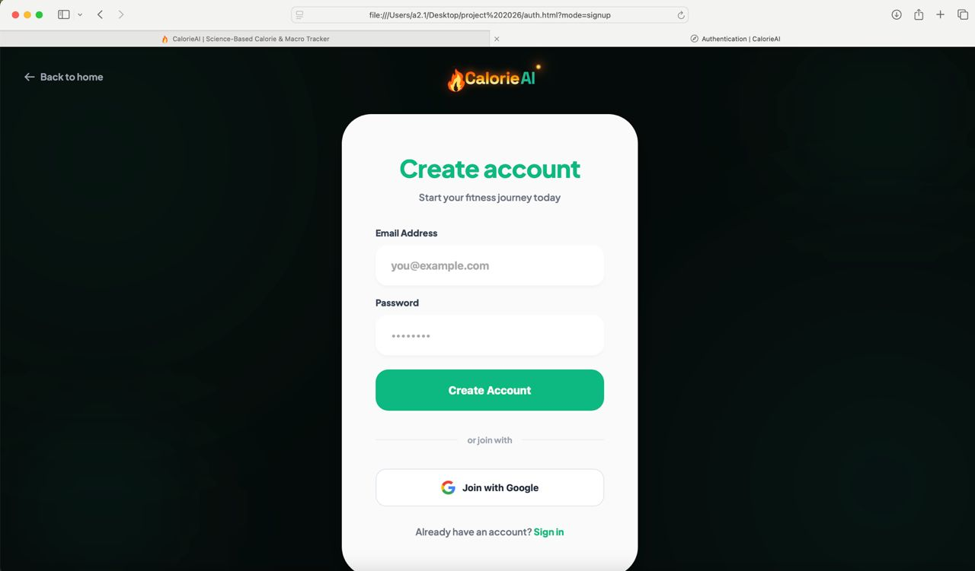
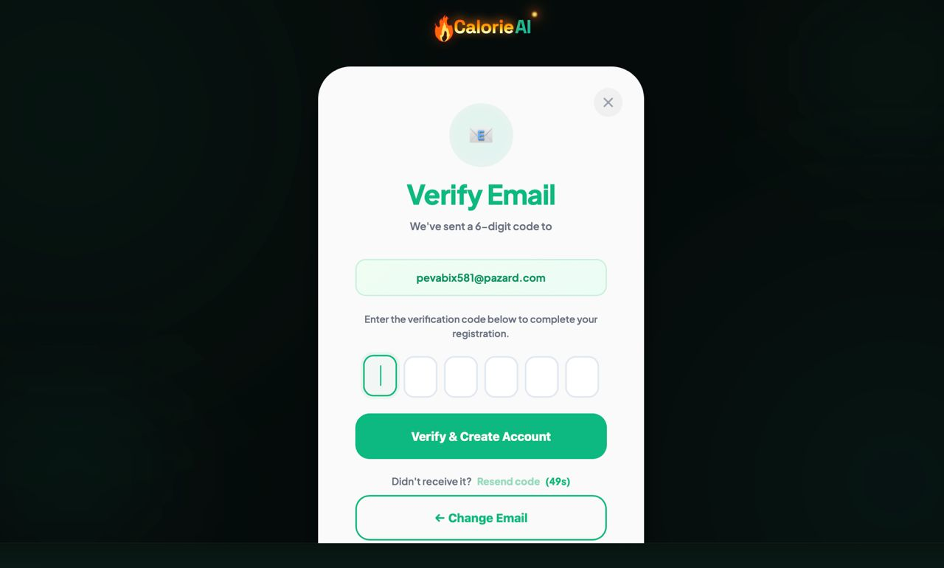
Figure 6: System Auth/Create Account Page

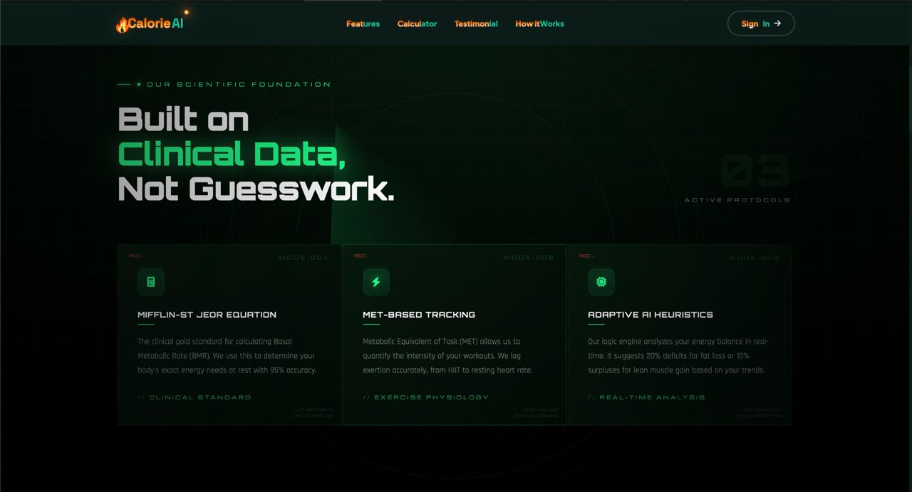
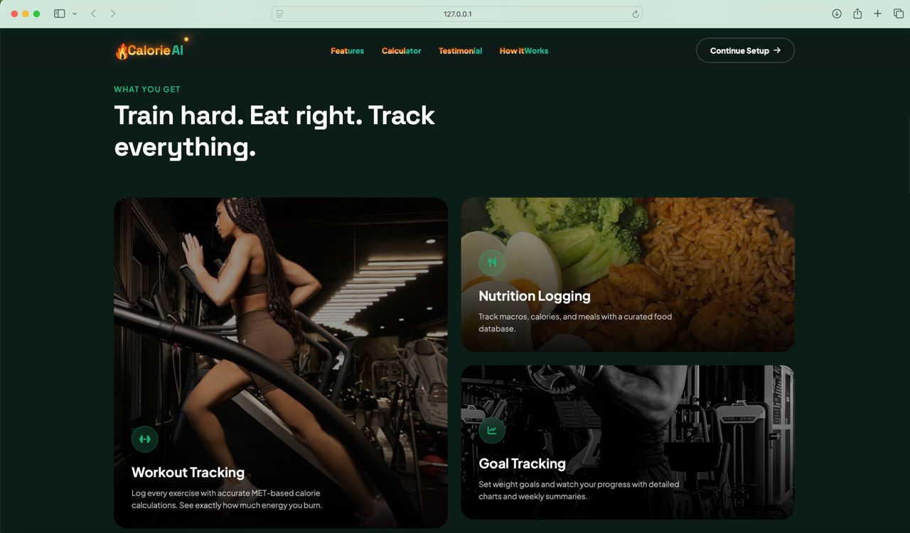
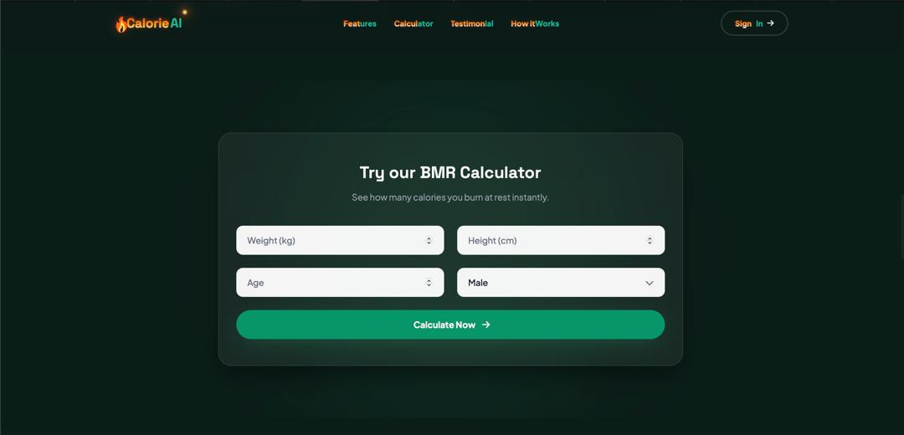
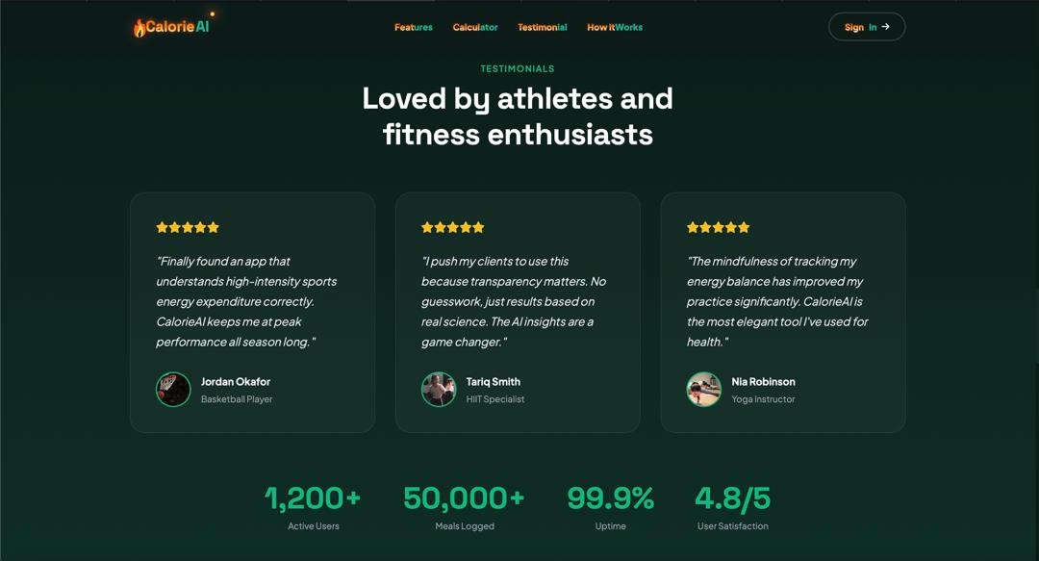
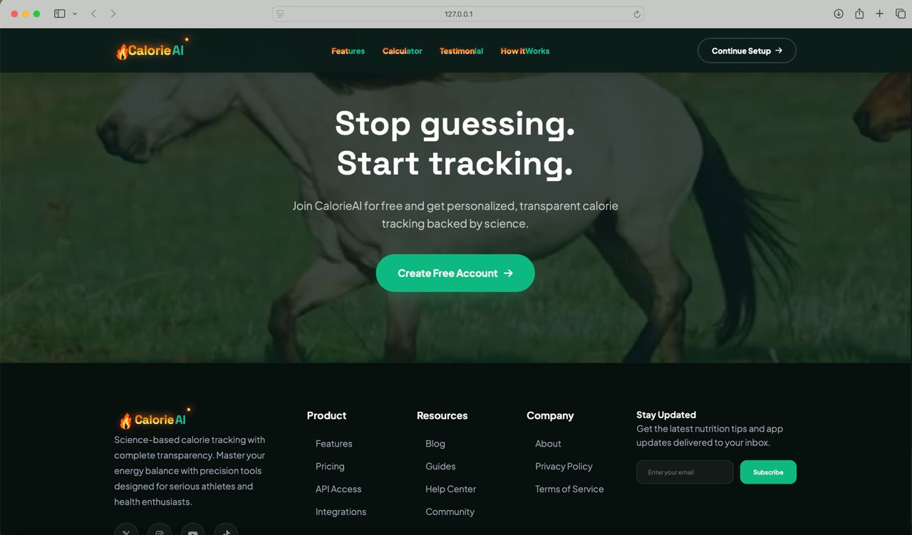

Figure 7: System Home Page

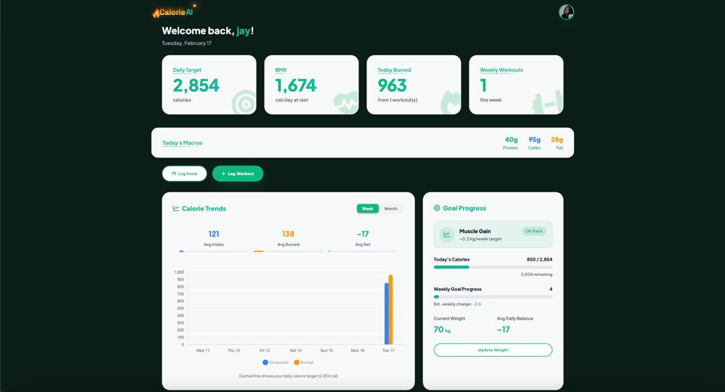
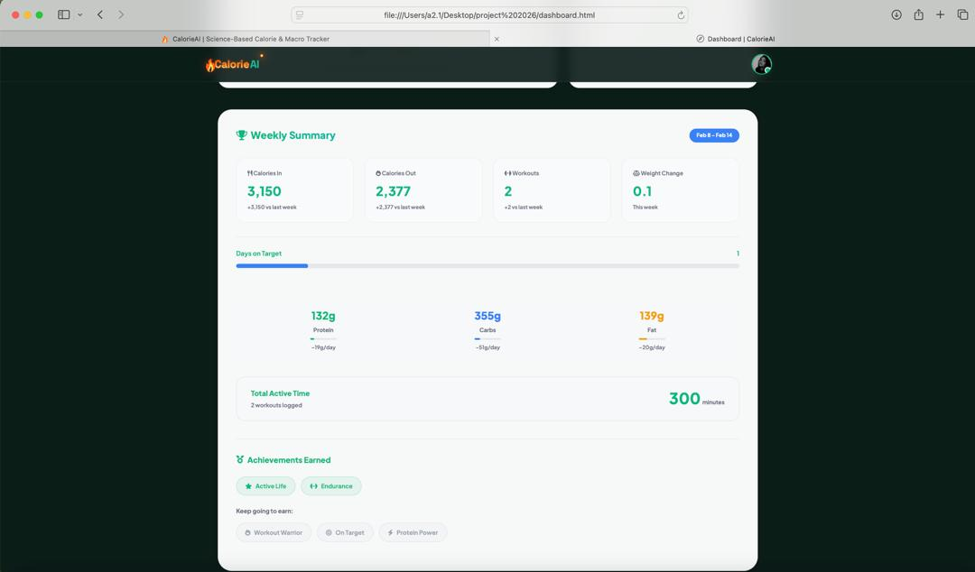
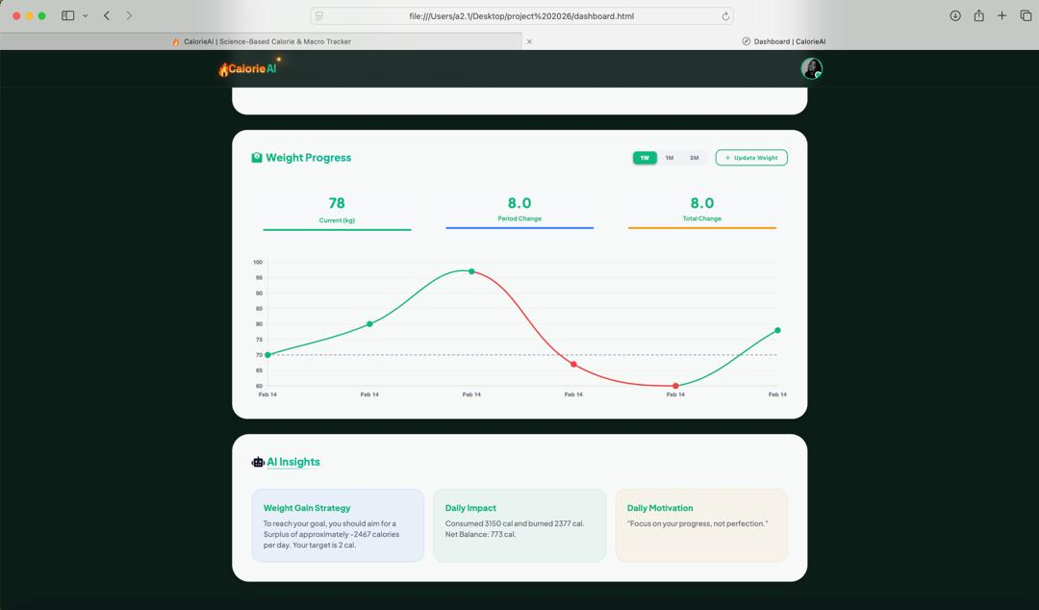

Figure 8: System Dashboard Page

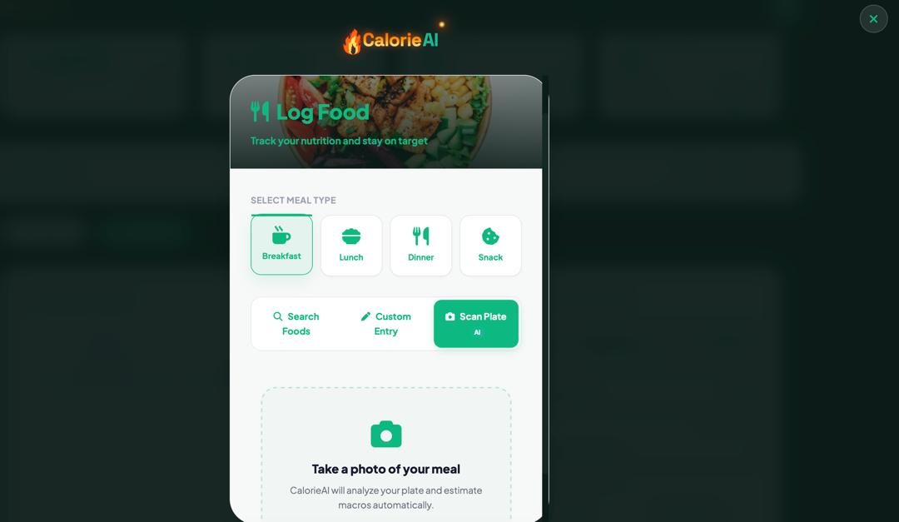

Figure 9: System Meal Log Page

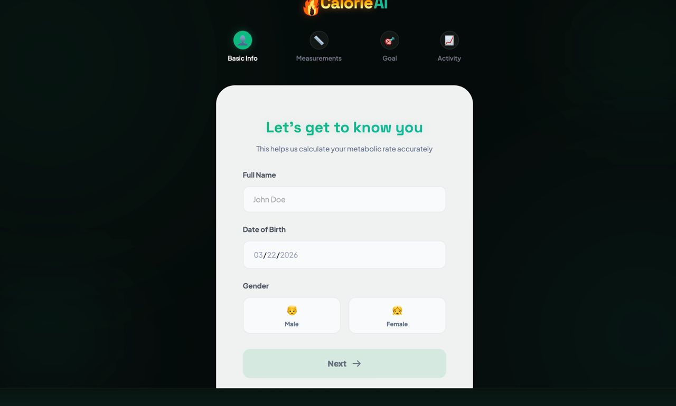
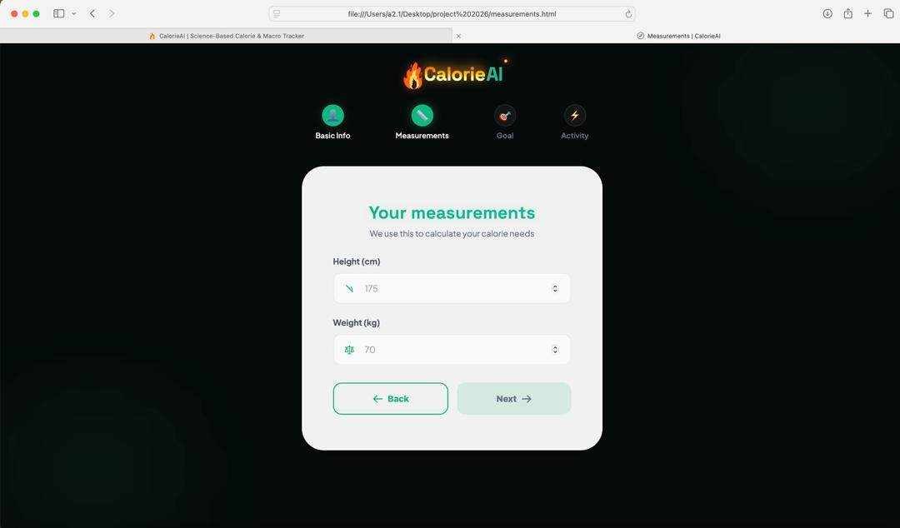
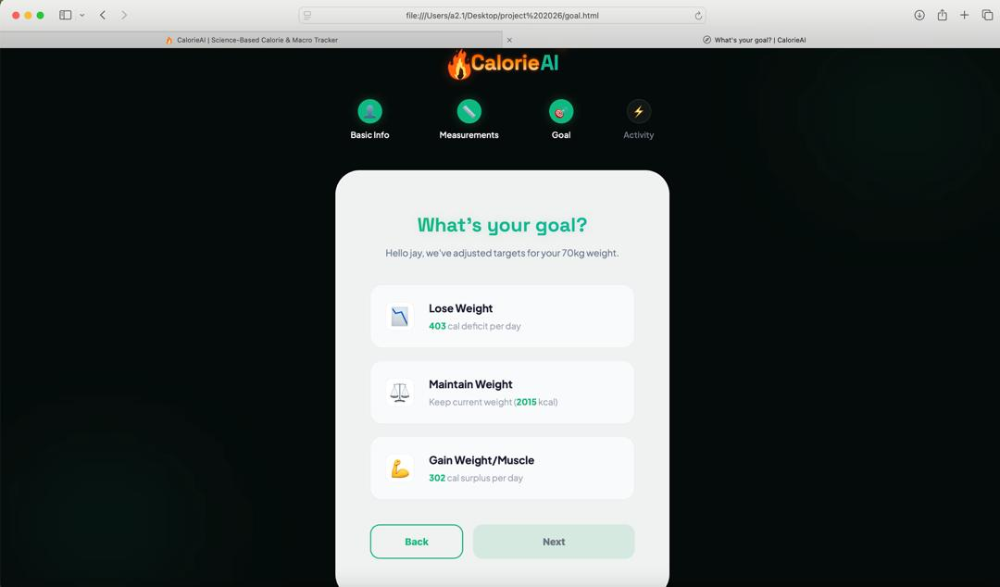
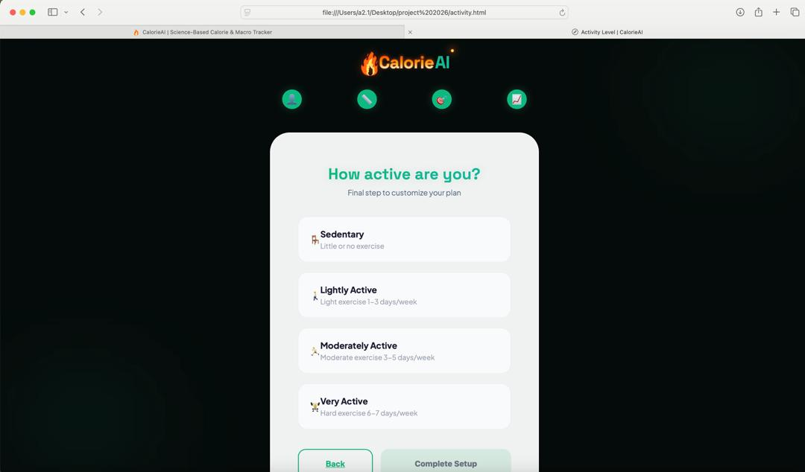

Figure 10: System Onboarding Page

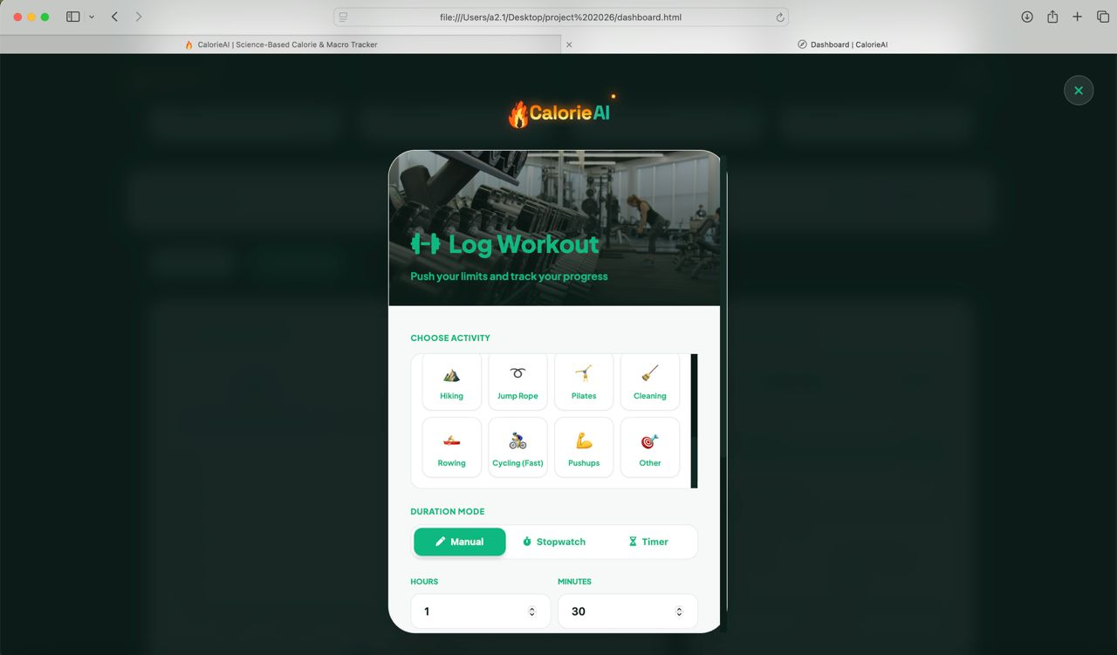

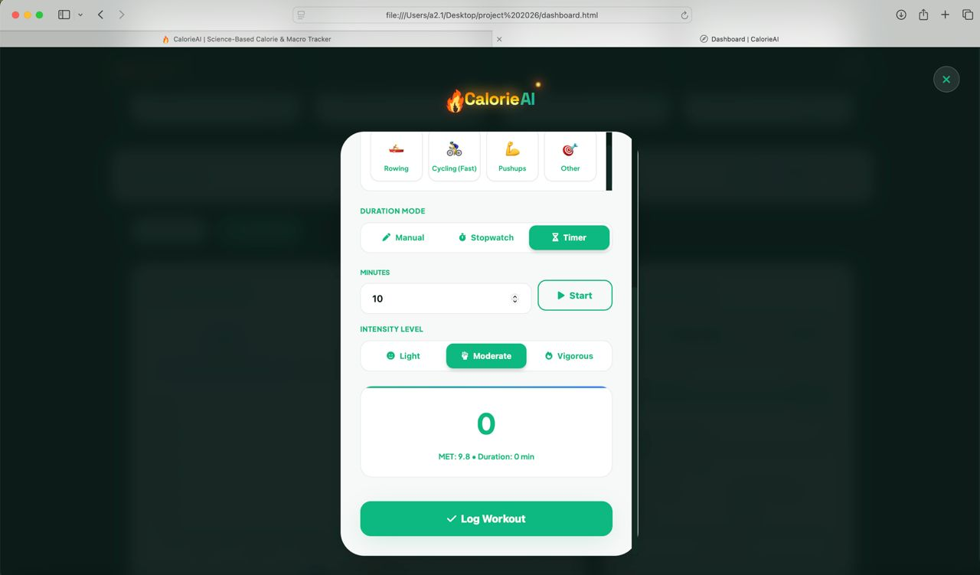

Figure 11: System Workout Page

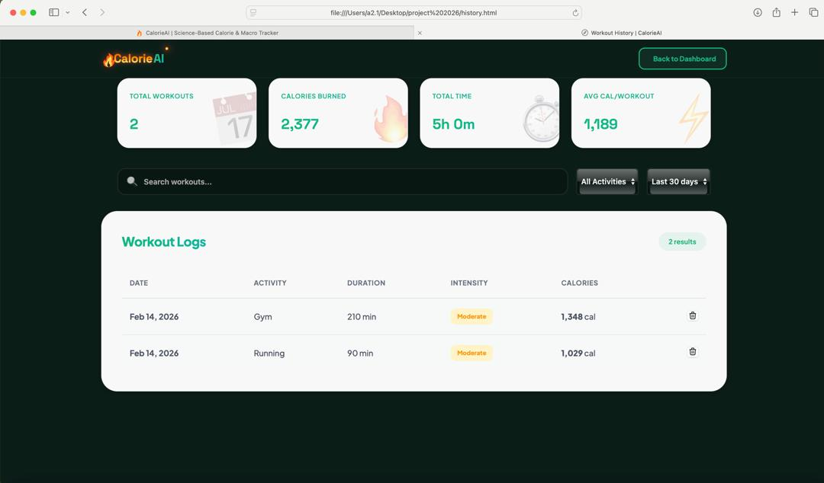
Figure 12: System Workout History Page
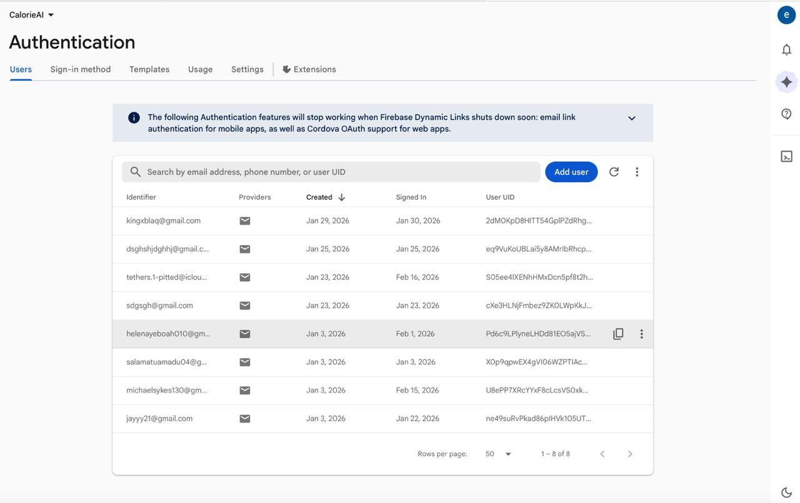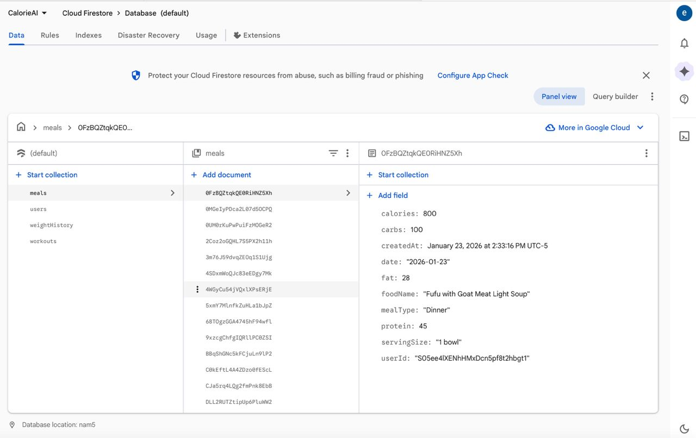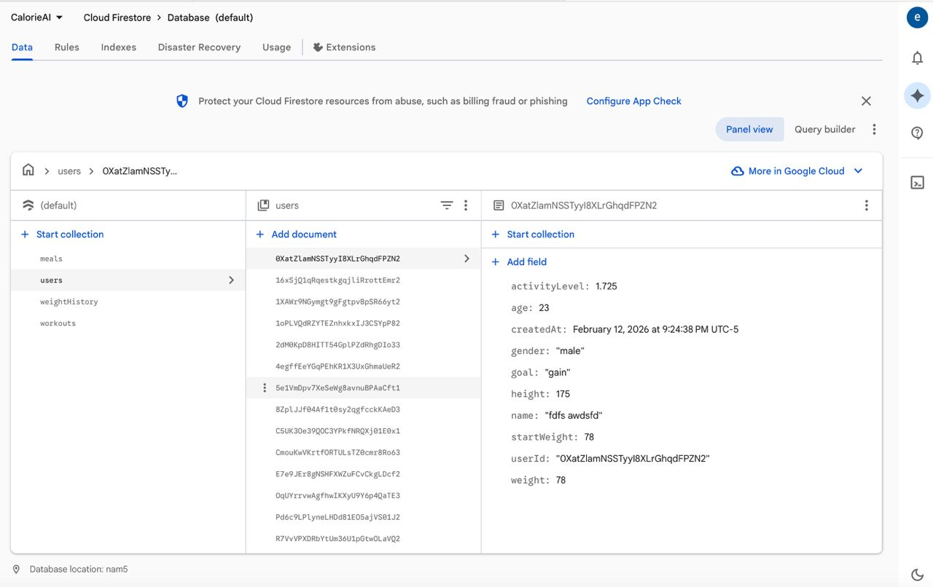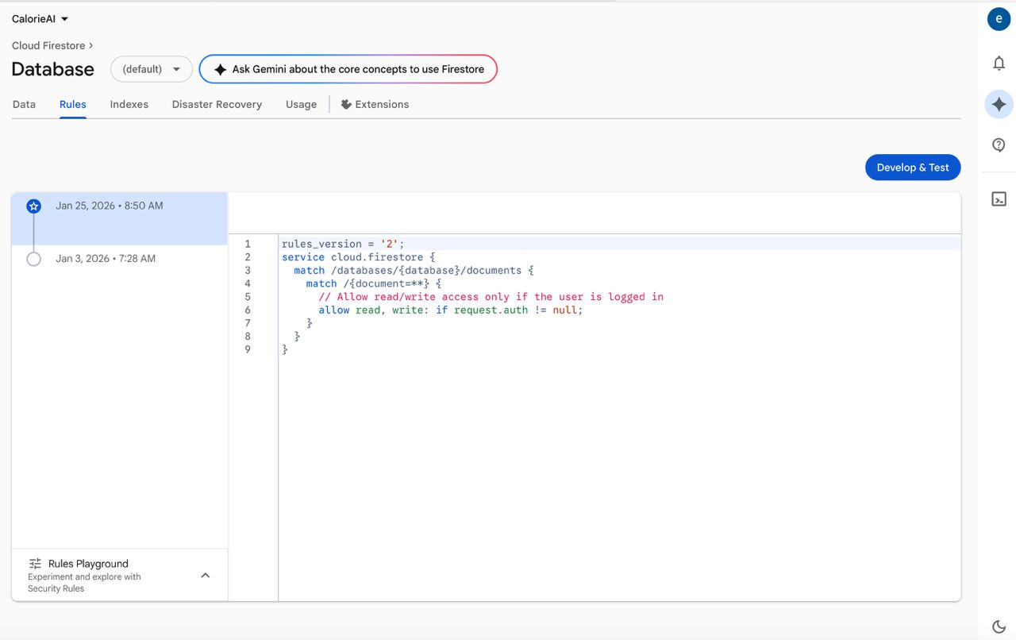
Figure 13: System Database Page
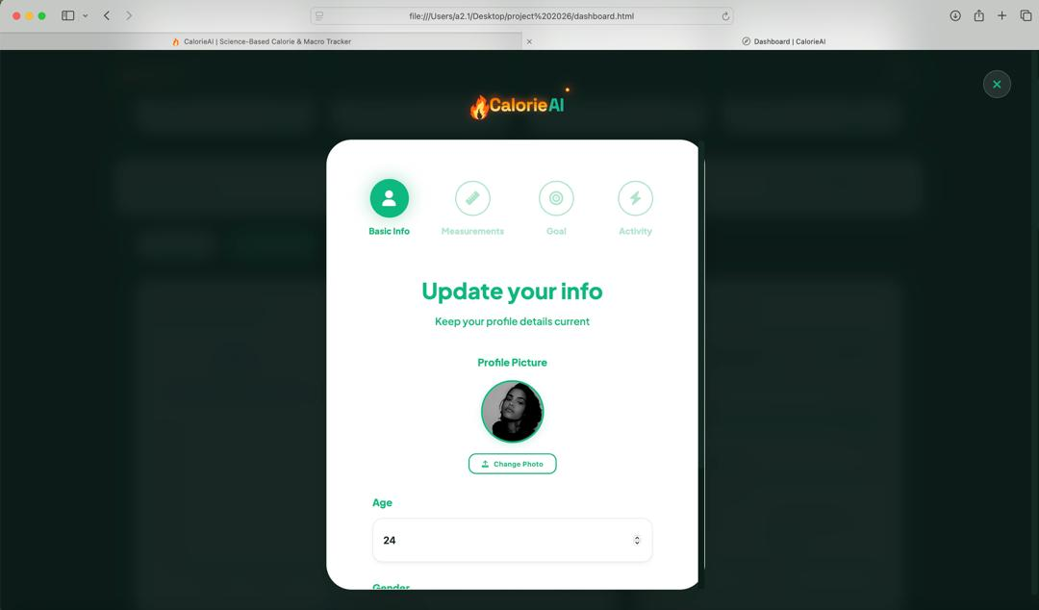
Figure 14: System User Update Info

4.5 Implementation Challenges
The technical realization of the AADES platform presented several unique challenges that required innovative software engineering solutions. A primary obstacle involved the complexity of document parsing, particularly when extracting text from diverse file formats like PDF and DOCX. It was observed that while standard paragraphs were easily retrieved, tables and non-standard layouts often resulted in fragmented text extraction. This was resolved by implementing a dual-parsing strategy using PyPDF2 and python-docx, with specific logic to iterate through table objects and inject structural markers into the raw text stream (Bird et al., 2009). Additional technical challenges emerged during the development of the structural evaluation engine. Students frequently utilize inconsistent nomenclature for section headings—such as "Background" instead of the canonical "Background of Study"—leading to false-negative results in structural matching. To mitigate this, a fuzzy alias matching algorithm was developed, utilizing a predefined dictionary of synonymous terms and string distance metrics to identify required sections accurately (Pressman & Maxim, 2020). Furthermore, managing the persistence of uploaded files during the transition from evaluation to final submission was problematic. This was addressed by utilizing server-side session tracking in Flask to maintain the file reference, ensuring that students did not have to re-upload documents if the evaluation page was refreshed. From a performance perspective, calculating the TF-IDF cosine similarity matrix against a growing institutional repository introduced potential latency issues. To maintain the sub-ten-second response time requirement, the vectorization process was optimized using scikit-learn’s efficient sparse matrix operations, ensuring that similarity scoring remained performant even with large datasets (Foltýnek et al., 2019). Usability challenges were also identified during early testing, where students expressed confusion over the technicality of AI-generated reports. To resolve this, explanatory tooltips and a color-coded status badge system (green for "Reviewed," orange for "Pending") were incorporated to improve interface clarity and user confidence, in accordance with established human–computer interaction principles (Nielsen, 1993; ISO 9241-11, 2018). These solutions collectively ensured that the final system is both technically robust and institutionally viable (Sommerville, 2016)

4.6 Chapter Summary
This chapter documented the technical implementation and empirical validation of the AADES platform, transitioning the system from conceptual design to a functional institutional tool. It provided a comprehensive overview of the testing protocols employed—including unit, functional, usability, and acceptance testing—demonstrating how these layered approaches ensured the reliability of the AI evaluation engine and the ergonomic quality of the user interface (Adesina et al., 2021; Sommerville, 2016). The chapter also analyzed several implementation strategies, concluding that a phased and pilot deployment approach is most suitable for introducing an AI-driven academic tool into the UPSA environment to minimize operational risks (Laudon & Laudon, 2020). Furthermore, the chapter examined the technical challenges encountered during the implementation phase, such as document parsing complexities and section nomenclature variations. By resolving these through innovative Natural Language Processing (NLP) solutions and fuzzy matching algorithms, the system’s diagnostic precision and institutional alignment were significantly enhanced (Pressman & Maxim, 2020). In conclusion, the rigorous testing and refinement processes documented here confirm that the AADES platform successfully satisfies its functional requirements and is ready for practical use. The final chapter will synthesize the study’s findings, draw comprehensive conclusions, and propose strategic recommendations for future system enhancement.

CHAPTER FIVE

SUMMARY, CONCLUSIONS AND RECOMMENDATIONS

5.1 Introduction
This concluding chapter synthesizes the research findings related to the design and implementation of the Automated Academic Documentation Evaluation System (AADES). It provides a comprehensive summary of the project’s objectives, the problem of manual academic oversight at UPSA, and the technical scope of the developed solution. Furthermore, this section identifies the inherent limitations of the current prototype and proposes strategic directions for future research and institutional integration. By evaluating the platform’s contribution to educational technology, this chapter establishes the system’s readiness for practical application in a scholarly environment.

5.2 Summary
This study was initiated to address the systemic challenges of manual document evaluation, which often results in subjective grading and delayed feedback cycles for students at the University of Professional Studies, Accra (UPSA). Many existing evaluation workflows lack standardized tools for verifying structural compliance and internal plagiarism, leading to inconsistencies in academic quality assurance (Bearman et al., 2020; Hattie & Timperley, 2007). To resolve these inefficiencies, the AADES platform was developed to automate the assessment of scholarly work through a multi-layered AI engine. The system utilizes TF-IDF cosine similarity for robust internal plagiarism detection and a fuzzy alias matching algorithm to verify the presence of required document sections (Salton & Buckley, 1988).
The platform was engineered using the Python Flask framework and evaluated through rigorous testing protocols to confirm its functionality and diagnostic reliability (Sommerville, 2016). Results indicated that AADES provides objective, sub-ten-second evaluations that align with institutional documentation standards. By offering specialized dashboards for students and faculty, the system successfully bridges the feedback gap, ensuring that all submissions meet a baseline technical standard before final human review.

5.3 Limitations of the Study
Despite the successful realization of the AADES prototype, several constraints were identified during the study. First, the system’s structural analysis engine is highly dependent on the quality of text extraction from PDF and DOCX files; documents with non-standard layouts or non-searchable text may yield incomplete evaluations (Bird et al., 2009). Second, the plagiarism detection module is restricted to an internal institutional repository and cannot currently verify content against external web-based sources or published academic journals (Foltýnek et al., 2019). Additionally, the study was conducted with a limited pilot group at UPSA, which may restrict the generalizability of the usability findings to other academic disciplines with different documentation requirements (Creswell & Creswell, 2018). Technically, the system utilizes rule-based Natural Language Processing (NLP) rather than deep-learning semantic models, limiting its capacity to detect complex paraphrasing where the original sentence structure is significantly altered. Finally, the use of a file-based SQLite database presents a scalability constraint for high-concurrency production environments, necessitating a transition to a more robust database engine for university-wide deployment (Pressman & Maxim, 2020).

5.4 Recommendations for Future Research
To enhance the system's analytical depth and institutional reach, future research should explore several key areas. Integrating large language models (LLMs) such as BERT or GPT-based embeddings would significantly improve the engine's semantic understanding, enabling it to detect sophisticated paraphrased plagiarism and provide more nuanced grammatical feedback (Goodfellow et al., 2016). Furthermore, expanding the similarity checker to integrate with external academic APIs like Crossref or Google Scholar would allow for a more comprehensive validation of textual originality against global literature (Foltýnek et al., 2019). From a technical perspective, migrating the backend to a managed PostgreSQL or MySQL environment is recommended to support thousands of concurrent users across various departments. Future iterations should also focus on developing a dedicated mobile companion application to facilitate real-time submission tracking and push notifications for students and supervisors. Additionally, integrating AADES with the university’s existing Student Information System (SIS) would automate user provisioning and streamline the routing of documents to departmental supervisors. Finally, incorporating advanced analytics dashboards for administrators could provide institutional insights into common student writing errors, thereby informing future curriculum adjustments in academic writing programs.

5.5 Conclusion
This study successfully designed and implemented the Automated Academic Documentation Evaluation System (AADES) as a solution for standardized quality assurance at UPSA. By addressing the limitations of manual review processes, the project demonstrates that institution-specific AI tools can significantly enhance the speed and objectivity of academic assessments. The system’s integration of validated linguistic models with an intuitive web-based interface provides a scalable framework for maintaining high scholarly standards. Testing and evaluation have confirmed that AADES is a reliable, user-friendly, and technically sound prototype that meets its intended objectives. These findings serve as a foundation for the digital transformation of academic administration, highlighting the critical role of automated tools in fostering a culture of academic integrity and excellence in the modern university.

REFERENCES (APA)

Adesina, A., et al. (2021). Quality Assurance in Automated Grading Systems: A Systematic Review of Implementation and Testing. Journal of Computer Assisted Learning, 37(2), 415–430.
Altbach, P. G., & de Wit, H. (2020). The Challenge to Higher Education: Post-pandemic. International Higher Education, (102), 4–5.
Bearman, M., Dawson, P., Ajjawi, R., Tai, J., & Boud, D. (2020). Re-imagining University Assessment in a Digital World. Springer Nature. https://doi.org/10.1007/978-3-030-41919-6
Beck, K., et al. (2001). Manifesto for Agile Software Development. Agile Alliance. http://agilemanifesto.org/
Bird, S., Klein, E., & Loper, E. (2009). Natural Language Processing with Python. O'Reilly Media.
Bloxham, S., den-Outer, B., Hudson, J., & Price, M. (2016). Let’s stop the pretence of consistent marking: Exploring the unreliability of assessment decisions. Assessment & Evaluation in Higher Education, 41(3), 466–481. https://doi.org/10.1080/02602938.2015.1024607
Chacon, S., & Straub, J. (2014). Pro Git. Apress.
Creswell, J. W., & Creswell, J. D. (2018). Research Design: Qualitative, Quantitative, and Mixed Methods Approaches (5th ed.). SAGE Publications.
Davis, F. D. (1989). Perceived usefulness, perceived ease of use, and user acceptance of information technology. MIS Quarterly, 13(3), 319–340. https://doi.org/10.2307/249008
Fielding, R. T., & Taylor, R. N. (2017). Principled Design of the Modern Web Architecture. ACM Transactions on Internet Technology (TOIT), 2(2).
Foltýnek, T., Meuschke, N., & Gipp, B. (2019). Academic Plagiarism Detection: A Systematic Literature Review. ACM Computing Surveys (CSUR), 52(6), 1–42. https://doi.org/10.1145/3345317
Ghufron, M. A., & Rosyida, F. (2018). The Role of Grammarly in Assessing English as a Foreign Language (EFL) Writing. Lingua Cultura, 12(4), 395-403.
Goodfellow, I., Bengio, Y., & Courville, A. (2016). Deep Learning. MIT Press.
Google Web Dev. (2020). Why speed matters. https://web.dev/why-speed-matters/
Hattie, J., & Timperley, H. (2007). The Power of Feedback. Review of Educational Research, 77(1), 81–112. https://doi.org/10.3102/003465430298487
International Organization for Standardization. (2011). Systems and software engineering — System and software quality models (ISO/IEC 25010:2011).
International Organization for Standardization. (2013). Information technology — Security techniques — Information security management systems — Requirements (ISO/IEC 27001:2013).
International Organization for Standardization. (2018). Ergonomics of human-system interaction — Part 11: Usability: Definitions and concepts (ISO 9241-11:2018).
Lall, M., & Chawla, S. (2021). The Role of AI in Transforming Assessment in Higher Education. IGI Global. https://doi.org/10.4018/978-1-7998-6745-6
Laudon, K. C., & Laudon, J. P. (2020). Management Information Systems: Managing the Digital Firm (16th ed.). Pearson.
Luckin, R., Holmes, W., Griffiths, M., & Forcier, L. B. (2016). Intelligence Unleashed: An Argument for AI in Education. Pearson.
Marcotte, E. (2014). Responsive Web Design. A Book Apart.
Meo, S. A., & Talha, M. (2019). Turnitin: Is it a text matching or plagiarism detection tool? Saudi Journal of Biological Sciences, 26(3), 459–463.
Microsoft. (2023). Visual Studio Code Documentation. https://code.visualstudio.com/docs
Mozilla Developer Network (MDN). (2023). Browser compatibility and hardware acceleration. https://developer.mozilla.org/en-US/docs/Web/Performance
Nicol, D. J., & Macfarlane-Dick, D. (2006). Formative assessment and self‐regulated learning: a model and seven principles of good feedback practice. Studies in Higher Education, 31(2), 199–218.
Nielsen, J. (1993). Usability Engineering. Morgan Kaufmann.
OWASP Foundation. (2021). OWASP Top 10:2021 – The Most Critical Web Application Security Risks. https://owasp.org/www-project-top-ten/
Pallets Project. (2023). Flask Documentation (2.3.x). https://flask.palletsprojects.com/
Pressman, R. S., & Maxim, B. R. (2020). Software Engineering: A Practitioner's Approach (9th ed.). McGraw-Hill Education.
Richey, R. C., & Klein, J. D. (2007). Design and Development Research: Methods, Strategies, and Issues. Lawrence Erlbaum Associates.
Rubin, J., & Chisnell, D. (2008). Handbook of Usability Testing: How to Plan, Design, and Conduct Effective Tests. Wiley Publishing.
Salton, G., & Buckley, C. (1988). Term-weighting approaches in automatic text retrieval. Information Processing & Management, 24(5), 513–523.
Silberschatz, A., Galvin, P. B., & Gagne, G. (2018). Operating System Concepts (10th ed.). Wiley.
Sommerville, I. (2016). Software Engineering (10th ed.). Pearson Education.
SQLite. (2023). About SQLite. https://www.sqlite.org/about.html
Stallings, W. (2017). Cryptography and Network Security: Principles and Practice (7th ed.). Pearson.
Stair, R. M., & Reynolds, G. W. (2018). Principles of Information Systems (13th ed.). Cengage Learning.
Suleman, A. S., et al. (2020). Natural Language Processing in Academic Research: A Systematic Review. Journal of Information Systems and Management.
UNESCO. (2021). Reimagining our futures together: A new social contract for education. UNESCO Publishing.
World Wide Web Consortium. (2022). HTML5 & CSS3 Standards. https://www.w3.org/standards/
Yourdon, E. (1989). Modern Structured Analysis. Yourdon Press.
Zawacki-Richter, O., Marín, V. I., Bond, M., & Gouverneur, F. (2019). Systematic review of research on artificial intelligence applications in higher education – where are the educators? International Journal of Educational Technology in Higher Education, 16(39). https://doi.org/10.1186/s41239-019-0171-0

APPENDICES
Appendix A: Programming Codes

