
BACHELORS OF ART IN PUBLIC RELATIONS MANAGEMENT
DEPARTMENT OF COMMUNICATION STUDIES
UNDERGRADUATE RESEARCH PROJECT
PROJECT TITLE: ASSESSING CRISIS COMMUNICATION STRATEGIES AT THE UNIVERSITY OF PROFESSIONAL STUDIES, ACCRA (UPSA).
PRESENTED BY GROUP 60:
- 10314603
- 10314653
- 10314652
- 10314620

CANDIDATES’ DECLARATION
We declare that this undergraduate research project, titled “Assessing Crisis Communication Strategies at the University of Professional Studies, Accra (UPSA),” is our original work, completed under the guidance of our supervisor. We confirm that this work has not been submitted elsewhere for any academic award, and that all sources used have been properly acknowledged. We take full responsibility for the accuracy and authenticity of the work, including any errors or omissions.

SUPERVISOR’ DECLARATION
I hereby declare that this undergraduate project titled “Assessing the Crisis Communication Strategies of the University of Professional Studies, Accra (UPSA)” was carried out by these students under my supervision. I confirm that the work has been supervised, reviewed, and meets the required academic standards.
To the best of my knowledge, this is the original work of the students and has not been submitted elsewhere for any academic award.

DEDICATION
This project is dedicated to our families, whose love, sacrifices, and constant support have been the foundation of our academic journey and gave us the strength to overcome challenges along the way. It also honours the University of Professional Studies, Accra (UPSA) community, students, staff, and administrators whose experiences inspired this research and underscore the importance of clear, honest, and timely communication, especially in moments of crisis.
Finally, this work is dedicated to future public relations professionals and communication leaders, encouraging them to lead with empathy, responsibility, and integrity, and to always remember that effective communication is ultimately about people and trust.

ACKNOWLEDGEMENTS
We express our deepest gratitude to the Almighty God for His grace, wisdom, strength, and protection throughout the course of this research. His guidance has been our source of perseverance, enabling us to successfully complete this study despite the academic and practical challenges encountered along the way.
We sincerely appreciate our supervisor for her invaluable guidance, constructive criticism, and continuous encouragement throughout this research. Her patience, professionalism, and insightful feedback played a critical role in shaping the direction and quality of this work. We are truly grateful for her commitment and dedication to our success.
Our heartfelt appreciation also goes to the students, staff, and administrators of the University of Professional Studies, Accra (UPSA), who willingly contributed to this study. Their cooperation, openness, and thoughtful responses provided the data and practical insights that formed the foundation of this research. Without their support, this study would not have been possible.
We are equally grateful to the lecturers and the Department of Communication Studies for equipping us with the academic knowledge, critical thinking skills, and practical exposure necessary to undertake this research. The foundation built throughout our academic journey significantly contributed to the successful completion of this work.
Finally, we extend our sincere appreciation to our families, friends, and colleagues for their unwavering support, encouragement, and understanding throughout this journey. Their belief in our abilities gave us the strength and confidence to persevere and bring this work to completion.

ABSTRACT
Universities are increasingly exposed to crises that can disrupt operations, reputation, and stakeholder trust. This study examines the crisis communication strategies at the University of Professional Studies, Accra (UPSA), with the aim of identifying potential gaps, strengths, and areas for improvement.
Using a descriptive case study design, combining both qualitative and quantitative methods to provide a comprehensive understanding. This mixed-method approach allows us to capture numerical patterns from student’s perspectives while gathering detailed insights from staff and communication officers who participate directly in crisis response processes.
Findings highlight both effective practices and areas where communication could be strengthened. The study identified effective practices such as the use of official communication channels, verification of information before release, and the emphasis on accuracy and professionalism during crisis situations. However, the findings also revealed the need for improvements in response timeliness, early communication, and the management of unofficial information spread on social media platforms. By grounding its conclusions in empirical data and established crisis communication frameworks, this study provides actionable recommendations for enhancing UPSA’s crisis preparedness, responsiveness, and stakeholder confidence. The insights generated are applicable to other higher education institutions seeking to strengthen their crisis communication strategies.

Table of Contents
CANDIDATES’ DECLARATION II
SUPERVISOR’ DECLARATION III
DEDICATION IV
ACKNOWLEDGEMENTS V
ABSTRACT VI
CHAPTER 1 1
1.0 INTRODUCTION 1
1.1 BACKGROUND 2
1.2 STATEMENT OF THE PROBLEM 3
1.3 STUDY OBJECTIVE 5
1.3.1 GENERAL OBJECTIVE 5
1.3.2 SPECIFIC OBJECTIVE 6
1.3.3 RESEARCH QUESTIONS 6
1.4 SCOPE OF THE PROJECT 6
1.5 SIGNIFICANCE OF THE PROJECT 7
1.6 LIMITATIONS OF THE STUDY 8
1.7 ORGANISATION OF THE STUDY 9
CHAPTER 2 11
LITERATURE REVIEW 11
2.1 INTRODUCTION 11
2.2 THEORETICAL REVIEW 13
2.3 REVIEW OF RESEARCH VARIABLES 14
2.4 CONTEXTUAL BACKGROUND OF THE STUDY 15
2.5 REVIEW OF EXISTING SYSTEMS AND TECHNOLOGIES AT UPSA 16
2.6 CHAPTER SUMMARY 20
CHAPTER 3 22
METHODOLOGY 22
3.1 INTRODUCTION 22
3.2 RESEARCH DESIGN 23
3.3 POPULATION 24
3.4 SAMPLE AND SAMPLING TECHNIQUES 25
3.4.1 SAMPLE TECHNIQUE 26
3.5 DATA COLLECTION INSTRUMENTS 26
3.6 ETHICAL CONSIDERATIONS 27
3.7 CHAPTER SUMMARY 28
CHAPTER 4 30
DATA PRESENTATION, ANALYSIS AND DISCUSSION 30
4.1 INTRODUCTION 30
4.1 Section A: 30
Demographic Profile of the respondents 30
Figure 4.1.1: Gender of respondents 30
4.2 Section B: 33
General Awareness of Crisis Communication 33
4.3 Section C: 36
Quality of Communication by UPSA during Crisis 36
4.4 Section D: 40
Awareness of Specific Crisis Situation at UPSA. 40
4.5 Section E: 44
Behavioural Response 44
4.6 Section F: Suggestions and Recommendations 48
Figure 4.6.1: 48
4.7 INTERPRETATION OF QUANTITATIVE DATA 50
4.8 Key Informant Interview 50
4.8.1 BACKGROUND INFORMATION 50
4.8.2 UNDERSTANDING CRISIS COMMUNICATION AT UPSA 51
4.8.3 EXPERIENCE WITH SPECIFIC CRISIS SITUATIONS AT UPSA 52
4.8.4 TIMELINESS OF COMMUNICATION 53
4.8.5 COMMUNICATION CHANNELS AND AWARENESS 54
4.8.6 EFFECTIVENESS OF CRISIS COMMUNICATION STRATEGY 55
4.8.7 IMPROVEMENT AND RECOMMENDATIONS 56
4.9 INTERPRETATION OF QUALITATIVE DATA 58
4.10 CHAPTER SUMMARY 59
DISCUSSION OF RESULTS 59
CHAPTER 5 61
SUMMARY, CONCLUSIONS AND RECOMNMENDATIONS 61
5.0 INTRODUCTION 61
5.1 SUMMARY OF FINDINGS 61
5.2 CONCLUSION 63
5.3 RECOMMENDATIONS 63
5.4 SUGGESTIONS FOR FURTHER RESEARCH 66
APPENDIXES 72

CHAPTER 1

1.0 INTRODUCTION
Crisis communication is a critical function for any organization, and universities are no exception. Having observed how institutions respond to unexpected events, we recognize that timely, accurate, and clear communication can make the difference between maintaining stakeholder trust and facing confusion or reputational damage. At the University of Professional Studies, Accra (UPSA), communication plays a key role in keeping students, faculty, and staff informed during critical incidents. However, the effectiveness of these strategies in practice remains unstudied.
This study seeks to assess UPSA’s crisis communication strategies, examining how the university disseminates information, engages stakeholders, and fosters trust during times of uncertainty. By evaluating effectiveness through measurable criteria such as timeliness, accuracy, and stakeholder responsiveness, we aim to identify both the strengths of current practices and areas where improvements could enhance preparedness and institutional resilience. Ultimately, this research is intended not only to provide evidence-based recommendations for UPSA but also to offer insights that other universities in Ghana and similar contexts can use to strengthen their own crisis communication frameworks.

BACKGROUND

Figure 1: Main Campus of the University of Professional Studies, Accra (UPSA)

The University of Professional Studies, Accra (UPSA), is one of Ghana’s leading public universities, established in 1965 as the Institute of Professional Studies and elevated to university status in 2008 (UPSA, n.d.). It offers a diverse range of undergraduate and postgraduate programs across faculties such as I.T & Communication Studies, Management Studies, Law, and the School of Graduate Studies, serving a large and varied community of students, faculty, and administrative staff. Given the size and complexity of the university, ensuring timely, accurate, and coordinated communication during crises presents a significant challenge (Calilao et al., 2024). While UPSA has formal communication structures in place such as; institutional emails, official notices, the University’s website, and administrative communication channels, it is reasonable to assume that gaps exist in how effectively these strategies are implemented, particularly in reaching all stakeholders promptly and maintaining consistent messaging across departments. Such gaps could result in confusion, misinformation, and diminished trust among administrators, staffs, students, faculty, and the public (Coombs, 2015). These considerations make UPSA an appropriate case for examining crisis communication strategies, as analysing its practices can reveal both strengths and areas for improvement, offering insights relevant to other higher education institutions operating in similarly complex environments.

1.2 STATEMENT OF THE PROBLEM
Crisis communication is important because universities will always face unexpected situations, whether related to student behaviour, safety concerns, or internal disciplinary issues (Coombs, 2015 & Banks, 2017). When communication is handled well, it reassures stakeholders that the institution is in control, reduces panic, and protects its reputation. More importantly, it ensures that students and staff receive clear and accurate information that helps keep them safe. (Seeger & Ulmer 2010)
In today’s digital world, this responsibility becomes even more critical. Information now spreads quickly through social media and messaging platforms, and once a situation goes viral, public opinion can form within hours. As (Coombs, 2015) explains, communication that is timely, accurate, and transparent helps reduce uncertainty and maintain credibility, especially during high pressure moments.
However, in many universities, crisis communication is often slower than it should be. Responses may be delayed, messages may differ across departments, and communication is sometimes not well coordinated. When this happens, confusion grows, misinformation spreads, and stakeholder trust begins to decline (Ulmer, Sellnow, & Seeger, 2017). This challenge is even greater in environments where students rely heavily on platforms like WhatsApp, where rumours can spread quickly before official information is released.
At the University of Professional Studies Accra, recent incidents have raised concerns about how effectively crises are communicated. For instance, in 2025, the university issued a public response following a widely shared dress code incident that attracted national attention (Citi Newsroom, 2025; Graphic Online, 2025). Similarly, in 2023, a hostel-related incident circulated online and generated public calls for clarification before an official response was fully communicated (Citi Newsroom, 2023). These cases show how quickly issues can gain attention and how important it is for institutional communication to keep pace with public discussion.
Overall, these situations suggest that UPSA’s crisis communication may face challenges such as delays, inconsistent messaging, and limited control over how information spreads during fast-moving events. In sensitive cases especially those involving student accommodation, online narratives can shape public perception before the university responds, increasing reputational risk and uncertainty (Frandsen & Johansen, 2017). This highlights the need to assess whether the university’s communication approach is proactive, structured, and aligned with best practices.
Despite this, there is still limited research on how UPSA’s crisis communication is experienced by stakeholders or how effective it is in managing uncertainty during real incidents. Without this understanding, it becomes difficult to identify gaps and improve communication strategies in a meaningful way.
For this reason, this study aims to examine UPSA’s crisis communication practices, identify key challenges, and provide practical recommendations to strengthen communication effectiveness and build greater stakeholder trust.

1.3 STUDY OBJECTIVE
The primary aim of this study is to examine and assess the crisis communication strategies employed by the University of Professional Studies, Accra (UPSA). Universities are complex institutions that face a wide range of potential crises, from operational disruptions to reputational challenges, and effective communication during such events is critical to ensuring the safety, trust, and confidence of stakeholders. At UPSA, recent events including controversies around dress code enforcement and staff-student interactions, hostel accommodation problems, have highlighted the importance of clear, timely, and consistent communication, while revealing potential gaps in existing communication practices.
The general objective of this study is to examine crisis communication practices at the University of Professional Studies, Accra (UPSA) and assess their effectiveness in managing institutional crises. Specifically, the study seeks to explore how UPSA communicates during crisis situations, evaluate the effectiveness of its current crisis communication strategies, identify existing gaps and challenges within its communication processes, and provide practical recommendations for improvement. Through these objectives, the study aims to enhance understanding of institutional crisis communication and contribute to improving communication practices within higher education institutions in Ghana.

1.3.1 GENERAL OBJECTIVE
The general objective is to assess and evaluate the crisis communication strategies of the University of Professional Studies, Accra (UPSA) during crises, with the aim of understanding how effectively the university conveys timely, accurate, and consistent information to its stakeholders.

1.3.2 SPECIFIC OBJECTIVE
The study is guided by the following specific objectives:
- Identifying the communication strategies currently used by UPSA during crisis situation.
- Examining how these communication strategies are implemented during crisis situations.
- Identifying the key challenges and gaps faced by UPSA in managing crisis communication.

1.3.3 RESEARCH QUESTIONS
This study is guided by the following research questions derived from the specific objectives:
- What communication strategies are currently used by UPSA during crisis situations?
- How are the communication strategies used by UPSA implemented during crisis situations?
- What are the key challenges and gaps faced by UPSA in managing crisis communication?

1.4 SCOPE OF THE PROJECT
According to Fageha, & Aibinu, A. A. (2013) the scope of a project is the process whereby a project is defined and prepared for execution. It helps to decide on whether or not to proceed with the project. This study focuses on assessing crisis communication practices at the University of Professional Studies, Accra (UPSA), with emphasis on how the institution communicates during crisis situations. Particular attention is given to the role of the Public Affairs Directorate as the primary unit responsible for managing official communication, as well as the strategies used to disseminate information, address stakeholder concerns, and maintain engagement during crises.
This study focuses specifically on University of Professional Studies Accra, using a case study approach to get a detailed understanding of how crisis communication works within one institution. The main participants are Level 400 Public Relations students, who are chosen because their advanced knowledge in communication and crisis management allows them to give more thoughtful and informed insights. In addition, a key informant was used because of their direct involvement in managing communication during crises. This made the key informant well-positioned to provide detailed, experience-based insights and a deeper understanding of how crisis situations are handled in practice. Although the wider student body is also affected by such situations, they are not covered in depth due to time and resource limitations. Overall, the study keeps its scope focused and manageable while still aiming to provide a balanced and reliable analysis.

1.5 SIGNIFICANCE OF THE PROJECT
This study is important because maintaining public trust, safeguarding stakeholder safety, and preserving institutional reputation all depend on effective crisis communication. According to (Coombs, 2015), prompt, accurate, and transparent communication lowers uncertainty and boosts confidence in times of crisis.
The study provides an assessment of current crisis communication procedures for UPSA management, pointing out both advantages and disadvantages. According to Mitroff and Anagnos (2001), Institutions must constantly evaluate and improve their crisis management systems, The results will help UPSA enhance its overall readiness and communication framework.
Improved communication clarity, timeliness, and consistency will benefit students and staff, who are directly impacted during crises. According to Ulmer, Sellnow, & Seeger (2017), good communication lowers uncertainty and increases stakeholder trust.
According to Boateng (2019), Antwi & Osei (2020), Crisis Management is pertinent to Ghana's larger tertiary education sector, where institutions frequently struggle with issues like ineffective information dissemination and delayed responses during crises. This research offers insights that institutions can adopt.
Lastly, by addressing the paucity of research on crisis communication in Ghanaian higher education, the study adds to the body of scholarly literature. Context-specific research is crucial, especially in developing nations, according to (Frandsen & Johansen 2017). This study offers empirical data and useful suggestions to aid in future research and policy formulation.

1.6 LIMITATIONS OF THE STUDY
This study is limited to the University of Professional Studies, Accra (UPSA), which may restrict the generalizability of the findings to other institutions. (Yin, 2018) explains that the case study method is used to investigate contemporary phenomena in depth and within their real-life context, especially when the boundaries between phenomenon and context are not clearly evident.
The study also focuses on Level 400 Public Relations students and a key informant. While these groups provide valuable analytical and practical insights, the exclusion of the wider student population may limit the diversity of perspectives captured. The study relies on self-reported data from surveys and interviews, which may be subject to biases such as social desirability and recall limitations. Time and resource constraints may limit the scope of data collection. Despite these limitations, efforts will be made to ensure the validity and reliability of the findings through careful research design. Although the study may be limited by factors such as sample size and access to respondents, efforts will be made to ensure validity and reliability by using carefully designed data collection instruments aligned with the research objectives.
Validity will be enhanced through content validation of the interview guide and questionnaire to ensure they measure what they intend to measure, while reliability will be improved by using consistent procedures in administering data collection tools to all participants. In addition, triangulation of data sources (e.g., combining responses from students and staff) will help to cross-check findings and strengthen the credibility of the results.

1.7 ORGANISATION OF THE STUDY
This study is organized into five chapters. Chapter One introduces the study by presenting the background, problem statement, research objectives, significance, scope, and limitations of the research. Chapter Two reviews relevant literature on crisis communication, focusing on key theories, concepts, and empirical studies that provide a foundation for the study.
Chapter Three outlines the research methodology, including the research design, population, sampling techniques, data collection methods, and data analysis procedures used in the study. Chapter Four presents and analyses the data collected from respondents, discussing the findings in relation to the research objectives and research questions.
Finally, Chapter Five summarizes the key findings of the study, draws conclusions, and provides recommendations for improving crisis communication practices at the University of Professional Studies Accra (University of Professional Studies Accra), as well as suggestions for future research.

CHAPTER 2

LITERATURE REVIEW

2.1 INTRODUCTION
According to Creswell (2005), a review of the literature is a written summary of journal articles, books and other documents that describes the past and current state of information, organizes the literature into topics and documents a need for a proposed study. This literature review examines the key theories, concepts, and previous research on crisis communication, with a focus on how they relate to higher education institutions such as the University of Professional Studies, Accra (UPSA). Over the past few years, universities have been dealing with a growing number of situations that could quickly become crises. These events can interrupt teaching and research, damage the school’s reputation, and reduce the confidence that students, staff, and other stakeholders have in the university (Coombs, 2015); (Ulmer, Sellnow, & Seeger, 2017). At UPSA, a few recent situations involving dress code enforcement and the way staff communicate with students have shown that, when issues like this come up, communication needs to be clear, timely, and well-coordinated.
If communication isn’t handled properly, people can get confused, misinformation may start circulating, and trust in the institution could decline. That’s why it’s worth paying attention to how people actually use communication strategies in real-life situations (Coombs, 2015). This review is based on ideas such as Situational Crisis Communication Theory and Image Repair Theory (Benoit, 1997). It also looks at practical details like what communication channels people use, whether the message stays consistent, and how different stakeholders are brought into the process. Earlier studies suggest that a lot of organizations tend to run into issues like communication moving too slowly, messages getting mixed up or not staying consistent, and reacting only after something happens instead of planning ahead (Ulmer et al., 2017).
Although more and more studies are focusing on crisis communication, there still isn’t much solid evidence on how it actually works in Ghanaian universities, especially at UPSA (Frandsen & Johansen, 2017). This study looks to fill that gap by examining how effective UPSA’s crisis communication strategies really are, and by giving practical ideas for how they can be made better.

2.2 THEORETICAL REVIEW
Rocco & Plakhotnik (2009), emphasized that theoretical reviews provide the grounding for research by tracing the life cycle of a theory and its verified and falsified statements. This research will use Situational Crisis Communication Theory and Image Repair Theory to evaluate the response of the University of Professional Studies, Accra (UPSA) in a crisis situation and how it attempts to influence stakeholders’ perceptions and feelings about the University.
According to Coombs (2015), SCCT theory argues that “an organization should respond to a crisis in a way consistent with the perceived responsibility for the crisis. Ultimately, it is about responding to the crisis in a timely, accurate, and consistent manner in order to protect the organization’s reputation and stakeholders’ trust in the organization.
On the other hand, Image Repair Theory, which was developed by Benoit (1997), attempts to explain how an organization attempts to repair or restore its image or reputation in the eyes of stakeholders, for example, by saying sorry for the crisis, denying responsibility for the crisis, or by resolving the issues that caused the crisis.
The theories have implications for understanding the manner in which the University of Professional Studies, Accra (UPSA) communicates in a crisis situation and how it attempts to influence stakeholders’ perceptions and feelings about the organization.

2.3 REVIEW OF RESEARCH VARIABLES
This study aims to examine the significant variables involved in determining the effectiveness of crisis communication in the University of Professional Studies, Accra (UPSA). These variables are presented in independent variables, dependent variables, and outcome variables, which in a combined form seek to reveal how crisis communication impacts university stakeholders.
The independent variable in this context is crisis communication strategies, which refer to the methods and approaches employed by UPSA in disseminating information to stakeholders during a crisis situation. Johnson & Christensen (2008) defined independent variables as those presumed to cause changes. Effective crisis communication strategies are significant in disseminating information during a crisis situation in a bid to reduce uncertainty and maintain stakeholder confidence in the institution (Coombs, 2015; Frandsen & Johansen, 2017). Empirical research has shown that institutions employing structured and proactive crisis communication strategies are better placed in managing crises and maintaining their reputations (Mitroff & Anagnos, 2001).
The dependent variable is communication effectiveness, which is the extent to which crisis communication is effective in the achievement of the desired goals. Communication effectiveness in this study is assessed based on the level of clarity in the communication message, the timeliness of the information communicated, consistency in the communication message, and the level to which the stakeholders understand the communication message. Good communication is believed to reduce confusion and misinformation, while poor communication can lead to confusion and loss of confidence in the institution (Ulmer, Sellnow, & Seeger, 2017; Reynolds & Seeger, 2005). Clear and transparent communication is also believed to reduce public anxiety during crisis situations (Seeger, 2006).
Stakeholder perception and trust is the other dependent variable. It is the way in which the stakeholders receive the crisis communication message. Good communication is believed to increase the trust and confidence level among the stakeholders, while poor communication can negatively affect the stakeholders and reduce the trust and confidence level in the institution (Coombs, 2015; Ulmer et al., 2017). According to other sources, the trust level among the stakeholders is largely dependent on the way the institution communicates its sense of responsibility during the crisis situation (Benoit, 1997).
The relationship between these variables is the main focus of the study. It is believed that the crisis communication strategies employed by the institution directly affect the communication effectiveness, which in turn affects the perception and trust level among the stakeholders. Through the relationship between the variables, the capability level of the UPSA institution in crisis communication is assessed.

2.4 CONTEXTUAL BACKGROUND OF THE STUDY
The University of Professional Studies, Accra (UPSA) is one of the premier public universities in Ghana. Founded in 1965 as the Institute of Professional Studies, the institution acquired university status in 2008. The institution offers a variety of programs in management, accounting, law, communication studies, among other fields. Thus, the institution serves a wide range of stakeholders, from students to staff. In light of the ever-changing environment of higher education institutions, UPSA operates in a dynamic environment.
Consequently, the institution has to maintain effective communication channels for the smooth coordination of activities. Just like other institutions of higher learning, UPSA is not exempt from experiencing crises that may hinder the smooth operation of activities. In such cases, effective communication is vital in ensuring that stakeholders are adequately informed.
In recent times, UPSA has witnessed several crises, ranging from controversies surrounding the implementation of the dress code policy by the institution, a hostel-related incident circulated online. Moreover, there have been issues surrounding the relationship between staff and students. These issues have attracted the attention of the public, leading to extensive discussions on the communication strategies of the institution. Thus, the Public Affairs Directorate has the responsibility of ensuring effective communication within the institution. In this respect, the institution has been a vital case study in the context of crisis communication. The case study can help in understanding the role of crisis communication in the institution.
The context of the case study has been drawn from the current issues affecting UPSA. The issues have attracted the attention of the public, thus leading to extensive discussions on the communication strategies of the institution. Therefore, the case study can help in understanding the role of crisis communication in the institution. The context of the case study has been drawn from the current issues affecting UPSA. The issues have attracted the attention of the public, hence leading to extensive discussions on the communication strategies of the institution.

2.5 REVIEW OF EXISTING SYSTEMS AND TECHNOLOGIES AT UPSA
The crisis communication system at the University of Professional Studies, Accra is built around both traditional institutional communication structures and modern digital communication tools. These systems support the dissemination of information and communication with stakeholders during crisis situations. According to W. Timothy Coombs (2015), institutions often rely on both formal and digital communication channels to manage information during emergencies.
- Institutional Communication Structures at UPSA
Crisis communication at UPSA is guided through formal administrative structures coordinated by the Public Affairs Directorate. Institutional communication systems help ensure that information released to stakeholders is accurate and officially approved.
The formal communication channels commonly used by institutions include: Official announcements and circulars, Press releases, Faculty and departmental communication structures
According to Coombs (2015), formal communication structures are important in maintaining credibility and reducing misinformation during crisis situations. However, studies on organizational communication suggest that communication processes involving multiple approval stages may sometimes affect the speed of response during emergencies.
- Digital Communication Technologies Employed by UPSA
With the increasing use of digital technology in higher educational institutions, universities now rely heavily on online communication platforms to engage students and disseminate information during both normal and crisis situations. Digital communication tools are widely considered effective because they support rapid information sharing and broader audience reach.
a. Social Media Platforms
UPSA uses social media platforms such as WhatsApp, Facebook, Instagram, and X (Twitter) to communicate with students and the general public. Social media platforms are widely used for: Rapid dissemination of information, Audience engagement and Real-time communication updates
In many universities, WhatsApp groups and other student-led platforms also play an important role in informal communication among students. However, studies by Coombs (2015), suggest that social media platforms may also contribute to: the spread of unverified information, message misinterpretation, and reduced control over information circulation.
b. Student Email System
UPSA also uses institutional email systems to facilitate formal communication between the university, students, and staff members. Email communication is commonly used for: official notices, detailed communication, and formal institutional correspondence.
According to Fearn-Banks (2017), institutional email systems remain important tools for formal organizational communication. However, some studies indicate that students may not always respond quickly to institutional emails, especially in situations where audiences rely more on instant digital communication platforms for timely updates.
c. Short Message Service (SMS)
Short Message Service (SMS) is another communication tool sometimes used by institutions during urgent situations.

SMS is considered useful in crisis communication because messages are delivered instantly and remain highly visible to recipients. In addition, SMS communication does not depend heavily on internet access, making it effective during emergencies. However, institutions may experience challenges in maintaining consistent use of SMS communication due to operational and administrative factors.
d. University Website
The university website serves as an official source of information, announcements, and institutional press releases. Institutional websites are recognized as credible communication platforms because they provide: centralized information, official documentation, and long-term access to announcements.
However, communication studies explain that websites often function as passive communication channels since users are expected to visit the platform before accessing information.

- Crisis Communication Practices at UPSA
Crisis communication practices within institutions are often guided by communication protocols, administrative procedures, and organizational communication policies. According to Kathleen Fearn-Banks (2017), effective crisis communication requires coordination, consistency, and clarity in the dissemination of information.
Existing literature on organizational crisis communication shows that institutions commonly adopt practices such as: coordination across multiple communication platforms, verification of information before release, and the use of both formal and informal communication channels.
Studies further suggest that informal communication platforms, particularly social media and messaging applications such as WhatsApp, often become major sources of information when audiences seek immediate updates during crises. Overall, the reviewed literature shows that effective crisis communication depends on timely information dissemination, message accuracy, and the proper coordination of communication channels during emergencies.

2.6 CHAPTER SUMMARY
This chapter looked at the systems and tools used in crisis communication, focusing on the University of Professional Studies, Accra (UPSA). It showed that the university relies on a mix of formal channels such as institutional emails, official notices, and its website, along with informal platforms like WhatsApp, which play a major role in how information spreads among students.
It also became clear that even though these channels are available, they are not always used in a coordinated way. Because of this, communication can be delayed, messages may differ across platforms, and unverified information can spread quickly. This makes it harder for the university to stay in control of communication during crisis situations.
To deal with these challenges, this chapter proposed a structured crisis communication framework to improve how communication is managed at UPSA. The framework creates a clearer flow of communication, outlines who is responsible at each stage, and promotes stronger use of official platforms such as institutional emails, the university website, and social media channels like Facebook and X (Twitter).
Overall, the chapter highlights the need for a more coordinated and people-focused approach to crisis communication. It shows that by making better use of the tools already available rather than introducing new technology, the university can respond more effectively, build trust, and better support its community during difficult situations.

CHAPTER 3

METHODOLOGY

3.1 INTRODUCTION
Research methodology, according to Powell and Connaway (2004), refers to the strategies that encompass the use of multiple methods of performing a research study as required by various efforts to achieve a high degree of accuracy and authenticity. This chapter explains how the study on crisis communication strategies at the University of Professional Studies, Accra, was carried out. It describes the overall research approach used to collect and analyse information, and it also shows the major choices made during the planning of the study. This matters because the usefulness of the research does not only depend on the findings, but also on how carefully and responsibly the research process was conducted.
The chapter also outlines the key parts of the study. It explains where the research took place, who participated, and how participants were selected. In addition, it discusses the tools and methods used to gather data, such as questionnaires and other relevant instruments. By presenting these details clearly, the reader can understand where the data came from and why the chosen methods were appropriate for the study.
Additionally, the chapter explains how the collected data will be analysed and how the results will be interpreted in line with the study’s objectives. It also highlights the ethical steps followed throughout the research process, including ensuring that participation was voluntary and protecting the privacy and confidentiality of respondents. Overall, the chapter gives a clear and practical account of how the study was conducted, with the aim of making the results both trustworthy and meaningful.

3.2 RESEARCH DESIGN
According to Kothari (2004), research design is a plan and strategy of investigation, conceived to obtain answers to research questions. Creswell (2003) states that, the research design would dictate the way a study is to be conducted. This study uses a descriptive case study design with a mixed-methods approach to look at how crisis communication is handled at the University of Professional Studies, Accra (UPSA). UPSA is treated as one case, which helps to focus on its real communication practices as they are, without changing anything. The research design demonstrates how the various aspects of the research, including the samples and data collection methods, work together to address the research questions (Thomas, 2014).
Data is collected in two ways at the same time. The quantitative part uses questionnaires given to Level 400 Public Relations students to capture their views on UPSA’s crisis communication. This focuses on key areas like timeliness, clarity, consistency of messages, accessibility of communication channels, and overall satisfaction. According to Aliaga and Gunderson (2000), defined quantitative research as explaining phenomena by collecting and analyzing numerical data using mathematically based methods. The responses are analysed using simple statistics such as frequencies, percentages, and tables.
The qualitative approach as per Creswell (2014), qualitative research is a method of investigating and comprehending the significance that individuals or groups attach to a social phenomenon or human situation. As noted by Patton and Cochran (2007), the fundamental aim of qualitative research is to reveal facts while preserving the natural state of the subject being studied. This aspect is based on a key informant approach, involving a staff member from the Public Affairs Directorate of the University of Professional Studies, Accra who has direct responsibility for institutional communication. This looks at how communication is planned and delivered, how decisions are made during crises, and the challenges they face. Data is gathered through a semi-structured interview and document review, including press releases, SMS alerts, memos, and social media updates. The two sets of data are then compared during analysis to see where student experiences match or differ from staff explanations and official documents.
To strengthen the study, we will use methodological triangulation, according to Bekhet, & Zauszniewski (2012) methodological triangulation involves using more than one kind of method to study a phenomenon. Meaning the different sources of data are checked against each other to improve the reliability of the findings. Overall, the design helps to show both how students experience crisis communication and how it is actually managed at UPSA, giving a balanced understanding of the system.

3.3 POPULATION
A research population constitutes the entire group of individuals or subjects that share common characteristics relevant to a study (Bryman, 2021). The study looks at individuals within the University of Professional Studies, Accra (UPSA) who are either part of crisis communication or are affected by it in some way. This includes Level 400 Public Relations students, who were selected because they regularly receive official updates from the university and also have a solid understanding of communication from their studies.
This also includes a key staff member from the Public Affairs Directorate because they are directly responsible for preparing and sending out official crisis communication messages on behalf of the university. According to Kumar, K. (1989), key informant interviews involve interviewing a person or selected group of individuals who are likely to provide needed information, ideas, and insights on a particular subject. Together, these groups provide a balanced view of crisis communication at UPSA by bringing in both the experiences of those who receive the information and those who manage and deliver it.

3.4 SAMPLE AND SAMPLING TECHNIQUES
This study uses a mixed sampling approach to select participants from the University of Professional Studies, Accra (UPSA), making sure both student and staff perspectives on crisis communication are properly captured.
For the quantitative part, about 100 – 200 Level 400 Public Relations students will be selected. The exact number within this range will depend on the students who are available and willing to take part during data collection. This group makes up the largest portion of the sample because they are the main recipients of crisis communication within the university.
For the qualitative component, purposive sampling was employed to select a staff member from the Public Affairs Directorate of the University of Professional Studies Accra. According to Dana P. Turner (2020), described purposive sampling as a technique used when the researcher has a specific target population with characteristics that match the research goals. Purposive sampling is a non-probability sampling method involves a deliberate process of selecting participants or cases based on predefined criteria or characteristics most relevant to the study's focus (Palinkas et al., 2015; Andrade, 2021; Saunders et al., 2023). Although the participant was assigned through administrative arrangements, the individual was considered suitable for the study due to their direct involvement and in-depth knowledge of institutional communication. As such, the participant served as a key informant, providing detailed insights into crisis communication practices within the university.

3.4.1 SAMPLE TECHNIQUE
As highlighted by Yin (2018), sampling refers to the selection of cases or participants for a study, with the goal of representing a larger population or phenomenon. Convenience sampling technique will be used to select respondents for the study. The study will target Level 400 Public Relations students, and data will be collected from those who are readily available and willing to participate until the desired sample size of 100–200 respondents is achieved.
Purposive sampling will be used to select a key staff member from the Public Affairs Directorate. Purposive sampling is a non-probability sampling involves a deliberate process of selecting participants or cases based on predefined criteria or characteristics most relevant to the study's focus (Palinkas et al., 2015; Andrade, 2021; Saunders et al., 2023). This is because the participant serves as a key informant, providing detailed insights into crisis communication and is directly involved in crisis communication and can provide the specific information the study needs.

3.5 DATA COLLECTION INSTRUMENTS
This study collects data using questionnaires, interviews, and document analysis, drawing on different groups within UPSA to get a full picture of how crisis communication works.
A structured questionnaire was designed to collect quantitative data from students in level 400 Public Relations (refer to Appendix A), because of their academic maturity they are able to understand, interpret and respond meaningfully to research questions. For the qualitative part, semi-structured interview is done with the selected staff. In qualitative research, interview protocols are recognized as the most frequently employed method for gathering deeply contextualized data (Dunwoodie et al., 2023). In qualitative research, the researcher acts as the instrument for data collection, utilizing specific tools to extract rich, descriptive information (Yin, 2018). This allows the selected staff to speak more freely about how crisis communication is handled at UPSA, based on his/her own experience (refer to Appendix B). It also gives space to explore how decisions are made during crises and the kinds of challenges they face when trying to communicate effectively.
In addition to this, document analysis is used to look at official communication materials such as press releases, SMS alerts, internal memos, and social media posts. This helps to compare what the university officially communicates with what students and staff actually experience on the ground. Together, these three methods help to give a more complete, unbiased and realistic understanding of how crisis communication is both practiced and experienced at UPSA.

3.6 ETHICAL CONSIDERATIONS
In qualitative research, informed consent is defined as a dynamic process where participants voluntarily agree to engage in a study based on a comprehensive understanding of its purpose, procedures, and potential risks (Aldridge, 2022). When conducting interviews within highly structured, hierarchical organizations, securing genuine, non-coerced consent requires specialized protocols to navigate inherent power dynamics. A two-stage consent process was implemented for this research, involving both the distribution of a written information sheet prior to the session (refer to Appendix B ) and a recorded verbal re-affirmation of consent immediately before the interview begins. Safeguarding the identity of research participants is a fundamental ethical obligation, particularly when individuals are sharing nuanced operational strategies regarding public perception (Kalkman et al., 2023).
As stated by Croucher and Cronn-Mills (2015), ethics are critical when performing study, particularly with human subjects. As a result, the key informant who took part in the open -ended interview was completely informed about the goal of this research and provided their consent before the study began. Again, the key informant was guaranteed their privacy and thoroughly informed on all aspects and goals of the research.

3.7 CHAPTER SUMMARY
This chapter explains how the study was conducted. It uses a descriptive case study design with a mixed-methods approach to explore crisis communication at the University of Professional Studies, Accra (UPSA). The study brought in Level 400 Public Relations students, a key informant at the Public Relations and Communications Directorate. These groups were chosen because they either experience crisis communication in real situations or are directly involved in managing it.
To select participants, convenience sampling was employed to recruit 100-200 Level 400 Public Relations students who were readily available and willing to participate. This approach enabled us to efficiently collect data from accessible respondents within the target population. Data was collected through questionnaires, interviews, and document analysis. This made it possible to capture students’ opinions, staff experiences, and official communication records all together.
For analysis, the questionnaire data was summarised using simple descriptive statistics, (refer to Chapter 4.1.1-4.6) while the interview and document data were examined using thematic analysis (refer to Appendix C). The findings from all sources were then compared using methodological triangulation (refer to Appendix D), to make the results more reliable. Overall, the chapter explains the full process of the study, from selecting participants to analysing the data, in a clear and organised way to achieve the research objectives.

CHAPTER 4

DATA PRESENTATION, ANALYSIS AND DISCUSSION

4.1 INTRODUCTION
This chapter presents the findings of the study, it employs a mixed-method research approach. The quantitative presentation is stratified into six (6) main sections (A, B, C, D, E and F), whereas the qualitative presentation focuses on an interview with a key informant at the Public Relations Affairs Directorate, took the group through and delivered an in-depth information.
Generally, the analysis was done under three (3) main research questions.
- What communication strategies are currently used by UPSA during crisis situations?
- How are the communication strategies used by UPSA implemented during crisis situations?
- What are the key challenges and gaps faced by UPSA in managing crisis communication?

4.1 Section A:

Demographic Profile of the respondents
This section presents the demographic characteristics of the respondents involved in the study. It provides a summary of key background information such as age, gender and level of study. This is important as it helps to understand the composition of the respondents and provides context for interpreting the findings of the study. The results are presented in the chart below.

Figure 4.1.1: Gender of respondents
GENDER | FREQUENCY | PERCENTAGE
Male | 41 | 33.3%
Female | 81 | 65.9%
Prefer Not to Say | 1 | 0.8%
Total: | 123 | 100

Source: Survey Data (2026).
This distribution indicates that both male and female respondents were represented in the study in varying proportions, with 81 females (65.9%), 41 males (33.3%), and 1 respondent (0.8%) who preferred not to disclose their gender. The inclusion of both genders ensures that the study captures diverse perspectives from respondents, thereby reducing gender bias in the findings. This balanced representation strengthens the credibility of the data, as views from different gender groups were considered in analysing crisis communication at UPSA.
Age of respondents
Figure 4.1.2
AGE RANGE | RESPONDENTS | PERCENTAGE
18-20 | 104 | 84.6%
21-26 | 15 | 12.2%
27 and above | 4 | 3.2%
Total: | 123 | 100

Source: Survey Data (2026).
The age distribution is relevant and significant to the study because the majority of respondents, 104 (84.6%), fall within the 21–26 age group, representing the active undergraduate population at University of Professional Studies, Accra. This age category is more engaged with campus communication channels, especially digital and social media platforms commonly used in crisis communication. As a result, the findings provide reliable insights into how students who are most exposed to and affected by the university’s crisis communication strategies receive, interpret, and respond to crisis-related information, thereby contributing meaningfully to assessing the effectiveness of the university’s communication practices during crises.

Level of respondents
Figure 4.1.3
Level of Respondents
Level 100 | -
Level 200 | 1 (1.6%)
Level 300 | 2 (1.6%)
Level 400 | 120 (97.6%)

Source: Survey Data (2026).
The table in figure 4.1.3 reveals the level of respondents. The survey specifically targeted only level 400 PR students of the University of Professional Studies, Accra (UPSA). During data collection, 3 responses were received from students outside the target group, including (2) two level 300 students interpreted as 1.6% and (1) one level 200 student interpreted as 0.8%. However, these 3 responses were excluded during data cleaning to ensure that the analysis reflects only the intended population. As a result, the final dataset used for analysis consists entirely of level 400 students (120) interpreted as 97.6%, which aligns with the study’s sampling focus and improves the validity of the findings.

4.2 Section B:

General Awareness of Crisis Communication
General awareness is the knowledge and understanding people have about important issues, events, and activities happening in society and the world around them. It helps individuals stay informed and make better decisions.
Familiarity of crisis communication concepts
Are you familiar with the concepts of crisis communication ?
Source: Survey Data (2026).
This section attempted to find out whether the respondents are familiar with the concepts of crisis communication in general sense. Out of 123 respondents, 121 students chose that they are familiar with the concepts of crisis communication representing 98.4% and 2 other respondents chose that they are unfamiliar with the concepts of crisis communication representing 1.6%. This shows that the majority 98.4% of the respondents are very aware and familiar with crisis communication concepts in a general setting.

Figure 4.2.2: Understanding of Crisis Communication
How would you rate your understanding of crisis communication strategies?
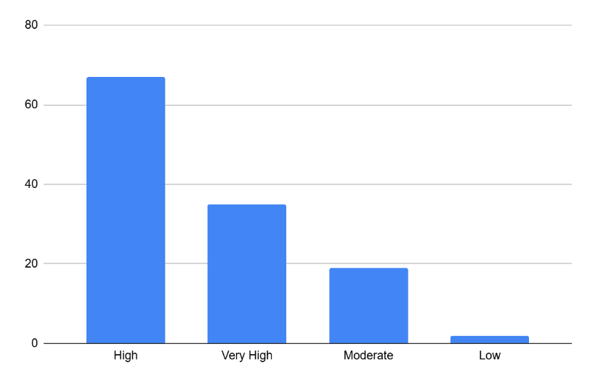
Source: Survey Data (2026).
According to the histogram above (Figure 4.2.2), 67 respondents indicated having a high understanding of crisis communication and 35 respondents selected very high understanding of crisis communication tactics. This suggests that most respondents are knowledgeable enough to provide informed opinions on the effectiveness of crisis communication at the University of Professional Studies, Accra (UPSA).

Figure 4.2.3: Existence of Crisis Communication Strategy
Do you believe UPSA has an established crisis communication strategy?
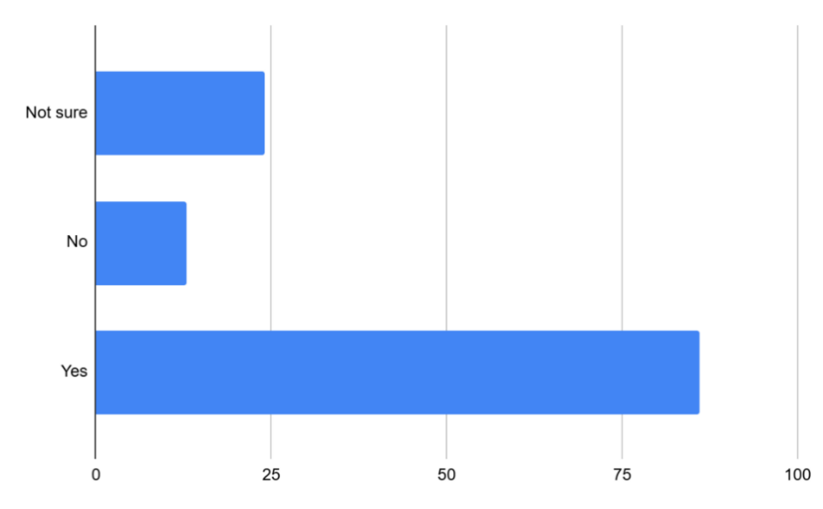
Source: Survey Data (2026).
From the bar graph above (Figure 4.2.3), a majority of respondents 86 chose Yes, these respondents believe that UPSA has an established crisis communication strategy, although a notable number 24 respondents are unsure and 13 respondents believe UPSA does not have a crisis communication strategy. This suggests that while the University may have systems in place, awareness of these strategies is not fully clear among students.

Figure 4.2.4: How often respondents check UPSA Communication channels during crisis
How often do you check official UPSA communication channels during crises? 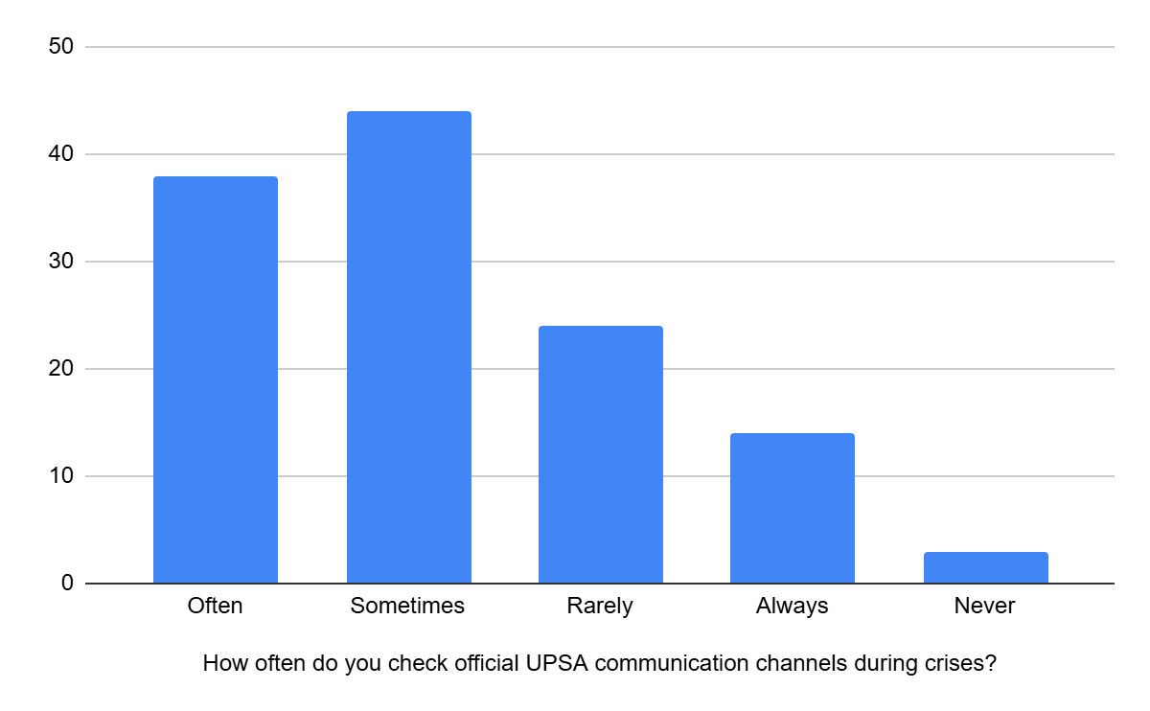
Source: Survey Data (2026).
From the chart (Figure 4.2.4), A majority of respondents check these channels with some level of regularity. The largest group, 44 respondents, indicated they “sometimes” check for updates. This is followed by 38 respondents who “often” check, suggesting a good number of people are fairly engaged during crises. However, only 14 respondents said they “always” check official channels, which indicates that consistent, proactive monitoring is relatively low, 24 respondents “rarely” check these channels, and a very small percentage 3 respondents “never” check them at all.

4.3 Section C:

Quality of Communication by UPSA during Crisis
The quality of communication by University of Professional Studies, Accra during crises refers to how clear, timely, accurate, consistent, and effective the university’s communication is in informing students and stakeholders about crisis situations. It reflects the institution’s ability to provide reliable information, reduce uncertainty, and maintain trust through appropriate communication channels during emergencies or challenging situations.
Figure 4.3.1: Timeliness of Crisis Information
Crisis information from UPSA is delivered promptly
RESPONSE  CATEGORY | RESPONDENTS | PERCENTAGE
Strongly Agree | 9 | 7.3%
Agree | 24 | 19.5%
Neutral | 75 | 61%
Disagree | 12 | 9.8%
Strongly Disagree | 3 | 2.4%
Total: | 123 | 100%

Source: Survey Data (2026).
According to the above table (Figure 4.3.1), 24 respondents, or 19.5%, agreed that crisis information is supplied rapidly, whereas the majority of respondents—75, or 61%—selected neutral. This shows uncertainty about the timeliness of communication, indicating that UPSA may not consistently communicate quickly enough during crises.

Figure 4.3.2: Clarity of Messages
Crisis messages from UPSA are clear and easy to understand.

RESPONSE  CATEGORY | RESPONDENTS | PERCENTAGE
Strongly Agree | 12 | 9.8%
Agree | 37 | 30.1%
Neutral | 64 | 52%
Disagree | 9 | 7.3%
Strongly Disagree | 1 | 0.8%
Total: | 123 | 100%

Source: Survey Data (2026).
The study tried to determine whether respondents get the clarity of message sent out by UPSA. From the table in figure 4.3.2, a significant number of respondents (64) representing 52% rated communication as neutral, while (38) others representing 30.1% agreed that messages are clear. This indicates that although communication is somewhat understandable, there is still room for improvement in making messages clearer and more direct.

Figure 4.3.3: Accuracy and Reliability
Accuracy and reliability of information during a crisis refer to the extent to which the information shared by University of Professional Studies, Accra is correct, trustworthy, and dependable. It focuses on whether the messages communicated to students and stakeholders are factual, consistent, and free from misinformation during crisis situations.
Information shared by UPSA during crisis is accurate.
RESPONSE  CATEGORY | RESPONDENTS | PERCENTAGE
Strongly Agree | 11 | 8.9%
Agree | 49 | 39%
Neutral | 58 | 47.2%
Disagree | 4 | 4.1%
Strongly Disagree | 1 | 0.8%
Total: | 123 | 100%

Source: Survey Data (2026).
The table above (Figure 4.3.3) reveals that most respondents rated the information as neutral with 58 respondents representing 47.2% and 49 respondents representing 39% agreeing. This implies moderate confidence in the accuracy of crisis communication. However, the neutral response indicates that students may not fully trust or verify the information provided.

Figure 4.3.4: Effective Use of Communication Channels
Communication channels used by UPSA are effective
RESPONSE  CATEGORY | RESPONDENTS | PERCENTAGE
Strongly Agree | 15 | 12.2%
Agree | 21 | 17.1%
Neutral | 62 | 50.4%
Disagree | 19 | 15.4%
Strongly Disagree | 6 | 4.9%
Total: | 123 | 100%

Source: Survey Data (2026).
The table above (Figure 4.3.4) reveals that most respondents rated the information as neutral with 62 respondents representing 50.4% and 21 respondents representing 17.1% agreeing to the fact that communication channels used by UPSA is effective. This implies that although student feel UPSA communication channels is somewhat effective, there is still more room for improvement in making the communication channels of UPSA very effective.

Figure 4.3.5: Timely Reach
RESPONSE  CATEGORY | RESPONDENTS | PERCENTAGE
Strongly Agree | 9 | 7.3%
Agree | 25 | 20.3%
Neutral | 62 | 50.4%
Disagree | 22 | 17.9%
Strongly Disagree | 5 | 4.1%
Total: | 123 | 100%

Source: Survey Data (2026).
The table above (Figure 4.3.5), interprets the findings revealing that many respondents are uncertain whether crisis information reaches them on time with the majority 50.4% that is 62 students selecting neutral and 20.3% that is 25 students agreeing. This reinforces concerns about delays or inefficiencies in communication channels.

4.4 Section D:

Awareness of Specific Crisis Situation at UPSA.
Awareness of specific crisis situations at University of Professional Studies, Accra refers to the extent to which students and stakeholders are informed and knowledgeable about particular crisis events or emergencies that occur within the university. It reflects their level of understanding, recognition, and exposure to crisis-related information communicated by the institution.
Figure 4.4.1: Crisis Awareness
Crisis situations students are aware of at UPSA
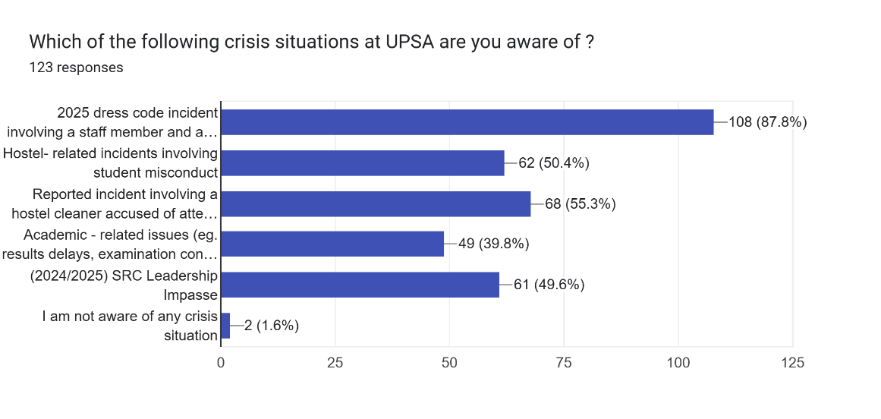
Source: Survey Data (2026).
The bar graph in Figure 4.4.1, presents the data shows that many respondents are aware of multiple crisis situations, particularly the widely discussed “2025 dress code incident” With 108 represented by (87.8%) to be aware of this particular crisis, along with 55.3% aware of reported incident involving a hostel cleaner accused of attempted misconduct toward a female resident and the others in regards to other hostel-related and academic issues.

Figure 4.4.2: Source of Information

RESPONSE  CATEGORY | RESPONDENTS | PERCENTAGE
Social Media (TikTok, X, Facebook,Snapchat) | 52 | 42.3%
WhatsApp Groups | 30 | 24.4%
Official University Communication | 6 | 4.8%
Friends/Peers | 35 | 28.5%
Total: | 123 | 100%

Source: Survey Data (2026).
According to the table (Figure 4.4.2), the majority of respondents 52, or 42.3% first learned about the crisis through social media (TikTok, X, Facebook, Snapchat), followed by friends and peers (35, or 28.5%) and WhatsApp groups (30, or 24.4%). The remaining respondents learned about the crisis through official university communications.

Figure 4.4.3: How closely students followed information about the crisis situation(s)
RESPONSE  CATEGORY | RESPONDENTS | PERCENTAGE
Very closely (actively followed updates) | 24 | 19.5%
Closely (kept up with most information) | 37 | 30.1%
Moderately | 53 | 43.1%
Slightly | 9 | 7.3%
Total: | 123 | 100%

Source: Survey Data (2026).
The table above (figure 4.4.3) indicates that majority 53 respondents covering a percentage of 43.1% followed information about the crisis situation(s) moderately, 37 students or 30.1% followed closely, 24 respondents or 19.5% followed very closely. This implies that one way or the other respondents kept track of such information at their convenience.

4.4.4:
Did you receive any official communication from the university regarding any of the crisis situation(s)
Source: Survey Data (2026).
The data indicates that, majority 62 respondents or 50.4% confirmed to have received official communication from the University regarding any of the crisis situation(s), and a significant number of 35 students representing 28.5% did not and a few represented by 21.1% were unsure. This indicates inconsistency in how official information is distributed during crisis.
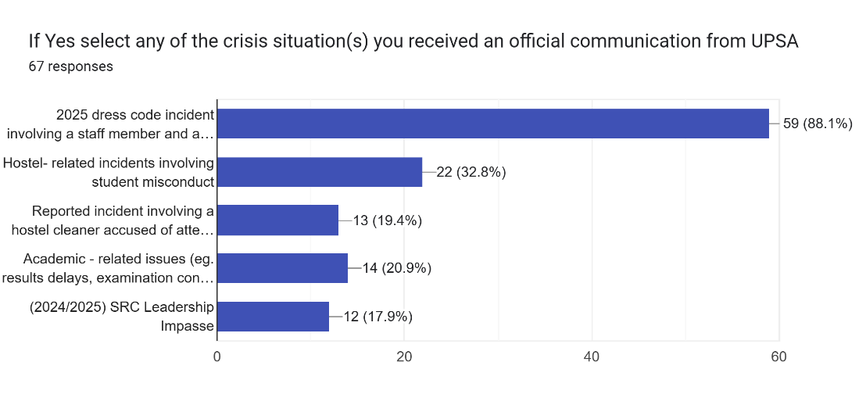
Source: Survey Data (2026).
As a follow-up to the data, the proportion who confirmed receiving official communication selected the exact crisis situation(s) shown on the bar graph. The majority chose the 2025 dress code incident involving a staff member and a student. Other respondents confirmed receiving official communication about different crisis situations. This indicates inconsistency in how official information is distributed during crisis.

4.5 Section E:

Behavioural Response
Behavioural response refers to the actions, reactions, or changes in behaviour shown by students and stakeholders in response to crisis situations and the communication provided by University of Professional Studies, Accra. It reflects how individuals respond emotionally, socially, or practically to crisis-related information, such as following instructions, staying calm, seeking information, or complying with safety measures.
Figure 4.5.1: Action based on information
Do you usually act on crisis information from UPSA?
RESPONSE  CATEGORY | RESPONDENTS | PERCENTAGE
Always | 23 | 18.7
Often | 37 | 30.1
Sometimes | 46 | 37.4
Rarely | 16 | 13%
Never | 1 | 0.8
Total: | 123 | 100%

Source: Survey Data (2026).
According to the table (figure 4.5.1), the majority of respondents 46, or 37.4% said they occasionally act based on crisis information, while 37, or 30.1%, said they frequently do so.
This suggests that while communication influences behaviour, it may not always be strong or convincing enough to prompt consistent action.

Figure 4.5.2: Safety Influence
Does UPSA’s communication influences your safety decisions?
RESPONSE  CATEGORY | RESPONDENTS | PERCENTAGE
Strongly Agree | 16 | 13%
Agree | 48 | 39%
Neutral | 52 | 42.3%
Disagree | 7 | 5.7%
Strongly Disagree | - | -
Total: | 123 | 100%

Source: Survey Data (2026).
The table (figure 4.5.2) indicates that 52 respondents (42.3%) were neutral on whether UPSA communication influences their safety decisions during crisis, indicating uncertainty amongst students. 48 respondents represented by 39% agreeing that UPSA’s communication influences their safety decisions during crisis. This suggests that while the University may have influence in regards to the safety of most of the students, it still lacks influence among students who are unsure and disagree implying that there is still more room for improvement.

Figure 4.5.3: How well do respondents share Official UPSA information
RESPONSE  CATEGORY | RESPONDENTS | PERCENTAGE
Always | 34 | 27.6%
Often | 27 | 22%
Sometimes | 38 | 30.9%
Rarely | 18 | 14.6%
Never | 6 | 4.9%
Total: | 123 | 100%

Source: Survey Data (2026).
The table (figure 4.5.3) indicates that most respondents 38 (30.9%) indicated that they sometimes share official UPSA information and 34 respondents representing 27.6% indicated that they always share official UPSA information and 27 respondents representing 22% share official UPSA information often. This suggests that majority of respondents take it upon themselves to share official communication to others.

Figure 4.5.4: Level of Compliance with UPSA’s Crisis Instructions
How well do you follow UPSA’s instructions during crises
RESPONSE  CATEGORY | RESPONDENTS | PERCENTAGE
Always | 29 | 23.6%
Often | 44 | 35.8%
Sometimes | 42 | 34.1%
Rarely | 8 | 6.5%
Never | - | -
Total: | 123 | 100%

Source: Survey Data (2026).
The chart indicates that while respondents generally follow UPSA’s instructions during crises, their compliance is not fully consistent. The majority fall under “often” (35.8%) and “sometimes” (34.1%), showing that people tend to follow guidelines but not at all times. Only 23.6% report “always” complying, which suggests that strict adherence is relatively low. This reflects moderate but inconsistent compliance, pointing to possible gaps in communication, clarity, or trust, and highlighting the need for UPSA to strengthen its strategies to encourage more consistent adherence during crises.

Figure 4.5.5: Perceived Safety from UPSA’s Crisis Communication
Does UPSA’s crisis communication makes you feel safe.
RESPONSE  CATEGORY | RESPONDENTS | PERCENTAGE
Strongly Agree | 15 | 12.2%
Agree | 37 | 30.1%
Neutral | 63 | 51.2%
Disagree | 7 | 5.7%
Strongly Disagree | 1 | 0.8%
Total: | 123 | 100%

Source: Survey Data (2026).
The chart shows that most respondents do not strongly feel a sense of safety from UPSA’s crisis communication. A majority remain neutral (51.2%), suggesting uncertainty or a lack of strong reassurance, while 30.1% agree and only 12.2% strongly agree, indicating that less than half feel positively about the safety provided. The findings point to a communication approach that is somehow effective but not fully convincing, as many respondents are not clearly assured of their safety, highlighting the need for UPSA to improve clarity, trust, and confidence in its crisis messaging.

4.6 Section F: Suggestions and Recommendations
Suggestions and recommendations in this study refer to the ideas provided by respondents on how to improve crisis communication at University of Professional Studies, Accra. They reflect the participants’ views on how the university can enhance the clarity, speed, and effectiveness of crisis information sharing to better support students during crisis situations.

Figure 4.6.1:
SUGGESTIONS AND RECOMMENDATIONS UPSA CAN ADOPT
RESPONSE  CATEGORY | RESPONDENTS | PERCENTAGE
Communicate more quickly during crises | 82 | 66.7%
Provide more detailed and transparent information | 54 | 43.9%
Make better use of social media platforms | 82 | 66.7%
Engage students more directly during crises | 61 | 49.6%
Improve official communication channels (e.g: email, website) | 61 | 49.6%
Train staff in crisis communication | 29 | 23.6%
think UPSA should come up with campaigns to educate us more

Source: Survey Data (2026).
The results shows that students mainly want faster communication and better use of social media, both recording the highest responses (66.7%). Many also emphasized the need for more direct engagement and improved official communication (49.6% each), while others highlighted clearer and more detailed information (43.9%). The findings suggest that timeliness, effective communication channels, and clearer messaging are the key areas students want the university to improve.

4.7 INTERPRETATION OF QUANTITATIVE DATA
The quantitative findings revealed that students are generally aware of crisis communication practices at UPSA and identified social media and WhatsApp platforms as the most common sources of crisis-related information. The results further showed that although official communication channels such as institutional emails and press releases are used by the university, students often receive information from informal platforms before official statements are released. Respondents also indicated that communication delays, slow approval processes, and the rapid spread of unverified information on social media affect the effectiveness of crisis communication at UPSA. Overall, the findings suggest that while the university has existing communication structures in place, there is a need to improve the timeliness, coordination, and transparency of communication during crisis situations.

4.8 Key Informant Interview
Interview with the key informant at the Public Affairs Directorate was conducted on Monday, 20th April 2026. The interview lasted 34 mins. The interview is presented below in a structured format, capturing the key discussions on crisis communication practices, processes and challenges within the university.

4.8.1 BACKGROUND INFORMATION
Professional Background and Institutional Role of the Participant
This presents the background of the key informant to establish the relevance of the responses provided to the study. The key informant occupies a communication-related role within the institution and is directly involved in the dissemination of official institutional information. Due to the key informant’s professional responsibilities and involvement in communication processes, valuable insights were provided regarding crisis communication practices, implementation strategies, and challenges within University of Professional Studies, Accra. The identity of the participant was kept anonymous to ensure confidentiality and encourage openness during the interview process.

4.8.2 UNDERSTANDING CRISIS COMMUNICATION AT UPSA
Understanding crisis communication at University of Professional Studies, Accra in relation to the qualitative data from the key informant refers to the insights, explanations, and experiences shared by the university representative regarding how crisis communication is managed within the institution. It focuses on understanding the strategies, communication processes, challenges, and effectiveness of the university’s response to crisis situations from an institutional perspective.
The nature of crisis communication within the context of UPSA
The nature of crisis communication within the University of Professional Studies, Accra (UPSA) is characterized by a structured, centralized, and formally regulated system of information dissemination. According to the key informant, all crisis-related communication follows an official chain of command, where messages must be verified and approved by designated authorities before release. This ensures that only accurate, consistent, and authorized information reaches students and stakeholders during crisis situations, thereby maintaining institutional control over communication flow and protecting the university’s credibility.
In addition, UPSA’s crisis communication is anchored in a defined communication plan coordinated by the Public Affairs Directorate, which serves as the central body responsible for all official messaging within the university. Within this framework, the institution applies a combination of crisis communication strategies depending on the nature and severity of the situation.
The strategies identified include a proactive strategy, where the university prepares in advance by assessing potential risks, developing key messages, and training spokespersons to respond effectively before a crisis occurs. A reactive strategy is also commonly employed, where communication is issued after a crisis has occurred to provide clarification, correct misinformation, and present official updates.
Furthermore, a defensive strategy is used to protect the university’s image and reputation, which may involve denying involvement, shifting responsibility, or minimizing the perceived impact of an issue. In certain situations, an apology strategy is adopted, where the institution accepts responsibility and issues formal apologies when at fault, as observed in a recent case involving a student and staff member regarding a dress code issue. In contrast, a silence strategy may also be applied, where the university refrains from making public statements while still addressing the issue internally.
Overall, the findings suggest that UPSA primarily relies on a reactive communication approach, supported by selective use of silence and occasional apology responses, with the choice of strategy largely dependent on the sensitivity and severity of the crisis at hand.

4.8.3 EXPERIENCE WITH SPECIFIC CRISIS SITUATIONS AT UPSA
Experience with specific crisis situations at University of Professional Studies, Accra, based on the qualitative data, refers to the varied accounts and perceptions of the key informant regarding how particular crisis events were communicated and managed within the university. It captures their lived experiences of receiving information, the channels used, and how they interpreted the effectiveness, timeliness, and clarity of the university’s response during those crisis situations.
Major crisis situations experienced in recent times
The major crisis situations enumerated during the interview at University of Professional Studies, Accra include several institutional and student-related incidents that have occurred in recent times. These involve examination paper leaks leading to cancellation of papers, reported cases of sexual misconduct within the hostel environment, SRC leadership disputes during the 2024/2025 academic year, enforcement issues related to the 2025 dress code policy, allegations of “sex for grades,” attempted sexual assault involving a hostel cleaner, and claims of grade manipulation, among others. These incidents reflect the range of crises managed by the institution. In handling such situations, the Public Affairs Directorate verifies all information, engages affected individuals to understand the situation, and applies appropriate responses such as issuing apologies or official statements where necessary. In communicating sensitive incidents to students and the public, the institution primarily relies on formal press statements and press conferences for public dissemination, while internal communication is usually channelled through class representatives who further disseminate messages via WhatsApp groups to ensure wider reach within the student body.

4.8.4 TIMELINESS OF COMMUNICATION
This refers to the duration and structured process through which crisis-related information is verified, approved, and released to students and the public. It captures the sequence of steps involved in ensuring that messages pass through the appropriate communication channels before dissemination, including verification of facts, internal approval, and final publication through official platforms such as press statements, press conferences, and student communication channels.
Timeliness and Responsiveness of Crisis Communication at UPSA
The interview indicates that the speed of crisis communication at University of Professional Studies, Accra is largely dependent on the severity and urgency of the situation. In highly urgent cases such as examination paper cancellations, information is released immediately through widely used platforms like WhatsApp to ensure students receive timely updates and can make necessary arrangements. This shows that more critical situations prompt faster communication to minimize disruption among students.
However, the speed of communication is also influenced by several internal factors, including fact verification, approval procedures, the sensitivity of the issue, and alignment with management decisions. These processes ensure that all information released is accurate and credible, even if they sometimes delay communication. Despite these checks, the timing of communication is generally considered appropriate, as priority is given to accuracy and reliability over speed in most crisis situations.

4.8.5 COMMUNICATION CHANNELS AND AWARENESS
Communication Channels and Awareness at University of Professional Studies, Accra encompasses the platforms and methods used to disseminate crisis-related information and how effectively these channels ensure that students and stakeholders are informed.
To understand communication channels and awareness, questions were asked about how crisis information is shared with students and the public, and the platforms used to ensure messages reach the wider student body during emergencies at University of Professional Studies, Accra.
Communication Channels and Information Reach in Crisis Situations at UPSA
From the interview, it was gathered that the communication channels used during crisis situations at University of Professional Studies, Accra include the university’s social media platforms, official website, press conferences, and press statements. At the student level, WhatsApp class groups are also used to ensure quick dissemination of information, depending on the urgency and severity of the crisis.
It was further indicated that these channels are considered very effective in reaching stakeholders. WhatsApp groups were highlighted as particularly effective for students and staff due to their speed, while press releases and press conferences were noted as effective for reaching external publics.
The interview also revealed that, from observation, students often get crisis-related information first through social media platforms, especially TikTok and Snapchat, before receiving official updates from the university’s communication channels.

4.8.6 EFFECTIVENESS OF CRISIS COMMUNICATION STRATEGY
To understand the effectiveness of crisis communication strategies at the university, questions were asked about how effective the institution’s communication has been in managing public perception and reducing misinformation, the key strengths of its communication approach, and the challenges or weaknesses observed in communicating crises. These questions were aimed at exploring both the positive outcomes and limitations of the university’s crisis communication practices from an institutional perspective. The discussion focuses on how the university’s communication strategies contribute to maintaining credibility, controlling the spread of misinformation, and ensuring stakeholder awareness during crisis situations, while also identifying areas that may affect the efficiency and overall impact of communication efforts.
Perceived Effectiveness, Strengths and Challenges of Crisis Communication at UPSA
From the interview, it was gathered that the crisis communication approach at University of Professional Studies, Accra is considered fairly effective, particularly when official communication is released promptly during crisis situations. However, it also emerged that the university does not respond publicly to every crisis situation, and in many instances, information tends to circulate first through unofficial social media sources before the institution releases an official response. This indicates the growing influence of social media in shaping public perception during crises.
The interview further revealed that the major strengths of the university’s crisis communication approach include accuracy, professionalism, and controlled communication. Information released by the institution is carefully verified and aligned with the image and reputation of the university before dissemination. These measures help ensure that official communication remains credible and reliable during crisis situations.
Despite these strengths, some challenges and weaknesses were also identified. One major challenge highlighted is the speed of response, as the verification and approval processes can sometimes delay communication. Additionally, once crisis-related information spreads rapidly on social media platforms, it becomes difficult for the university to fully control narratives and misinformation surrounding the issue.

4.8.7 IMPROVEMENT AND RECOMMENDATIONS
To understand possible ways of improving crisis communication within the university, questions were asked about the recommendations for enhancing UPSA’s crisis communication strategy, how the institution can improve the timeliness and transparency of communication during crises, and any additional views regarding crisis communication at the university. These questions were aimed at identifying practical suggestions, institutional gaps, and possible strategies for strengthening communication effectiveness during crisis situations.
The discussion under this theme focuses on proposed measures for improving the speed, transparency, coordination, and overall efficiency of crisis communication to ensure that students and stakeholders receive timely, accurate, and credible information during emergencies.

Perceived Effectiveness, Strengths and Challenges of Crisis Communication at UPSA.
From the interview, it was suggested that University of Professional Studies, Accra could improve its crisis communication strategy by adopting a more proactive approach to handling crisis situations. This includes acknowledging issues earlier even when investigations are still ongoing, rather than waiting until all processes are completed before communicating with stakeholders. It was also indicated that streamlining approval procedures and establishing a dedicated crisis communication team could improve the speed and effectiveness of responses during crises.
The responses further revealed that improving timeliness and transparency in communication would require the university to issue brief holding statements at the early stages of crises while investigations continue. Regular updates were also identified as important in keeping students and stakeholders informed rather than relying on a single official response. Additionally, the use of effective communication channels such as WhatsApp, Facebook, and X (Twitter) was emphasized as a way of ensuring that accurate information reaches students quickly and helps reduce misinformation.
It also emerged from the interview that crisis communication remains highly important within the university, particularly because of the fast-paced nature of today’s digital environment where information spreads rapidly through social media platforms. Although the current communication system was viewed as having strengths in accuracy and professionalism, it was noted that improving response speed, transparency, and early engagement would further strengthen public trust and enhance the university’s ability to manage crisis situations effectively.

4.9 INTERPRETATION OF QUALITATIVE DATA
The interpretation of the qualitative data focused on the research questions which sought to identify the communication strategies currently used by University of Professional Studies, Accra during crisis situations and examine how these strategies are implemented in practice. To understand this phenomenon, questions were asked about the communication channels used during crises, the processes involved in verifying and approving information, the speed and effectiveness of communication, and the institution’s approach to managing sensitive crisis situations. The responses provided deeper insights into the university’s structured communication system, the use of official and digital platforms, and the procedures adopted in disseminating crisis-related information to students and stakeholders.
The key informant interview reveals that UPSA’s crisis communication is centrally coordinated under the Public Affairs Directorate and follows a strict verification and approval process before information is released. This helps in ensuring accuracy although it sometimes leads to delayed response. The university mainly uses a reactive approach, supported by proactive, defensive, apology, and selective silence strategies depending on the situation. Communication during crises is delivered through multiple channels such as WhatsApp groups, press statements, and the university website, although students often first receive information from unofficial social media sources, showing a gap in immediate official communication. Overall, the system can be described as fairly accurate and professional; however, challenges such as delayed responses and the spread of misinformation remain common, highlighting the need for a more proactive and timely approach supported by a dedicated crisis communication team.

4.10 CHAPTER SUMMARY
The quantitative data collected provided a broad overview of students’ experiences and perceptions of crisis communication at UPSA, highlighting patterns related to communication channels, response time, and overall effectiveness. These findings were further supported by insights from the Key Informant Interview, which offered a deeper understanding of the processes behind crisis communication, including its strengths in accuracy, structure, and professionalism, as well as challenges such as delays in response and the rapid spread of information through unofficial channels. According to Timothy Coombs (2015), these results align with existing literature which emphasizes the importance of timely, transparent, and coordinated communication in managing crises effectively. These results align with the objectives of the study and provide a solid foundation for the next chapter, which presents the interpretation of findings, conclusions, and recommendations for improving crisis communication at UPSA.

DISCUSSION OF RESULTS
The findings of the study affirm existing literature on crisis communication within institutions, particularly the importance of timely, accurate, and structured communication during crisis situations. The study revealed that University of Professional Studies, Accra adopts a centralized communication structure where information passes through verification and approval processes before dissemination. This supports the views in the literature that effective crisis communication requires credibility, consistency, and message control in order to protect institutional reputation and reduce uncertainty among stakeholders. However, the findings also revealed that these approval procedures sometimes delay communication, which slightly digresses from studies that emphasize immediate institutional responses during crises.
The study further confirmed literature that identifies social media and digital platforms as dominant sources of information dissemination during crises. Findings showed that students often receive crisis-related information first through platforms such as WhatsApp, TikTok, Snapchat, Facebook, and X (Twitter) before official institutional communication is released. This aligns with existing studies which argue that social media has transformed crisis communication by increasing the speed at which information and misinformation spread. The findings therefore highlight the growing challenge institutions face in controlling narratives once issues emerge online.
Additionally, the study supports the Situational Crisis Communication Theory (SCCT) by W. Timothy Coombs, which explains that organizations adopt different response strategies depending on the nature and severity of the crisis. The findings showed that UPSA employs strategies such as reactive responses, apology strategies, controlled communication, and selective engagement during crises. These approaches are aimed at protecting the image and credibility of the university while maintaining stakeholder trust. The findings also reflect the assumptions of Image Repair Theory by William Benoit, particularly in the university’s emphasis on professionalism, accuracy, and reputation management during sensitive situations.
The importance of these findings lies in the fact that they provide insight into how higher educational institutions manage crisis communication within a rapidly changing digital environment. The findings demonstrate that while professionalism and accuracy remain essential, institutions must also prioritize timeliness, transparency, and proactive engagement to effectively manage public perception and reduce misinformation during crises.

CHAPTER 5

SUMMARY, CONCLUSIONS AND RECOMNMENDATIONS

5.0 INTRODUCTION
This chapter presents the summary, conclusions, recommendations, and suggestions for further research based on the findings of the study on crisis communication strategies at University of Professional Studies, Accra. The chapter discusses the major findings in relation to the research questions and objectives of the study, highlighting the communication strategies used by the university during crisis situations, how these strategies are implemented, and their effectiveness in managing stakeholder awareness and public perception. The chapter also provides recommendations aimed at improving crisis communication practices within the university and concludes with suggestions for future studies in the area of crisis communication within higher educational institutions.

5.1 SUMMARY OF FINDINGS
This study examined crisis communication strategies at University of Professional Studies, Accra by addressing the research questions on the communication strategies used during crisis situations, how these strategies are implemented, and the effectiveness of these approaches in managing crises within the university. The findings revealed that UPSA employs a structured and centralized communication system coordinated through the Public Affairs Directorate to manage crisis-related communication.
In answering the first research question on the communication strategies currently used by UPSA during crisis situations, the study found that the university mainly adopts reactive communication strategies supported by apology, defensive, and controlled communication approaches depending on the nature and severity of the crisis. The institution uses official communication channels such as press statements, press conferences, the university website, and social media platforms including Facebook and X (Twitter). Internally, WhatsApp class groups and course representative channels are also widely used to disseminate information quickly to students and staff.
Regarding the second research question on how these communication strategies are implemented, the findings showed that crisis communication at UPSA follows verification and approval procedures before information is released. The university prioritizes professionalism, accuracy, and credibility in communicating crisis-related information. The findings further revealed that communication implementation depends on the urgency and sensitivity of the crisis, with more urgent situations receiving quicker responses through digital communication platforms.
In relation to the effectiveness of UPSA’s crisis communication strategies, the study found that the communication channels used by the university are generally effective in reaching stakeholders, particularly students, due to the widespread use of WhatsApp and social media platforms. However, the findings also identified challenges such as delays caused by approval procedures, the rapid spread of information through unofficial social media sources, and difficulties controlling misinformation once crises become public online.
The study therefore concludes that while UPSA’s crisis communication system demonstrates strengths in professionalism, accuracy, and structured communication, there is a need for improvements in timeliness, transparency, and proactive engagement. Recommendations from the findings emphasized the importance of streamlining approval procedures, issuing early holding statements during crises, and establishing a dedicated crisis communication team to improve the overall effectiveness of crisis communication within the university.

5.2 CONCLUSION
Based on the findings, the study concludes that UPSA’s crisis communication system is structured, professional, and focused on accuracy, which helps maintain institutional credibility. However, this emphasis on control and verification often affects the speed of communication, making it difficult for the university to respond promptly in a digital environment were information spreads rapidly.
The study further concludes that the increasing influence of social media has shifted how crises unfold, with students and the public often receiving information from unofficial sources before official responses are issued. This reduces the university’s ability to control narratives and manage public perception effectively.
In essence, while UPSA demonstrates strong internal communication processes, there is a need to balance accuracy with timeliness and adopt a more proactive and responsive approach to crisis communication.

5.3 RECOMMENDATIONS
The findings of the study revealed several challenges affecting crisis communication at University of Professional Studies, Accra. Key challenges identified include delays in communication caused by lengthy verification and approval procedures, the rapid spread of misinformation through unofficial social media platforms, limited proactive engagement during crisis situations, and difficulties in controlling public narratives once information circulates online. The study also found that students often receive crisis-related information first through informal digital platforms before official institutional communication is released. These challenges indicate the need for practical and policy-oriented measures to strengthen the effectiveness of crisis communication within the university.
Firstly, the study recommends that UPSA should streamline its verification and approval procedures during crisis situations to improve response speed. Although message verification is important for maintaining accuracy and credibility, excessive approval delays reduce the effectiveness of crisis communication in fast-moving situations. The university should therefore establish a simplified emergency communication approval process that allows verified holding statements to be released quickly while investigations continue. This recommendation is linked to the Situational Crisis Communication Theory (SCCT) by W. Timothy Coombs, which emphasizes the importance of timely responses in protecting organizational reputation and stakeholder trust during crises. This recommendation also has policy implications, as the university may need to develop an institutional crisis communication policy that outlines timelines and procedures for emergency responses.
Secondly, the study recommends the establishment of a dedicated crisis communication team within the Public Affairs Directorate. The findings revealed that centralized communication procedures sometimes slow down institutional responses during crises. A specialized crisis communication team would improve coordination, speed, and consistency in handling crisis-related information. This recommendation aligns with Image Repair Theory by William Benoit, which stresses the importance of strategic communication and reputation management during crisis situations. The recommendation has practical and policy implications because it may require the university to formally integrate crisis communication roles into its administrative structure and communication policies.
Thirdly, the study recommends that the university adopt a more proactive and transparent communication approach during crises. The findings showed that unofficial social media sources often shape public perception before official communication is released. To address this challenge, the university should issue early holding statements, provide regular updates, and increase engagement across digital communication platforms such as WhatsApp, Facebook, X (Twitter), and the university website. This recommendation is practical in nature and also relates to SCCT, which supports continuous stakeholder engagement to reduce uncertainty and misinformation during crises. The policy implication of this recommendation is that UPSA may need to establish guidelines for digital crisis communication and social media engagement during emergencies.
Additionally, the study recommends increased monitoring of social media platforms during crisis situations. Since students frequently receive information first through platforms such as TikTok, Snapchat, and WhatsApp, the university should actively monitor online discussions and respond quickly to misinformation before it escalates. This would help improve institutional control over public narratives and strengthen stakeholder trust. This recommendation is practical and supports existing crisis communication literature emphasizing the growing role of digital media management in crisis response.
Finally, the study recommends regular crisis communication training and simulation exercises for university management, staff, and communication personnel. The findings suggest that improving preparedness and coordination would enhance the university’s ability to respond effectively during emergencies. Training programmes and simulation exercises would help improve decision-making, response speed, and communication consistency during crisis situations. This recommendation has both practical and policy implications, as the university may need to incorporate crisis communication preparedness into institutional training and administrative policies.

5.4 SUGGESTIONS FOR FURTHER RESEARCH
This study focused on crisis communication strategies at University of Professional Studies, Accra with emphasis on the communication strategies used during crises, their implementation, and their effectiveness in managing stakeholder perception and awareness. However, future studies can expand the scope by examining crisis communication practices across multiple universities in Ghana to provide a broader comparative understanding of how higher educational institutions manage crises.
Further research can also explore the impact of social media on crisis communication management within universities, particularly the role platforms such as WhatsApp, TikTok, Snapchat, Facebook, and X (Twitter) play in spreading information and misinformation during crisis situations. This would help provide deeper insights into how institutions can effectively manage digital communication during emergencies.
Additionally, future studies may focus on students’ perceptions and trust in official institutional communication during crises. Such studies would help determine the extent to which students rely on official communication channels compared to unofficial social media sources for crisis-related information.
Finally, future researchers can examine the relationship between response speed and institutional reputation during crisis situations within higher educational institutions. This would contribute to understanding how timeliness, transparency, and proactive engagement influence stakeholder confidence and organizational image during crises.

REFERENCES
Andrade, C. (2021). The inconvenient truth about convenience and purposive samples.
Indian Journal of Psychological Medicine, 43(1), 86–88.
https://doi.org/10.1177/0253717620977000
Antwi, E., & Osei, K. (2020). Crisis communication practices in Ghanaian tertiary institutions.
Journal of African Communication Studies, 12(2), 45–60.
Banks, S. P. (2017). Crisis communications: A casebook approach (5th ed.). Routledge.
Bekhet, A. K., & Zauszniewski, J. A. (2012). Methodological triangulation: An approach to
understanding data. Nurse Researcher, 20(2), 40–43.
https://doi.org/10.7748/nr2012.11.20.2.40.c9442
Benoit, W. L. (1997). Image repair discourse and crisis communication. Public Relations
Review, 23(2), 177–186. https://doi.org/10.1016/S0363-8111(97)90023-0
Boateng, R. (2019). Crisis management and communication in Ghanaian universities. Ghana
Journal of Higher Education, 8(1), 22–37.
Bryman, A. (2021). Social research methods (6th ed.). Oxford University Press.
Calilao, A. J., Domingo, A., Labaro, R. J., & Pascua, A. J. (2024). Assessing the
effectiveness of university public relations in crisis management. People and
Behavior Analysis, 2(1), 27–47.
Citi Newsroom. (2023). UPSA responds to hostel-related incident. https://citinewsroom.com
Citi Newsroom. (2025). UPSA responds to dress code controversy https://citinewsroom.com
Coombs, W. T. (2015). Ongoing crisis communication: Planning, managing, and responding
(4th ed.). Sage Publications.
Creswell, J. W. (2005). Educational research: Planning, conducting, and evaluating
quantitative and qualitative research (2nd ed.). Pearson Education.
Creswell, J. W. (2014). Research design: Qualitative, quantitative, and mixed methods
approaches (4th ed.). Sage Publications.
Dana P. Turner. (2020). Sampling methods in research design. Headache: The Journal of
Head and Face Pain, 60(1), 8–12. https://doi.org/10.1111/head.13707

Fageha, M. K., & Aibinu, A. A. (2013). Managing project scope definition to improve
stakeholders’ participation and enhance project outcome. Procedia - Social and
Behavioral Sciences, 74, 154–164. https://doi.org/10.1016/j.sbspro.2013.03.030
Frandsen, F., & Johansen, W. (2017). Organizational crisis communication.
Sage Publications.
Graphic Online. (2025). UPSA dress code incident sparks public reaction.
https://graphic.com.gh
Johnson, B., & Christensen, L. (2008). Educational research: Quantitative, qualitative, and
mixed approaches (3rd ed.). Sage Publications.
Kumar, K. (1989). Conducting key informant interviews in developing countries. United
States Agency for International Development.
Mitroff, I. I., & Anagnos, G. (2001). Managing crises before they happen: What every
executive and manager needs to know about crisis management. AMACOM.
Palinkas, L. A., Horwitz, S. M., Green, C. A., Wisdom, J. P., Duan, N., & Hoagwood, K. (2015).
Purposeful sampling for qualitative data collection and analysis in mixed method
implementation research. Administration and Policy in Mental Health and Mental
Health Services Research, 42(5), 533–544. https://doi.org/10.1007/s10488-0130528-y
Patton, M. Q., & Cochran, M. (2007). A guide to using qualitative research methodology.
Medecins Sans Frontieres.
Powell, R. R., & Connaway, L. S. (2004). Basic research methods for librarians (4th ed.).
Libraries Unlimited.
Reynolds, B., & Seeger, M. W. (2005). Crisis and emergency risk communication as an
integrative model. Journal of Health Communication, 10(1), 43–55.
https://doi.org/10.1080/10810730590904571
Rocco, T. S., & Plakhotnik, M. S. (2009). Literature reviews, conceptual frameworks, and
theoretical frameworks: Terms, functions, and distinctions. Human Resource
Development Review, 8(1), 120–130. https://doi.org/10.1177/1534484309332617
Saunders, M., Lewis, P., & Thornhill, A. (2023). Research methods for business students
(9th ed.). Pearson.
Seeger, M. W. (2006). Best practices in crisis communication: An expert panel process.
Journal of Applied Communication Research, 34(3), 232–244.
https://doi.org/10.1080/00909880600769944
Seeger, M. W., & Ulmer, R. R. (2010). Communication and organizational crisis. In R. L. Heath
(Ed.), The SAGE handbook of public relations (2nd ed., pp. 487–500). Sage
Publications.
Ulmer, R. R., Sellnow, T. L., & Seeger, M. W. (2017). Effective crisis communication: Moving
from crisis to opportunity (4th ed.). Sage Publications.
University of Professional Studies, Accra. (n.d.). History. UPSA. Retrieved May 7, 2026, from https://upsa.edu.gh/about/history/
Yin, R. K. (2018). Case study research and applications: Design and methods (6th ed.).
Sage Publications.

APPENDIXES

APPENDIX A: QUESTIONNAIRE

This appendix presents the questionnaire used to collect quantitative data for the study. The instrument was administered to Level 400 students of the University of Professional Studies, Accra (UPSA) to assess their perceptions of crisis communication strategies.

PURPOSE:
This questionnaire is part of an undergraduate research project titled:
“Assessing Crisis Communication Strategies at the University of Professional Studies, Accra (UPSA)”
The purpose of this study is to understand how students perceive and experience crisis communication within the University of Professional Studies Accra. Your participation is completely voluntary, and you are free to withdraw at any time without any consequences. This questionnaire will take approximately 5–7 minutes to complete.
All responses will be treated with strict confidentiality and anonymity. You are not required to provide your name or any identifying information, and the data collected will be used strictly for academic purposes only. There are no right or wrong answers. You are encouraged to provide honest responses based on your personal experiences and opinions.
By proceeding with this questionnaire, you agree to participate in this study.

SECTION A - DEMOGRAPHIC INFORMATION
Gender
FEMALE
MALE
Low
Moderate
High
Very High
How would you rate your understanding of crisis communication strategies?
Are you familiar with the concepts of crisis communication?
No
Yes
Section B - General Awareness of Crisis Communication
What is your current level at UPSA?
27 and above
21 - 26
18 - 20
Age Range
Prefer not to say

Level 400
Level 300
Level 200
Level 100
Do you believe UPSA has an established crisis communication strategy?
No
Yes
Strongly Disagree
Disagree
Agree
Neutral
Neutral
Strongly Agree
Crisis messages from UPSA are clear and easy to understand.
Strongly Disagree
Strongly Agree
Disagree
Agree
Crisis information from UPSA is delivered promptly.
Section C – Quality of Communication
Never
Rarely
Sometimes
Often
Always
How often do you check official UPSA communication channels during crises?
Not Sure
Agree
Strongly Agree
Information shared during crises is accurate and reliable.
2025 dress code incident involving a staff member and a student
Which of the following crisis situations at UPSA are you aware of?
Reported incident involving a hostel cleaner accused of attempting sexual assault on a female student, which resulted in a fatal fall
Academic - related issues (eg. results delays, examination concerns)
Hostel- related incidents involving student misconduct
Section D – Awareness of Specific Crisis Situations
Please thick all that apply
Strongly Disagree
Disagree
Neutral
Agree
Strongly Agree
Communication channels used by UPSA are effective.
Strongly Disagree
Disagree
Neutral
Agree
Strongly Agree
UPSA provides sufficient details during crises.
Strongly Disagree
Disagree
Neutral
Other………………………………………………………………………………………………………………….
I am not aware of any crisis situation
(2024/2025) SRC Leadership Impasse
Academic - related issues (eg. results delays, examination concerns)
Reported incident involving a hostel cleaner accused of attempting sexual assault on a female student, which resulted in a fatal fall
Hostel- related incidents involving student misconduct
2025 dress code incident involving a staff member and a student
If Yes select any of the crisis situation(s) you received an official communication from UPSA
How closely did you follow information about the crisis situation(s)?
No
Yes
Did you receive any official communication from the University regarding any of the crisis situation(s)?
Not at All
Slightly
Moderately
Closely (kept up with most information)
Very closely (actively followed updates)
Other………………………………………………………………………………………………………………….
Friends/Peers
Official University Communication
WhatsApp Groups
Social Media (TikTok, X, Facebook, Snapchat)
How did you first become aware of the crisis situation(s)?
(2024/2025) SRC Leadership Impasse
Never
Rarely
Sometimes
Often
Always
UPSA’s communication influences my safety decisions.
I share official UPSA information with others.
Strongly Disagree
Disagree
Neutral
Agree
Strongly Agree
Never
Rarely
Sometimes
Often
Always
I usually act on crisis information from UPSA.
Section E – Behavioural Response
Other………………………………………………………………………………………………………………….
I am not aware of any crisis situation
I follow UPSA’s instructions during crises
Always
Often
Sometimes
Rarely
Never
UPSA’s crisis communication makes me feel safe.
Strongly Agree
Agree
Neutral
Strongly Disagree
Disagree

Section F - Suggestions and Recommendations
You may select more than one
In your opinion, what should the University of Professional Studies, Accra do to improve its crisis communication?
Communicate more quickly during crises
Provide more detailed and transparent information
Make better use of social media platforms
Engage students more directly during crises
Improve official communication channels (e.g: email, website)
Train staff in crisis communication
Other………………………………………………………………………………………………………………….

Appreciation
Thank you very much for taking the time to complete this questionnaire. Your responses are highly valuable and will contribute significantly to understanding crisis communication strategies at the University of Professional Studies, Accra.
All information provided will be treated with strict confidentiality and used solely for academic purposes.
We sincerely appreciate your participation.

APPENDIX B: INTERVIEW GUIDE & SUPPORTING DOCUMENT
BACKGROUND INFORMATION
1. What is your role at UPSA, and how does it relate to communication or crisis management?
2. How long have you been working at UPSA?

UNDERSTANDING OF CRISIS COMMUNICATION
3. How would you describe crisis communication within the context of UPSA?
4. Does UPSA have a formal crisis communication strategy or plan? If yes, can you briefly describe it?

EXPERIENCE WITH SPECIFIC CRISIS SITUATIONS
5. What types of crisis situations have you experienced or are aware of within UPSA?
(Probe: academic issues, security incidents, misconduct cases, reputational crises, etc.)
6. Can you describe how the university handled communication during one major crisis?
7. In your view, how were sensitive incidents (e.g., misconduct or security-related cases) communicated to students and the public?

TIMELINESS OF COMMUNICATION
8. How quickly does UPSA typically respond to crisis situations?
9. What factors influence the speed of communication during a crisis?
(Probe: approval processes, verification of facts, management decisions)
10. Do you think the timing of communication has been appropriate in past crises? Why or why not?
COMMUNICATION CHANNELS AND AWARENESS
11. What communication channels does UPSA primarily use during crises?
(Probe: social media, email, official statements, student platforms)
12. How effective are these channels in reaching students and stakeholders?
13. From your observation, where do students usually get their information first during a crisis?

EFFECTIVENESS OF CRISIS COMMUNICATION STRATEGY
14. How effective do you think UPSA’s crisis communication has been in managing public perception and reducing misinformation?
15. What are the key strengths of UPSA’s crisis communication approach?
16. What challenges or weaknesses have you observed in how crises are communicated?

IMPROVEMENT AND RECOMMENDATIONS
17. What improvements would you recommend for UPSA’s crisis communication strategy?
18. How can UPSA improve the timeliness and transparency of its communication during crises?

19. Is there anything else you would like to add regarding crisis communication at UPSA?

SUPPORTING DOCUMENT
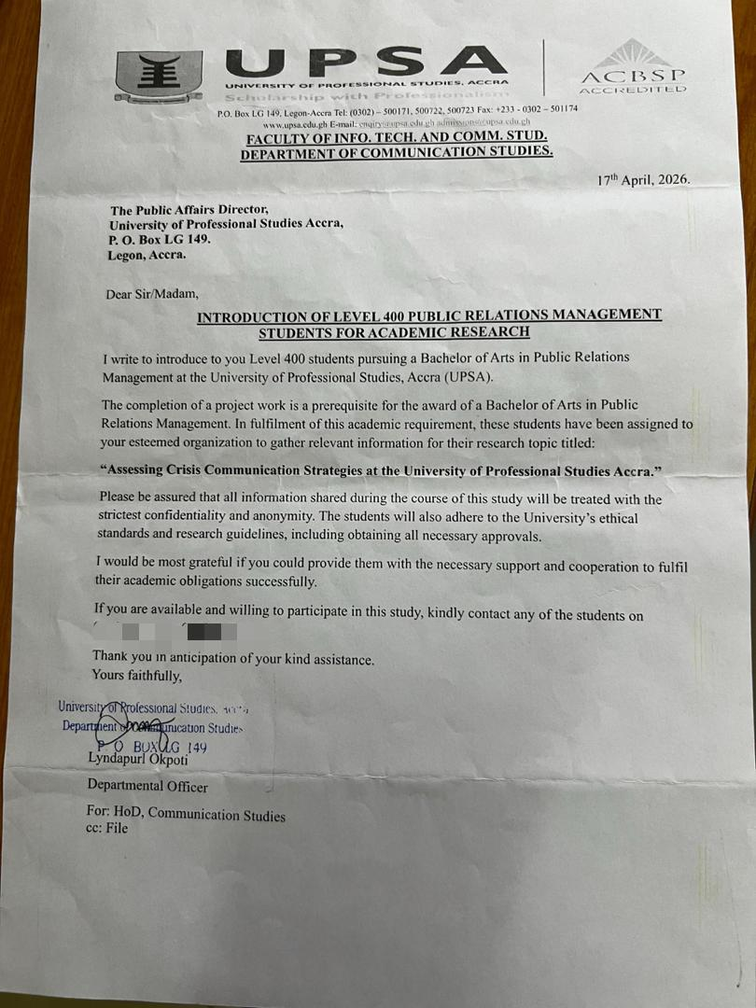
APPENDIX C: THEMATIC ANALYSIS
Transcribed Data | THEME / PATTERN IDENTIFIED AND CODED
“All crisis-related communication follows an official chain of command where messages are verified and approved before release.” | CENTRALIZED COMMUNICATION STRUCTURE AND INFORMATION VERIFICATION
“The Public Affairs Directorate is responsible for coordinating official communication within the university.” | CRISIS COMMUNICATION COORDINATION
“The university prepares key messages and assesses possible risks before certain crisis situations occur.” | PROACTIVE CRISIS COMMUNICATION STRATEGY
“Most communication is released after the crisis has already occurred in order to provide clarification and updates.” | REACTIVE CRISIS COMMUNICATION APPROACH
“The institution sometimes protects its image by minimizing issues or responding carefully to sensitive matters.” | REPUTATION MANAGEMENT AND DEFENSIVE STRATEGY
“In some situations, the university issues apologies when it accepts responsibility for an issue.” | APOLOGY AND ACCOUNTABILITY
“There are situations where the university decides not to make public statements immediately while handling matters internally. | STRATEGIC SILENCE DURING CRISIS
“Examination paper leaks, dress code controversies, hostel incidents, and SRC disputes were identified as major crisis situations experienced by the university.” | TYPES OF CRISIS SITUATIONS EXPERIENCED
“The university first verifies information and engages affected persons before releasing communication.” | FACT-CHECKING AND STAKEHOLDER ENGAGEMENT
“Press statements and press conferences are mainly used to communicate sensitive issues to the public.” | FORMAL COMMUNICATION CHANNELS
“Internal communication is mostly shared through class representatives and WhatsApp groups.” | INFORMAL DIGITAL COMMUNICATION CHANNELS
“Communication delays sometimes occur because messages must pass through approval processes before release.” | DELAYED RESPONSE DUE TO ADMINISTRATIVE PROCEDURES
“Social media platforms often spread information quickly before official communication is released.” | RAPID SPREAD OF UNOFFICIAL INFORMATION
“The institution tries to maintain accuracy and professionalism in all official communication.” | PROFESSIONALISM AND ACCURACY IN COMMUNICATION
“The choice of communication strategy depends on the sensitivity and seriousness of the crisis situation.” | SITUATIONAL CRISIS RESPONSE STRATEGY
“The university combines proactive, reactive, defensive, apology, and silence strategies depending on the issue.” | MULTIPLE CRISIS COMMUNICATION STRATEGIES
“Students tend to rely heavily on WhatsApp and social media platforms for updates during crises.” | DIGITAL DEPENDENCY FOR CRISIS INFORMATION
“The institution acknowledges that misinformation can spread quickly during crisis situations.” | MISINFORMATION AND RUMOUR MANAGEMENT
“Effective crisis communication requires coordination, consistency, and clarity.” | EFFECTIVE COMMUNICATION PRINCIPLES
“The university aims to protect stakeholder trust and institutional credibility during crises.” | STAKEHOLDER TRUST AND INSTITUTIONAL IMAGE

APPENDIX D: METHODOLOGICAL TRIANGULATION
ISSUE/THEME | QUESTIONNAIRE FINDINGS | INTERVIEW FINDINGS | DOCUMENT ANALYSIS FINDINGS | TRIANGULATED INTERPRETATION
Timeliness of communication | Majority of students were neutral about whether UPSA communicates promptly during crises. | Key informant explained that communication delays occur because messages pass through approval and verification stages. | Official statements and press releases were sometimes released after information had already circulated online. | All three data sources confirm that delays in communication are a major challenge affecting crisis communication at UPSA.
Use of communication channels | Students mostly receive crisis information through social media and WhatsApp groups. | Key informant stated that class representatives and WhatsApp groups are widely used for internal communication. | Social media posts and WhatsApp screenshots showed rapid dissemination of crisis information. | Findings from all sources indicate that informal digital platforms play a major role in crisis communication at UPSA.
Accuracy of information | Many respondents believed UPSA communication is generally accurate. | Interview participant emphasized that information is verified before release. | Official statements contained formal and carefully verified communication. | The findings suggest that UPSA prioritizes accuracy and professionalism in crisis communication.
Misinformation during crises | Students reported hearing information first from rumours and social media. | Key informant acknowledged that unofficial information spreads quickly before official clarification. | Online discussions and social media reactions showed the circulation of unverified information. | All data sources confirm that misinformation is a major challenge during crisis situations.
Effectiveness of crisis communication | Students viewed communication as moderately effective but inconsistent. | Key informant explained that UPSA mainly uses reactive communication strategies. | Press releases often appeared after public discussions had already begun. | The findings suggest that UPSA’s crisis communication system exists but requires improvements in speed, coordination, and proactiveness.

The study applied methodological triangulation by comparing findings from questionnaires, key informant interviews, and document analysis. This helped to cross-check information from different sources and improve the credibility and reliability of the findings. The triangulated results revealed consistency across the three methods, particularly regarding communication delays, the dominance of social media platforms, the spread of misinformation, and the need for more proactive crisis communication strategies at UPSA.

