Student Information:
Jahaziel Guzman

Agency/ College Office: Brooklyn College Department of Biology, Genetics
Contact Person/ Supervisor:
Dr. James Nishiura Room 300NE Telephone: (718) 951-500 x2668 E-mail: jamesn@brooklyn.cuny.edu
Relationship:
I was previously a research assistant for Dr. Nishiura during the spring 2014 semester.
Introduction:
In an attempt to understand the gene expression of developing Mosquitos in their larval stage, I am using the R, Python, and Bash programming languages to organize and analyze gene expression data obtained through RNA sequencing laboratory experiments. These data are maintained on a computer in the Department of Biology’s Genetics division, which runs Cent OS Linux. I am working under the supervision of Dr. James Nishiura.
The Problem:
Mosquitos, and in particular a species known as Aedes Aegypti, are responsible for the transmission of many human afflicting diseases such as Malaria, Dengue etc… Dr. Nishiura intends to understand how certain genes are expressed in certain mosquito populations during various developmental stages and under certain drug treatments. With this understanding, Dr. Nishiura may be able to determine if these genes are unique to the mosquito. Genes which are highly expressed and are also unique to the mosquito may be possible targets for chemical treatments. These treatments will be designed based on the expression profiles of the target genes.
The Solution:
In order to understand the gene expression of an arbitrary mosquito population A, the genetic material mRNA(A) is extracted and sent to RNA sequencing laboratories. The set mRNA(A) is also known as a sample. The data produced from these laboratories are in the form of text-files which contains strings of the alphabet {A, T, G, C}. Each string corresponds to a gene fragment obtained from a particular sample that was sequenced. These strings are known as reads.
Each read is then matched against a set of predetermined gene sequences stored in text-files known as the reference genome, and the annotated genome serves as metadata describing the sequences in the reference genome. The matching is performed by the programs Bowtie and TopHat. The set of reads obtained from a particular sample are then input into the program FeatureCounts. The program FeatureCounts then determines the amount of reads in the input sample that matched each predetermined sequence in the Annotated Genome. This step is known as read summarization.
Once read summarization has been performed for each sample, the summarizations for each sample are merged into a single integer matrix M known as a count matrix, where each row i corresponds to a predetermined sequence, each column j corresponds to a sample, and each entry M_{ij} corresponds to the number of reads which matched sequence i in sample j.
The integer values (known as counts) of the count matrix can be used to infer the expression level of each sequence within each sample. These counts are averaged and transformed in order to produce various summary statistics. These statistics are then visualized using heat-maps and scatter plots.
Accomplished Tasks:
Since the read files are stored across several folders on the lab computer, I created the file copy_bam.sh. This script moves several files containing reads to an external hard drive I use to store my scripts and plots. The file also performs read summarization commands, and fixes various naming errors which occur during the read summarization step.
Dr. Nishiura intended to ignore sequences which were tagged as “rRNA” sequences in the annotated genome file. I created the file filter_rRNA_genome.py which scans each line in the entire reference genome file, searching for sequences with identifiers which match rRNA sequence identifiers. These identifiers were obtained using grep.
There are a total of 25 read files, each file corresponds to a different sample. The samples can be divided into 2 groups known as midgut and carcass, which are further subdivided based on certain experimental conditions. Dr. Nishiura was particularly interested in the expression levels of sequences labeled as exons. Exons are subsequences of DNA sequences which are expressed because they are used to produce proteins in an organism. Thus exons are also said to be protein-coding. Once read summarization was obtained for exons in the midgut sample files, get_counts.R merged the count data from these files into a matrix with column and row names. This matrix was then written to the file exon_counts.txt.
Using the count values in the exon_counts.txt file, I used the R package DESeq to obtain “normalized” count values for each of the samples. The normalization process is an attempt to bring count values across samples to a common scale, this is done to account for large differences in sample sizes. I then averaged exon-wise expression levels in each sample. I plotted the 500-most expressed exons per sample in 5 separate graphs of 100 exons each. Count values were plotted on a log₂-scale using the heatmap.2 function in the gplots R package.
Dr. Nishiura was also interested in the rank of certain exons within 10 of the midgut samples. This rank was to be determined by expression level. To this end I obtained the identifiers of the 100 most expressed exons within each of the 10 midgut samples. Then I filtered these 1000 exon identifiers and obtained 425 unique exon identifiers. I then determined the rank of each of these 425 unique exon’s within each sample. From this I produced a 425-by-10 matrix which showed the rank of each of the 425 exons in each of the 10 samples.
The midgut and cuticle samples are further subdivided into groups of replicates. Replicate samples correspond to different biological organisms which are subjected to the same experimental conditions. In Dr. Nishiura’s experiments, midgut samples were divided into replicate groups 1,2,3,4 and 5. Each replicate group contains 2 samples. Dr. Nishiura was interested in exons which were most differentially expressed across samples belonging to replicate groups 2 and 4. In other words, exons which showed highly variable expression levels across samples belonging to the same experimental condition. The DESeq R package was used to determine differential expression across exons. Count levels for the most differentially expressed genes were plotted and it was determined that both samples in groups 2 and 4 showed highly variable exon expression levels. It was determined that this was a result of the sequencing procedures used. Of the two replicate samples in each replicate group, one was sequenced in a different sequencing laboratory than the other. The differences must then result from differences in the sequencing procedures used.
Hypothetical Proteins:
Dr. Nishiura became interested in certain sequences which are determined to be “hypothetical proteins” in the annotated genome. Hypothetical proteins are DNA sequences which are predicted to be protein-coding genes by an annotation algorithm used to produce the annotated genome. Despite their similarity to protein-coding genes, their biological function is unknown. Dr. Nishiura believes these sequence are more likely to be unique within the mosquito.
In order to understand the expression level of these sequences, I chose to isolate hypothetical protein sequences for read summarization, I used the CSV python package to scan the annotated genome to obtain subsequences belonging to hypothetical protein sequences. Ones I isolated these subsequences in the file hp_list.txt, I summarized the midgut sample reads for each of these subsequences. I then plotted the log₂ counts for each subsequence on a scatter plot using the ggplot2 python package. These subsequences showed a greater level of expression, which was consistent throughout much of the samples. I also plotted the log₂ counts on a heat-map using the heatmap.2 function in the R gplots package.
I later performed the same summarization for hypothetical protein subsequences, but this time I summarized reads obtained from 5 cuticle samples. I also obtained heat-maps for these counts. Dr. Nishiura showed great interest in these plots and so I saved them to one of his external hard drives.
Discrepancies between 3’-UTR’s in the annotation and in RNA-Seq experiments:
Every Gene sequence has several subsequences, one of which is known as the 3’-UTR (untranslated region). The 3’-UTR is a suffix of a gene sequence and biologically, it may affect the protein-producing ability of the gene it belongs to. Understanding the nucleotide sequences of 3’-UTR’s can provide insight into their impact on gene expression.
One particular issue that arises when understanding 3-UTR sequences is that the 3’-UTR’s predicted by gene annotation programs have been observed to be much shorter than those obtained through RNA sequencing experiments.
Let the string U be a 3’-UTR sequence produced by a gene annotation program and the string R be an arbitrary read produced from an RNA sequencing experiment. If a suffix of U is a prefix of R then the 3’-UTR U predicted by a genome annotation program is shorter than the 3’-UTR R which is observed experimentally. This discrepancy provides evidence for the inaccuracy of gene annotation software and the need to verify the predicted sequences experimentally.
Finding the discrepancies:
Dr. Nishiura wanted to determine which 3’-UTR’s may be incorrectly predicted by annotation software. To determine discrepancies between 3-UTR’s and experimentally obtained reads, I stored the 3’-UTR identifiers and metadata from the gene annotation in the file 3_prime_utr_list.txt. I then created the script utr_annotation_errors.py to determine the number of proper prefixes of each 3’-UTR as well as the number of suffixes of each 3’-UTR that are prefixes of some read. These results were then output to a file corresponding to the name of the input read file. For example, if the input read file was named “accepted_hits15” the output file would be named “utr_results_for_accepted_hits15.txt”.
Final Work Done:
The last thing I had time to do was compare expression results between 2 midgut replicate samples and 2 carcass replicate samples. Sequences were selected using DESeq and graphed on a heat-map.

Scope of my Work:
My main task has been to perform read summarization for several read files. I used the R package DESeq to determine the average expression level of each predetermined sequence as well as the levels of differential expression for each of these sequences. The expression data produced by DESeq were used to determine which sequences were to be plotted on heat-maps. Regular expressions with egrep and sed were used to process read files and fix errors in the annotated genome and to obtain various summary statistics regarding sequence data. Python was used to filter the annotated genome for sequences of interest. I also used Python to determine discrepancies between 3’-UTR sequences in the annotated genome and in the read files.
Summary:
I have generated several plots showing the expression of various genetic sequences contained in the mosquito’s annotated genome. Many of These plots have yet to be properly interpreted. These data will aide Dr. Nishiura in understanding the expression levels of various mosquito genes throughout their stages of larval development. If Dr. Nishiura determines certain sequences show interesting expression profiles, these sequences can be further investigated experimentally. The script utr_annotation_errors.py will also provide insights regarding the accuracy of the mosquito’s annotated genome. The output from this script will allow Dr. Nishiura to focus his attention to certain 3’-UTR sequences he may wish to verify experimentally. The scripts I have written will serve as a guide for future research undertaken in Dr. Nishiura’s lab.
Tasks not completed:
- There were still two read files I did not have time to summarize reads for.
- There is further functionality in DESeq I did not have time to use.
System Documentation:
The R, Python and Bash scripts I created can also be found on Github using the web address https://github.com/JahazielGuzman/differential_expression
Listing of programs:

Data inputs and outputs:
copy_bam.sh: Inputs: files from the external directory data on the local computer. Output: Moves the files into the stranded and unstranded folders, also creates read summarization files using FeatueCounts and stores them in the diffexp folders of the stranded and unstranded directories.
get_counts.R: Inputs: Opens the read summarization files stored in the diffexpf subdirectory of the stranded and unstranded directories. Outputs: Merges the counts corresponding to exons and hypothetical proteins from these files into a count matrix and outputs the matrix to the files exon_counts.txt and hp_counts.txt in the tests directory.
filter_rRNA_genome.py: Inputs: opens the annotated genome file aegypti.gff3 Outputs: An edited annotated genome file noriboaegypti.gff3 which has rRNA sequence metadata removed.
find_hypothetical_proteins.py: Inputs: opens the annotated genome file noriboaegypti.gff3 Outputs: An edited annotated genome file hypothetical_proteins.gff3 which has rRNA sequence metadata removed. Also outputs a list of hypothetical protein identifiers in the file hp_list.txt.
get_3prime_UTRs.py: Inputs: opens the annotated genome file noriboaegypti.gff3 Outputs: prints the identifiers and metadata for 3’-UTR sequences to the file 3_prime_utr_list.txt
aegypti_de.R: Inputs: Opens the files noriboaegypti.gff3, aegypti_metadata.txt, exon_counts.txt, and hp_counts.txt. Outputs: Produces several heat-maps and scatter plots displaying the log₂ transformed count data for certain sequences of interest. Also produces the file comparison_table.txt which displays the rank of highly expressed sequences across several samples.
get_bam.sh: Inputs: accesses several read files in the bam_files folder. Outputs: Outputs the contents of each read file to a plain text file and compresses it using pigz (a multi-threaded implementation of gzip).
utr_annotation_errors.py: Inputs: Opens the file 3_prime_utr_list.txt and the read file the users supplies as an argument to the program. Outputs: Determines the number of reads which are prefixes for each 3’-UTR and number of reads containing prefixes that are also suffixes of the 3’-UTR.
Sample Outputs:
Sample 1: This is sample output is for the file comparison_table.txt which is a table where each row corresponds to an exon identifier and each column corresponds to a sample. The values in the cells of the table are integers in the range [0,100] corresponding to the rank (weighted by level of expression) of each exon in the corresponding sample.
"accepted_1" "accepted_2" "accepted_3" "accepted_4" "accepted_5" "accepted_01" "accepted_02" "accepted_03" "accepted_04" "accepted_05"
"E068084" 1 2 1 1 2 0 35 10 32 19
"E067244" 2 1 3 4 1 0 66 29 19 34
"E067806" 3 3 2 2 3 0 52 20 53 45
"E067819" 4 6 4 3 12 0 86 21 38 58
"E065920" 5 14 24 11 16 1 2 2 2 2
"E026753" 6 4 7 12 6 0 0 0 0 0
"E066645" 7 20 43 15 27 0 0 0 0 0
"E067304" 8 7 5 5 7 0 0 0 0 0
"E036339" 9 0 0 8 71 2 5 3 3 1
"E032701" 10 18 26 19 18 0 0 0 0 0
"E059401" 11 15 27 21 19 0 0 0 0 0

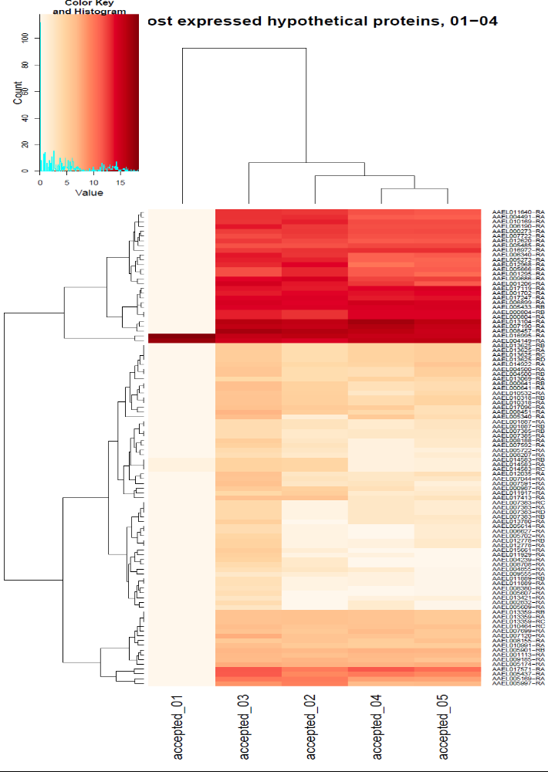
Sample 2: This is output showing a typical heat-map I generate using the gplots package and the RColorBrewer package in R. Each row corresponds to a sequence, each column corresponds to a sample, and the cells are shaded based on the logarithm base 2 transformed count values.

Sample 3: This is a sample output of a typical scatter plot generated using the ggplot2 package in R. This particular scatter plot belongs to hypothetical_proteins_sample_02.pdf.
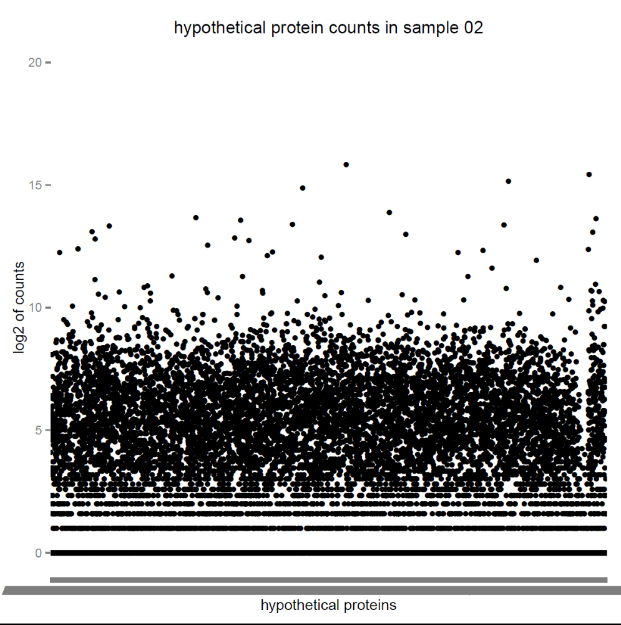

Sample 4: This sample output corresponds to the output of the script utr_annotation_errors.py. The string in the first column is a 3’-UTR identifier, and the first integer corresponds to the number of reads determined to be prefixes of the sequence, the second integer corresponds to the number of reads prefixed by a suffix of the sequence.
AAEL014889-RA 0 0
AAEL005027-RA 0 0
AAEL005019-RA 6 0
AAEL005021-RA 0 0
AAEL005015-RA 0 0
AAEL005040-RA 0 0
AAEL005023-RA 57 0
AAEL005042-RA 0 0
AAEL005018-RA 0 0
AAEL005037-RA 69 0
AAEL005025-RA 8 0
AAEL005028-RA 0 0
AAEL005033-RA 0 0
AAEL005041-RA 0 0
AAEL005035-RA 6 0
AAEL005016-RA 42 0
AAEL005022-RA 0 0
AAEL005022-RA 1 0
AAEL005017-RA 0 0
AAEL005017-RA 46 0
AAEL005013-RA 85 0
AAEL005043-RA 0 0
AAEL005046-RA 103 0
AAEL005036-RA 0 0

User Documentation:
The user must have the programs Samtools, FeatureCounts and pigz installed on their Linux computer. The user should also have the latest versions of the Python and R programming environments installed as well. The necessary R packages are as follows: gplots, ggplot2, DESeq, RColorBrewer, and dplyr. The Python packages used should already come preinstalled with the language. All scripts were run from the Linux command line.
In order to run my scripts a user must have the file aegypti.gff3, the file aegypti_metadata.txt and several read files in the directories stranded and unstranded. Unfortunately the read files are hundreds of gigabytes in size and the compressed files are more than 20 gigabytes in size. Due to their size, the read files are not available to download online. However, the scripts filter_rRNA_genome.py, find_hypothetical_proteins.py, get_3prime_UTRs.py, and aegypti_de.R will run if the user only has the noriboaegypti.gff3, exon_counts.txt and hp_list.txt files.
Once the user has the necessary files in the proper directories, the user must first run the programs filter_rRNA_genome.py, find_hypothetical_proteins.py, and get_3prime_UTRs.py. Then the user should run copy_bam.sh. These programs are necessary to produce the count matrix files which will subsequently be used for plot generation. Now the user should run aegypti_de.R. This will produce several heat-maps which will be stored in the tests subdirectory. The user should now run get_bam.sh which will prepare the necessary files for 3’-UTR error detection. Large text files will now be stored in the bam_files folder. These files are the read files which will be passed as arguments to the utr_annotation_errors.py script. The user should now run utr_annotation_errors.py from their command line supplying a read file as in argument in the following manner.
python utr_annotation_errors.py accepted_hits18
utr_annotation_errors.py will produce an output text file for the preceding read file named utr_annotation_errors_accepted_hits18.txt. This file will be stored in the tests subdirectory.

Personal Evaluation of the Project:
I learned many interesting things working with Dr. Nishiura. I gained an interest in biology, and genetics in particular. I witnessed first hand many of the interesting applications of probability and statistics and sorting, searching and string matching algorithms. There are many interesting bioinformatics problems to solve in Dr. Nishiura’s lab, and I wish I had more time and understanding to solve more of them. Performing this work requires a good understanding of probability theory and simple genetics. Though obtaining the appropriate knowledge to work in bioinformatics is time consuming and challenging, it is rewarding. I believe Dr. Nishiura’s goal of understanding the genetic expression of the mosquito is an important one. More Computer Science majors should definitely work with Dr. Nishiura in achieving his goal. The effect this further understanding may have on the development of mosquito-sides and mosquito-born diseases is critical.

