FARI
Manual Walkthrough
Case 04: SpaceCAN Spoofing and Replay
A filled, step-by-step Report Author example
Version 0.3 Draft | 8 June 2026

FARI preserves the auditor's technical independence while giving the Report Author a consistent path from source material to an executive conclusion.

Purpose
This guide demonstrates how a Report Author can analyze supplied source material and complete a FARI investigation report by hand. It uses cases/04_Spacecanbus.md and its screenshots. The external auditor is not required to complete any FARI fields.

Starting Material
The Report Author receives:
- A short scenario and declared white-box, dynamic environment.
- An injection command for a reply-like SpaceCAN frame.
- A replay command for previously captured traffic.
- Screenshots showing injection, replay, and changed monitor values.
- Expected impact statements and proposed SPARTA mappings.
- A generic denial-of-service finding unrelated to the SpaceCAN evidence.
The task is not to rewrite the auditor's notes. The task is to determine what the material supports, what it does not support, and what decision follows.

Step 1: Register the Source Material
Create source-material records without changing the supplied files.
Source ID | Supplied Item | Controlled Reference | Initial Note
SRC-SCAN-001 | Auditor narrative | cases/04_Spacecanbus.md | Mixed observations, assertions, and proposed mappings
SRC-SCAN-002 | Injection screenshot | cases/spacecan_scinjection_cmd_spoof.png | Direct evidence of injection-tool output
SRC-SCAN-003 | Replay screenshot | cases/spacecan_screenplay_replay.png | Direct evidence of replay-tool output
SRC-SCAN-004 | Monitor comparison | cases/Spacecan_tui_value_change.png | Direct evidence of displayed value differences

Manual note:
Received: 2026-06-08
Evidence producer: auditor; identity not supplied
Hashes / revisions: missing
Handling restrictions: not supplied

Step 2: Define the Investigation and Claim
Write one testable claim that can be resolved by the evidence.
Investigation ID: INV-SCAN-001
Claim ID: CLM-SCAN-001
Claim: SpaceCAN monitoring and consumers reject or visibly distinguish
unauthenticated forged or replayed reply-like frames before treating them as
trusted state.
Gating: Yes
Do not use a vague claim such as "SpaceCAN is secure." The exact claim allows a conclusion inside the demonstrated scope.

Step 3: Frame the Scope
Fill the Frame section:
Field | Handwritten Entry
Primary asset | SpaceCAN lab bus
Related asset | SpaceCAN monitor and represented node 0x04
Access | White box, as stated by auditor
Environment | Dynamic local lab
Included | Injection, replay transmission, displayed monitor values
Excluded | Physical actuators, autonomy, production controls, RF path, on-orbit behavior
Assumption | Displayed bus values may inform operators or automated consumers
Authorization gap | No rules-of-engagement or safety reference supplied

Step 4: Separate Facts, Assertions, and Inferences
This is the most important manual step. Use separate lists or colored marks on paper.

Evidence-Backed Facts
FACT-1: Injection screenshot shows ID 0x304, DLC 2, DATA 01 FF.
FACT-2: Replay screenshot shows retransmission of multiple frames including 0x304.
FACT-3: Monitor comparison shows thruster values changing from 12 to 255.
FACT-4: Displayed status remains nominal in the comparison.

Evidence-Producer Assertions
ASSERTION-1: ID 0x304 is a reply from node 0x04.
ASSERTION-2: Consumers trust reply IDs.
ASSERTION-3: Replay preserves original timing.
ASSERTION-4: No authentication or freshness window blocks replay.
ASSERTION-5: Forged data can poison higher-level decision logic.

Report-Author Inferences
INFERENCE-1: The lab monitor displays state that can be influenced by injected traffic.
INFERENCE-2: The value change is consistent with injection, but the exact causal
capture is incomplete.
INFERENCE-3: Replay transmission is demonstrated; replay-specific receiver
acceptance is not isolated.
Never move an assertion or inference into the facts list without new evidence.

Step 5: Record Contradictions and Gaps
ID | Manual Entry | Decision
GAP-SCAN-001 | Generic APID 0x06 DoS finding is unrelated | Exclude from report conclusion
GAP-SCAN-002 | Same monitor screenshot is used for spoofing and replay | Keep replay-specific effect candidate
GAP-SCAN-003 | Exact meaning of 01 FF is not evidenced | Describe display change only
GAP-SCAN-004 | No control configuration proves missing authentication/freshness | Request source/configuration evidence
GAP-SCAN-005 | Status remains nominal, but alarm semantics are unknown | Record possible detection gap

Step 6: Make the Three Sufficiency Decisions
Sufficiency Question | Entry | Why
Technical condition | Sufficient for lab display-trust failure; partial for replay effect | Injection/replay actions and displayed change are evidenced
Reachability | Partial | Local bus access is demonstrated; operational path is unknown
Mission consequence | Partial | Misleading display is observed; physical/autonomous effect is not

These three decisions prevent a demonstrated lab issue from being overstated as a demonstrated on-orbit mission impact.

Step 7: Normalize Findings

Finding 1
ID: FND-SCAN-001
Title: Forged reply-like frame influences displayed telemetry
State: Confirmed within lab monitor scope
Observed effect: Displayed thruster values change from 12 to 255
Technical confidence: Medium
Operational reachability confidence: Low
Mission consequence confidence: Low

Finding 2
ID: FND-SCAN-002
Title: Captured SpaceCAN traffic can be replayed
State: Candidate for receiver/control failure; transmission confirmed
Observed effect: Replay tool retransmits recorded frames
Missing proof: Receiver reaction caused specifically by replay
One investigation may contain findings with different states.

Step 8: Validate SPARTA Mappings
Mapping | Handwritten Decision
EX-0014.02 Bus Traffic Spoofing | Confirmed in lab scope; directly describes forged internal-bus traffic
EX-0001.02 Bus Traffic Replay | Confirmed for transmission; candidate for receiver effect
DE-0002.03 Inhibit Spacecraft Functionality | Candidate; no inhibited spacecraft function is demonstrated
REC-0005.01 Uplink Intercept Eavesdropping | Not selected; no uplink interception is evidenced

SPARTA explains the behavior. It does not create evidence or determine the FARI Conclusion automatically.

Step 9: Complete the FARI Result Card
Start with the claim, then compare it with the evidence.
Field | Filled Result
Conclusion | Does Not Meet
Confidence | Medium within the lab monitoring scope
Required Action | Remediate, then Retest
Priority | Immediate before displayed state is trusted for operational decisions
Scope Boundary | Supplied lab injection/replay tools and monitor screenshots; physical and on-orbit behavior excluded
Rationale | Forged traffic and changed displayed values demonstrate failure of the lab-scope claim

Why this is not Inconclusive: the defined claim requires forged state to be rejected or visibly distinguished before trusted display, and the evidenced lab monitor behavior fails that claim.
Why this is not a mission-wide Does Not Meet: the scope boundary excludes physical consumers, production controls, and on-orbit behavior.

Step 10: Define Action and Acceptance Criteria
Write actions that can be closed by evidence:
Action: Implement origin/freshness validation and untrusted-data indication.
Acceptance criterion 1: Forged reply-like frames are rejected or clearly marked.
Acceptance criterion 2: Replayed frames outside the freshness window are rejected.
Acceptance criterion 3: Critical consumers do not act on unauthenticated state.
Acceptance criterion 4: Representative retest covers monitoring, control,
autonomy, alarms, and recovery.

Step 11: Add the Investigation to the Consolidated Report
Add one row:
Investigation | Gating | Conclusion | Confidence | Required Action
INV-SCAN-001 | Yes | Does Not Meet | Medium in lab monitor scope | Remediate, then Retest

Because this is a gating claim and it is Does Not Meet, the overall portfolio cannot conclude Meets.

Completed Manual Checklist
- [x] Source material preserved and registered.
- [x] Claim and exact scope defined.
- [x] Facts, assertions, inferences, and assumptions separated.
- [x] Contradictions and missing information recorded.
- [x] Technical, reachability, and mission-consequence sufficiency decided.
- [x] Findings normalized and mapped to SPARTA with rationale.
- [x] Investigation Result Card completed.
- [x] Actions and acceptance criteria defined.
- [x] Result added to consolidated assessment.

Web Workflow Translation
A future FARI web application should implement these same steps as a guided Report Author workflow:
Diagram source is available in the canonical Markdown edition.

The web application may make the work faster, but it must preserve the same manual reasoning and evidence boundaries.

Evidence Visuals
These figures reproduce supplied source material for the walkthrough. They do not expand the evidence boundary described in the analysis.

Spacecan Scinjection Cmd Spoof
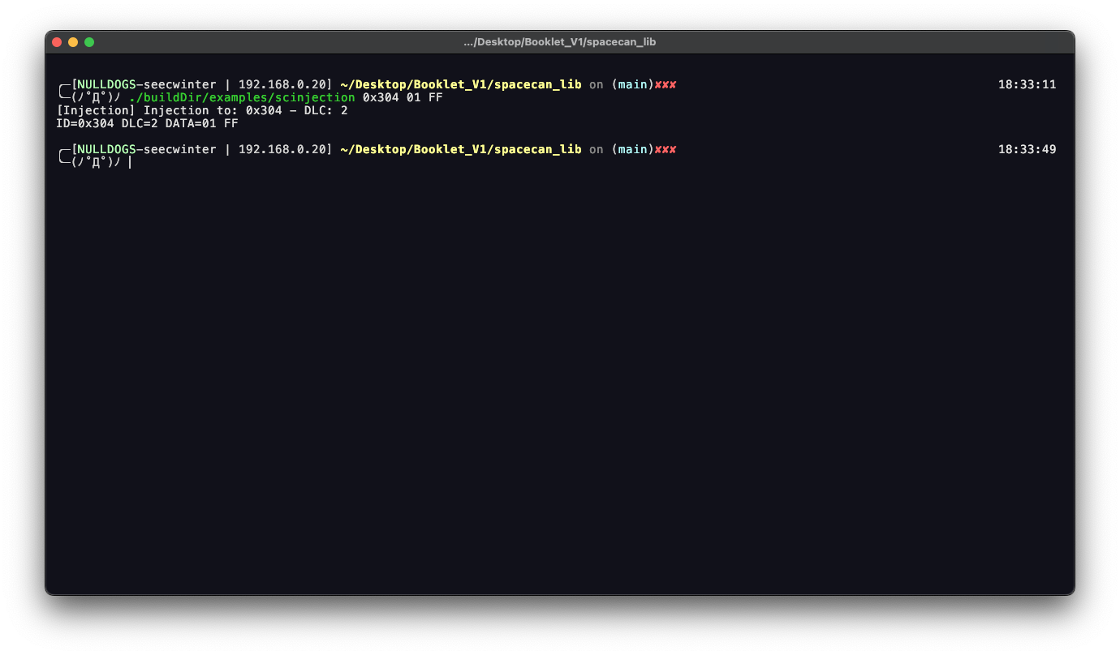
Supplied source material: cases/spacecan_scinjection_cmd_spoof.png

Spacecan Screenplay Replay
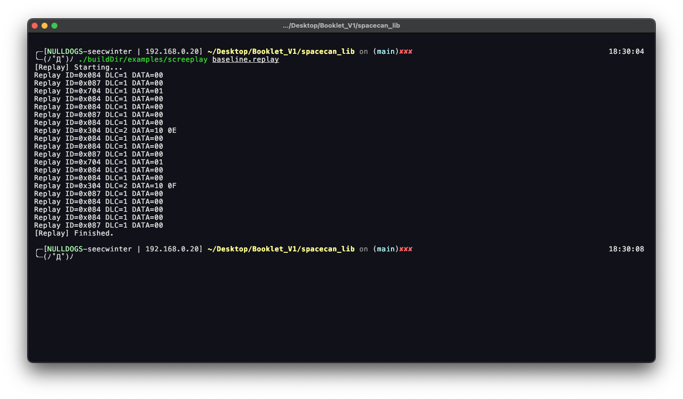
Supplied source material: cases/spacecan_screenplay_replay.png

Spacecan Tui Value Change
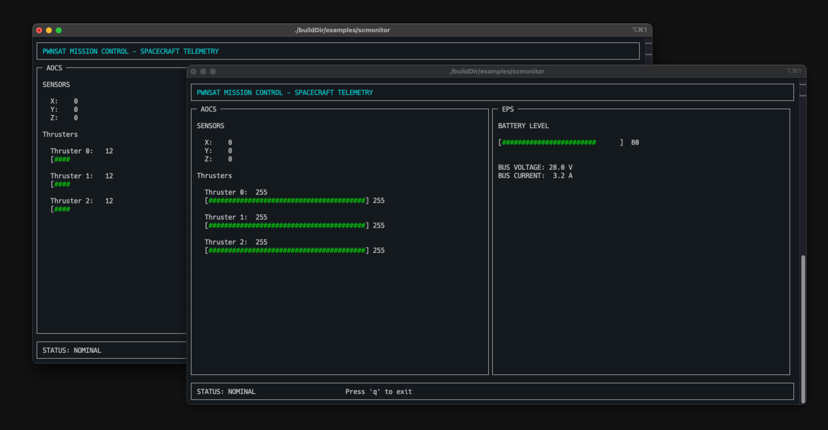
Supplied source material: cases/Spacecan_tui_value_change.png

