**Project Report on University**

**Pre-Registration System**



Course Code: CSE- 3612 & CSE- 3606

Course Name: Software Development sessional &

System Analysis sessional

Submitted By Submitted To

1. Name: Mohammad Abid Uddin Mr. Gulam Sarwar Chuwdhury

ID: C151085 Lecturer,

Dept of CSE, IIUC

2. Name :Nazim uddin

ID: C151094

Dr. Abdul Kader Muhammad Masum

3. Name:Jahedul Kader AssociateProfessor,

ID:C151097 Dept of CSE, IIUC

4.Name :Kalim amzad Chy.

ID: C151113

ACKNOWLEDGEMENT

We take this occasion to thank Allah(swt), almighty for blessing us with his grace and taking our endeavor to a successful culmination. The success and final outcome of this project required a lot of guidance and assistance from many people and we are extremely privileged to have got this all along the completion of our project. All that we have done is only due to such supervision and assistance and we would not forget to thank them. We respect and thank **Mr.** **Gulam Sarwar Chuwdhury** for providing us an opportunity to do the project work in university and giving us all support and guidance which made us complete the project duly. We are extremely thankful to him for providing such a nice support and guidance, although he had busy schedule managing the corporate affairs. We owe our deep gratitude to our project guide **Dr.** **Abdul Kader Muhammad Masum** who took keen interest on our project work and guided us all along, till the completion of our project work by providing all the necessary information for developing a good system. We perceive as this opportunity as a big milestone in our career development. we will strive to use gained skills and knowledge in the best possible way, and we will continue to work on their improvement, in order to attain desired career objectives. Hope to continue cooperation with all of you in the future.

**Kalim amzad Chy**

**Jahedul Kader**

**Nazim uddin**

**Mohammad Abid Uddin**

**ABSTRACT**

Language such as Pyhton Django Framework has been used to develop this system as well as the Django SQL for the database. Security has been provided properly and future enhancements will be available to make the system more reliable.

**CONTENTS**

Chapter 1

1.1 Introduction -------------------------------------------------------- 6

1.2 Objectives ----------------------------------------------------------- 6

Chapter 2

System Environment

2.1 Recommended Hardware Requirements ------------------- 7

2.2 Recommended Software Requirements -------------------- 7

2.3 Language ------------------------------------------------------------ 7

2.4 Databases ----------------------------------------------------------- 7

Chapter 3

System Analysis

3.1 Study of The Existing System----------------------------------- 8

3.2 Need of The Proposed System--------------------------------- 9

3.3 Scope of The System---------------------------------------------- 9

3.4 Feasibility Study--------------------------------------- ------------ 10-11

Chapter 4

Information Gathering --------------------------------------------------------11-12

Chapter 5

System Description

5.1Course Selection ---------------------------------------------------- 12

5.2 Approvement ---------------------------------------------------- 12

5.3 Get Semester Specific Information------------------------------ 13

Chapter 6

System Design

6.1 Case Diagram-------------------------------------------------------- 13-14

6.2 Database Table Diagram------------------------------------------ 15

6.3 Data Flow Diagram-------------------------------------------------- 16-17

6.4 Entity Relationship Diagram & Database---------------------- 18-19

6.5Input Output Design ------------------------------------------------ 20-25

Chapter 7

Scheduling & Testing

7.1 Cost-Benefit Analysis------------------------------------------------26

7.2 Type Of Testing------------------------------------------------------ 27

7.3 Testing Of “Pre-registration System” ---------------------------28

7.4 User Manual --------------------------------------------------------- 28

Chapter 8

Final Discussion----------------------------------------------------------- 29

8.1 Conclusion------------------------------------------------------------30

8.2 References-------------------------------------------------------------31

**CHAPTER 1**

**1.1 INTRODUCTION :**

In our present circumstances, we can see that there is a number of Educational Institutions which registration system can not predict how many teachers, lab, section etc will be needed for its upcoming semester. Additionally, section choice and section change raise some problem. One student chooses a section of a particular course at his/her sweet will. For that reason, sometime misdistribution of student in section wise problem arises. Maybe in one section with an extra student more than 50 when in other section less than 30 students. For that reason, supporting lab facility to a large no of the student for a section become difficult. Now we introduce our system which name is pre-registration system. We have designed this system in such a way so that it can remove the all difficulties problem to provide the proper information to predict the maintenance system of an educational institution.

**1.2 OBJECTIVES**

The system is developed to reach the following goals:-

1. We can distribute section equally among the student.

2. To assign a teacher of a particular course we can do that easily.

3. We can pre-assumption how many the numbers of the classroom, lab, teachers will be required for a new semester.

4. The system can be handle section change problem of the student easily.

5. The teacher can provide course results easily.

6. Providing an easier method to maintain records.

7. We can easily list out the number of regular and irregular student of a particular course.

**CHAPTER 2**

System Environment

**2.1 Recommended Hardware Requirements:-**

1.Processor 1 GHz

2.RAM 512 MB

3.Hard disk 320 GB

**2.2 Recommended Software Requirements:-**

1.Operating System: Windows XP or above

2.Browser: Mozila Firefox, Chrome, Internet Explorer

**2.3 Language:-**

1. Bootstrap HTML

2. CSS

3. Python web framework

**2.4 Database:-**

Django SQLite

**CHAPTER 3**

System Analysis

**3.1 Study Of The Existing System:**

By existing system dept of a university section, classroom, lab distribution and other facilities doing in the semester begging. Which create much pressure on the teacher to handle them properly. All the distribution activities are done using pen and paper. All the data records and information are recorded on paper and need a proper supervision of the records to ensure security. Direct interaction is required between the students and the teacher to maintain the activities. And because of all these manual activities, the system suffers from the following problems:

1. Time consuming system as all the activities are needed to be maintained manually.
2. Always requiring the direct interaction between the students and teachers.
3. Paper work need to be done for all the activities which is not so efficient.
4. It requires an updating process.
5. Inaccuracy of data.

**3.2 Need Of The Proposed System:**

The proposed system i.e, “Pre-Registration System” is required to diminish the difficulties which are caused because of the manual system. It will provide the user with a systematic approach of maintain the activities which will fulfill the following requirements:

1. Reduce the time required to manage the activities.
2. Requires less interaction between the user and the teacher.
3. Accuracy of data is ensured.
4. Remove redundant data.
5. Minimize the human efforts.
6. Speed up the process.

**3.3 Scope Of The System:**

Project scope determines the area of the environment where the system will render it services. It determines how the package can be used at the various sphere to ensure the proper maintenance of the requirements that has been proposed. This proposed system can be transformed into full registration system. Teacher can propose their desired section by which admin can assign to a section at teacher’s will. Prediction can be possible in next 3 year how much retake student may exist. By result analysis ups and downs of the student result can be noticed.

**3.4 Feasibility Study:-**

We can discuss the feasibility study in terms of the four factors which are:

1. Technology
2. Finance
3. Time
4. Resource

**3.4.1 Technology:-**

We have used very simple and user friendly technology to ensure that the system can be used easily by the people of all sectors having a little IT knowledge. The Django framework is used which will ensure a good quality security to the system and a low system requirements is ensured.

**3.4.2 Finance:-**

This sector discuss about the funds and money needed to develop and use the system. As we have confirmed that there is a low Software and Hardware requirements so the financial need was not a major problem and which made the system financially feasible.

**3.4.3 Time:-**

The management and uses of the time is discussed in this sector. As the system is not so big and not so complex to be developed so there was not a vast amount of time requires. So from this point of view the system was feasible in terms of time.

**3.4.4 Resource:-**

The Resources required to develop the system was the basic hardware and software requirements which was ensured very easily and hence made the project feasible from all the four dimensions.

**CHAPTER 4**

Information Gathering

Information gathering in any Centralized Pre-registration System is not an easy task. It has to be gathered in an organized way so that

1. No system details are left out.
2. Right problems are identified.
3. Repetitive work is avoided.
4. Wrong or incomplete details are not collected.

Considering the above points we can use various techniques to gather the information such as:

1. Interviewing
2. Questionnaire
3. Direct Observation
4. JAD session

For a significant amount of time we have developed and mixed questionnaire of Open and Close ended to gather the information. To gather the required information we have analysis our present registration system and discuss the what type of problem face a student and department of university. These activities include:

1. Meeting with the students and provide them questionnaire.
2. Collecting information by interviewing if necessary.
3. Discussing with faculty members and gathering requirements.
4. Observing the activities of the manual system to get the proper concept.

# 

**CHAPTER 5**

System Description

## 5.1 Course Selection:

The student gets the courses offered for the upcoming next semester as well as the sections for the course. The system gets student’s curriculum and filters out the courses that cannot be registered. The system, adds the repeat courses to the selected courses analyzing the academic history of the student. The student provides the courses and sections preferred. The system applies the rules and regulations to find out if student’s course registration satisfies the conditions such as credit restrictions, prerequisites and collisions. The accepted and rejected courses are provided to the student. The student makes new selections if there are any rejected courses. Finally, student approves the registration. The system displays the registration form.

## 5.2 Approvement :

The advisor can display the list of students that she/he advises and the course list that are offered for that semester. The advisor selects a student and displays her/his course registration form. If the registration is acceptable approves the registration. Otherwise rejects the whole registration or some of the courses providing the reason of rejection. If the registration is rejected, the student must make registration again completing the missing courses.

## 5.3 Get Semester Specific Information :

The Academic Year Management System provides the academic year information. The Semester Management system provides the information about the semester. The Curriculum Management System provides students’ curriculums. The Academic History Management System provides students academic histories. The Course Offering system provides the courses offered for that semester. The advisor’s student information is provided by Advisor Management System.

**CHAPTER 6**

System Design

**6.1 Case Diagram:**

A **use case diagram** at its simplest is a representation of a user's interaction with the system that shows the relationship between the user and the different [use cases](https://en.wikipedia.org/wiki/Use_case) in which the user is involved. A use case diagram can identify the different types of users of a system and the different use cases and will often be accompanied by other types of diagrams as well.

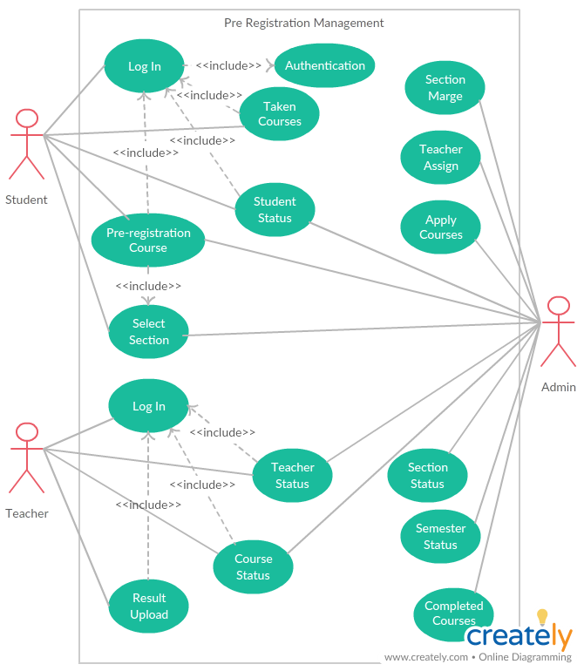

**Figure 6.1.1: Case diagram of the Pre - Registration System**

**6.2 Database Table Diagram :**

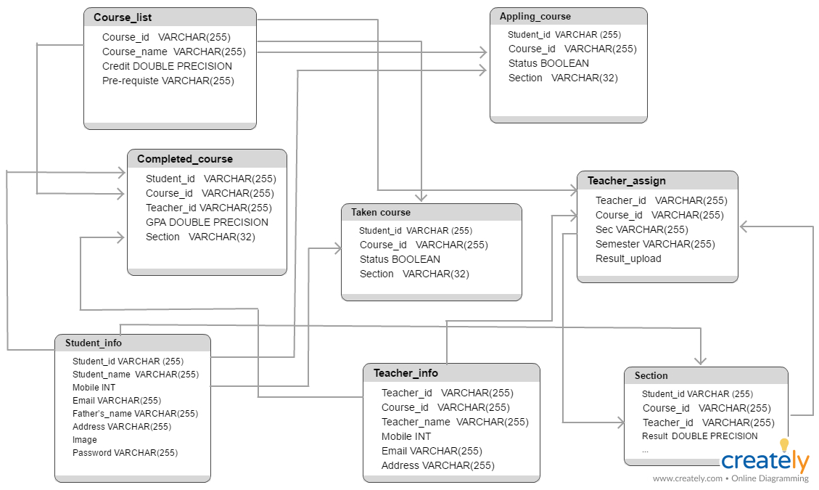

Figure 6.2.1 : Database table diagram of the Pre - Registration System

**6.3 Data Flow Diagram (DFD) :**

A data flow diagram (DFD) maps out the flow of information for any process or system. It uses defined symbols like rectangles, circles and arrows, plus short text labels, to show data inputs, outputs, storage points and the routes between each destination.

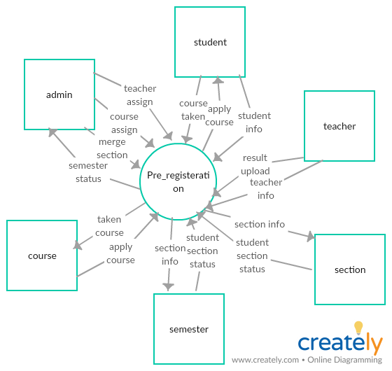

**Fig 6.3.1 : context diagram**

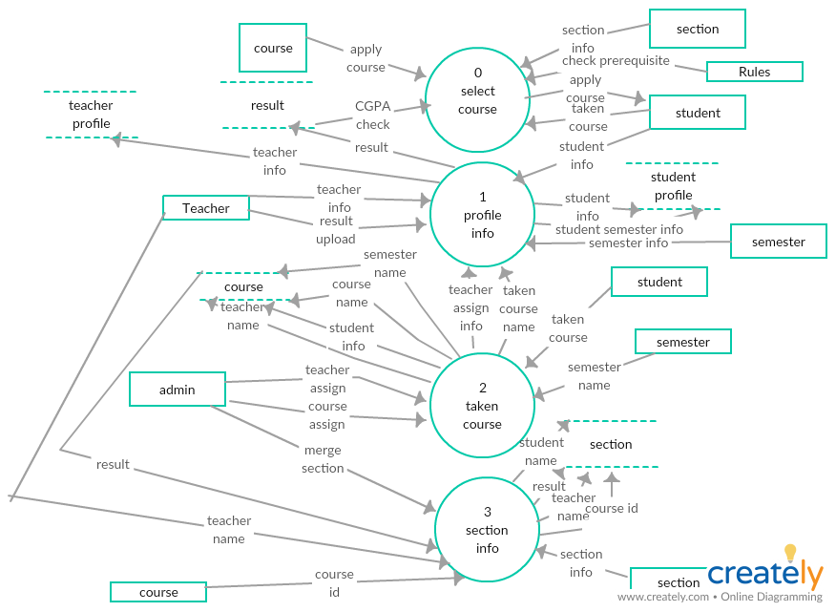

**Fig 6.3.2 : level 0 dfd**

**6.4 Entity Relationship Diagram &** **Database :**

An entity relationship diagram (ERD) shows the relationships of entity sets stored in a database. An entity in this context is a component of data. In other words, ER diagrams illustrate the logical structure of databases. The E-R diagram for the Pre-registration Management System is given here:

* **Student** *registers* to 1 or one **section** of a **course**. A **section** *has* 1 or many **students**.
* **Student** has one or many **registration form**s each of which is created for one **academic semester**. A **registration form** is created for only one **student**.
* A **registration form** contains one or many **section**s each of which is just for one **course**. **Section** is included just once in a **registration** form of a **student** for one **semester**.
* A **course** has one or more **section**s. A **section** is created just for one **course**.
* A **section** is instructed by just one **instructor**. An **instructor** instructs one or many **sections**.
* Each **Academic Year** has more than one **semester**. A **semester** belongs to exactly one **academic year**.
* A **course** is offered in one **semester** and many **courses** are offered at a **semester**.

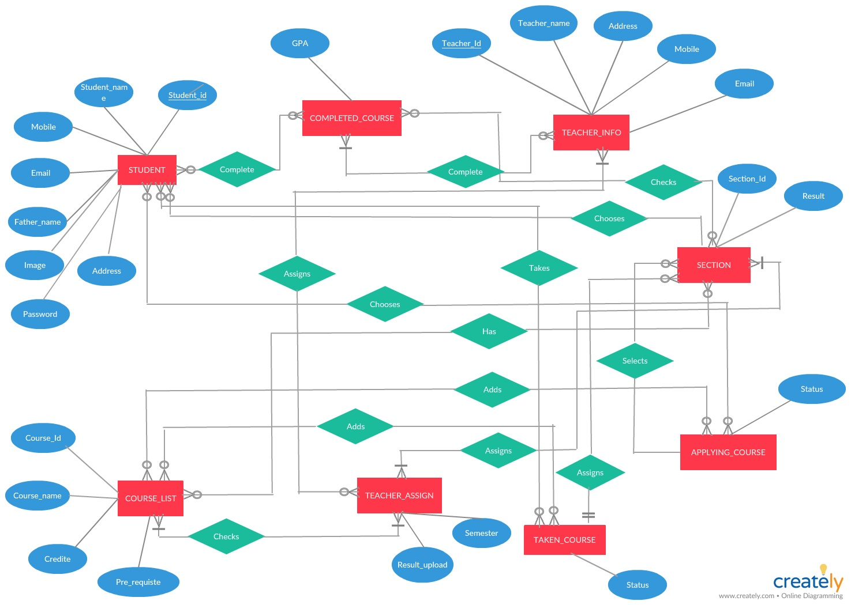

Figure 6.4.1 : The Entity Relationship Diagram of the Course Pre - Registration System

**6.5 Input Output Design :**

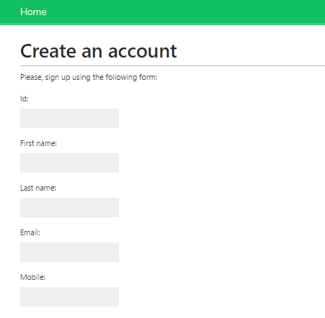

**Fig 6.5.1: Create account**

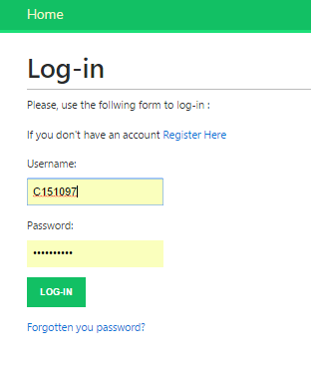

**Fig 6.5.2 : Login user account**

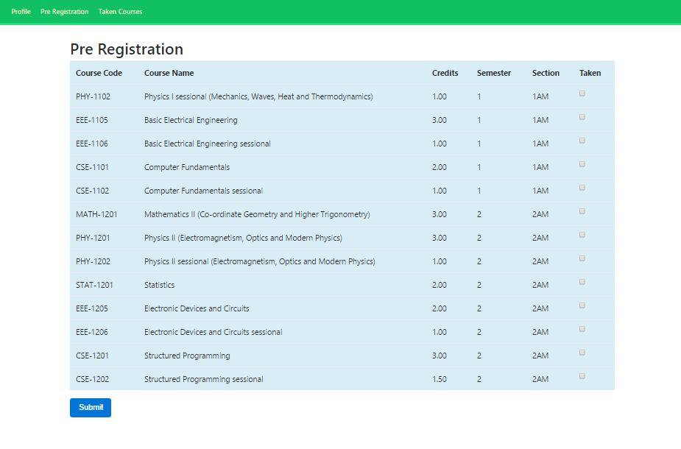

**Fig 6.5.3: Pre-registration for courses**

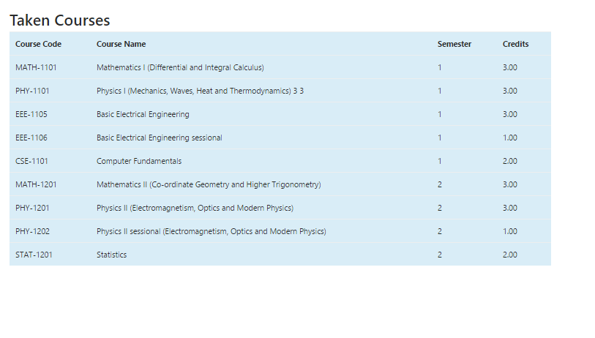

**Fig 6.5.4: List of courses taken by a student**

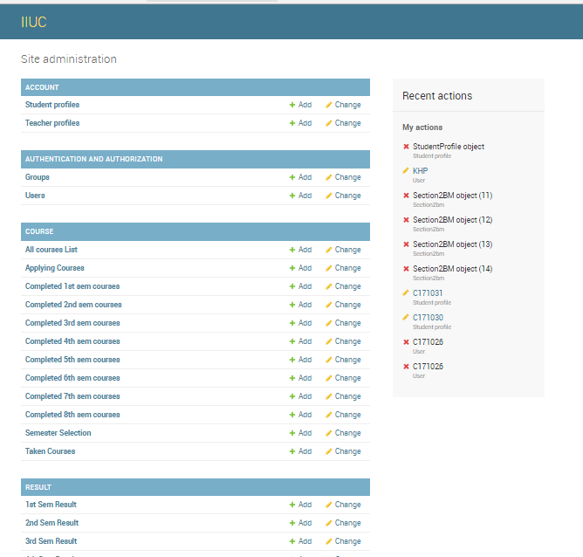

**Fig 6.5.5: Admin dashboard**

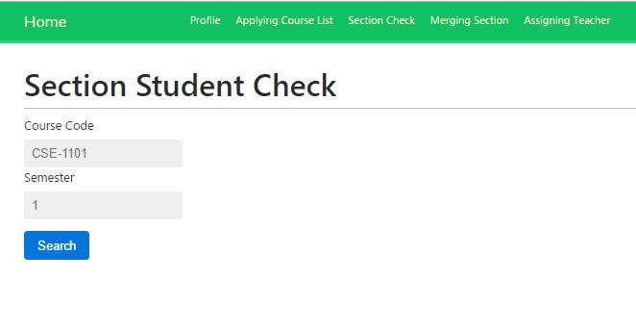

**Fig 6.5.6: 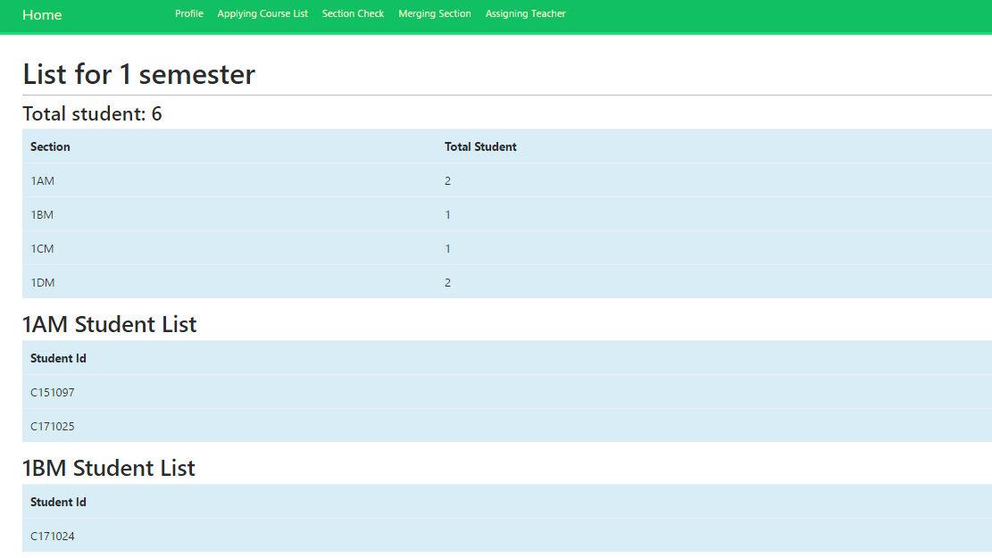Check the number of student in a section or under the course**

**Fig 6.5.7: List of students in each section**

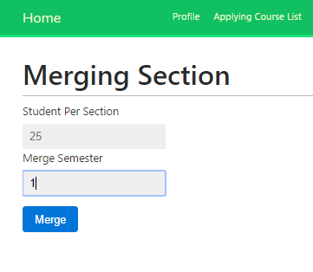

**Fig 6.5.8: Merging Section**

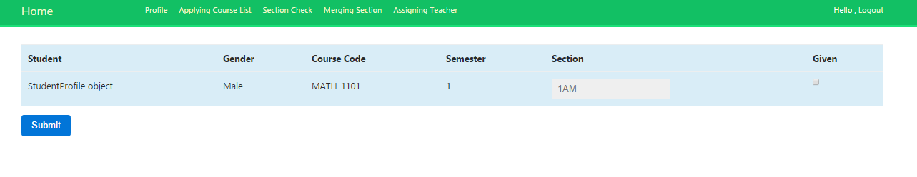

**Fig 6.5.9: Applying course list of irregular students**

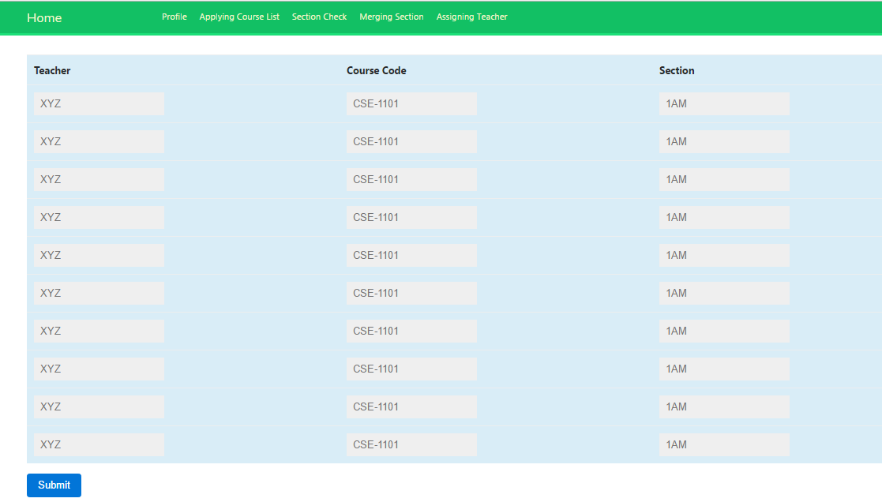

**Fig 6.5.10: Teacher assign in each course**

**CHAPTER 6**

Scheduling & Testing

**7.1 Cost-Benefit Analysis:**

Cost Benefit Analysis gives you a simple, quantitative approach for deciding whether to go ahead with a decision.

When doing the analysis we should consider the factors like:

1. Operating costs
2. Geographic diversification
3. Competitive Position
4. Demand for the services

A table showing the cost regarding the project is given below:

|  |  |
| --- | --- |
| Item | Cost |
| Tools | 500 tk |
| Printing & photocopy | 500 tk |
| Transportation | 300 tk |
| Communication | 100 tk |

**7.2 Time Scheduling :**

Time scheduling means the time management for the different phase of the project development life cycle so that the project can be done in the estimated time.

The Time Schedule for this project is shown below:

1. Requirements: 5 days
2. Analysis: 5 days
3. Design: 10 days
4. Coding: 15 days
5. Testing: 3 days
6. Implementation: 10 days
7. Documentation: 5 days

**7.3 Type Of Testing:**

**Unit Testing**

Also known as Program Testing, it is a type of testing where the analyst tests or focuses on each program or module independently. We have done a number of unit testing for different unit modules.

**Integration Testing**

In Integration Testing, the analyst tests multiple module working together. It is used to find discrepancies between the system and its original objective, current specifications, and systems documentation.

**Functional Testing**

Function testing determines whether the system is functioning correctly according to its specifications and relevant standards documentation. Functional testing typically starts with the implementation of the system, which is very critical for the success of the system.

**7.4 Testing Of “Pre-registration System”:**

In the testing phase we have done the unit testing and then we performed the integration testing and finally the functional testing was done. And doing so we have ensured the following statements:

1. Proper validations were done.
2. Exceptions were handled.
3. Backup is been built in case of accidental situations
4. If it can detect the intruders or not.

**7.5 User Manual :**

This system is developed for the students and other faculty members so we have tried to develop the system user friendly as much as possible. We haven’t introduced any complex functionalities that may affect the usability of the project.

The user just need to install the software in his operating system based on our requirements and then opening the software one will get the proper guideline or instructions as the interface is been developed based on this concept. The user will just need to register to be a part of the system. Then the user can use the functionality easily.

**CHAPTER 7**

Final Discussion

When developing the project many difficulties were faced. We have tried our best to cope with the difficulties. And still there may be some limitations such as:

1. It is developed for only Windows operating system.
2. Messaging service or email service are still not included.
3. Restrictive features may limit the use.

So to recover from these limitations we have thought of some plan given below:

1. Messaging and email service will be introduced.
2. Will be developed for different operating system.

**8.2 References** :

1. <https://www.tutorialspoint.com/index.htm>
2. <https://creately.com/>
3. <https://en.wikipedia.org/wiki/Main_Page>
4. <https://docs.djangoproject.com/en/2.0/>