Individual Assignment #2

Storyboard

Web Programming

Module code: CIT 2011

Name: Jaheem Shaw

ID: 2205642

**Wireframe**

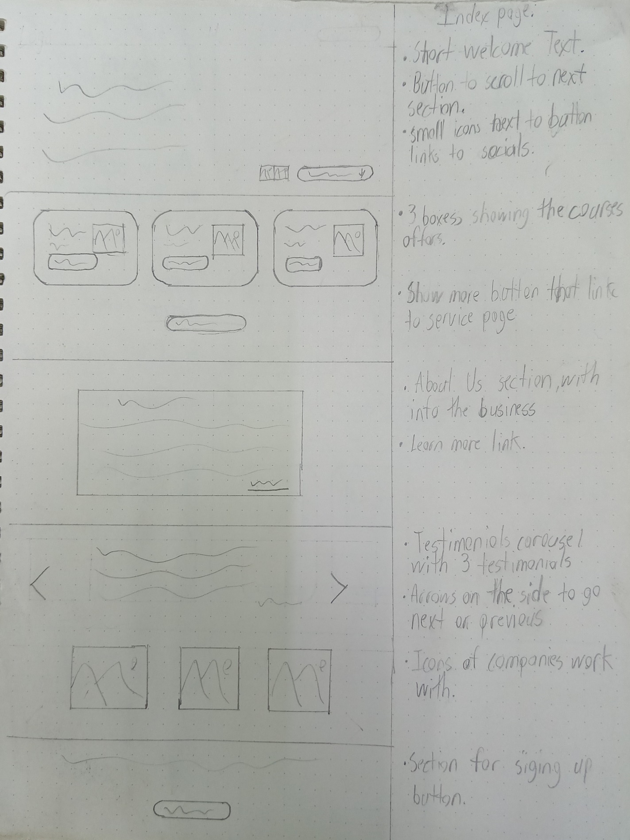

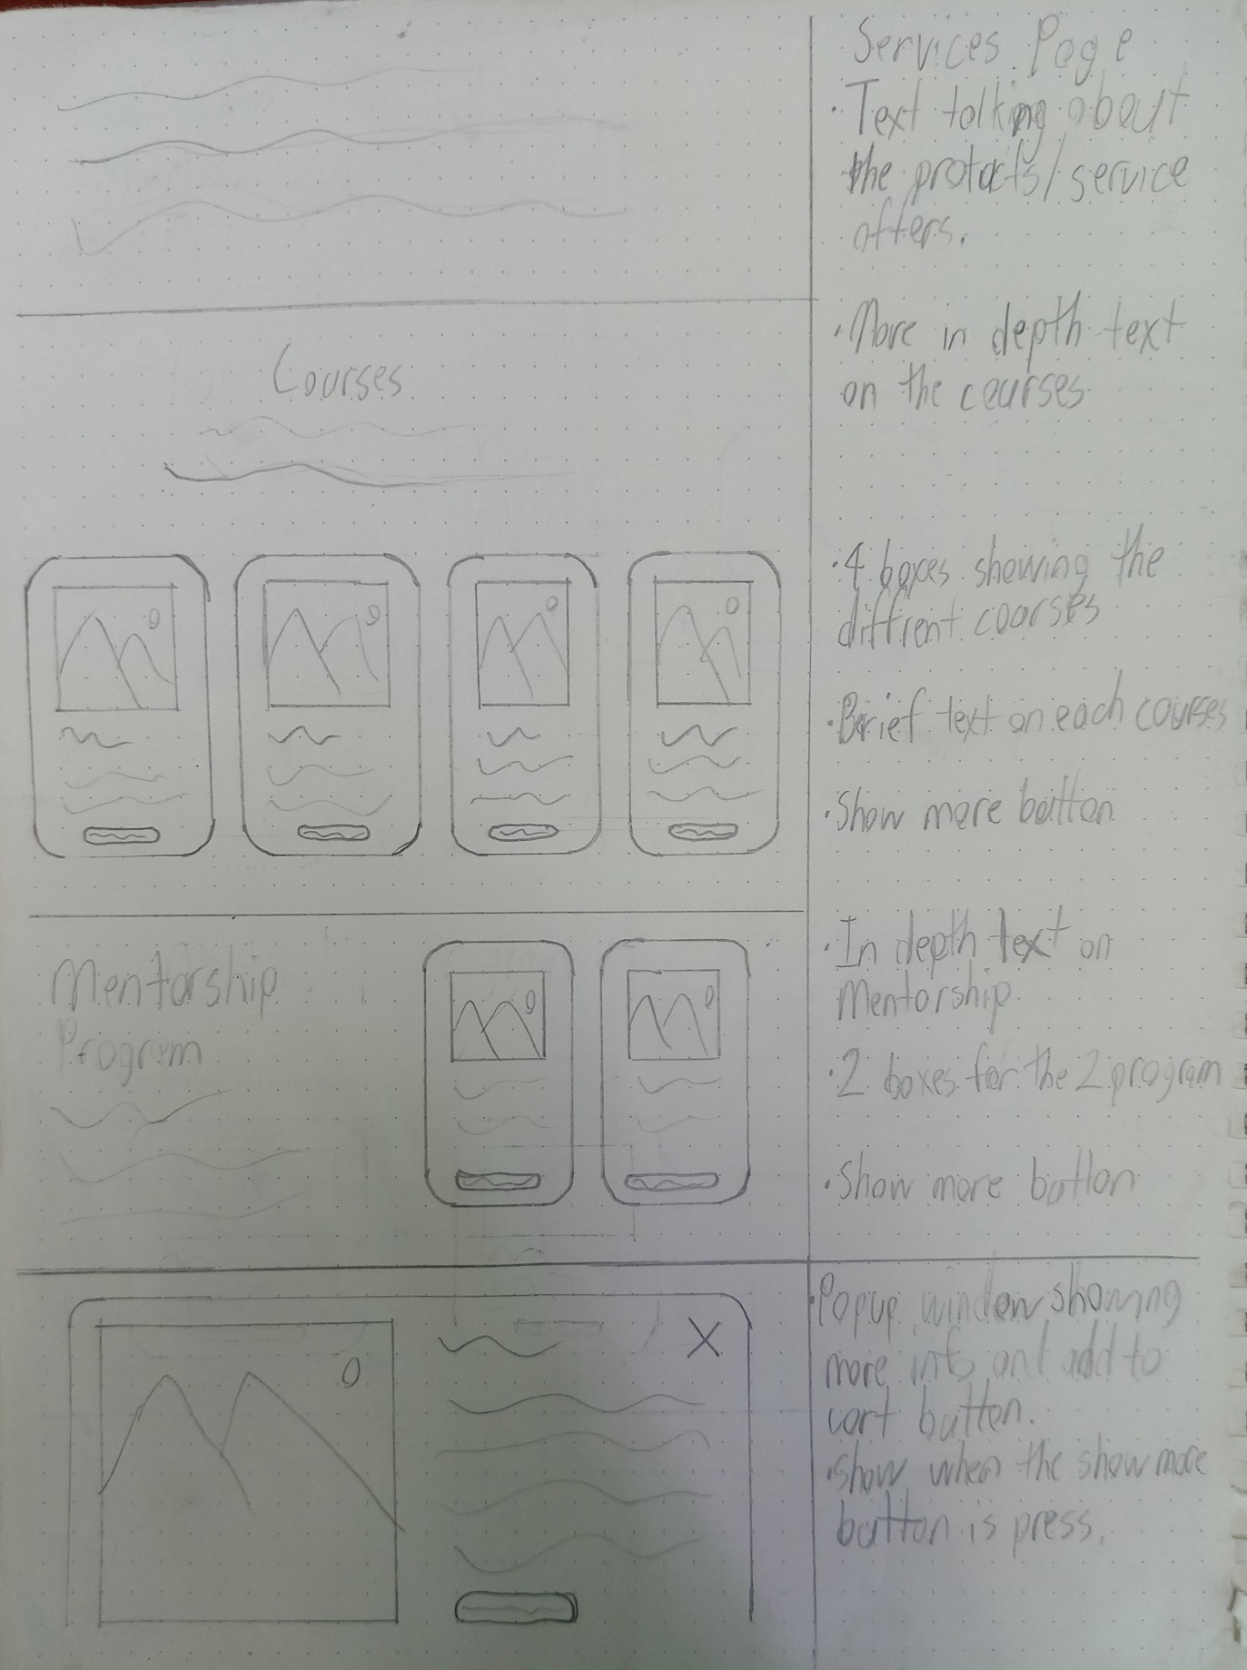

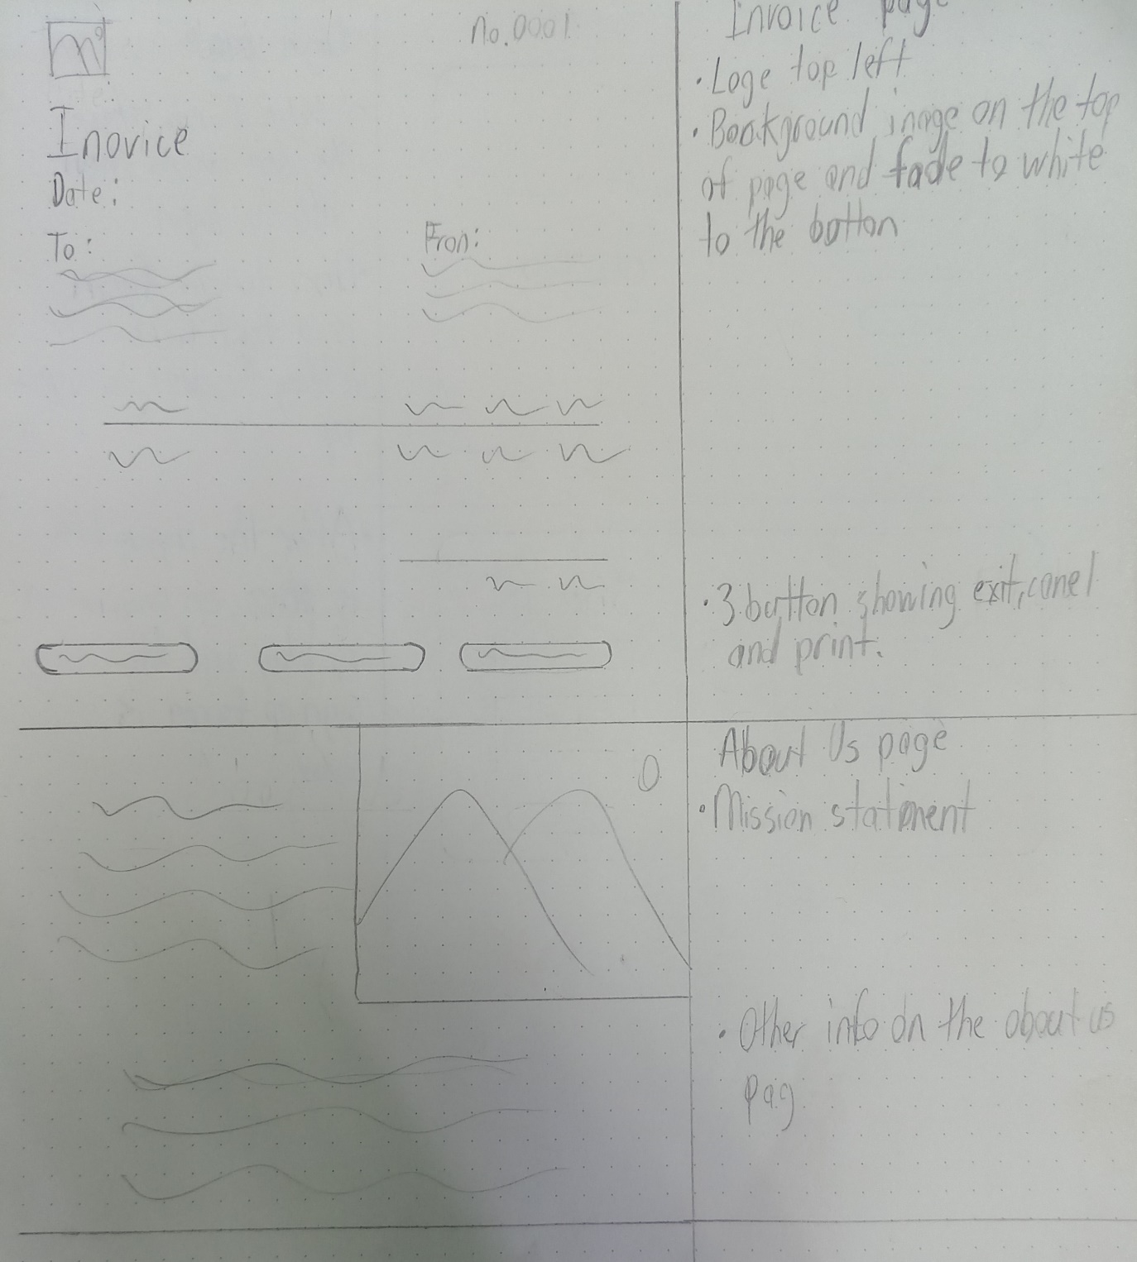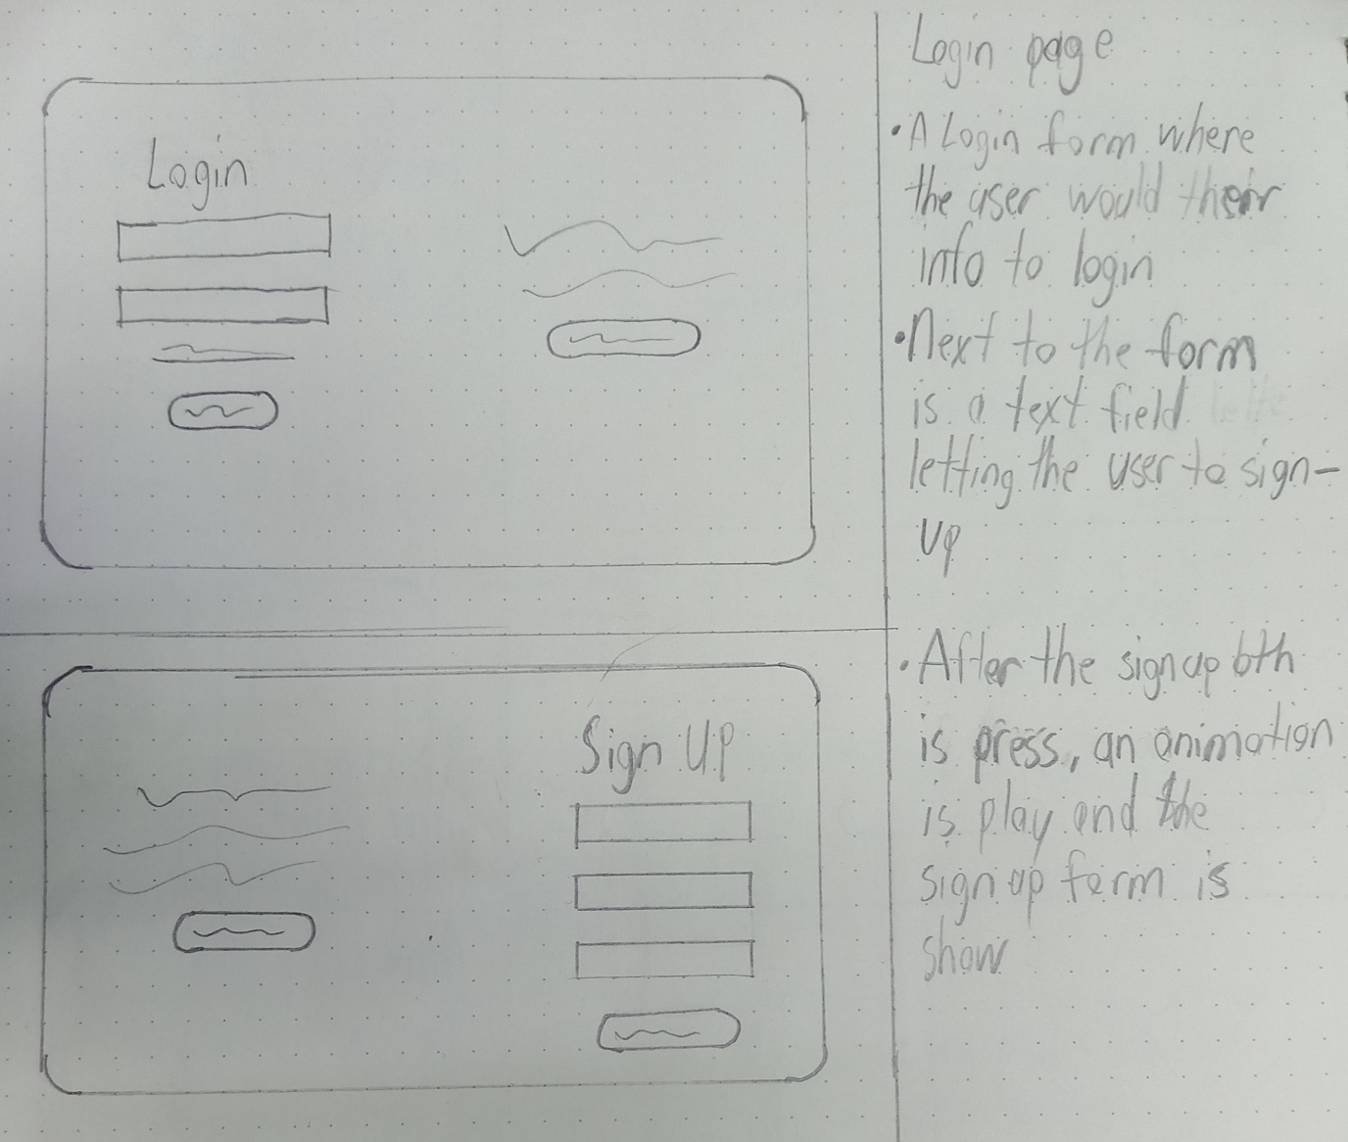

**Sitemap**

The sitemap outlines the structure of the website to ensure smooth navigation:

* **Home Page**: Introduction to the platform with a hero section, a brief overview of services, and a call to action.
* **Courses Page**: A detailed list of web development courses, including descriptions, pricing, and enrollment options.
* **About Us Page**: Information about the company, mission statement, and team.
* **Login/Signup Page**: A secure area for user registration and authentication.
* **Invoice Page**: The invoice page is where you can view the invoice of the courses picked, a link only shows when a user is logged in.

**Colour Palette**

The colour palette has been carefully selected to evoke a sense of professionalism, trust, and creativity. The primary colours are:

* **Primary Blue (#6482AD): A calm and professional blue, representing trust, knowledge, and technology. It will be used main colour**
* **Light Blue (#7FA1C3): A softer shade of blue used for call-to-action buttons, and section dividers, maintaining a clean and visually cohesive design.**
* **Warm Beige (#E2DAD6): A neutral, warm tone that contrasts well with the blues. It will be used for background elements, ensuring the legibility of text and providing a soft, inviting feel.**
* **Pale Pink (#F5EDED): A gentle accent colour used for call-to-action buttons, hover effects, or section highlights to draw attention without being too bold.**

Justification: This palette balances trust and professionalism (blue tones) with warmth and approachability (beige and pale pink), creating a visually appealing and user-friendly experience. The gentle contrast helps focus attention on key interactive elements while maintaining an overall calm and clean aesthetic.

**Typography**

* **Primary Font**: **Roboto** – A clean and modern sans-serif font used for headings and body text. It ensures readability and maintains a professional appearance.
* **Secondary Font**: **Lora** – A serif font used for quotes and testimonials, adding a touch of elegance and variation.

**Description of business**

**“webDevMastery”** is an e-learning platform that offers comprehensive web development courses, mentorship, and code review services. The website is designed to provide users with easy navigation, clear information, and an engaging learning experience.

**Mission Statement**

At “webDevMastery”, we believe that anyone can learn to code and build the web of tomorrow. Founded on the principles of accessibility, quality education, and hands-on experience, our platform is dedicated to empowering aspiring web developers through comprehensive courses and personalised support.

**Vision**

The vision is to become a leading global platform for web development education, fostering a community where anyone, regardless of their prior experience, can unlock their potential, master the art of coding, and contribute to the digital future. We aim to shape the next generation of web developers who will innovate, inspire, and drive the future of technology.

**The intended audience**

Its intended audience is aspiring web developers who are new to coding and want to learn the fundamentals of web development, including HTML, CSS, JavaScript, and more. And also, for developers who have basic knowledge but want to deepen their skills with advanced topics such as full-stack development, frameworks like React and Node.js, and project-based learning.

**Hosting Link:** [**https://jaheethedan.github.io/Individual-Assignment-2/index.html**](https://jaheethedan.github.io/Individual-Assignment-2/index.html)

**References**

Batinić, A. (2020, August 5). *Black Screen With Code · Free Stock Photo*. Pexels. https://www.pexels.com/photo/black-screen-with-code-4164418/

Danilevich, O. (2020, August 5). *Two Men Looking at a Laptop · Free Stock Photo*. Pexels. https://www.pexels.com/photo/two-men-looking-at-a-laptop-4974920/

DC Studio. (n.d.-a). *Free Photo | Engineer talking with management in videocall about errors found in code*. Freepik. Retrieved October 15, 2024, from https://www.freepik.com/free-photo/engineer-talking-with-management-videocall-about-errors-found-code_356521163.htm

DC Studio. (n.d.-b). Multicultural development team intensively looking for changes in database storage settings. In *freepik*.

Font Awesome 5. (n.d.). *Font Awesome 5*. Fontawesome.com; Font Awesome 5. https://fontawesome.com/

Fotios, L. (2023, April 5). *Man Coding on PC · Free Stock Photo*. Pexels. https://www.pexels.com/photo/man-coding-on-pc-16129728/

*freeCodeCamp logo.svg - Wikimedia Commons*. (2014). Wikimedia.org. https://commons.wikimedia.org/wiki/File:FreeCodeCamp_logo.svg

*GitHub Logo*. (n.d.). Projectpythia.org. Retrieved October 15, 2024, from https://foundations.projectpythia.org/_images/GitHub-logo.png

Kondratiev, S. (2022, January 18). *Screen With Code · Free Stock Photo*. Pexels. https://www.pexels.com/photo/screen-with-code-10816120/

Magnetme. (2020, November 11). *Two People using Electronic Devices · Free Stock Photo*. Pexels. https://www.pexels.com/photo/two-people-using-electronic-devices-5839461/

Mikhail Nilov. (2021, May 21). *Men Working on a Computer · Free Stock Photo*. Pexels. https://www.pexels.com/photo/men-working-on-a-computer-7988742/

Morillo, C. (2018, June 25). *Two Women Looking at the Code at Laptop · Free Stock Photo*. Pexels. https://www.pexels.com/photo/two-women-looking-at-the-code-at-laptop-1181263/

Mueller, M. (2017, February 19). *Close-up of Computer Screen · Free Stock Photo*. Pexels. https://www.pexels.com/photo/close-up-of-computer-screen-325111/

picjumbo.com. (2016, October 29). *White Printer Paper · Free Stock Photo*. Pexels. https://www.pexels.com/photo/white-printer-paper-196645/

RealToughCandy.com. (2022, April 19). *A Person Holing a Sticker in Close-up Photography · Free Stock Photo*. Pexels. https://www.pexels.com/photo/a-person-holing-a-sticker-in-close-up-photography-11035380/

Space, N. (2017, September 8). *Macbook Pro · Free Stock Photo*. Pexels. https://www.pexels.com/photo/iphone-dark-notebook-pen-34140/

ThisIsEngineering. (2020). *Free Person using Gray Laptop Stock Photo*. Pexels.com. https://www.pexels.com/photo/person-using-gray-laptop-3861964/

*W3Schools logo.svg - Wikipedia*. (2021, April 28). Wikipedia.org. https://en.m.wikipedia.org/wiki/File:W3Schools_logo.svg