Multilanguage QA

Testing guide

**Jahia**

9 route des Jeunes, CH-1227, Carouge Switzerland

http://www.jahia.com > The company web site http://www.jahia.net > The community web site

# Version

This table records the versions of this document and their last updates

|  |  |  |  |
| --- | --- | --- | --- |
| Version | Author | Date | Modifications |
| 1.0 | Anna Afshar | 2008-06-17 | Initial document |
|  |  |  |  |
|  |  |  |  |

# Summary

Page

Version 2

Summary 3

Introduction 4

User Guide 5

Manage languages 5

Important point to keep in mind before starting the tests 8

Tests scenarios 9

Scenario 1 9

Scenario 2 9

Scenario 3 9

Scenario 4 9

Scenario 5 9

Scenario 6 10

Scenario 7 10

Scenario 8 11

Scenario 9 11

Scenario 10 11

Scenario 11 11

Scenario 12 12

Scenario 13 **Error! Bookmark not defined.**

# Introduction

This document contains all the QA test scenarios that should be done on Jahia Multilanguage functional module. It also contains an end user guide of this module for less familiar user.

# User Guide

Here we have a short end user guide about how using Multilanguage functionality of Jahia. That will help you to follow easier QA test scenarios concerning this module in the case you are not enough familiar with this part of Jahia functionality, otherwise you can skip it and start directly your tests in test scenarios section.

## Manage languages

From the interface *Manage language* reachable through Admin Center, you can manage all parameters related to language for the current virtual site. The upper part of the panel displays all the languages currently configured. For each lan­guage, you can select 2 options:

- **Active**: if checked, this language will be available in the edition pop-up and users will be able to switch to this language. At least one language must be activated.

- **Mandatory**: if checked, you won’t be able to validate a page until content for all mandatory languages have been completed. For instance, if you add a new page but only entered a title in English when French is a mandatory language, you won’t be able to publish it in any lan­guages. This prevents content from being published before it is available for all mandatory lan­guages.

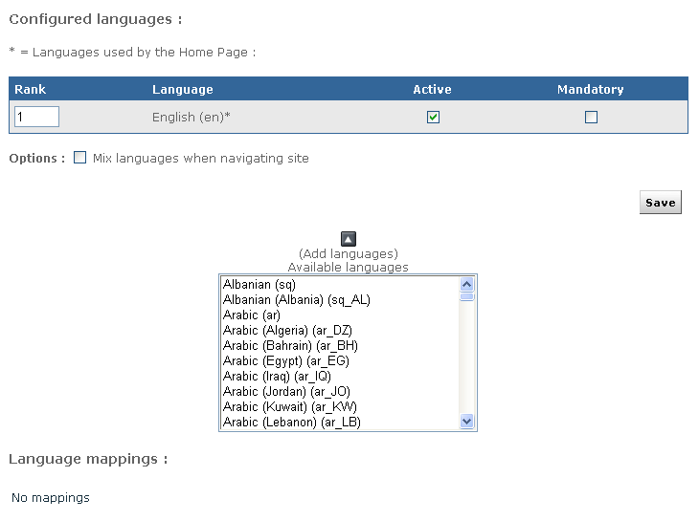

Figure 1: Manage language menu

For intranet or extranet purposes, you may often want to be able to display content to the user whatever the language he is currently browsing the site. For example, if you do not wish to have empty pages for languages where content is not available yet, you can activate the “mix languages when navigating site” option. This will use existing content of the other lan­guages to fill in the blanks. You may, for instance, have some area with English content in the French part of a virtual site if this content is not yet available in the French language.

If you want to remove a language from a virtual site, just unselect the “Active” checkbox and click on “Save changes”.

To add a new language to the virtual site, select it from the list of available languages. You may notice that many languages are listed multiple times. In fact the list is based on “locale” or language for a region, so it does not only specifies a language, but also a region. Jahia will identify this “locale” setting of browsers, and can behave differently whether it identifies a French-configured browser from a Canadian user (“fr_CA”) or from a French user (fr_FR). If you wish to add the “generic” French language, just choose the “French (fr)” option.

Unless you plan to add some content specific to a country or region (like fr_CA or fr_FR), you should normally use the generic locale (fr) for a given language.

Click on the



Icon to add the language to the list of configured languages.

Language mappings

The “language mappings” option is useful when you have created a site with two different locales for the same language. In for example you have both French-Canada (fr_CA) and French-France (fr_FR) locales configured on your site, you may want to specify which language will be displayed when a user with a generic French (fr) locale access your site.

Click on “edit language mappings” once you have added both fr_FR and fr_CA to choose which locale will be mapped to the fr locale.

To summarize, here is the normal behavior if you have the following configured languages and mapping:

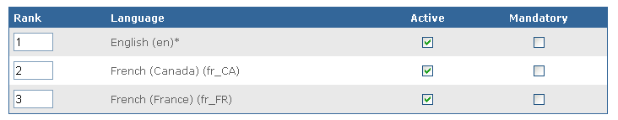

Figure 2: Language configured

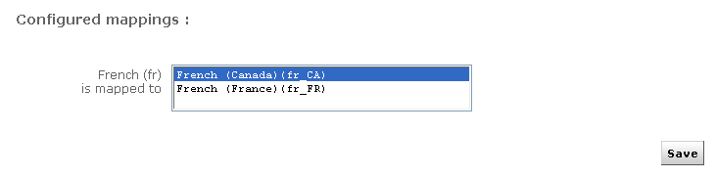

Figure 3: Language mapping

# Important point to keep in mind before starting the tests

Here are all the points which should be done/respected before starting your QA tests.

* Jahia supports six languages by default: French, English, German, Italian, Spanish, and Portuguese. Create a Multilanguage site (don’t use English; it seems ‘en’ is hardcode somewhere in the source). Set one language as mandatory (not the first one in the list, it seems Jahia behaviour is different when the first language is not mandatory, maybe somewhere in the code the first one is considered as the mandatory language by mistake)
* Create several different Jahia users with different rights (e.g. John as manager with RWA and Steven as employee with RW). Use two different navigators for your users (e.g. John in IE and Steven in FF), by this way you don’t need to login/logout each time. At each step of your test verify what each user is able to see and do.
* Don’t forget to verify the console regularly and if an exception occurs, make a ticket by detailing the scenario by which such an exception has occurred and paste the exception content in you ticket as attachment.
* Jahia considers this order of languages for each user: the language set in his My Setting, the default language of user’s browser, the list of language of the Site set in Admin Center.
* We should not be able to publish content when it’s not translated yet in the site mandatory language.

# Tests scenarios

Here are all Multilanguage QA testing scenarios to be followed. Please don’t hesitate to add your own scenarios if you have some which are not mentioned between them.

## Scenario 1

**Checking all the labels and text in Multilanguage**

Verify during all your tests when switching form one language to the other, do the texts and labels correctly switch to the other language? On all sub-engines.

## Scenario 2

**Email’ content in Multilanguage**

Add the address email to several users (each user with different language in his/her ‘my setting’) and verify the emails they receive during they work with workflow process, are all their e-mail’s contents are translated to their corresponding correct language?

## Scenario 3

**Testing Templates**

Test all type of fields in Multilanguage by using ‘Testing Template’ . Create all types of fields and verify its contents in all your languages.

In jahia 6, use” all fields” test template in TCK template set for this use case.

## Scenario 4

**Copy to other languages feature**

Test the "copy to other languages" feature. Switch to another language, change a value and recopy to all other language and verify if it works correctly.

## Scenario 5

**Validate a page only in one language**

Create a page in all your available languages. Validate it only in one language. Does it work? Is the other language available in live mode? Do some global tests on the workflow features by trying to validate, roll-back, etc... Your page on each language separately.

## Scenario 6

**Restoring a page in only one language**

Validate the other language. Then try to restore to the previous operation when only one language was present in live mode.

In jahia 6, what you need to keep in consideration is this option is only available on content object level and no more at page field level so perfom this use case only for content objects.

## Scenario 7

**Mandatory language**

Enforce a mandatory language and verify:

* The blocking errors in the workflow if a container is not translated in such a mandatory language.
* Could you validate such a container in another language when the content of mandatory language is empty?
* Could you modify the concerned container directly from within the workflow engine?
* Are the warning and error messages self-speaking?

Don’t forget not to use the admin account for this test; an admin user is able to validate a page event without content in its mandatory language.

## 

## Scenario 8

**Mix language mode**

Test the mixed language mode (it means that if the current language is not found, the other language (according to the ranking of language firstly in my setting secondly in the language list in the admin center) will be used. So you should always see all the possible containers on a page. Test such a feature with 3 or more languages and by only entering one container in each language. Do you see all containers on your page? If you edit such a container on which language are you redirected? Don’t forget to flush the cache during this test.

## Scenario 9

**Translation role**

Create some users and assign them to the translation roles (in the admin center).Verify that Such users will then only be able to modify one given language and shouldn't be able to update content in other language (in edit mode and within the engine themselves)

## Scenario 10

**Removing a language for the site**

Remove a language from your site by inactivating it in the language list in the Admin Center. Check all the content of your site, are all in this language are removed in both edit and live mode.

## Scenario 11

**Linked copy and Multilanguage**

Do a linked copy of your site and verify in your destination all the validated contents of your site in all its languages are copied correctly. Create an other site in only one language and content pick some content of you first site in this new one, is only the validate part in the correct language copied? Add a new language in your new site, revalidate the copied content in the source site, is the second language copied now in destination?

## Scenario 12

**Cron and maltilanguage**

Create an other virtual site in only one language and export the content of your site to this new one by using cron. Verify only the content in the correct language are exported. Add another language in your destination site; verify now that the contents in this language are copied after the next export.

## Scenario 13

**Export/Import and Multilanguage**

Now export you site and import its zip file by creating an other site, verify you have the content in all the languages.