GWT and Jahia

Jahia
9 route des Jeunes, CH-1227, Carouge Switzerland
http://www.jahia.com > The company web site http://www.jahia.net > The community web site

Version
This table records the versions of this document and their last updates
Version | Author | Date | Modifications
1.0 | Khaled TLILI | 2007-11-01 | Initial document

Summary
Page
Version 1
Summary 2
Installation 1
Install Google Web Toolkit 1.4.60 (example: C:/gwt-windows-1.4.60 , use for this document) 1
Google Web Toolkit 1
GWT Maven plugin 1
GWT and IDEA 2
Presentation GWT-Jahia 3
Introduction 3
Package structure 3
GWT modules Vs GWT Jahia Modules 3
Jahia Base Module 3
GWT-Jahia Service entry point 4
Maven goal 5
Compile GWT-Jahia 5
Generate jahia-gwt-api.jar 5
How to share parameters? 5
Class Dictionary 5
JahiaGWT parameter class 6
Ajax GWT Tag lib 7
<ajax:gwt-init> 7
<ajax:gwt-import> 7
GWT-Jahia Modules 9
Adding new module 9
Compiling 9
Use it 9
Example: layout manager 9

Installation

Install Google Web Toolkit 1.4.60 (example: C:/gwt-windows-1.4.60 , use for this document)

Google Web Toolkit
- Install Google Web Toolkit 1.4.60
  - Example: C:/gwt-windows-1.4.60 (use for this document)

GWT Maven plugin
MAVEN_GWT PLUGIN:
http://gwt-maven.googlecode.com/svn/docs/maven-googlewebtoolkit-plugin/index.html
- add in your build.properties the following remote repository:
  - http://repo1.maven.org/maven,
  - http://gwt-maven.googlecode.com/svn/trunk/mavenrepo/
maven.repo.remote = http://repo1.maven.org/maven,http://gwt-maven.googlecode.com/svn/trunk/mavenrepo/, ...

- add in your build.properties the following properties
# GWT path
google.webtoolkit.home= C:/gwt-windows-1.4.60

# palteform specific
maven.jar.gwt-dev-platform=${google.webtoolkit.home}/gwt-dev-windows.jar

- install maven gwt plugin
maven plugin:download -DgroupId=com.totsp.gwt -DartifactId=maven-googlewebtoolkit-plugin -Dversion=1.5.6 -Dmaven.repo.remote=http://gwt-maven.googlecode.com/svn/trunk/mavenrepo/,http://repo1.maven.org/maven

GWT and IDEA
- Update your idea project. In core:
maven idea

Be careful, this will erase your previous settings

- I your idea project add scr/conf/java as project resources (this allows idea to index gwt modules)

Presentation GWT-Jahia

Introduction
To do.

Package structure

GWT modules Vs GWT Jahia Modules
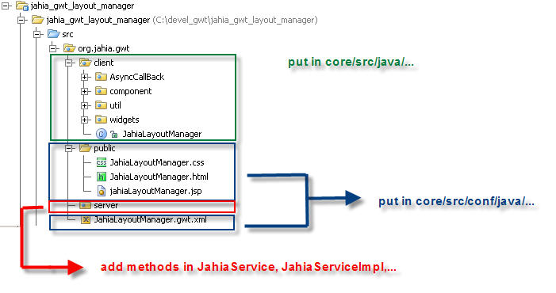

Jahia Base Module
Jahia Base module defines all nested classes that allows to deal with Jahia as Jahia Server implementation, GWT bean, some useful class, basic entrypoint,…
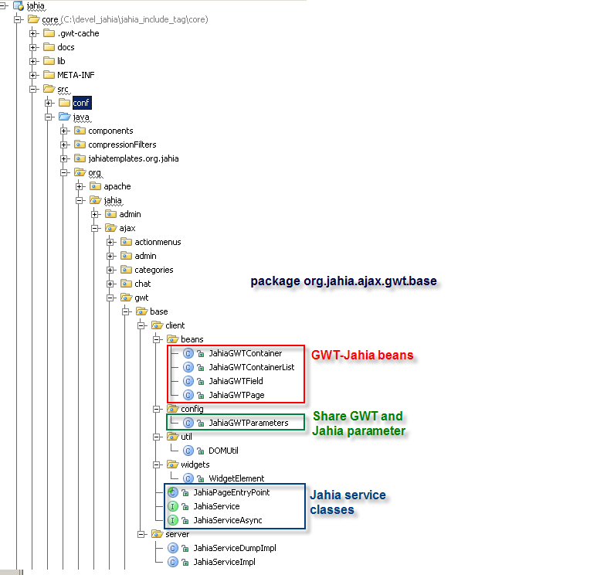

GWT-Jahia Service entry point
Usually, gwt service entry point is generated like that:
instance = (JahiaServiceAsync) GWT.create(JahiaService.class);
instance.setServiceEntryPoint(GWT.getModuleBaseURL() + "/gwt/");

The problem is that ajax url depends on where GWT module is located. That means that we need one servlet mapping per modules. In order to have only one servlet mapping for all modules, we generate the servlet EntryPoint url from JahiaGWTparameters class:
String serviceEntryPoint = JahiaGWTParameters.getServiceEntryPoint();
instance = (JahiaServiceAsync) GWT.create(JahiaService.class);
ourInstance).setServiceEntryPoint(serviceEntryPoint);

And in the jsp:
<script type="text/javascript">
var jahiaGWTParameters = {
pid: "9",
op: "edit",
serviceEntrypoint: "http://localhost:8080/jahia/gwt"
};
</script>

For more details, refers to “how to share parameters”

Maven goal

Compile GWT-Jahia
In order to compile GWT classes into javascript file, a new maven goal has been added:
maven jahia:gwt-compile

This goal is executed at the deploy (jahia:deploytomcat) and hotdeploy (jahia:hotdeployt-tomcat) steps.
When you generate javascript file, please take care to flush your javascript browser cache.

Generate jahia-gwt-api.jar
In order to allow template or portlet developers to user gwt without recompiling Jahia, a new goal has been added:
maven jahia:gwt-api
This goal generates gwt-jahia-api.jar that contains all base module classes and configuration files.

How to share parameters?

Class Dictionary
Provides dynamic string lookup of key/value string pairs defined in a module's host HTML page. Each unique instance of Dictionary is bound to a named JavaScript object that resides in the global namespace of the host page's window object. The bound JavaScript object is used directly as an associative array.
For example, suppose you define the following JavaScript object in your host page:
-
var CurrentTheme = {
highlightColor: "#FFFFFF",
shadowColor: "#808080",
errorColor: "#FF0000",
errorIconSrc: "stopsign.gif"
};

You can then use a Dictionary to access the key/value pairs above:

public void useThemeDictionary() {
Dictionary theme = Dictionary.getDictionary("CurrentTheme");

String highlightColor = theme.get("highlightColor");
String shadowColor = theme.get("shadowColor");
applyShadowStyle(highlightColor, shadowColor);

String errorColor = theme.get("errorColor");
String errorIconSrc = theme.get("errorIconSrc");
Image errorImg = new Image(errorIconSrc);
showError(errorColor, errorImg);
}

JahiaGWT parameter class
This class allows to share data between a jahia jsp and a GWT module.
In the jsp file:
<script type="text/javascript">
var jahiaGWTParameters = {
pid: "9",
op: "edit",
serviceEntrypoint: "http://localhost:8080/jahia/gwt"
};
</script>

And in GWT-Jahia module
public class JahiaGWTParameters {
public static final String SERVICE_ENTRY_POINT = "serviceEntryPoint";
public static final String PID = "pid";
public static final String JAHIA_GWT_PARAMETERS = "jahiaGWTParameters";
public static final String OPERATION_MODE = "op";
private static Dictionary jahiaParamDictionary = Dictionary.getDictionary(JAHIA_GWT_PARAMETERS);

public static int getPID() {
String value = jahiaParamDictionary.get(PID);
if (value != null) {
return Integer.parseInt(value);
}
return -1;
}

public static String getServiceEntryPoint() {
return jahiaParamDictionary.get(SERVICE_ENTRY_POINT);
}

public static String getOperationMode() {
return jahiaParamDictionary.get(OPERATION_MODE);
}

public static String getParameter(String name) {
return jahiaParamDictionary.get(name);
}
}
…

JahiaGWTParameters.getOperationMode();

GWT-Jahia Tag lib

<ajax:gwt-init>
This tag creates a javascript object that contains jahia parameters value.
Example:
<ajax:gwt-init/>

Generates
<script type="text/javascript">
var jahiaGWTParameters = {
pid: "9",
op: "edit",
serviceEntrypoint: "http://localhost:8080/jahia/gwt"
};
</script>

If GWT is used, this that has to be used once and only once.

<ajax:gwt-import>
This tag allows importing a GWT module in a jsp.
Example:
<ajax:gwt-import module=”org.jahia.ajax.gwt.layoutManager.JahiaLayoutManager”/>

Generates
!-- The fully-qualified module name, followed by 'nocache.js' -->
<script language="javascript" src="/jahia/jsp/jahia/gwt/org.jahia.ajax.gwt.layoutManager.JahiaLayoutManager/org.jahia.ajax.gwt.layoutManager.JahiaLayoutManager.nocache.js"></script>

GWT-Jahia Modules

Adding a new module
To do.

Compiling
To do.

Test in hosted mode with idea
To do.

Use it in a jsp
To do.

Example: layout manager
To do.

