AIU Unified Portal vs Open-Source University Finance & HR Repositories
Repository-based gap analysis, Graphify findings, and implementation roadmap
Generated: 6 July 2026

1. Executive summary
Your AIU Unified Portal is already a broad university portal rather than a small student-management app. It implements admissions, academic directory, semesters, course registration, scheduling, LMS, attendance, results, student services, venue booking, elections, library, canteen, finance subscriptions, ICT helpdesk, chatbot, notifications, reports and audit. The GitHub repository comparison shows that the major missing areas are not basic academic modules; they are enterprise-grade Finance and HR: student ledger, full fee lifecycle, general ledger, procurement/AP, budgets, reconciliation, employee master, recruitment, onboarding/offboarding, staff leave, employee attendance, payroll, deductions/tax, payslips, performance appraisal and HR self-service.
- Finance priority: convert accountant_app from subscription/fine handling into a student-finance subledger, then optionally integrate a full accounting/GL layer.
- HR priority: create a unified hr_app around existing role-detail models, then add employee lifecycle, leave/attendance and payroll in phases.
- Architecture fit: the project already has Profile, role routing, notifications, audit logs, reports, Celery tasks, XLSX exports and payment-gateway patterns, so new HR/Finance modules can be added without replacing the existing portal.
- Open-source reference patterns: Kuali KFS is the best higher-ed finance model; Frappe/ERPNext + Frappe HRMS is the best modular implementation model; Odoo/OCA and OrangeHRM are useful HR/payroll references.

2. Visual comparison
The following charts summarize the 100-repository comparison and the functional coverage gap.
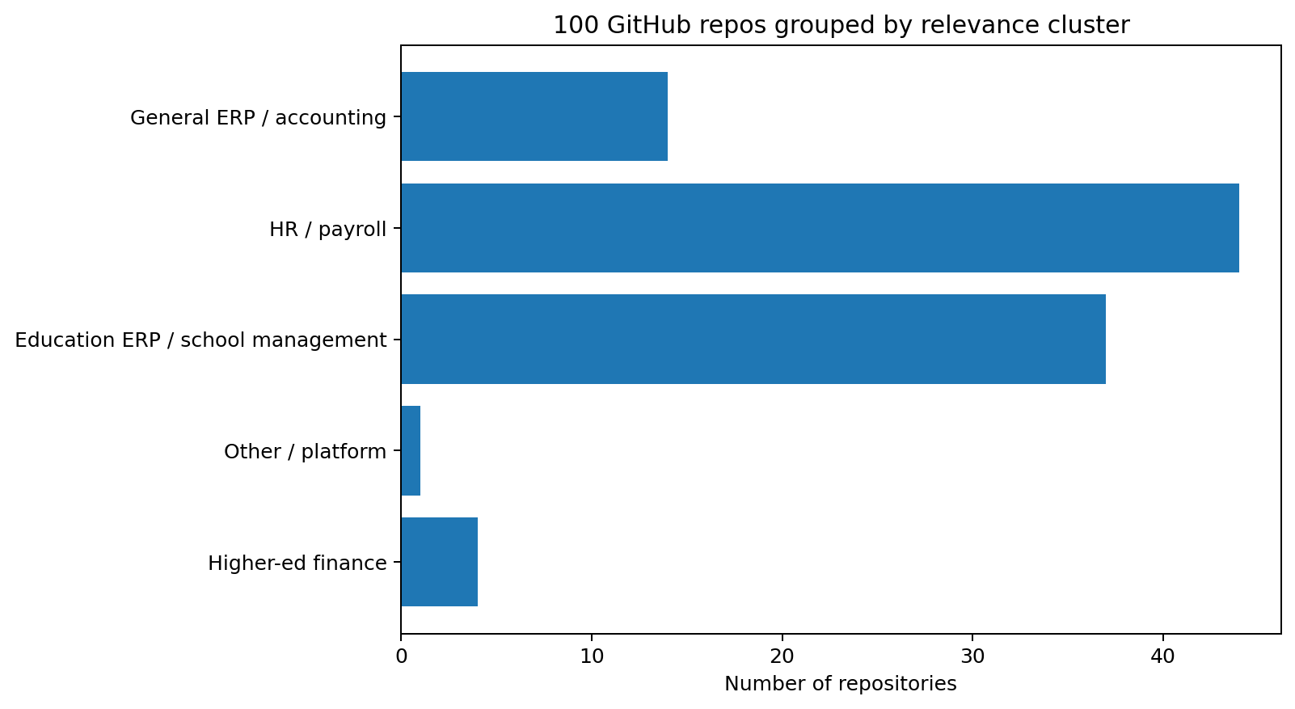
Figure 1. Repository corpus by relevance cluster.
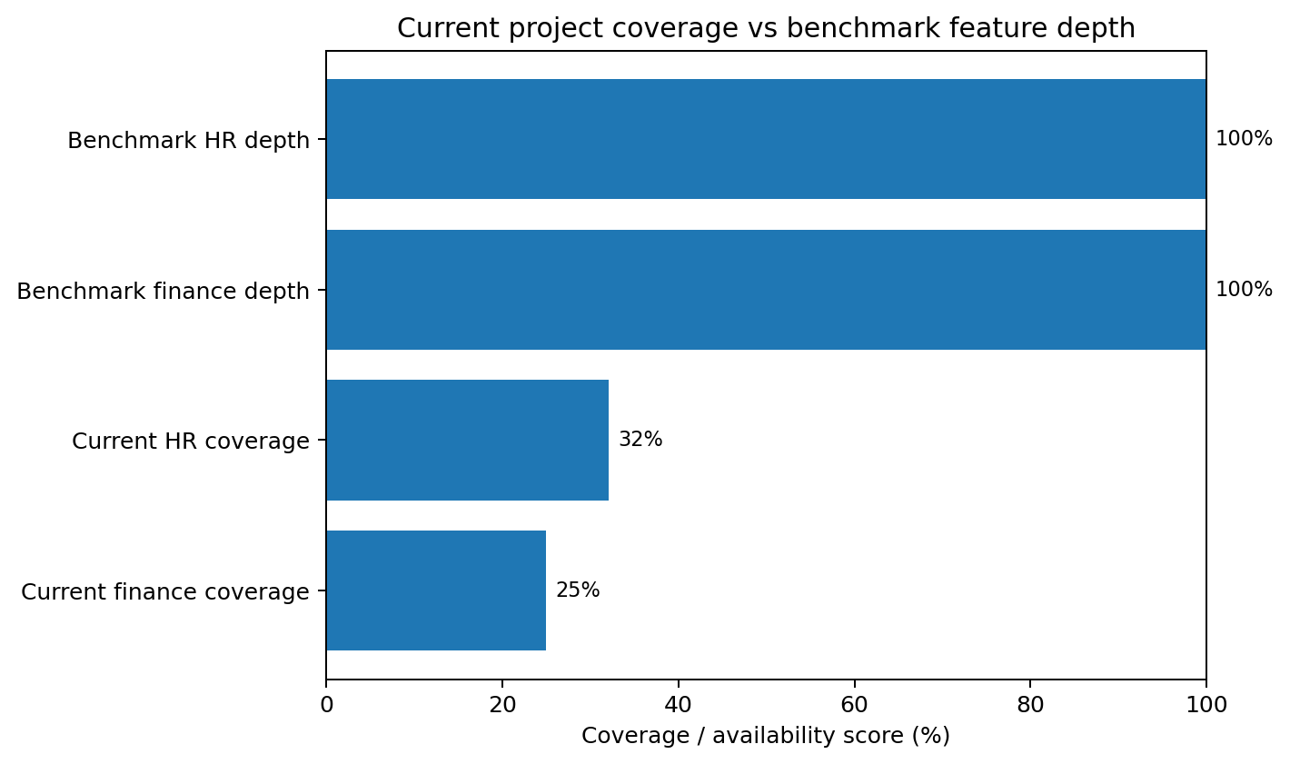
Figure 2. AIU current coverage vs benchmark feature depth.
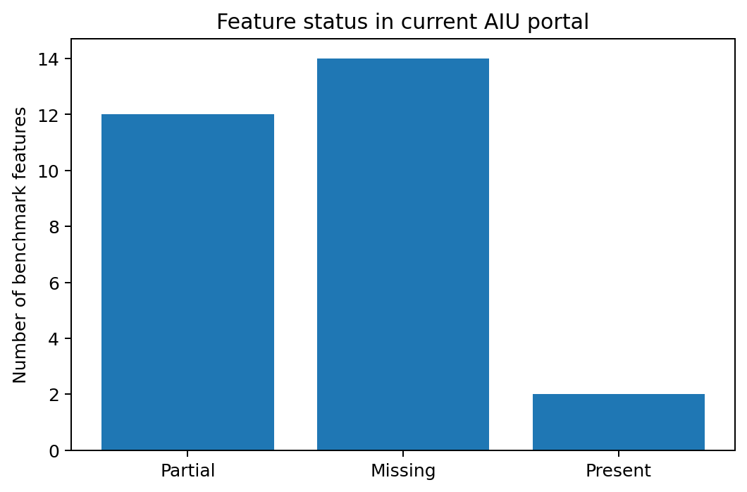
Figure 3. Count of present, partial and missing benchmark features.
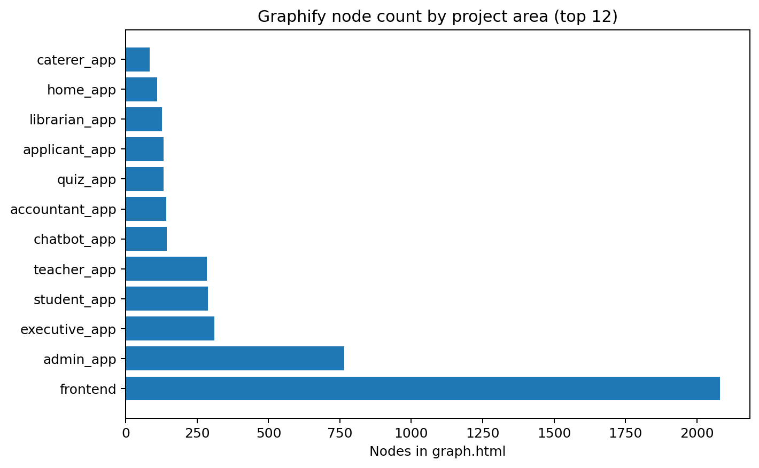
Figure 4. Graphify node count by project area.

3. Current project baseline from your documentation and Graphify output
Graphify report summary: 5665 nodes · 16050 edges · 345 communities (226 shown, 119 thin omitted). Graph HTML embedded summary: 4858 nodes · 12607 edges · 352 communities. The two uploaded graph artifacts appear to be from slightly different Graphify exports; the analysis treats the HTML graph as the inspectable node graph and the Markdown report as the broader corpus summary.
Domain | Implemented capability | Maturity
Public website & CMS | Home, about, admissions, scholarship, schools, centres,  departments, programmes, units, services, student life,  directories, news, events, announcements, official links, and  dynamic pages. | Implemented
Identity & accounts | Username/password login, applicant registration, admin-created  role accounts, profile picture updates, account recovery, role  routing, and role-detail lifecycle. | Implemented
Admissions | Applicant profile, intake/programme options, draft application,  scholarship data, documents, submission, status events, and  staff review. | Implemented
Academic directory | Schools, centres, departments, units, programmes, courses,  organizational scope, and public reuse of directory data. | Implemented
Semester administration | Calendar groups, registration phases, holidays, teaching/exam  periods, planned/running semesters, notifications, and IELTS  sessions. | Implemented
Course offerings & registration | Prerequisites, eligible schools, tutorial/lab groups, credit  limits, capacities, registration periods, enrollment, executive  manual registration, and history. | Implemented
Scheduling & calendar | Scoped executives create and maintain semester class schedules  with lecturer/venue conflict checks. Teachers can adjust one  class occurrence at a time, and students and teachers receive  role-filtered timetable and combined academic-calendar views.  Final exams and XLSX schedule export are also supported. | Implemented
Learning management | Course sections, folders, resources, course announcements,  capacity-limited presentation slots, individual and group  assignments, lab activities, upload rules, group invitations,  leader-only final actions, rubrics, submissions, comments,  feedback, and activity deadlines. | Implemented
Attendance | Teacher sessions, attendance codes, QR tokens, manual statuses,  corrections, student submission logs, reports, and  low-attendance notifications. | Implemented
Results & exams | Teacher result submissions, executive  batches/review/publication, transcript records, GPA/CGPA views,  coursework, semester PDFs, final exam schedules, venue  allocations, and exam slips. | Implemented
Leave & student life | Student leave requests, teacher/dean approval chain, tracking  history, emergency contacts, student affairs contacts, wardens,  hostels, and hostel rooms. | Implemented
Venue booking | Student/teacher requests, admin approval/rejection, reasons,  recurring-class conflicts, approved-booking conflicts, and  final-exam integration. | Implemented
Elections | SRC and school-scoped elections, seat counts, candidate  approval, exact ballot rules, result snapshots, publication, and  notifications. | Implemented
Library | Book catalogue, physical copies, shelves, laptops, student  borrow and acquisition requests, fulfillment, loans, returns,  due reminders, and role restrictions. | Implemented
Canteen | Monthly allowance policy, eligibility, monthly bonuses, student  accounts, caterer deductions, admin adjustments, and student  balance history. | Implemented
Finance subscriptions | Accountant role, ToyyibPay/DuitNow-compatible gateway settings,  gym and kitchen subscription plans, purchase checkout, callback  activation, printable subscription cards, and role-based  subscription access. | Implemented
ICT helpdesk | Student ticket submission, category/location, technician  assignment, status updates, progress notes, resolution, and  admin account management. | Implemented
Portal chatbot | Public AIU information answers, public directory email lookup,  privacy refusals, authenticated student/teacher timetable and  assignment tools, optional Ollama-backed generation, and chatbot  API tests. | Implemented
Notifications, reports & audit | Per-user notifications, unread summary/read actions, role  fan-out, deep links, admin/executive exports, report history,  structured change auditing, and scheduled assignment/library  reminders. | Implemented

4. Existing finance and HR-adjacent capabilities in your project

Finance-adjacent features already present
Existing capability | How it helps expansion
Accountant role and routing | accountant_app + frontend accountant workspace; already supports a finance user persona.
Finance gateway settings | FinanceGatewayConfig and ToyyibPay/DuitNow-compatible gateway configuration already exist.
Subscription plan/payment attempts | SubscriptionPlan, Subscription and PaymentAttempt support gym/kitchen subscriptions and payment return/callback.
Student fines/charges | Fine model/service/views plus student/accountant fine pages, due/overdue handling, payment link creation and manual deduction from meal allowance.
Canteen allowance integration | Student canteen account, monthly allowance, deductions, adjustments and balance history can become a subledger source.
Notifications/reporting/audit | Shared notification system, report exports and audit logs can be reused for finance and HR approvals.

HR-adjacent features already present
Existing capability | How it helps expansion
Identity and role-detail models | Profile links users to Student, Teacher, Executive, Librarian, Caterer, Technician, Accountant and Admin role details.
Academic staff roles | Teacher/executive workflows exist, but they are academic roles, not full employee HR records.
Student leave and class attendance | Useful patterns for approval and attendance, but not yet staff leave or employee time tracking.
Surveys/evaluations | Can be adapted into staff performance review and appraisal cycles.
Admin account management | Can seed onboarding/offboarding workflows, but currently lacks HR appointment lifecycle.

5. Repository corpus summary
The comparison uses all 100 repositories from the previously generated GitHub list. The purpose is to extract reusable feature patterns, not to recommend copying code directly. License compatibility and code quality must be checked before reuse.
Cluster | Repository count | What this cluster contributes
Higher-ed finance | 4 | Deep university finance patterns: GL, labor distribution, grants, AP, travel, effort certification.
Other / platform | 1 | Workflow/API/platform examples that may help architecture but are not core finance/HR.
Education ERP / school management | 37 | Student administration plus fees, invoice, accounting, HR/payroll patterns in school/college context.
HR / payroll | 44 | Employee lifecycle, attendance, leave, payroll, deductions, payslips, self-service.
General ERP / accounting | 14 | Accounting, procurement, inventory/assets, reporting, vendor and workflow patterns.

6. Feature gap matrix: what other repos have but your project lacks
Interpretation: Present = implemented or directly documented. Partial = adjacent foundation exists but not a full module. Missing = no clear implementation in current documentation/Graphify evidence.
Feature/functionality | Current AIU status | Repos showing pattern | Example repos | Recommended action
Higher-ed financial system | Partial | 3 | kuali/kfs, kuali/kfs-db, CU-CommunityApps/cu-kfs | Extend existing model/service into full workflow. Accountant role, gateway configuration, subscriptions, payment attempts and fines exist, but not a full KFS-like finance system.
General ledger / chart of accounts | Missing | 17 | frappe/education, frappe/erpnext, okoyechuka/school-managment-software, ashikahmed-bd/School-management-and-accounting-software, LitGrey-Technologies/Student-Dynamics, odoo/odoo | Add as new module or submodule with role, audit and report support. No chart of accounts, journal entries, ledger posting, trial balance or double-entry finance model is documented.
Student fee structure | Missing | 16 | frappe/education, Akshat4112/SchoolErp, adams-okode/school-management-system, hrshadhin/school-management-system, fayazkhan121/SMS-system, okoyechuka/school-managment-software | Add as new module or submodule with role, audit and report support. Roadmap explicitly recommends adding tuition fee structures.
Student ledger / AR | Missing | 1 | nong04/human-resources-management | Add as new module or submodule with role, audit and report support. Roadmap explicitly recommends student ledger/outstanding balances/finance holds.
Invoices and receipts | Partial | 11 | hrshadhin/school-management-system, fayazkhan121/SMS-system, Pinnacle96/Edulab-Software, SPF-UiO/spbm, odoo/odoo, Dolibarr/dolibarr | Extend existing model/service into full workflow. Subscription receipt/card generation exists; student invoice and tuition receipt lifecycle is not documented.
Payment gateway / online payment | Present | 6 | hrshadhin/school-management-system, fayazkhan121/SMS-system, Pinnacle96/Edulab-Software, TareqMonwer/Django-School-Management, krishsharma5169/university-management-system, akaunting/akaunting | Keep and harden; integrate with audit/reporting. ToyyibPay/DuitNow-compatible gateway settings, subscriptions, callbacks and fine payment links are documented.
Payment reconciliation | Missing | 1 | artivisi/balaka | Add as new module or submodule with role, audit and report support. Roadmap recommends gateway reconciliation; no reconciliation workflow currently appears.
Scholarship / sponsorship offsets | Partial | 2 | kuali/kfs, kuali/kc | Extend existing model/service into full workflow. Admissions scholarship data exists; finance offsets/sponsorship posting are not implemented.
Budgeting / budget construction | Missing | 3 | hrshadhin/school-management-system, akaunting/akaunting, ever-co/ever-gauzy | Add as new module or submodule with role, audit and report support. No institutional budget, department budget or budget-control module is documented.
Procurement / purchasing / AP | Missing | 36 | kuali/kfs, kuali/kfs-db, CU-CommunityApps/cu-kfs, frappe/education, frappe/erpnext, frappe/hrms | Add as new module or submodule with role, audit and report support. Roadmap recommends procurement, suppliers and purchase approvals.
Asset management | Partial | 6 | pbse/College-Management-System---Ruby-On-Rails, odoo/odoo, Dolibarr/dolibarr, aureuserp/aureuserp, artivisi/balaka, benjdiasaad/ERP | Extend existing model/service into full workflow. Library laptops, venues/rooms and hostel directories exist, but no fixed-asset accounting lifecycle.
Travel / expense claims | Missing | 8 | kuali/kfs, Akshat4112/SchoolErp, hrshadhin/school-management-system, fayazkhan121/SMS-system, Pinnacle96/Edulab-Software, akaunting/akaunting | Add as new module or submodule with role, audit and report support. No expense claim/travel reimbursement workflow is documented.
Research grants administration | Missing | 2 | kuali/kfs, kuali/kc | Add as new module or submodule with role, audit and report support. Roadmap recommends research and ethics management; finance/grants are not implemented.
Financial reports | Partial | 5 | TAIJULAMAN/scholarstika--saas-development, Harishganth-0704/College-Management-System, Sairam-Radhakrishnan/PayFlow, ajithb236/PayrollManagementSystem, LucasMissiba/Ghost-RH | Extend existing model/service into full workflow. Reports and XLSX exports exist, but not accounting statements such as GL, trial balance, AR aging.
Employee master / HRIS | Partial | 36 | openeducat/openeducat_erp, frappe/hrms, hrshadhin/school-management-system, okoyechuka/school-managment-software, Kyalo-kekee/Kenya-SMS-Core, kngetich45/School-management-system | Extend existing model/service into full workflow. Teacher/executive/librarian/caterer/technician/accountant role details exist, but not a unified employee master/personnel file.
Recruitment / ATS | Missing | 5 | frappe/hrms, aureuserp/aureuserp, ever-co/ever-gauzy, apipulse/brbhr-frontend, preston-56/hr-management-system | Add as new module or submodule with role, audit and report support. No employee recruitment or job applicant tracking workflow is documented.
Onboarding / offboarding | Missing | 1 | frappe/hrms | Add as new module or submodule with role, audit and report support. Admin-created role accounts exist, but no HR appointment/onboarding/offboarding lifecycle.
Employee leave management | Partial | 20 | frappe/hrms, LitGrey-Technologies/Student-Dynamics, doptor/doptor, phphrm/phphr, Gaurav241/OfficeOps-WPS, aryapatel23/Attendance-and-Payroll-Management | Extend existing model/service into full workflow. Student leave exists; staff/employee leave policies and approval flows are not documented.
Employee attendance / time tracking | Partial | 29 | navariltd/Junior-School, prajapatikaml/EduSec, Akshat4112/SchoolErp, pbse/College-Management-System---Ruby-On-Rails, kngetich45/School-management-system, adeshasur/Akuru-School-Managment-System | Extend existing model/service into full workflow. Class attendance exists for students; employee clock-in/timesheets are not documented.
Payroll engine | Missing | 52 | openeducat/openeducat_erp, frappe/hrms, adams-okode/school-management-system, hrshadhin/school-management-system, fayazkhan121/SMS-system, okoyechuka/school-managment-software | Add as new module or submodule with role, audit and report support. No salary structure, payroll period, payroll run or employee compensation engine is documented.
Statutory deductions / tax | Missing | 6 | frappe/hrms, kngetich45/School-management-system, lizardcat/usiu-payroll-system, artivisi/balaka, KeneanDita/PayRoll-System, alfredang/ai-hrms | Add as new module or submodule with role, audit and report support. No payroll tax, statutory contributions, Zakat/EPF/SOCSO-style deductions or localization rules are documented.
Payslips / paycheck PDFs | Missing | 5 | Pinnacle96/Edulab-Software, lizardcat/usiu-payroll-system, aryapatel23/Attendance-and-Payroll-Management, thaokvu/PayFlow, Marwanthe0/Employee_Management_Software | Add as new module or submodule with role, audit and report support. No employee payslip or payroll report PDF is documented.
Performance appraisal | Partial | 7 | openeducat/openeducat_erp, frappe/hrms, meowmeow9567/College-Management-System, ArshnoorKaur21/Edutopia, Gaurav241/OfficeOps-WPS, digitalinnovations-tech/hr_management_system | Extend existing model/service into full workflow. Course evaluation and surveys exist; staff performance appraisal/review workflow is not implemented.
Training / learning | Partial | 4 | itsproali/university_core, jeffjeff2023/CollegeManagementSystem, thaokvu/PayFlow, KeneanDita/PayRoll-System | Extend existing model/service into full workflow. LMS exists for courses; employee training and professional development records are not documented.
Employee self-service | Partial | 2 | aryapatel23/Attendance-and-Payroll-Management, SafetyMP/HR-ERP | Extend existing model/service into full workflow. Role dashboards exist; HR self-service for staff profile, leave, payslips and claims is missing.
Organization positions / job roles | Partial | 6 | SPF-UiO/spbm, Harishganth-0704/College-Management-System, ArshnoorKaur21/Edutopia, hubleto/erp, thaokvu/PayFlow, preston-56/hr-management-system | Extend existing model/service into full workflow. Roles/scopes exist, but HR positions, grades, reporting managers and employment types are not documented.
Workflow approvals | Present | 9 | kuali/kc, kuali/rice, frappe/education, ashikahmed-bd/School-management-and-accounting-software, Harishganth-0704/College-Management-System, meowmeow9567/College-Management-System | Keep and harden; integrate with audit/reporting. The portal already has approval patterns for admissions, leave, bookings, elections, results and reports.
Compliance / localization | Missing | 4 | frappe/hrms, odoo/odoo, yarsa/nepal-compliance, artivisi/balaka | Add as new module or submodule with role, audit and report support. No HR/finance localization framework is documented.

7. How to add Finance Management into the current project

Phase F1: Student billing and ledger foundation
- Add models: FeeCategory, FeeStructure, FeeItem, StudentCharge, StudentLedgerEntry, StudentBalanceSnapshot, StudentFinanceHold.
- Connect charges to AdmissionApplication, Enrollment, CourseRegistration, Hostel/Library/Canteen/Fine sources.
- Use immutable ledger entries; never update old financial rows except through reversal/adjustment entries.
- Expose APIs: /finance/fee-structures, /finance/student-ledgers, /finance/students/{id}/balance, /finance/holds.

Phase F2: Invoicing, receipts and payment allocation
- Add Invoice, InvoiceLine, Receipt, PaymentAllocation, RefundRequest and PaymentReconciliationBatch.
- Reuse existing PaymentAttempt and gateway callbacks, but allocate payments against invoice lines and ledger entries.
- Generate PDF invoices/receipts and store signed immutable copies with audit trail.
- Add accountant dashboard cards: billed, paid, outstanding, overdue, unallocated payments, failed callbacks.

Phase F3: Financial control and reporting
- Add chart of accounts and posting rules only after student ledger stabilizes.
- Add department/programme budgets, purchase requests, vendors, AP invoices and approvals.
- Add AR aging, trial balance, daily collection report, refund report, finance-hold report and scholarship-offset report.
- Export to XLSX/CSV and optionally integrate with ERPNext/Odoo/Kuali instead of rebuilding full GL.

Suggested finance model skeleton
class StudentCharge(models.Model):
student = ForeignKey(Student)
source_type = CharField() # tuition, hostel, fine, library, canteen, manual
source_id = PositiveIntegerField(null=True)
amount = DecimalField()
due_date = DateField()
status = CharField(choices=[DRAFT, POSTED, WAIVED, REVERSED])
class StudentLedgerEntry(models.Model):
student = ForeignKey(Student)
charge = ForeignKey(StudentCharge, null=True)
entry_type = CharField() # debit, credit, payment, waiver, refund, reversal
amount = DecimalField()
balance_after = DecimalField()
posted_by = ForeignKey(Profile)
posted_at = DateTimeField(auto_now_add=True)
class PaymentAllocation(models.Model):
payment_attempt = ForeignKey(PaymentAttempt)
ledger_entry = ForeignKey(StudentLedgerEntry)
amount = DecimalField()

8. How to add HR Management into the current project

Phase H1: Unified employee master
- Create hr_app and Employee model linked 1:1 to Profile, but do not remove Teacher/Executive/etc. role-detail models.
- Add EmploymentRecord, Position, DepartmentAssignment, SupervisorRelationship, ContractDocument and EmployeeDocument.
- Add staff status lifecycle: draft, active, probation, suspended, resigned, terminated, retired.
- Map existing role accounts into employee records with a migration command.

Phase H2: Staff leave and employee attendance
- Reuse student leave approval patterns but add LeaveType, LeavePolicy, LeaveEntitlement, LeaveRequest and LeaveApproval for employees.
- Add employee attendance/check-in with shift schedules, holiday calendars, late/absent rules and manual corrections.
- Expose self-service pages: My HR Profile, My Leave, My Attendance, My Documents.

Phase H3: Payroll
- Add SalaryStructure, SalaryComponent, EmployeeSalaryAssignment, PayrollPeriod, PayrollRun, PayrollLine, DeductionRule, Payslip.
- Support fixed salary, allowance, deduction, overtime, unpaid leave, advances and manual adjustment components.
- Lock payroll runs after approval; corrections should create adjustment lines in the next payroll period.
- Generate payslip PDFs, payroll journal export and bank-transfer file export.

Phase H4: Recruitment, onboarding and performance
- Add JobOpening, JobApplicant, Interview, Offer, OnboardingTask and OffboardingTask.
- Adapt existing survey/evaluation architecture into PerformanceCycle, AppraisalForm, ReviewSubmission and ReviewOutcome.
- Connect onboarding/offboarding to identity lifecycle: account creation, role provisioning, MFA, access revocation.

Suggested HR model skeleton
class Employee(models.Model):
profile = OneToOneField(Profile)
employee_no = CharField(unique=True)
employment_status = CharField()
joining_date = DateField()
reporting_manager = ForeignKey('self', null=True)
class PayrollRun(models.Model):
period = ForeignKey(PayrollPeriod)
status = CharField(choices=[DRAFT, REVIEW, APPROVED, PAID, CANCELLED])
approved_by = ForeignKey(Profile, null=True)
class Payslip(models.Model):
payroll_run = ForeignKey(PayrollRun)
employee = ForeignKey(Employee)
gross_pay = DecimalField()
total_deductions = DecimalField()
net_pay = DecimalField()
pdf_file = FileField(null=True)

9. Integration plan with your existing architecture
Existing project area | Integration action
Profile and role routing | Add Employee as a cross-role master; keep existing role details for academic permissions.
accountant_app | Keep subscriptions/fines; add finance_ledger.py, invoice_service.py, reconciliation_service.py and reporting endpoints.
admin_app | Add HR admin pages for positions, departments, employee creation, offboarding and role provisioning.
student_app | Expose student ledger, invoices, receipts, finance holds and payment history.
teacher/executive/librarian/caterer/technician roles | Map each role-detail record to Employee for HR, leave, payroll and documents.
notifications_package | Reuse for invoice issued, receipt paid, overdue, HR approval, payroll published, leave decision and document expiry alerts.
reports/audit | Reuse audit for every money/HR mutation; add export definitions for finance and payroll reports.
Celery beat/worker | Add scheduled jobs: invoice due reminders, reconciliation imports, payroll calculations, leave accruals, document expiry warnings.
Frontend | Create route groups /finance/*, /hr/* and self-service pages under existing role-zone navigation.

10. Prioritized backlog
Priority | Backlog item | Scope | Suggested size
P0 | Student ledger core | StudentCharge, StudentLedgerEntry, invoice/receipt baseline, balance API, finance hold integration. | 2-3 sprints
P0 | Unified employee master | Employee linked to Profile, employment record, position, supervisor, documents, migration from existing staff roles. | 2 sprints
P1 | Invoice/payment allocation/reconciliation | Allocate existing gateway payments against invoices/fines/subscriptions; reconciliation batch; unallocated payment handling. | 2-3 sprints
P1 | Staff leave + attendance | Employee leave policy, entitlement, approvals, employee check-in/timesheet and correction workflow. | 2-3 sprints
P1 | Payroll MVP | Salary structure, payroll period/run, payslips, allowances/deductions, PDF and XLSX export. | 3-4 sprints
P2 | Budgets/procurement/AP | Purchase request, vendor, AP invoice, budget line, approval and reporting. | 4+ sprints
P2 | Recruitment/onboarding/performance | Job openings, applicants, onboarding tasks, performance cycles and offboarding access revocation. | 4+ sprints
P2 | GL/accounting integration | Either build simple GL or integrate ERPNext/Odoo/Kuali export connector. | Depends on policy

11. Appendix A: all 100 repositories used in comparison
# | Repository | Category | Fit | Feature notes
1 | kuali/kfs | Higher-ed finance | Strong | Kuali Financial System; comprehensive financial management system for higher education, including modules such as contracts & grants, labor distribution, purchasing/AP, travel/entertainment, and effort certification.
2 | kuali/kfs-db | Higher-ed finance support | Strong | Database import/export, demo data, and bootstrap datasets for Kuali Financial System; useful when evaluating or setting up KFS.
3 | CU-CommunityApps/cu-kfs | University finance customization | Strong | Cornell University customizations for Kuali Financial System; useful as a real university implementation/reference customization layer.
4 | kuali/kc | Research finance/grants | Strong | Kuali Research/Kuali Coeus; research administration system for grants, sponsored projects, and faculty research administration workflows.
5 | kuali/rice | Workflow/platform | Useful | Kuali Rice workflow/platform services used across Kuali higher-education administrative systems; useful if exploring legacy Kuali stack architecture.
6 | openeducat/openeducat_erp | Education ERP | Strong | Education ERP for schools/colleges/universities. Search snippet highlights HR & Payroll Management for staff records, payroll, and performance reviews.
7 | frappe/education | Education ERP | Strong | Frappe Education; open-source education/school management module built on ERPNext/Frappe, with administrative and academic workflows and ERPNext accounting integration for fees.
8 | frappe/erpnext | ERP + education/finance | Strong | 100% open-source ERP with accounting, operations, and education-domain support; useful as the base ERP when paired with Frappe Education and Frappe HR.
9 | frappe/hrms | HR/payroll | Strong | Frappe HR / HRMS; open-source HR and payroll software covering employee management, onboarding, leave, payroll, taxation, recruitment, shifts, and performance.
10 | fderyckel/ifitwala_ed | Education operating system | Strong | Ifitwala Ed; open-source Education Operational System for schools, colleges, and education groups with a unified permission model and analytics surface.
11 | fderyckel/ifitwala_ed_v2 | Education operating system | Strong | Ifitwala_Ed v2; described as a unified institutional operating system replacing fragmented SaaS tools with one data model and permissions system.
12 | fderyckel/ifitwala_ed_V0 | Education ERP variant | Useful | Earlier Ifitwala Ed / Frappe app based on ERPNext Education domain; useful for implementation history and ideas.
13 | navariltd/Junior-School | Frappe Education extension | Useful | Frappe Education extension for scheduling, attendance, assessment, automated student lifecycle, and multi-school environments.
14 | prajapatikaml/EduSec | College/university ERP | Strong | EduSec college management system; covers university functions including admission, administration, timetable, examination, HR, finance, library, transport, and attendance.
15 | djoudi/EduSec2.0.0 | College/university ERP | Useful | Fork/new version of EduSec 2.0.0; includes education-industry modules such as HR and finance according to README snippet.
16 | Akshat4112/SchoolErp | School ERP | Strong | SchoolERP with student management, accounts, attendance, faculty management, HR management, fees, expenses, results, and marks.
17 | pbse/College-Management-System---Ruby-On-Rails | College management | Strong | Ruby on Rails school/college management system with Student, Faculty/Non-Faculty, HR, Finance, messaging, hostel, inventory, online exam, and attendance modules.
18 | adams-okode/school-management-system | School MIS | Strong | ALANA Open Source School MIS; includes finance management, HRM, payroll, student fees, accommodation, and library modules.
19 | hrshadhin/school-management-system | School management | Strong | School system with account management, budget, account heads, student invoice, income/expense management, payroll, salary template, and employee salary payment.
20 | fayazkhan121/SMS-system | School management fork/reference | Useful | School management system referencing CloudSchool/hrshadhin setup; includes student invoice, income/expense, payroll, salary templates, and salary payment in snippet.
21 | okoyechuka/school-managment-software | School management | Strong | Open-source PHP school management software with fee module, financial accounting, double-entry accounting, HR module, employee payroll, pay-slip generation, and processing.
22 | Kyalo-kekee/Kenya-SMS-Core | School MIS | Useful | K-SMS: Kenyan School Management Information System with student, class, staff, exam, HR, hostel, and fee management modules.
23 | kngetich45/School-management-system | School management | Useful | School management system with fees, attendance, staff/student management, and easy payroll with allowances and deductions.
24 | TAIJULAMAN/scholarstika--saas-development | Multi-tenant school SaaS | Strong | Scholarstika: multi-tenant school management system with fees, transactions, earnings, payroll, financial reports, staff/student management, and branch payroll administration.
25 | Pinnacle96/Edulab-Software | School SaaS | Strong | Edulab SaaS multi-tenant school management system with finance: fee management, invoicing, online payments, expense tracking; HR & Payroll: staff management, payroll, payslips.
26 | Dantechdevs/CBC-school | School management | Useful | ElimuMS / CBC school management system for Kenyan schools; includes fees and finance management and broader operational modules.
27 | musaibasrar/Curium | School management | Useful | Curium comprehensive school management software; includes fee collection and mess/payroll according to README snippet.
28 | hk-kumawat/College-Management-System | College management | Useful | Digital solution for college operations, student/teacher management, fee tracking, and record keeping.
29 | TareqMonwer/Django-School-Management | School management | Useful | Django school management system; snippet highlights payments, e-admissions, and results management.
30 | ashikahmed-bd/School-management-and-accounting-software | School accounting | Strong | School Management and Accounting Software; useful for education finance/accounting workflows and local customization ideas.
31 | LitGrey-Technologies/Student-Dynamics | Education ERP | Useful | Student Dynamics ERP for educational institutes; topics include HR, HRMS, leave management, accounting software, library, admissions, SMS, and school management.
32 | aisuresh/School-Management-System | School management | Useful | SaaS-based school management system for school-related activities and process automation.
33 | adeshasur/Akuru-School-Managment-System | Education ERP | Useful | Akuru school ERP for Sri Lankan schools; handles core operations including student management, attendance, exam grading, and finance management.
34 | SPF-UiO/spbm | University student personnel/payroll | Useful | Student Personnel Booking Manager for University of Oslo student pub personnel organization; topics include Django, invoicing, booking, student management, and payroll.
35 | Emalsha/hris | University HRIS | Useful | Human Resource Information System for University of Colombo School of Computing by team Helix.
36 | lizardcat/usiu-payroll-system | University payroll | Useful | USIU-Africa Payroll System for a hypothetical university in Kenya; salary computation, statutory deductions, and payslip generation.
37 | Marwanthe0/Payroll_Management_Software | University payroll | Useful | FastAPI + Streamlit payroll management software for a university according to GitHub topic snippet.
38 | krishsharma5169/university-management-system | University management | Limited | Python university management system for student registration, course enrollment, attendance, and payments.
39 | itsproali/university_core | University core service | Limited | University Management Core Service for academic operations such as courses, semesters, registration, and student management.
40 | jeffjeff2023/CollegeManagementSystem | College management | Limited | College management system for automating student records, faculty details, courses, and related operations.
41 | bonitoflakez/college-student-management-system | College management | Limited | React/TypeScript/Node/PostgreSQL web app for college operations and student experience management.
42 | themohitshaw/KMBB-CMS | College CMS | Limited | Flask/MySQL college management system for students, faculty, notices, and academic activities.
43 | shshwtsrkr/College-Management-System | College management | Limited | Full-stack college management website with PHP/MySQL backend and HTML/Bootstrap/JavaScript frontend.
44 | Harishganth-0704/College-Management-System | College management | Limited | MERN college management system with admin, faculty, and student roles, attendance tracking, notes, notifications, and reports.
45 | meowmeow9567/College-Management-System | College/school management | Limited | MERN school/college management system for students, faculty, classes, attendance, performance, marks, and communication.
46 | ArshnoorKaur21/Edutopia | School management | Limited | MERN school management app for class organization, student/faculty records, attendance, assessment, and feedback.
47 | AmitXShukla/Online-School-Management-App-Angular-Firebase | School management | Limited | Angular/Firebase online school management app for students, records, grades, fees, attendance, staff, and notifications.
48 | odoo/odoo | General ERP | Strong | Odoo Community; web-based open-source business apps including billing/accounting, project management, HR, inventory, manufacturing, marketing, and more.
49 | OCA/hr | Odoo HR addons | Strong | Odoo Community Association HR addons; useful for extending Odoo HR functionality in an open-source/community stack.
50 | OCA/payroll | Odoo payroll addons | Strong | Odoo payroll management modules from OCA; useful for payroll on top of Odoo Community.
51 | yarsa/nepal-compliance | ERPNext compliance | Useful | ERPNext compliance app for Nepal covering HR, Payroll, and Accounting modules; useful as an ERPNext localization/compliance pattern.
52 | Dolibarr/dolibarr | General ERP/CRM | Strong | Dolibarr ERP/CRM for contacts, suppliers, invoices, orders, stocks, agenda, accounting, and other business/foundation activities.
53 | aureuserp/aureuserp | General ERP | Strong | Free and open-source ERP platform with sales, accounting, maintenance, invoice, manufacturing, recruitment, inventory, HRM, warehouse, PMS, and purchasing modules.
54 | akaunting/akaunting | Accounting/finance | Strong | Online accounting software covering finance, invoices, payments, payroll, billing, budgets, expenses, and bookkeeping.
55 | idurar/idurar-erp-crm | ERP/CRM accounting | Useful | Free open-source ERP/CRM software with accounting and invoicing built with Node.js and React.
56 | metasfresh/metasfresh | General ERP | Useful | Open-source ERP described as fast, flexible, and free; includes business, accounting, CRM, manufacturing, and PostgreSQL-based operations.
57 | apache/ofbiz-framework | General ERP framework | Strong | Apache OFBiz ERP framework with broad business-process automation; official snippet says it houses libraries, entities, services, and features for business operations.
58 | apache/ofbiz-plugins | OFBiz plugins | Useful | Complementary plugins for Apache OFBiz, adding enterprise/e-commerce/business features to the framework.
59 | ever-co/ever-gauzy | ERP/CRM/HRM/ATS | Strong | Ever Gauzy open business management platform covering ERP, CRM, HRM, ATS, project management, employees, finance, invoices, expenses, time tracking, and budgets.
60 | wp-erp/wp-erp | WordPress ERP | Useful | Open-source ERP solution for WordPress with accounting, CRM, and HR topics/modules.
61 | notrinos/NotrinosERP | ERP/accounting/HR | Strong | Web-based ERP/accounting system in PHP/MySQL including CRM, sales, purchasing, warehousing, manufacturing, payroll, and human resource modules.
62 | minthcm/minthcm | HCM | Useful | Open-source HCM system for managing HR processes with full data ownership and no vendor lock-in.
63 | hubleto/erp | ERP/CRM | Useful | Hubleto ERP/CRM core with free-to-use apps for managing organizations; customizable and fully open source according to topic snippet.
64 | iota-uz/iota-sdk | Modular ERP | Useful | Open-source modular ERP alternative to SAP/Oracle/Odoo; topic snippet mentions ERP finance.
65 | artivisi/balaka | Accounting + payroll | Useful | Open-source accounting application for Indonesian SMEs with tax compliance, payroll, inventory, bank reconciliation, and invoicing.
66 | benjdiasaad/ERP | ERP | Useful | Multi-company ERP with sales, purchasing, inventory, finance, HR, CRM, projects, events, permissions, and tenant isolation.
67 | ItzKssBerc/comproller | ERP | Useful | Modern Laravel ERP with finance, HR, attendance monitoring/tracking, payroll-management topics, and Filament UI.
68 | doptor/doptor | Accounting/HR/payroll/college | Useful | Doptor platform mentioned in Laravel OSS lists as including accounting, HR, payroll management, and college management modules.
69 | phphrm/phphr | HRMS/payroll | Strong | PHPHR Open-Source Edition; HR management system with employee, attendance, leave, and payroll modules.
70 | Devnawjesh/hr-payroll | HR/payroll | Strong | Modern responsive HRM built with PHP/Laravel for office and employee management.
71 | MusheAbdulHakim/Smarthr-hr-payroll-project-employee-management-System | HR/payroll | Useful | Smart HR management system with PHP and MySQL; useful for employee management/payroll workflows.
72 | ahmedsaadawi13/splash-hr | HR/payroll | Strong | Complete HR and Payroll management system in PHP/MySQL with multi-tenancy, HR features, and REST API integration.
73 | Gaurav241/OfficeOps-WPS | Workforce/HR | Useful | Django Workforce Productivity Suite for HR and office management, attendance, feedback, leave, and employee operations.
74 | aryapatel23/Attendance-and-Payroll-Management | Attendance/payroll | Useful | Full-stack attendance and payroll management with HR/admin and employee dashboards, salary slip generation, leave, holidays, and payroll processing.
75 | shashikiran-dev/Payroll-Management-System | Payroll | Useful | Scalable payroll management with microservice architecture, attendance, leave processing, WFH tracking, analytics, and chatbot integration.
76 | thaokvu/PayFlow | Payroll | Useful | Secure Flask payroll management system with paycheck generation, roles, financial data, and PDF paychecks.
77 | Sairam-Radhakrishnan/PayFlow | Payroll | Useful | Employee Payroll Management System for employee records, salary calculations, and reports for full-time/part-time employees.
78 | Duisternis/Payroll-Management-System | Payroll | Useful | Python payroll management application for employee payroll and salary processing; MIT license shown in search snippet.
79 | emmanpbarrameda/Employee-Payroll-Management-System-Java-GUI | Payroll | Useful | Java Swing Employee Payroll Management System with installer, desktop app, and MySQL database.
80 | ajithb236/PayrollManagementSystem | Payroll | Useful | Django web-based payroll system for compensation, attendance tracking, leave management, and financial reporting.
81 | KeneanDita/PayRoll-System | Payroll | Limited | Java console payroll management system for salary calculations, tax deductions, and employee records.
82 | RJGATON007/hr-payroll | HR/payroll | Useful | Human Resource Management System in PHP CodeIgniter and Laragon; payroll/HRMS focus.
83 | Ranazia943/multi-company-payroll-attendance-system | HR/payroll | Useful | Multi-company HR & Payroll system with fingerprint attendance, leave, and salary management.
84 | MiraiNetwork/hr-platform | HR/payroll | Useful | Open-source HR management platform covering employee, attendance, leave, shift, accounting, payroll, and multi-tenant SaaS topics.
85 | SafetyMP/HR-ERP | HR/payroll SaaS scaffold | Useful | Open-source reference for multi-tenant HR SaaS with payroll kernel, employee self-service/manager flows, and governance harness.
86 | nong04/human-resources-management | Odoo HR modules | Useful | Odoo 17 HR management suite with core HR, leave balances, systray attendance, and automated payroll.
87 | 4ban-university/HRMS-MicroServices | HRMS microservices | Useful | Software project management HRMS microservices repository with payroll folder/topic; Java/Spring microservice reference.
88 | lagunadevs/hris | HRIS/payroll | Useful | SEA HR Systems: payroll, leave management, and time attendance management.
89 | apipulse/brbhr-frontend | HRMS frontend | Useful | Frontend for brbhr HRMS built with React/Chakra UI; aims at production-grade HRMS with hiring, attendance, payroll, leave, and enterprise HR topics.
90 | digitalinnovations-tech/hr_management_system | HR management | Useful | HR management system for employees, payroll, attendance, leave requests, performance tracking, and secure admin dashboard.
91 | Trevor-Kayeyia-Madara/Vegro-HR-Management-Platform | HR platform | Useful | Modern HR platform for employee management, payroll, attendance, and access control built with PHP/Laravel concepts.
92 | dev-javid/bit-hrms | HRMS | Useful | .NET + React HRMS with employee management, attendance tracking, leave management, and salary processing.
93 | preston-56/hr-management-system | HR management | Useful | Next.js HR management system for employees, recruitment, leave tracking, performance reviews, and organizational workflows.
94 | alexisbriandev/php-attendance-management-system | Attendance/leave | Useful | PHP Attendance Management System for HR attendance lifecycle; supports leave-management topic.
95 | LucasMissiba/Ghost-RH | HR support | Useful | HR support system with QR-code time tracking, vacation management, document upload, reporting, and dashboard.
96 | Xilantra/coralhr | HR/payroll | Limited | HRMS/payroll-related repository with broad HR software keywords; evaluate actual code before use.
97 | alfredang/ai-hrms | HRMS | Useful | AI-powered HRMS with employee management, leave tracking, Singapore CPF payroll, expense claims, and chatbot.
98 | Marwanthe0/Employee_Management_Software | Employee/payroll | Useful | Employee management software with add/delete/update employees, pay amount adjustment, and monthly payslip printing.
99 | hassanmahfuj/HR-Glance | HRMS | Useful | Java HR management system for personal data, attendance, leaves, and payroll.
100 | SupportComeos/HR-API | HR API | Limited | Spring Boot API for an HR SaaS solution.

12. Sources and evidence used
- Uploaded project documentation: documentation.html (AIU Unified Portal — Project Documentation).
- Uploaded Graphify files: GRAPH_REPORT(1).md and graph.html.
- Previously generated repo list: open_source_university_finance_hr_github_repos.docx / repos.json containing 100 GitHub repositories.
- Representative GitHub/official project pages checked for major reference projects: Kuali KFS, Frappe Education, ERPNext, Frappe HRMS, OpenEduCat, Odoo/OCA, Dolibarr, OrangeHRM, Axelor, Apache OFBiz and related repos.

