Book

Page 1
Status: approved | Confidence: 85.0 | Size: 2550x3270 px

Background
Colour #F8D0A4. Warm peach page background with a few faint lighter diagonal light streaks on the left and right edges
Rebuild notes: Flat peach colour across the page; faint pale light rays from upper left and along the left and right edges, no pattern and no printed text. Plain colour used because the streaks are very faint.

Text
আমি ও আমার পরিবার
t1 | heading | box [630, 185, 1920, 385] | agreed | read-agreement 1.0 | SolaimanLipi 36 pt | bold yes | italic no | colour #E31E24 | align center | order 1
আমি নাবিল। আমার বোন নুহা। এই আমার বাবা, এই আমার মা। এই আমার দাদি। আমার দাদা বাড়িতে নেই। এই আমার পরিবার। আমরা সবাই একসাথে থাকি।
t2 | body | box [215, 2385, 2360, 3065] | agreed | read-agreement 1.0 | SolaimanLipi 30 pt | bold no | italic no | colour #1B1B1B | align center | order 2

Pictures
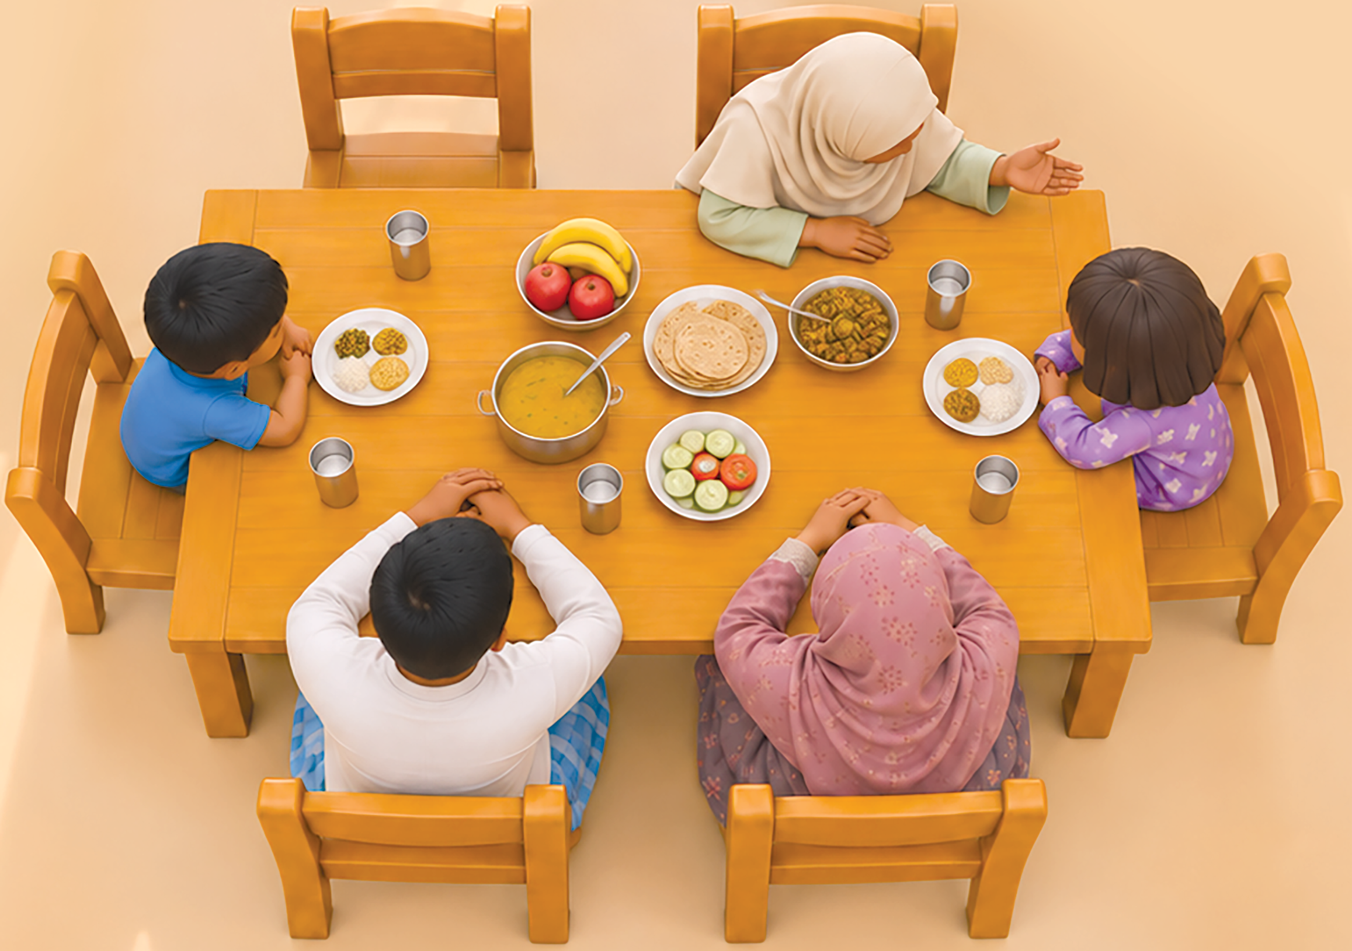
i1 | illustration | file images/i1.png | box [110, 620, 2425, 2250] | layer 2 | rotation 0 | opacity 1.0 | overlaps text: none
Description: A 3D-style rendered overhead view of a family sitting at a wooden dining table: a woman in a beige headscarf and sage-green sleeves on the upper right, a small boy in blue on the left, a girl in purple pyjamas on the right, and a boy in a white shirt and a woman in a pink patterned headscarf seated at the bottom. Six wooden chairs surround the table. On the table are a pot of yellow dal with a ladle, a plate of flatbread (roti), a bowl of fruit (bananas and apples), a bowl of cooked vegetables, a plate of cucumber and tomato, three plates of rice with side dishes, and four metal cups.
Purpose: Shows the family sitting together at the meal, as the picture for the page
Style: photorealistic-style 3D render, soft even lighting, soft shadows under the chairs and table, no outline
Main colours: #E0A24A, #F7E7CF, #2B7BD6, #8E4FA3, #F4F2EE, #C9708C, #D9B07A, #F0C94A, #D63A2F
Rebuild notes: One crop of the whole scene (table, six chairs, people and food together). The people, chairs and food are not saved as separate pictures because they sit in one scene and touch each other. Include the chair shadows at the bottom. The scene has no printed text. The table is a warm orange wood with plank lines. Each person is seen from above and behind.

Doubts and unknown words
- doubt: t1: font name and size are a guess from the image
- doubt: t2: font name and size are a guess; box covers 4 lines, top and bottom margins set at about 30 px by eye
- doubt: t2: the four lines may need splitting into separate blocks if the vote fails on line breaks
- doubt: Background colour #F8D0A4 is estimated by eye from the image; check against the real page
- doubt: The faint light streaks on the background were left out (image_file null); a checker may want them as bg.png if they matter
- doubt: The illustration box was set by eye from the displayed image (scale 1.64); the chair edges and shadows at the bottom should be checked against the crop

Page 2
Status: approved | Confidence: 55.0 | Size: 2550x3270 px

Background
Colour #F9D98C. Warm sandy-yellow ground behind the house scene and the lower text area
Rebuild notes: Flat warm sand colour with a soft lighter patch near the lower middle; no printed text. Bottom-middle is a pale grey-white street, which is part of the scene picture i3 and the top scene i1, not the background

Text
Working
t1 | heading | box [690, 1310, 1870, 1700] | agreed | read-agreement 1.0 | Serif (English display) 72 pt | bold no | italic no | colour #231F20 | align center | order 1
আমাদের বাড়ি
t2 | heading | box [510, 1850, 1300, 2070] | agreed | read-agreement 1.0 | SolaimanLipi 36 pt | bold yes | italic no | colour #E0202A | align center | order 2
এটা আমাদের বাড়ি। শোবার ঘরে আমরা ঘুমাই। খাবার ঘরে আমরা খাই। মেহমানের ঘরে মেহমান বসেন। বাথরুমে হাত-মুখ ধুই। বারান্দায় খেলি।
t3 | body | box [200, 2069, 1630, 3113] | agreed | read-agreement 1.0 | SolaimanLipi 28 pt | bold no | italic no | colour #231F20 | align center | order 3

Pictures
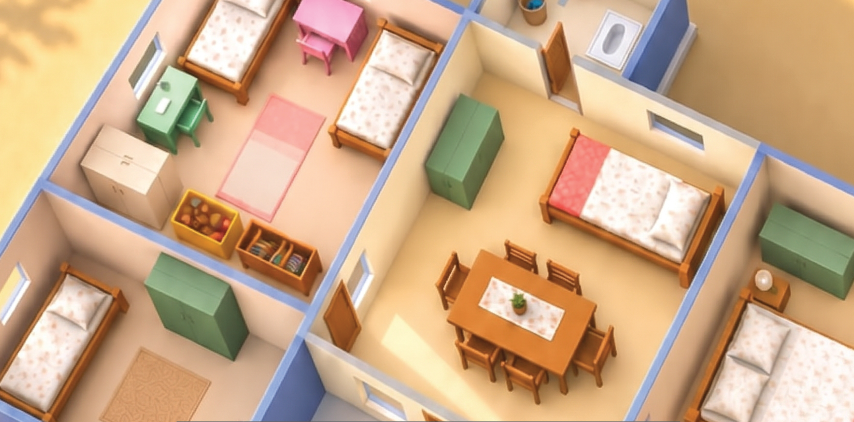
i1 | illustration | file images/i1.png | box [0, 0, 2550, 1263] | layer 2 | rotation 0 | opacity 1.0 | overlaps text: none
Description: Isometric 3D cutaway of a family house: several rooms with beds, a pink desk and chair, a green wardrobe, a wooden dining table with six chairs, a bathroom toilet, rugs and blue-grey walls, seen from above
Purpose: Full-page scene that sets the story setting above the title
Style: photo-like 3D render, soft shading, no outlines, soft shadows on the floor
Main colours: #F3D9A4, #8FA0D6, #C9793A, #F5B8C0, #4E7A4E, #FFFFFF
Rebuild notes: Bottom edge is cut at the top of the grey label box, so the lower rooms and street continue in i3 and the lower-left rooms are cut through. Contains the pink desk, green wardrobe, dining set and bed pieces, all part of this one scene (no separate pictures cropped from it)

i2 | shape | file images/i2.png | box [530, 1263, 2040, 1738] | layer 3 | rotation 0 | opacity 0.5 | overlaps text: t1
Description: Semi-transparent dark grey rectangle with the English word Working printed in large black serif letters across it
Purpose: Label box that holds the English heading over the scene
Style: flat grey, about 50% opacity, sharp corners, no outline
Main colours: #6E6E6E, #231F20
Rebuild notes: The word Working is printed on this box and is text (heading t1), not part of the picture; it is included in the crop only because it sits on the box. Box edges are estimated by eye. Behind the box the scene shows through
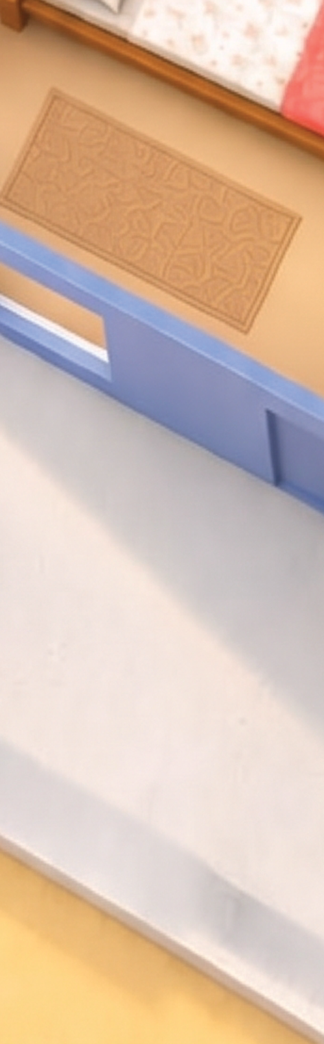
i3 | illustration | file images/i3.png | box [2050, 1263, 2550, 2870] | layer 2 | rotation 0 | opacity 1.0 | overlaps text: none
Description: Right-hand part of the house scene: the lower-right bedroom with a bed with a red blanket and a rug, a green sofa, and a pale grey-white street running diagonally
Purpose: Continues the house scene down the right edge
Style: photo-like 3D render, soft shading
Main colours: #F4E3C4, #C9793A, #D9454F, #4E7A4E, #E4E0E0
Rebuild notes: Cut along a vertical line at x 2050; the lighter street and wall in the middle of the page (x 1100 to 2050) are not cropped and stay in the background/scene, so this crop is only the right edge. Contains a bed and a sofa that are part of this scene
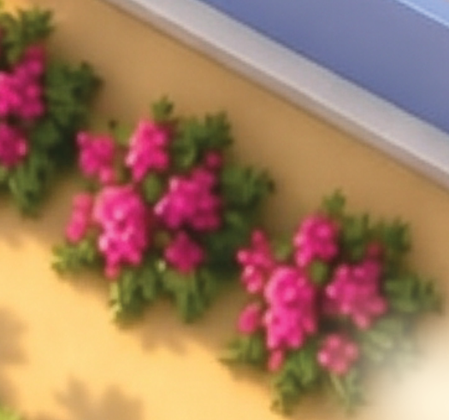
i4 | illustration | file images/i4.png | box [0, 1476, 525, 1968] | layer 2 | rotation 0 | opacity 1.0 | overlaps text: none
Description: Cluster of pink flowering shrubs with dark green leaves at the left edge
Purpose: Decorates the lower-left corner beside the text
Style: photo-like 3D render, soft shading
Main colours: #E0479A, #2F5A2A, #7DB35A
Rebuild notes: Several dozen small pink blossoms on dark green bushes, in a loose cluster
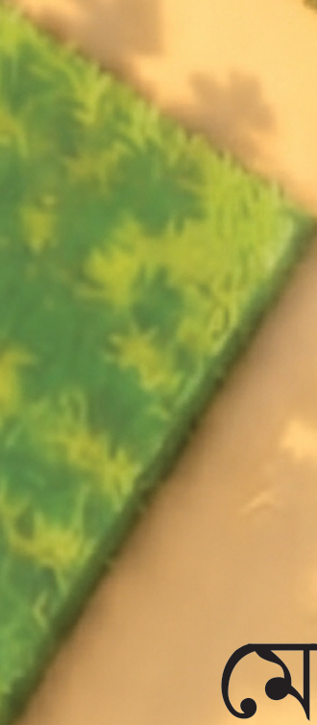
i5 | illustration | file images/i5.png | box [0, 1952, 330, 2706] | layer 2 | rotation 0 | opacity 1.0 | overlaps text: none
Description: Green grass lawn patch at the left edge of the ground
Purpose: Decorates the lower-left ground
Style: photo-like 3D render, soft shading
Main colours: #6FAE4A, #3E7A2E
Rebuild notes: Solid green lawn with a straight right edge and a rounded bottom edge

Doubts and unknown words
- doubt: t1: English heading 'Working' sits on a grey translucent box; box edges are a judgement by eye
- doubt: t1: font name and size are guesses
- doubt: t2: font name and size are guesses; the red title has a light glow behind it
- doubt: t3: six Bangla lines in one block; line 1 top and line 6 bottom are estimated, font size is a guess
- doubt: i1 and i3 are cut through rooms and the street at the edges, so the scene is in several pieces; box edges are estimated by eye
- doubt: i2 box edges are estimated; the word Working is printed on the box (t1), so the crop contains text
- doubt: background colour is a guess from the sand colour; the street at the middle is not cropped and may need a separate picture or a redraw
- doubt: the lower-middle and bottom sand area is plain background; no separate crop was made

Page 3
Status: approved | Confidence: 55.0 | Size: 2550x3270 px

Background
Colour #8FC9EC. Full-page illustration of a sunny school scene. Sky is light blue with white cumulus clouds at the top; the lower page is a warm sand-coloured paved ground. The page's scene is drawn in a 3D-style cartoon (soft lighting, realistic-looking shading).
Rebuild notes: No background crop saved: the sky and sand ground contain printed text (title in the sky, three body lines on the sand), so no text-free crop exists. Sky: top ~270 px of the page, blue gradient to pale near horizon, clouds at left top and right top, one small cloud near the flag. Ground: sand/peach #E8C49A-like flat tone with soft shadows under the children and the gates. Grass lawn sits between the building and the ground (y about 1100-1300 at display scale, roughly 1800-2100 px original). Left and right brick pillar bases are brick red #A4553A with cream plaster above.

Text
আমাদের স্কুল
t1 | heading | box [890, 200, 1660, 407] | agreed | read-agreement 1.0 | unknown Bangla font 42 pt | bold no | italic no | colour #000000 | align center | order 1
এটা আমাদের স্কুল। আমাদের স্কুল ভালো।
t2 | body | box [320, 2560, 2240, 2720] | agreed | read-agreement 1.0 | unknown Bangla font 30 pt | bold no | italic no | colour #000000 | align center | order 2
স্কুলের মাঠ সুন্দর। আমি ছাত্র। নুহা ছাত্রী।
t3 | body | box [306, 2742, 2236, 2900] | agreed | read-agreement 1.0 | unknown Bangla font 30 pt | bold no | italic no | colour #000000 | align center | order 3
আমরা স্কুলে যাই। স্যার আমাদের পড়ান।
t4 | body | box [350, 2881, 2203, 3064] | agreed | read-agreement 1.0 | unknown Bangla font 30 pt | bold no | italic no | colour #000000 | align center | order 4

Pictures
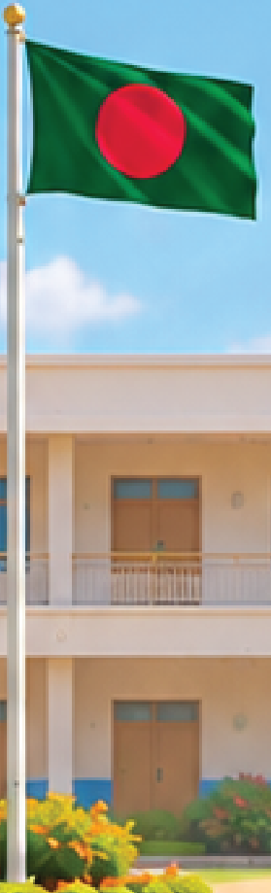
i1 | illustration | file images/i1.png | box [1484, 500, 1763, 1419] | layer 2 | rotation 0 | opacity 1.0 | overlaps text: none
Description: A tall silver-grey flagpole with a Bangladesh flag: green field with a red disc, flying to the right. Pole has a small gold finial at the top.
Purpose: Stands in the middle of the scene as the focal point above the courtyard
Style: 3D cartoon render, soft shading, slight highlight on the pole
Main colours: #C9CED3, #1B6B3A, #E0202E, #F2C14E
Rebuild notes: Pole is thin (about 14 px wide original). Flag is about 150 by 110 px display, red disc about 40 percent of flag height and centred slightly left of middle. Crop includes a small piece of sky and building behind the pole; the pole base sits in a round flower bed (included at the bottom edge).
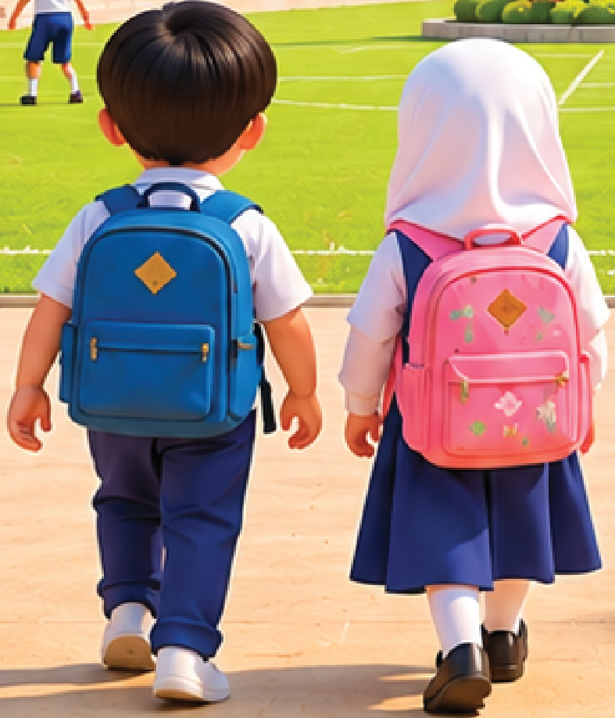
i2 | illustration | file images/i2.png | box [722, 1414, 1509, 2332] | layer 4 | rotation 0 | opacity 1.0 | overlaps text: none
Description: Two young children seen from behind, walking away towards the school gate. Left child: short black hair, white shirt, blue backpack with a gold diamond badge, navy trousers, white shoes. Right child: white headscarf, white long-sleeved top, navy skirt, white socks, black shoes, pink backpack with a floral pattern and a gold diamond badge.
Purpose: The two main characters of the scene, walking into the school
Style: 3D cartoon render, soft lighting, cast shadows on the ground
Main colours: #1F3A8A, #2B5BB5, #F4A7C3, #FFFFFF, #111111, #F2C14E
Rebuild notes: Front-most figures. Ground shadows under both children are included at the bottom of the crop. Backpack straps and the gold diamond badges are small (about 40 px). Pink backpack has a floral print in pale pink and green.
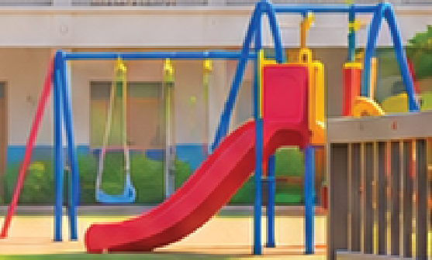
i3 | illustration | file images/i3.png | box [1862, 1115, 2419, 1451] | layer 2 | rotation 0 | opacity 1.0 | overlaps text: none
Description: Children's playground set: a red slide with a yellow handrail, a blue metal frame with two swings, and a red and yellow canopy on the top of the slide.
Purpose: Shows the play area on the right of the school grounds
Style: 3D cartoon render, glossy plastic look
Main colours: #E0202E, #F2C14E, #2B5BB5, #B0B8C0
Rebuild notes: Blue frame: two upright poles and a crossbar, two swing seats hanging on chains. Red slide is angled to the lower right. Crop includes a few green bushes at the base.
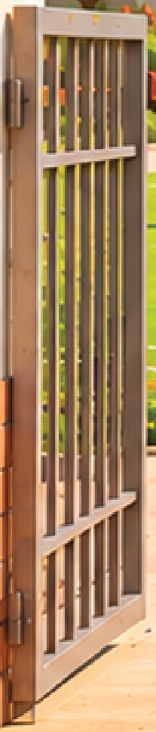
i4 | illustration | file images/i4.png | box [151, 1246, 358, 2214] | layer 3 | rotation 0 | opacity 1.0 | overlaps text: none
Description: Left school gate: a tall brown metal gate with vertical bars, hinged to a cream plaster pillar with a brick-red lower section. Gate is opened outwards.
Purpose: Frames the school entrance on the left
Style: 3D cartoon render, dark metal bars with light edge highlights
Main colours: #5A4A3F, #A4553A, #F3EBDD
Rebuild notes: Gate has about 9 vertical bars and two horizontal rails. Bottom of the crop is at the paved ground level. The crop does not include the left pillar, which is part of the building scene (i7).
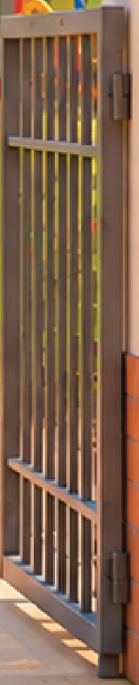
i5 | illustration | file images/i5.png | box [2283, 1246, 2480, 2214] | layer 3 | rotation 0 | opacity 1.0 | overlaps text: none
Description: Right school gate: a tall brown metal gate with vertical bars, hinged to a cream plaster pillar with a brick-red lower section. Gate is opened outwards.
Purpose: Frames the school entrance on the right
Style: 3D cartoon render, dark metal bars with light edge highlights
Main colours: #5A4A3F, #A4553A, #F3EBDD
Rebuild notes: Mirror of i4: same bar count and rails. The crop does not include the right pillar.
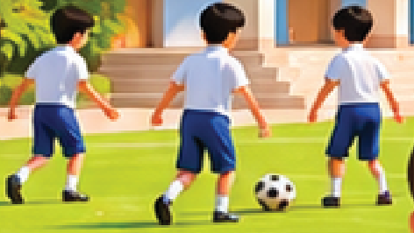
i6 | illustration | file images/i6.png | box [381, 1312, 853, 1578] | layer 2 | rotation 0 | opacity 1.0 | overlaps text: none
Description: Three children in white shirts and navy shorts on a green lawn: two run on the left, one stands kicking, and a black-and-white football lies on the grass in front of them.
Purpose: Shows other pupils playing football on the field behind the children
Style: 3D cartoon render, small figures, soft shadows
Main colours: #FFFFFF, #1F3A8A, #111111, #4CAF50, #7CC04A
Rebuild notes: Figures are about 80 px tall at this scale. Ball is about 30 px diameter with black pentagons. Crop includes grass and a small patch of the lawn border at the bottom.
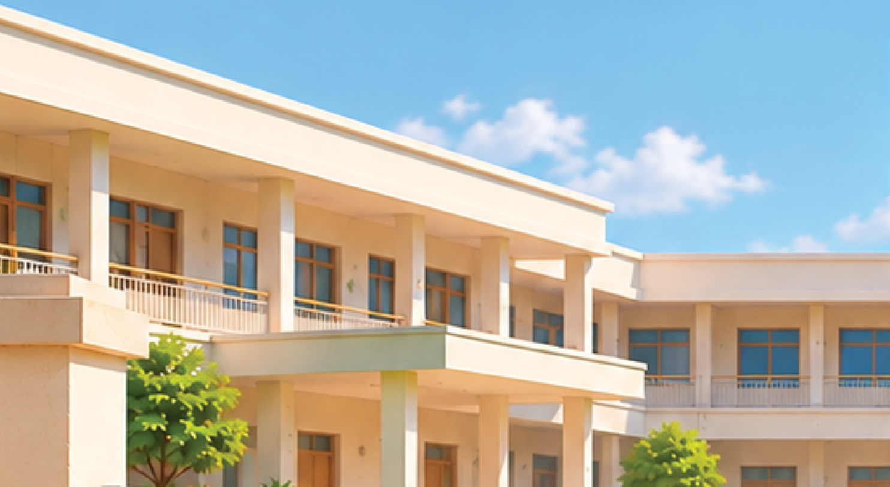
i7 | illustration | file images/i7.png | box [0, 443, 1484, 1255] | layer 1 | rotation 0 | opacity 1.0 | overlaps text: none
Description: The left and centre part of the two-storey school building: cream plaster walls, flat roof with a deep overhang, columns, windows with brown frames, balconies with railings, brown wooden doors, blue plinth at the base, a small green tree and shrubs in front.
Purpose: Forms the back wall of the school courtyard
Style: 3D cartoon render, architectural, soft lighting
Main colours: #F3EBDD, #D9CDB8, #8B5E3C, #2B5BB5, #4CAF50
Rebuild notes: Contains the flagpole base area on its right edge (the flagpole i1 is saved separately, so the crop only includes its base shadow). Left pillar and the top of the left gate (i4) sit on the left edge of this crop. The crop does not include the title text, which is in the sky above this crop. Shrubs and tree in front of the building are included.
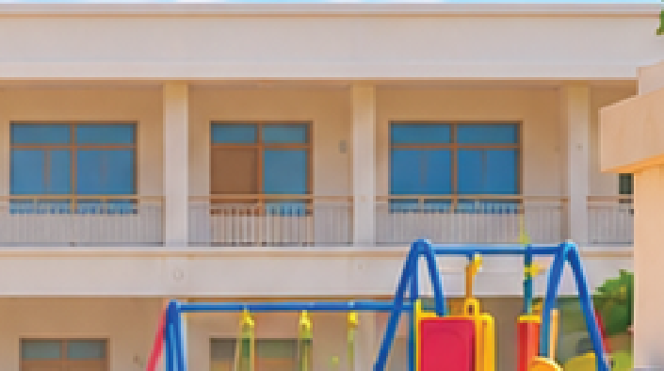
i8 | illustration | file images/i8.png | box [1755, 861, 2460, 1255] | layer 1 | rotation 0 | opacity 1.0 | overlaps text: none
Description: The right part of the school building: cream walls, a row of windows with blue glass, brown doors, white railings on the balconies, and a blue plinth at the base.
Purpose: Forms the back wall of the school courtyard on the right side
Style: 3D cartoon render, architectural, soft lighting
Main colours: #F3EBDD, #2B5BB5, #8B5E3C, #D9CDB8
Rebuild notes: Crop starts just right of the flagpole. Bottom edge is at the lawn line. Right edge touches the right gate pillar (i5 is saved separately).

Doubts and unknown words
- doubt: t1: font name and size are guesses from the image; box edges estimated by eye from a downscaled view (display 1559x2000 mapped to 2550x3270 by x1.64)
- doubt: t2-t4: body lines are placed as one block per line; font name and size are guesses
- doubt: Page size taken from the original image dimensions (2550x3270); confirm against pages/page-003.png if the saved PNG differs
- doubt: No background crop: the sky and sand ground both contain printed text, so bg.png cannot be made without text. image_file is null and the scene is described in rebuild_notes instead.
- doubt: i1 (flag pole) and i7/i8 (building) touch: a small piece of building is inside the flagpole box and the base of the flagpole sits on the building crop edge. Check the seam.
- doubt: i4/i5 (gates) and i7/i8 (building) touch at the top edge of the gates: the pillars sit in the building crops. Pillars are in i7 (left) and the right pillar is partly in i8.
- doubt: Box edges are estimated by eye from a downscaled view (display 1559x2000 mapped to 2550x3270 by x1.64). Confirm the crop edges against the page image; crops may be a few px short or long.
- doubt: The scene is one connected illustration split into objects. Some pixels are shared between neighbouring crops (lawn, grass, shadows). This is a deliberate choice so no object is cut in half.

Page 4
Status: approved | Confidence: 70.0 | Size: 2550x3270 px

Background
Colour #8EC8F0. Full-page outdoor scene: blue sky with white clouds at top, sandy brown ground at bottom, river and green trees behind. Printed text sits over the sky (top) and over the sand (bottom).
Rebuild notes: Sky is light blue #8EC8F0 fading to paler blue near the horizon; ground is sandy orange-brown #E8B873. The scene contains the flag and pole (i1), the boat (i2) and the house at the left edge (i3), which are saved separately and not repeated here. The remaining landscape (banana trees, bamboo fence, bushes, river, distant tree line, grass strip) is not cropped as a separate picture; it cannot be cut out without also cutting the pictures above or the text.

Text
আমাদের দেশ, আমাদের পতাকা
t1 | heading | box [420, 190, 2130, 375] | agreed | read-agreement 1.0 | unknown Bangla sans (guess) 36 pt | bold yes | italic no | colour #000000 | align center | order 1
আমাদের দেশ বাংলাদেশ। আমরা দেশকে ভালোবাসি। এই আমাদের পতাকা। পতাকার রং লাল আর সবুজ । আমাদের পতাকা সুন্দর।
t2 | body | box [220, 2560, 2330, 3060] | agreed | read-agreement 1.0 | unknown Bangla sans (guess) 30 pt | bold no | italic no | colour #000000 | align center | order 2

Pictures
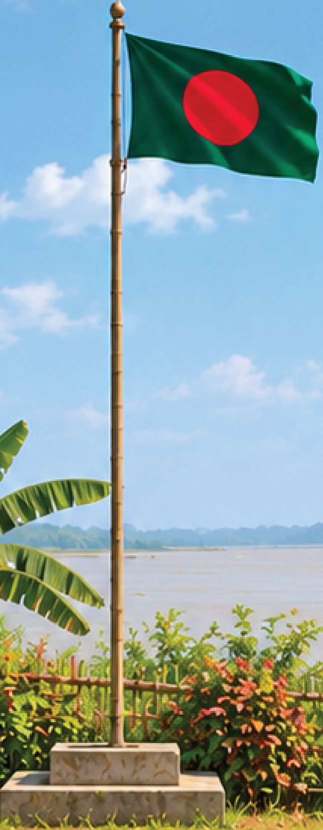
i1 | illustration | file images/i1.png | box [828, 582, 1476, 2244] | layer 2 | rotation 0 | opacity 1.0 | overlaps text: none
Description: A tall metal flagpole standing on a two-step grey-white concrete base, with the Bangladesh flag flying from the top: dark green field with a red disc slightly left of centre.
Purpose: Central focal picture of the page, shows the national flag the page is about
Style: photo-realistic, soft natural lighting, slight folds in the flag cloth
Main colours: #006A4E, #F42A41, #B8A27A, #9C9C9C
Rebuild notes: Pole is thin and pale brass/grey, about 10 px wide in the crop; red disc is centred roughly at 45% of the flag width; flag is waving to the right. Box includes the plants and river behind the pole base, which are part of the background scene.

i2 | photo | file images/i2.png | box [2168, 1752, 2550, 1829] | layer 2 | rotation 0 | opacity 1.0 | overlaps text: none
Description: A small wooden river boat with a dark grey canopy over the middle, with one person standing at the back, on brown river water.
Purpose: Adds a small detail of river life to the right side of the scene
Style: photo-realistic, small and distant
Main colours: #3E3A36, #6E6A63, #8A7558
Rebuild notes: Boat is about 230 px long and 50 px high in the crop; the canopy is a rounded grey metal shape; the person is at the stern on the right.
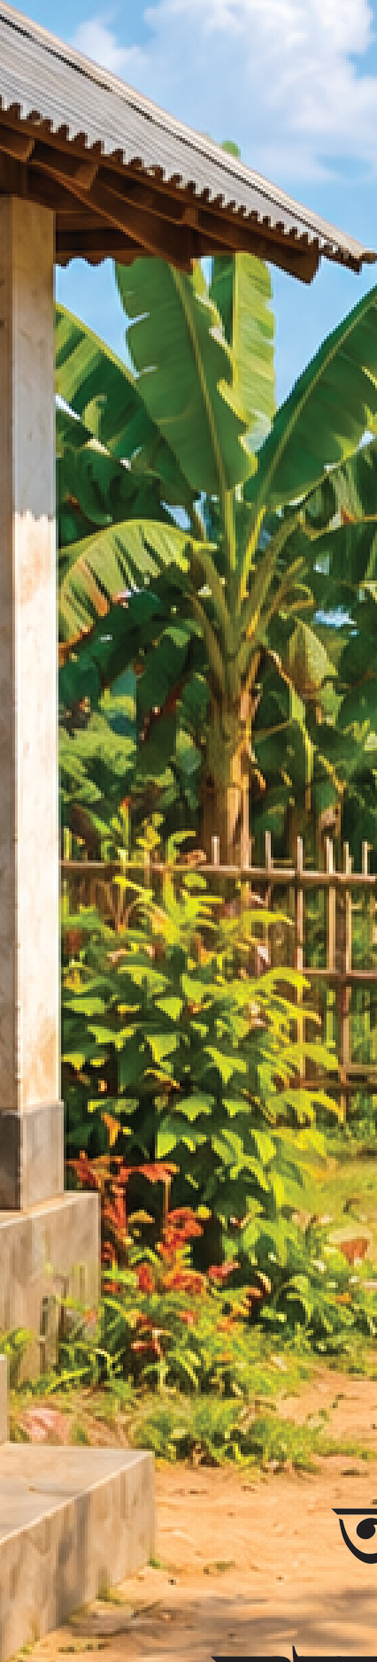
i3 | photo | file images/i3.png | box [0, 910, 426, 2788] | layer 2 | rotation 0 | opacity 1.0 | overlaps text: none
Description: The left edge of the scene: a corner of a small building with a sloped corrugated roof and a light grey concrete pillar, plus its concrete step at the bottom.
Purpose: Frames the left side of the scene as the edge of a house
Style: photo-realistic, cut off by the page edge on the left
Main colours: #D9D6CF, #7A6A55, #8C8C8C
Rebuild notes: Roof is a dark sloped edge running from top-left to right; pillar is pale grey and about 40 px wide; the bottom steps are at the foot of the crop. Box includes some banana leaves and bushes at the right edge of the crop which are part of the background scene.

Doubts and unknown words
- doubt: t1: font name and size are a guess by eye (heading over the sky, black on blue)
- doubt: t2: font name and size are a guess by eye; 3 centred lines in one block, box made wide and tall for the top and bottom margins
- doubt: t1: box top edge chosen with extra margin above the headmarks; scale taken from the displayed size (1559x2000) to the real image (2550x3270)
- doubt: t2: block ends near the bottom of the last line (the lower margin is about 30 px)
- doubt: Background: the landscape between the pictures (river, banana trees, bamboo fence, bushes, grass strip, distant trees) is not saved as a separate image. It cannot be cut out without also cutting the flag, boat or house, so background image_file is null. A human should decide whether to keep it as one image with holes.
- doubt: i1 and i3 boxes include small pieces of the background scene (plants, river, leaves) inside the rectangle; these are not pictures of their own.
- doubt: Box edges are estimated from the displayed image (scale 1.64); check that the boat box and the house box include the whole object.

Page 5
Status: approved | Confidence: 35.0 | Size: 2550x3270 px

Background
Colour #F2D9A6. Sandy beige schoolyard ground with soft shadows of trees; below the last text line it is plain sand with a faint speckled pattern
Rebuild notes: Sand colour about #F2D9A6 with lighter and darker speckles and soft blurred shadow patches on the upper half. The upper part of the page is a blue sky with white clouds (not saved as a crop; see doubts). Crop bg.png is only the text-free sand strip below the last text line.

Text
আমাদের দেশ, আমাদের পতাকা
t1 | heading | box [425, 190, 2120, 382] | agreed | read-agreement 1.0 | unknown Bangla sans 30 pt | bold no | italic no | colour #000000 | align center | order 1
আমাদের দেশ বাংলাদেশ।
t2 | body | box [700, 2255, 1845, 2390] | agreed | read-agreement 1.0 | unknown Bangla sans 24 pt | bold no | italic no | colour #000000 | align center | order 2
আমরা দেশকে ভালোবাসি।
t3 | body | box [685, 2415, 1860, 2550] | agreed | read-agreement 1.0 | unknown Bangla sans 24 pt | bold no | italic no | colour #000000 | align center | order 3
এই আমাদের পতাকা।
t4 | body | box [780, 2585, 1765, 2720] | agreed | read-agreement 1.0 | unknown Bangla sans 24 pt | bold no | italic no | colour #000000 | align center | order 4
পতাকার রং লাল আর সবুজ ।
t5 | body | box [605, 2750, 1950, 2885] | agreed | read-agreement 1.0 | unknown Bangla sans 24 pt | bold no | italic no | colour #000000 | align center | order 5
আমাদের পতাকা সুন্দর।
t6 | body | box [730, 2915, 1815, 3065] | agreed | read-agreement 1.0 | unknown Bangla sans 24 pt | bold no | italic no | colour #000000 | align center | order 6

Pictures

i1 | illustration | file images/i1.png | box [1309, 463, 1800, 941] | layer 3 | rotation 0 | opacity 1.0 | overlaps text: none
Description: Bangladesh national flag: dark green rectangle with a red circle, waving on a tall silver flagpole with a round ball finial at the top
Purpose: Shows the flag that the page title and poem are about
Style: photo-like digital painting, soft shading, no outline, slight fold shadows on the flag
Main colours: #006A4E, #F42A41, #C0C0C0, #FFFFFF
Rebuild notes: Flag is about 2:3 with the red disc slightly left of centre; flag edge is wavy. Pole is a thin silver shaft with a ball on top. Pole shaft below the flag (down to the base) is inside the building scene and is not part of this crop.
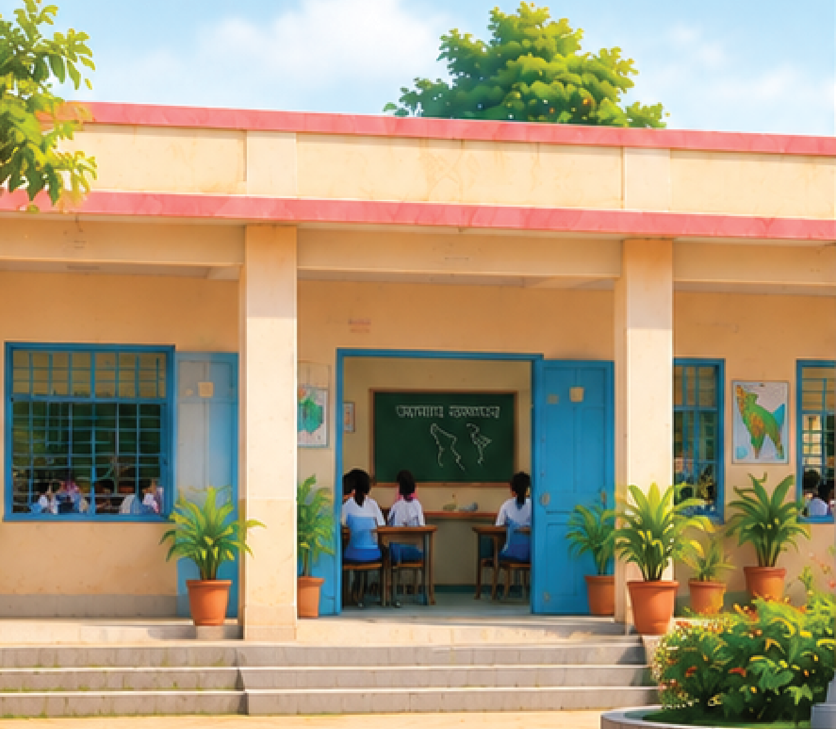
i2 | illustration | file images/i2.png | box [0, 941, 1351, 2119] | layer 2 | rotation 0 | opacity 1.0 | overlaps text: none
Description: Left half of a one-storey school building: cream walls, pink roof edge, cream columns, a blue-framed window with grey grid bars, an open blue door showing a classroom with a green blackboard, students in white shirts and blue skirts at desks, potted plants, concrete steps, and a tree at the top
Purpose: Shows the school in the scene
Style: photo-like digital painting, soft light, no outline
Main colours: #F5DEB3, #E9867A, #2F6FB0, #2E7D32, #1F4E23, #FFFFFF
Rebuild notes: Building is one storey with a flat pink-edged roof. Pillars are cream. Blue wood doors and window frames. Chalkboard on the classroom wall has tiny chalk writing and a small map drawing; it is too small to redraw as text. The classroom door at the centre-right of this crop is open. The flagpole base and the flower bed in front are not in this crop (see i4). The tree at the top of this crop is part of the sky scene.
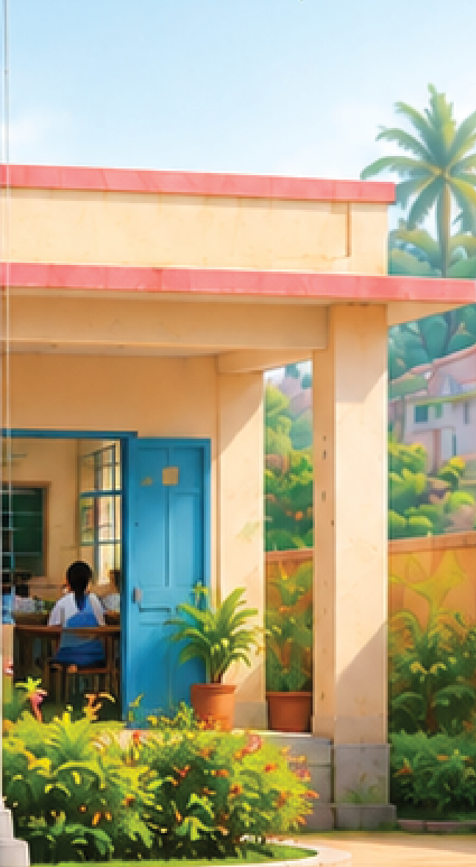
i3 | illustration | file images/i3.png | box [1374, 941, 2021, 2119] | layer 2 | rotation 0 | opacity 1.0 | overlaps text: none
Description: Right half of the school building: a blue-framed window with a classroom behind it, a green blackboard and a wall map poster, an open blue door with students at desks, potted plants, and the cream end wall with its pink roof edge
Purpose: Shows the school in the scene
Style: photo-like digital painting, soft light, no outline
Main colours: #F5DEB3, #E9867A, #2F6FB0, #2E7D32, #FFFFFF
Rebuild notes: Same style as i2. Blue door at the right of the building is open. A map poster hangs on the cream wall to the left of the door. The flagpole passes in front of the building left edge of this crop; the pole itself is not in this crop.
i4 | illustration | file images/i4.png | box [965, 2119, 1857, 2184] | layer 4 | rotation 0 | opacity 1.0 | overlaps text: none
Description: Round pale stone base ring around the flagpole with a flower bed of green and red-orange plants in front of the building steps
Purpose: Frames the base of the flagpole
Style: photo-like digital painting
Main colours: #D8CFC0, #4E8F3A, #E0523A, #2E7D32
Rebuild notes: Only the bottom strip of the base ring and flower bed. The top of the flower bed is in i2 and i3. The flagpole base (grey square plinth) is at the centre of this crop.

i5 | illustration | file images/i5.png | box [0, 82, 180, 941] | layer 1 | rotation 0 | opacity 1.0 | overlaps text: none
Description: Leafy green tree branches at the top-left edge of the page, cut off by the page edge
Purpose: Frames the top-left corner of the scene
Style: photo-like digital painting
Main colours: #4E8F3A, #7CB342, #2E7D32, #87CEEB
Rebuild notes: Tree is cut by the left page edge. Light blue sky behind it.
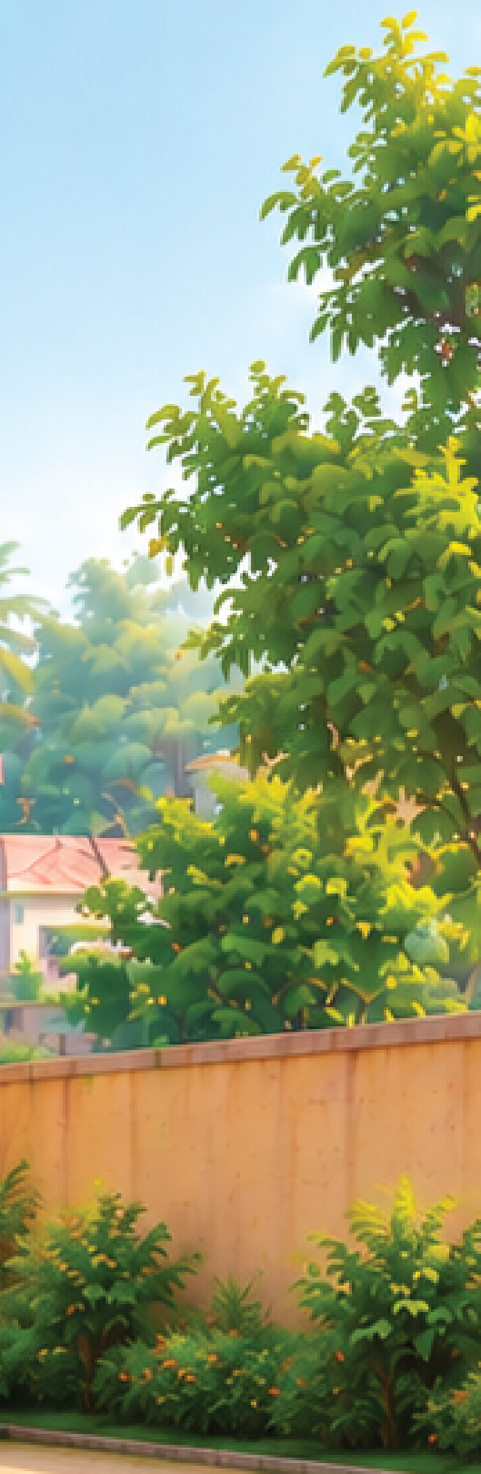
i6 | illustration | file images/i6.png | box [2021, 491, 2550, 2111] | layer 1 | rotation 0 | opacity 1.0 | overlaps text: none
Description: Right-hand trees and garden: large leafy trees, a palm tree in the distance, a small pink-roofed house on the hill, a cream boundary wall and green shrubs in front of it
Purpose: Frames the right side of the scene
Style: photo-like digital painting
Main colours: #4E8F3A, #7CB342, #2E7D32, #F5DEB3, #E9867A, #87CEEB
Rebuild notes: Trees cut by the right page edge. The cream boundary wall starts at the right end of the school building (i3 ends at x 2021). Shrubs in front of the wall are green with small orange flowers.

Doubts and unknown words
- doubt: t1: font weight looks regular or medium, not clearly bold; size and font name are estimates
- doubt: t2-t6: font name and size_pt are estimates from the image, not measured
- doubt: t1-t6: boxes re-drawn with at least 30 px margin above the first mark and below the last mark (attempt 2); edges still judged by eye from the display scale (x1.64)
- doubt: Tiny chalk writing on the blackboard and the map/poster on the wall are inside the picture, not listed as text blocks; left for the picture-saver
- doubt: No page number seen on this page
- doubt: Sky with clouds at the top of the page is not saved as a crop: it is behind the title and would need a crop that avoids the title text. The background crop is therefore sand only; the sky is described here but not saved as a file.
- doubt: The flagpole shaft between the flag bottom (y 941) and the base is not in any crop (it runs between i2 and i3, x 1351 to 1374). It is part of the scene and may show as leftover ink.
- doubt: Tree and bush areas between the building crops and the side trees (i5, i6) are split on the box edges; a few leaves may fall in the gap between crops.
- doubt: Boxes were judged by eye from the displayed image (scale x1.64); edges may be off by a few pixels.
- doubt: Chalk writing on the classroom blackboard and the wall map are too small to read and are not separate pictures.

