Forward (Light-Based) Ray Tracing for Multiple Spheres
A Hand-Written Assignment Solution with Multiple Point Lights, Full RGB Color Computation, Reflection, & Refraction
1. Problem Statement
Design and describe an efficient forward (light-based) ray-tracing algorithm that renders a multi-object 3D scene containing multiple spheres with diverse optical and chromatic properties (RGB color materials: diffuse, specular, transparent filter tint, and reflective) illuminated by multiple point light sources (L1, L2, ..., Ln) each emitting spectral/RGB illumination. Unlike classical backward ray tracing covered in class—where primary rays originate at the camera eye and shadow rays test light visibility—here primary rays originate at each light source carrying color energy, propagate forward into the scene, undergo recursive reflection and refraction with spectral color filtering, and are connected to the eye via camera-connection rays to compute and composite the final full-color RGB image on the projection plane.
2. Introduction & Comparative Algorithm Analysis
Ray tracing is a comprehensive global illumination paradigm that integrates hidden-surface removal, shadow generation, specular reflection, Snell's law refraction, and color shading into a single framework. In backward ray tracing, rays are cast from the eye through each pixel. Forward ray tracing reverses this physical causality: energy is emitted directly from the light sources into the environment. To solve this problem efficiently, three candidate forward paradigms were evaluated:
- Option A: Naive Random Forward Ray Tracing — Emits rays from each light source in uniformly distributed random directions across 4π steradians. Rays bounce around the scene and are recorded only if they randomly hit the camera aperture. Critical Flaw: The probability P ≈ A_eye / (4π d²) of a randomly bounced ray hitting a pinhole camera aperture is practically zero. Almost all traced rays are wasted in empty space, causing catastrophic noise and unacceptable computational cost.
- Option B: Photon Mapping (Two-Pass Global Illumination) — A two-pass technique where Pass 1 forward-traces photon rays from light sources and stores their RGB energy, positions, and incident directions inside a spatial k-d tree (the photon map). Pass 2 casts rays from the camera and performs k-nearest-neighbors (k-NN) density estimation. Critical Flaw: While highly effective for complex caustics, it introduces heavy auxiliary data-structure overhead (k-d tree construction, balancing, and radius searching) and requires an extra backward gathering pass, exceeding the scope of direct forward tracing.
- Option C: Targeted Forward Ray Tracing with Direct Eye Connection & Recursive Spawning (Chosen) — Constrains light emission strictly to the solid bounding cones subtended by all spheres in the scene (100% ray-object engagement). When an emitted ray strikes a sphere, the intersection is solved in O(1) via the closed-form quadratic equation. Local Phong RGB color shading is evaluated, and a direct connection ray is cast from the hit point to the eye (inverting the classical shadow ray) to evaluate visibility and splat RGB radiance into the image buffer. Simultaneously, specular reflection and refraction rays are spawned recursively to propagate illumination across subsequent spheres.
Rationale for Selecting Option C:
1. Maximum Sampling Efficiency: Solid angle cone bounding prevents wasted rays in void directions, achieving 100% ray-object engagement.
2. Exact Mathematical Dual of Class Slides: Swaps eye-to-light shadow rays with surface-to-eye connection rays, preserving identical O(1) quadratic intersection, Snell's law formulas, and Phong shading.
3. Full RGB Spectral Fidelity: Directly tracks color propagation channel-by-channel across reflections and refractions without channel crosstalk.
4. Zero Memory Overhead: Evaluates multi-bounce specular reflection and transparent refraction deterministically without requiring spatial k-d trees.

3. Forward Ray-Tracing System Architecture & 2D Diagrams
To clearly visualize the forward ray-tracing pipeline across multiple spheres with distinct material and chromatic properties, the diagrams below illustrate the reversed geometric scene setup and the corresponding recursive forward ray tree.

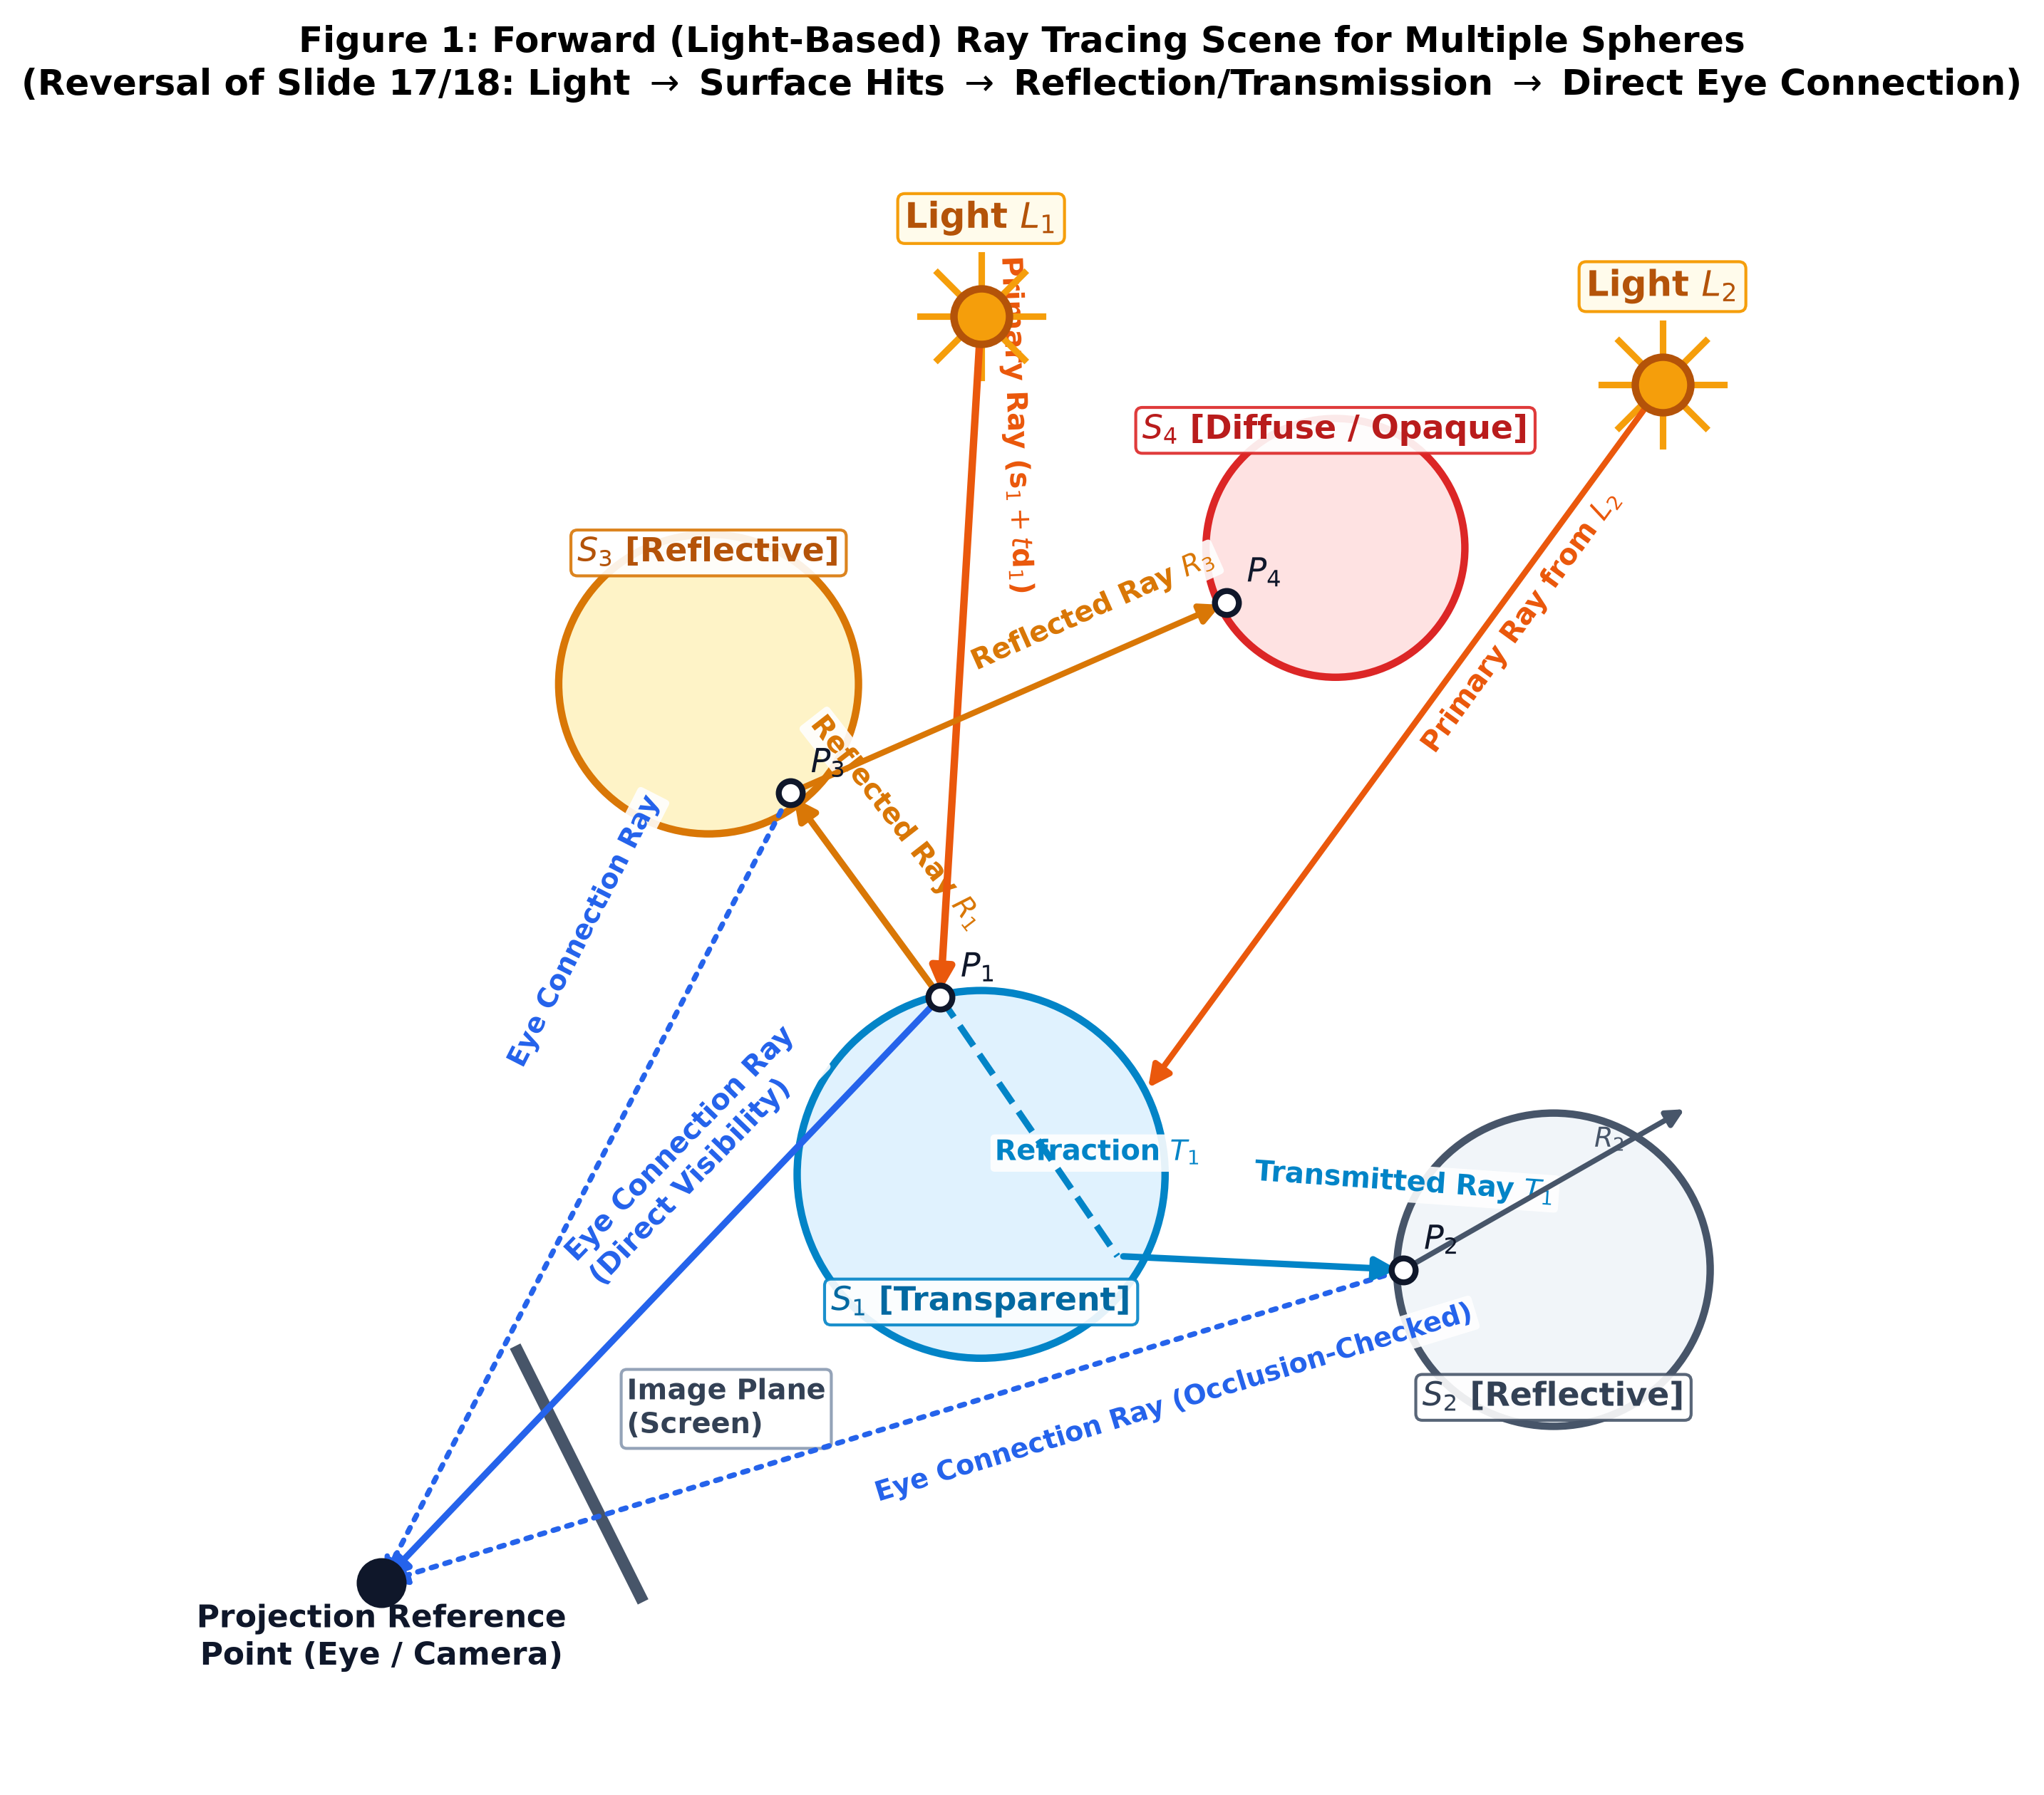
Figure 1 Description: Figure 1: Forward ray-tracing scene with multiple point lights (L1, L2), multiple spheres (S1: transparent, S2: reflective, S3: reflective, S4: diffuse), and direct eye-connection rays. Notice that secondary reflected (R1) and refracted (T1) rays propagate light forward, while surface-to-eye connection rays replace classical shadow rays. Occlusion is tested along the connection line.

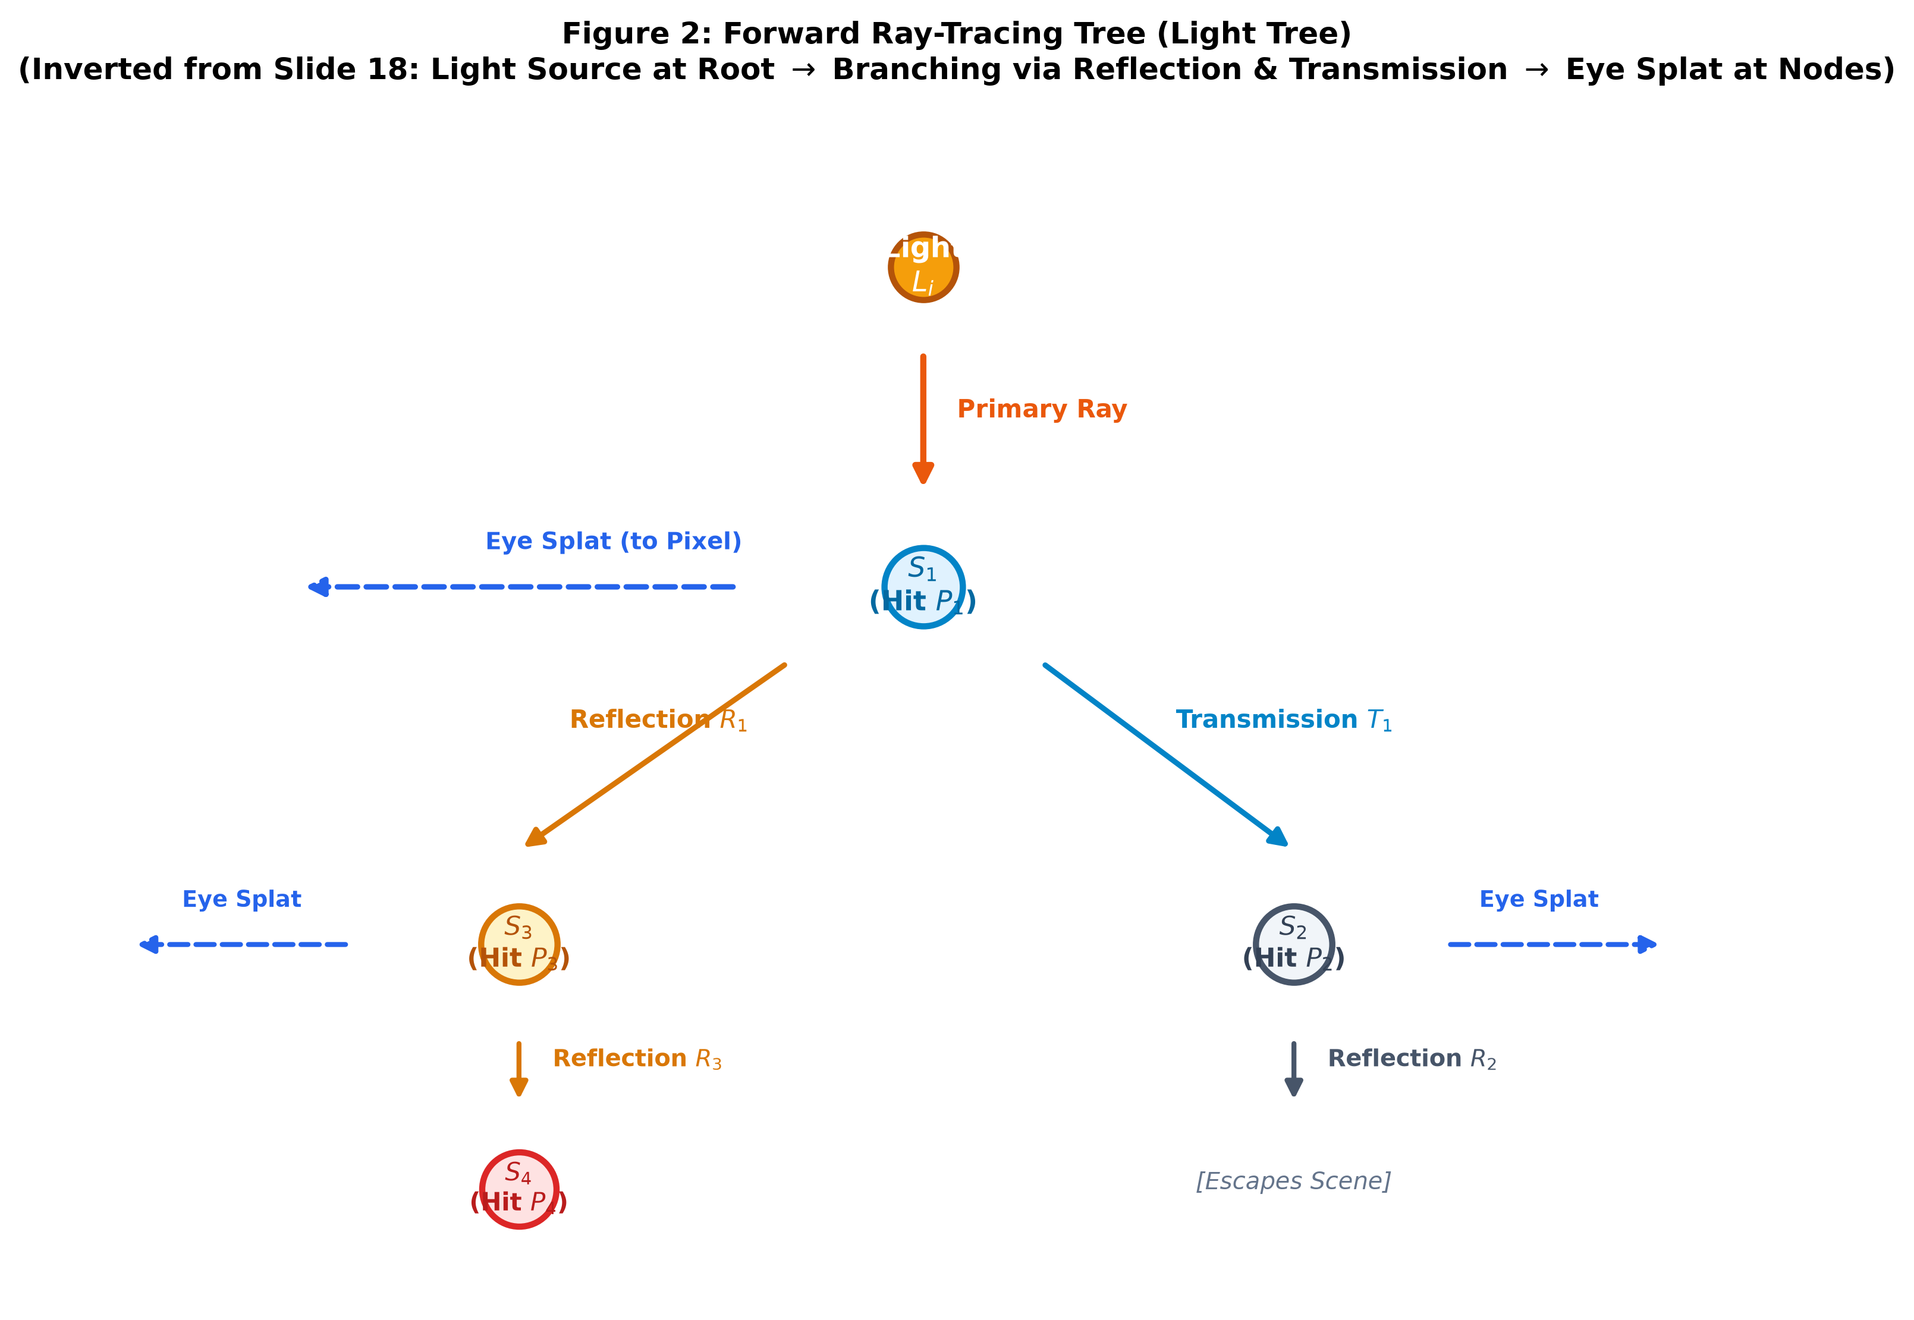
Figure 2 Description: Figure 2: Forward Ray Interaction Tree (Dual of Lecture Slide 18). Rays originate at light source Li (Root). At transparent sphere S1, the ray bifurcates into transmitted ray T1 (striking S3 then S4) and reflected ray R1 (striking S2). At every visible hit node, a direct connection ray splats radiance directly to the Eye / Image Plane.
Hand-Drawing Guide for 2D Figures: When sketching these 2D figures by hand on your A4 page:
• Draw Light L1 (top-center) and Light L2 (top-right) emitting yellow/gold rays toward transparent sphere S1.
• Color S1 light blue (Transparent), S2 slate grey (Reflective), S3 amber (Reflective), and S4 red (Diffuse/Opaque).
• Draw S1 refracting light (cyan ray T1) toward S2, and reflecting light (amber ray R1) toward S3.
• Draw Eye / Camera on the far right with a 1D/2D projection screen, and draw dashed purple connection lines from each hit point to Eye.
• Draw the Forward Tree (Figure 2) branching downwards: Root Light -> S1 -> (Left: S3 -> S4, Right: S2), with dashed eye arrows at each node.

4. Mathematical Formulations & Geometric Derivations
The mathematical foundation directly implements the vector formulation taught in class (Slides 25–30, 45–46), extended to multi-sphere sorting, specular reflection, and Snell's refraction.
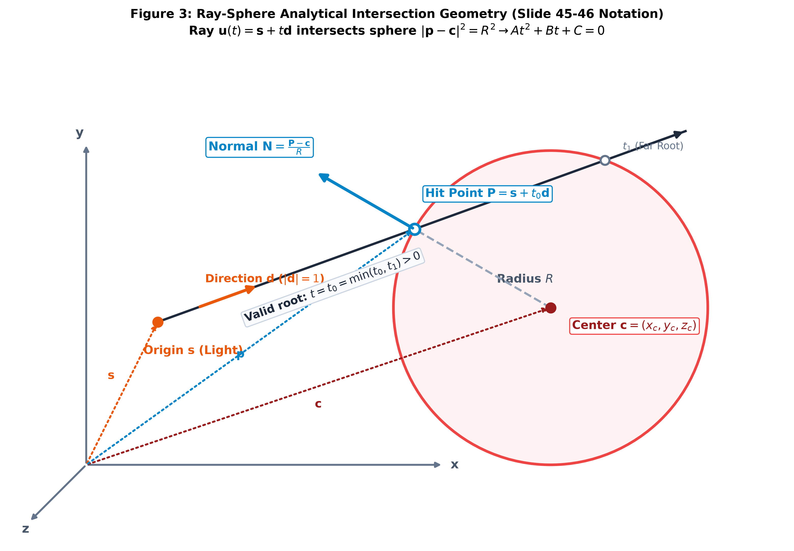 | 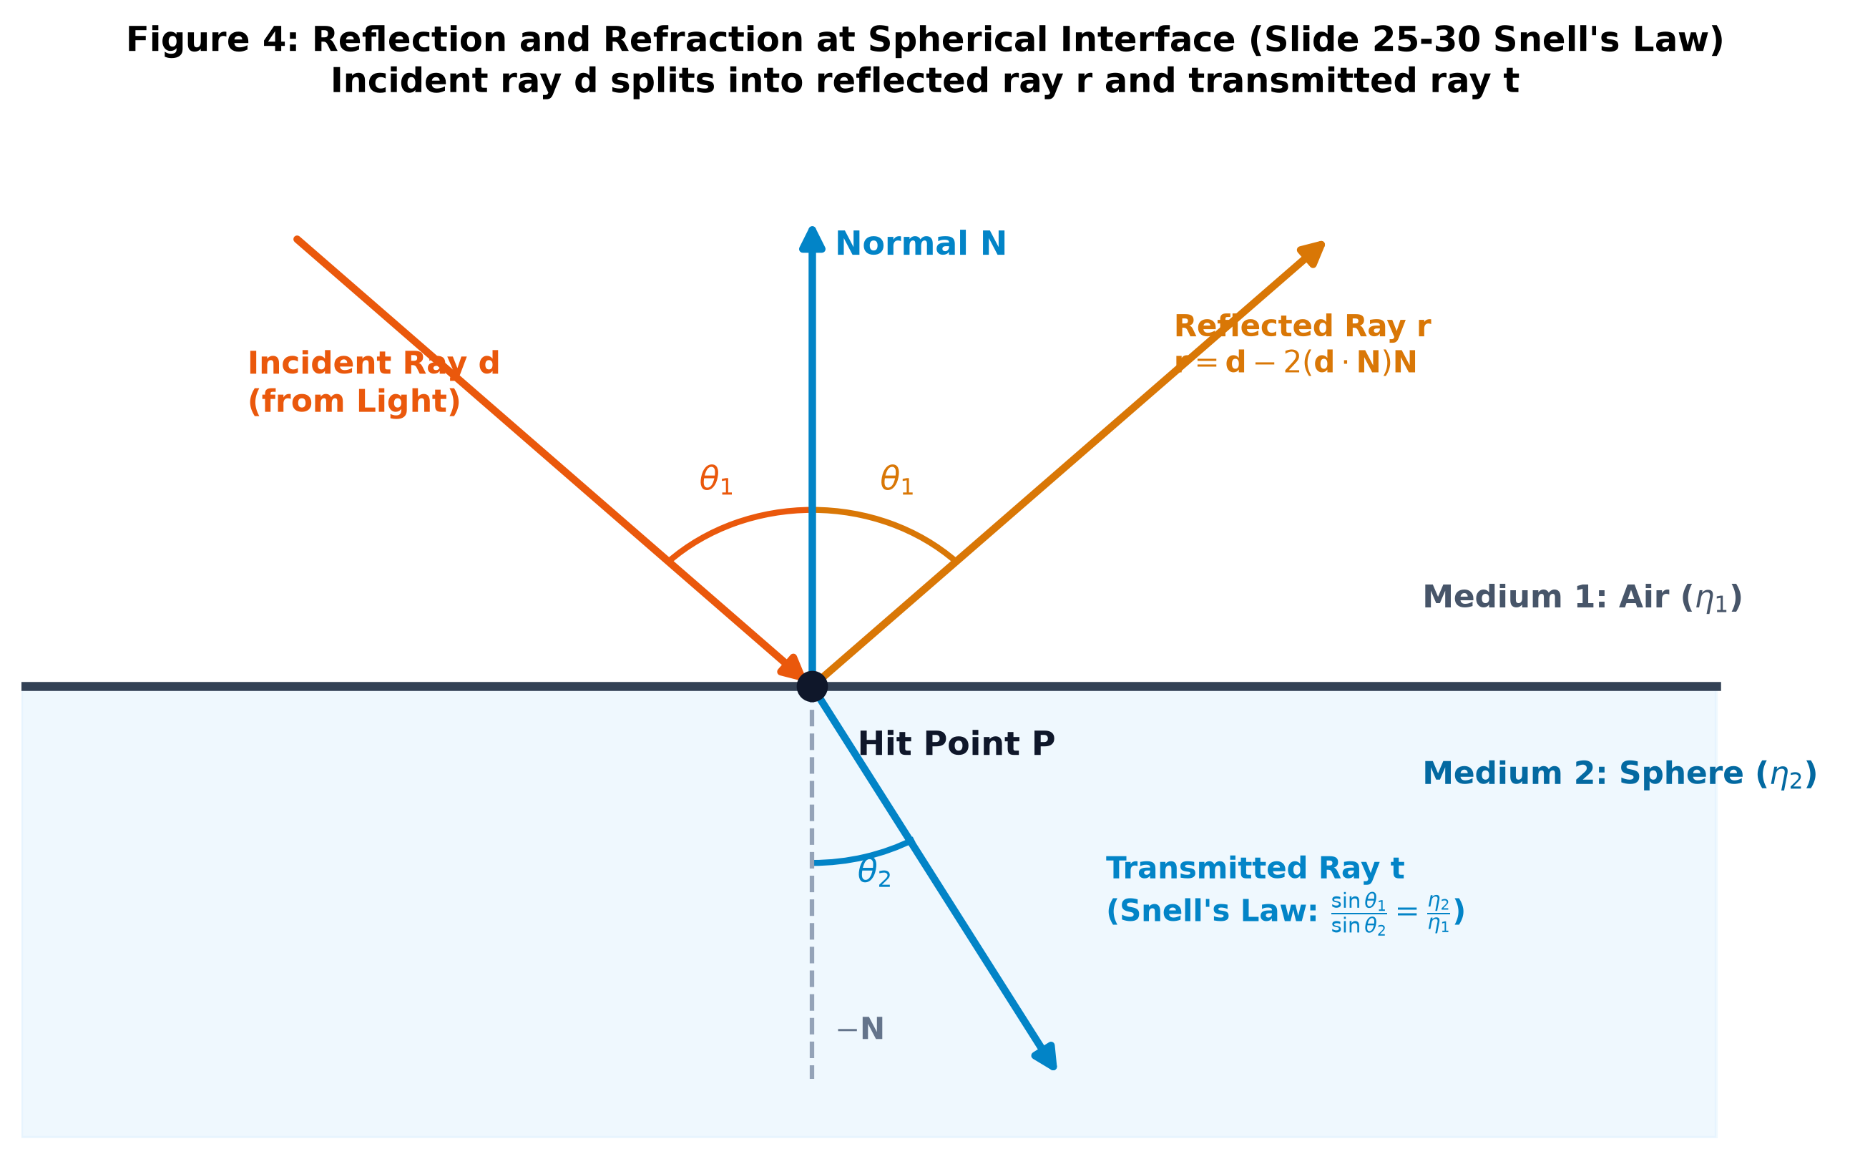
Figure 3: Analytical Ray-Sphere Geometry (Slide 45) | Figure 4: Reflection & Snell's Refraction (Slides 25–30)
4.1 Parametric Ray & Implicit Sphere Equations
- Parametric Ray: u(t) = s + t·d, with origin s, unit direction ||d|| = 1, and t > 0.
- Implicit Sphere: ||p - c||² = R² <=> (p - c) · (p - c) - R² = 0, with center c and radius R.
4.2 Quadratic Intersection Derivation (Slide 45)
Substitute ray u(t) into the sphere equation: ((s + t·d) - c) · ((s + t·d) - c) - R² = 0
Expanding terms yields: (d · d)·t² + 2((s - c) · d)·t + ((s - c) · (s - c) - R²) = 0
Standard Quadratic Form: A·t² + B·t + C = 0, where:
• A = ||d||² = 1 (unit direction vector)
• B = 2 (s - c) · d
• C = ||s - c||² - R² = (s - c) · (s - c) - R²
4.3 Discriminant Analysis & Multi-Sphere Nearest-Hit Sorting
The discriminant is: Δ = B² - 4AC = B² - 4C
• Δ < 0: Ray misses the sphere entirely (no real roots).
• Δ = 0: Ray is tangent to the sphere at a single point t = -B / 2.
• Δ > 0: Ray intersects at two points: t0 = (-B - √Δ)/2 and t1 = (-B + √Δ)/2.
Multi-Sphere Nearest-Hit Rule: Iterate over all spheres k in {1, ..., M}. The true physical hit point is the smallest positive root:
t* = min_{k=1...M} { t in {t0,k, t1,k} | t > ε }, where ε ≈ 10⁻⁴ prevents self-intersection shadow acne.
4.4 Hit Point, Surface Normal, and View Vector
- Hit Point: P = s + t*·d
- Outward Unit Normal: N = (P - c) / R. (If ray hits from inside a transparent sphere, reverse: N = -N).
- Unit View Vector (toward eye at E): V = (E - P) / ||E - P||
4.5 Specular Reflection & Snell's Law Refraction (Slides 25–30)
- Ideal Specular Reflection Vector: r = d - 2(d · N) N (or for light incident vector L: R_spec = 2(N · L) N - L).
- Refraction Vector (Slide 30): Snell's Refraction Vector: Let relative index η = η1 / η2, and cos θ1 = -(d · N). From Snell's Law:
cos² θ2 = 1 - η² (1 - cos² θ1) = 1 - η² (1 - (d · N)²)
• If cos² θ2 < 0: Total Internal Reflection (TIR) occurs; no refraction, all energy reflects along r.
• If cos² θ2 ≥ 0: Transmitted Unit Direction: t = η·d + (η (d · N) - √(cos² θ2)) N
4.6 Direct Eye-Connection Ray & Occlusion Test (Inverted Shadow Ray)
To test visibility from P to Eye E, define the connection ray: r_eye(τ) = P + τ·V, τ in (ε, ||E - P||).
1. Back-face culling: If N · V ≤ 0 (for opaque surfaces), point faces away from camera; connection is culled.
2. Occlusion test: Solve quadratic A·τ² + B·τ + C = 0 against all other spheres Sj (j ≠ hit). If any valid root τ lies in (ε, ||E - P||), P is occluded from the eye (in shadow). Otherwise, connect and splat to the image plane.

4.7 Full Multi-Channel RGB Color Illumination Model
In physical rendering and standard ray tracing (Slides 20–25), illumination is evaluated across three independent color channels: Red, Green, and Blue (λ ∈ {R, G, B}). All radiant intensities and material reflectance properties are formulated as 3-component color vectors in the normalized RGB space [0, 1]³:
4.7.1 Tri-stimulus RGB Color Vectors & Material Definitions
- Light Source Emission Color: I_{p,i} = [I_{p,i}^R, I_{p,i}^G, I_{p,i}^B]^T for each point light i = 1 to n.
- Scene Ambient Illumination: I_a = [I_a^R, I_a^G, I_a^B]^T (uniform background environmental lighting).
- Sphere Material Color Coefficients (Sphere k):
• Ambient Reflectance: k_a = [k_a^R, k_a^G, k_a^B]^T (response to ambient lighting)
• Diffuse Body Color: k_d = [k_d^R, k_d^G, k_d^B]^T (Lambertian intrinsic color, e.g. red sphere = [0.85, 0.1, 0.1])
• Specular Highlight: k_s = [k_s^R, k_s^G, k_s^B]^T (achromatic [k_s, k_s, k_s] for plastics; tinted for metals)
• Specular Exponent: m (shininess power, controlling highlight tightness, typically m ∈ [10, 150])
• Mirror Reflection Tint: k_r = [k_r^R, k_r^G, k_r^B]^T (specular reflection attenuation per bounce)
• Transmission Tint: k_t = [k_t^R, k_t^G, k_t^B]^T (transparency filter color; e.g. cyan glass = [0.1, 0.9, 0.95])
4.7.2 Vector Phong Color Illumination Equation (Slide 22 Dual)
At surface hit point P with outward normal N and view direction V, the local reflected RGB color vector is computed using the component-wise (Hadamard / Schur) product ⊙ across all visible light sources:
C_local(P) = I_a ⊙ k_a + Σ_{i=1}^n S_i · I_{p,i} ⊙ [ k_d · max(0, N · L_i) + k_s · max(0, R_i · V)^m ]
where S_i ∈ {0, 1} is the binary visibility factor (tested via occlusion against intervening spheres), and:
L_i = (pos(L_i) - P) / ||pos(L_i) - P||, R_i = 2(N · L_i)N - L_i.
Scalar Form per Color Channel (λ ∈ {R, G, B}):
C_{local,λ}(P) = I_{a,λ} · k_{a,λ} + Σ_{i=1}^n S_i · I_{p,i,λ} [ k_{d,λ}(N · L_i) + k_{s,λ}(R_i · V)^m ]
4.8 Recursive Color Accumulation & Forward Splatting (Whitted Dual)
Total Recursive RGB Color at Hit Point P (Slide 23 Dual):
C_total(P) = C_local(P) + k_r ⊙ C_refl + k_t ⊙ C_trans
Per Channel: C_{total,λ}(P) = C_{local,λ}(P) + k_{r,λ}·C_{refl,λ} + k_{t,λ}·C_{trans,λ}, ∀ λ ∈ {R, G, B}
• Total Internal Reflection (TIR): If cos² θ2 < 0, all transmitted energy reflects: C_total = C_local + (k_r + k_t) ⊙ C_refl.
Forward Ray Energy Transport & Splatting Pipeline:
1. Emitted Ray Color Flux: Primary ray emitted from light L_i carries initial spectral flux Φ_ray = I_{p,i} · Δω_i.
2. Bounce Filtering: Reflected ray carries Φ_refl = Φ_ray ⊙ k_r; Transmitted ray carries Φ_trans = Φ_ray ⊙ k_t.
3. Beer-Lambert Absorption: For transparent spheres, light traveling path length d inside the medium is attenuated by absorption coefficient vector α: k_t(d) = exp(-α · d), naturally modeling colored glass saturation.
4. Eye Splatting: At visible point P, energy scattered toward Eye E is: C_splat = Φ_ray ⊙ [k_d(N·(-d)) + k_s(r·V)^m].
5. Subpixel Bilinear Accumulation: Point P projects to subpixel (p_x, p_y); C_splat is accumulated into ColorBuffer[W][H][3] and normalized by continuous WeightBuffer[W][H].
6. Final Compositing & Gamma Correction: C_pixel = I_a ⊙ k_a + ColorBuffer / WeightBuffer; C_final = clamp(C_pixel^(1/2.2), 0, 1).
4.9 Optical Dispersion & Chromatic Aberration (Cauchy's Equation)
A major physical advantage of forward ray tracing is the natural simulation of chromatic dispersion (prism rainbow caustics). The refractive index of dielectric glass varies with wavelength λ according to Cauchy's empirical formula:
η(λ) = A + B / λ² ==> η_Red < η_Green < η_Blue (since λ_R ≈ 700 nm > λ_G ≈ 546 nm > λ_B ≈ 436 nm)
When a white light ray (Φ = [1, 1, 1]) strikes a transparent sphere, it automatically bifurcates into three separate spectral rays with refraction angles θ_{2,R} > θ_{2,G} > θ_{2,B}, rendering realistic physical rainbow caustics without extra post-processing.

5. Concise Pseudo-Algorithm with Full RGB Color (Step-by-Step Text Form)
Below is the complete, concise forward ray-tracing algorithm incorporating full RGB color computation, designed to be handwritten clearly on your final A4 submission page:
- Step 1: Scene & Color Property Initialization — Define M spheres {S1, ..., SM} with centers c_k, radii R_k, and RGB material coefficients: ambient k_a, diffuse k_d, specular k_s, mirror reflection k_r, transmission filter k_t, shininess m, and refractive indices η_k (or η(λ)). Define n point lights with positions pos(L_i) and RGB emission colors I_{p,i}. Set ambient color I_a and background C_bg. Allocate RGB image color buffer ColorBuffer[W][H][3] and WeightBuffer[W][H]. For each light i, compute bounding solid angle cones.
- Step 2: Targeted Primary Emission with Spectral Energy — For each light i, sample unit ray directions d restricted strictly within the solid angle bounding cones. Set primary ray origin s = pos(L_i), initial ray RGB color flux Φ_ray = I_{p,i} · Δω_i, and recursion depth = 0.
- Step 3: Multi-Sphere Quadratic Intersection — For current ray (s, d), test intersection against every sphere k = 1 to M. Compute A = ||d||² = 1, B = 2(s - c_k)·d, and C = ||s - c_k||² - R_k². Evaluate discriminant Δ_k = B² - 4C.
- Step 4: Discriminant & Nearest-Hit Selection — If Δ_k < 0, discard sphere k. If Δ_k ≥ 0, compute roots t0, t1. Find global nearest valid hit: t* = min_k {t > ε}. If no sphere intersects with t > ε, ray escapes into background; terminate trace.
- Step 5: Surface Differential Geometry — Compute 3D hit point P = s + t*·d, surface outward unit normal N = (P - c)/R (reverse N = -N if ray hits from inside a transparent sphere), and unit view vector toward eye V = (E - P) / ||E - P||.
- Step 6: Direct Eye Connection & RGB Color Splatting (Inverted Shadow Ray) — If N · V > 0 (or if surface is transparent): Cast connection ray r_eye(τ) = P + τ·V toward Eye E. Test quadratic intersection of r_eye against all other spheres Sj (j ≠ hit). If unoccluded for all τ in (ε, ||E - P||), compute scattered RGB color C_splat = Φ_ray ⊙ [k_d max(0, N·(-d)) + k_s max(0, r·V)^m]. Project P through camera pinhole to pixel (x, y) and splat C_splat into ColorBuffer with bilinear weighting.
- Step 7: Specular Reflection Ray Spawning — If sphere is reflective (||k_r|| > 0) and depth < MAX_DEPTH: Compute reflection direction r = d - 2(d · N) N. Filter ray color flux: Φ_refl = Φ_ray ⊙ k_r. Spawn secondary ray with origin P + ε·r, direction r, and flux Φ_refl; recurse to Step 3.
- Step 8: Transparent Refraction Ray Spawning (Snell's Law & Dispersion) — If sphere is transparent (||k_t|| > 0) and depth < MAX_DEPTH: Compute cos² θ2 = 1 - η²(1 - (d · N)²). If cos² θ2 < 0 (TIR), redirect all energy along r with flux Φ_ray ⊙ (k_r + k_t). Otherwise, compute transmission direction t = η·d + (η(d·N) - √(cos² θ2))N and filter color flux Φ_trans = Φ_ray ⊙ k_t. (Optionally split into λ ∈ {R, G, B} for chromatic dispersion). Spawn transmitted ray from P + ε·t along t; recurse to Step 3.
- Step 9: Radiance Blending & Multi-Light Composition — Synthesize total color across the ray tree: C(P) = C_local + k_r ⊙ C_refl + k_t ⊙ C_trans. Direct photon connections and secondary scattered radiance deposit energy additively into the image accumulation buffer.
- Step 10: Buffer Normalization, Ambient Addition & Gamma Correction — Repeat Steps 2–9 for all sampled rays across all n lights. For every pixel (x, y), compute final linear color: C_linear = I_a ⊙ k_a + ColorBuffer(x, y) / max(ε, WeightBuffer(x, y)). Apply display gamma correction: C_final(x, y) = clamp((C_linear)^(1/2.2), 0, 1), producing the final rendered RGB image.
6. Key Findings and Analytical Comments (Point Form)
- Targeted Emission Efficiency: Restricting emitted light rays to the solid angle cones subtended by spheres converts a near-zero naive hit probability (P ≈ 0) into 100% ray-surface engagement, making forward ray tracing practical.
- Exact Dual of Lecture Setup: Forward ray tracing directly inverts the classical slide workflow: lights act as primary ray emitters, while eye connection rays replace shadow rays, demonstrating algorithmic duality.
- Multi-Channel RGB Spectral Fidelity: Operating component-wise with Hadamard products (⊙) across R, G, and B channels faithfully models physical wavelength filtering through colored transparent glass and metallic specular reflections without non-physical channel crosstalk.
- O(1) Intersection with Early Rejection: The closed-form quadratic equation resolves ray-sphere intersections in constant O(1) time per sphere. The discriminant check (Δ < 0) provides early rejection before computing square roots.
- Multi-Object Shadowing: Unlike a single-sphere scene (where self-shadowing is impossible on a convex hull), a multi-sphere scene requires testing the eye-connection ray against all other spheres to correctly render cast shadows and mutual occlusions.
- Natural Chromatic Dispersion & Caustics: Because rays originate at the light, forward ray tracing naturally handles wavelength-dependent refraction η(λ) via Cauchy's dispersion equation, splitting white light rays into rainbow caustics with zero extra gathering overhead.

