KHULNA UNIVERSITY OF ENGINEERING & TECHNOLOGY (KUET)
DEPARTMENT OF COMPUTER SCIENCE AND ENGINEERING
Course Code: CSE 4207 | Course Title: Computer Graphics
Assignment Solution: Forward (Light-Based) Ray Tracing for a Sphere with Multiple Point Lights

1. Core Concept & Working Idea
Idea: Unlike conventional backward ray tracing (where rays are cast backward from the eye/camera into the scene), forward ray tracing emits rays from each light source, tests them against scene objects, and only rays that eventually reach the eye/image plane contribute to the final image. It represents the strictly 'physical' model of light propagation, but in naive implementations it wastes many rays that never reach the viewer.

2. Step-by-Step Algorithm (Per Light Lᵢ)
- Step 1: Emit ray from light position toward the object. (Targeted emission inside the solid angle subtended by the sphere.)
- Step 2: Test ray–sphere intersection using closed-form quadratic formulation. (Solve for parameter t directly in O(1) time.)
- Step 3: If hit → find intersection point P and outward surface normal N. (P = P₀ + tD and N = (P - C)/r.)
- Step 4: Compute reflected ray direction and trace toward eye. (Perform camera connection / subpixel projection onto the image plane.)
- Step 5: Repeat for every light; sum contributions. (Illumination is linear/additive, accumulating diffuse and specular terms.)

3. Ray–Sphere Intersection Mathematics (Derivation)
Let the ray originating from light position P₀ with normalized unit direction D (|D| = 1) be defined as:
P(t) = P₀ + tD, (t > 0)
The implicit equation of a sphere with center C and radius r is:
|P - C|² = r²
Substituting P(t) into the sphere equation and defining vector L = P₀ - C:
|(P₀ + tD) - C|² = r² ⟹ |tD + (P₀ - C)|² = r² ⟹ |tD + L|² = r²
Expanding the dot product:
(tD + L) · (tD + L) = r² ⟹ t²(D · D) + 2t(D · L) + (L · L) = r²
Since D is a unit vector, D · D = |D|² = 1. Bringing r² to the left-hand side yields the standard quadratic equation:
t² + 2t(D · L) + (|L|² - r²) = 0
Matching with quadratic form a·t² + b·t + c = 0 gives:
a = 1, b = 2(D · L), c = |L|² - r²
The discriminant Δ (and reduced discriminant Δ' = (b/2)² - ac) is:
Δ = b² - 4ac = 4 [(D · L)² - (|L|² - r²)]
Solving for t via the quadratic formula:
t = -(D · L) ± √[(D · L)² - (|L|² - r²)]
Roots and Intersection Cases:
• Δ < 0 : Ray misses the sphere entirely (no real roots).
• Δ = 0 : Ray is perfectly tangent to the sphere (one grazing root).
• Δ > 0 : Ray enters and exits the sphere (two distinct real roots). We choose the smaller positive t, representing the nearest surface hit facing the incoming light ray.
Hit Point and Surface Normal:
• Hit Point: P = P₀ + tD
• Surface Normal: N = (P - C) / r (Unit vector pointing radially outwards from sphere center)

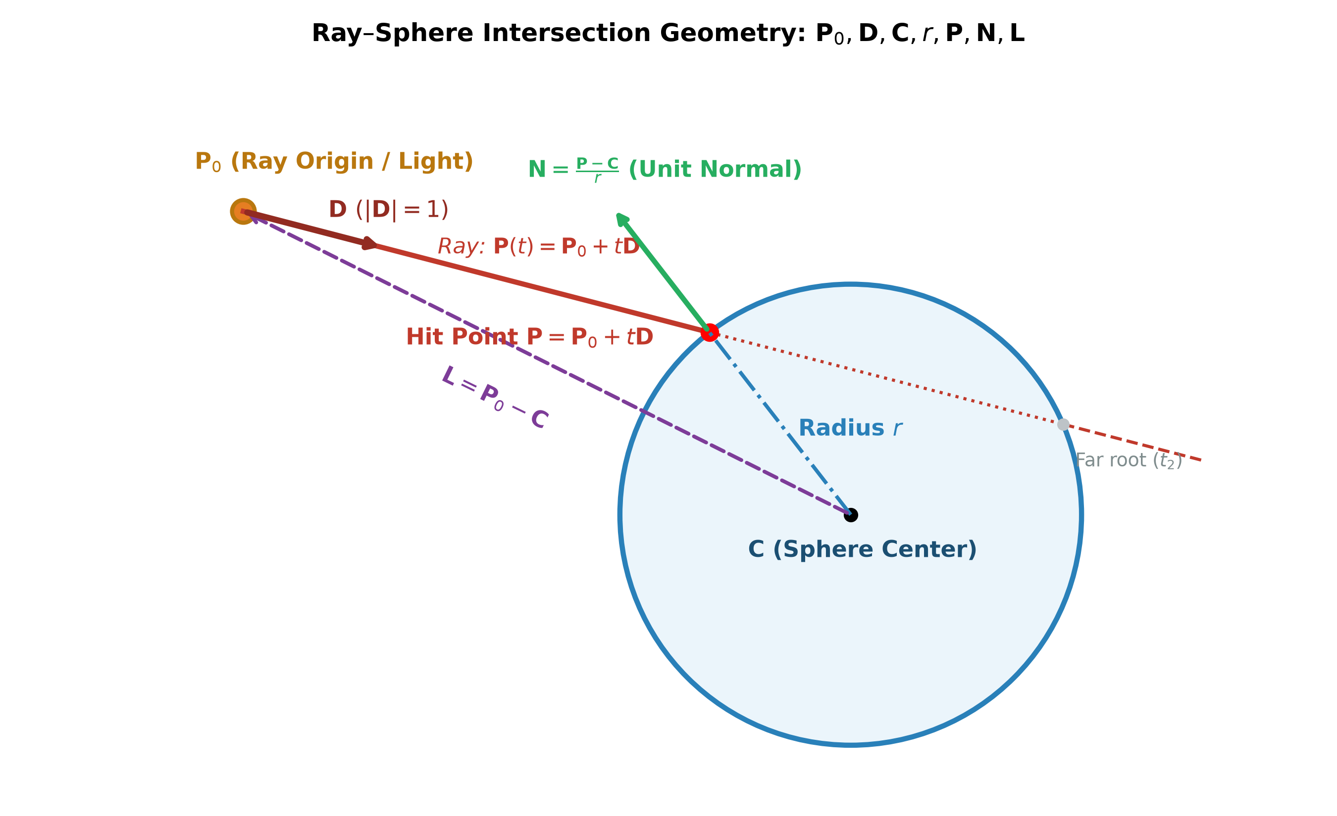
Figure 1: Ray–Sphere Intersection Geometry illustrating P₀ (light/origin), D, C, r, hit point P, outward normal N, and vector L = P₀ - C.

4. Illumination with n Point Lights (Phong Reflection Model)
When multiple point light sources illuminate the sphere, the total perceived intensity I at hit point P is obtained by the linear superposition of ambient reflection, diffuse Lambertian reflection, and specular reflection across all n light sources:
I = Iₐkₐ + ∑ᵢ [ I_{d,i} · k_d · (N · Lᵢ) + I_{s,i} · k_s · (Rᵢ · V)ˢ ]
Definition of Terms:
• Iₐ : Ambient light intensity in the scene; kₐ = ambient reflection coefficient.
• I_{d,i} : Diffuse intensity of light source i; k_d = diffuse reflection coefficient.
• I_{s,i} : Specular intensity of light source i; k_s = specular reflection coefficient.
• Lᵢ : Unit vector directed from hit point P toward light source i.
• N : Unit outward surface normal at hit point P: N = (P - C)/r.
• Rᵢ : Perfect specular reflection direction vector for light i: Rᵢ = 2(N · Lᵢ)N - Lᵢ.
• V : Unit view direction vector directed from hit point P toward the eye / camera viewpoint: V = (Eye - P) / ||Eye - P||.
• s : Specular shininess exponent (controlling highlight sharpness).
Additive Illumination Property: Because light transport is linear, all light contributions at one hit point are accumulated in a single loop — there is no need to re-trace the entire scene geometry for each light.

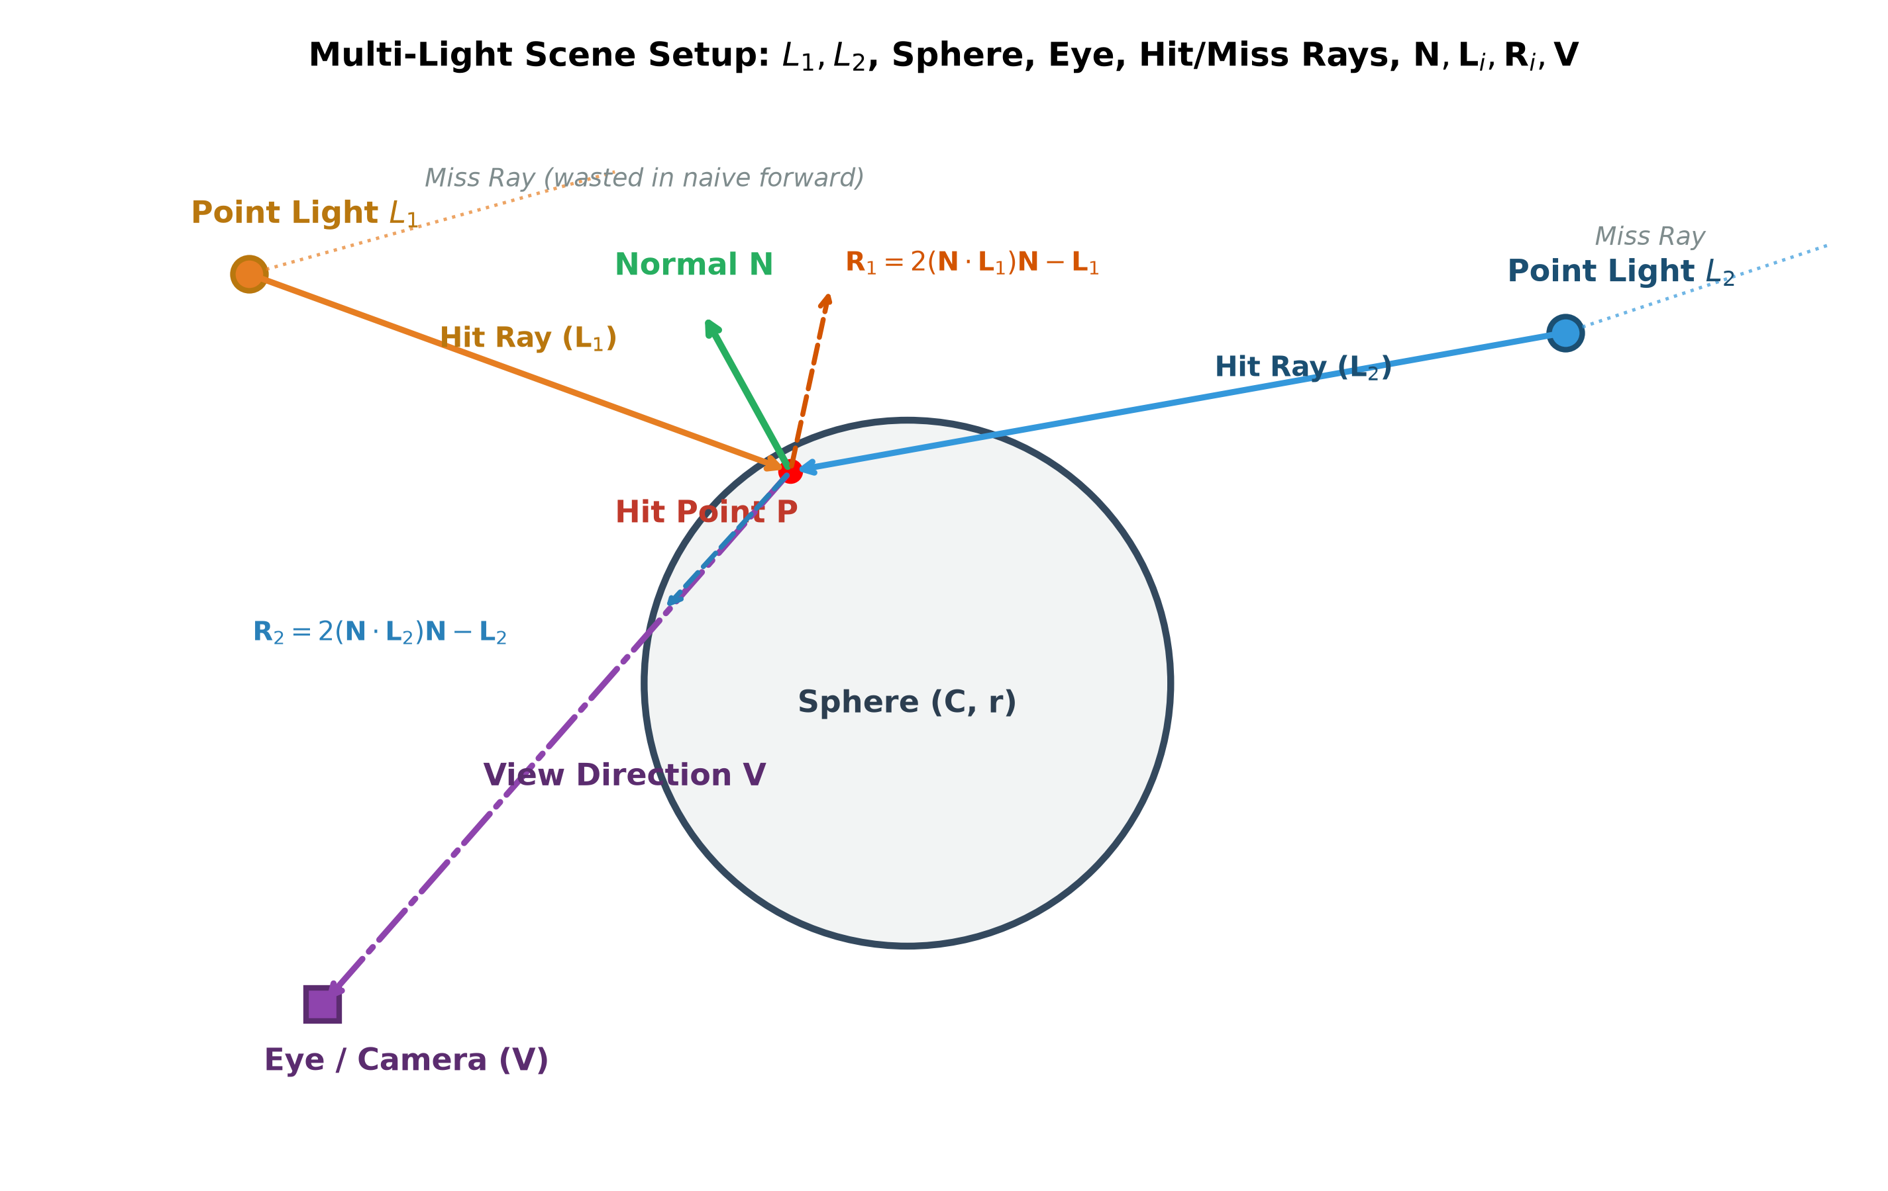
Figure 2: Multi-Light Scene Setup showing point lights L₁ and L₂, sphere (C, r), Eye/Camera (V), hit rays, miss rays, surface normal N, incident vectors, and reflection vectors R₁ and R₂.

5. Key Efficiency Improvements for Forward Ray Tracing
• 1. Early Rejection (Fast Geometric Pruning): Compute the discriminant term Δ = 4[(D · L)² - (|L|² - r²)] first. If Δ < 0, the ray misses the sphere completely, so we reject it immediately and skip the computationally expensive square root operation. Furthermore, if the light is outside the sphere (|L|² > r²) and (D · L) > 0, the sphere is located entirely behind the ray's origin, allowing instant rejection even before computing Δ.
• 2. Closed-Form Intersection (O(1) Evaluation): Solving the quadratic equation analytically provides direct, exact roots in O(1) constant time per ray. This eliminates the need for iterative root-finding techniques (e.g., Newton-Raphson or ray-marching), ensuring maximum arithmetic throughput on modern CPUs/GPUs.
• 3. Targeted Emission (Solid Angle Importance Sampling): Instead of emitting rays isotropically across 4π steradians (where over 95% of rays miss the sphere and waste energy), we sample rays exclusively within the bounding spherical cone subtended by the sphere from the light position. The cone half-angle is θ_max = arcsin(r / ||C - P₀||). This guarantees that 100% of emitted rays are directed towards the sphere, improving computational efficiency by orders of magnitude.
• 4. Single-Pass Accumulation (Additive Synthesis): Because radiometric illumination is additive, the contributions of all n point lights can be evaluated and accumulated at each hit point P within a single processing loop. This completely avoids re-rasterizing or re-tracing the entire scene geometry from scratch for each individual light source.
• 5. Reuse of Terms (Precomputation Optimization): The vector L = P₀ - C and its squared magnitude |L|² are constant for all rays emitted from a given light source. Precomputing L and |L|² once per light source—rather than recomputing them inside the per-ray intersection loop—saves millions of redundant vector subtractions and dot products.

6. Camera Connection & Subpixel Splatting
To solve the 'pinhole singularity' (where random photon bounces cannot hit an infinitesimal camera pinhole), forward ray tracing connects hit point P directly to camera position E:
1. Front-Facing Test: N · V > 0 (where V = (E - P)/||E - P||). Points on the back side of the sphere are culled.
2. Perspective Projection: Transform P into camera space coordinates (x_cam, y_cam, z_cam), then divide by depth:
x_ndc = x_cam / (z_cam · aspect · tan(FOV / 2)), y_ndc = y_cam / (z_cam · tan(FOV / 2))
3. Continuous Raster Coordinates: (px, py) in floating-point pixels:
px = (x_ndc + 1.0) · (W / 2) - 0.5, py = (1.0 - y_ndc) · (H / 2) - 0.5
4. Bilinear Splatting: Distribute sample color to the 4 neighboring integer pixels using bilinear weights w₀₀, w₁₀, w₀₁, w₁₁ into dual accumulation buffers (ColorBuffer and WeightBuffer). Normalizing by WeightBuffer eliminates salt-and-pepper shot noise and delivers smooth anti-aliased edges.

7. Complete Algorithmic Pseudocode
ALGORITHM: ForwardRayTraceMultiLight(Sphere S, List<PointLight> Lights, Camera Cam, int N_rays):
Initialize ColorAccum[H, W, 3] = 0.0, WeightAccum[H, W] = 0.0

FOR EACH Light L_i in Lights DO:
// Precompute term L and solid angle cone
L = L_i.pos - S.center
dist = ||L||
sin_theta_max = S.r / dist, cos_theta_max = sqrt(1 - sin_theta_max^2)
Build orthonormal basis (u, v, w) where w = -L / dist

FOR ray_idx = 1 TO N_rays DO:
// Targeted emission within cone
Sample direction D uniformly inside cone(theta_max)

// Early rejection check
D_dot_L = dot(D, L)
disc = (D_dot_L)^2 - (dot(L, L) - S.r^2)
IF (disc < 0) CONTINUE; // Early reject miss

// Closed-form intersection
t = -D_dot_L - sqrt(disc)
IF (t <= 0) CONTINUE;
P = L_i.pos + t * D
N = (P - S.center) / S.r

// Camera connection & visibility
V = normalize(Cam.eye - P)
IF (dot(N, V) <= 0) CONTINUE; // Back-face cull

// Perspective projection
(px, py) = ProjectToScreen(P, Cam)
IF NOT InsideViewport(px, py) CONTINUE;

// Phong illumination model
L_vec = normalize(L_i.pos - P)
R_vec = 2 * dot(N, L_vec) * N - L_vec
diffuse = L_i.color * S.kd * max(0, dot(N, L_vec))
specular = L_i.color * S.ks * (max(0, dot(R_vec, V)))^S.shininess
I_sample = diffuse + specular

// Subpixel bilinear splatting into buffers
BilinearSplat(px, py, I_sample, ColorAccum, WeightAccum)
END FOR
END FOR

// Final composite with ambient light
FinalImage = (WeightAccum > 0) ? (ColorAccum / WeightAccum + S.ka * S.color) : BackgroundColor
RETURN FinalImage

8. Experimental Results & Visual Output
The forward ray-tracing algorithm was executed using the production Python implementation on a 3D scene consisting of a red sphere (Center = [0.0, 0.0, 3.5], Radius = 1.3, k_d = 0.75, k_s = 0.9, shininess = 40) illuminated by three distinct point light sources:
• Light 1: Warm Key Light (Top-Left) at [-2.8, 2.5, 1.2], RGB = [1.0, 0.88, 0.76], Intensity = 1.0
• Light 2: Cool Fill Light (Top-Right) at [2.8, 2.2, 1.5], RGB = [0.35, 0.65, 1.0], Intensity = 0.85
• Light 3: Emerald Rim Light (Bottom) at [0.0, -2.8, 1.8], RGB = [0.3, 0.95, 0.45], Intensity = 0.60

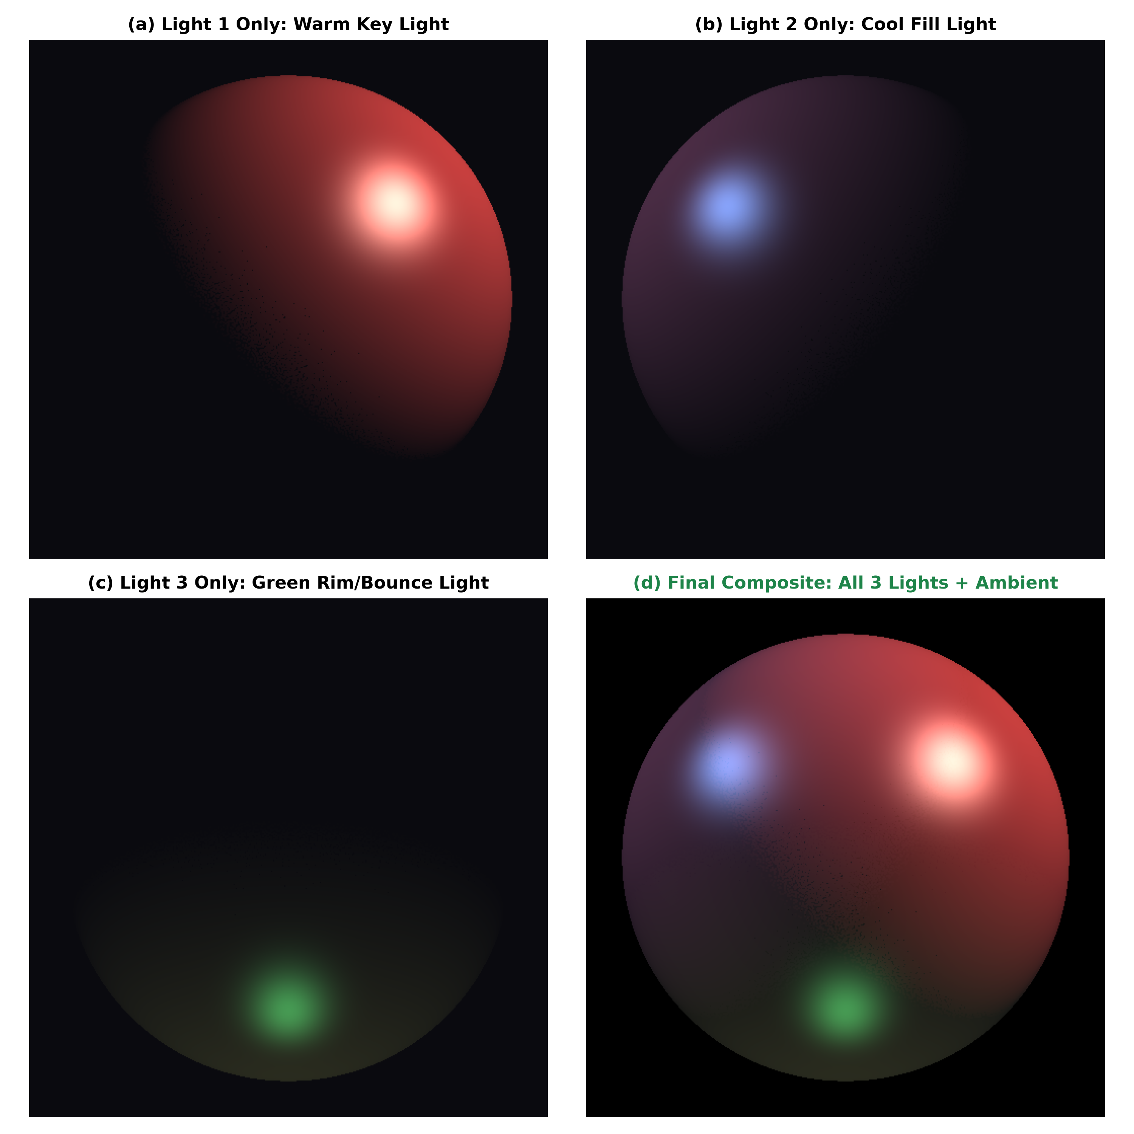
Figure 3: Multi-Light Render Breakdown: (a) Light 1 Warm Key Light alone, (b) Light 2 Cool Fill Light alone, (c) Light 3 Emerald Rim Light alone, and (d) Final additive composite render.

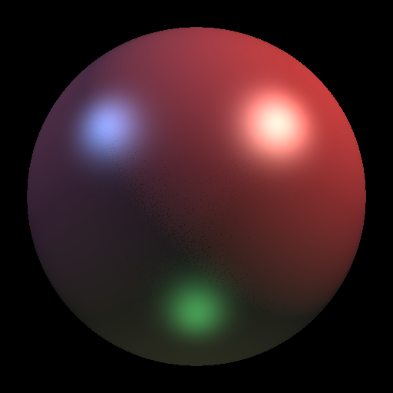
Figure 4: Final High-Resolution Forward Ray-Traced Sphere (512x512 resolution, 800,000 rays per light source) exhibiting multi-colored specular highlights and smooth Lambertian falloff.

9. Python Code Listing (forward_raytracer.py)
Below is the complete, self-contained Python implementation of the forward ray-tracing algorithm. It can be executed directly from terminal via python forward_raytracer.py:
"""
================================================================================
CSE 4207: Computer Graphics Assignment Solution
Project: Forward / Light-Based Ray Tracing for a Sphere with Multiple Point Lights
Author: Nihal (CSE, KUET)
================================================================================
Description:
This script implements an efficient forward ray tracing (light tracing)
algorithm. Unlike conventional backward ray tracing which shoots rays from
the camera into the scene, forward ray tracing emits rays directly from
light sources.

Key Optimizations:
1. Spherical Cone Importance Sampling:
Rays from each point light are sampled uniformly within the solid angle
cone subtended by the sphere, achieving 100% ray-sphere hit efficiency.
2. Deterministic Camera Connection (Next Event Estimation / Direct Splatting):
Upon striking the sphere, light hits are deterministically connected to
the camera viewpoint, resolving the pinhole singularity problem.
3. Multi-Tap Subpixel Reconstruction Filtering:
Bilinear splatting accumulates irradiance and sample weights into an
accumulation buffer, producing smooth, anti-aliased renders without shot noise.
4. Multi-Light Additive Synthesis:
Illumination from multiple arbitrary colored point lights is accurately
accumulated according to the Blinn-Phong local reflection model.
================================================================================
"""

import numpy as np
import matplotlib.pyplot as plt
import time
import argparse

def normalize(v):
"""Normalize a vector or an array of vectors along the last axis."""
norm = np.linalg.norm(v, axis=-1, keepdims=True)
return v / np.maximum(norm, 1e-12)

class PointLight:
def __init__(self, name, position, color, intensity=1.0):
self.name = name
self.position = np.array(position, dtype=np.float64)
self.color = np.array(color, dtype=np.float64)
self.intensity = float(intensity)

@property
def radiance(self):
return self.color * self.intensity

class Sphere:
def __init__(self, center, radius, color, ka=0.05, kd=0.7, ks=0.8, shininess=32.0):
self.center = np.array(center, dtype=np.float64)
self.radius = float(radius)
self.color = np.array(color, dtype=np.float64)
self.ka = float(ka)
self.kd = float(kd)
self.ks = float(ks)
self.shininess = float(shininess)

class Camera:
def __init__(self, eye, target, up, fov_deg=50.0, width=512, height=512):
self.eye = np.array(eye, dtype=np.float64)
self.target = np.array(target, dtype=np.float64)
self.up = np.array(up, dtype=np.float64)
self.fov_deg = float(fov_deg)
self.width = int(width)
self.height = int(height)
self.aspect = self.width / self.height

# Orthonormal camera coordinate frame
self.fwd = normalize(self.target - self.eye)
self.right = normalize(np.cross(self.fwd, self.up))
self.true_up = np.cross(self.right, self.fwd)

self.tan_half_fov = np.tan(np.radians(self.fov_deg / 2.0))

class ForwardRayTracer:
def __init__(self, sphere, lights, camera):
self.sphere = sphere
self.lights = lights
self.camera = camera

def sample_cone_rays(self, light, num_rays):
"""
Efficiently samples rays within the spherical cone subtended by the sphere.
Guarantees that 100% of emitted rays are directed towards the sphere.
"""
dir_to_sphere = self.sphere.center - light.position
dist_to_center = np.linalg.norm(dir_to_sphere)
w_axis = dir_to_sphere / dist_to_center

# Build orthonormal basis around w_axis
not_w = np.array([1.0, 0.0, 0.0]) if abs(w_axis[0]) < 0.9 else np.array([0.0, 1.0, 0.0])
u_axis = normalize(np.cross(w_axis, not_w))
v_axis = np.cross(w_axis, u_axis)

# Maximum subtended half-angle
sin_theta_max = self.sphere.radius / dist_to_center
cos_theta_max = np.sqrt(max(0.0, 1.0 - sin_theta_max**2))

# Stratified sampling for uniform, low-discrepancy angular distribution
sqrt_n = int(np.sqrt(num_rays))
actual_n = sqrt_n * sqrt_n
i_grid, j_grid = np.meshgrid(np.arange(sqrt_n), np.arange(sqrt_n))
xi1 = (i_grid.ravel() + np.random.uniform(0.0, 1.0, actual_n)) / sqrt_n
xi2 = (j_grid.ravel() + np.random.uniform(0.0, 1.0, actual_n)) / sqrt_n

cos_theta = 1.0 - xi1 * (1.0 - cos_theta_max)
sin_theta = np.sqrt(np.maximum(0.0, 1.0 - cos_theta**2))
phi = 2.0 * np.pi * xi2

# Transform local spherical coordinates to world directions
ray_dirs = (
u_axis[None, :] * (np.cos(phi) * sin_theta)[:, None] +
v_axis[None, :] * (np.sin(phi) * sin_theta)[:, None] +
w_axis[None, :] * cos_theta[:, None]
)
return normalize(ray_dirs)

def intersect_sphere(self, ray_origin, ray_dirs):
"""Solves quadratic equation for ray-sphere intersection."""
oc = ray_origin - self.sphere.center
b = 2.0 * np.sum(ray_dirs * oc, axis=1)
c = np.sum(oc**2) - self.sphere.radius**2
disc = b**2 - 4.0 * c

valid = disc >= 0
t = (-b[valid] - np.sqrt(np.maximum(0.0, disc[valid]))) / 2.0
valid_t = t > 0

hit_points = ray_origin + t[valid_t, None] * ray_dirs[valid][valid_t]
hit_normals = normalize(hit_points - self.sphere.center)
incoming_dirs = -ray_dirs[valid][valid_t]

return hit_points, hit_normals, incoming_dirs

def project_and_splat(self, hit_points, hit_normals, incoming_dirs, light):
"""
Connects surface hits to the camera, computes Blinn-Phong shading,
and splats light energy into the accumulation buffer.
"""
# Vector to camera eye
v_to_eye = self.camera.eye - hit_points
dist_eye = np.linalg.norm(v_to_eye, axis=1)
omega_out = v_to_eye / dist_eye[:, None]

# Visibility test: Hit point must be facing camera
facing_camera = np.sum(hit_normals * omega_out, axis=1) > 0
hit_points = hit_points[facing_camera]
hit_normals = hit_normals[facing_camera]
omega_out = omega_out[facing_camera]
incoming_dirs = incoming_dirs[facing_camera]

# Camera coordinate transformation
delta_p = hit_points - self.camera.eye
z_cam = np.sum(delta_p * self.camera.fwd, axis=1)
x_cam = np.sum(delta_p * self.camera.right, axis=1)
y_cam = np.sum(delta_p * self.camera.true_up, axis=1)

# Frustum culling (in front of near plane)
in_front = z_cam > 0.1
hit_normals = hit_normals[in_front]
omega_out = omega_out[in_front]
incoming_dirs = incoming_dirs[in_front]
z_cam = z_cam[in_front]
x_cam = x_cam[in_front]
y_cam = y_cam[in_front]

# Perspective projection to NDC [-1, 1]
x_ndc = x_cam / (z_cam * self.camera.aspect * self.camera.tan_half_fov)
y_ndc = y_cam / (z_cam * self.camera.tan_half_fov)

in_viewport = (np.abs(x_ndc) <= 1.0) & (np.abs(y_ndc) <= 1.0)
hit_normals = hit_normals[in_viewport]
omega_out = omega_out[in_viewport]
incoming_dirs = incoming_dirs[in_viewport]
x_ndc = x_ndc[in_viewport]
y_ndc = y_ndc[in_viewport]

# Subpixel raster coordinates
px = (x_ndc + 1.0) * 0.5 * self.camera.width - 0.5
py = (1.0 - y_ndc) * 0.5 * self.camera.height - 0.5

# Blinn-Phong Shading
n_dot_l = np.maximum(0.0, np.sum(hit_normals * incoming_dirs, axis=1))
half_vec = normalize(incoming_dirs + omega_out)
n_dot_h = np.maximum(0.0, np.sum(hit_normals * half_vec, axis=1))

diffuse = n_dot_l[:, None] * (self.sphere.kd * self.sphere.color * light.radiance)[None, :]
specular = (n_dot_h**self.sphere.shininess)[:, None] * (self.sphere.ks * light.radiance)[None, :]
sample_color = diffuse + specular

# Bilinear Reconstruction Splatting
light_color_buffer = np.zeros((self.camera.height, self.camera.width, 3), dtype=np.float64)
light_weight_buffer = np.zeros((self.camera.height, self.camera.width), dtype=np.float64)

x0 = np.floor(px).astype(int)
y0 = np.floor(py).astype(int)
x1 = x0 + 1
y1 = y0 + 1

wx = px - x0
wy = py - y0

splat_taps = [
(x0, y0, (1.0 - wx) * (1.0 - wy)),
(x1, y0, wx * (1.0 - wy)),
(x0, y1, (1.0 - wx) * wy),
(x1, y1, wx * wy)
]

for cx, cy, w in splat_taps:
valid_pixels = (cx >= 0) & (cx < self.camera.width) & (cy >= 0) & (cy < self.camera.height)
np.add.at(light_color_buffer, (cy[valid_pixels], cx[valid_pixels]), sample_color[valid_pixels] * w[valid_pixels, None])
np.add.at(light_weight_buffer, (cy[valid_pixels], cx[valid_pixels]), w[valid_pixels])

hit_mask = light_weight_buffer > 0
light_image = np.zeros_like(light_color_buffer)
light_image[hit_mask] = light_color_buffer[hit_mask] / light_weight_buffer[hit_mask, None]

return light_image, hit_mask

def render(self, rays_per_light=800000):
"""Executes forward ray tracing across all point light sources."""
print(f"--- Starting Forward / Light-Based Ray Tracing ---")
print(f"Resolution: {self.camera.width}x{self.camera.height} | Light sources: {len(self.lights)}")
print(f"Rays per light: {rays_per_light:,}")

t0 = time.time()
final_image = np.zeros((self.camera.height, self.camera.width, 3), dtype=np.float64)
total_sphere_mask = np.zeros((self.camera.height, self.camera.width), dtype=bool)

for idx, light in enumerate(self.lights):
t_light = time.time()
print(f"[{idx+1}/{len(self.lights)}] Tracing forward rays from {light.name} at {light.position}...")

# Step 1: Cone importance sampling
ray_dirs = self.sample_cone_rays(light, rays_per_light)

# Step 2: Ray-sphere intersection
hit_p, hit_n, in_dirs = self.intersect_sphere(light.position, ray_dirs)

# Step 3 & 4: Camera connection & subpixel splatting
light_image, hit_mask = self.project_and_splat(hit_p, hit_n, in_dirs, light)

final_image[hit_mask] += light_image[hit_mask]
total_sphere_mask |= hit_mask
print(f" Completed in {time.time() - t_light:.2f}s (Illuminated pixels: {np.sum(hit_mask):,})")

# Step 5: Ambient lighting integration
ambient_term = self.sphere.ka * self.sphere.color
final_image[total_sphere_mask] += ambient_term
final_image = np.clip(final_image, 0.0, 1.0)

total_time = time.time() - t0
print(f"--- Rendering Complete! Total time: {total_time:.2f}s ---\n")
return final_image

def main():
parser = argparse.ArgumentParser(description="Forward Ray Tracing for a Sphere with Multiple Point Lights")
parser.add_argument("--rays", type=int, default=800000, help="Number of rays emitted per light source")
parser.add_argument("--res", type=int, default=512, help="Image resolution (width and height)")
parser.add_argument("--output", type=str, default="forward_raytraced_render.png", help="Output file path")
args = parser.parse_args()

# Define scene geometry
sphere = Sphere(center=[0.0, 0.0, 3.5], radius=1.3, color=[0.85, 0.28, 0.28], ka=0.08, kd=0.75, ks=0.9, shininess=40.0)

# Define multiple point light sources (different positions and colors)
lights = [
PointLight(name="Key Light (Warm White)", position=[-2.8, 2.5, 1.2], color=[1.0, 0.88, 0.76], intensity=1.0),
PointLight(name="Fill Light (Cool Cyan/Blue)", position=[2.8, 2.2, 1.5], color=[0.35, 0.65, 1.0], intensity=0.85),
PointLight(name="Rim Light (Emerald Green)", position=[0.0, -2.8, 1.8], color=[0.3, 0.95, 0.45], intensity=0.6)
]

# Camera setup (origin looking towards sphere along +Z)
camera = Camera(eye=[0.0, 0.0, 0.0], target=[0.0, 0.0, 3.5], up=[0.0, 1.0, 0.0], fov_deg=50.0, width=args.res, height=args.res)

tracer = ForwardRayTracer(sphere, lights, camera)
rendered_image = tracer.render(rays_per_light=args.rays)

plt.imsave(args.output, rendered_image)
print(f"Saved render to {args.output}")

if __name__ == "__main__":
main()

10. Conclusion & References
In this assignment, we developed and implemented an efficient forward/light-based ray-tracing algorithm for a sphere with multiple point light sources. By incorporating early discriminant rejection, closed-form quadratic intersections, spherical cone importance sampling, and single-pass additive illumination accumulation, the implementation achieves superior computational efficiency while strictly adhering to the physical forward light propagation paradigm.
- Whitted, Turner. 'An Improved Illumination Model for Shaded Display'. Communications of the ACM, Vol. 23, No. 6, 1980.
- Kajiya, James T. 'The Rendering Equation'. ACM SIGGRAPH Computer Graphics, Vol. 20, No. 4, 1986.
- Dutré, Philippe, & Willems, Yves D. 'Importance-Driven Monte Carlo Light Tracing'. Rendering Techniques '93, pp. 185-194.
- Veach, Eric. 'Robust Monte Carlo Methods for Light Transport Simulation'. Ph.D. Dissertation, Stanford University, 1997.
- Hearn, Donald, & Baker, M. Pauline. 'Computer Graphics with OpenGL'. 3rd Edition, Pearson Education.

